Description of the Clean-booth Outfit
The storage of the clean-booth-outfit is placed to the wall of SR area.
Also, the laundry boxes have been located beside the storage cases.
- A person who wore the clean-booth outfit has the responsibility to put the laundry into a laundry box.
- Write the number of the laundry to the form and put it into the laundry box.
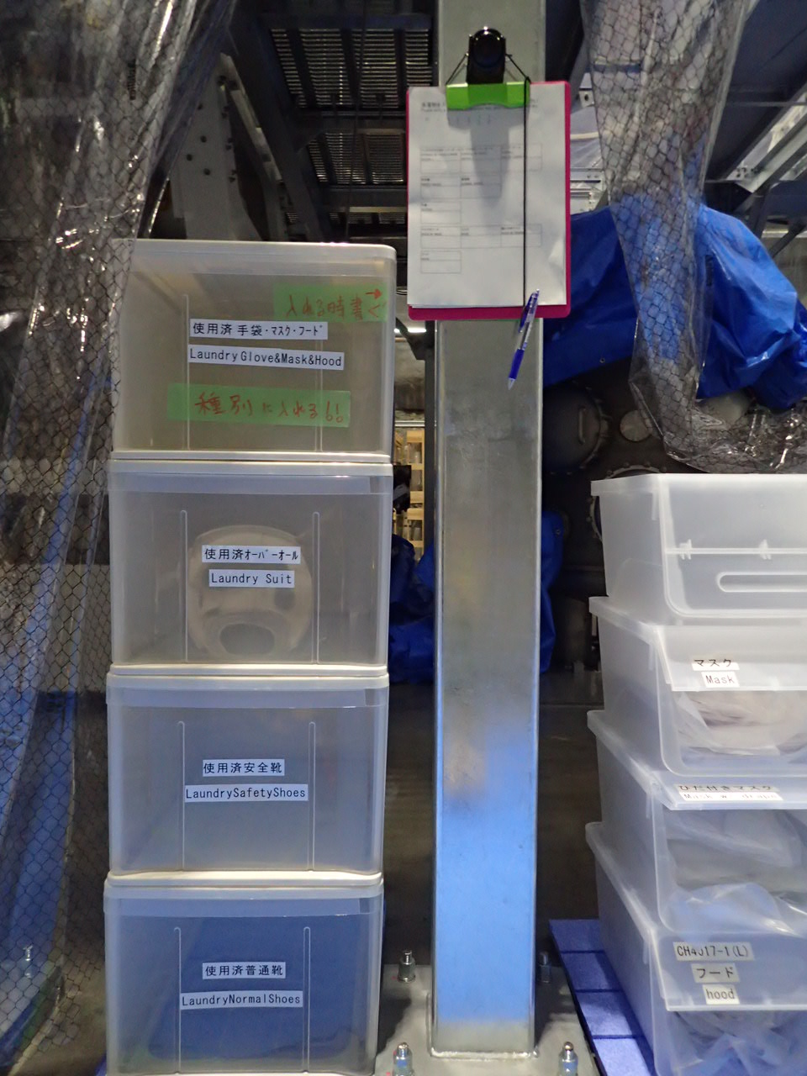
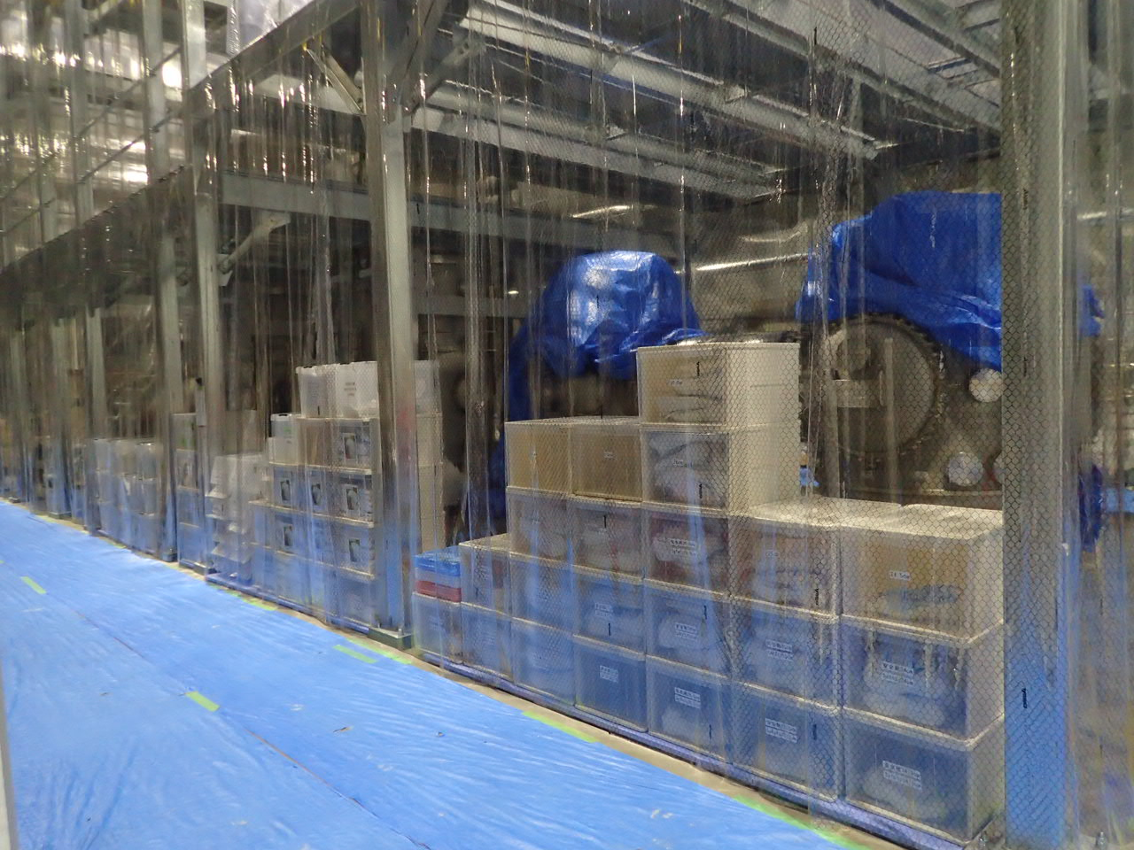
Place of the storage boxes
安全靴
靴
クリーンスーツ
フード
マスク
手袋
ニトリル手袋
洗濯物
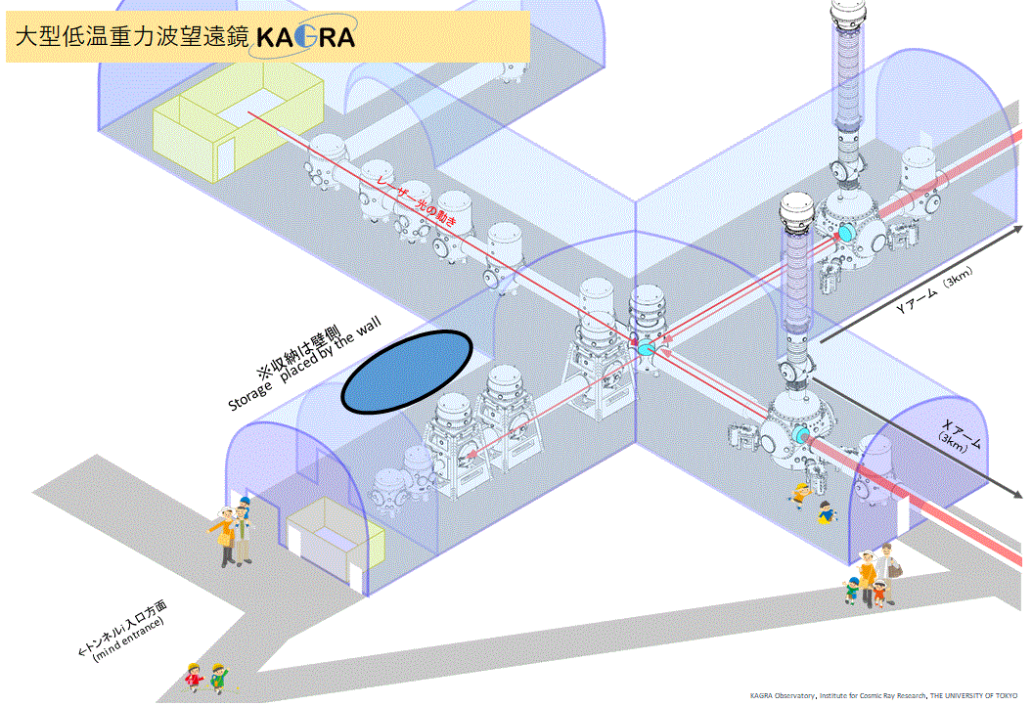

The clean-booth outfit (overall, safety shoes, shoes, gloves, mask, hood) is classified by size. If you have clothes needing to be washed, fill out the form and put them into the laundry box starting from ①.
