Description of the Clean-booth Outfit

The storage cases for the clean-booth outfit have been located inside the cover of SR area.
Also, the laundry boxes have been located beside the storage cases.

- A person who wore the clean-booth outfit has the responsibility to put the laundry into each laundry box.
- Note the number of the laundry you put beside the laundry boxes.

※If the laundry boxes are likely to be full, please contact Sakamoto, NAOJ.

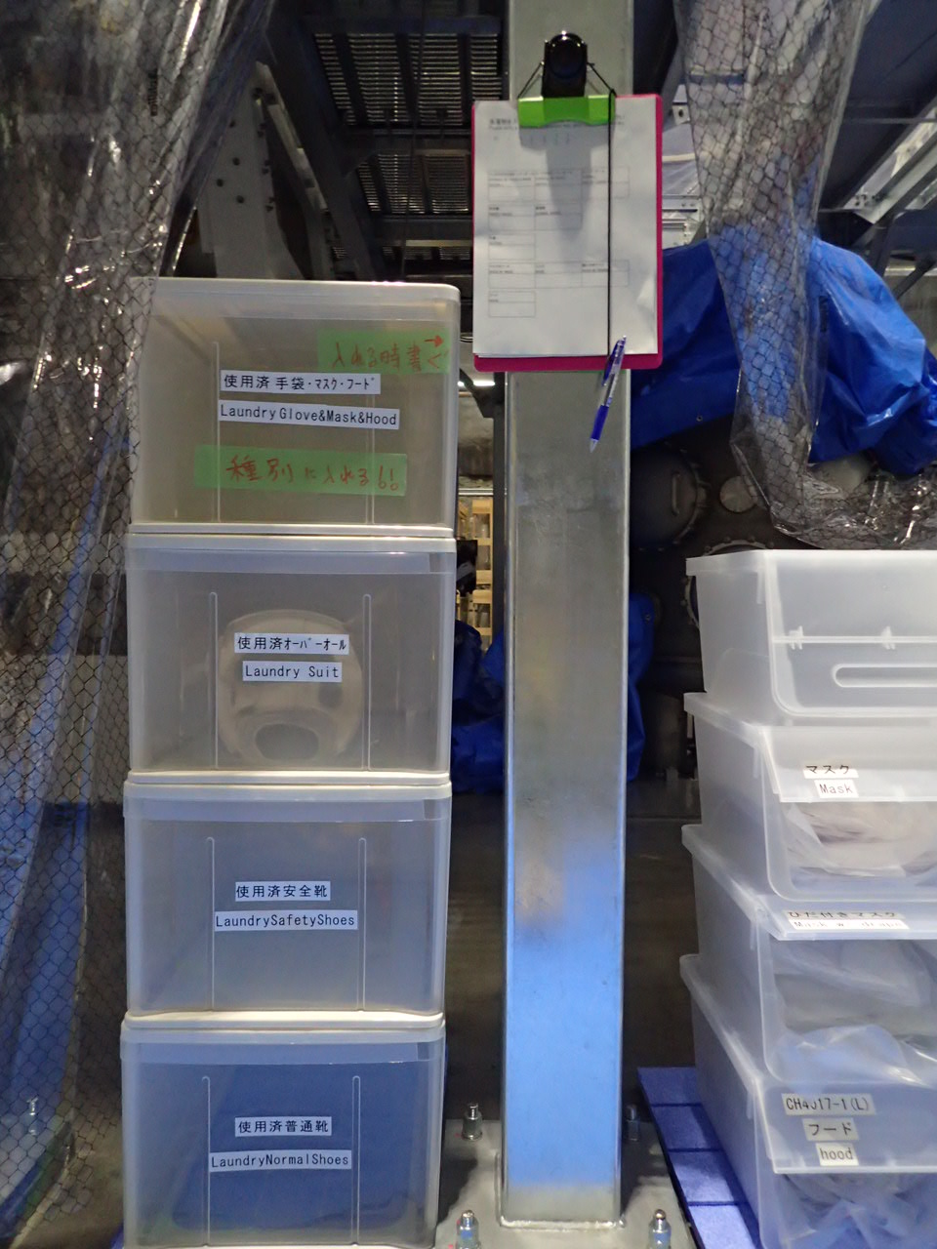
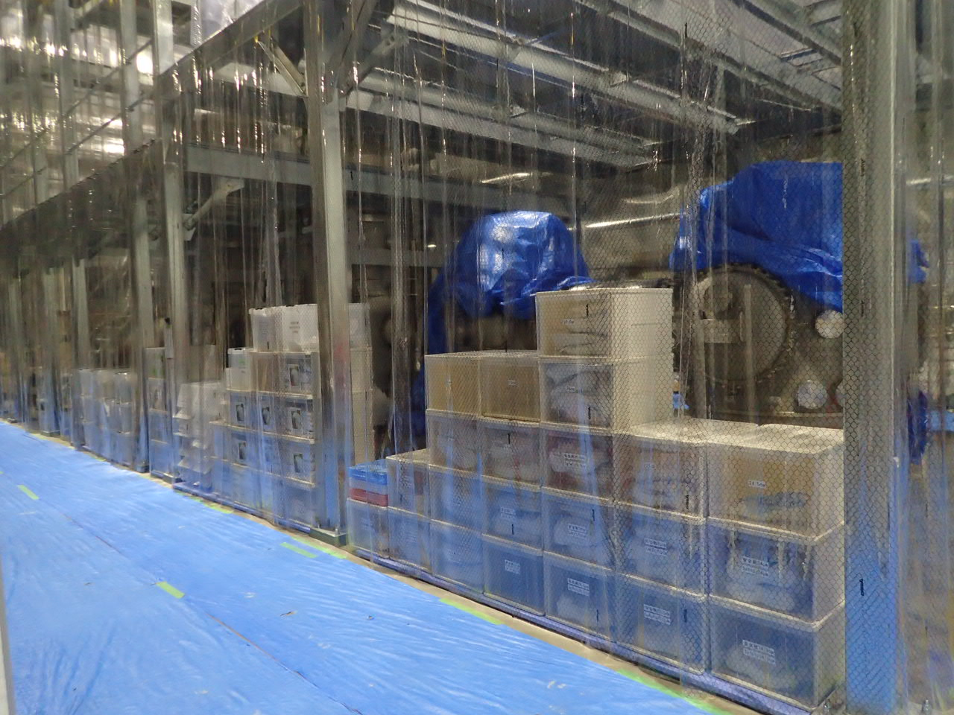
Place of the storage boxes
安全靴
靴
クリーンスーツ
フード
マスク
手袋
ニトリル手袋
洗濯物
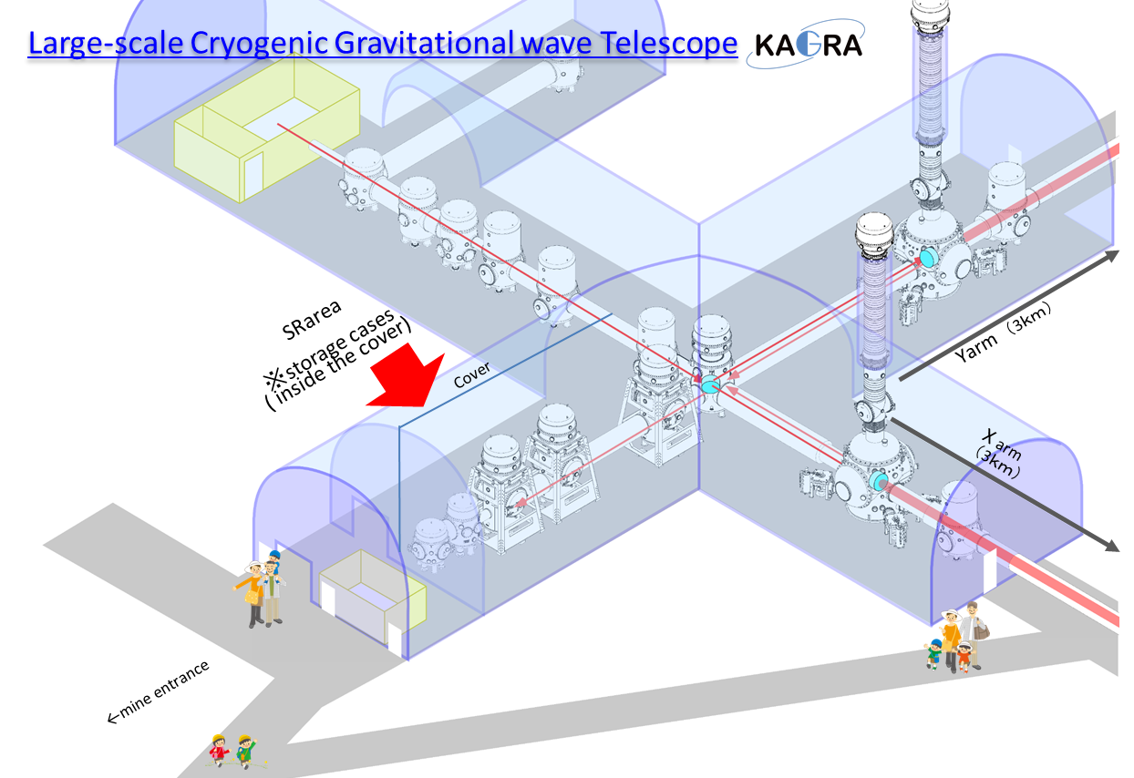

The clean-booth outfit (overall, safety shoes, shoes, gloves, mask, hood) is classified by size.

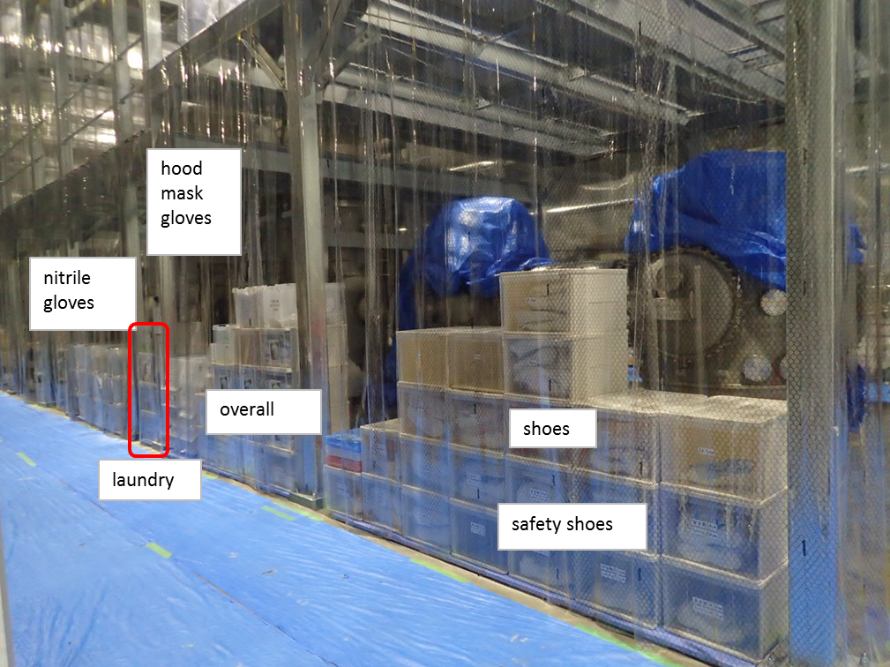
If you have clothes needing to be washed, fill out the form and put them into the laundry box. (See the form for the details.)
