JGW-T1605123-v1 KAGRA 13 April 2016

BS Cleanbag Design

Mark Barton

Distribution of this document:
JGW-DCC

This is an internal working note
of the KAGRA collaboration.

http://gwcenter.icrr.u-tokyo.ac.jp

Table of Contents
1 Introduction 3
1.1 Purpose and Scope 3
1.2 References 3
1.3 Version history 3
2 Design 3

Introduction

Purpose and Scope
We need a cleanbag to go over the BS during installation

References

Version history
4/13/2016: -v1.

Design
The second Mirapro design (of 4/7/2016) for the BS assembly frame is shown in Figure 1. Relative to the initial design, the top has been made taller to accommodate a load gauge adapter. The very top crossbars are for strength while the load gauge adapter is in use, and will be removed later when the PI is craned in. Feet and wheels have also been added, to allow the frame to be moved into its final position more easily and to compensate for unevenness of the floor.
I propose to have Mirapro add an extension made of 40 mm x 80 mm Misumi extrusion as also shown in Figure 1 (also Figure 2 and Figure 2: Frame extension top view with half bag
) to support the bag so that it can surround the PI without touching it. This will enable measurements to be done without interfering with the top filter.
The outside corners of the extension define a rectangle 1580 m x 1500 mm. The distance between the inside edges of the extension bars is 1500. The PI is 1430 mm in diameter, so there is 35 mm of clearance to the bar on each side. Thus the suspension can be craned out without interfering with the bars.
The bars go on the ±x side of the frame next to the tank (see Figure 4). The distance between the beams in the clean booth is 1800-100-80 = 1620 mm, so there is (1620-1500)/2 = 60 mm clearance.
The zips divide the bag into halves near the tank and away from the tank. The zips run down the ±x sides of the frame so it’s easy to partially unzip them to access to the lower masses.
There are secondary short zips in the top to allow better access to the lifting fixture on the top filter
A good length for the bag is 4310 mm including the top crossbars and lifting rings, but not counting the feet/wheels. This reaches the floor if the bag is used on the frame without the top crossbars, and to the top of the feet if the bag is used on the full frame.
I have asked for slits in positions corresponding to the uprights in the basic frame, so that the lifting rings can poke out the top.
Shoda-san says that windows in the sides were not helpful so I omitted them to save weight and expense. However she says that windows in the top would be helpful, so I added two (in each half-bag).
The exact dimensions are given in Figure 5.

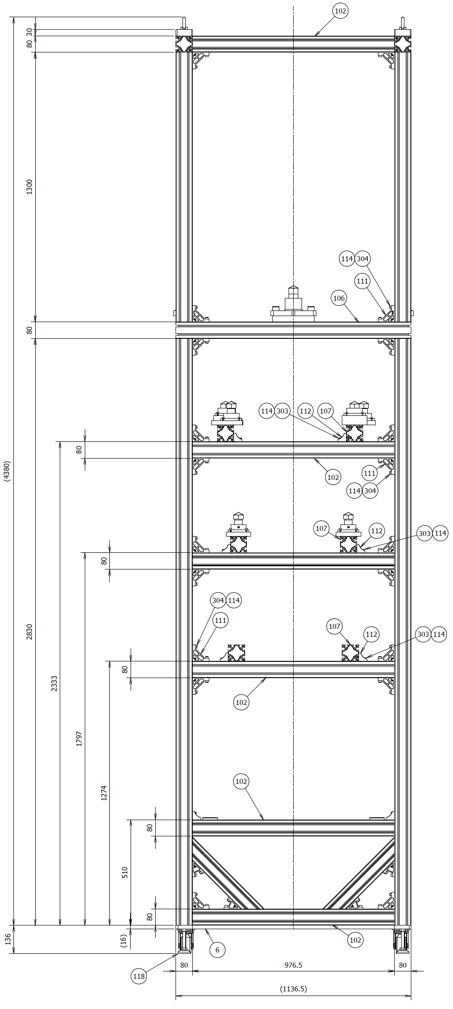
4310 mm

Figure 1: Mirapro’s revised frame design

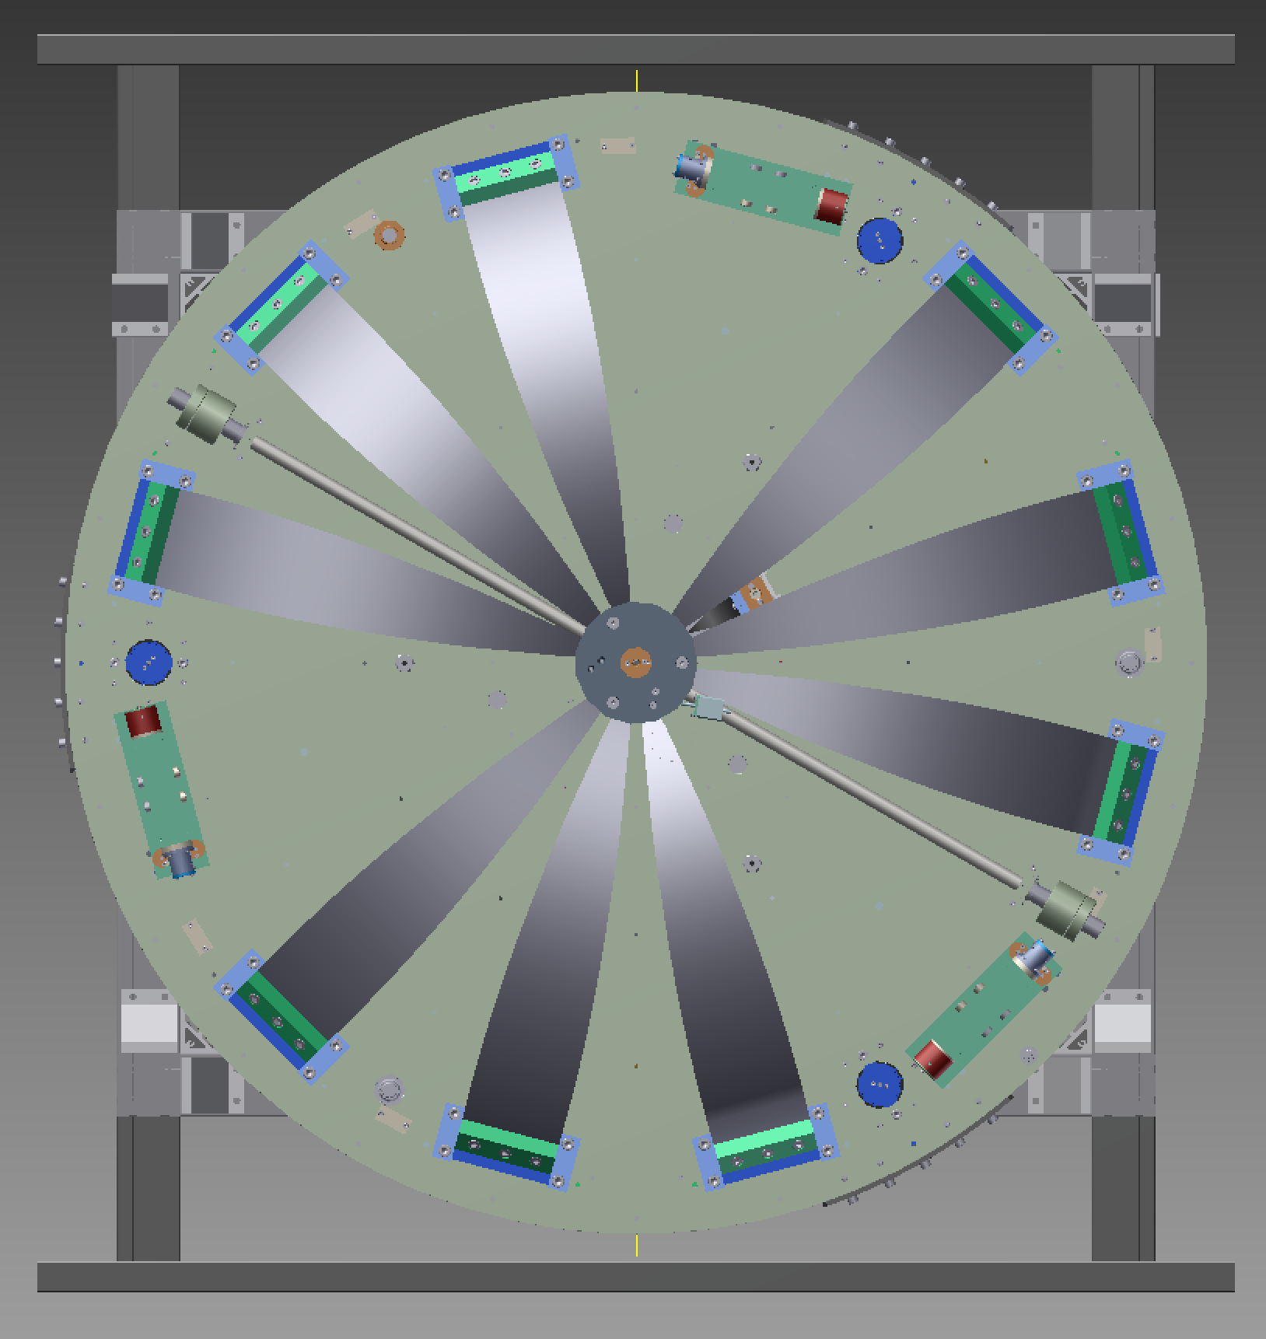
x
y
Tank
side
Figure 2: Frame extension top view with half bag
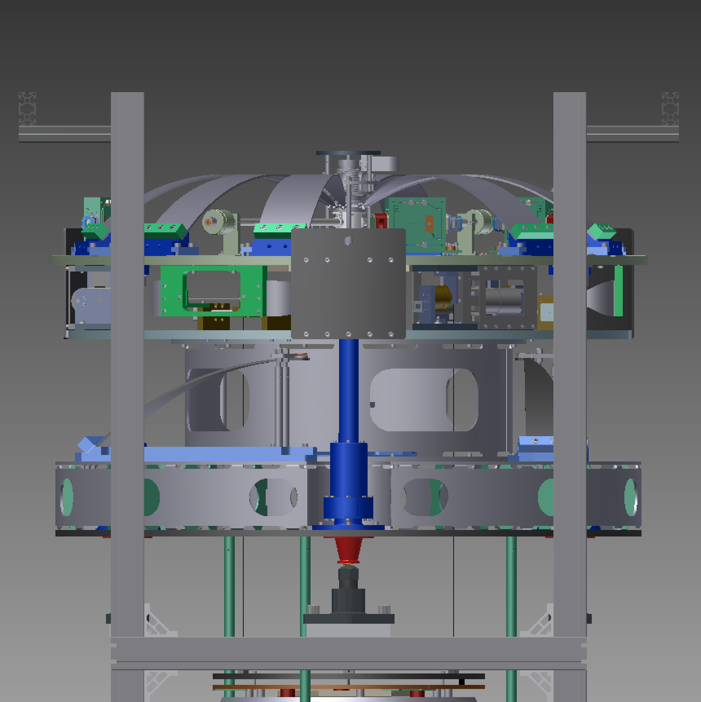
Figure 3: Frame extension – side view
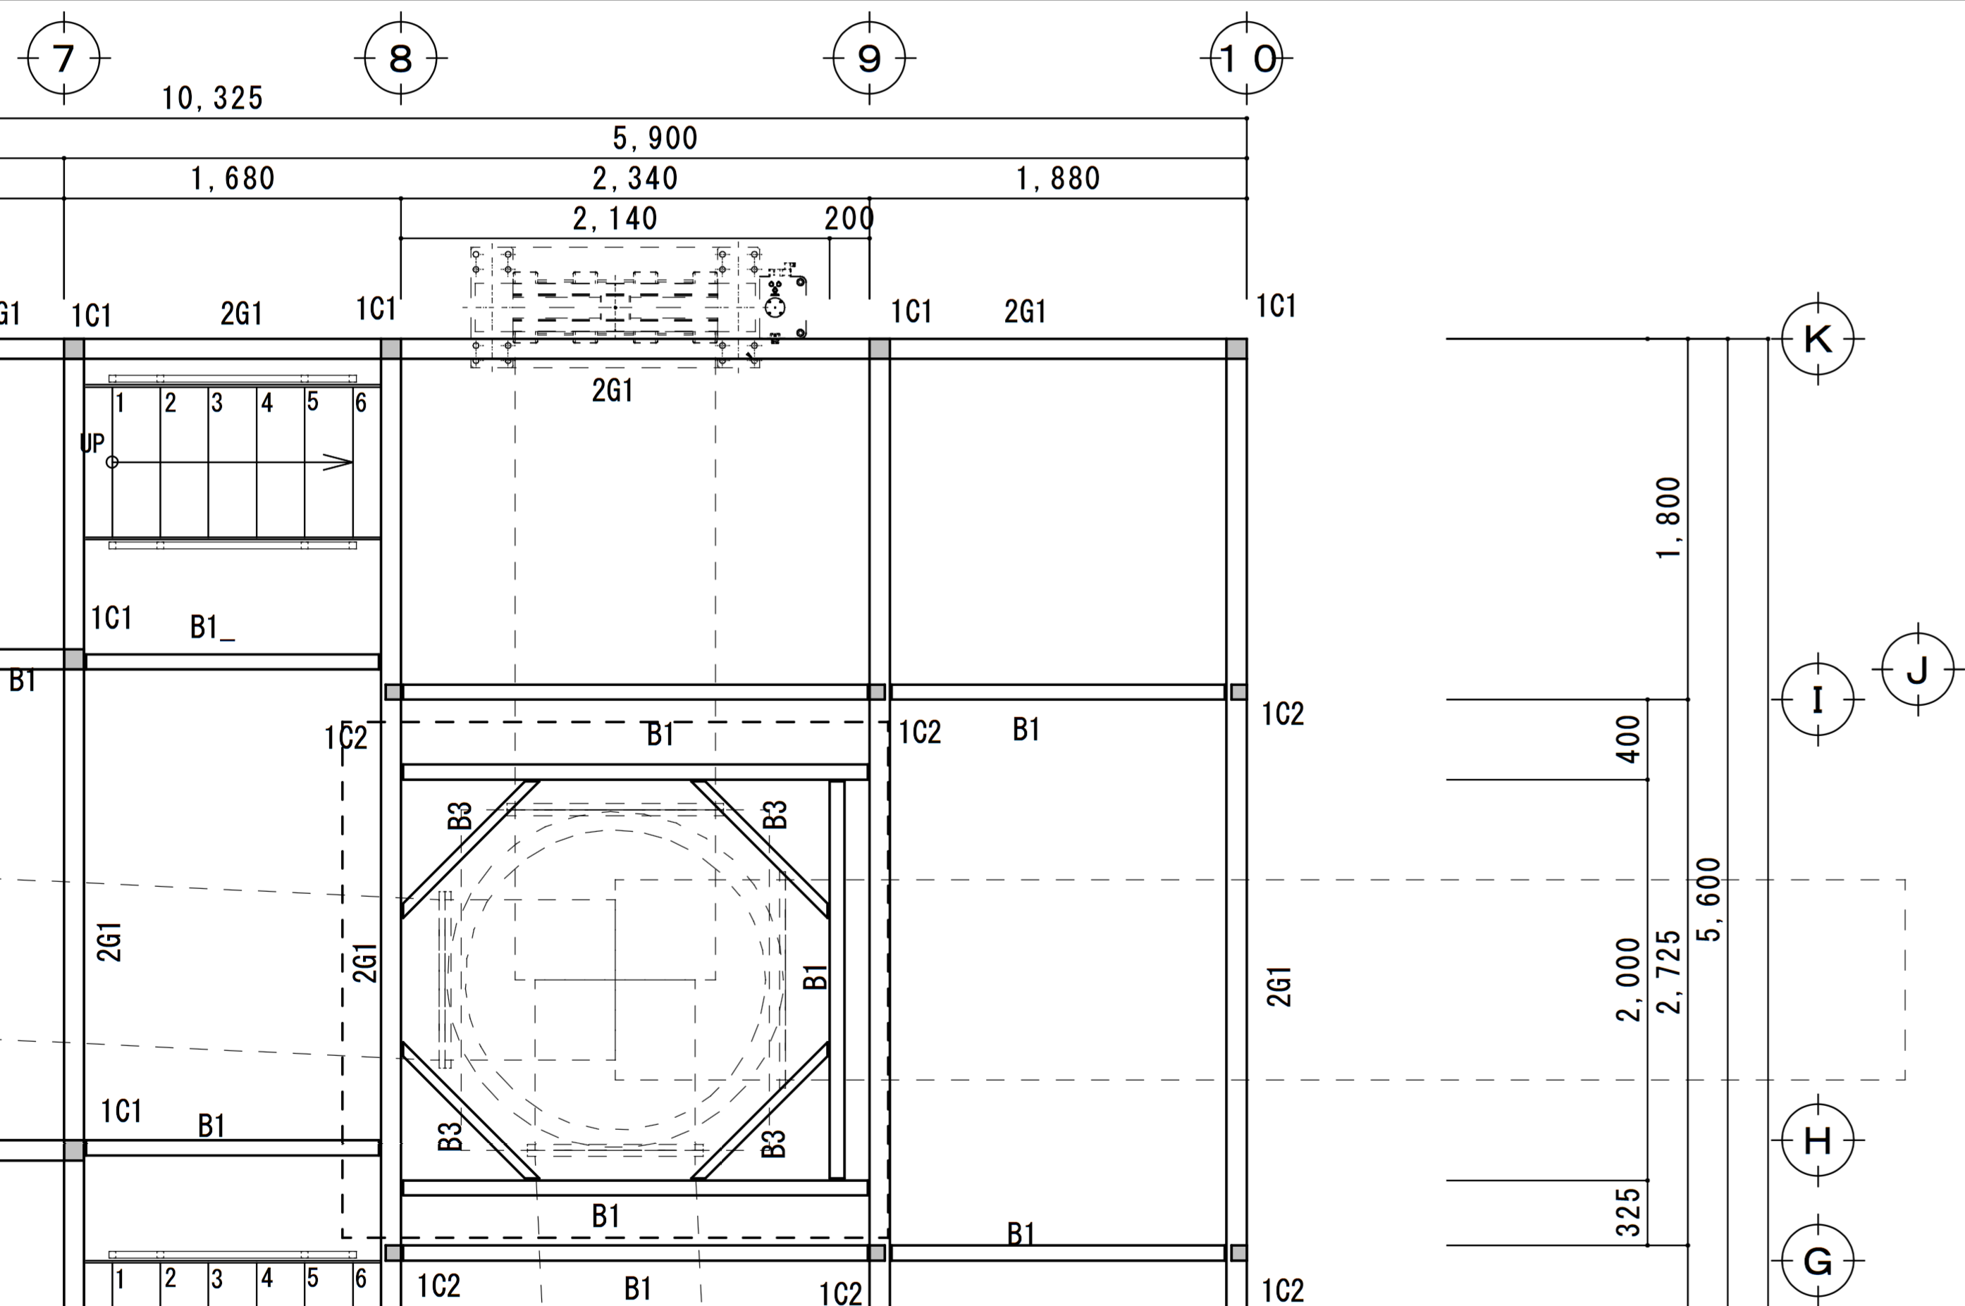
1580 mm
1500 mm
∅1430 mm
Figure 4: Cleanbooth Second Floor
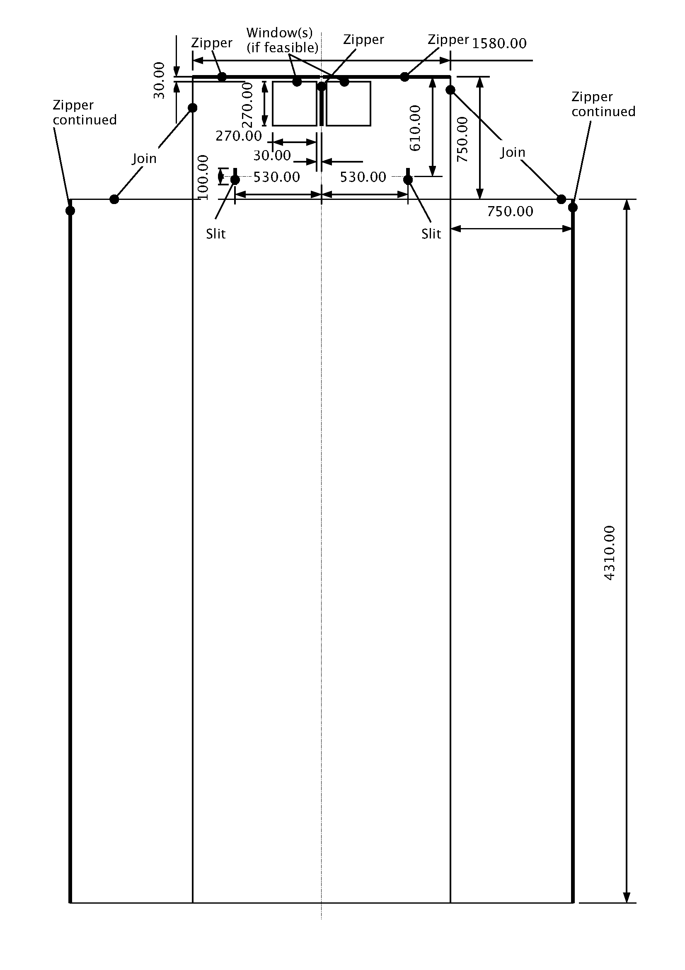
Figure 5: Final cleanbag design

