Recent news and status of
the KAGRA gravitational wave telescope

Yuta Michimura^{1, *} for the KAGRA Collaboration
¹Department of Physics, University of Tokyo, Bunkyo, Tokyo 113-0033, Japan
* michimura@granite.phys.s.u-tokyo.ac.jp

Abstract― KAGRA is a 3-km cryogenic interferometric gravitational wave telescope which is being built at the underground site of Kamioka mine in Gifu prefecture, Japan. The project started in 2010, and the construction of the basic infrastructures including the tunnel and the vacuum system completed in 2015. Between March and April 2016, we have performed the very first test runs with a simplified configuration; 3-km Michelson interferometer at room temperature. Here we present some of our recent results of the test runs, and discuss future plans and development status for the full configuration of KAGRA.

I. Introduction
On September 14, 2015 the two LIGO detectors observed gravitational waves for the first time. It not only proved the existence of gravitational waves directly, but also proved that observation of gravitational waves is a totally new way to listen to our Universe.
It also showed the importance of a global network of the gravitational wave detectors. In order to resolve the sky location of the source more accurately, three or more detectors are needed.
In Japan, a 3-km interferometric gravitational wave telescope called KAGRA is being built at Kamioka ⁽¹⁾. As an advanced detector, we use two unique technologies to reduce noises: (1) the construction of the interferometer at the quiet and stable underground site to reduce seismic and Newtonian noise, (2) the use of cryogenic sapphire mirrors to reduce thermal noises.
The development of KAGA is performed in two phases. iKAGRA is the initial phase to operate a simple 3-km Michelson interferometer at room temperature. bKAGRA is the final phase to operate a baseline cryogenic RSE interferometer. We have recently conducted iKAGRA test run, and transitioned to bKAGRA phase.

II. iKAGRA test run
iKAGRA test run was carried out on March 25 to 31 and April 11 to 25, 2016. Between two test runs, a little commissioning was done to improve the stability of the interferometer. Duty cycle and the longest lock duration of the March run was 85.2 % and 3.6 hours. Those for the April run was 90.4 % and 21.3 hours. The strain sensitivity was about 6e-16 /rtHz @ 100 Hz (Fig 1).
Although the sensitivity was not great, we have confirmed that the alignment of the vacuum ducts, the data transfer flow, and the observation shift procedure do not have big problems. Also, we have acquired valuable data 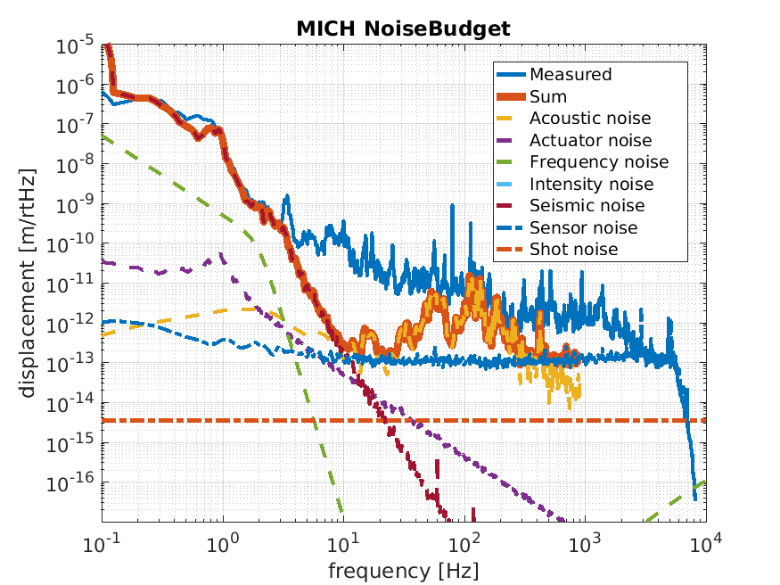
[Fig.1] Displacement sensitivity of iKAGRA (blue line) compared with various noise sources (dotted lines).

for differential tidal drift of the arm lengths and for other environmental sensors (e.g. seismometer, hydrometer, etc.). Hardware injection test of gravitational wave signals was also done to check the data analysis pipelines.

III. bKAGRA development
The operation of bKAGRA is planned to begin in 2019. Production of seismic attenuation system for room temperature mirrors, first prototype test of cryogenic suspension, procurement of high quality sapphire mirrors, and development of 180 W high power laser are currently underway.

Acknowledgements
This work was supported by MEXT, JSPS Leading-edge Research Infrastructure Program, JSPS Grant-in-Aid for Specially Promoted Research 26000005, MEXT Grant-in-Aid for Scientific Research on Innovative Areas 24103005, JSPS Core-to-Core Program, A. Advanced Research Networks, and the joint research program of the Institute for Cosmic Ray Research, University of Tokyo.

References
[1] Yoichi Aso, Yuta Michimura, Kentaro Somiya, Masaki Ando, Osamu Miyakawa, Takanori Sekiguchi, Daisuke Tatsumi, Hiroaki Yamamoto, Interferometer design of the KAGRA gravitational wave detector, Phys. Rev. D 88, 043007 (2013).

