JGW-E1605037-v1 KAGRA 1 April 2016

BS Assembly Frame Requirements

Mark Barton

Distribution of this document:
JGW-DCC

This is an internal working note
of the KAGRA collaboration.

http://gwcenter.icrr.u-tokyo.ac.jp

Table of Contents
1 Introduction 3
1.1 Purpose and Scope 3
1.2 References 3
1.3 Version history 3
2 Outline of Task 3
3 Notes on Assembly Frame 5
4 Notes on Optical Lever 6
5 Notes on Work Platforms 7

Introduction

Purpose and Scope
Gives requirements for the BS assembly frame and associated components to be supplied by Mirapro.

References
JGW-E1605035: VIS Document and Drawing Tree (BS)
JGW-E1504235: BS Installation Procedure
JGW-E1604817: BS Payload Assembly Procedure
JGW-E1604966: BS Mass Budget
JGW-D1504404: BS hanging frame ASSY

Version history
4/1/2016: For discussion at meeting with Mirapro at Mitaka, 4/1/16.

Outline of Task
From May 2016, we want to do a practice assembly and installation of the Type B suspension for the beamsplitter (BS) using a dummy optic, and then follow up with the installation of the real optic.
The suspension will be assembled in the BS cleanbooth next to the tank and will be craned into the tank as a single unit. The roof of the cleanbooth has been modified to permit this. The suspension will need to have a cover over it while it is partially outside the cleanbooth.
The installation will probably be done on the Y-arm side of the BS, with the BS side of the suspension facing toward the MC area. See Figure 1 and Figure 2.
Figure 1: Cleanbooth First Floor
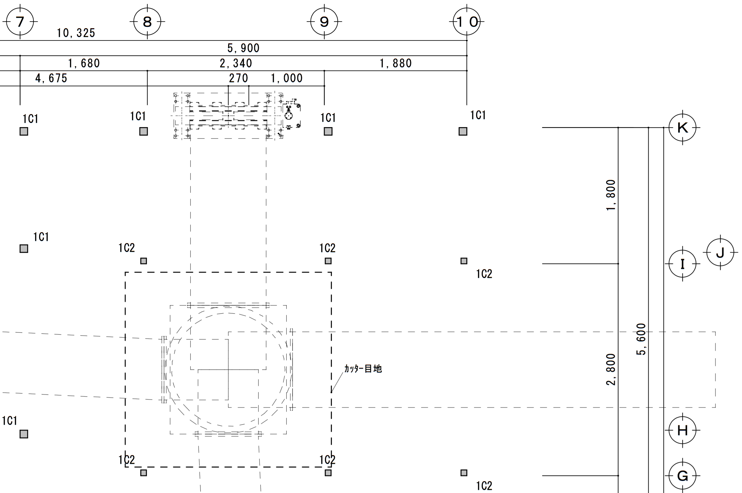
RM
side
BS
side
∅1430 mm
Figure 2: Cleanbooth Second Floor
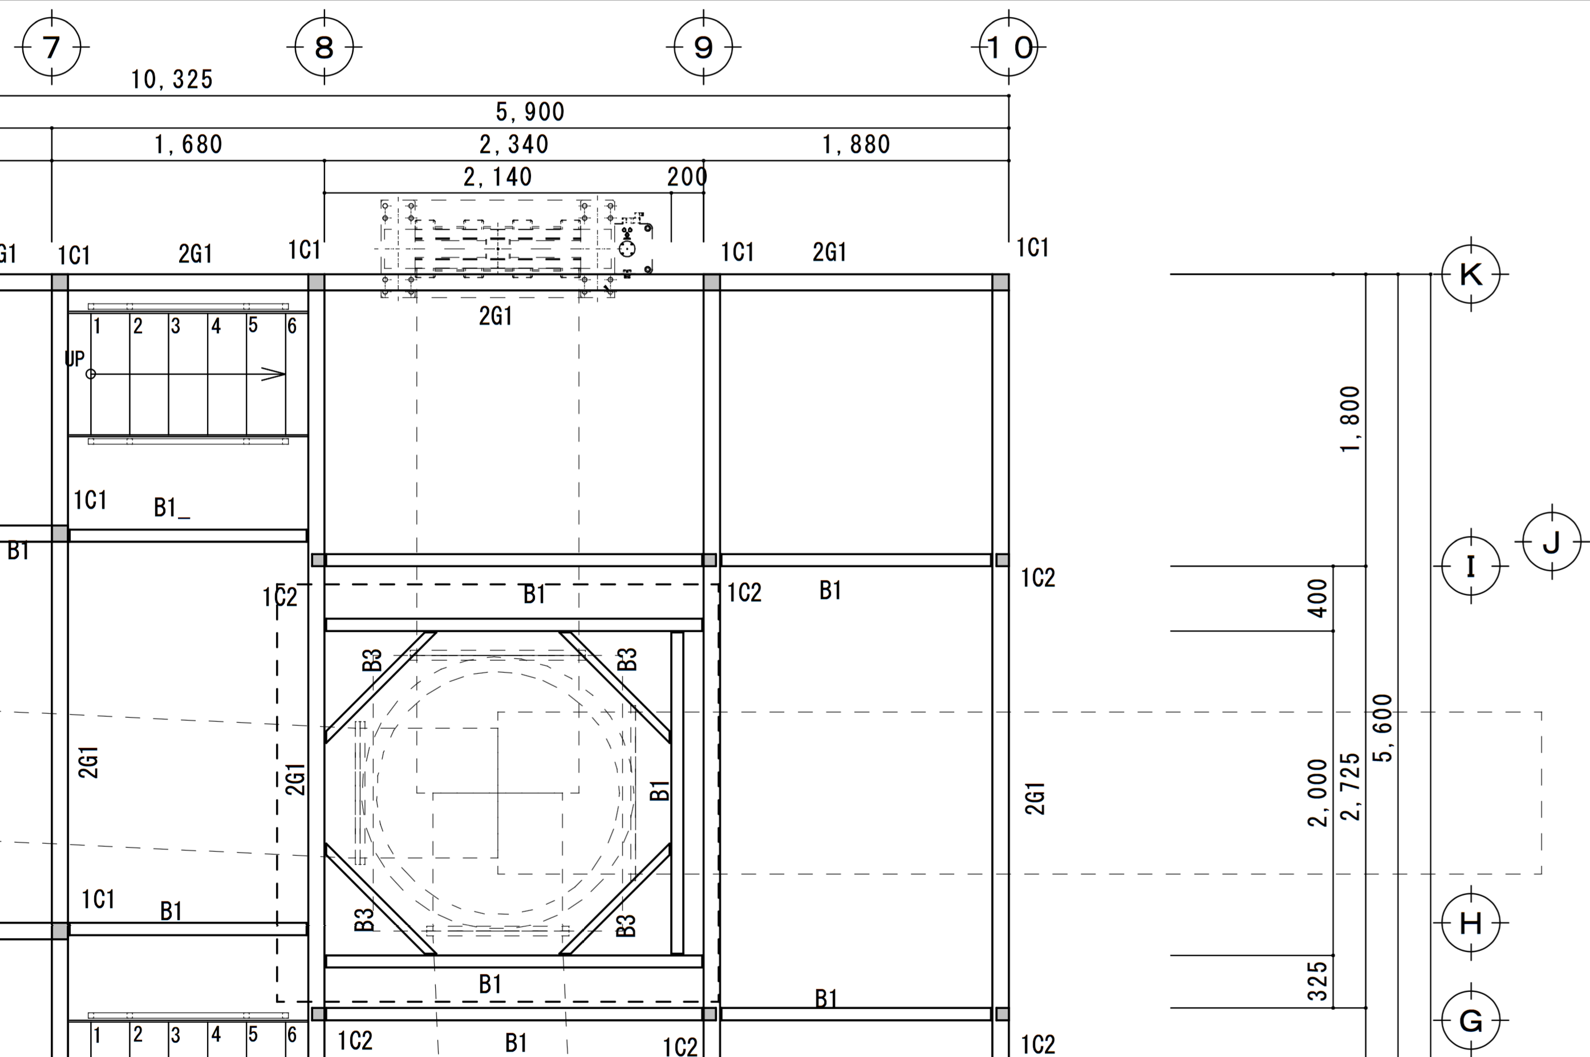
BS
side
RM
side
∅1430 mm

We would like Mirapro to supply a number of items required for the assembly:
- An assembly frame based on the design concept provided to them by Mark Barton and Naoatsu Hirata. See JGW-D1504404 for Inventor files of the assembly. Version –v1 of this is very close to final, but some of the crossbars may need to be increased in thickness and some of the details of the rail system at the bottom are to be decided.
- A lifting fixture, the “load gauge adapter”, which can be placed on the jacks at the top of the assembly frame and be used to lift partially assembled sections of the suspension via a load gauge to check their weight. Alternatively, if there is some electric hoist that could be attached to the main crane so as to allow items to be lifted extremely slowly and gently, that would also be OK.
- Work platforms to allow people to work on the higher parts of the suspension, and associated safety gear.
- A feedthrough rack which can be used to hold four vacuum feedthroughs at a convenient position near the top of the suspension, so that electrical connections can be made and electrical components tested while the suspension is still on the assembly frame. (The in-vacuum sides of the feedthroughs and the in-vacuum cables that connect to them have to be kept clean, but the cables on the air side will be dirty.)
- A frame to allow a clean bag to be draped over the frame and suspension at night or whenever it is not being worked on.
- A system of light-weight panels that can be quickly placed on the sides of the assembly frame (preferably with magnetic attachments) to protect it from wind currents while sensitive measurements are being made.
We would also like Mirapro to do a number of related tasks:
- Remove sections of the second floor of the cleanbooth to make room for the assembly frame.
- Remove the vacuum spool on the +Y side of the BS tank (and preferably also the one on the –X side).
- Clean the floor, lay down stainless steel sheet, and construct the assembly frame.
Installation-related items that are not the responsibility of Mirapro include:
- The clean bag mentioned will be designed by Mark and ordered by Aso-san.
- The optical table that will be part of the frame has already been purchased.
- The mirror box used to hold the BS during transport and initial installation will be designed and ordered by Tatsumi-san. The trolley plate (part of the rail system) that interfaces to the mirror box will also be designed and ordered by Tatsumi-san. Hirata-san will coordinate to ensure that it works properly with the rail system.
- The winches that allow adjustment of the wires holding the BS and reaction mass (RM) will be designed and made by ATC and Akutsu-san.

Notes on Assembly Frame
The design is based on the frame that was used for the Type B test at the West End station of TAMA. See Figure 3.
Unlike the PRx frame, the BS frame is not square, but 1300 x 1164 mm. The long axis will go in the Y direction. The suspension will be constructed with the optic axis parallel to the short axis of the frame.
Like the PRx frame, the BS frame has jacks at several levels to allow parts of the suspension to be raised and lowered smoothly to allow hooking and unhooking.
Unlike the PRx frame, most of the system for hanging the optic and recoil mass is supported directly off the main frame. Nothing except the rail system is placed on the optical table.
The crossbars at the lower levels have been made from thinner Misumi sections so as to allow better access. However we need to do a strength analysis to check that they are not too thin. The weights of the various masses are given in JGW-E1604966: BS Mass Budget.
Figure 3: Left (tank side), back-left and back views of the suspension on the assembly frame
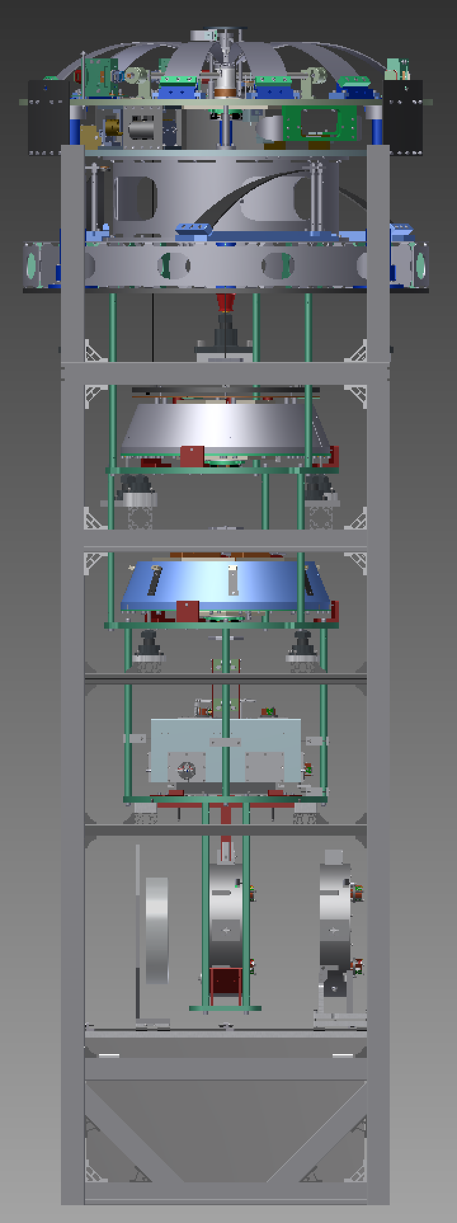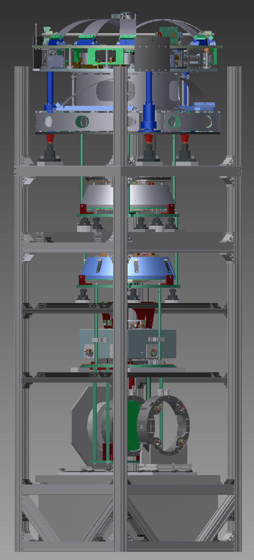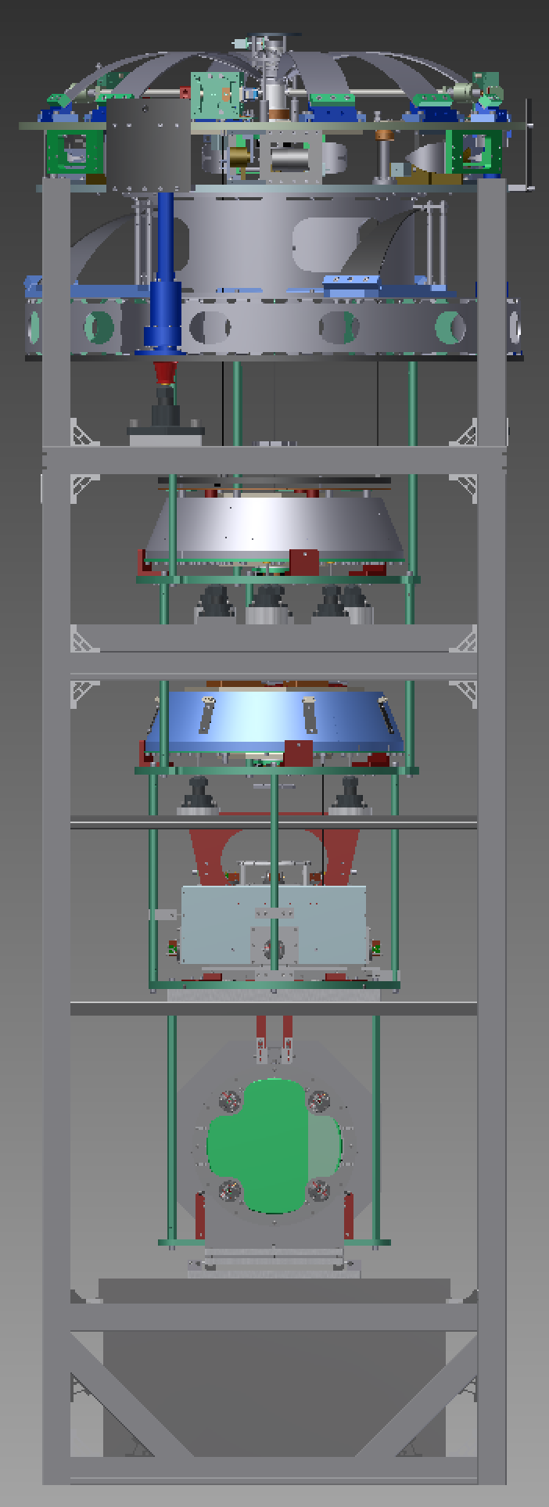

Notes on Load Gauge Adapter
We need to be able to lift various sections of the suspension and weigh them, and we need to do this very gently. A small very-slow speed electric hoist attached to the main crane might work. Alternatively a frame that can be placed on the top jacks might be good. See Figure 4
The frame has to be able to pick up:
- The standard filter and everything below (about 300 kg).
- The bottom filter and everything below (about 200 kg).
- The intermediate mass, optic and recoil mass (about 75 kg).
That means it has to sit fairly high to pick up the SF and have an adjustable section in the connection below it to pick up the other combinations.
The load gauge adapter and the preisolator will never be on the frame at the same time, so the three jacks that support the PI can be used for the load gauge adapter (possibly in different positions).
Figure 4: Load gauge adapter
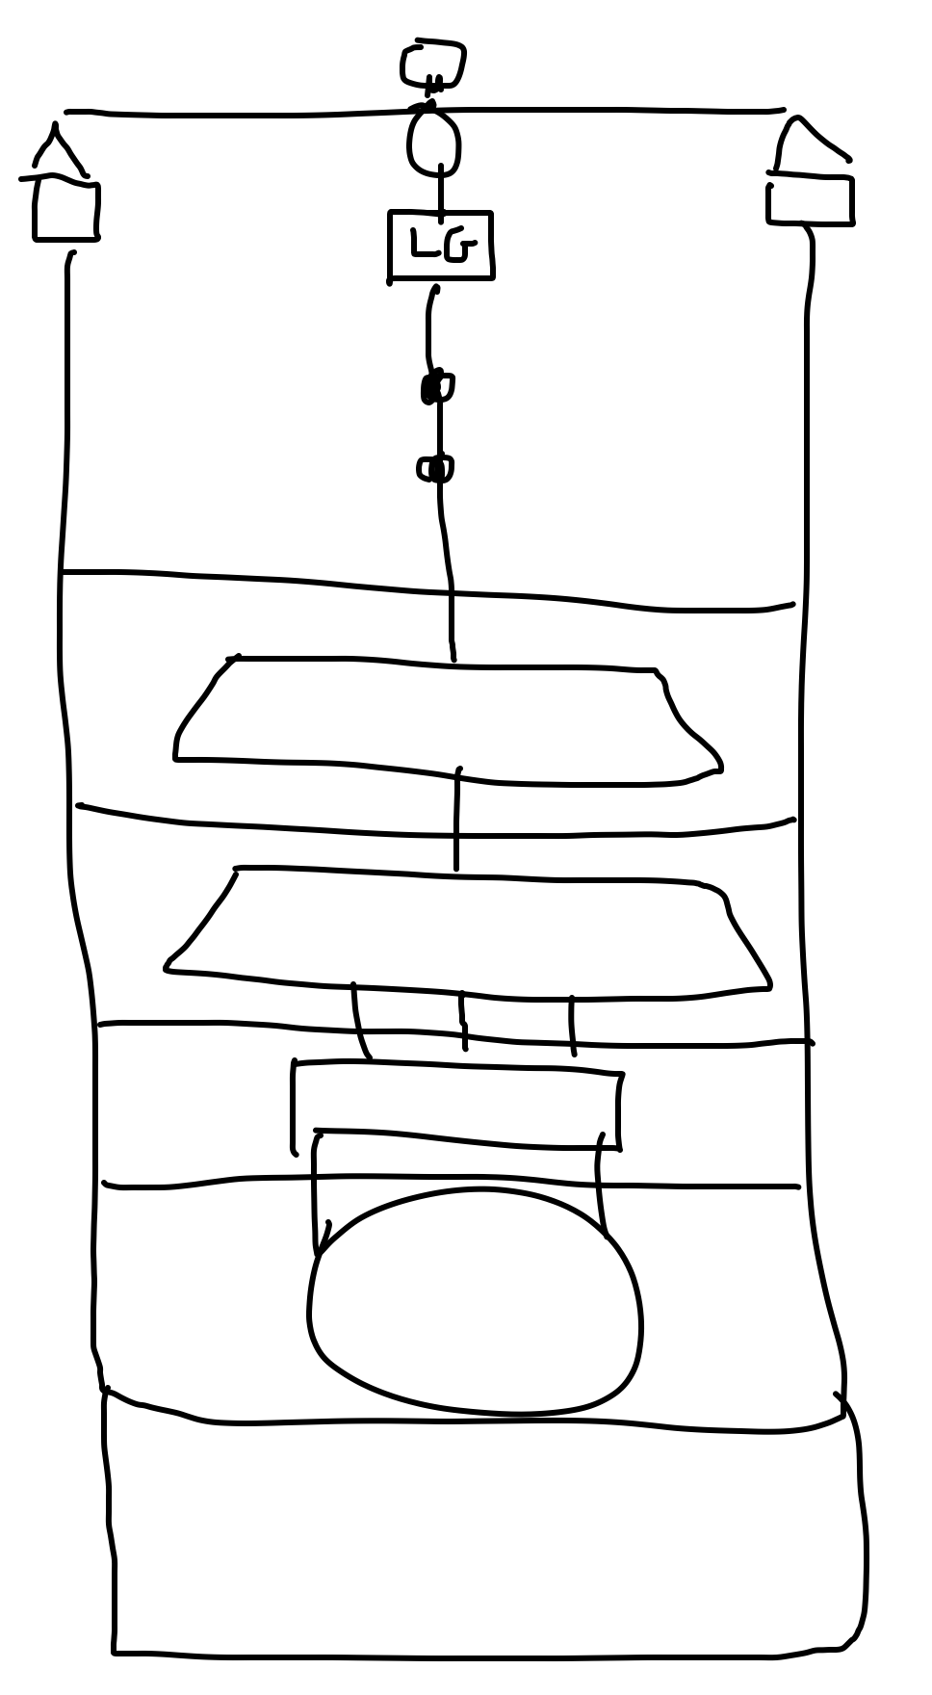

Notes on Optical Lever Platform
We need some sort of platform on the front side of the frame with a small breadboard on top to allow an optical lever to be installed. See the PRx assembly frame for the concept (Figure 4). We will supply the exact height as soon as possible.
Figure 4: PRx assembly frame with OL platform at right
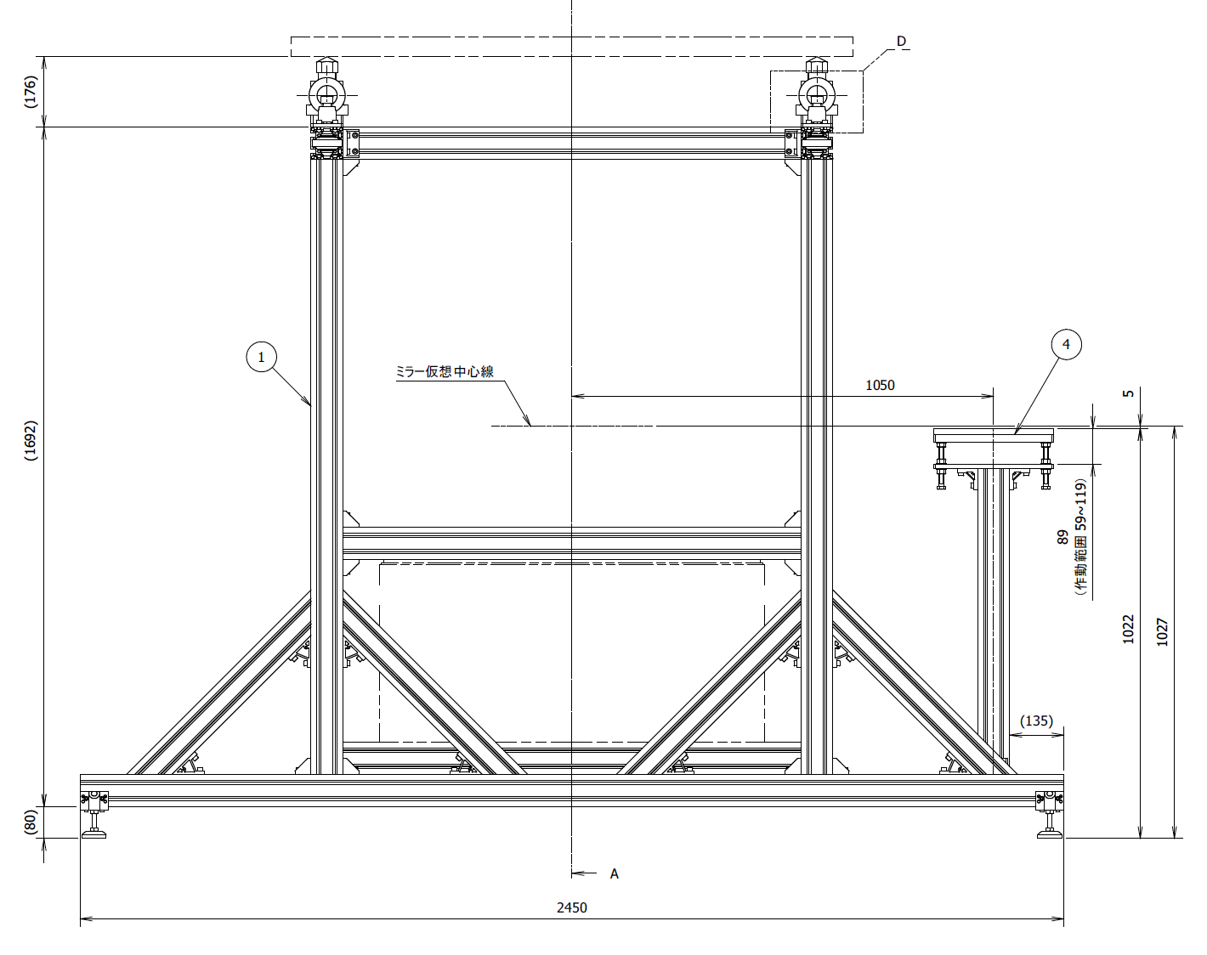

Notes on Clean Bag Support Frame
A clean bag similar to that used for PRx (Figure 5) is being designed, so that the suspension and frame can be covered when not being worked on. The bag will be somewhat wider than the frame so that it will cover the preisolator at the top. The frame will require extensions that will support the bag even when the preisolator is not installed.
Figure 5: (Half of) PRx clean bag
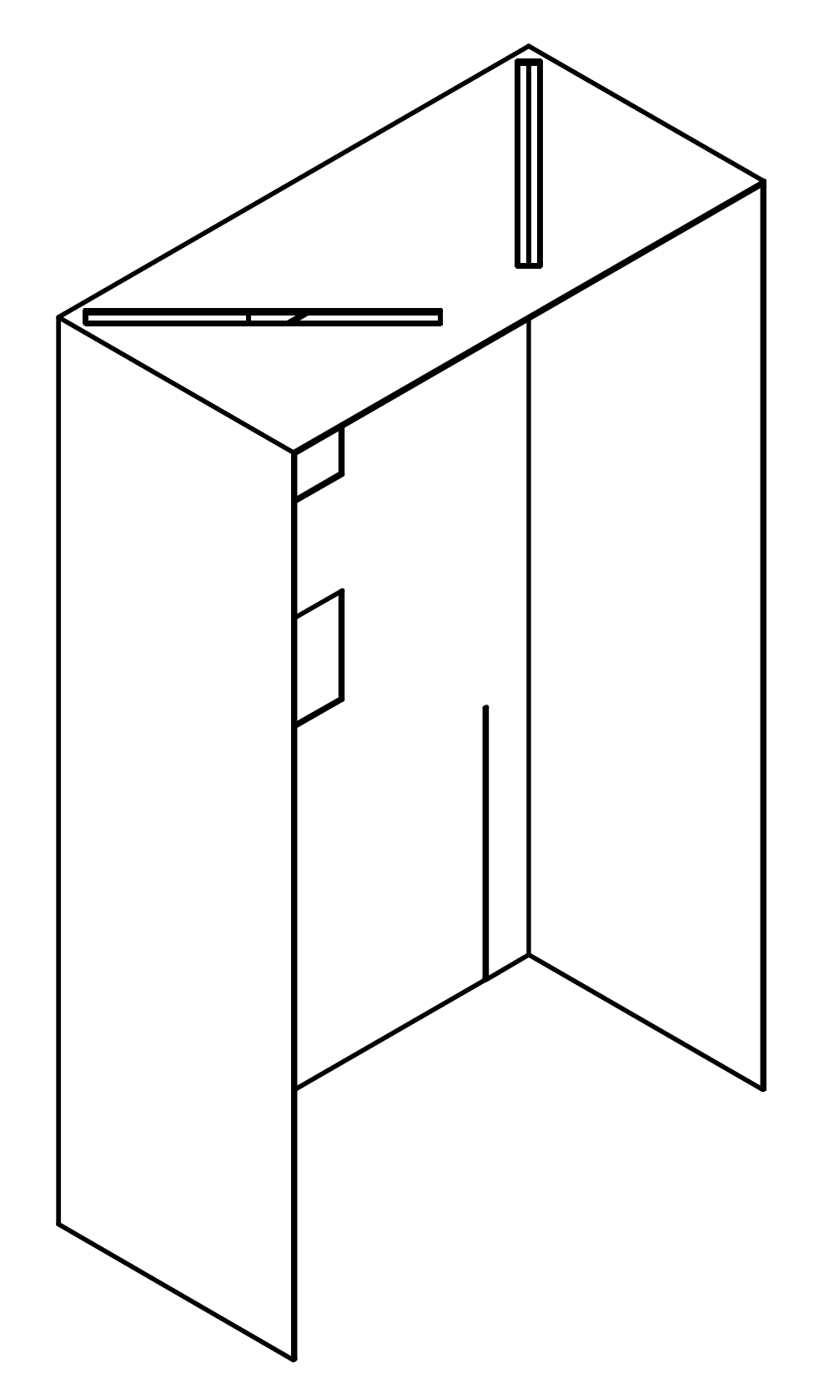

Notes on Work Platforms
We would like two sets of two work platforms with heights of approximately 1500 mm and 600 mm that can be placed on on the front and back sides of the frame. See Figure 5.
We would like some anchor points on the frame to allow connection of safety harnesses when working on the 1500 mm platforms.
Figure 5: Work platform heights
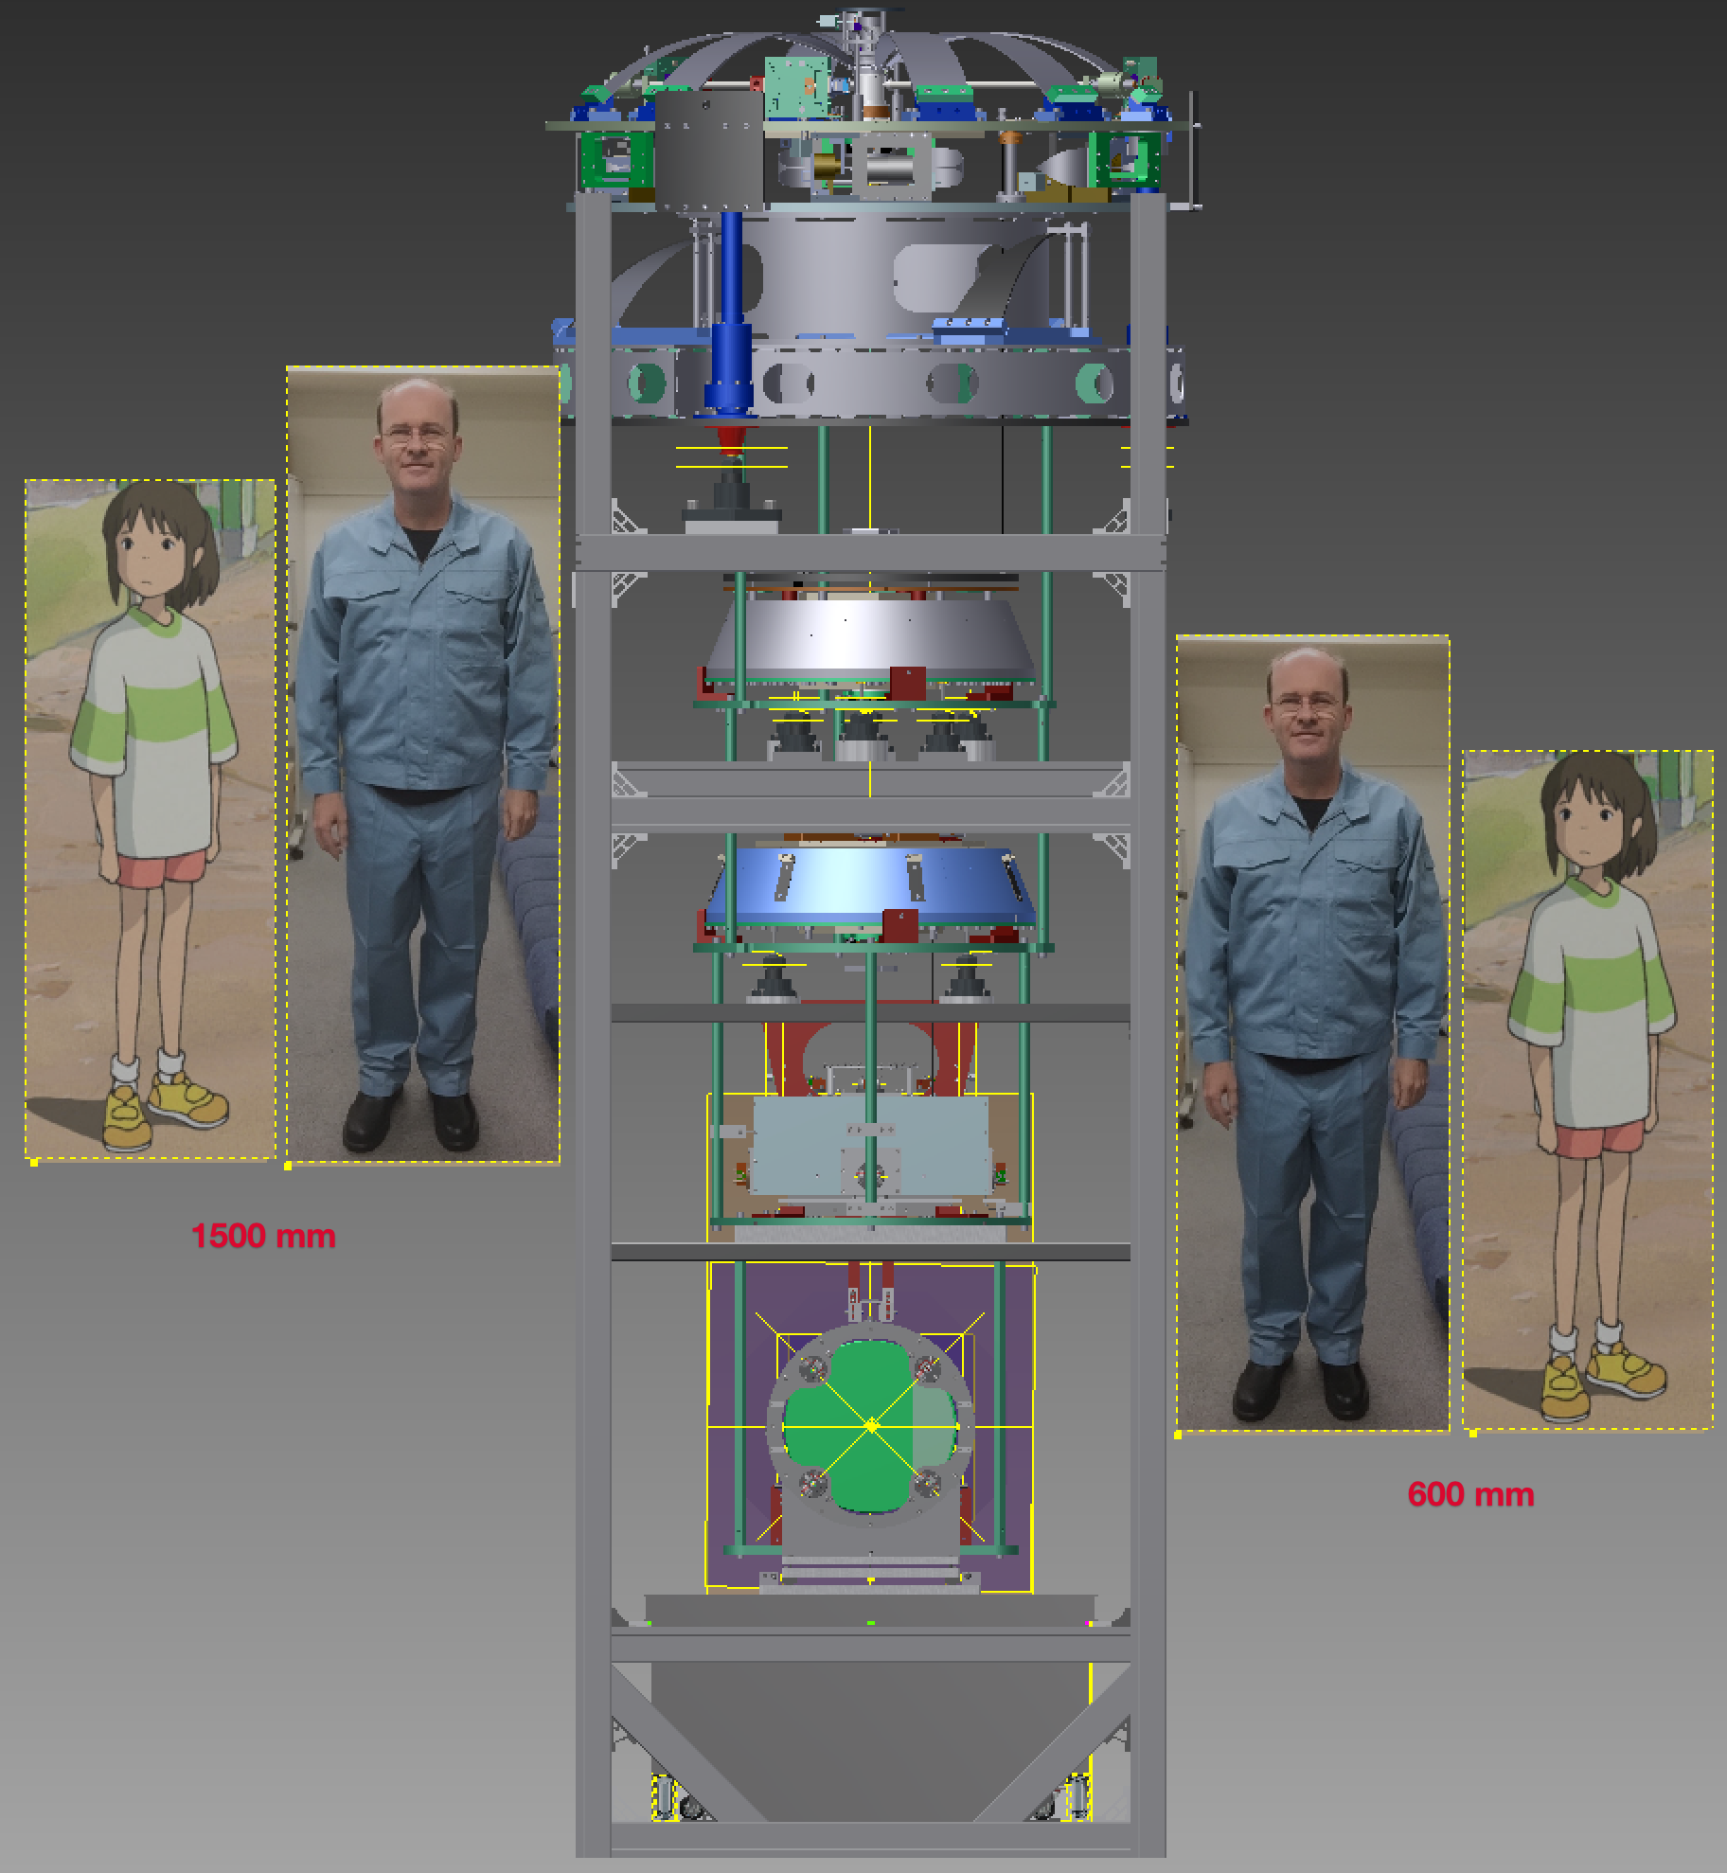

Notes on Rail System
Unlike the PRx frame where the hanging system was a separately designed frame, the BS hanging system (Figure 7) is mostly part of the main frame, and we would like Mirapro to supply it. The exception is the trolley for the mirror box (arrowed in the figure), which will be made along with the box by Tatsumi-san. However, Tatsumi-san is not doing the stop for the box (circled in the diagram)! Hirata-san will coordinate to make sure this works.
Figure 7: Hanging system with trolley for mirror box arrowed, and stop for trolley circled
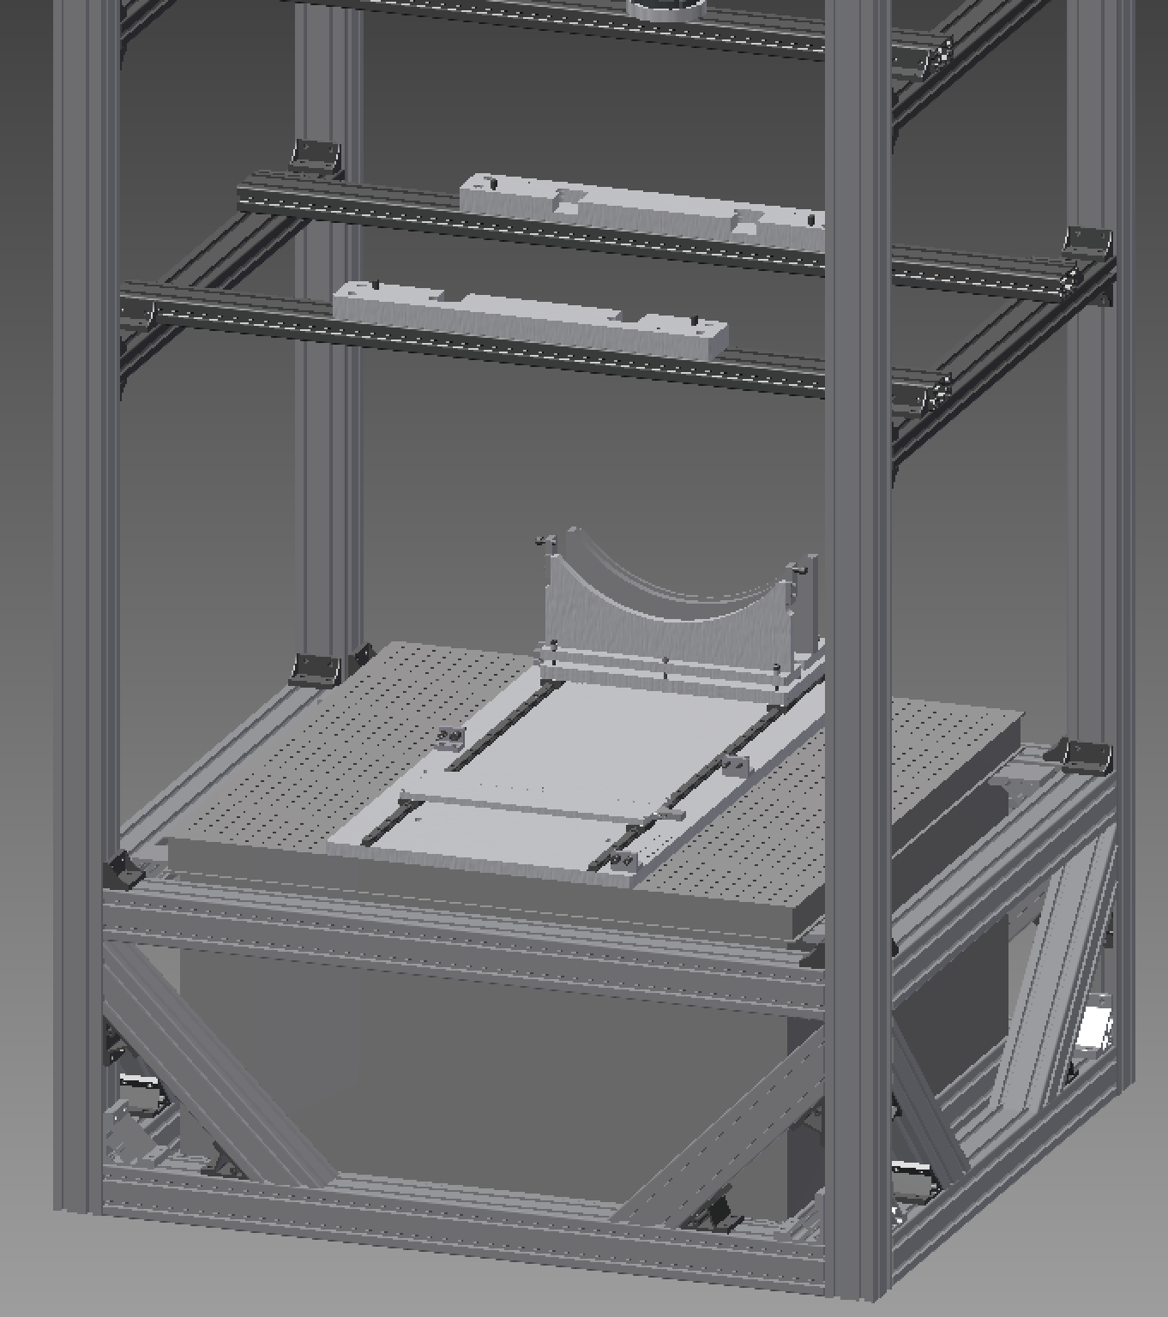

Notes on Feedthrough Rack
We need a rack attached to the suspension so that three (or TBD) vacuum feedthroughs can be attached temporarily to allow for making electrical connections while the suspension is in the tank. One side of each of the feedthroughs has to stay vacuum clean, and the other side will be “dirty”. See Figure 8. The rack needs to be in an out of the way place towards the top. It must be possible to put the clean bag on with the rack in place.
Figure 8: Feedthrough rack concept
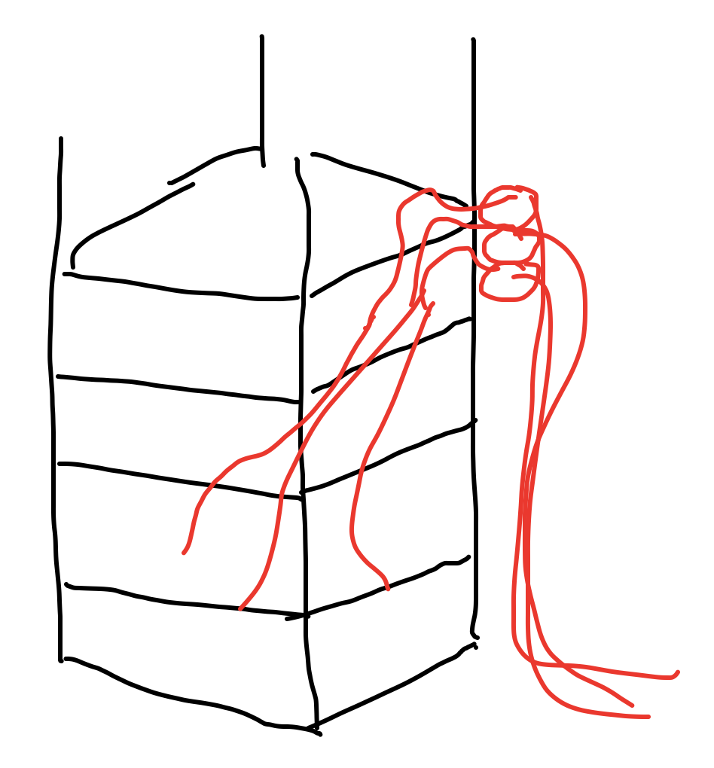

Notes on Wind Shields
Experience with PR3 shows that the clean bag is not sufficient protection against air currents when measuring the performance of the suspensions. We would like to have a system of thin plastic or metal panels that could be easily stuck magnetically to plates on the frame. See Figure 9.
Figure 9: Wind shield panel concept (one of many panels shown)
