JGW-E1604966-v1 KAGRA 10 Mar 2016

BS Mass Budget

Mark Barton, Naoatsu Hirata

Distribution of this document:
JGW-DCC

This is an internal working note
of the KAGRA collaboration.

http://gwcenter.icrr.u-tokyo.ac.jp

Table of Contents
1 Introduction 3
1.1 Purpose and Scope 3
1.2 References 3
1.3 Version history 3
2 Individual Masses 3
3 Combinations important to GAS filter tuning 4
3.1 Up through IM (for setting BF GAS filter) 4
3.2 Up through BF (for setting SF GAS filter) 4
3.3 Up through SF (for setting PI GAS filter) 4
4 Combinations important to crane and/or tank loading 4
4.1 Up through PI (for install) 4
4.2 Everything hanging from PI (including lower bread board) 4
4.3 Everything (for load on vacuum tank) 4
5 Appendix – Raw Data 4
5.1 Standard filter with damper ring + magnets 4
5.2 Standard filter without upper ring 5

Introduction

Purpose and Scope
Describes the masses of the major parts of the Type-B suspension for BS, for use in adjusting GAS filters and planning lifting procedures.

References
JGW-E1504006: VIS Document and Drawing Tree (Type-B)

Version history
3/10/2016: -v1.

Individual Masses
These values were provided from Hirata-san based primarily on a model of the BS suspension in the vacuum chamber dated 3/9/2016. The mass of the PI with ballast came from an older model of the Type B prototype at TAMA. Some of them are known to be slightly out of date because the versions of the BF and SF in the model have the wrong configuration of blades and no “fishing rod” components. The weight of the cables will probably be important to tuning the GAS filters but no values are available yet.

Item | Mass (kg) | Notes
Optic (BS) | 18.71
Recoil Mass (RM) | 22.3
Intermediate Mass (IM) | 34.6
Intermediate Recoil Mass (IRM) | 16.1
Bottom Filter (BF) | 105.2 | need to upgrade blades and add fishing rod
Cables up to BF | ccc | (value not yet available)
Standard Filter (SF) | 95.4 | need to upgrade blades and add fishing rod
Damper Ring for SF | 18
Cables from BF/SF up to PI | ddd | (value not yet available)
Preisolator | 976.2 | with ballast mass: 6*17.3 kg
Preisolator with ballast removed | 872.4
Cables within PI | eee | (value not yet available)
Cables from PR to Flange | fff | (value not yet available)
Security Structure | 183.4
Lower Breadboard | 86
Lower Breadboard Intermediate Ring | 116.4 | “yellow ring”
Lower Breadboard Damper Ring | 49.3 | “green ring”

Combinations important to GAS filter tuning

Up through IM (for setting BF GAS filter)
BF+RM+IM = 18.71+22.3+34.6 = 75.61 kg.

Up through BF (for setting SF GAS filter)
BF+RM+IM+IRM+BF+cables= 18.71+22.3+34.6+16.1+105.2+ccc = 196.91+ccc kg

Up through SF (for setting PI GAS filter)
BF+RM+IM+IRM+BF+cables+SF+some fraction of BF/SF-to-PI cables
= 18.71+22.3+34.6+16.1+105.2+ccc+95.4+???*ddd = 292.31+ccc+???*ddd

Combinations important to crane and/or tank loading

Up through PI (for install)
BF+RM+IM+IRM+BF+cables+SF+cables+DR+PI+cables+SS
= 18.71+22.3+34.6+16.1+105.2+ccc+95.4+ddd+18+976.2+eee+183.4
= 1,469.91 kg +ccc+ddd+eee

Everything hanging from PI (including lower bread board)
BF+RM+IM+IRM+BF+cables+SF+cables+DR+PI+cables+SS+cables+YR+LBB
= 18.71+22.3+34.6+16.1+105.2+ccc+95.4+ddd+18+976.2+eee+183.4+fff/2+116.4+86
=1,672.31 kg +ccc+ddd+eee+fff/2

Everything (for load on vacuum tank)
BF+RM+IM+IRM+BF+cables+SF+cables+DR+PI+cables+SS+YR+LBB+GR+cables
= 18.71+22.3+34.6+16.1+105.2+ccc+95.4+ddd+18+976.2+eee+183.4+116.4+86+49.3
= 1,721.61 kg +ccc+ddd+eee+fff

Appendix – Raw Data

Standard filter with damper ring + magnets
(The damper ring is actually independently suspended, so this is not a natural grouping.)
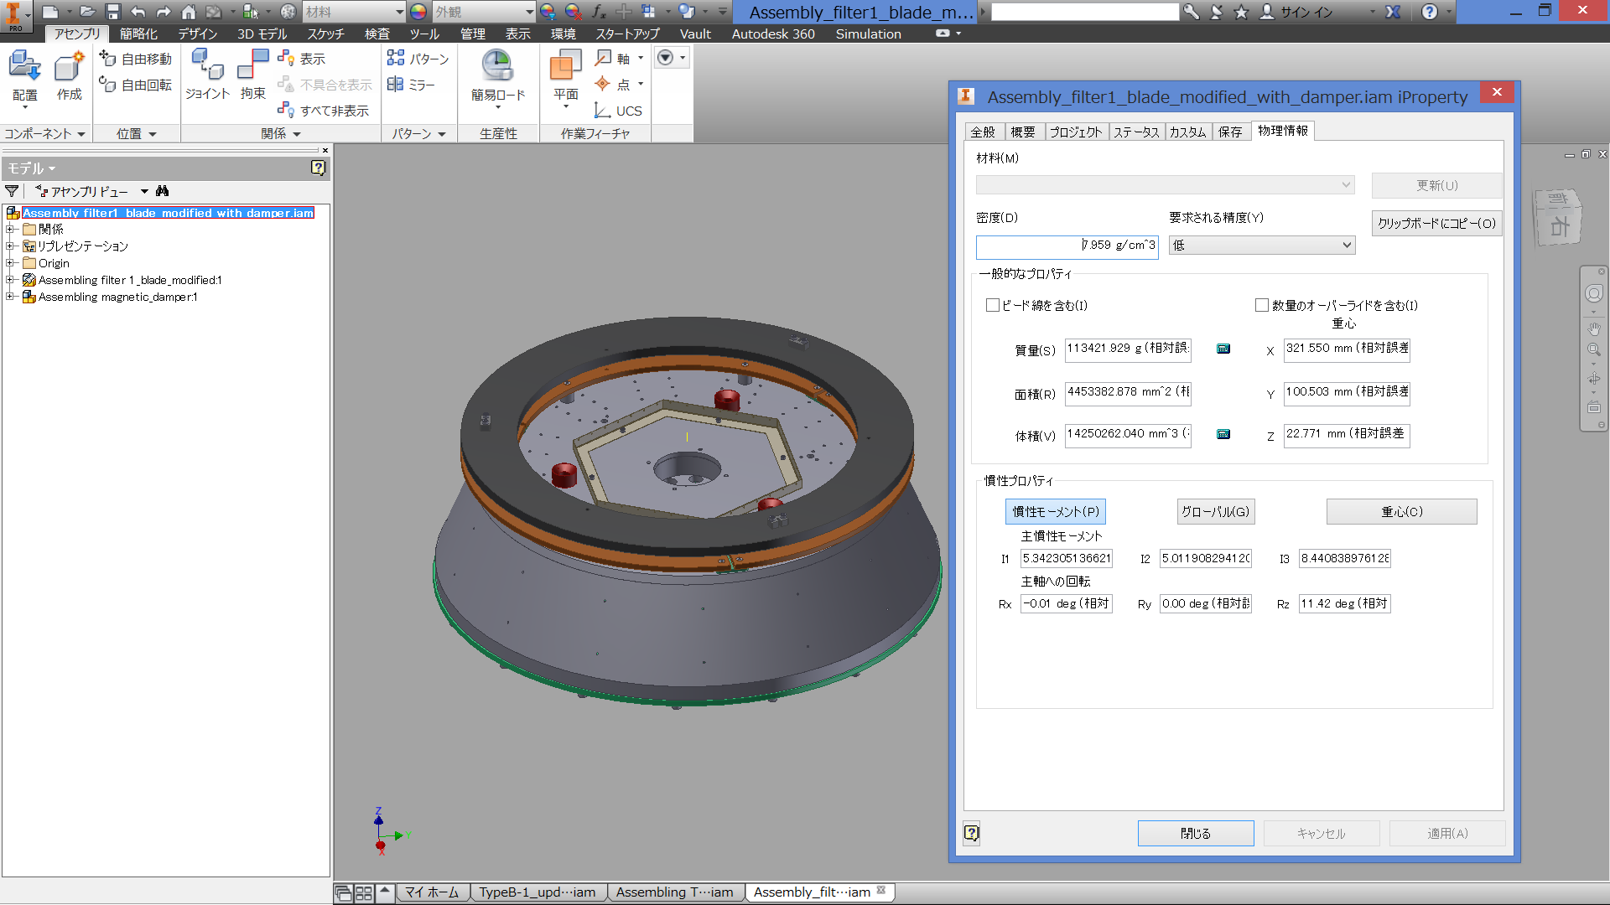

Standard filter without upper ring
This is the SF as suspended. Subtracting this from the previous gives 18 kg for the damper ring.
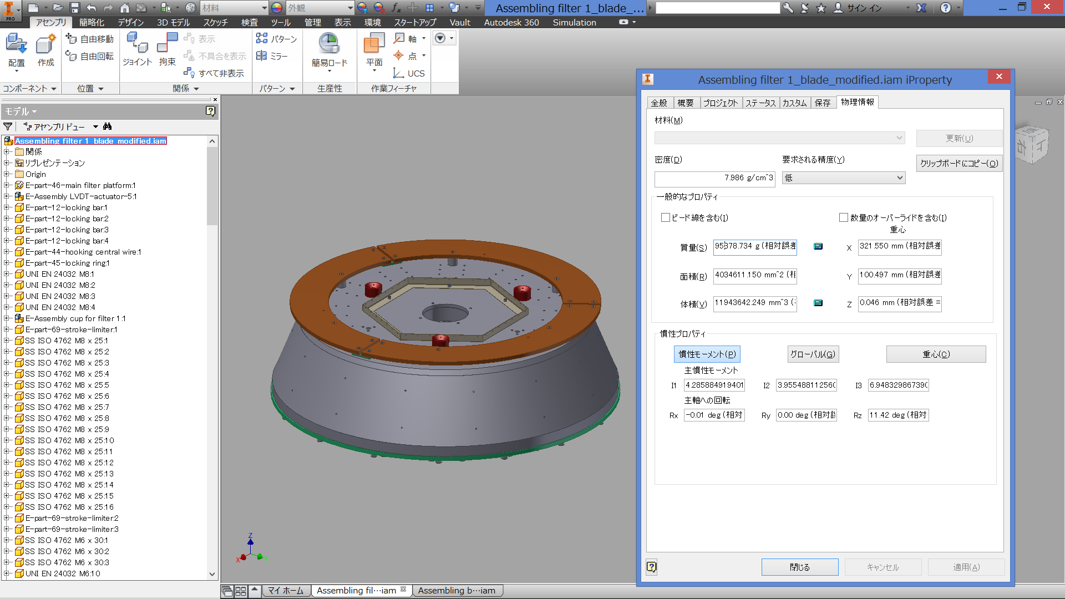

・Yellow ring with copper plate
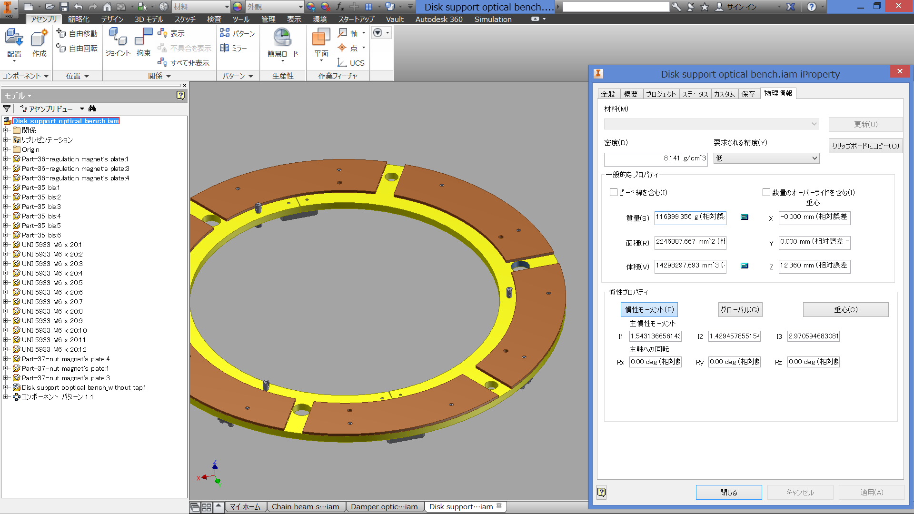

・Green ring
