JGW-E1604817-v1 KAGRA 13th of May 2016

Beam splitter payload assembly procedure

Mark Barton, Fabián E. Peña Arellano, et al.

Distribution of this document:
JGW-DCC

This is an internal working note
of the KAGRA collaboration.

http://gwcenter.icrr.u-tokyo.ac.jp

Table of Contents
1. Introduction 3
1.1 Purpose and Scope 3
1.2 References 3
1.3 Version history 3
1.4 Related documents 3
1.5 Photos 3
2. How edit this document 3
3. Physical features 3
4. Assembly of the BS dummy optic 4
5. Assembly of the Recoil Mass 6
6. Assembly of Recoil Mass pedestal 13
7. Assembly of the Intermediate Mass 13
8. Assembly of the Intermediate Recoil Mass 20
9. Optical lever 20
10. Payload hanging procedure 20
11. To do list 20
12. Thus 20

Introduction

Purpose and Scope
This document explains how to assemble the BS payload. It assumes that the BS assembly frame has been constructed. For the rest of the BS assembly procedure, see JGW-E1504235.

References
stuff

Version history
5/13/2016: -v1 with IM and RM sections.

Related documents
- This document: JGW-E1604817.
- Mass budget: JGW-E1604966.
- Intermediate Mass 2D assembly drawing: JGW-D1605028-v2.
- Beam splitter wire clamps 2D drawing: JGW-D1503474-v2.
- Beam Splitter installation procedure: JGW-E1504235.
- Beam splitter hanging frame assembly: JGW-D1504404.
- PR/SR payload assembly procedure: JGW-E1503830.
- Spare mirror hanging procedure: JGW-T1604756.
- Mirror subgroup wiki: Database.
- Beam splitter optic drawing and 3D CAD: JGW-D1100713.
- Beam splitter dummy optic drawings: JGW-D1604820.
- Power recycler Intermediate Mass assembly procedure: JGW-T1503907.
- Payload 3D CAD location: ROOM214 (only accessible from the GWPO at NAOJ).

Photos
- May 2016: 1st, 2nd, 3rd, 4th, etc.
- June:
- July:

How edit this document
The Word 2013 source document has been uploaded to OneDrive. Edit it using the following link.
Use the following characters for referring to the screws: ① ② ③ ④ ⑤ ⑥ ⑦ ⑧ ⑨ ⑩ ⑪ ⑫ ⑬ ⑭ ⑮ ⑯ ⑰ ⑱ ⑲ ⑳.
And these for the parts: ⑴ ⑵ ⑶ ⑷ ⑸ ⑹ ⑺ ⑻ ⑼ ⑽ ⑾ ⑿ ⒀ ⒁ ⒂ ⒃ ⒄ ⒅ ⒆ ⒇

Physical features
Bottom filter
Filter number: 7
Optimum load:
- without fishing rod: 79.81kg
- with fishing rod : 80.16kg

Assembly of the BS dummy optic
The OSEM flags and wire breaker prisms should not be on the dummy optic yet. In order to put the flags the substrate has to be put inside the box, from which it will come out only after hanging.
Note that an engraved arrow points to the back of the dummy optic, where the coating in the real mirror is (a.k.a. HR side). In the real optic the arrow is engraved at the narrow side.
- Fix the three mirrors onto their holders. Create three instances of the mirror_small_assembly:
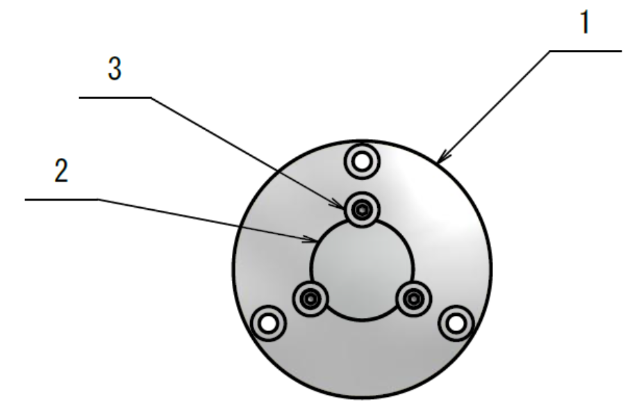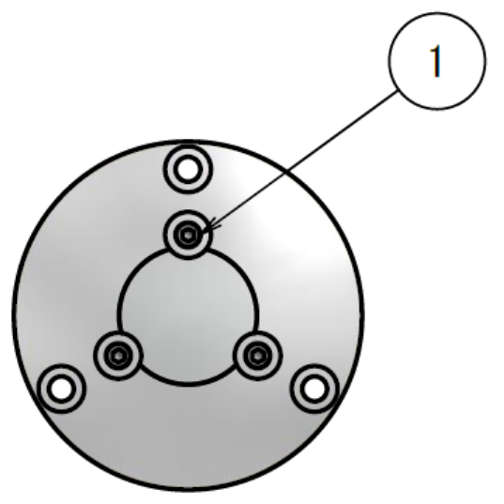
Use the following:
  - Mirror support: 3×JGW-D1604820-4,
  - Mirror: 3×TFA-30C05-4 from Sigma Koki.
  - Peek washers: 9×PKW10-3 from Misumi.
- Screws: 9×ISO4762-M3×8 vented, CBAS3-8 from Misumi.
- Fix the three holders onto the main cylinder JGW-D1604820-1 at:
  - Back center (the back is indicated by an arrow on the cylindrical surface),
  - Back top,
  - Front center.
- Use 9×ISO4762-M5×8 vented, CBAS5-8 from Misumi.
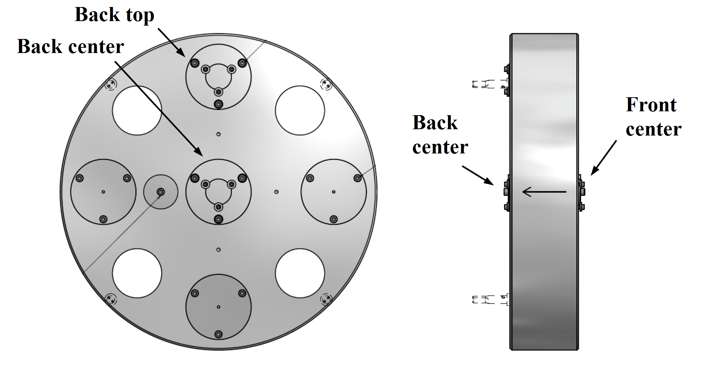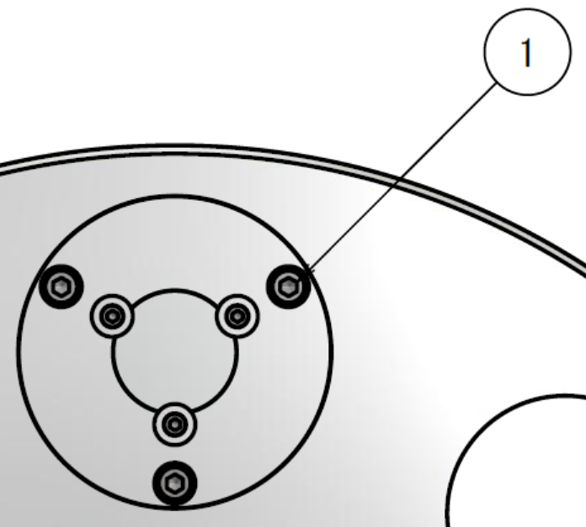

- Fix the ballast discs in place:
- 7×JGW-D1604820-3. At the back at 3, 6 and 9 o’clock (shown below). At the front at 3, 6 and 9 and 12 o’clock (not shown).
- Use 21×ISO4762-M5×8 vented, CBAS5-8 from Misumi.
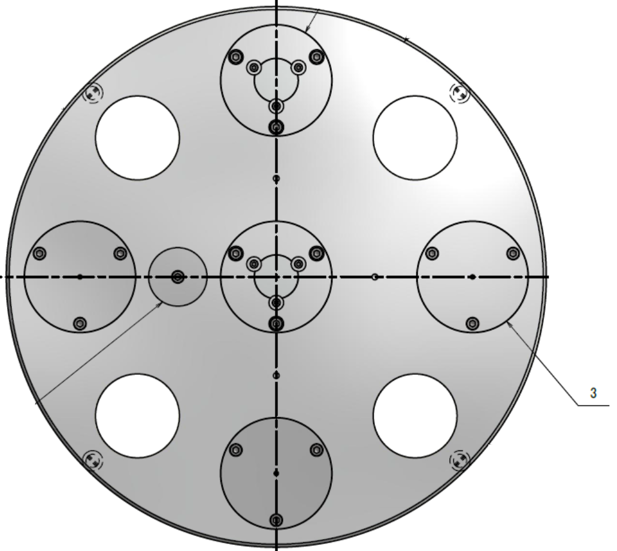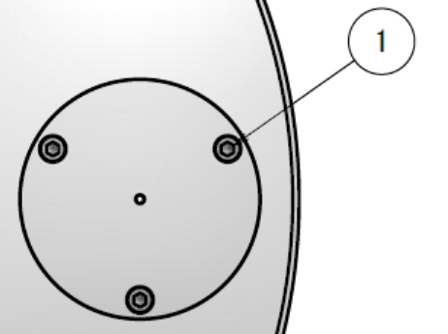
- Fix the compensation discs in place:
- 2×JGW-D1604820-2. One at each side, away from the arrow on the cylinder.
- 2×ISO4762-M5×8 vented, CBAS5-8 from Misumi.
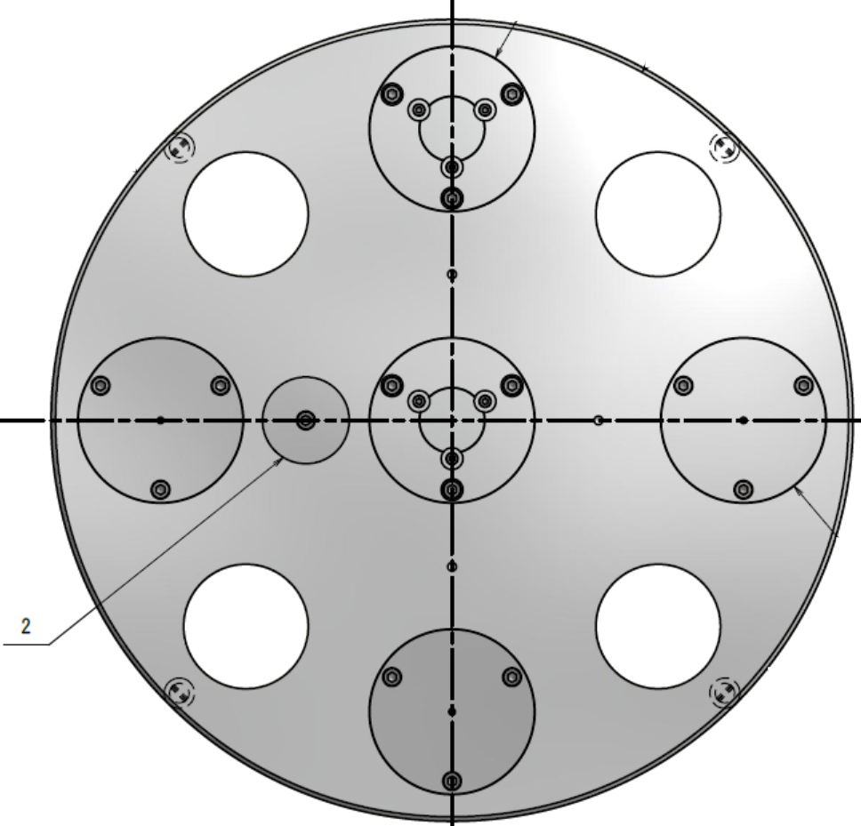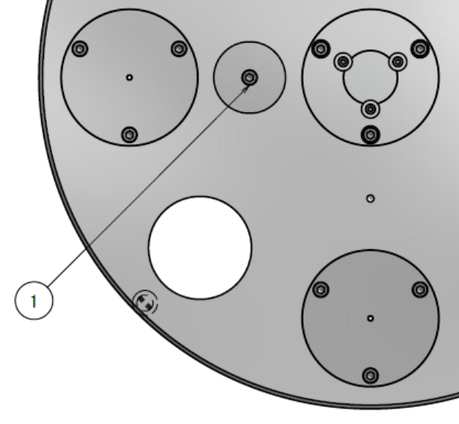
- Weight the whole assembly.
- Find out how much the OSEM flags, bases and magnets weight.
Drawing: JGW-D1604820.

Assembly of the Recoil Mass
Drawing: JGW-D1503446.
- Attach wire breakers to RM.
- On the RM cylinder 2:JGW-D1503446-1 attach the wire breakers 7:2×JGW-D1503446-10 in the grooves on the flats on the sides. Check with a ruler that the wire breaker is at the centre. Provide this information from the 3D CAD.
- Use the clamps 8:2×JGW-D1503446-11 and the screws (3):4×ISO4762-M3×8.
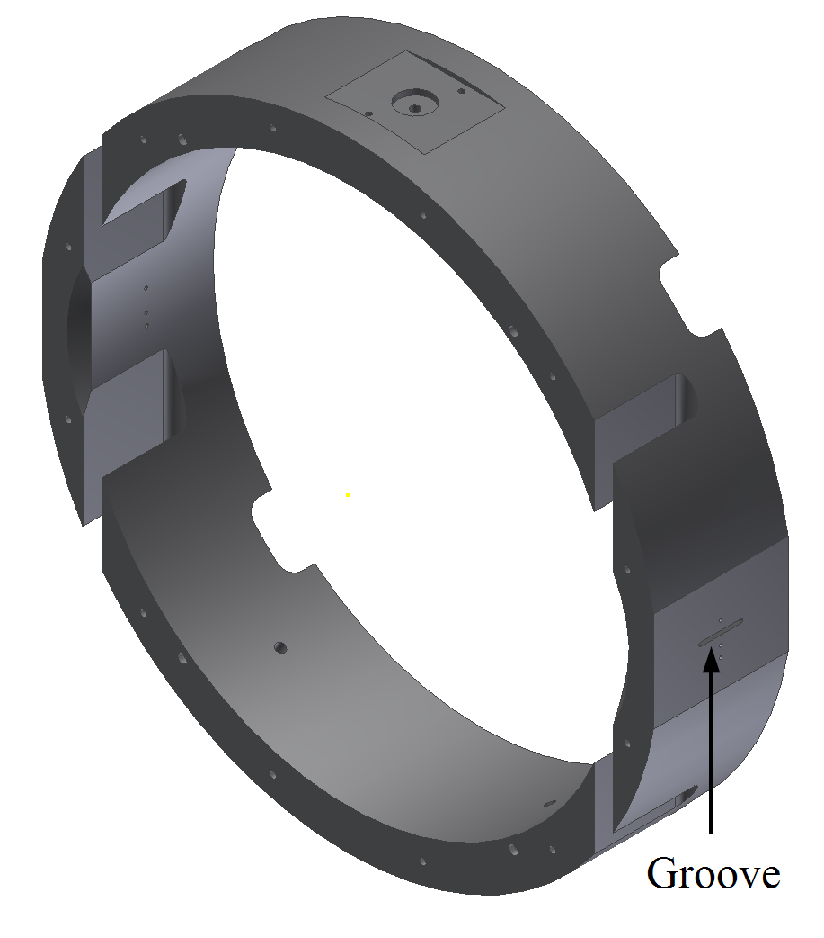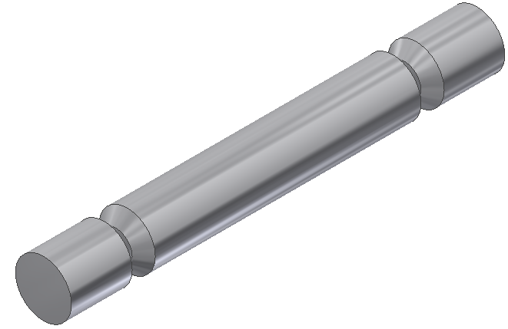
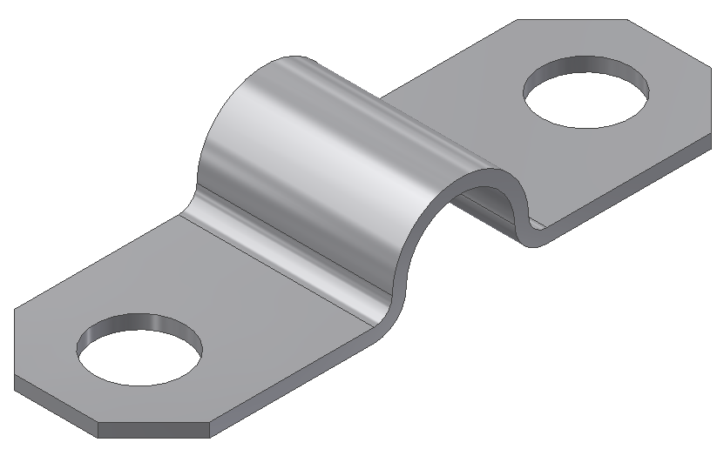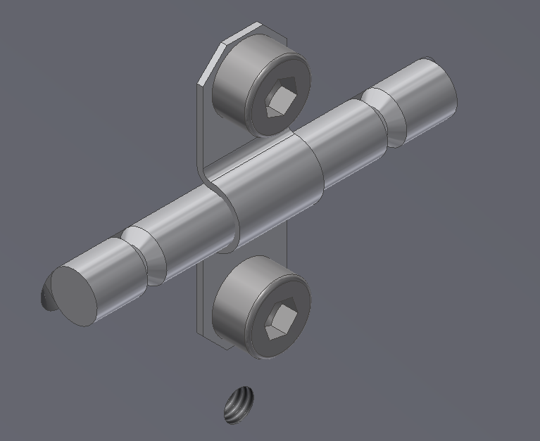
Pictures: BS hanging test, XX/YY/2016.

- Attach the cable clamp support 6:JGW-D1503446-9 to the multipurpose cube 5:JGW-D1503446-8. Use screws (11):4×ISO7046-1-M2.5×8-4.8-H, and hexagonal nuts (2):4×ISO4032-M2.5. The screws are not SDC although the nuts are made of stainless steel also. Because of the size there should not be any problem.

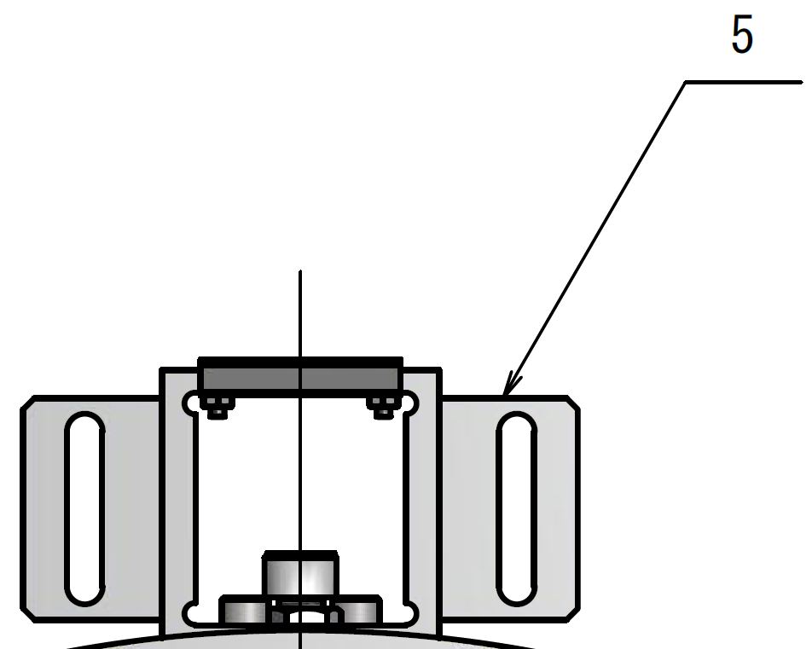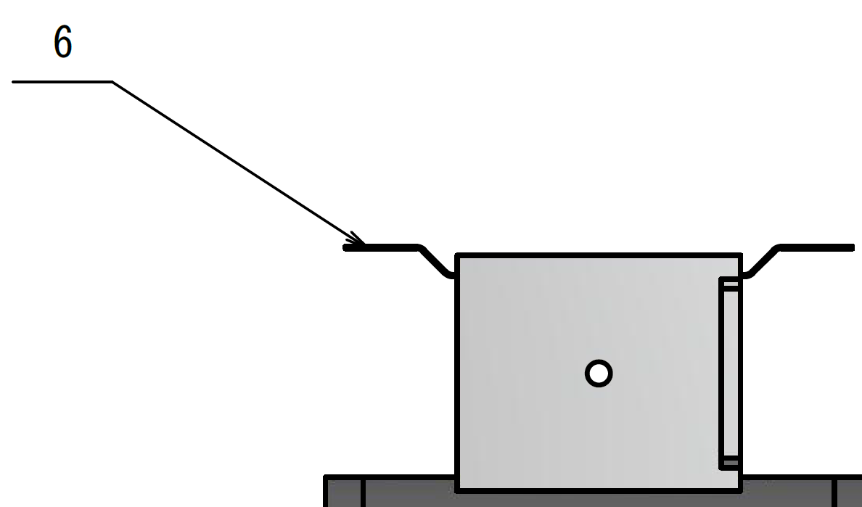
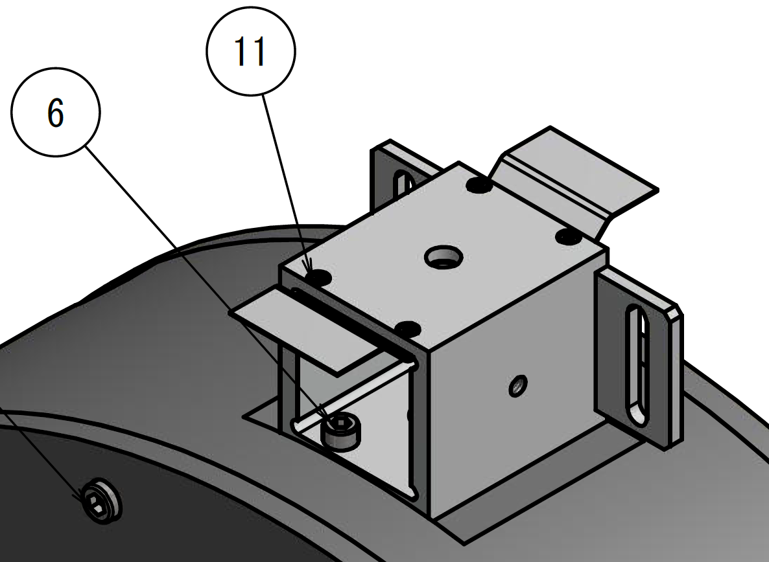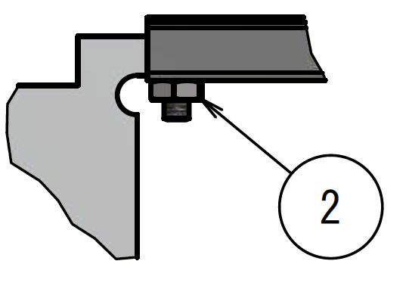

Pictures: BS hanging test, XX/YY/2016.
- Fix the multipurpose assembly on top of the RM. Use screws (6): 2×ISO4762-M5×10.
Pictures: BS hanging test, XX/YY/2016.
- Assemble earthquake stop screws 17:3×JGW-D1504354 for the cylindrical part the optic. Use the following:
  - Coated screws 1:3×JGW-D1503761-11 whose specification is ISO4762 M8×45 with a M2×0.4 threaded hole.
  - PTFE cylindrical head 2:3×JGW-D1503761-1.
  - SDC screws (3):3×SNSS-M2-6-SD whose size is M2×0.4×6.
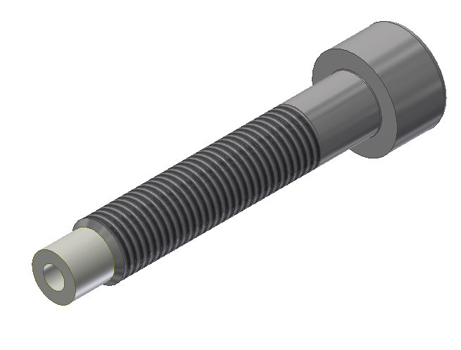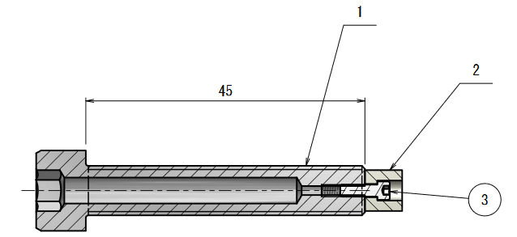
Pictures: PR3 hanging test, 08/10/2015. Note that this assembly is also used in the PR and SR Recoil Masses.
- Insert them into the cylinder.
  - Use 3 shim rings per screw (12):9×PCIMAS-D12-V8-T0.5 from Misumi. The 2D drawing still has to be updated.
  - One at 12 o'clock where the multipurpose cube is, one at 5 o'clock and one at 7 o'clock. Use lock nuts 10:3×JGW-D1503761-9. Set the threaded part of the nut towards the cylinder.
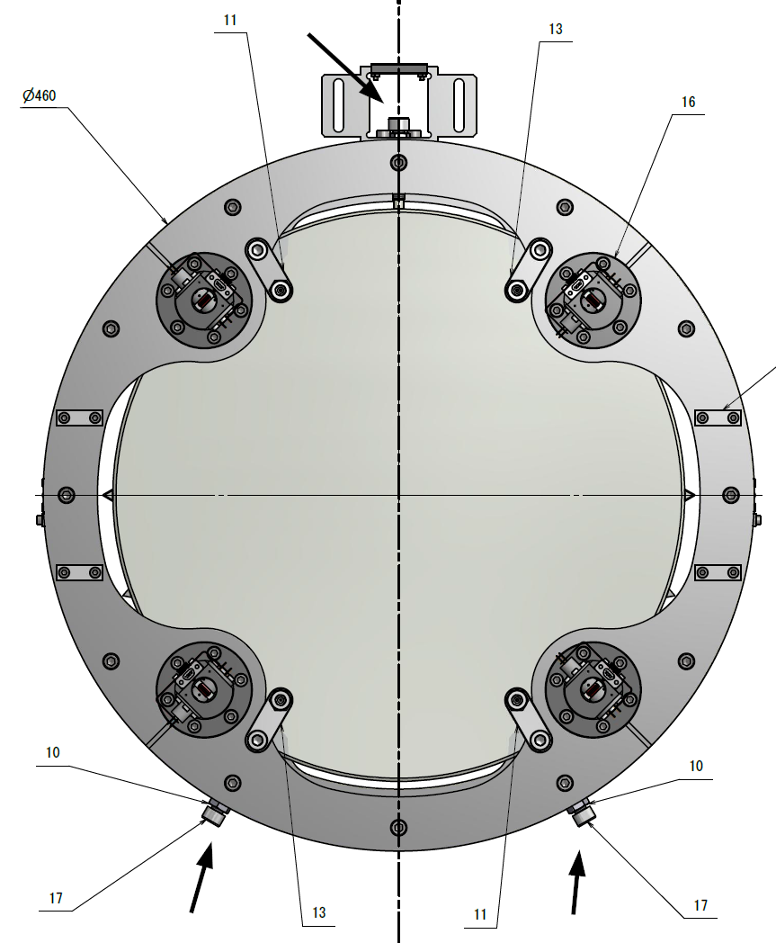
Pictures: PR3 hanging test, 08/10/2015.
- Attach the back ring of the RM.
- Back ring: 3:JGW-D1503446-2.
- Screws (8):12×ISO4762-M6×16.
- The back side of the RM cylinder has cut-outs for the OSEM.
- The plate is not symmetric with respect to the horizontal midline. See the screw holes for the OSEMs.
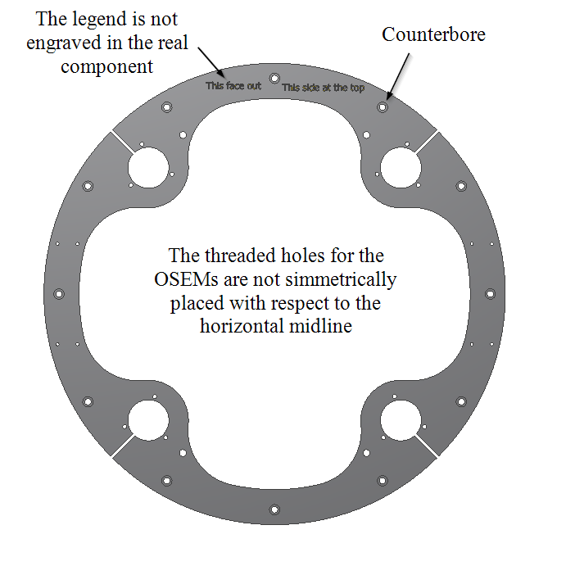
Pictures: PR3 hanging test, 08/10/2015.

- Take the OSEMs and insert the push screws into their threaded holes.
  - Low magnetic Bumax 88 screws (7):12×ISO4762 M5×20.
  - The screws should stick out 6.5 mm on the opposite side of insertion.
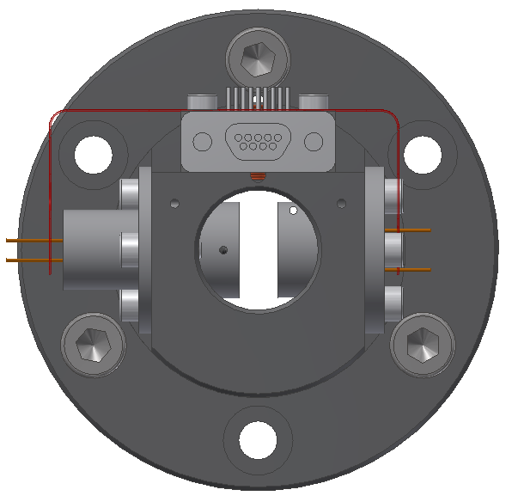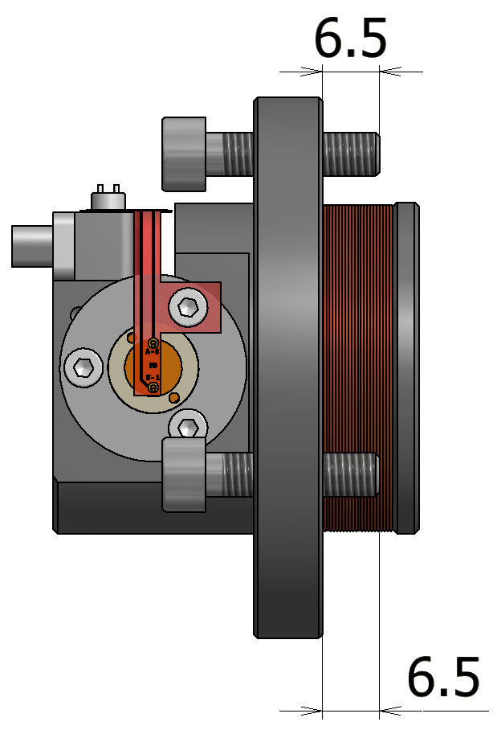
Pictures: no pictures yet.

- Fix the OSEM to the back ring of the RM using pull low magnetic Bumax 88 screws (7):12×ISO4762 M5×20. (Change drawing!)
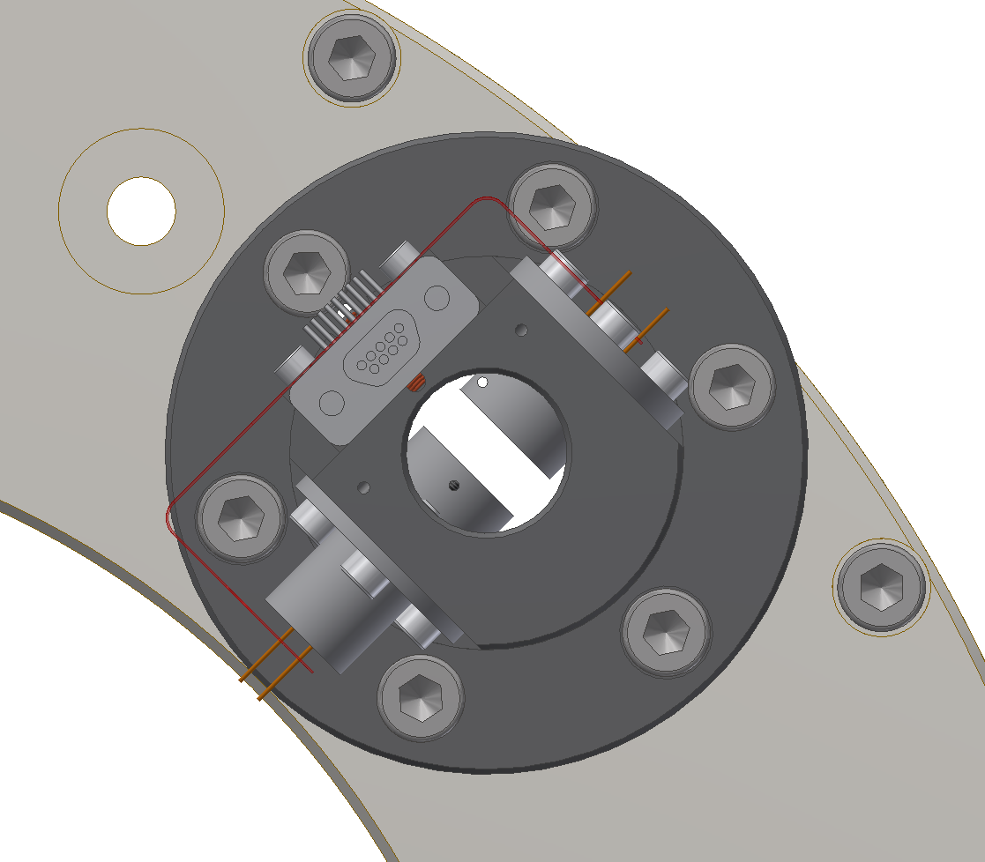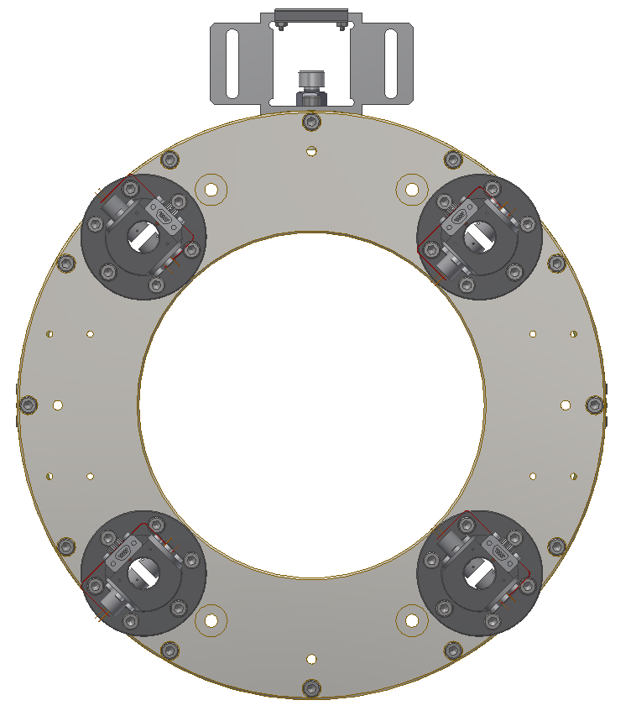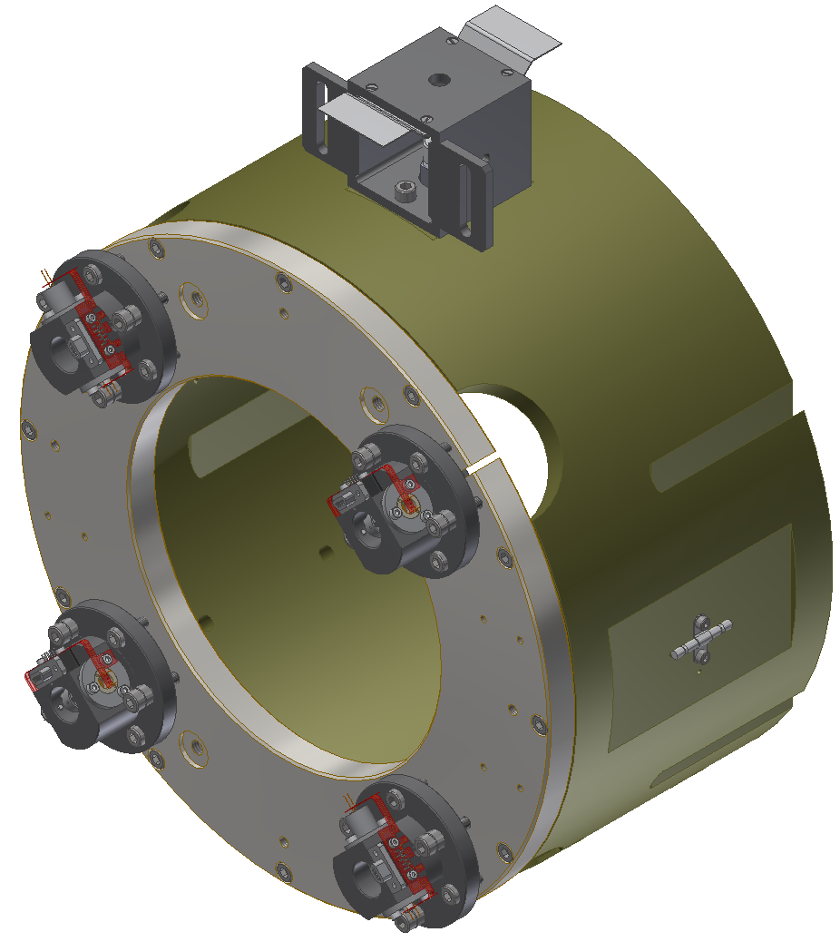
Pictures: PR3 hanging test, 08/10/2015.
- Assemble 18:8×JGW-D1604818 earthquake stop screws for the back and front face of the optic:
- Screws 2:4×JGW-D1604818-1 whose specification is ISO4762-M8×30 with a M2×0.4 threaded hole.
- PTFE cylindrical head: 4×JGW-D1503761-1.
- Coated screws (3):4×SNSS-M2-6-SD whose size is M2×0.4×6.
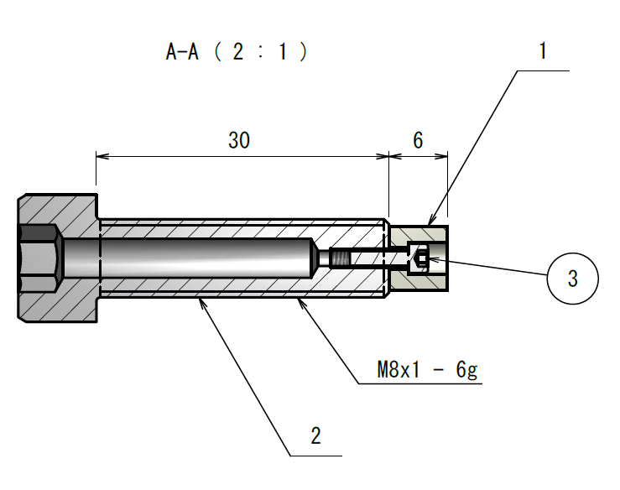
Pictures: PR3 hanging test, 08/10/2015.
- Take extension components 11:JGW-D1604819-1 and 13:JGW-D1604819-2 and fix them onto the back ring with screws (1):4×CSHH-SUS-MS8-12, which are fine pitch screws from Misumi. Mind the position as 11 and 13 are not interchangeable.
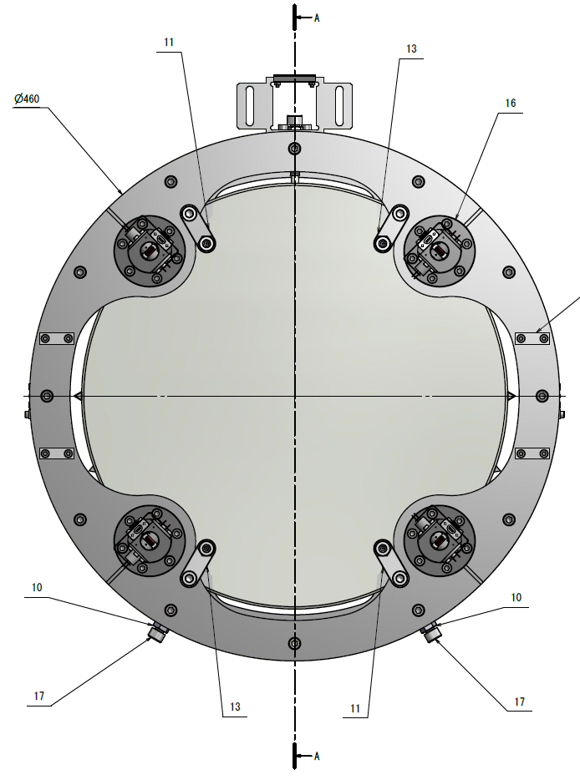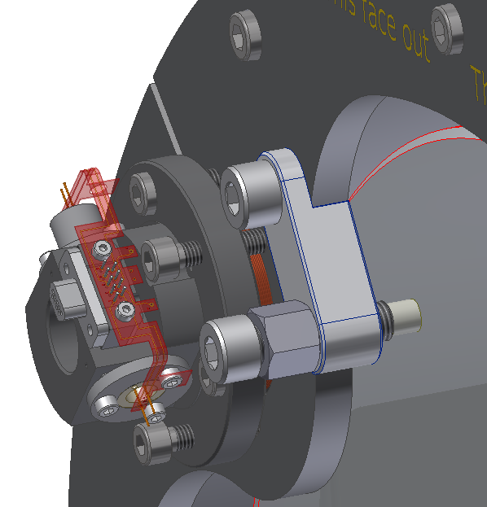
- Insert 4 earthquake stop screws into extension components 11 and 13. Use lock nuts 10:4×JGW-D1503761-9. Set the threaded part of the nut towards the back plate. Use 3 shim rings per screw (12):12×PCIMAS-D12-V8-T0.5 from Misumi. (Update drawing!)
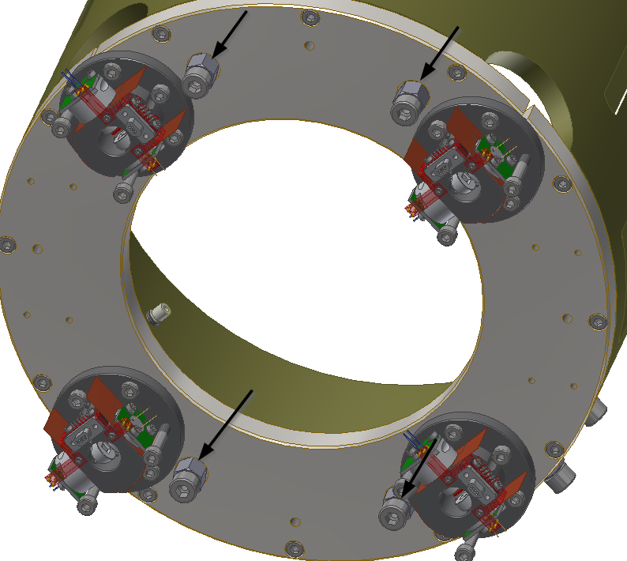
Pictures: no pictures yet.
- Place cable clamps 1:4×JGW-D1503444-40 on the back ring. Use screws (5):8×ISO4762-M4×10.
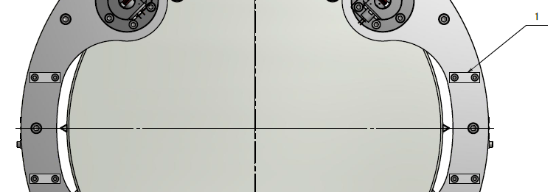
The recoil mass is ready to be brought around the optic, but the pedestal still has to be assembled.
- Assemble the pedestal for the RM.
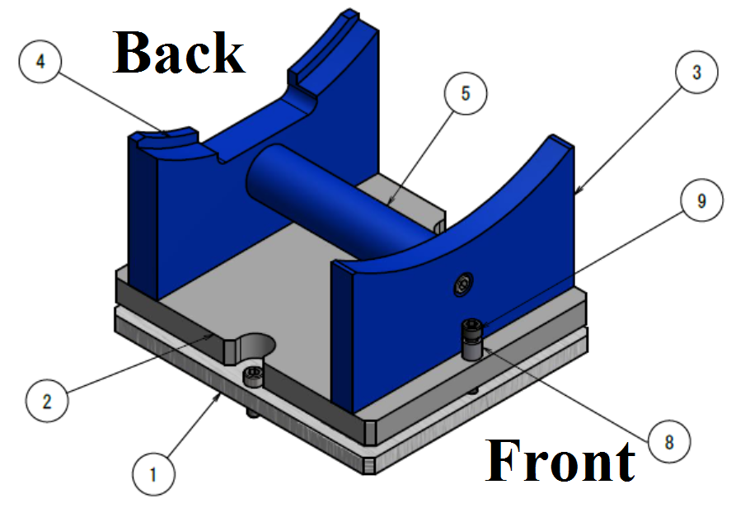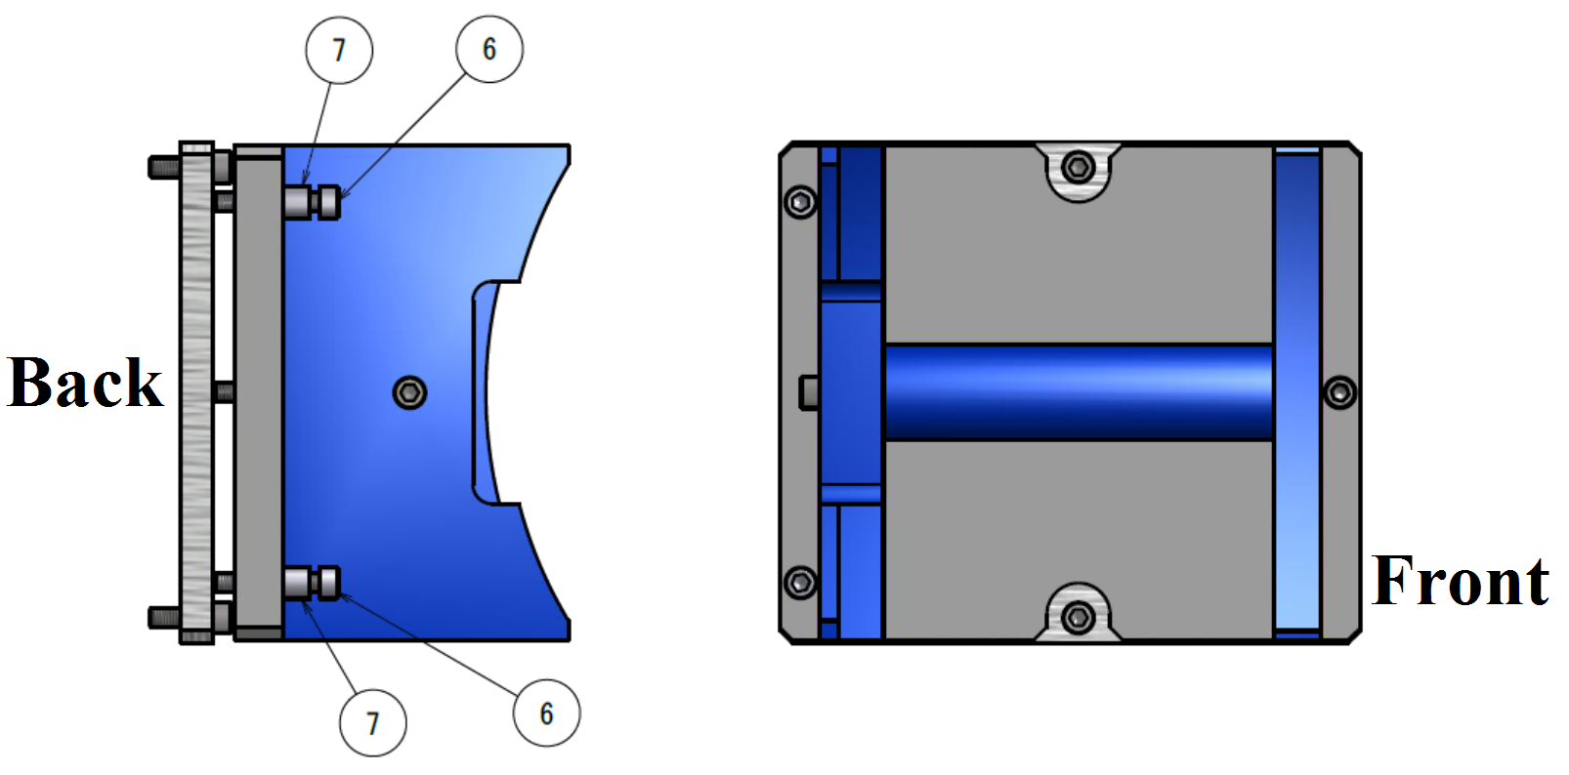
Use the following:
  - Base: 1×JGW-D1504001-6. (This is a provisional link.)
  - Base 2: 1×JGW-D1504001-7. (This is a provisional link.)
  - Front plate: 1×JGW-D1504001-8. (This is a provisional link.)
  - Back plate: 1×JGW-D1504001-9. (This is a provisional link.)
  - Cylinder: 1×JGW-D1504001-10. (This is a provisional link.)
  - Adjustment screw: 2×JGW-D1504001-11. (This is a provisional link.) Note that the current drawing (provisional link: link) lists only two but maybe three are needed. Is the drawing correct?
  - Spacer washer type 1: 2×JGW-D1504001-12. (This is a provisional link.)
  - Spacer washer type 2: 1×JGW-D1504001-13. (This is a provisional link.) Why do we have two types of spacers (⑦ and ⑧) and not only one?
  - Fully threaded screw: 1×M6×35mm, ASCB6-35. Shouldn’t we use an adjustment screw ⑥ here also?
Use the following additional fasteners:
  - 2×ISO4762-M6×20mm, for fixing plate ① to whatever goes below in a future step (cite step).
  - 1×ISO4762-M6×25mm, for the front plate ③ and the cylinder ⑤.
  - 1×ISO4762-M6×30mm, for the back plate ④ and the cylinder ⑤.
  - 4×ISO4762-M6×16mm, for fixing on to the base plate ② the front and back plates ③ and ④ respectively.
Drawing: JGW-D1504216. In case the drawing is not at that address yet please notify the responsible person and use this provisional link.
Pictures: Spare mirror hanging test, 8/10/2015.
- Stuff…
- More stuff…
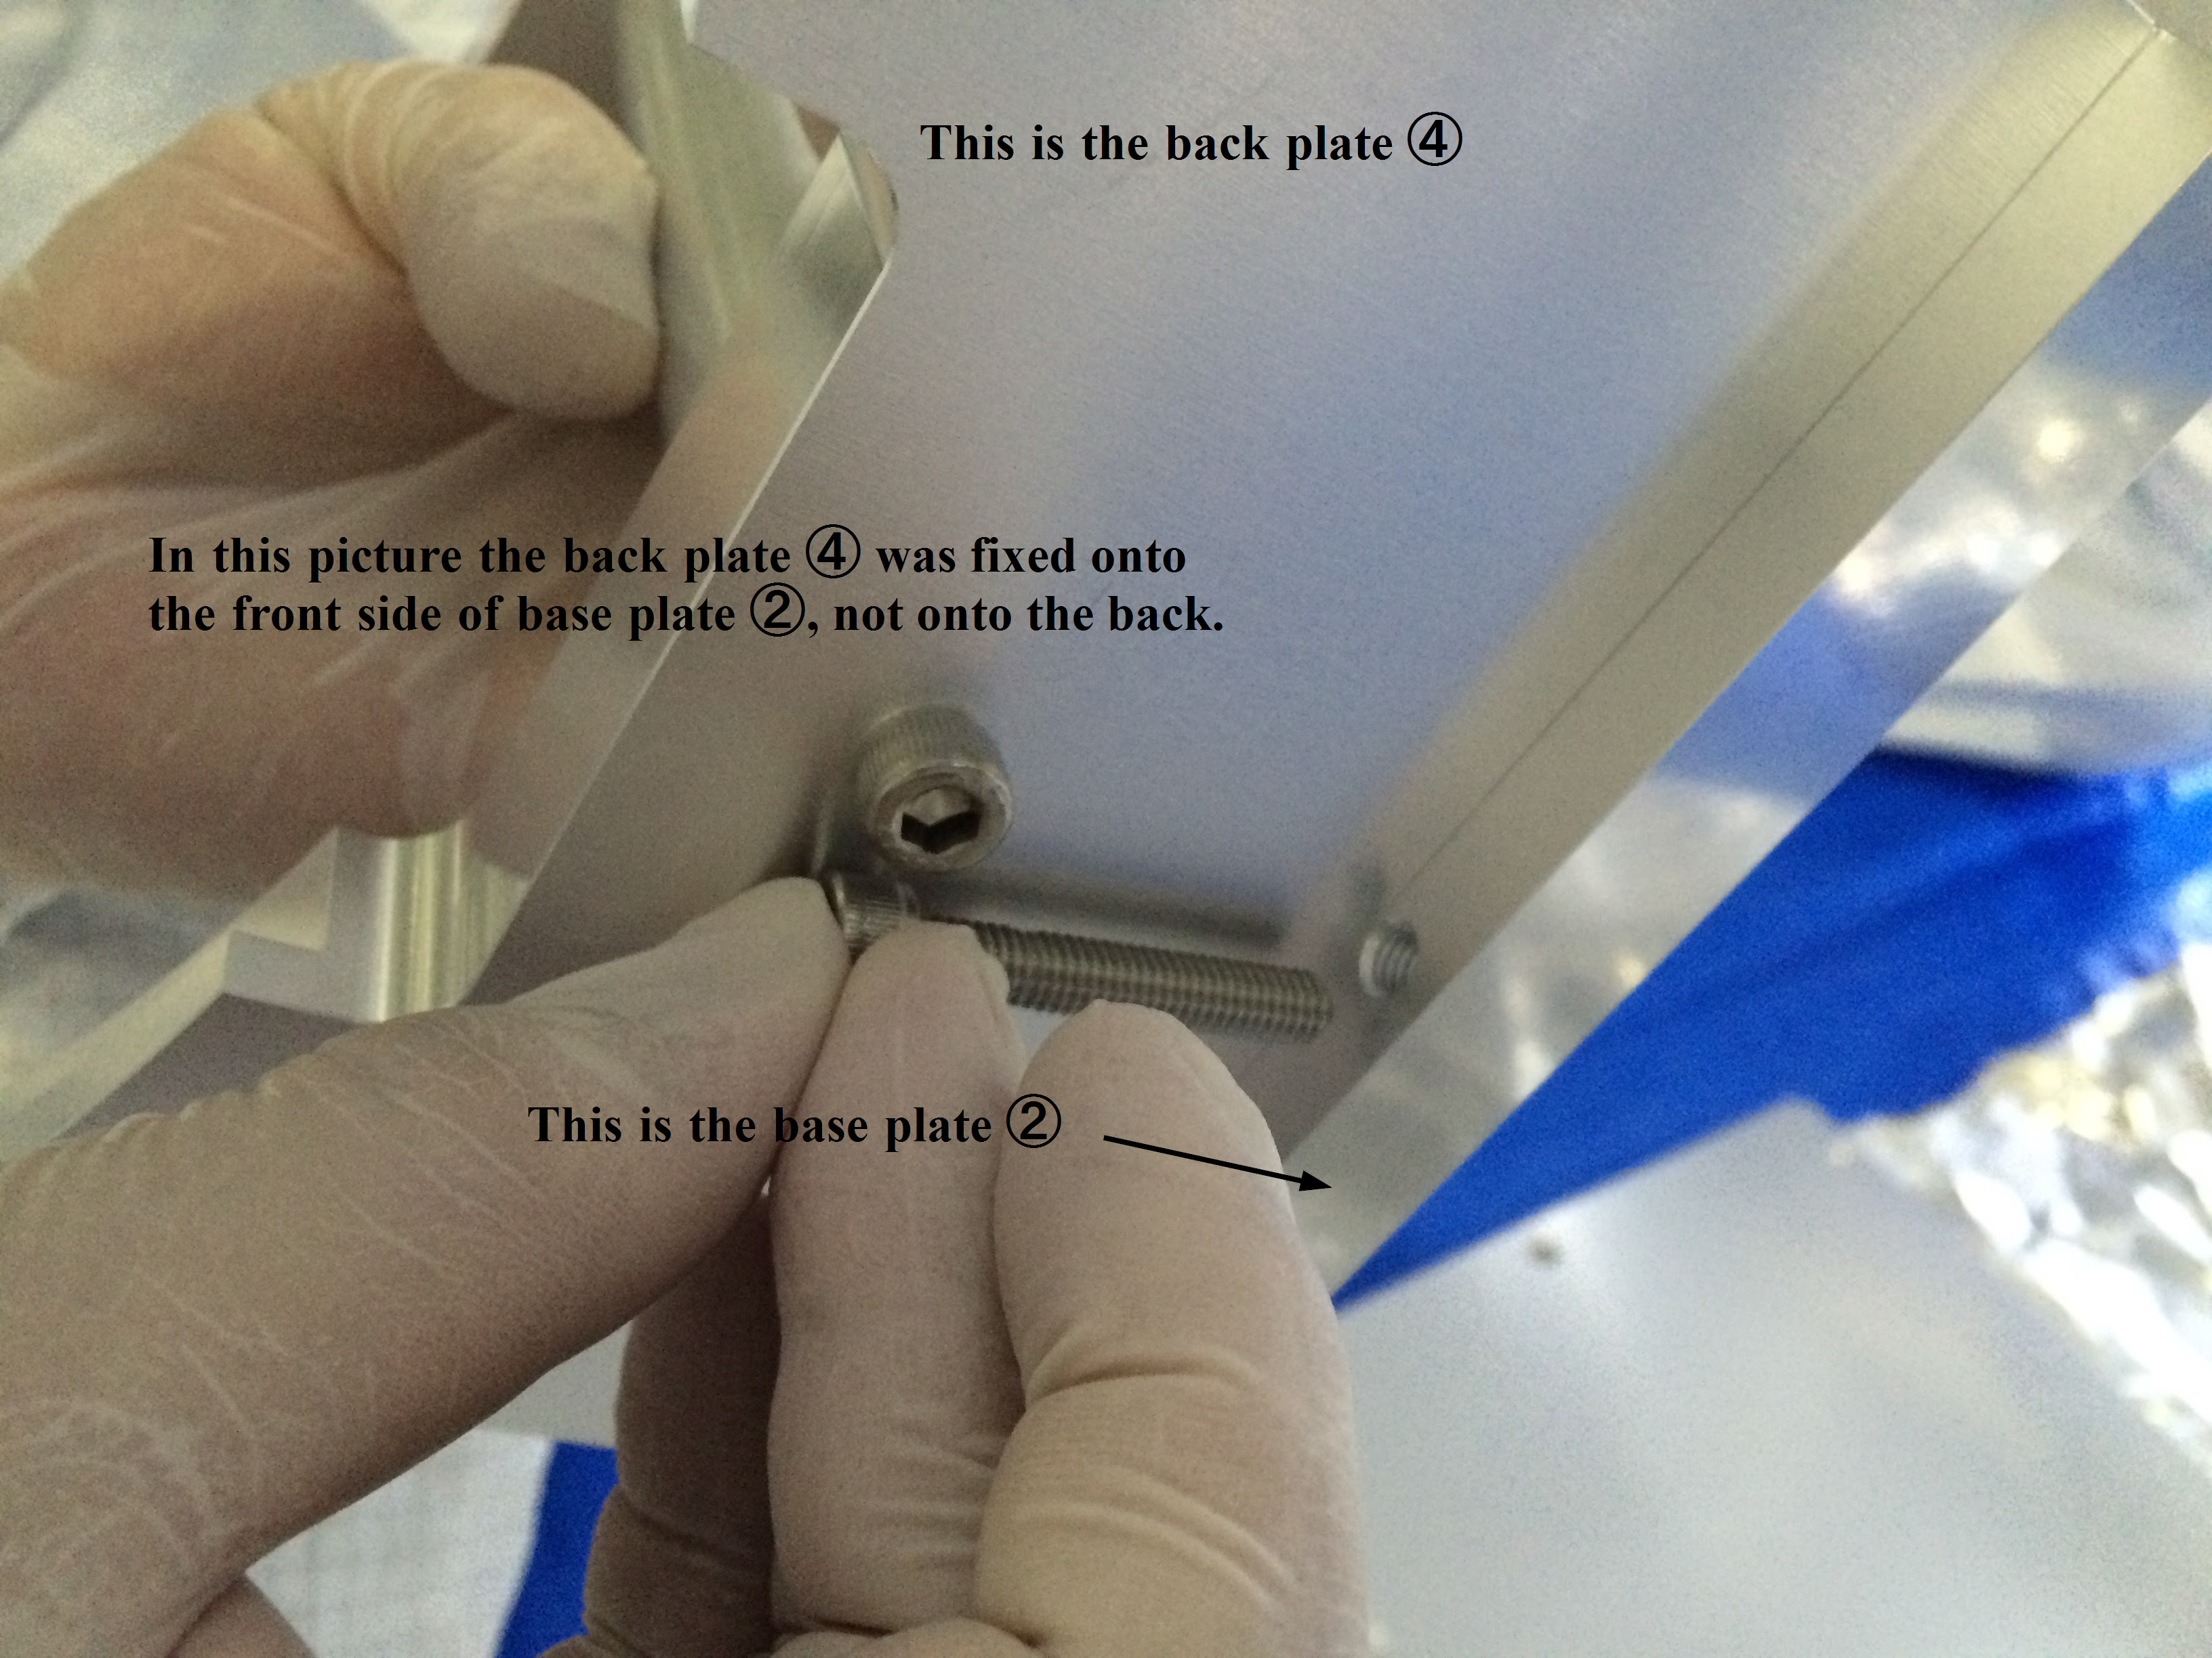
Pictures: Spare mirror hanging test, 8/10/2015.

Assembly of Recoil Mass pedestal
Stuff
Drawing: JGW-D1504406.

Assembly of the Intermediate Mass
The assembly of the IM comprises the assembly of the mechanical components and the ribbon cables that connect the picomotors from within the IM to the outside.
- Intermediate Mass 2D assembly drawing: JGW-D1605028-v2.
- Wire clamps 2D drawing: JGW-D1503474-v2.
- Attach the male pins (4×100171 from Accu-Glass) to the cables of the two picomotors 26 (2×8032-UHV from Newport/New Focus) using the crimp tool. We have two types of crimp tools: the 214-CTOOL-HQ from Allectra and a simpler one from RS.
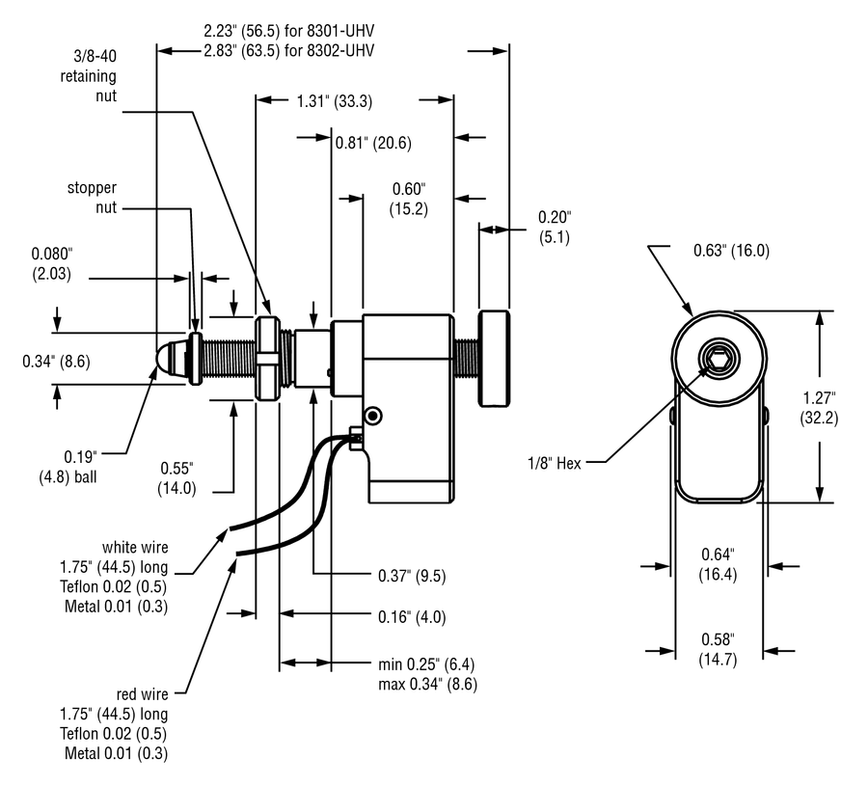
- Build the cable assembly C-BS-IM—PP/PR-0 with the following specifications:
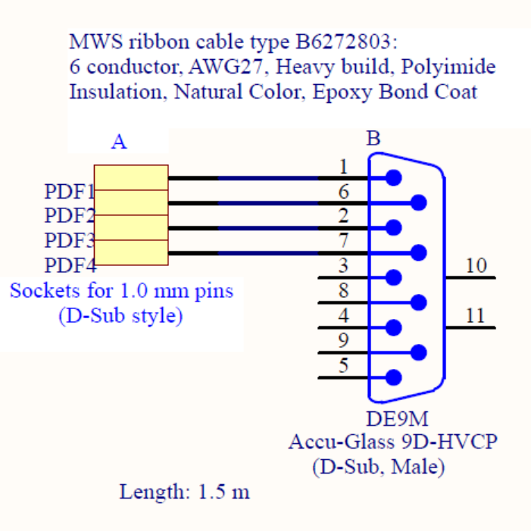
- The cable B6272803 from MWS is a six way ribbon cable although only four threads are used.
- The four PDFX (X=1,2,3,4) sockets are the female pins 4×100181 from Accu-Glass.
- The D-sub connector is the 9 way male 1×110000 (model number 9D-HVCP) from Accu-Glass.
- Use a mechanical stripper to remove the insulation. There should be two at the Kamioka site.
Cable diagram: JGW-D1503901, page 3.
- Fix the picomotors 26 (2×8032-UHV) to their supports 4 (2×JGW-D1503444-6) using the nut and the tool included with the picomotors.
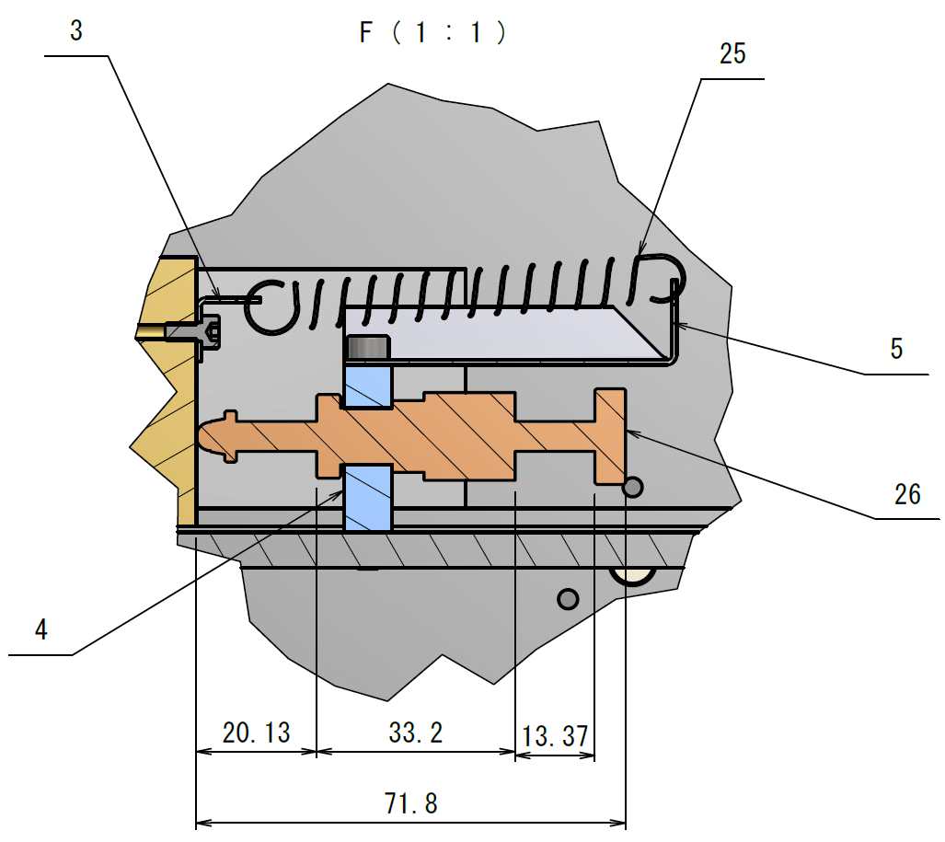
- Put together two instances of assembly 22 (2×JGW-D1503475), which is used to adjust the position of the center of mass of the IM. Attach to stainless steel pieces 2×JGW-D1503444-3 the PTFE edge pieces 4×JGW-D1503444-4 using 12×JISB1111(H)- M3×10-4.8-H. Also attach the small piece 3 (JGW-D1503444-5) onto the steel block with SDC screw (1) 1×ISO4762-M3×6. We might not require an SDC screw as it is very small.
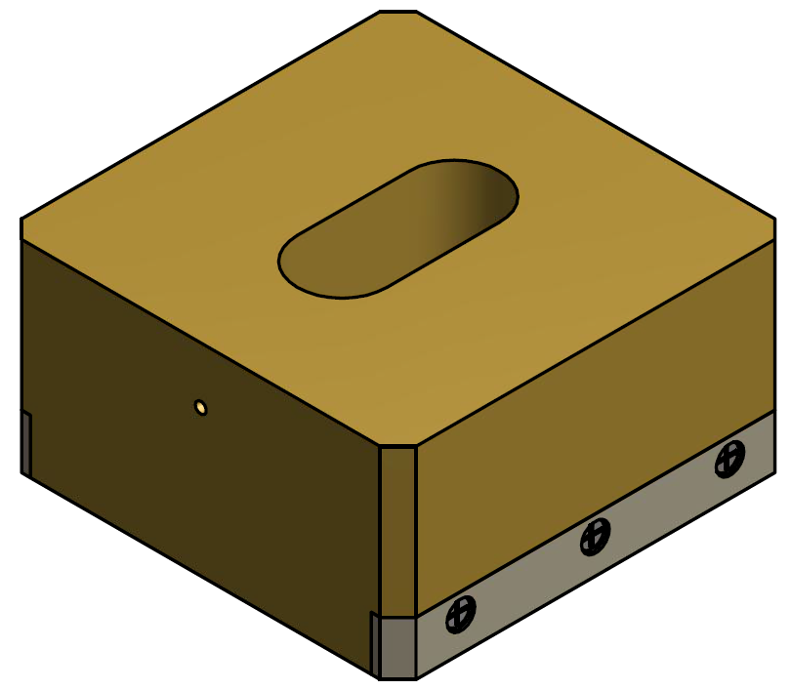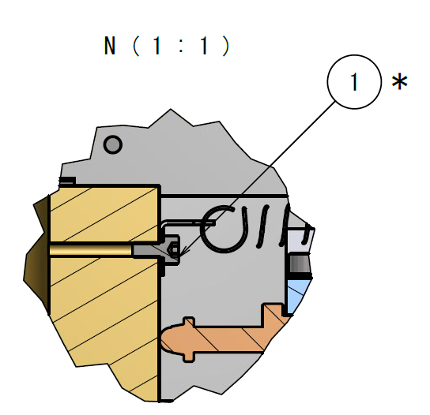
- Take the bottom plate 1 (JGW-D1503444-1) and place it on four improvised supports in such a way that the bottom side is accessible for screws. The supports could be four of the metallic cups we use to store screws, for example. The top side of the plate can easily be recognized by the rectangular feature to host a compensation mass.
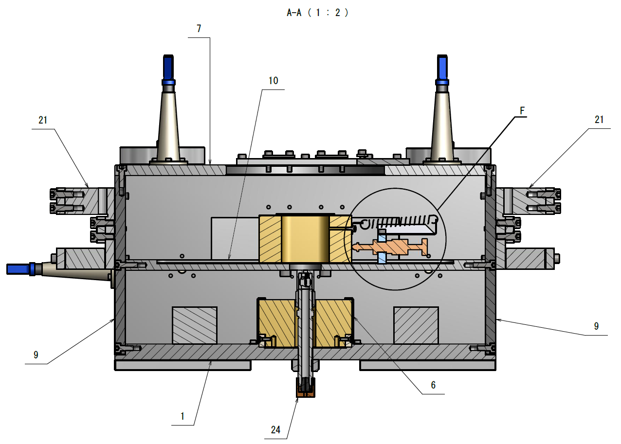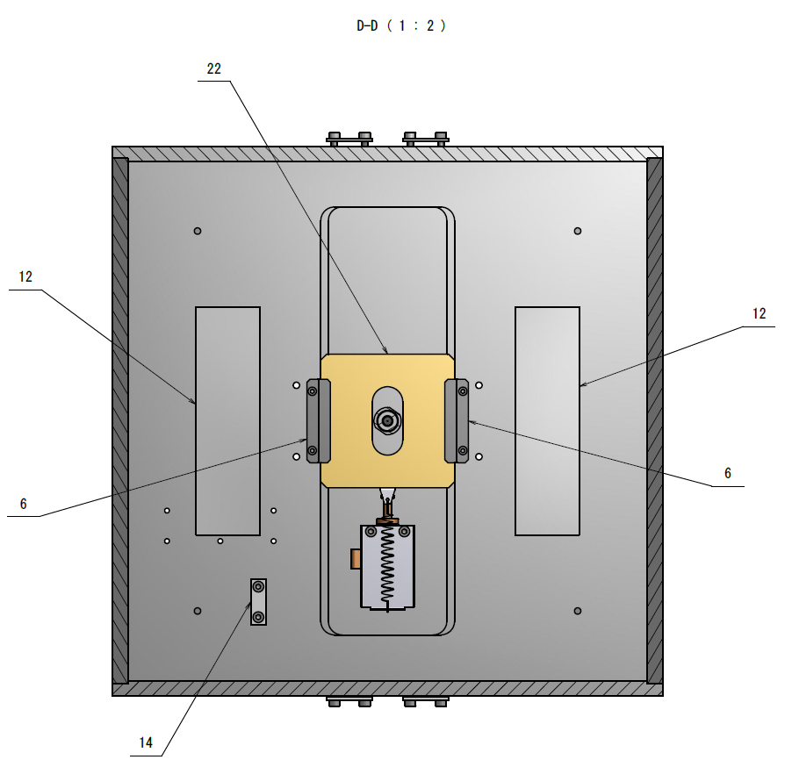
- Fix the two ballast masses 12 (2×JGW-D1503444-29) on to the bottom plate 1 (JGW-D1503444-1) with vented SDC screws (10) 4×ISO4762-M6×20.

- Place security brackets 6 (2×JGW-D1503444-8) on the top of the plate. Fix them with the screws (1) 4×ISO4762-M3×6.
- Place one compensation mass assembly 22 (1×JGW-D1503475) within the central feature of the bottom plate and slide it in between the pair of brackets.
- Fix one of the picomotors with its support 4 (JGW-D1503444-6) and plate 5(1×JGW-D1503444-7) to the bottom plate with (6) 2×ISO4762-M4×35.
- Use the extension spring 25 751-837 from RS to hook the compensation mass 22 (JGW-D1503475) to plate 5 (JGW-D1503444-7).
- Connect the picomotor cables to the cable assembly C-BS-IM--PP/PR-0 according to the following diagram:
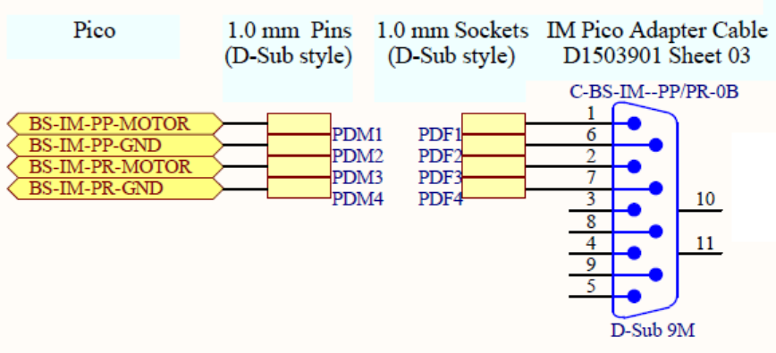
- Red cable: motor. (To which pin of the 9 D-sub? Decide and update the diagram.)
- White cable: ground. (To which pin of the 9 D-sub? Decide and update the diagram.)
- Although two picomotors connections in the diagram appear connect only one.
Cable diagram: JGW-D1503600, page 3, left side.
- Secure the cables onto the bottom plate using the clamp 14 1×JGW-D1503444-40 and 2×ISO4762-M4×16. Use heat-shrink (111130 from Accu-Glass) in order to isolate the connection pins from the metallic bottom plate.
- The following step is to connect the picomotor to the driver in order to set the shaft in the appropriate position. Produce the in-air adapter cable C-BS-IM--PP/PR-5 to connect the picomotors to the drivers. There is not a clear requirement for the length yet.
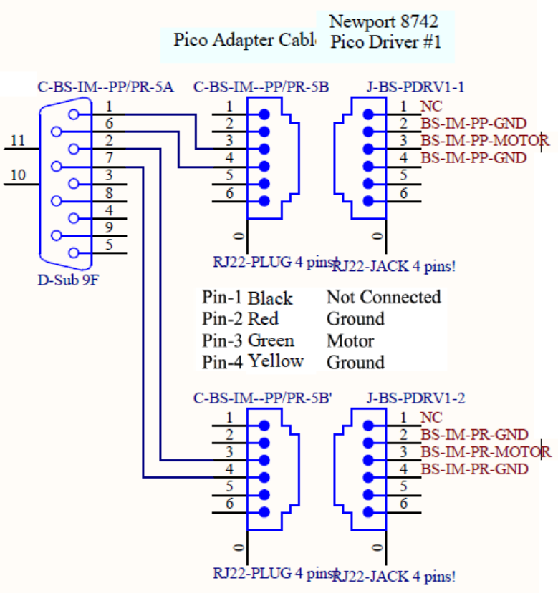
- 1×9 way D-sub connector female. As this is an in-air connector, the Analog Electronics (AEL) group will provide it from stock at Kamioka.
- 2×RJ22 plug (male) 4 pins. This connector with a cable segment likely comes with the picomotors.
- Cable diagram: JGW-D1503600, page 3, right side.
- As this is an in-air cable assembly we might be able to use solder.
- Produce the following test cable:
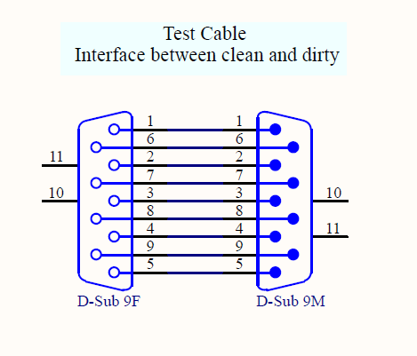
Clearly label the female end “clean” and the male end “dirty”. Use a UHV compatible connector for the clean female end and a regular connector for the male end. There is no particular requirement for the length.
- Produce the following cable
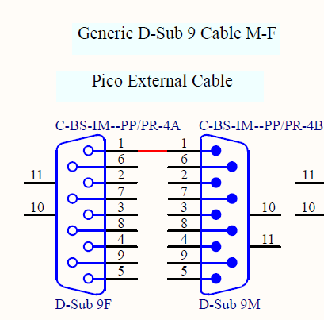
This is an in-air cable. The cable has to be long enough in order to reach the rack or place where the picomotor drivers are.
- Connect all the cables as follows
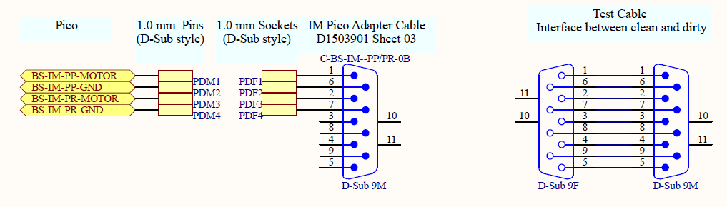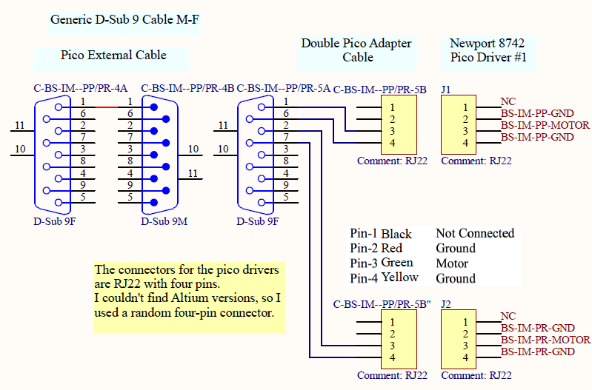

- Insert the two RJ22 plugs (end B, males) of cable C-BS-IM--PP/PR-5 into the jacks (female) in the driver.
- Using the joystick set the shaft of the picomotor to its nominal position.
- (Likewise step 5 above.) Take the middle plate 10 (JGW-D1503444-25) and place it on four improvised supports in such a way that the bottom side is accessible for screws. The supports could be four of the metallic cups we use to store screws, for example. The top side of the plate can easily be recognized by the rectangular feature to host a compensation mass.
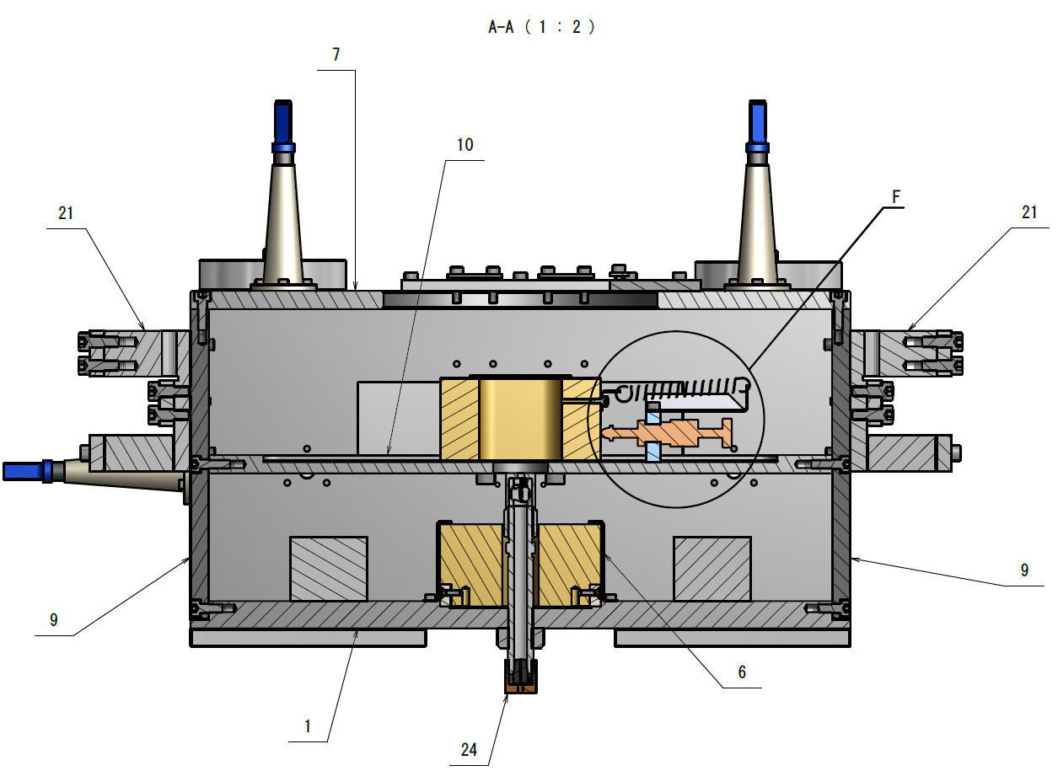
- (Likewise step 6 above.) Fix the two ballast masses 11 (2×JGW-D1503444-28) onto the middle plate 10 (JGW-D1503444-25) with vented SDC screws (10) 4×ISO4762-M6×20.
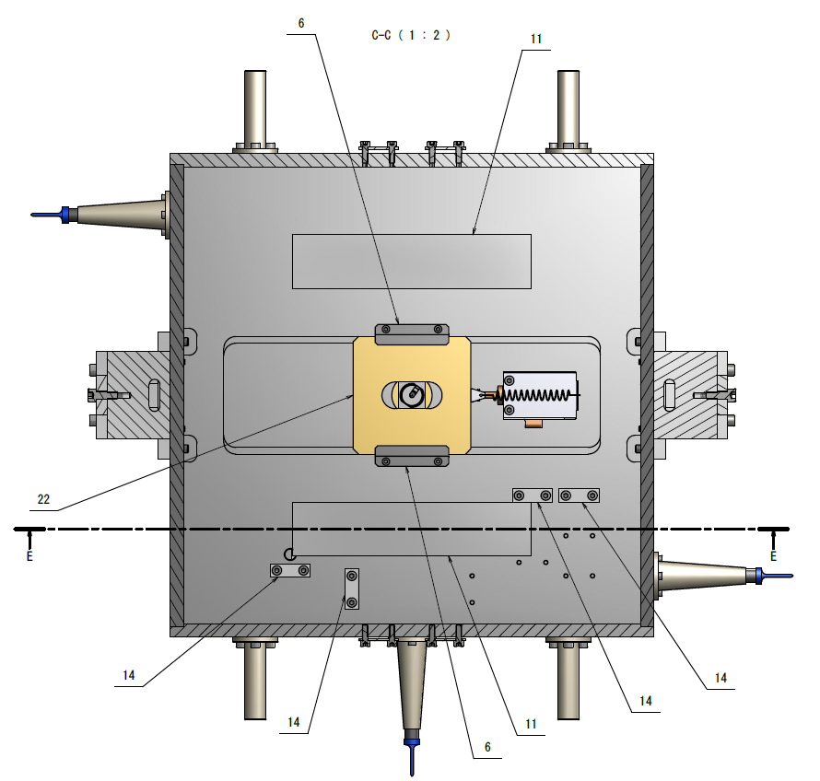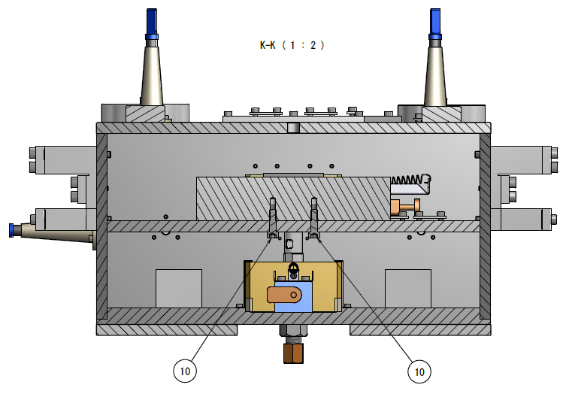
- (Likewise step 7 above.) Place security brackets 6 (2×JGW-D1503444-8) on the top of the plate. Fix them with the screws (1) 4×ISO4762-M3×6
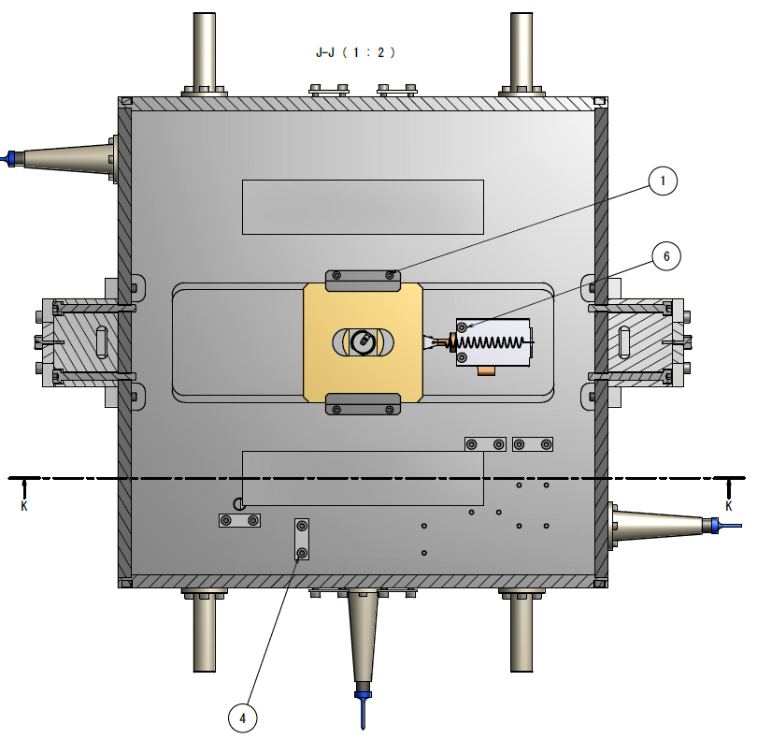
- (Likewise step 8 above.) Place the other compensation mass assembly 22 (1×JGW-D1503475) within the central feature of the middle plate and slide it in between the pair of brackets.
- (Likewise step 9 above.) Fix the other picomotor 26 with its support 4 (JGW-D1503444-6) and the other plate 5 (1×JGW-D1503444-7) to the middle plate with screws (6) 2×ISO4762-M4×35.
- (Likewise step 10 above.) Use the other extension spring to hook the compensation mass 22 (JGW-D1503475) to plate 5 (JGW-D1503444-7).
- (Likewise step 11 above.) Connect the picomotor cables to the cable assembly C-BS-IM--PP/PR-0 according to the following diagram:
Additionally,
- Disconnect the other picomotor.
- Red cable: motor. (To which pin of the 9 D-sub? Decide and update the diagram.)
- White cable: ground. (To which pin of the 9 D-sub? Decide and update the diagram.)
Cable diagram: JGW-D1503600, page 3, left side.
- (Like step 12 above.) Secure the cables onto the middle plate using the clamps 14 4×JGW-D1503444-40 (or less) and (4) 8×ISO4762-M4×12 (or less). Use heat-shrink (111130 from Accu-Glass) in order to isolate the connectors from the metallic bottom plate. Do not shrink the heat-shrink.
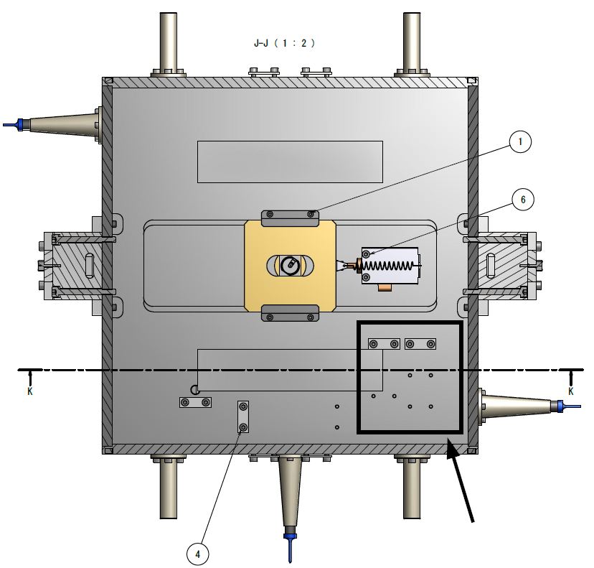
- (Likewise step 14 and 15 above.) Make sure cables are connected to the picomotor driver.
- (Like step 16 above.) Using the joystick set the shaft of the picomotor to its nominal position.
- Disconnect all the cables.
- Attach the lateral plates 9 (2×JGW-D1503444-24) onto the bottom plate 1. These plates are parallel to the long sides of the central feature of the bottom plate 1 (JGW-D1503444-1). Use vented screws (7) 10×ISO4762-M5×12 vented. Do not tighten them strongly yet as other pieces still have to be added to the assembly.
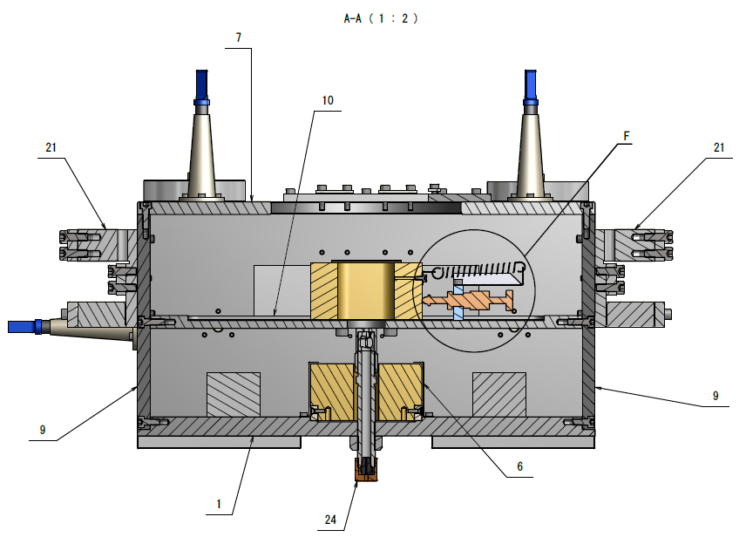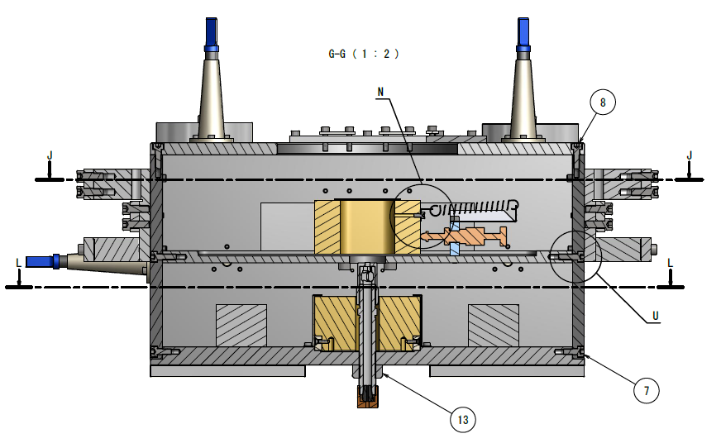
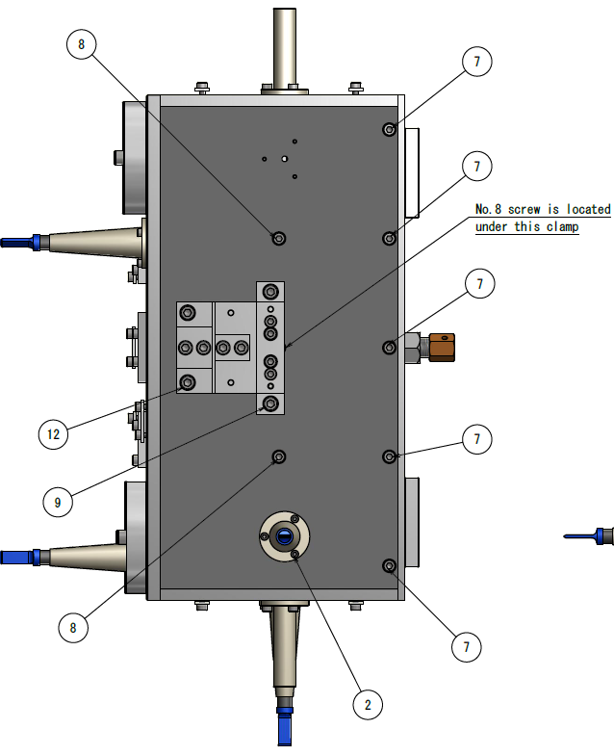
- Attach the middle plate 10 (JGW-D1503444-25) to the two lateral plates 9 (2×JGW-D1503444-24) using vented screws (8) 4×ISO4762-M5×16 vented. Do not tighten them strongly yet.
- The clean in-vacuum cable C-BS-IM--PP/PR-0 has four threads. The end of the cable which connects to the picomotors has to be split at the centre such that two threads can go into the bottom cavity and the other two remain in the upper cavity. The length along which the pair of threads have to be divided has to be decided in situ.
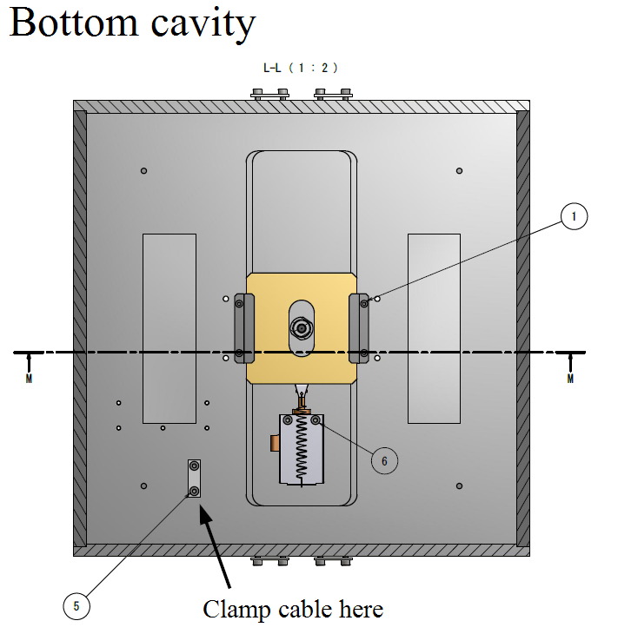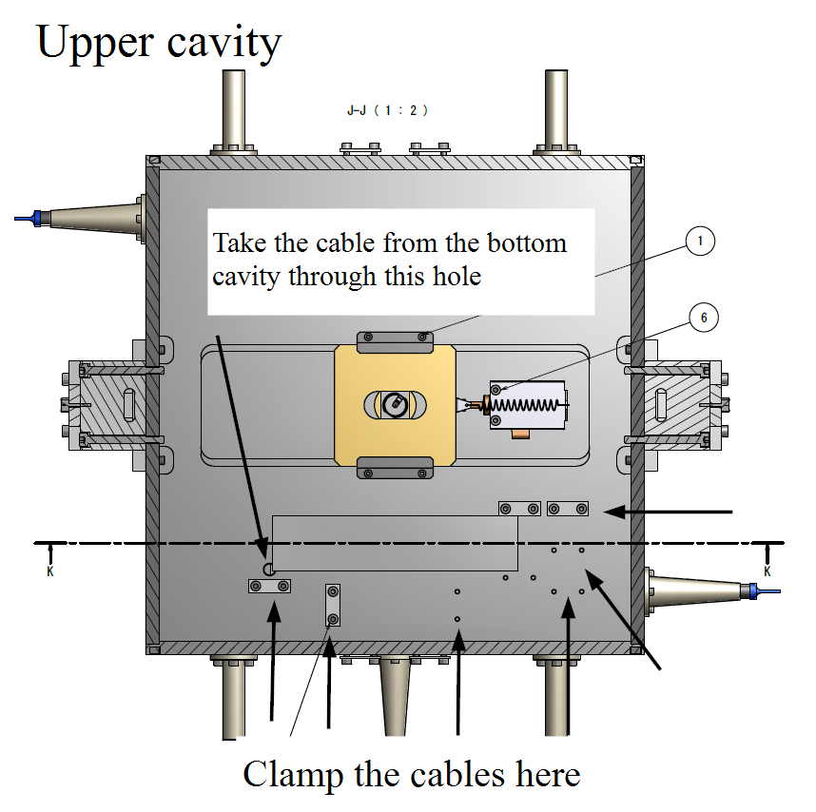
The drawing on the left shows where the cable in the bottom cavity has to be clamped. The one on the right shows the hole through which it has to go into the upper cavity and where it has to be clamped. It also shows where the cable for the upper picomotor has be clamped. Note that the cable also has to go through a hole in the top plate 7 (1×JGW-D1503444-9)
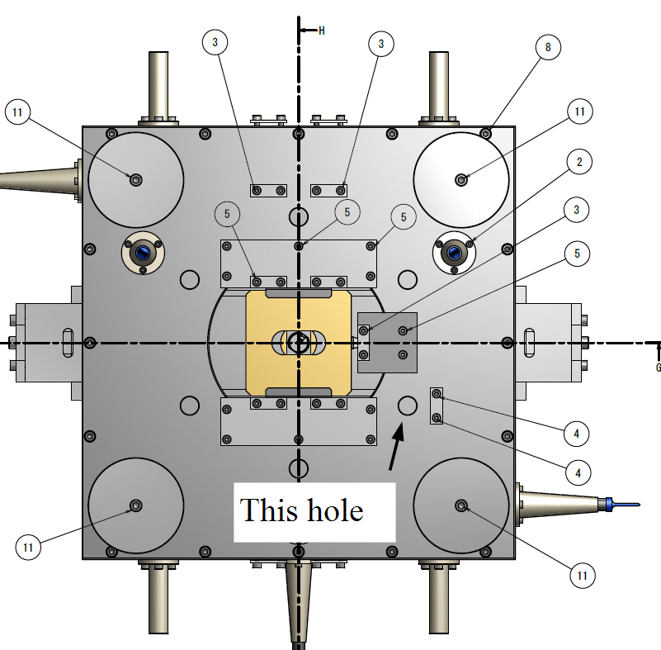
This implies that the end which is connected to the picomotors has to be inserted first through the top plate 7 and then through the middle plate 10 before fixing the plates in their places.
- Attach the other two lateral plates 2 (JGW-D1503444-2) to the bottom plate 1 (JGW-D1503444-1), middle plate 10 (JGW-D1503444-25) and lateral plates 9 (2×JGW-D1503444-24).
  - To fix the lateral plates 2 to the bottom plate 1 use vented screws (7) 10×ISO4762-M5×12 vented. Do not tighten them strongly yet.
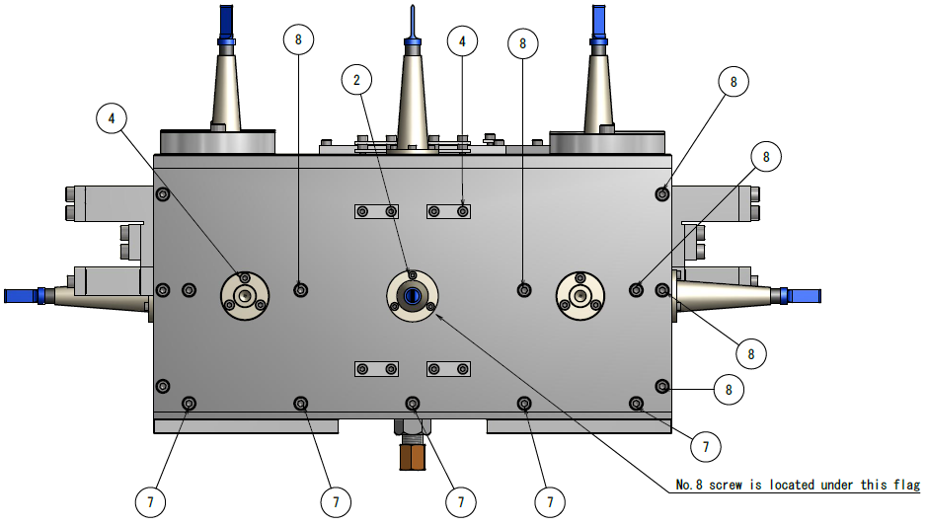
- To fix the lateral plates 2 to middle plate 10 use vented screws (8) 10×ISO4762-M5×16.
- To fix the lateral plates 2 to lateral plates 9 use vented screws (8) 12×ISO4762-M5×16.
- Put the top plate 7 (1×JGW-D1503444-9) in place. Use vented screws (8) 16×ISO4762-M5×16.
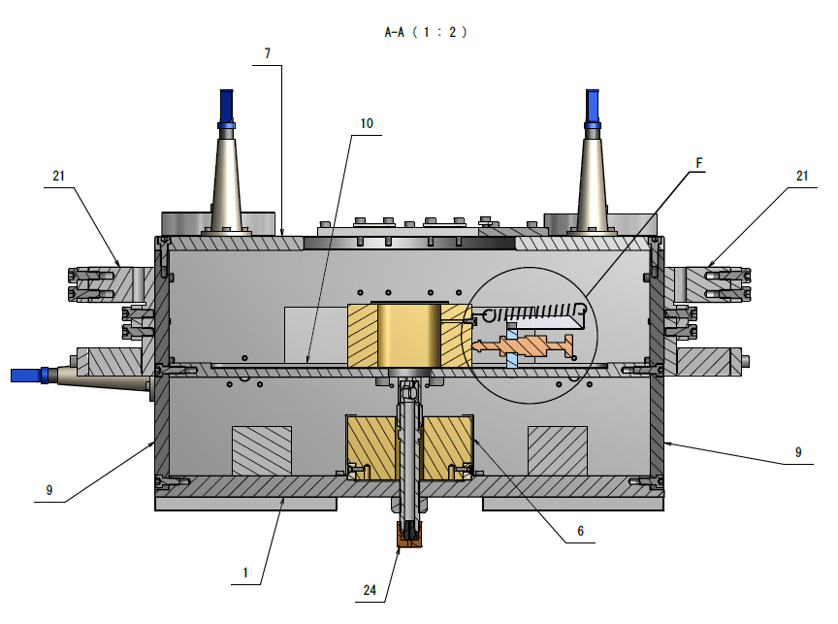
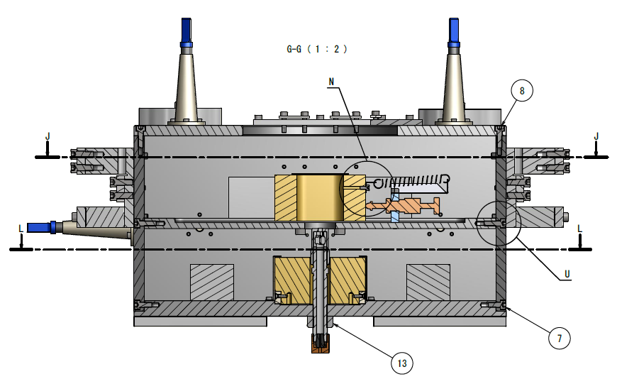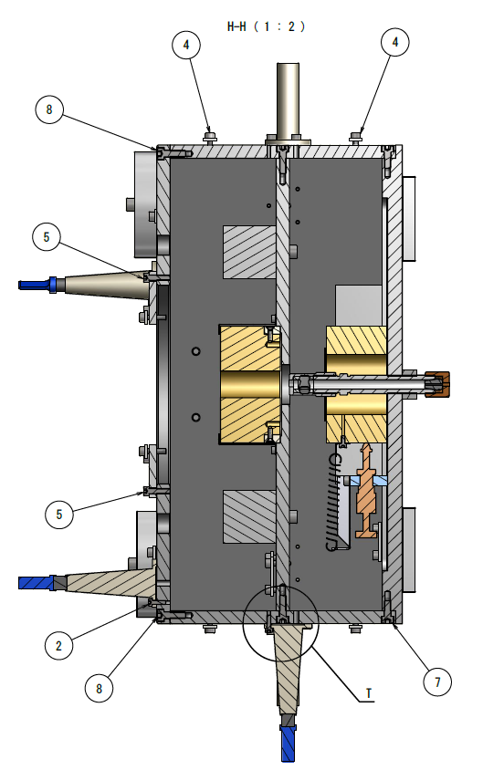
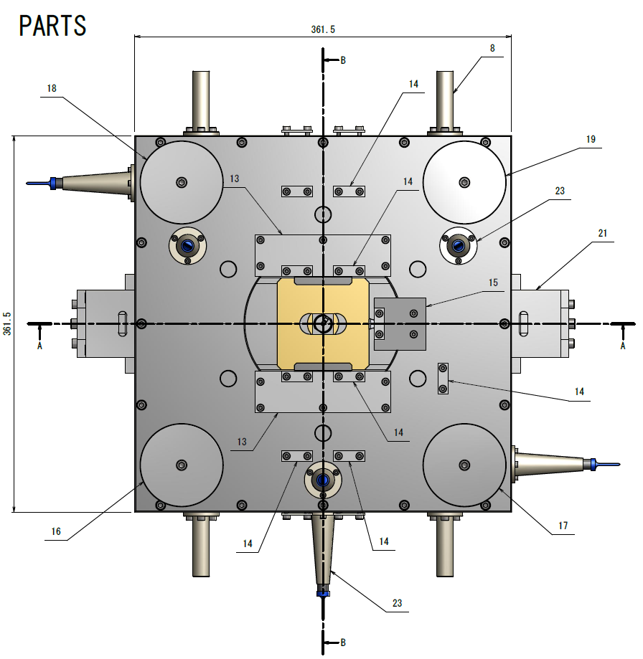
- Now tighten properly all the screws that hold the box together.
- Attach the lock receptacles 8 (4×JGW-D1503444-15). Use screws (4) 12×ISO4762-M4×12.
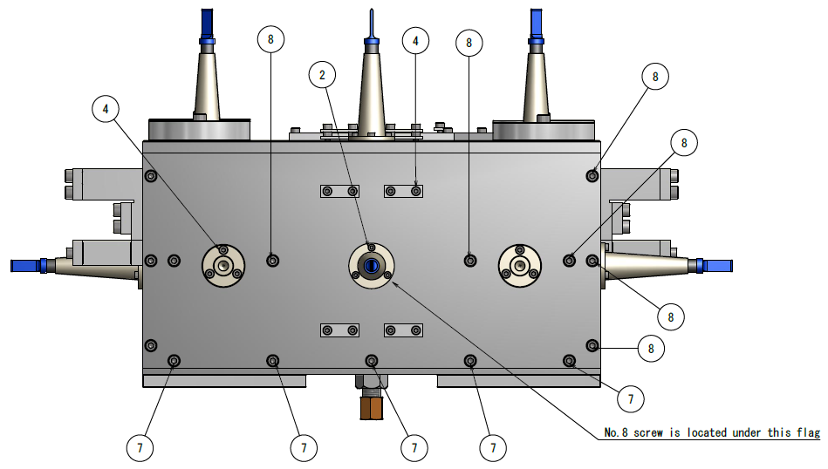
- Attach the cable clamps 14 (4×JGW-D1503444-40) and bases 13 (2×JGW-D1503444-39) and 15 (JGW-D1503444-47). Only five of the clamps go on these bases.
- For base 13 (2×JGW-D1503444-39) use screws (5) 10×ISO4762-M4×16.
- For base 15 (JGW-D1503444-47) use screws (5) 2×ISO4762-M4×16.
- Cable clamps (18×JGW-D1503444-40). Use screws (5) 36×ISO4762-M4×16 for the clamps on the bases, screws (3) 10×ISO4762-M4×10 for the rest on the top plate and (4) 16×ISO4762-M4×12 for the clamps on the lateral plates.
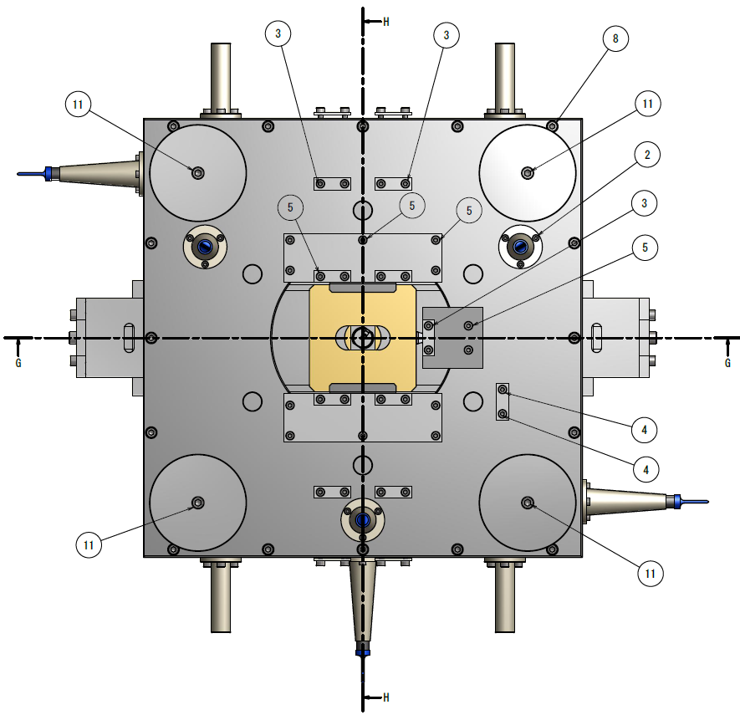
- Assemble the wire clamps.
  - Fix 1 (2×JGW-D1503444-19) to the sides of the IM (see 2D drawing JGW-D1503474-v2). Use the locating pins (7) 2×pin20mm_ISO2338B, to place the piece accurately and the screws (12) 4×ISO4762-M6×55 and (9) 4×ISO4762-M6×16 in the upper holes and lower holes respectively (see different 2D drawing JGW-D1605028-v2). The pins fit loosely into the holes in the IM and tightly into the holes in pieces 1.
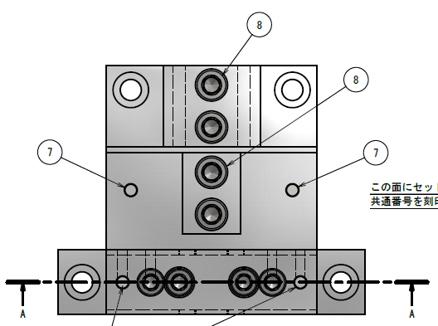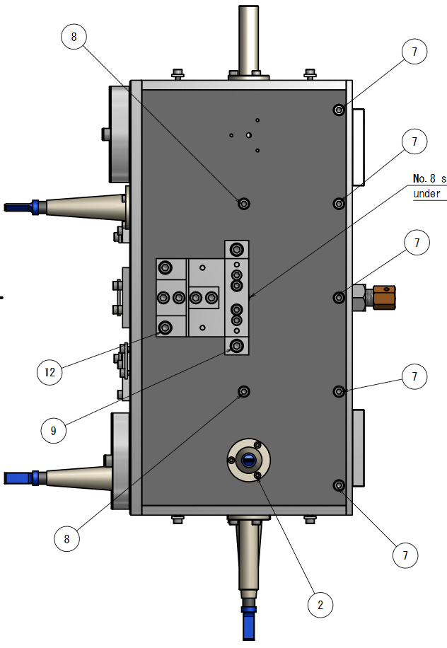
  - Fix pieces 5 (2×JGW-D1503444-23) to pieces 1 (2×JGW-D1503444-19) using screws (8) 4×ISO4762-M6×16. Do not tighten the screws strongly.
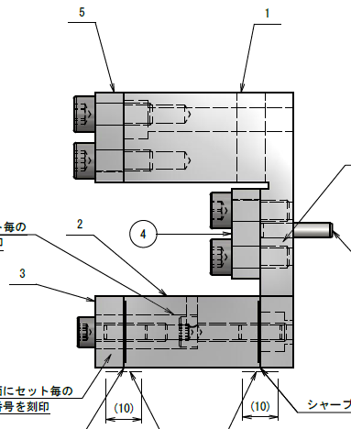
  - Fix pieces 4 (2×JGW-D1503444-22) to pieces 1 (2×JGW-D1503444-19) using screws (8) 4×ISO4762-M6×16. Do not tighten the screws strongly.
  - Fix pieces 2 (2×JGW-D1503444-20) to pieces 1 (2×JGW-D1503444-19) using pins (6) 4×pin12mm_ISO2338B and screws (10) 4×ISO4762-M5×25. Do not tighten the screws strongly. The pins fit loosely into pieces 2 and tightly into pieces 1.
  - Fix pieces 3 (2×JGW-D1503444-21) to pieces 2 (2×JGW-D1503444-20) using pins (6) 4×pin12mm_ISO2338B and screws (9) 4×ISO4762-M5×20. Do not tighten the screws strongly. The pins fit loosely into pieces 2 and tightly into pieces 3.
- The ballast/compensation masses and OSEM flags can be assembled later in the mine.
Intermediate Mass 2D assembly drawing: JGW-D1605028-v2.
Drawing IM and IRM assembly: JGW-D1503444.
Drawing wire clamps: JGW-D1503474.

Assembly of the Intermediate Recoil Mass
There are two ways in which the intermediate mass can be assembled.
Drawing: JGW-D1503445.

Optical lever
Stuff

Payload hanging procedure
Stuff
- Put on the front ring the ballast weights. The information below is for the PR payloads, update it.
  - At 12, 3 and 9 o'clock: 3×JGW-D1504732-1 (thickness = 4.5 mm) with coated ISO4762 M6×10mm screw.
  - At 6 o'clock: 1×JGW-D1504732-2 (thickness = 19 mm) with coated ISO4762 M6×25 mm screw.

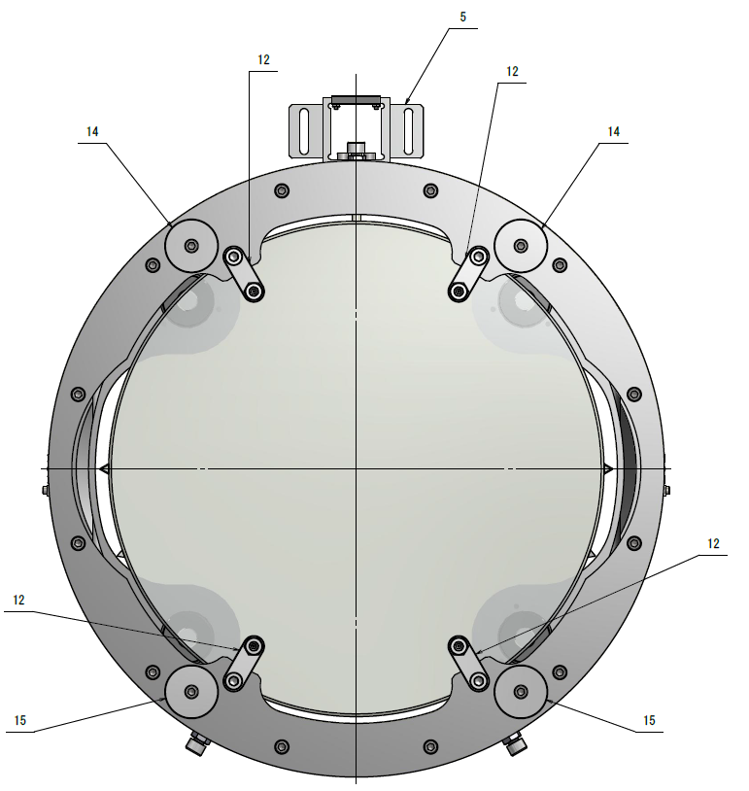
Drawings: JGW-D1504732.

To do list
This is just for me.
- Check design of the ballast discs on the back of the RM.
- Check what the optimum load for the Bottom Filter is and review the value of the ballast weights in the IM together with those of the RM.

Thus

