JGW-T1504420-v1 KAGRA 22 Oct 2015

BS Assembly Frame Concept

Mark Barton

Distribution of this document:
JGW-DCC

This is an internal working note
of the KAGRA collaboration.

http://gwcenter.icrr.u-tokyo.ac.jp

Table of Contents
1 Introduction 3
1.1 Purpose and Scope 3
1.2 References 3
1.3 Version history 3
2 Design 3
2.1 Base section 6
2.2 Bottom filter section 7
2.3 Standard filter section 8
2.4 Preisolator section 9
3 Files 10

Introduction

Purpose and Scope
This document describes a conceptual design of the BS assembly frame.

References
stuff

Version history
10/21/2015: -v1. Main frame complete; needs Hirata-san’s hanging frame to be added, plus detailing by MiraPro. Most brackets have been added, but no screws.

Design
The frame and suspension are shown in Figure 1 and Figure 2. The frame is 1300 mm wide x 1136 deep, which is the same as for the TAMA prototype test. The total height is 4058 mm, which is about 500 mm taller than at TAMA, to allow for the addition of the optical bench. (In fact the optical bench is a bit too tall, and could be shorter to allow better access to the winches that will be placed on top of the IM, but it has already been ordered and cannot easily be changed.) The different levels are described in more detail below.

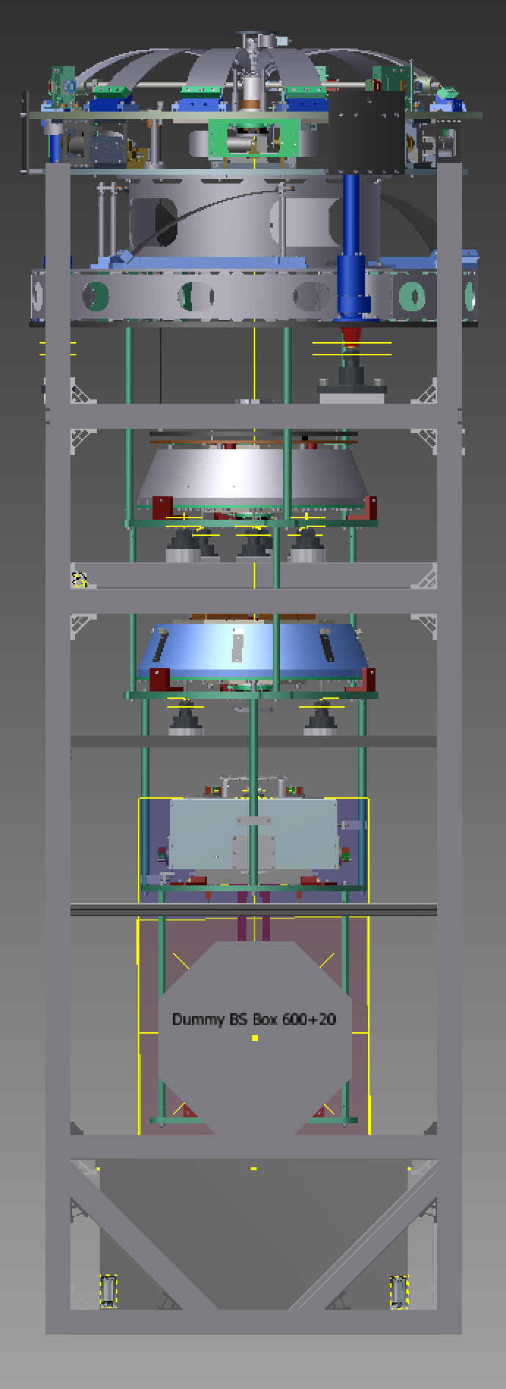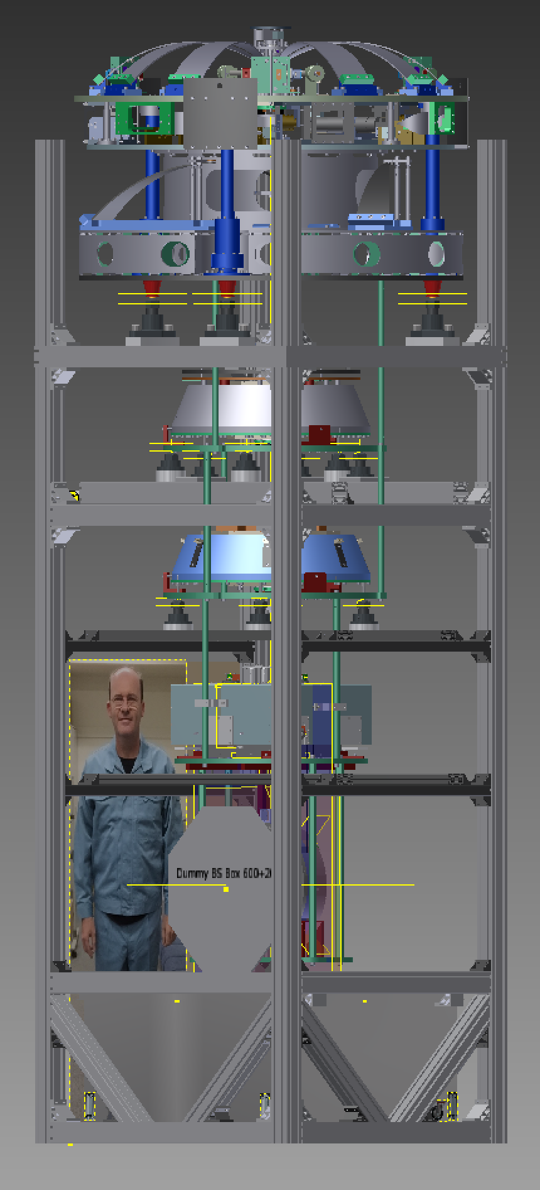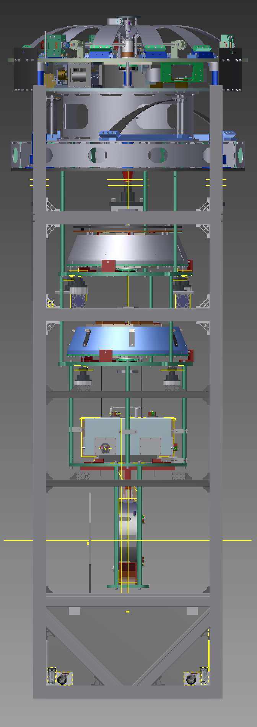
Figure 1: Front, corner and side views, with 175 cm person to show scale, and a red line indicating the height of the clean booth second floor in the BS area (3150 mm).
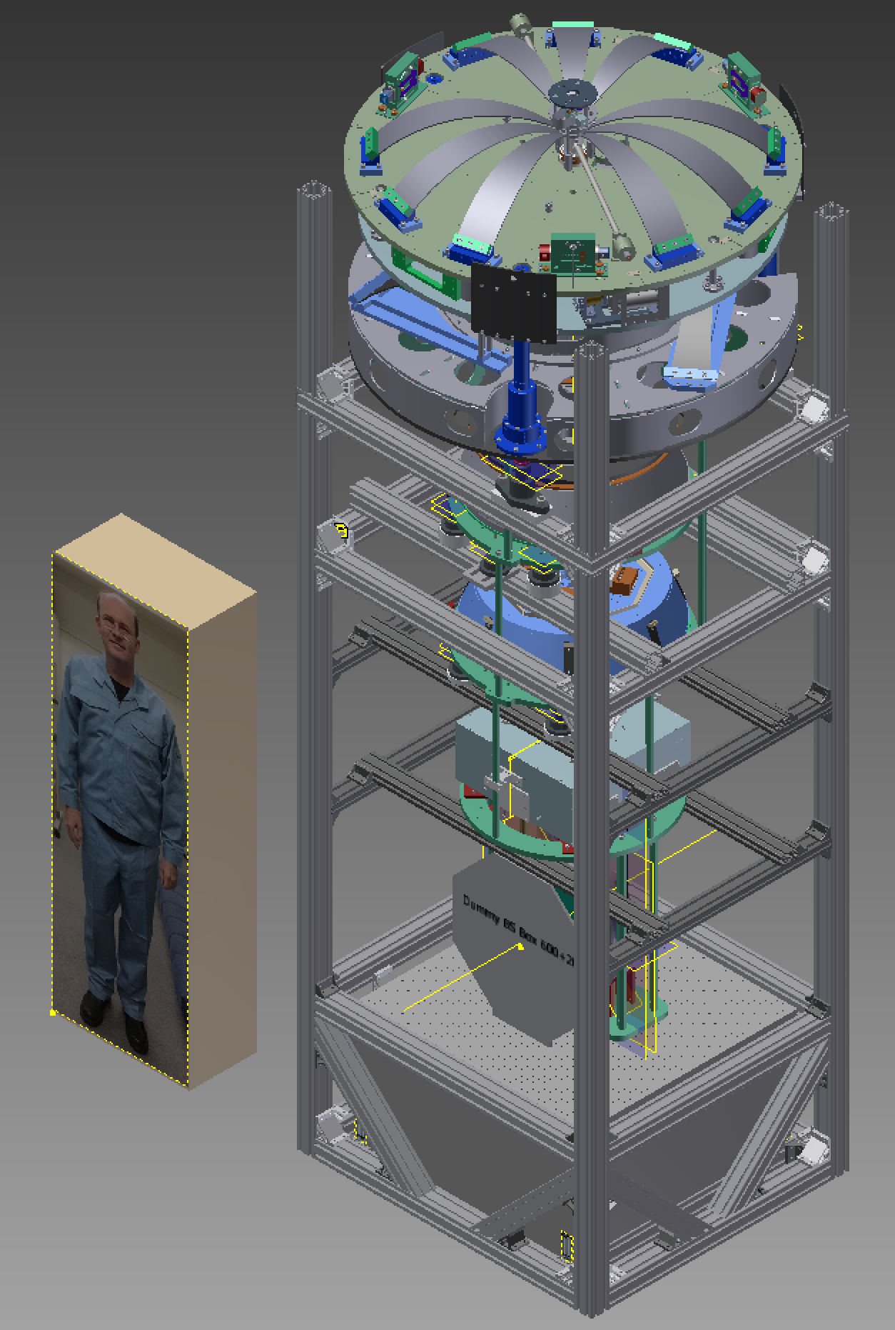
Figure 2: Isometric view, with 175 cm person for scale.

Base section
Because of the much greater weight of the BS compared to the PRx, the four corner pillars sit directly on the ground and there are no feet. As well as the crossbars visible around the bottom edges, there are two additional crossbars at the bottom to support the optical table - see Figure 3.
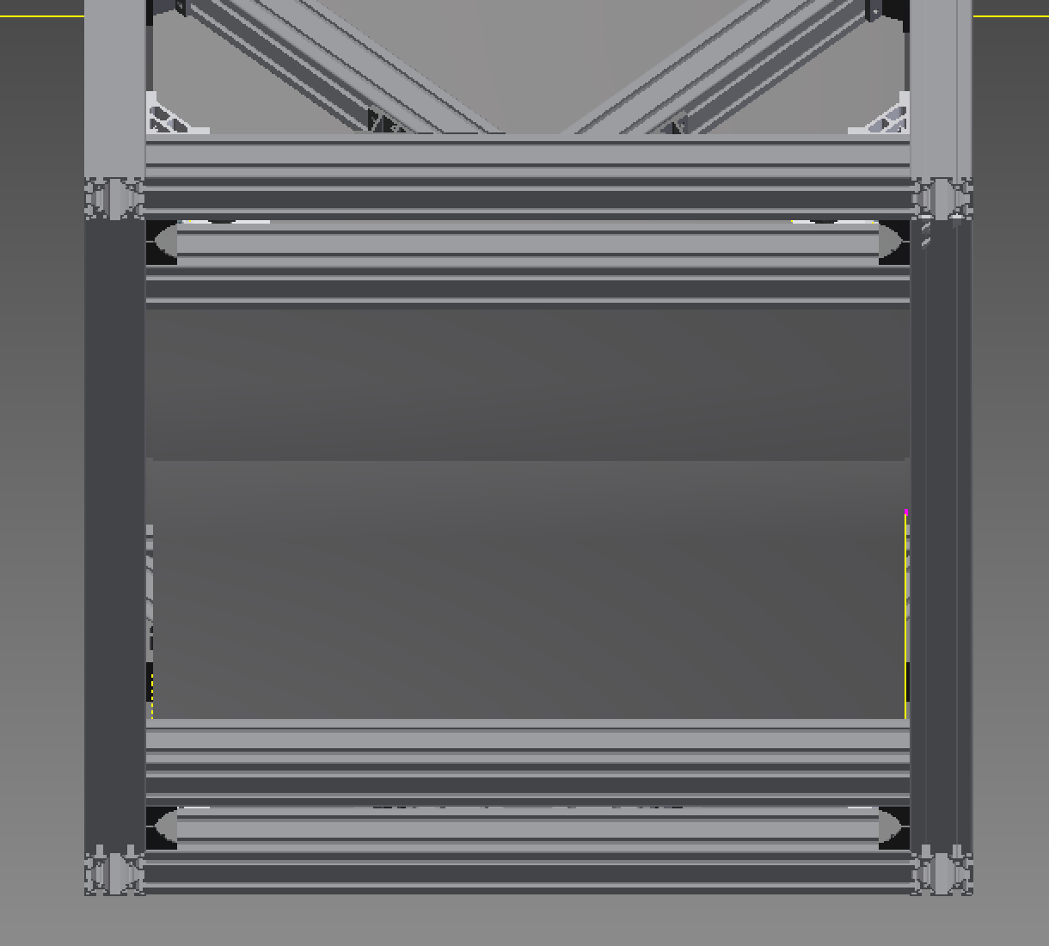
Figure 3: Base section from below, with extra crossbars to hold feet of optical bench.

Diagonal braces have been placed on all the corners to give rigidity - see Figure 4. Crossbars near the top of the optical bench are to prevent the bench being bumped, and can also be climbed on.
A plate with rails for the BS and RM will go on the optical bench, as for the PRx.
However, instead of a hanging frame mounted to the plate, the bottom ring of the security structure (green in the diagram) and the IM mass (grey-blue) will be supported by the crossbars at the level between the BS and IM/IRM support.
Hirata-san will make adapter pieces to go between the Misumi HFS8-4080 beams and the security structure.
The four corner pillars may have to be adjusted slightly in length to accommodate the height of the hanging components.
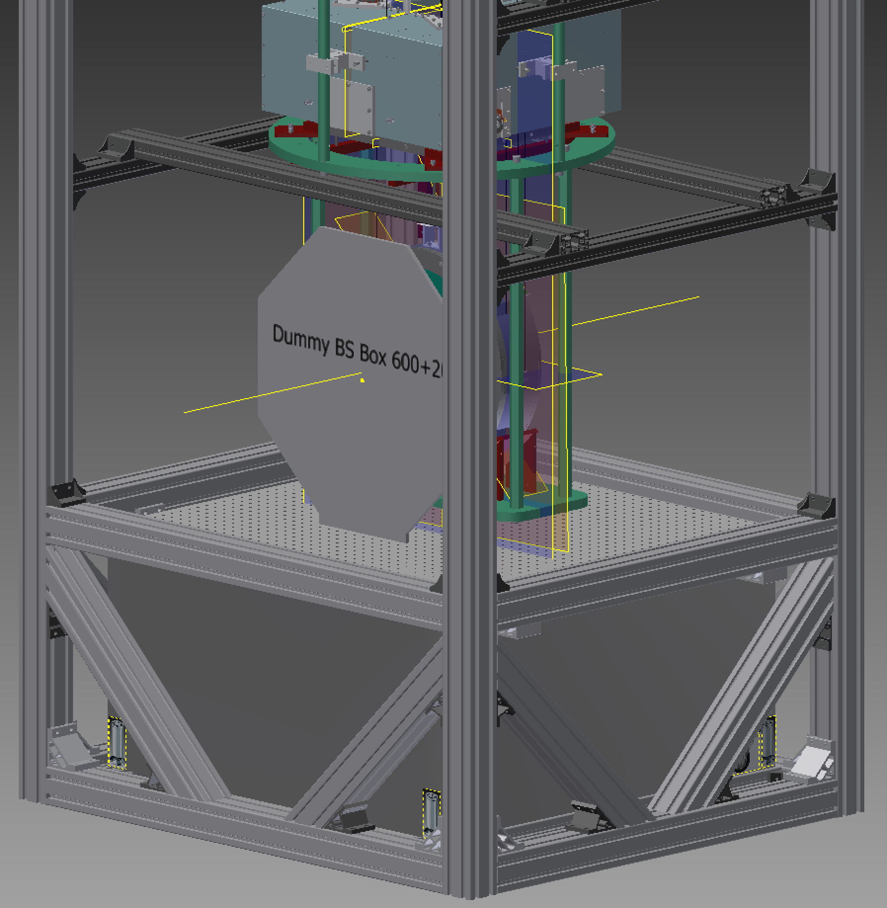
Figure 4: Base section, with optical table and placeholder for hanging frame. Brackets indicated with red arrows prevent the optical table from falling off the crossbars it sits on (see next figure).

Bottom filter section
The ring of the security structure under the bottom filter is supported by the bars of the security structure, and in turn by the ring under the IM/IRM, and by the crossbars in the previous section.
However in a change from the TAMA procedure, the Bottom Filter itself is supported by four Nabeya LJ-01 jacks and pushrods, to allow it to be lowered for installing the maraging rods for the IM/IRM.
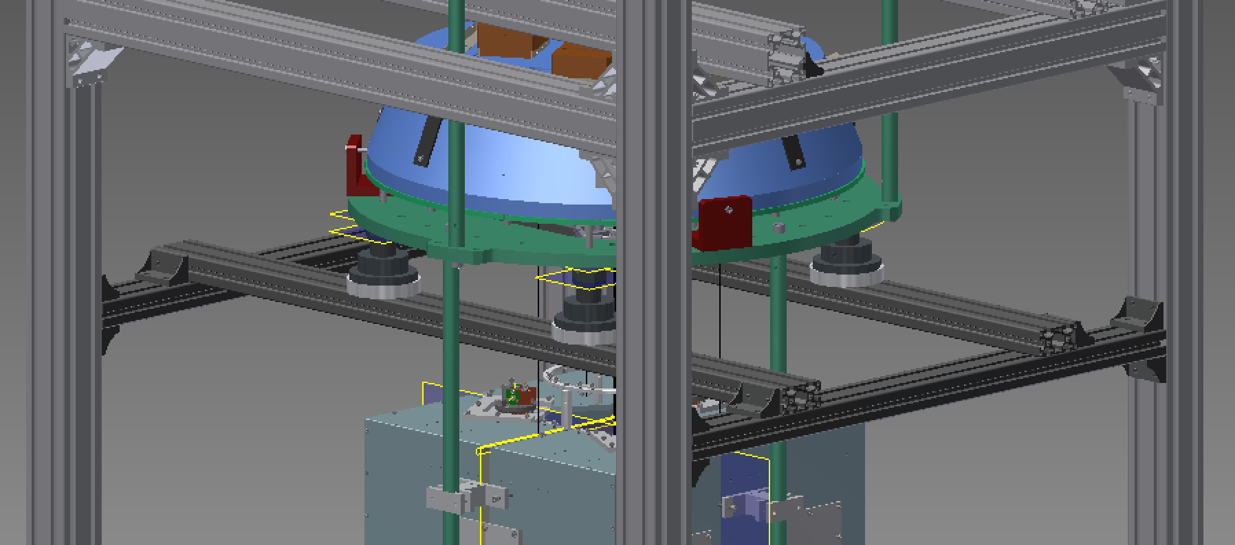
Figure 5: Bottom Filter section of frame, with crossbars supporting the BF via jacks.
The pushrods are 10.4 mm in diameter and go through existing 10.5 mm holes in the security structure ring. See Figure 6. Each has a cap on top which mates with an unused 10.5 mm hole in the bottom of the BF. The cap has a non-threaded hole on the bottom which receives the pushrod. It is made as a separate piece to allow the pushrod to be easily removed before the suspension is installed in vacuum.
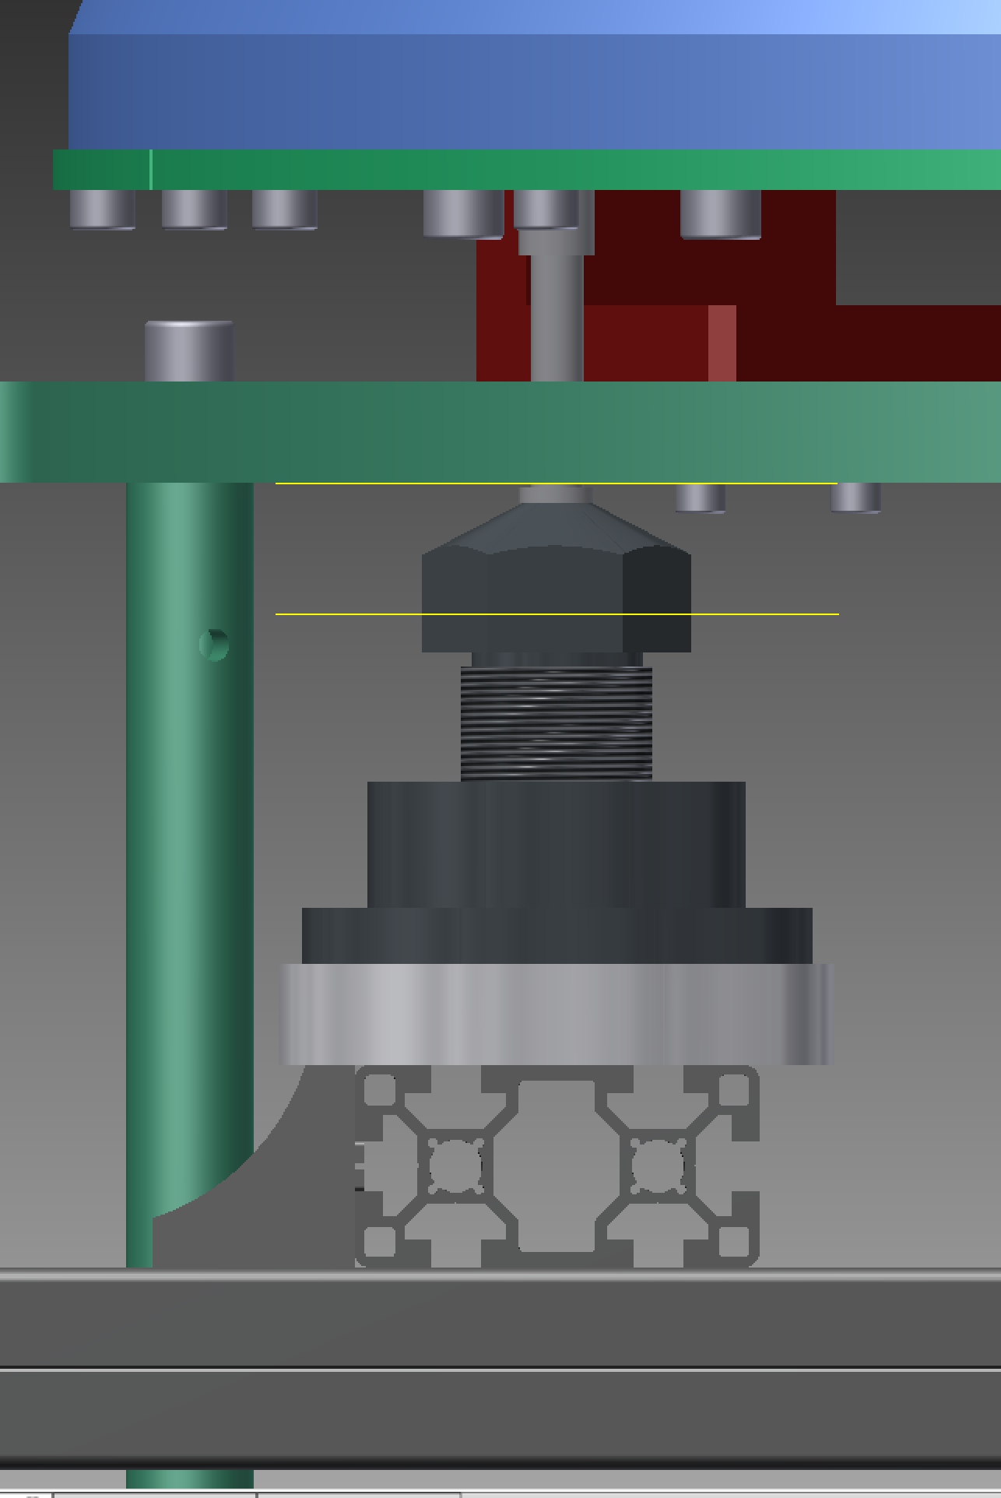
Figure 6: Detail of BF jack and pushrod.

Standard filter section
The security structure ring below the Standard Filter (SF) is supported partially by the rods of the security structure coming up from below, but mostly by three NJ-01 jacks on crossbeams. See Figure 7. (This is similar to the TAMA arrangement, except that NJ-01 jacks have been used instead of NJ-03 to save space.) The crossbeams have been made thicker than the ones at the lower levels due to the increasing weight - about 300 kg for the SF+BF+IM/IRM+BS/RM.
The SF itself is supported on three additional NJ-01 jacks via pushrods. (This is new relative to TAMA.) Because there aren’t conveniently located holes on the bottom of the SF, the pushrods have been given pointy tops instead of caps.
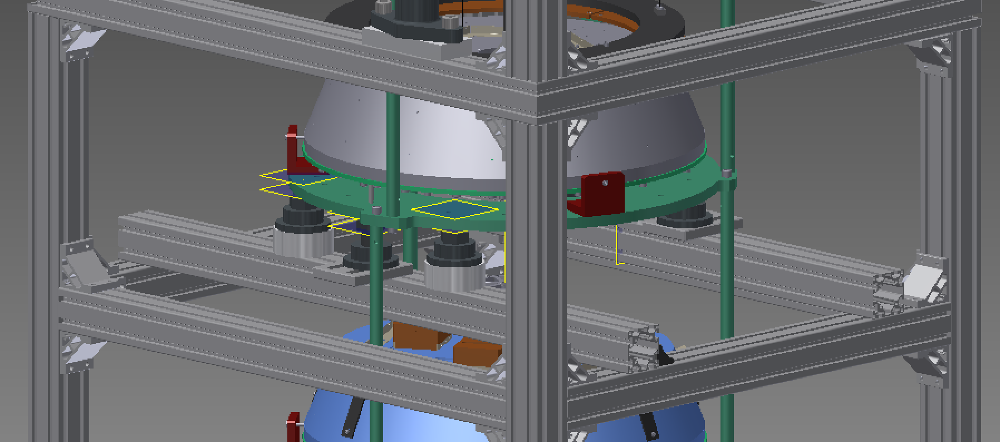
Figure 7: Standard Filter section of frame.
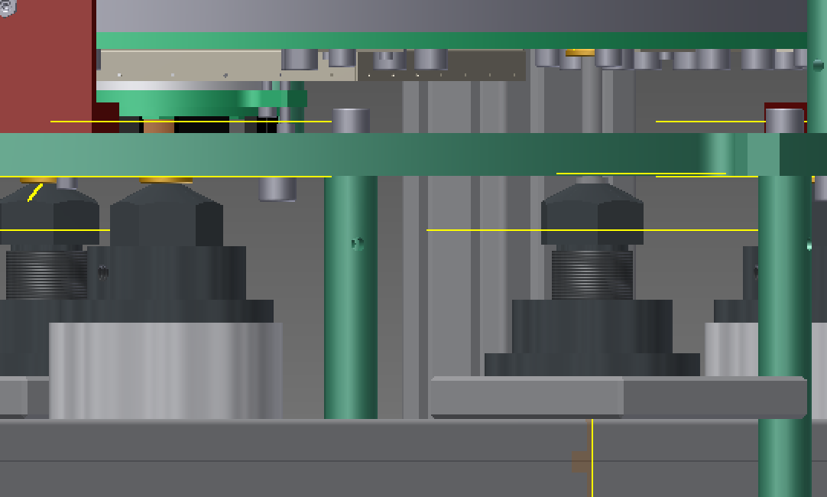
Figure 8: Detail of SF jacks and pushrods.

Preisolator section
This section is as for TAMA. Three Nabeya LJ-03 jacks support the pre-isolator (PI). The crossbars for the jacks sit on top of the four corner pillars (rather than bolting to the sides as for lower crossbeams). On top of the top crossbeams are extensions to the four corner pillars to give some protection against the PI toppling off the frame.
Somewhere at about this level, Mirapro should arrange some horizontal struts to anchor the frame to the second floor or one or more pillars of the cleanbooth.

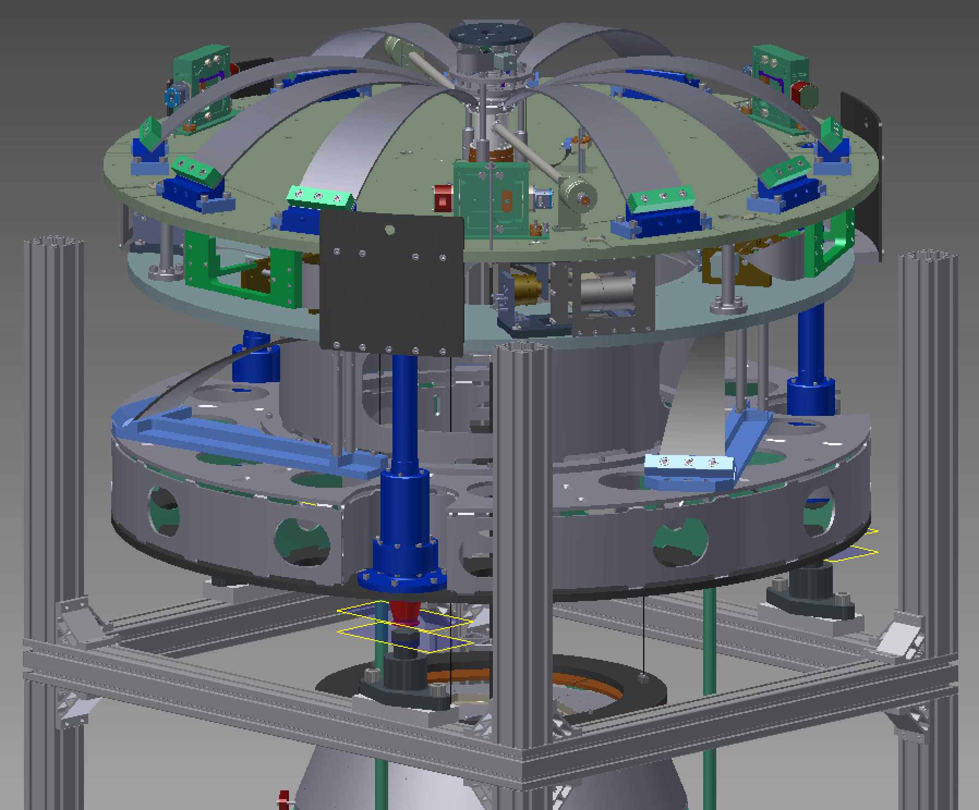
Figure 9: Pre-isolator section.

Files
The JGWDoc file card for this document (T1504420) should also have Inventor Pack’n’Go and STEP versions of the design.

