JGW-T1504271-v1 KAGRA 24 September 2015

BS Standoffs

Mark Barton

Distribution of this document:
JGW-DCC

This is an internal working note
of the KAGRA collaboration.

http://gwcenter.icrr.u-tokyo.ac.jp

Table of Contents
1 Introduction 3
1.1 Purpose and Scope 3
1.2 References 3
1.3 Version history 3
2 Standoff issues 3
3 New design 4

Introduction

Purpose and Scope
This document describes a possible redesign of the BS wire prism to

References
LIGO-T1300322: Guidance on Gluing with EP30-2
LIGO-T080422: ALIGO SUS ETM Production of grooves in Noise Prototype break off prisms
LIGO- T080270: Summary of Research Results on the Initial LIGO Suspensions
LIGO-G1001148: Considerations in double prism placement for wire suspensions
LIGO-T1100086: note on prism placement in adv ligo triple suspensions
LIGO-T1100441: Further notes on prism placement:large and small triple suspensions
LIGO-T970158: Large Optics Suspension (LOS) Final Design (Mechanical System)

Version history
9/24/15: -v1

Standoff issues
iLIGO used a grooved, cylindrical fused-silica standoff for the large optics. See Figure 1.
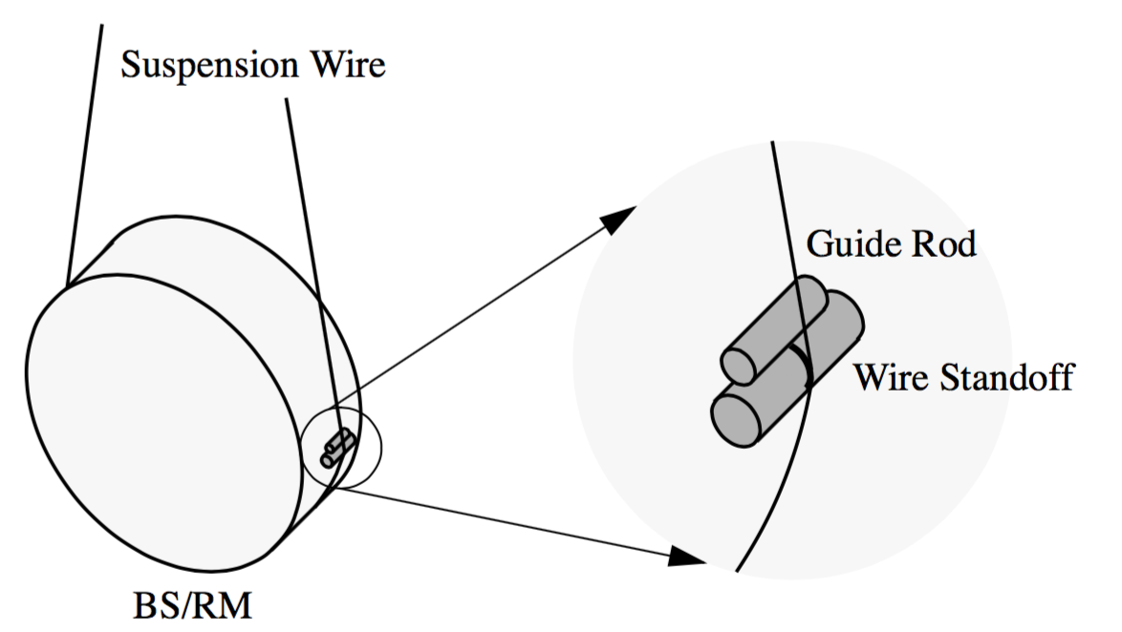
Figure 1: iLIGO standoff
Experience with iLIGO (LIGO-T080270) showed there was significant excess noise from this type of standoff because the fused silica tended to fragment to dust where pressed on by the wire. That means the wire could slip as the optic swung, which amounts to damping for the purposes of thermal noise production.
The aLIGO design for wire standoffs on sensitive optics uses a sapphire prism as the main standoff, with a secondary metal prism below to better constrain the wire.
Sapphire was chosen because it is stronger than fused silica, and if it does chip it produces much less dust.
The original design of the BS and Type B suspension for it assumed a 380 mm optic and a single grooved cylindrical wire standoff similar to that on PRx on each side. Following LIGO experience, the PRx system was redesigned to have a sapphire standoff. To keep the optic-wire distance the same, the PRx standoff was made very small: only 1.28 mm tall, with the wire at approximately 1.2 mm. Following LIGO experience where very thin glue joints caused cracking due to differential thermal expansion of the optic and glass or spphire prisms, the plan is to bond the prism to the optic with a mixture of EP30 glue and 120 µm glass beads, to enforce a 120 µm glue thickness.
The same combination of prisms was planned to be used on the BS, but this was never entirely satisfactory because the very short primary prism meant that it was difficult to put the secondary prism far enough away without the wire fouling on the surface. See Figure 2, and compare the LIGO design in Figure 3, which has a 18.8° breakoff angle. The lower breakoff angle is a potential problem because it means the wire is not firmly pressed into the notch in the prism.
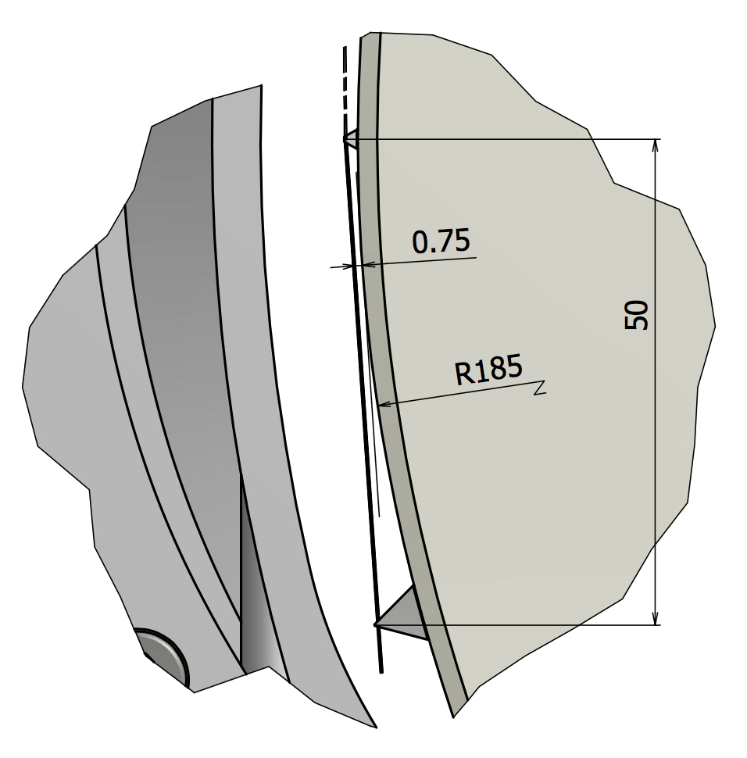
Figure 2: KAGRA BS (380 mm version) with PRx prisms, showing low breakoff angle (3.2°) at primary standoff
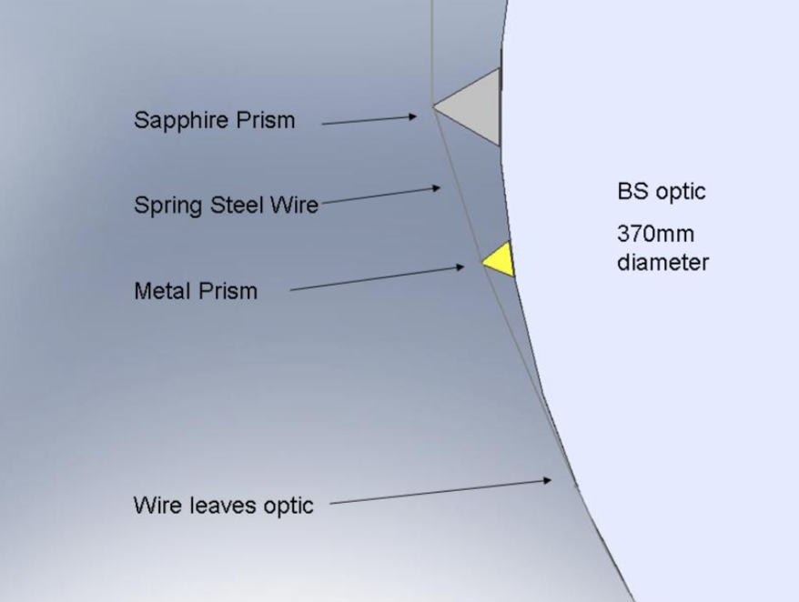
Figure 3: LIGO BS, showing much greater wire angle difference (19°) at primary standoff (from LIGO-T080266)
At about the same time, it was realized that an earlier decision to reduce the diameter of the BS from 380 mm to 370 had not been incorporated in the VIS design. So the wire clamps at the IM are 382.3 mm apart, whereas the prism grooves are 370+2*1.2+2*0.128 = 372.656 apart (optic plus prisms plus glue with beads).
Of these two problems, the one with the wire break-off angle is more serious. However the reduction in size of the BS creates the opportunity to fix it, and make the wires vertical as a bonus.

New design
So if there is still time left to incorporate it, it would be good to use larger prisms approximately 5 mm tall to make the wire breakoff angle greater. Figure 4 shows two possible arrangements, one with the existing secondary prism, and one with a smaller secondary to allow a slightly greater breakoff angle. The secondary has been place 20° around the circumference from the primary, which is as large as possible while keeping the secondary visible in the cutout of the ring of the recoil mass. The breakoff angles at the main prism are 11.2° and 14.1° respectively (improvement factors of 3.5 and 4.4).
The new prisms have been drawn up in Inventor, and could be turned into drawings quickly.

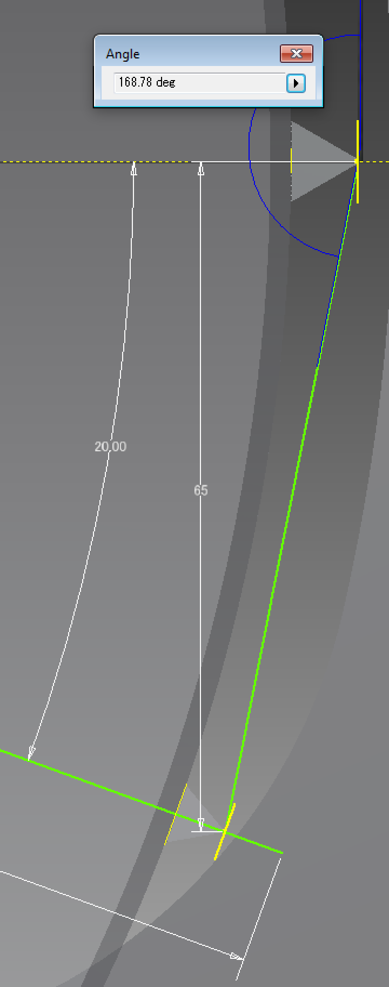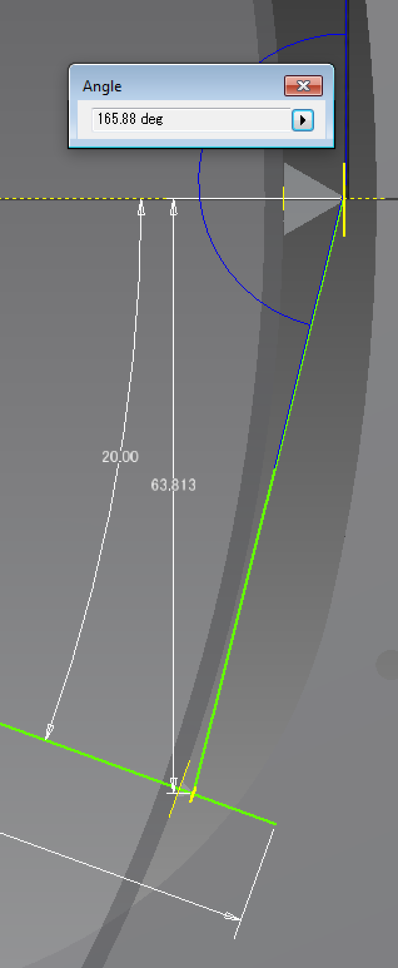
Figure 4: Suggested new 5 mm sapphire prism. Placing the secondary prism 20° around the circumference gives an 11.22° breakoff angle (factor 3.5 improvement) with existing metal secondary prism, and 14.12° (factor 4.4 improvement) with smaller secondary.

