JGW-T1504218-v1 KAGRA 9 September 2015

Optical Lever for Setting Pitch of Optic

Mark Barton, Fabian Peña Arrellano

Distribution of this document:
JGW-DCC

This is an internal working note
of the KAGRA collaboration.

http://gwcenter.icrr.u-tokyo.ac.jp

Table of Contents
1 Introduction 3
1.1 Purpose and Scope 3
1.2 References 3
1.3 Version history 3
2 Concept 3
2.1 Components and layout 3
2.2 Detailed procedure 3
3 Representative Component Choices 5

Introduction

Purpose and Scope
Outline of concept for using an optical lever to set the pitch of the optic.

References

Version history
9/9/2015: -v1. For discussion at VIS meeting.

Concept

Components and layout
About 1 m from the optic there is an extension of the assembly frame to be designed by Mirapro to support the OL lever.
The OL setup is supplied by Akutsu-san from stock for the KAGRA OLs and will include a 670 mm laser and a QPD on a breadboard.
On the baseplate of the hanging frame, as close as possible to the optic, there is a small tripod table made from a small (150 mm x 150 mm square?) breadboard and some optical posts.
On the tripod table there is a 1-axis tilt and rotation stage such as the Newport M-36.
On the tilt/rotation stage, a 90° prism is secured with a clamp, with space to place a bubble level next to it.
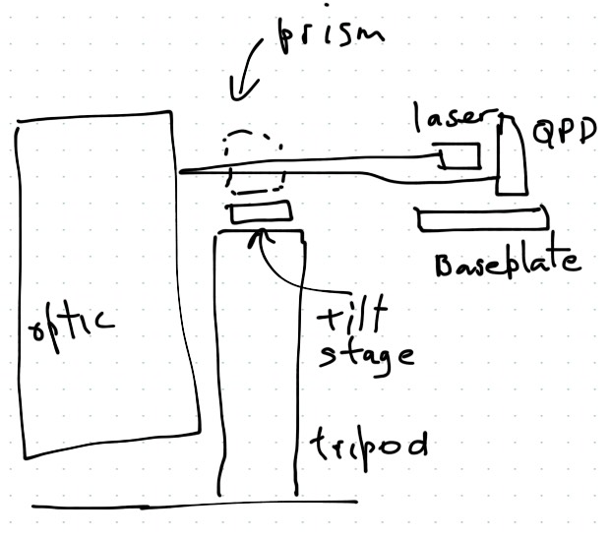

Detailed procedure
The optic in its case is placed on the track in the hanging frame in the position where it will be hung.
The breadboard is set up on the assembly frame.
The lever arm L from the breadboard to the optic is measured or found from CAD, and the desired vertical offset offset for the laser/QPD is calculated as Z=L/300.
The OL laser and QPD are set up on the breadboard, as close as possible to Z above (for PR2) or below (for PR3) the target spot on the AR side of the optic, as close together as possible horizontally, and symmetrically on either side of the symmetry axis of the hanging frame. (The laser mount can be in slightly front of the QPD if it helps to get them closer horizontally.)
(top view)
The pitch and yaw of the laser and the height of the baseplate are adjusted until the beam spot on the optic is 125 - 81 - 3 = 41 mm from the top edge of the optic, and the beam comes back to a point approximately 2Z below (for PR2) or above (for PR3) the QPD. (The -3 mm in the previous calculation allows for the fact that the optic will later be raised by 3 mm in hanging.)
(side view)
The tripod table and tilt/rotation stage are assembled on the baseplate of the breadboard as close as possible to the optic. The height and lateral position should be such that a prism on top of the tilt/rotation stage will be in the laser beam, with space next to the prism for a spirit level.
The yaw DOF of the tilt/rotation stage is centered.
The bubble level is placed on the tilt/rotation stage, and the tilt DOF is adjusted to make it level.
The prism is placed on the tilt/rotation stage and adjusted so that it sends a beam back towards the QPD. The pitch of the return beam does not have to be accurate at this stage, and the yaw should be within a few mm.
Without disturbing its position, the prism is clamped gently to the tilt/rotation stage so that one face is in good contact with the moving plate (so the other face is accurately at right angles).
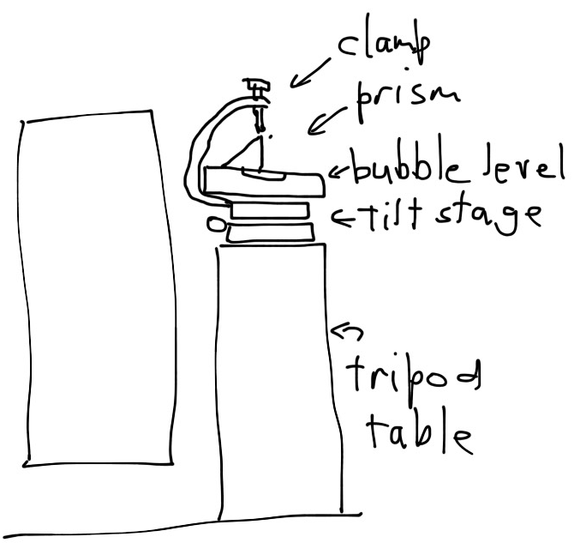(side view)
(tilt/rotation stage top view)
The yaw of the prism is adjusted until the return beam is directly above or below the QPD.
The reading on the micrometer for the tilt DOF is noted, and the required final reading to give the final 1:300 = 3.33 mrad tilt is calculated and applied.
The height of the QPD is adjusted to make the beam fall in the center of it.
The vertical output of the QPD is noted.
The tripod table is removed and the hanging of the optic is resumed according to Fabian’s procedure JGW-E1503830.
Once the optic is suspended, the QPD is moved sideways to center the beam horizontally.
The pitch of the optic is set with the winches to restore the vertical QPD output recorded earlier.

Representative Component Choices
Any of these items can be replaced by similar Japanese ones if cost and/or delivery time is better.
Level:
Starrett 98-6 Machinists’ Level with Ground and Graduated Vial, $126.00 USD
http://www.starrett.com/metrology/product-detail/1-Precision-Measuring-Tools/11-Precision-Hand-Tools/1117-Machinsts-Levels/111701-Levels/98-6
Tilt stage:
Newport M-36, 1 Axis Tilt & Rotation Platform, (3) SM-13 Micrometers, Metric, ¥78900
http://search.newport.com/?q=*&x2=sku&q2=M-36
Right Angle Prism
Newport BRAP18, Standard Right-Angle Prism, N-BK7, 30 mm, λ/8, Uncoated
http://search.newport.com/?q=*&x2=sku&q2=BRAP18
Breadboard:
Newport M-SA2-06x06-LC, LaserClean™ Solid Aluminum Optical Breadboard, 150 x 150 mm, 25 mm M6 Grid, ¥7418

