JGW-E1504235-v1 KAGRA 16 June 2016

BS Installation Procedure

Mark Barton

Distribution of this document:
JGW-DCC

This is an internal working note
of the KAGRA collaboration.

http://gwcenter.icrr.u-tokyo.ac.jp

Table of Contents
1 Introduction 6
1.1 Purpose and Scope 6
1.2 References 6
1.3 Version history 6
1.4 Dummy procedure step for cutting and pasting 6
1.5 Resources for editing 6
2 Background Information 6
2.1 Location 6
3 Pre-Assembly 8
3.1 Optic 8
3.2 Recoil Mass 8
3.3 Intermediate Mass 9
3.4 Bottom filter 9
3.5 Standard filter 9
3.6 Prepare space 9
3.7 Construct assembly frame and optical table - Mirapro 10
3.8 Install optical table immobilization brackets 11
3.9 Adjust assembly frame crossbars for IM 11
3.10 Install adapter bars, rails and trolleys 12
3.11 Double check vertical alignment 13
4 Random stuff for filing 13
4.1 Set up electronics rack 13
4.2 Make anti-feedthrough adapters 14
4.3 Install feedthroughs on feedthrough support rack 14
4.4 Set up Ethernet hub 14
4.5 Make IM flag assemblies 14
4.6 Assemble “security recoil mass” units 15
4.7 Pre-assemble optical bench blade units 15
4.8 Check OSEMs with multimeter 17
4.9 Dummy procedure step for cutting and pasting 17
5 Install the IM 17
5.1 Install “green ring”, "red bars" and brackets at below-IM level 18
5.2 Install, level and center IM 18
5.3 Install winches 19
5.4 Mount mirror box with BS on trolley 19
5.5 Suspend BS 19
5.6 Setup optical lever 19
5.7 Align BS 20
5.8 Bring in RM back section on trolley 20
5.9 Attach front ring 20
5.10 Route OSEM cables from RM up to IM 20
5.11 Suspend RM 21
5.12 Check BS alignment 21
5.13 Install Security Structure Lower Section 21
5.14 Connect and test IM picomotors 21
6 Hang IM/RM/TM group 22
6.1 Tighten RM-to-BS stop screws 22
6.2 Install the IM-RM Safety bar 22
6.3 Dummy procedure step for cutting and pasting 23
6.4 Install load gauge adapter and jacks 23
6.5 Weigh IM/RM/BS 23
6.6 Trim payload assembly 24
6.7 Remove load gauge adapter 24
6.8 Dummy procedure step for cutting and pasting 24
6.9 Install assembly frame crossbars for under BF 24
6.10 Install EQ structure parts up to ring under BF 24
6.11 Install pushers and jacks at ring under BF 24
6.12 Crane in BF 24
6.13 Remove BF cap with crane 24
6.14 Wire up BF yaw pico, stepper, LVDT 25
6.15 Route IM cables through IRM top plate up to BF 25
6.16 Suspend IM top plate with rods from BF 25
6.17 Hook IM to BF 25
6.18 Remove security bar between IM and RM 25
6.19 Raise BF with jacks, test payload weight match 26
6.20 Level payload 26
7 Suspend IRM 26
7.1 Build IRM around IM 26
7.2 Attach OSEMs 26
7.3 Route OSEM cabling up to BF 26
7.4 Crane in BF cap 27
7.5 Connect payload cables to BF cap 27
8 Suspend BF + payload 27
8.1 Install load gauge adapter 27
8.2 Weigh/trim/balance BF+payload 27
8.3 Remove load gauge adapter 27
8.4 Install crossbars for under SF 27
8.5 Install EQ stop parts up to ring under SF 28
8.6 Install jacks and pushers at ring under SF 28
8.7 Crane in SF 29
8.8 Remove SF cap with crane 29
8.9 Wire up SF stepper, LVDT 29
8.10 Replace SF cap with crane 30
8.11 Route cables from BF up to SF 30
8.12 Hook BF+payload to SF and raise SF to suspend BF+payload 30
8.13 Install load gauge adapter 30
8.14 Weigh/trim/balance SF+BF+payload 30
8.15 Remove load gauge adapter 31
8.16 Place damper ring 31
8.17 Reposition top jacks 32
8.18 Remove top crossbars 32
8.19 Attach crane adapter 33
8.20 Install PI Guides 33
8.21 Insert screws for security structure 33
8.22 Crane in PI 34
8.23 Adjust PI Guides 35
8.24 Insert conical bellows 35
8.25 Attach SS rods to PI 36
8.26 Connect SS rods to ring below SF 36
8.27 Raise jacks to support PI 37
8.28 Suspend SF damper ring 38
8.29 Route cables up to PI 38
8.30 Wire up LVDTs, picos, steppers 39
8.31 Place PI ballast 39
8.32 Install magic wands 39
8.33 Install geophones 40
8.34 Hook SF+BF+payload and lower SF to suspend SF+BF+payload 41
8.35 Level, center, tune PI 41
8.36 Attach security transport plates 41
8.37 Dummy procedure step for cutting and pasting 41

Introduction

Purpose and Scope
Explains how to assemble the BS suspension

References
JGW-E1604817: BS Payload Assembly Procedure

Version history
1/25/2016: Pre-rev-v1 draft.
6/16/2016: -v1 for discussion at review

Dummy procedure step for cutting and pasting

Resources for editing
In lists of items, use [1], [2], etc for suspension parts, (1), (2) etc for screws, and {1}, {2} etc for other items.

Background Information

Location
The installation will be done on the Y-arm side of the BS tank. To minimize the angle the suspension needs to be rotated during installation, the side of the optic with the BS coating will face toward the MC area (-X). This is also the side with the flags and OSEMs (unlike the PRx which has the HR surface on the opposite side from the flags).
Figure 1: Cleanbooth First Floor
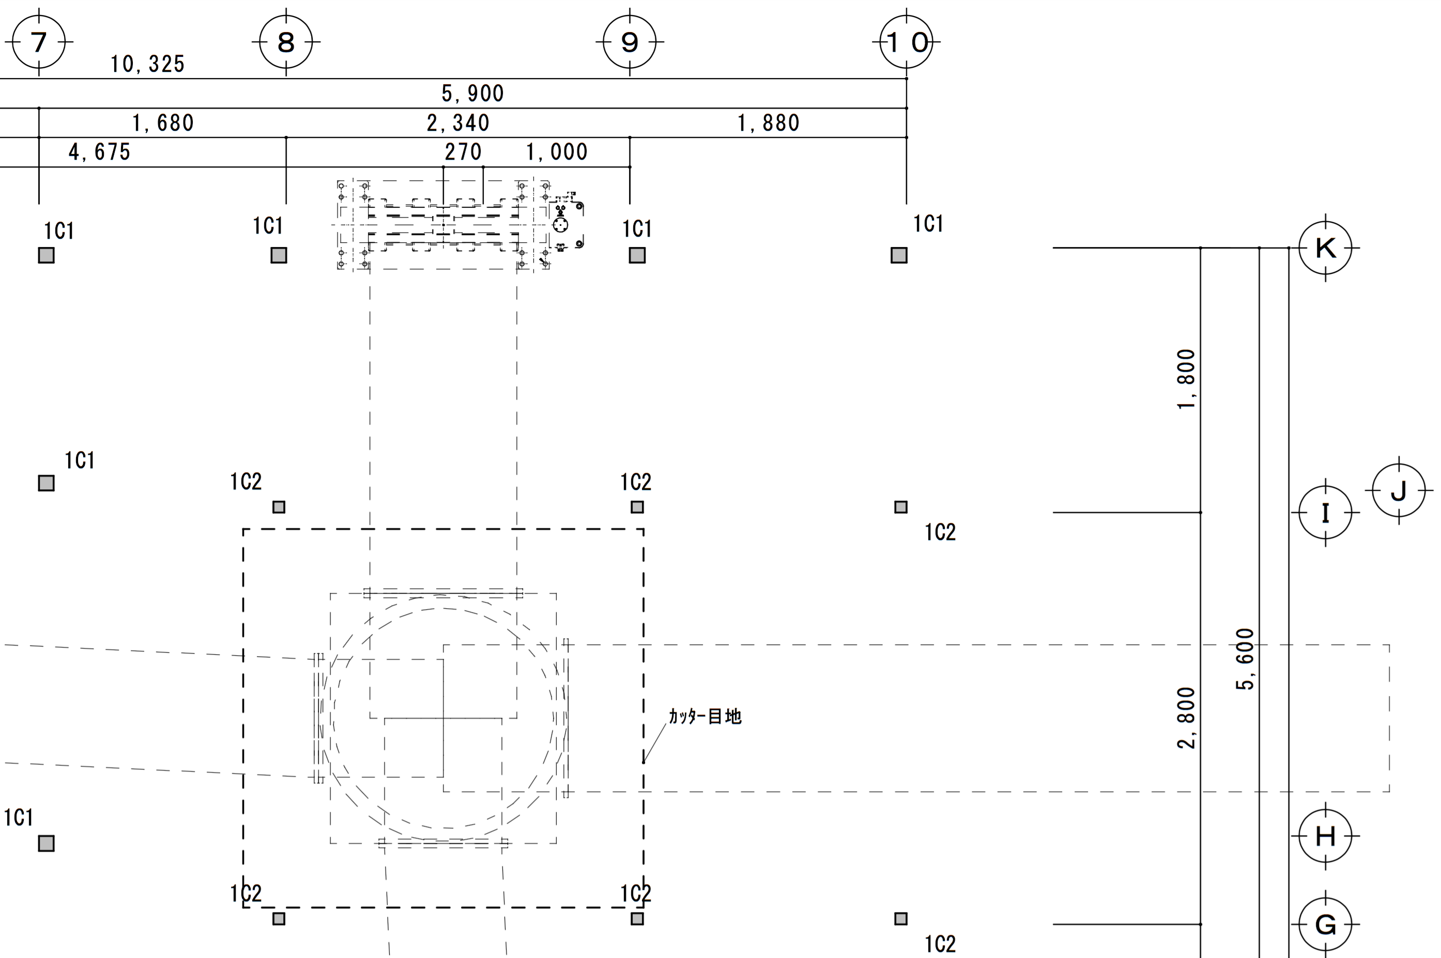
BS/ OSEM
side
AR
side
1500 mm
1580 mm
∅1430 mm
Figure 2: Cleanbooth Second Floor
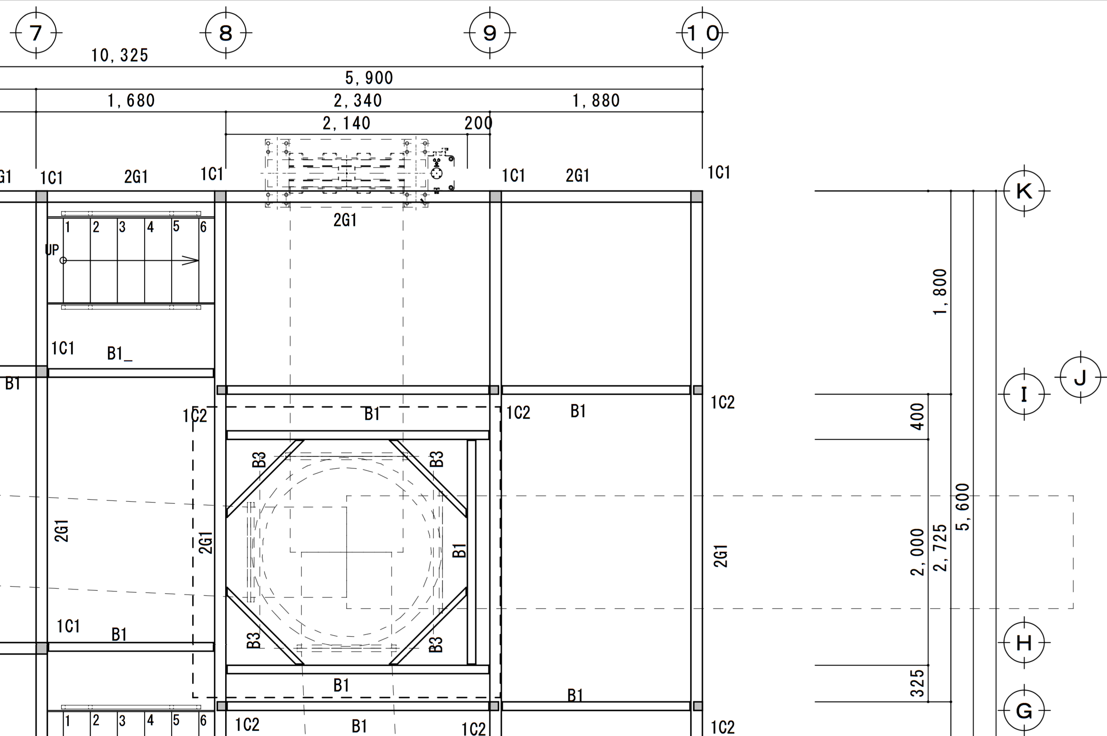
AR
side
BS/ OSEM
side
1500 mm
1580 mm
∅1430 mm
Figure 3: The suspension on the assembly frame as it will be constructed on the +Y side of the tank – views in the -X, -X/Y and -Y directions (towards the PR2, diagonal, towards the BS tank.
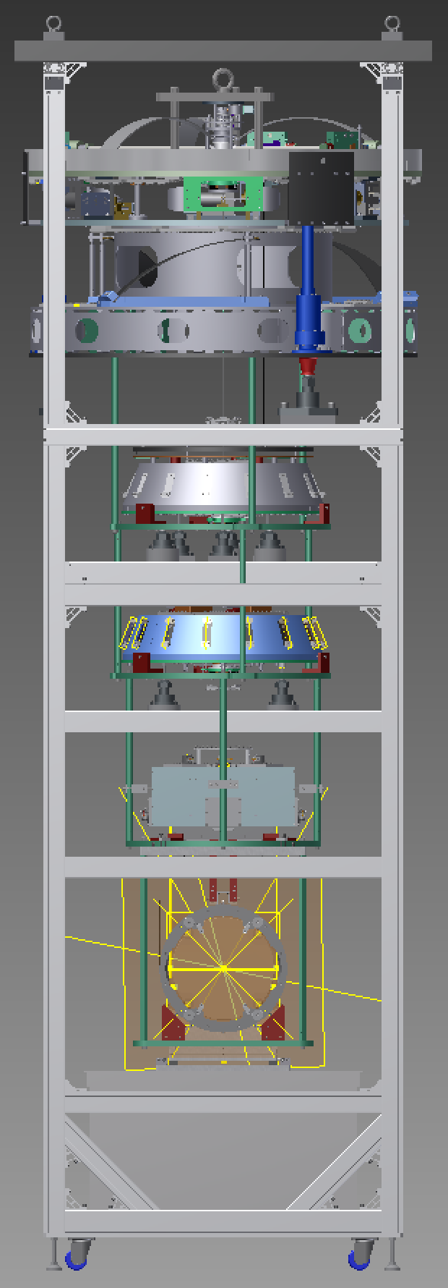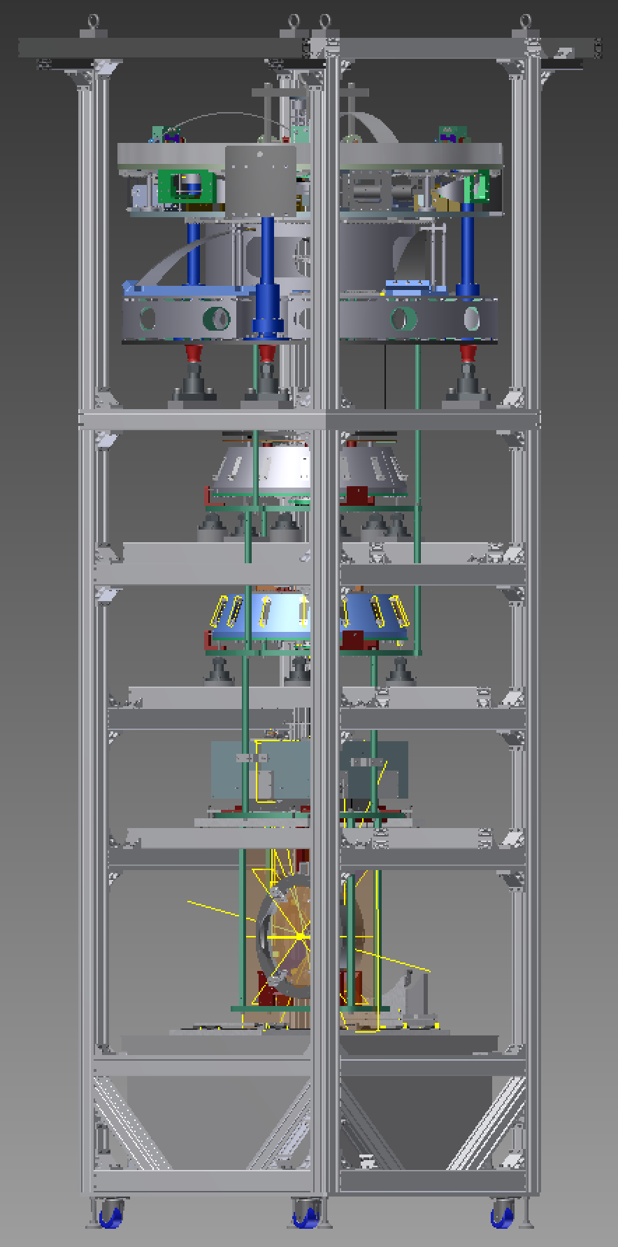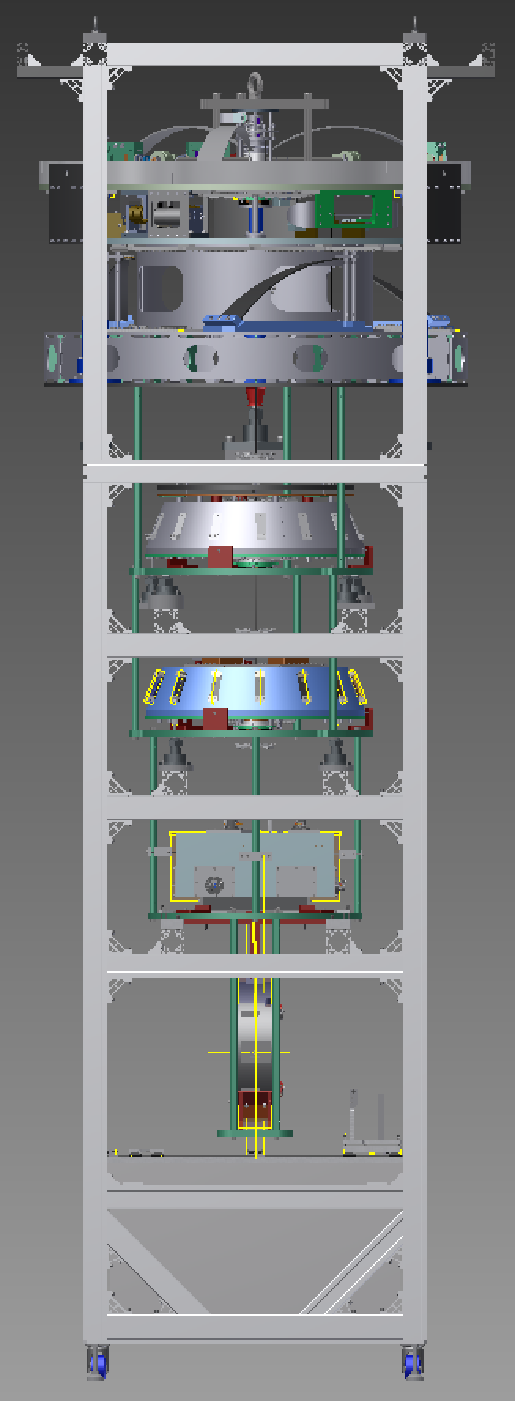

Pre-Assembly

Optic
For the test hang, a dummy optic will be used. See JGW-D1604820.
Tatsumi-san will glue the flags and prisms on the optic or dummy optic. The flags go on the “front” of the optic, with the beamplitting coating. See JGW-E1504248.

Recoil Mass
See JGW-E1604817 by Fabian.

Intermediate Mass
See JGW-E1604817 by Fabian.

Bottom filter
[Hirata-san already did most of this. Add link to any procedure document.]

Standard filter
[Hirata-san already did most of this. Add link to any procedure document.]

Prepare space
Remove spool piece between Y-arm and BS chamber.
Also remove spool pieces on ±X sides of chamber.
Remove flooring above work area. If possible, remove only the section between pillars (8) and (9) in Figure 1 and Figure 2, and leave the section between (9) and (10).
Wipe down all surfaces above or near work area, working from the top down.
Clean floor, paying particular attention to small rocks and debris.
Lay down SS sheet.

Construct assembly frame and optical table - Mirapro
Construct assembly frame according to Mirapro assembly VP6845.  Move the frame into position on the +X side of the BS tank.  Position it directly under the line of the crane and midway between the (K) and (I) rows of pillars (see Figure 1), with the long axis aligned with Y and the side where the BS will be facing in the –X direction (towards the MC area).  There should be 1800-100-80 = 1620 mm between the rows of pillars, and the frame is 1300 mm in the Y direction at the bottom (1500 mm at the cleanbag support bars), so there should be 160 mm clearance on the ±Y sides at the bottom (60 mm at the top).  Extend the feet of the frame until they support the weight and the uprights of the frame are as vertical as possible as measured by a bubble level.  Remove the internal crossbars at the BF and SF levels, wrap them in foil and store them in a clean place. | 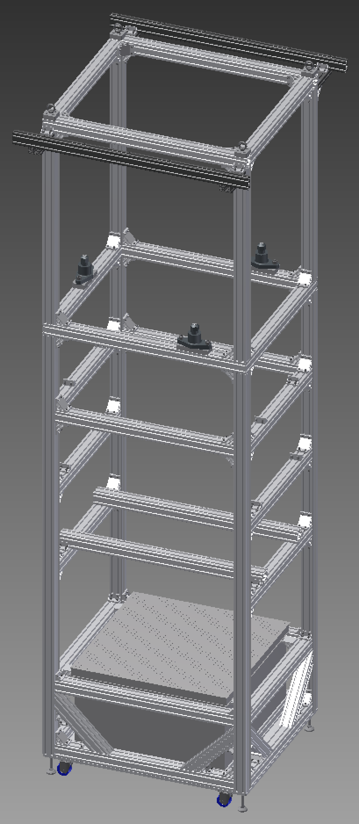  +Y  (curtain)  -Y  (tank)  -X (PR2 tank/  BS coating/ OSEMs)  +X  (AR coating/“back”)  Crane path  (SF crossbars removed)  (BF crossbars removed)

Install optical table immobilization brackets
If it has not already been done, install the four brackets near the corners of the optical table using 2 M8 screws each to prevent it slipping off if there is an earthquake. | 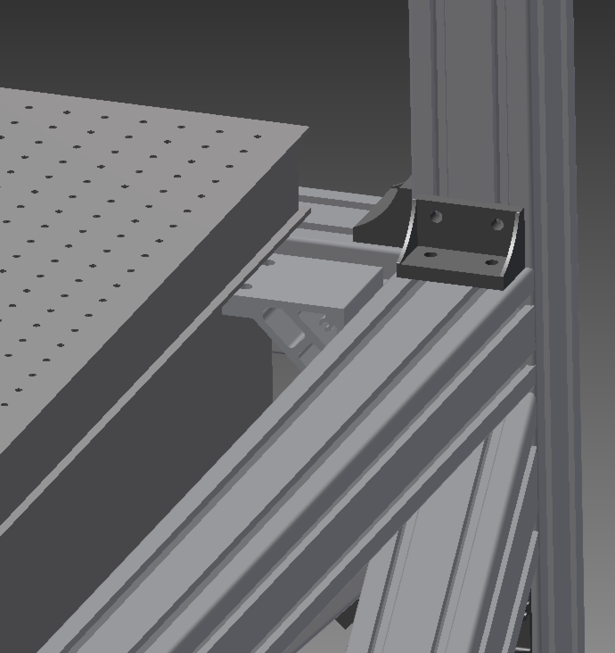  bracket

Adjust assembly frame crossbars for IM
Set the legs of the optical table so that it is level as measured by a bubble level and there is 694 mm to the underneath of the internal crossbars below the IM and level in both directions as measured by a bubble level. (This should mean that it is 500 mm tall.)  Center the optical table in the space. There should be 68 mm to the outside of the frame in the ±X direction and 150 mm to the outside of the frame in ±Y.  Double-check the levelness. | 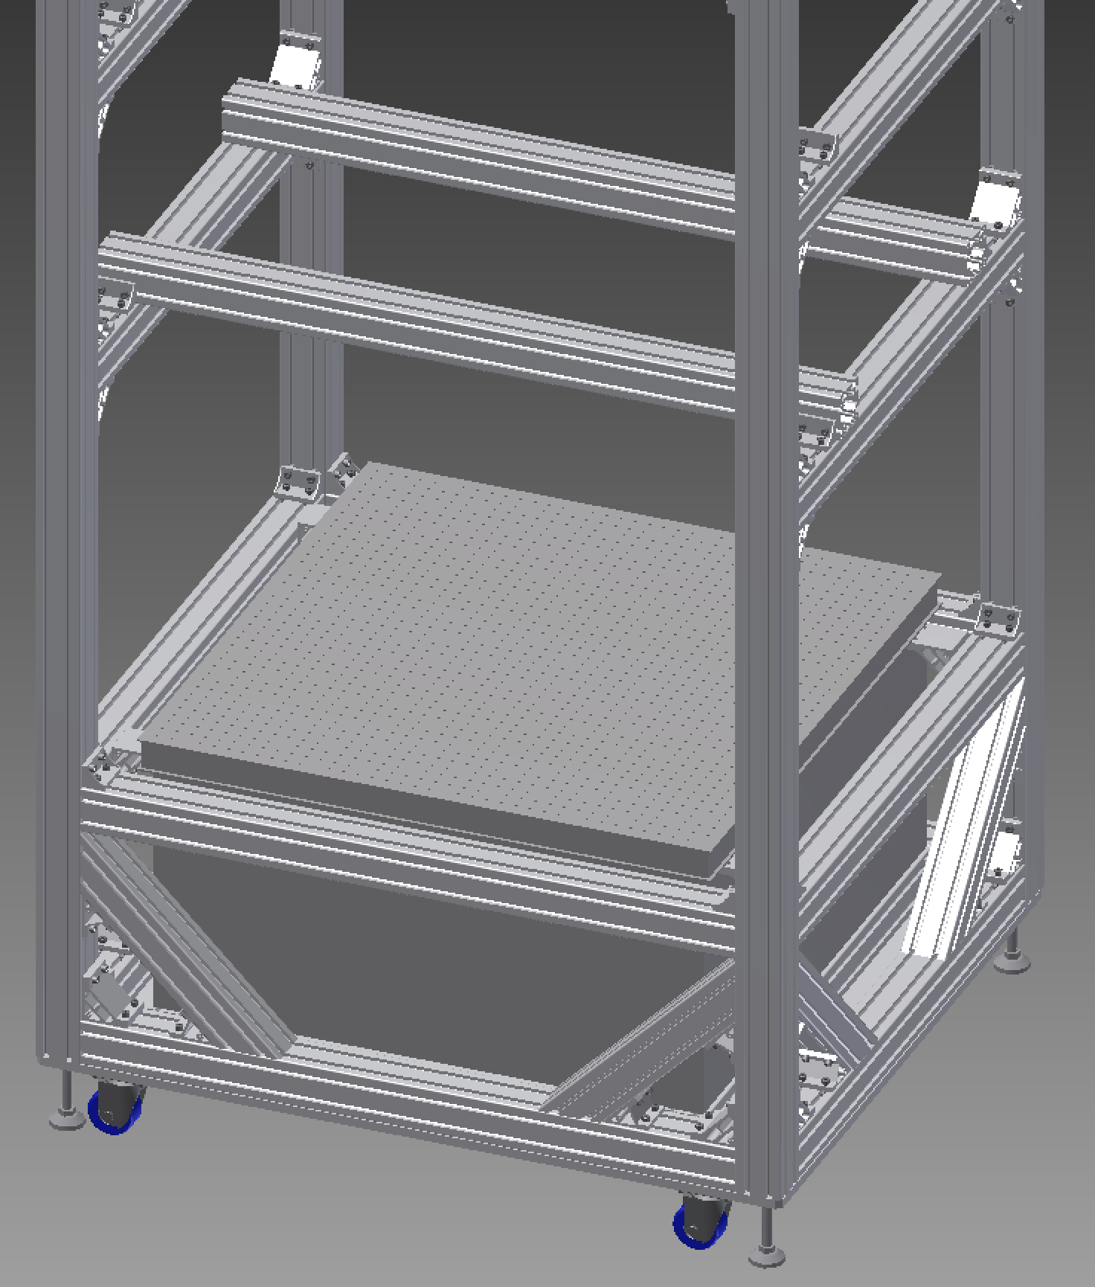  694 mm

Install adapter bars, rails and trolleys
Install the two adapter bars on the internal crossbars using 8 x M8. Check that the separation is 470 mm.  Insert the locating pins in the adapter bars and loosely attach the clamp pieces with TBD M6 pusher screws and TBD M6 puller screws.  Install the baseplate for the rails centrally on the optical table with 4 x ??? M6 screws. It should be flush with the edge of the table at front and back and there should be 10 rows of visible holes on each side.  Install the rails on the baseplate with ??? screws, leaving them very loose.  Install the 4 stop brackets using 8 x ??? screws, leaving the screws loose.  Install the stop screws in the brackets.  Install the trolley baseplates on the carriages using TBD screws. The trolley for the RM goes at the –X end.  Run the trolleys back and forth to ensure they run smoothly and the rails are parallel, then tighten the screws holding the rails.  Install the stop bars on the sides of the trolleys.  For each trolley and each stop bracket, move the trolley to the bracket, check that the puller screws enter the holes in the side bars properly, and tighten down the brackets. | 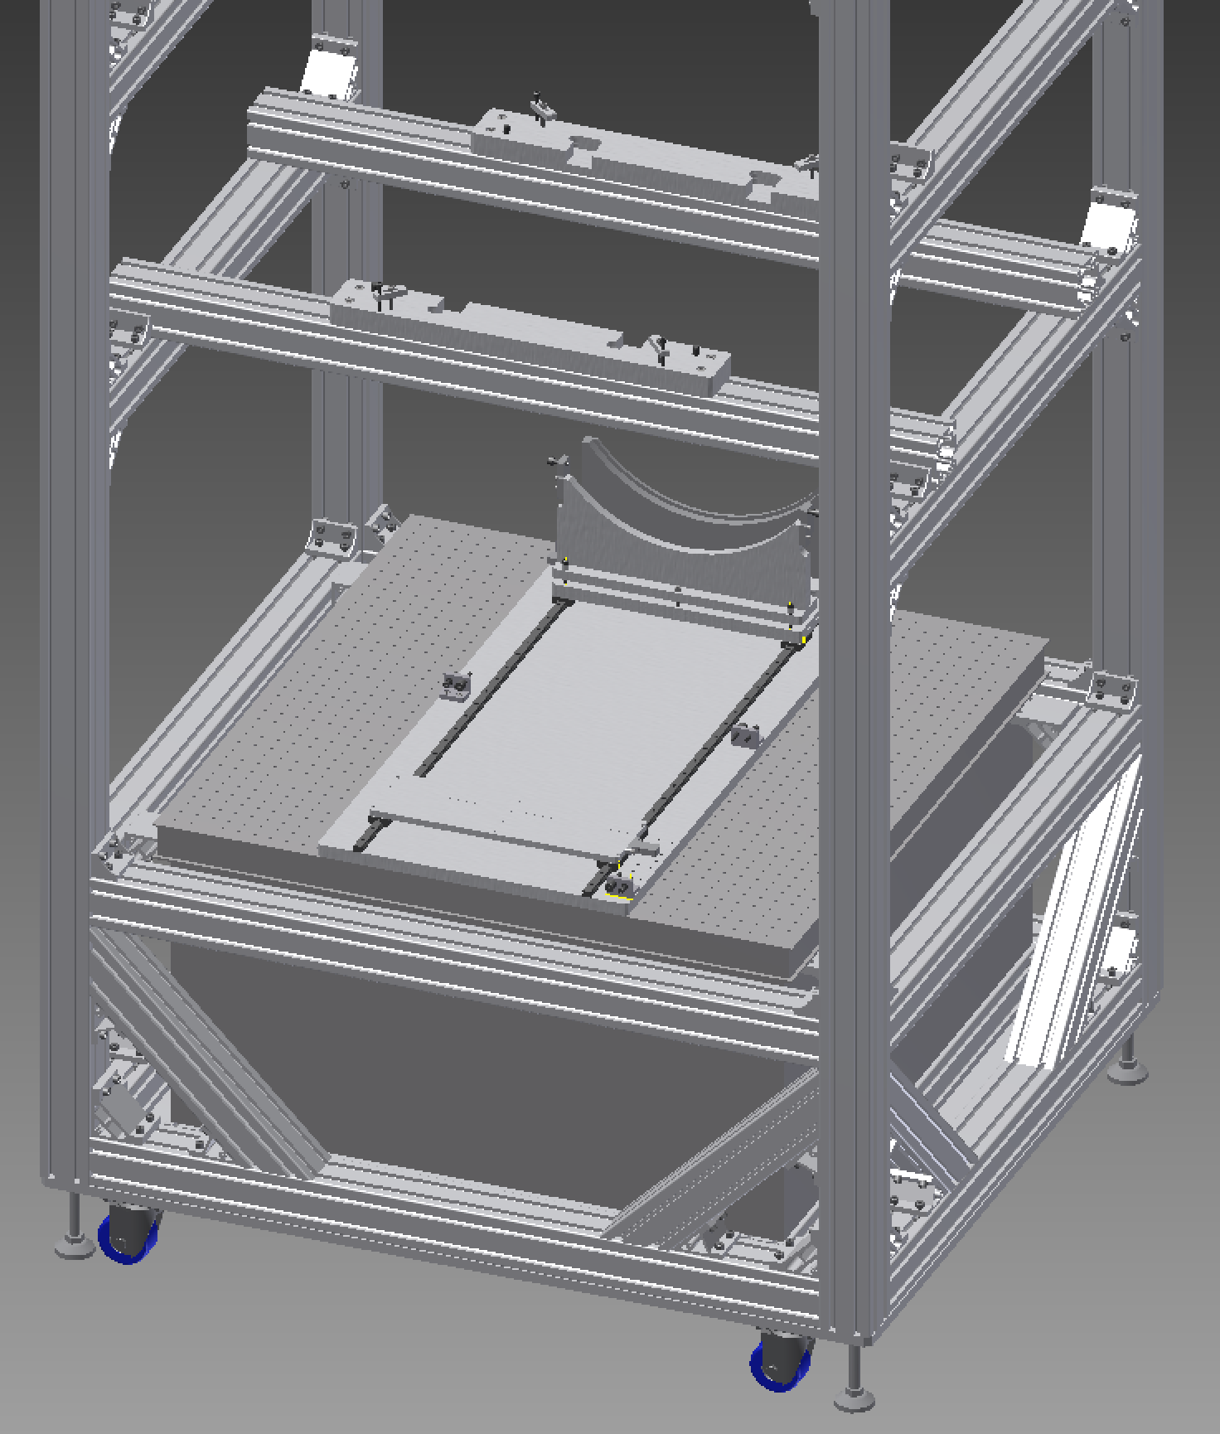  +X  -X  (tank)  470 mm

Double check vertical alignment
Suspend a plumb bob over the center of the table from the midpoints of the the two top crossbars as indicated, and check that it lines up with the scribe lines indicating the center of the rail system baseplate.  If necessary, adjust the centering of the optical table and/or the verticality of the main frame.  Repeat at 90°.  (If preferred, this whole step can also be done earlier, before the baseplate is attached. In that case, note that there is an odd number of rows of holes, so the bob should be directly over a row.) | 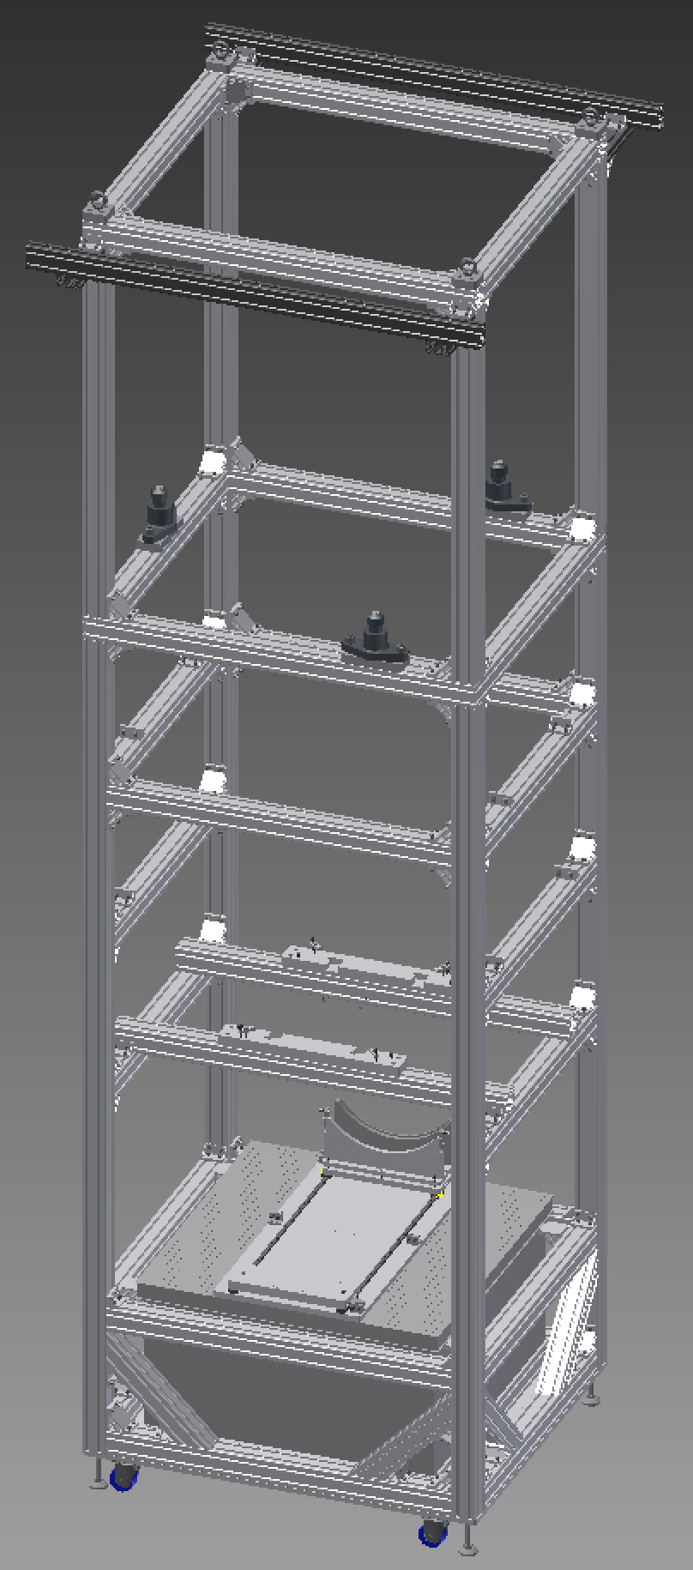

Random stuff for filing

Set up electronics rack
Set up the rack according to JGW-D1503600: BS Suspension Cabling, and JGW-E1605111: BS Suspension Electronic Items List.
Measure the distances from the rack to the feedthrough positions on the vacuum tank.
Also measure the distance to the feedthrough support rack.
Determine the longest distance the cables will need to run and get 27 D-Sub 9 cables, JGW-D1402377: D-SUB cable specifications, of appropriate length from the AEL stock.

Make anti-feedthrough adapters
Get 27 male and 27 female crimp-style D-Sub 9 connectors and 27 50-mm lengths of 9-conductor ribbon cable. Crimp a male and a female connector to each piece of cable such that Pin 1 connects to Pin 5 and vice versa, per any sheet of JGW-D1503600: BS Suspension Cabling. | 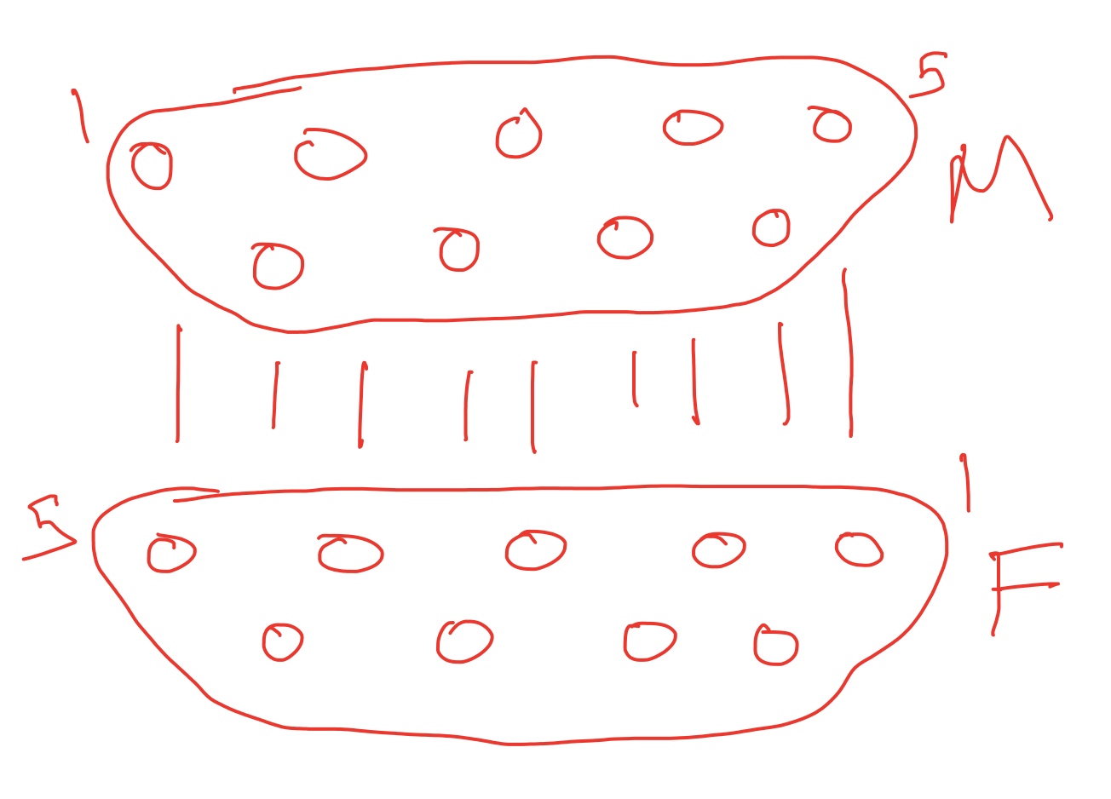

Install feedthroughs on feedthrough support rack
Attach three feedthroughs, each with 10 D-Sub 9’s to the feedthrough support rack with TBD screws.
Use great caution to keep the vacuum-facing sides of the feedthroughs clean.
Put anti-feedthrough adapters on 27 of the outside connectors.

Set up Ethernet hub
Put the Ethernet hub in the rack, and connect it to the network via a suitable PoE (power over Ethernet) cable.

Make IM flag assemblies
Lay out 6 flag bases D1605088-1, 6 flag tips D1605088-3, 18 magnetic disks D1605088-2 and 12 magnets on UHV Al foil.  Check the disks, the recesses in each end of the flag base, and the recess in the flag tip carefully for burrs or other irregularities.  Check that the disks fit easily and squarely into the recesses. Remove the disks again.  Make a small boat from UHV Al foil, and a glue applicator from clean Cu wire.  Mix a sachet of EP30-2 adhesive, cut the sachet open and squeeze the tube into the boat.  Use the Cu wire to apply ??? amount of glue to the.  Press a disk into each recess on top of the glue and check that it is square. If necessary, wipe away any excess glue.  Put away the flag bases, flag tips and the boat with the remaining glue in a clean place, and let the glue cure for 24 hours.  Check that the glue in the boat has dried properly – it should be clear and brittle.  Check the magnets for any dirt or magnetic particles, and wipe them firmly if necessary.  Stick magnets to the disks at either end of the flag bases, with the N pole facing out at both ends.  Stick the flag tips onto the magnets at the small ends of the bases. | 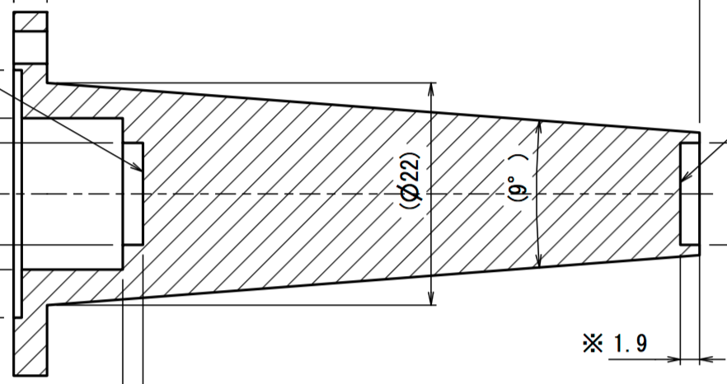 x 6  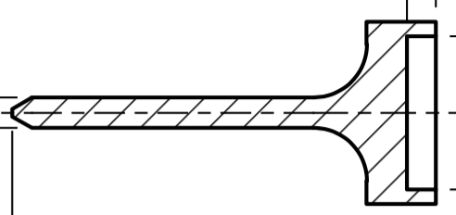x 6  x 18  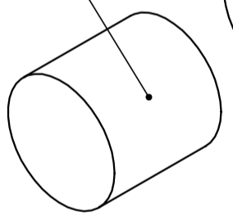x 12

Assemble “security recoil mass” units
See JGW-D1605124.  [1]: 2 x JGW-D1605122-552 main plate  [2]: 4 x JGW-D1605122-553 support main plate  (1): 8 x ??? [not called out in JGW-D1605124]  (2): 4 x ??? [not called out in JGW-D1605124]  For each [1] plate, connect 2 x [2] plate with 4 x (1).  For each [1] plate, insert 2 x (2) stop screws from | 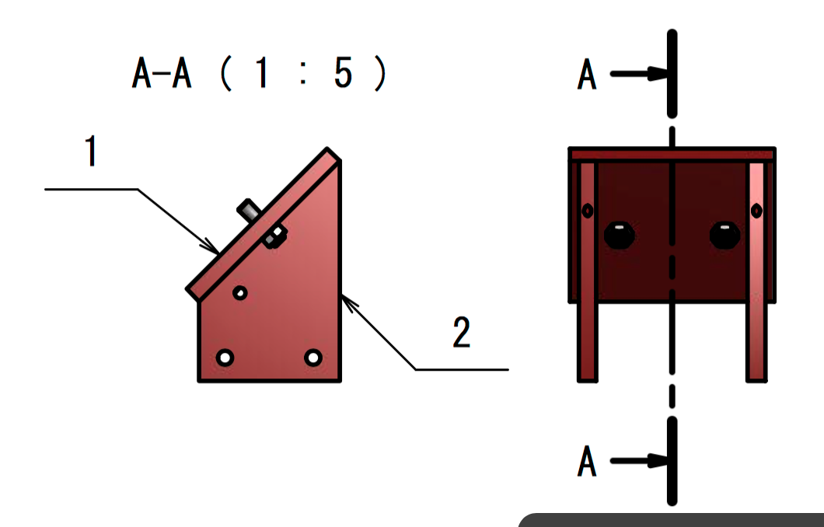

Pre-assemble optical bench blade units
Needed (for 3 units):  [1]: 3 x Part-52-base support blade  [2]: 3 x Part-51-blade curve  [3]: 3 x Part-53-clamp blade  [4]: 6 x Part-56-column blade  [5]: 3 x Part-57-retainer blade  [6]: 3 x Part-54-orientation washer  [7]: 3 x Part-55-orientation washer  [8]: 3 x clamp_base_preisolator_3  [9]: 3 x clamp_base_preisolator2  [10]: 54 x clamp_on_TM_BS  (1): 6 x ISO 4762 M8 x 45  (2): 6 x ISO 4762 M12 x 50  (3): 6 x ISO 4026 M12 x 50  (4): 6 x ISO 4026 M12 x 60  (5): 9 x ISO 4672 M10 x 30  (6): 9 x ISO 7093 A ST 10 – 140 HV – A  (7): 9 x UNI EN 24032 M12  (8): 12 x UNI EN 24032 M12  (9): 30 x ISO 4762 M6 x 16  (10): 108 x ISO 4672 M4 x 8  For each assembly:  Insert 2 x (3) set screws into [1] base from below and screw in until flush.  Screw [4] column onto each (3) stud from above and tighten firmly with a hex wrench through the through-hole.  Screw a (4) set screw into the top end of each [4], until it won’t go further or until only 44 mm is left sticking out, whichever is sooner.  Screw a (8) nut onto each (4) set screw until there is a gap of 11 mm between the top of [4] and the bottom of the (7).  Fix the [1] base to a clean work table by TBD method (e.g., C-clamp or the screws that are part of the assembly: 3 each of (5) screw, (6) washer and (7) nut (and if helpful, 2 of (1))).  By TBD method, hang TBD kg of mass [???: ≈(84+116)/3 = 67 kg] on the end of the [2] blade.  Place the [5] retainer over the two (4) set screws and secure with 2 more (8) nuts.  Remove the load mass and unfasten the [1] base from the work table.  Attach [8] joint to [9] clamp base with 5 of (9) screw.  Attach 18 of [10] to [9] clamp base with 36 of (10).  Wrap the two main sub-assemblies ([1]++ and [9]++) and the remaining parts and fasteners ([6], [7], (5), (6), (7), remainder of (9)) and store for later. | 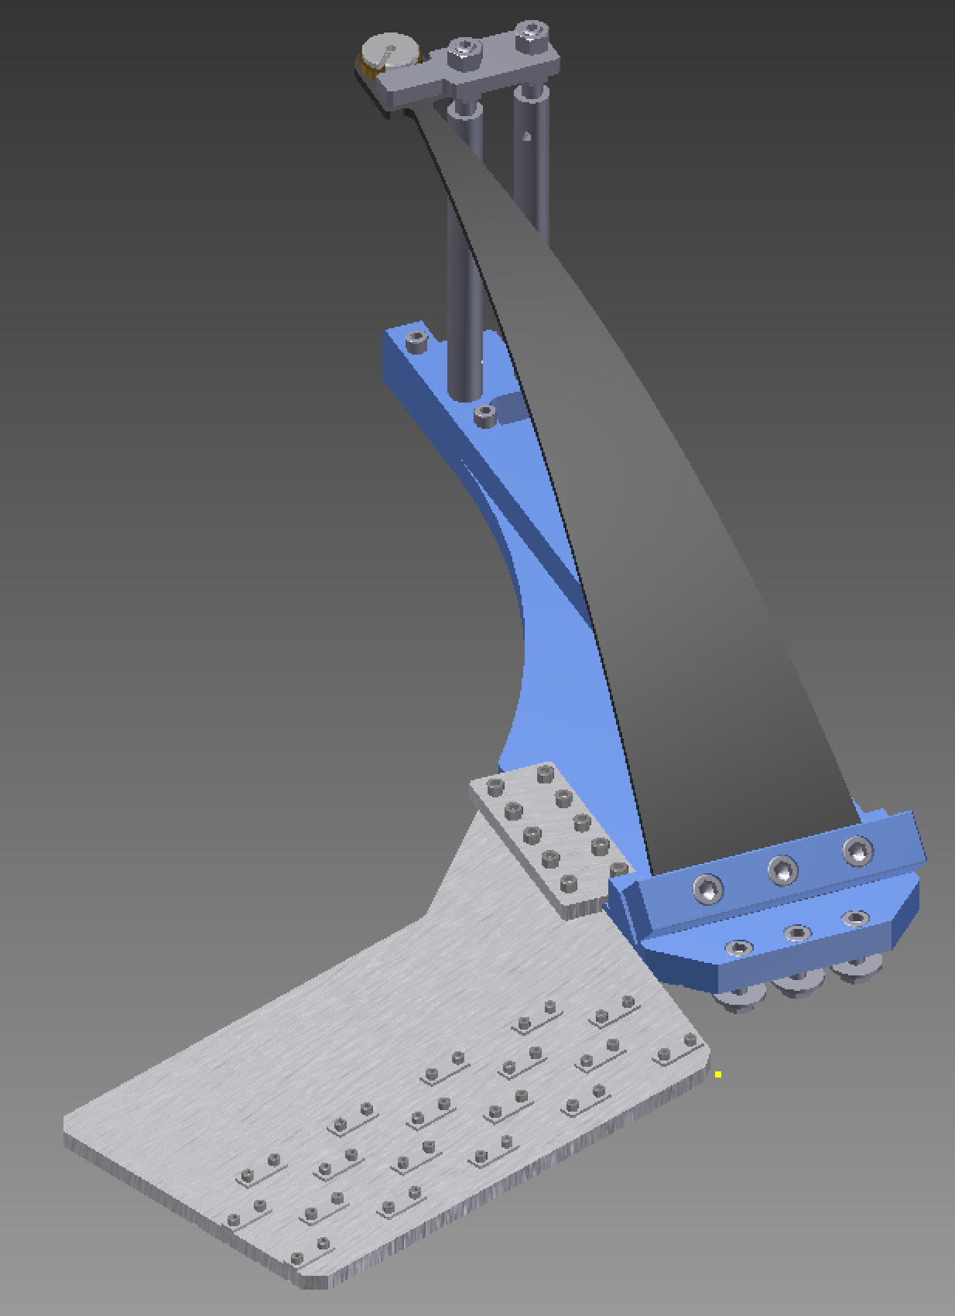  (1)  [5], (4), (8)  [2], [3], (2)  [6], [7]  [4]  (3)  [9]  (5), (6), (7)  [10], (10)  [8], (9)  [1]

Check OSEMs with multimeter
Check OSEM connections (per D1503600):
LED – forward voltage 1.051 V
At OSEM, red=anode=3, black=cathode=7
Elsewhere, red=anode=3, black=cathode=8
PD – forward voltage 0.47 V
At OSEM, red=anode=9, black=cathode=5
Elsewhere, red=anode=6, black=cathode=1
Coil - ?? ohms
At OSEM, 8 and 4
Elsewhere, 2 and 7

Dummy procedure step for cutting and pasting

Install the IM
See Fabian’s JGW-E1604817: BS Payload Assembly Procedure. The following section headings outline the main steps.

Install “green ring”, "red bars" and brackets at below-IM level
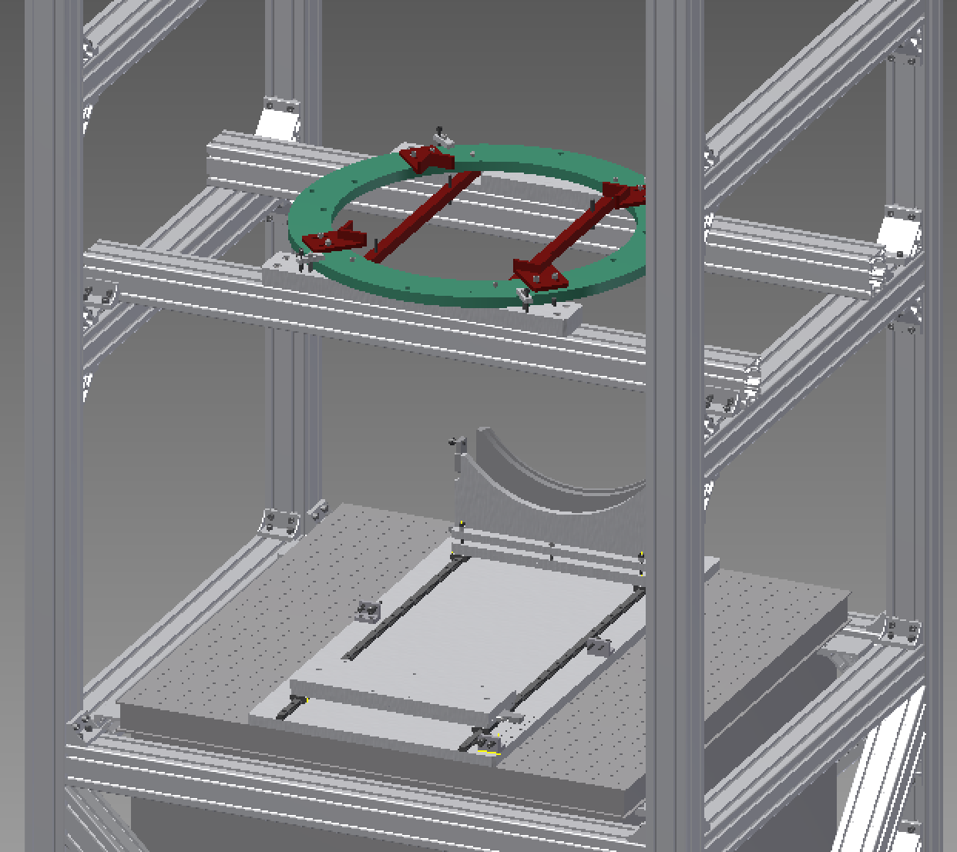

Install, level and center IM
Adjust the 4 ??? support screws in the red bars until the tips are 24 mm above the red bars or 4 mm above the green ring.  Place the IM on the screws, facing so that the triangle formed by the top flag positions (circled in red in the picture) points in the –X direction.  Attach a plumb-bob (下げふり) to the screw mount at the center of the bottom of the IM (originally intended for the damper).  Adjust the horizontal position of the IM until the plumb-bob lines up with the scribe lines in the center of the rail system base plate.  Check the levelness of the IM using a bubble level placed on top and adjust using the screws below.  Move the mirror box trolley to the center, and double check that the plumb-bob lines up with the “X” on the trolley in the ±Y direction. Adjust the “pusher” stop screw so that when the trolley contacts the screw, the plumb-bob is also in line with the “X” in the ±X direction.  Repeat the previous step with the RM trolley. | 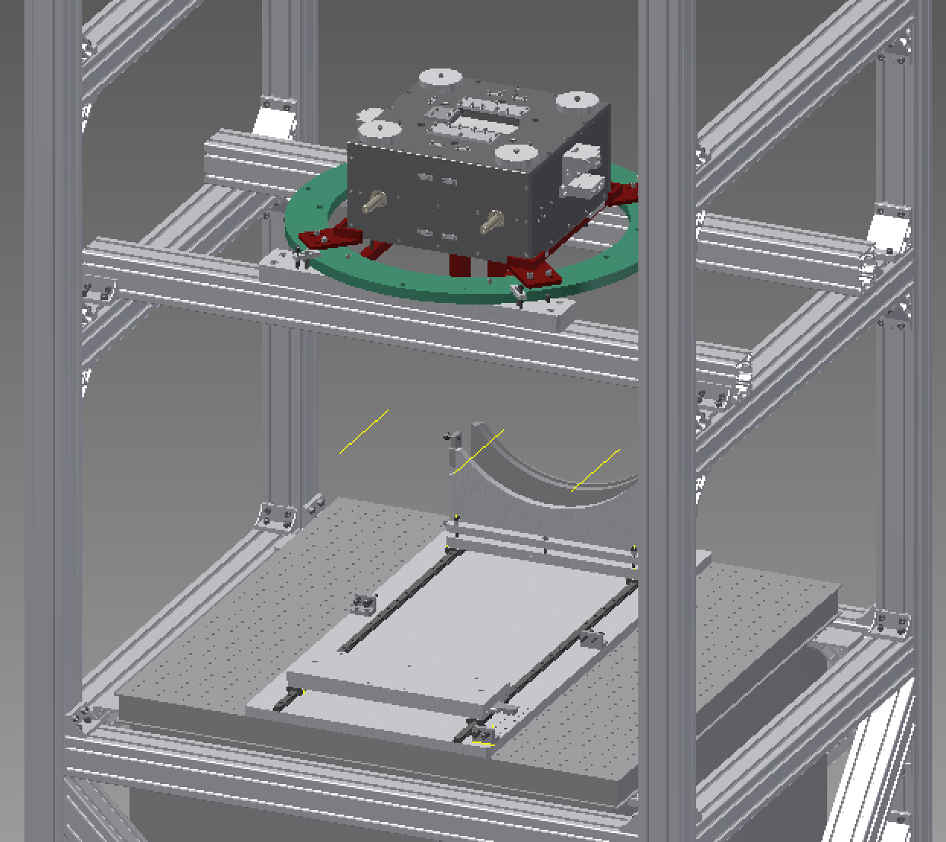  +X  -X  (tank)

Install winches

Mount mirror box with BS on trolley
[???: This section recycles text for the PRx, and may need editing for the BS.]
Remove the screws holding the lid of the mirror box.
Remove the lid.
Remove the outer cylinder.
Add hex bars to the corner of the base plate.
Add the leg plate with TBD 2 screws.
Add the foot with TBD 5 screws.
Check the guide rods are tight.
Move the trolley to the end of track on the =X side of the assembly frame and engage the side screw to immobilize.
Working with an assistant (one person on each side) stand the mirror box up on the trolley
Lift optic onto trolley, holding base and foot (two people).
Secure the mirror box with TBD 3 screws.
Release the side screw and move the trolley to the center.
Engage the side screw to immobilize the trolley.

Suspend BS

Setup optical lever
Note that the yellow optical fibre is permanently connected to light source.
Leave the light source disconnected from AC to begin with.
Fix the light source to the breadboard with dog clamps.
Fix mirror mount 1 m from mirror, slightly off center horizontally.
Pass the tail of the blue optical fibre into the mirror mount from the front, and carefully pull all fibre through.
Mount the head of blue optical fibre in the mirror mount.
Mount the optical fibre junction connector on the breadboard.
One at a time, clean the ends of the optical fibre with the cleaner device and plug into the connector. Note that there is a bayonet fitting on each side to ensure correct alignment of the optical fibres in roll.
Plug the light source into AC power.
Aim the beam at the optic.
Using a T-square or the like, measure the height of the middle of the diode aperture above the breadboard.
Use the laser level to level the outgoing beam.
Using the T-square, measure the height of the return beam.

Align BS

Bring in RM back section on trolley

Attach front ring

Route OSEM cables from RM up to IM

Suspend RM
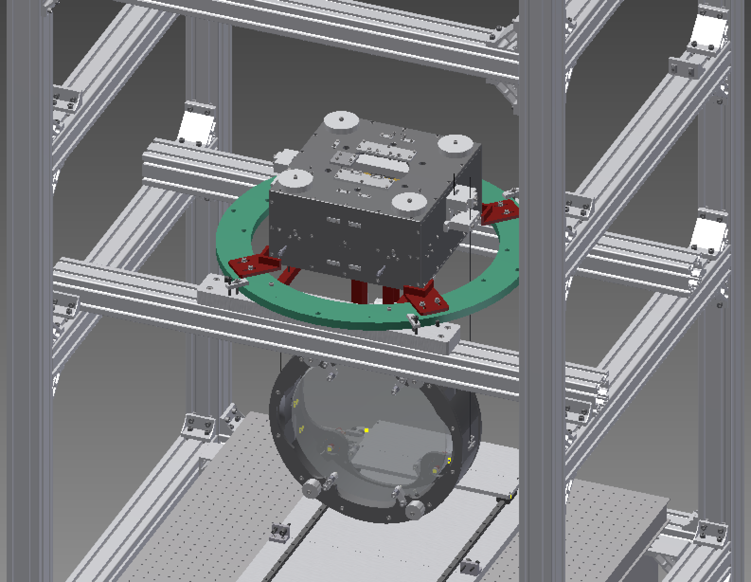

Check BS alignment

Install Security Structure Lower Section
See JGW-D1605124.  [1]: 4 x JGW-D1605122-550 hex rods  [2]: 1 x JGW-D1605122-551 plate  [3]: 2 x security recoilmass assembly (see 4.6)  (1): 8 x ISO 4762 - M12 x 35 SDC  (2): 8 x ISO 4762 - M5 x25  Insert 4 x (1) from the top through the holes in the ring under the IM.  Screw 4 x [1] rods on to the (2) screws.  Carefully bring in the [2] plate under the bottom of the rods, being careful not to bump the RM. (It may be convenient to put it on one of the trolleys and roll it in.)  Lift the [2] plate and secure with another 4 x (1) screws.  Slide in the 2 x [3] assemblies, being careful not to bump the RM, and secure with 8 x (2) screws inserted from underneath. | 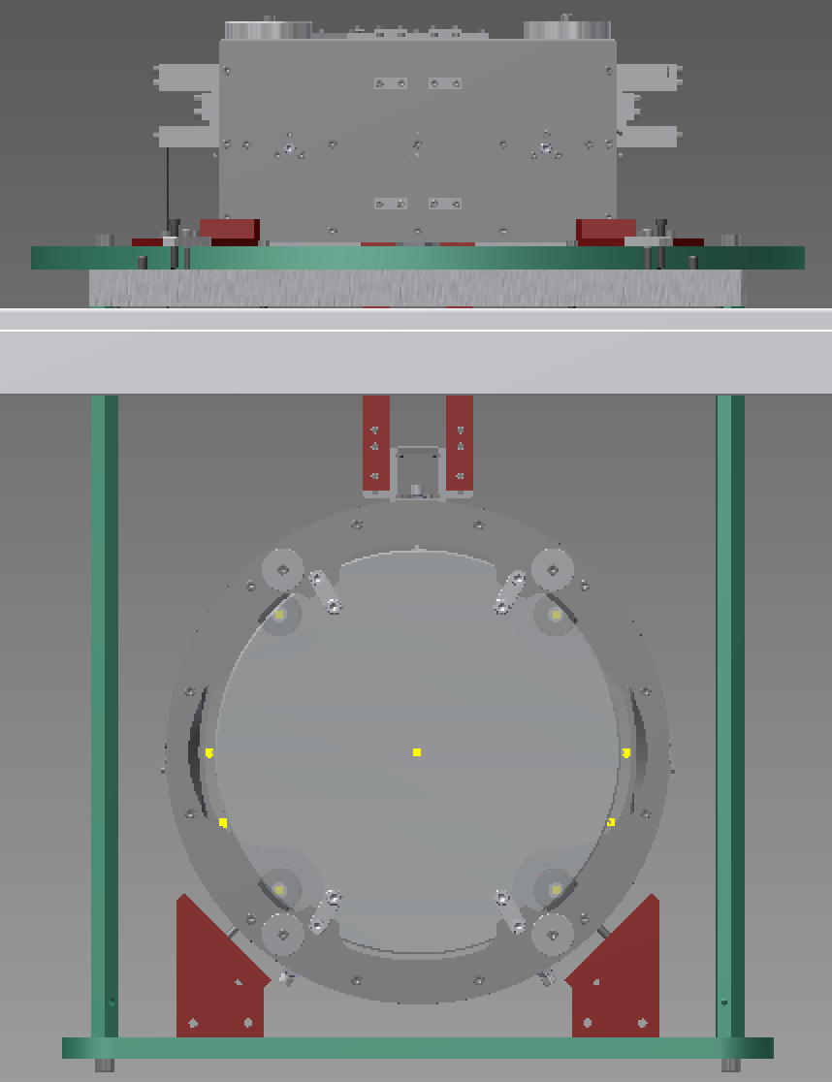  [2]  [3]  [1]  (1)  (1)

Connect and test IM picomotors
Connect the IM picos to the feedthrough via cables:
IM Pico Adapter Cable D1503901-03
BF to PI Motor Cable D1503901-14
TR to Flange Motor Cable D1503901-20
Continue to the rack via cables:
Anti-Feedthrough D1503600-01
Generic D-Sub 9 Tank to Rack D1402377
Double Pico Splitter Cable D1503600-03
Newport Pico Driver 8742 (and joystick)

Hang IM/RM/TM group

Tighten RM-to-BS stop screws
[???: Decide best order]

Install the IM-RM Safety bar
See D1605127.  Required:  [1]: 2 x D1503444-16 Clamp safety joint  (9): 4 x ISO 4762 - M5 x 16. [???: Need to add these to the drawing]  [2]: 2 x D1503444-17 Safety joint mirror  (5): 4 x ISO 4762 - M5 x 10.  [3]: 2 x D1503444-26 Frontal lock aid  (6): 6 x ISO 4762 – M6 x 25 [???: Need to add 2 extra of these to the drawing.]  (7): 2 x ISO 4762 - M6 x 35  (8): 4 x ISO 7092 - ST 6 - 140 HV [???: Need to add 2 extra of these to the drawing.]  [4]: 2 x D1503444-27 Spacer frontal lock  Check the RM-to-BS stop screws are entered so as to immobilized the BS, per the previous step.  On each side of the bottom of the IM attach [1] with 2x(9). [???: Need to decide whether these can remain on IM permanently.]  To each [1], attach a [2] using 2x(5).  In the outside channel of each [2], place a [3], aligned so the slot in [3] lines up with the hole at the back of the channel, and the side of [3] is flush with the side of the channel on the non-AR side of the RM - see figure (c). (The slot in [3] is placed asymmetrically, so you might have to rotate the part to get it on the right side.) Attach each [3] with 2x(6) screws inserted from the non-OSEM side but do not tighten yet.  Very gently, from each of the ±Y sides, insert a (7) screw and (8) washer through [3] and [2] into the cube, but do not tighten yet.  Very gently, on each of the ±Y sides, lower a [4] over the screws (6) into the gap between the [2] and the “wings” on the cube.  Very gently, on each of the ±Y sides, insert a (6) screw and an (8) washer from the non-OSEM side through the side wall of the [2] into the [3].  Gently tighten all screws until the RM is immobilized. | (a):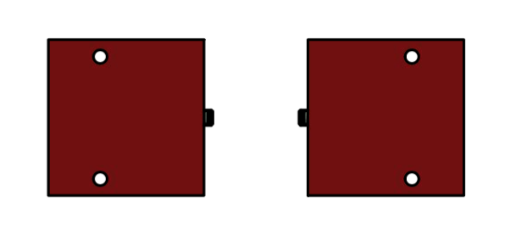  (9)  (b):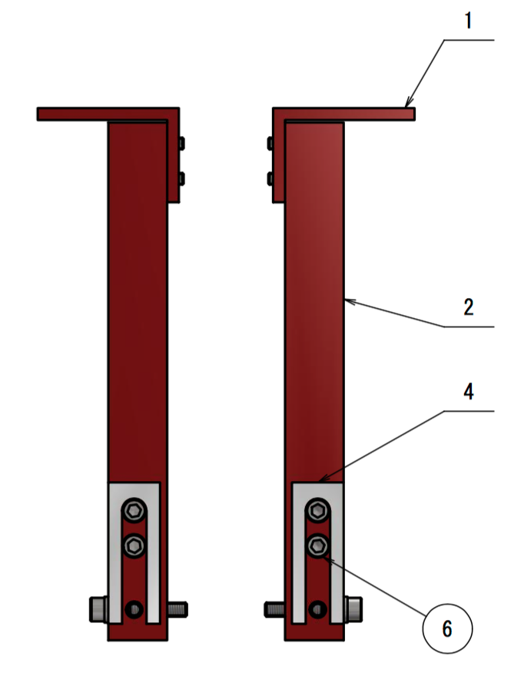(c):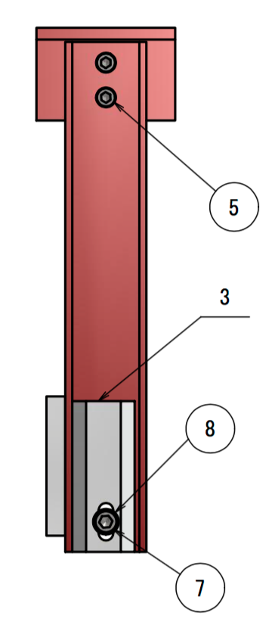  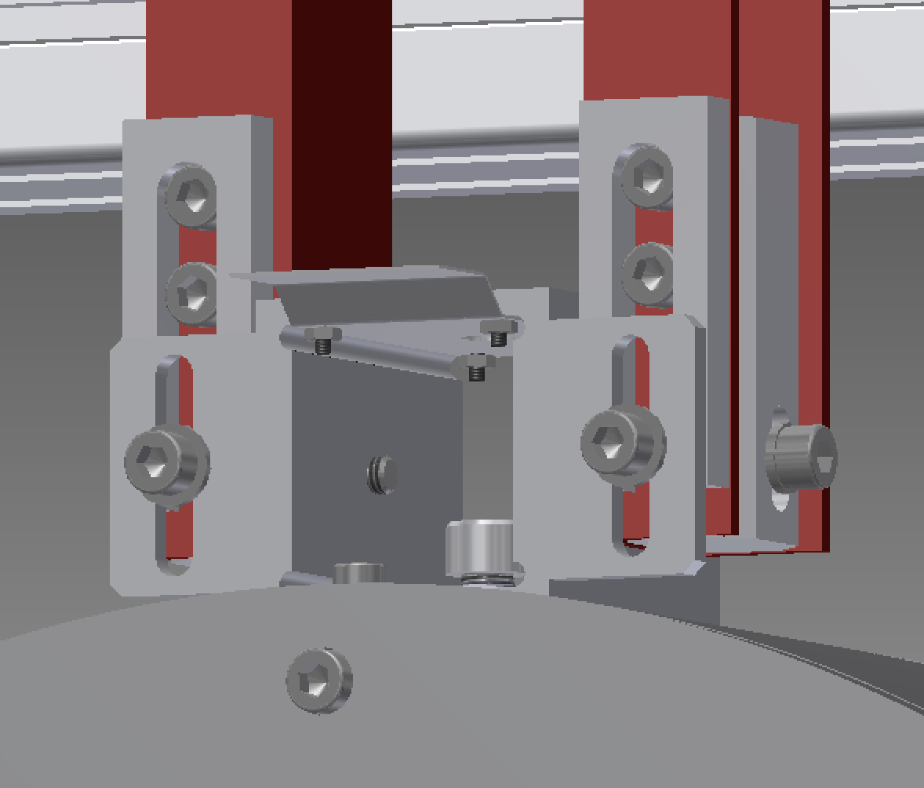  (6), (8)

Dummy procedure step for cutting and pasting

Install load gauge adapter and jacks
If the 3 NB-03 jacks are installed at the level under the PI, move them to the top level of the assembly frame at TBD positions. [???: check positions when design is finalized.]
Crane the load gauge adapter onto the jacks.

Weigh IM/RM/BS
Install the IM-RM Safety bar, D1605127, per 6.2.
Retract the four Part-15009-locking recoil mass.
Connect the load gauge adapter to the IM with TBD load gauge, TBD length adjuster, TBD maraging rod adapter, and maraging rod Part-15006-wire intermediate-bottom filter, and adjust the length until there is a small amount of tension.
Have three assistants with 46 mm wrenches, slowly raise the load gauge adapter until the IM/RM/BS is suspended.
Check the IM/RM/BS is level using a bubble level on top and diagnose/correct any large error. (The safety bar being present will reduce the effect of any mass imbalance.)
Lower the load gauge adapter again until the IM/RM/BS touches down on the support screws.

Trim payload assembly
Subtract the mass of the IM-RM Safety bar, D1605127, from the measured mass and compare to the rated load of the BF.
Add/remove mass as appropriate.

Remove load gauge adapter
Unhook the load gauge and chain block, and crane away the load gauge adapter. Leave the jacks in place for the next few steps.

Dummy procedure step for cutting and pasting

Install assembly frame crossbars for under BF

Install EQ structure parts up to ring under BF

Install pushers and jacks at ring under BF

Crane in BF

Remove BF cap with crane
Remove 16 x ISO 4762 M8 x 25 screws from the bottom of the BF around the outside edge, and crane away the cap.

Wire up BF yaw pico, stepper, LVDT
[???: The arrangement of cables in E1503600-v9/ E1503901-v2 is not going to be convenient because the pitch and roll picos are on the top of the cap and their wires will go straight to the cable clamps but the yaw pico is inside and its wires need to come out the bottom. The following assumes that we put the BF yaw pico on the same cable as the IM picos (which has the bonus that it’s also more logical – the BF yaw really rotates the IM in any case).]
Create adapter cables for the BF pico, stepper and LVDT per JGW-E1503901-04, -05 and 06, choosing the length to run neatly from the inside of the BF to the cable clamps on the outside of the BF cap.
Connect the adapters to the pins of the pico/stepper per JGW-E1503600-04 and -05, route the cables.

Route IM cables through IRM top plate up to BF

Suspend IM top plate with rods from BF
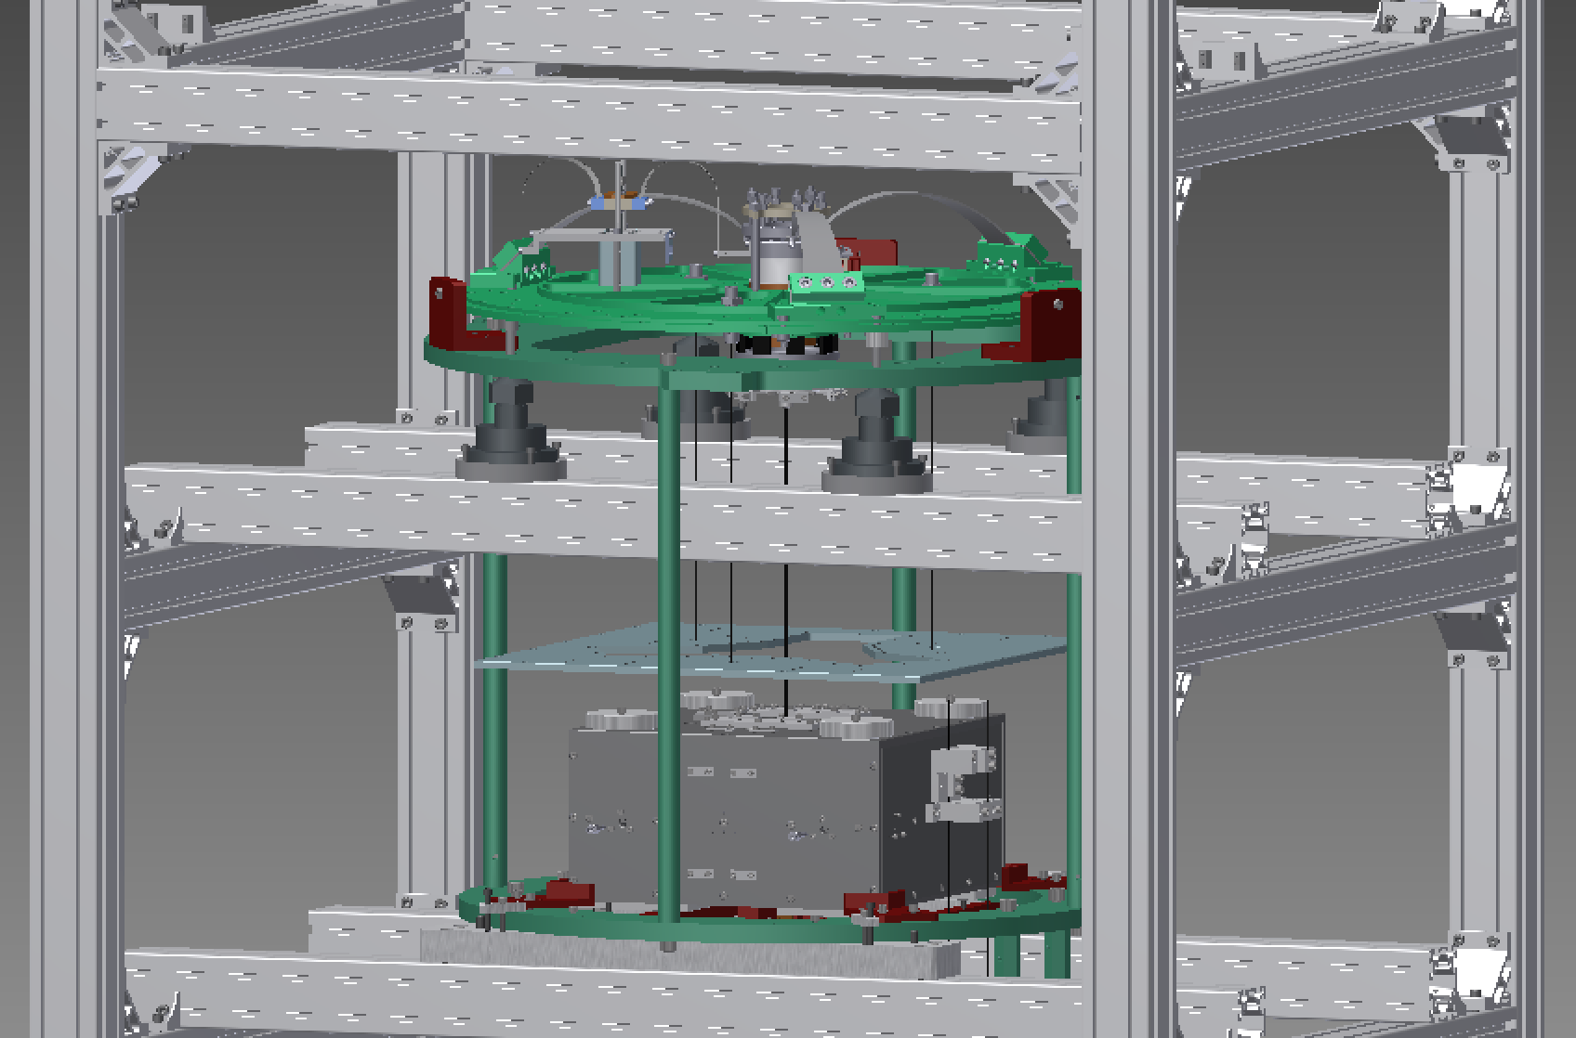

Hook IM to BF

Remove security bar between IM and RM

Raise BF with jacks, test payload weight match

Level payload

Suspend IRM

Build IRM around IM
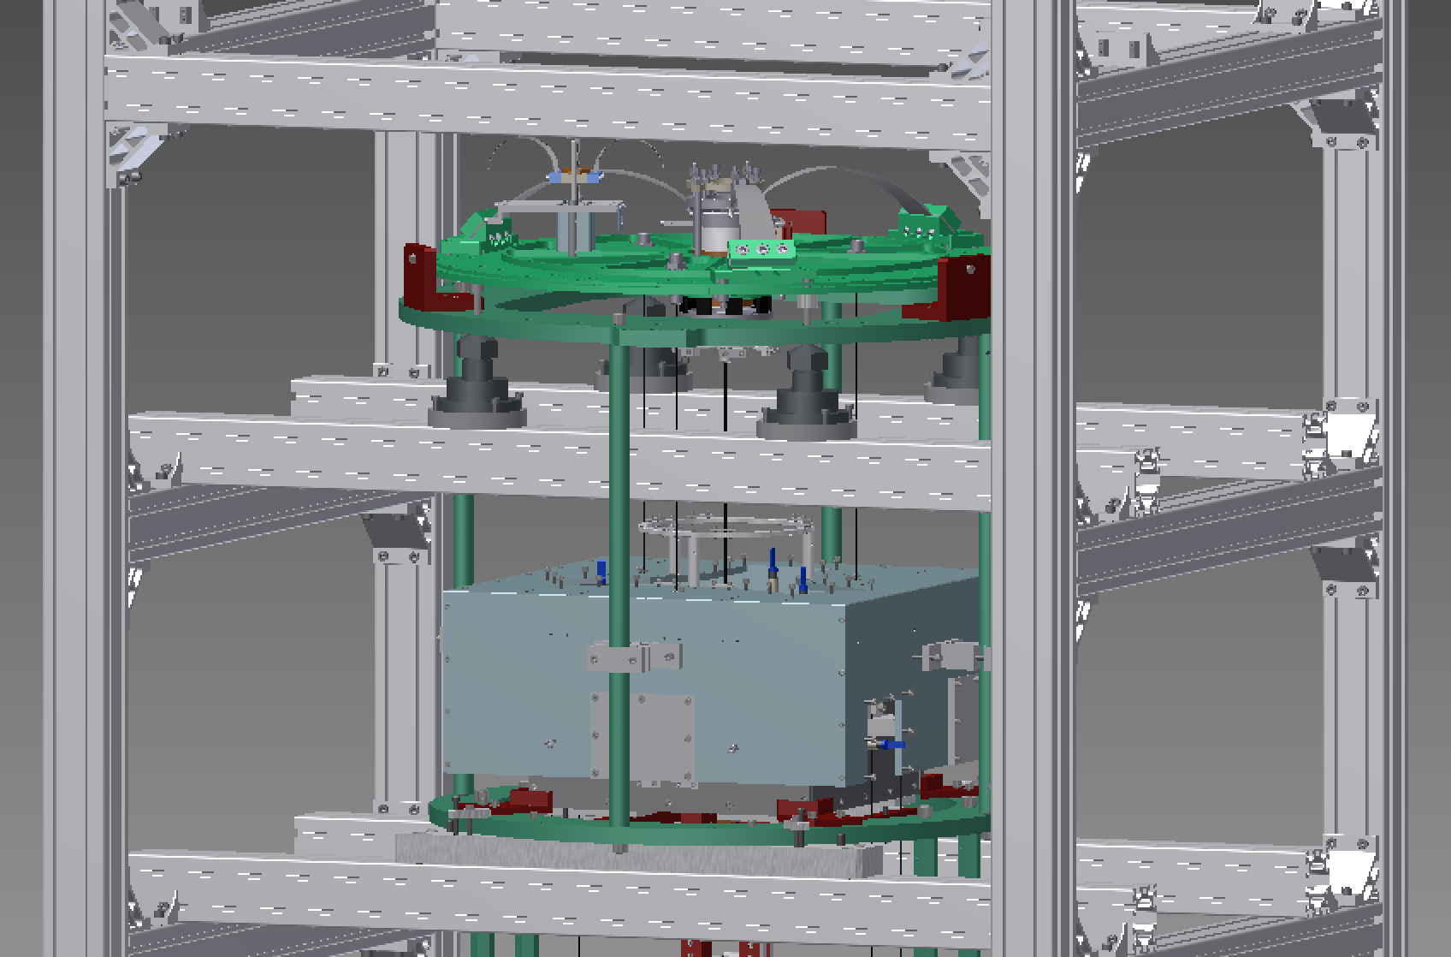

Attach OSEMs
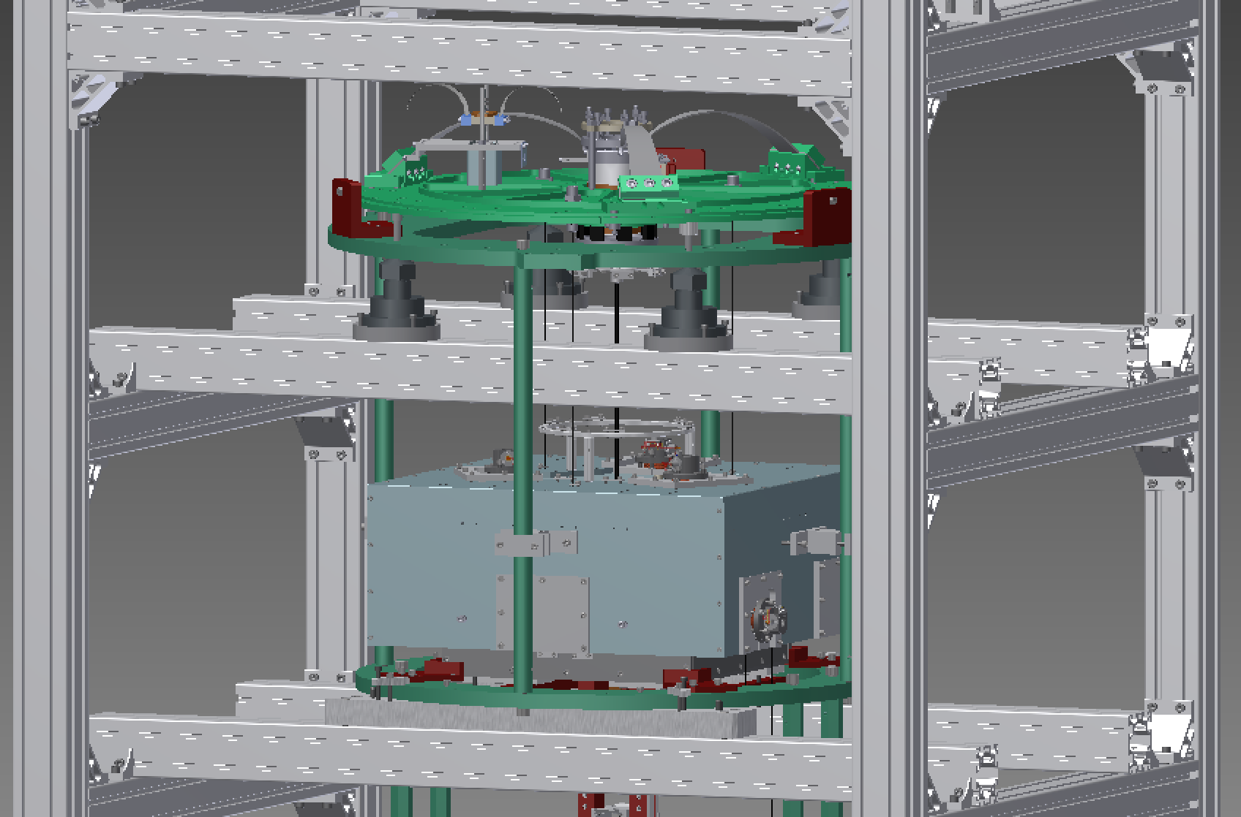

Route OSEM cabling up to BF

Crane in BF cap
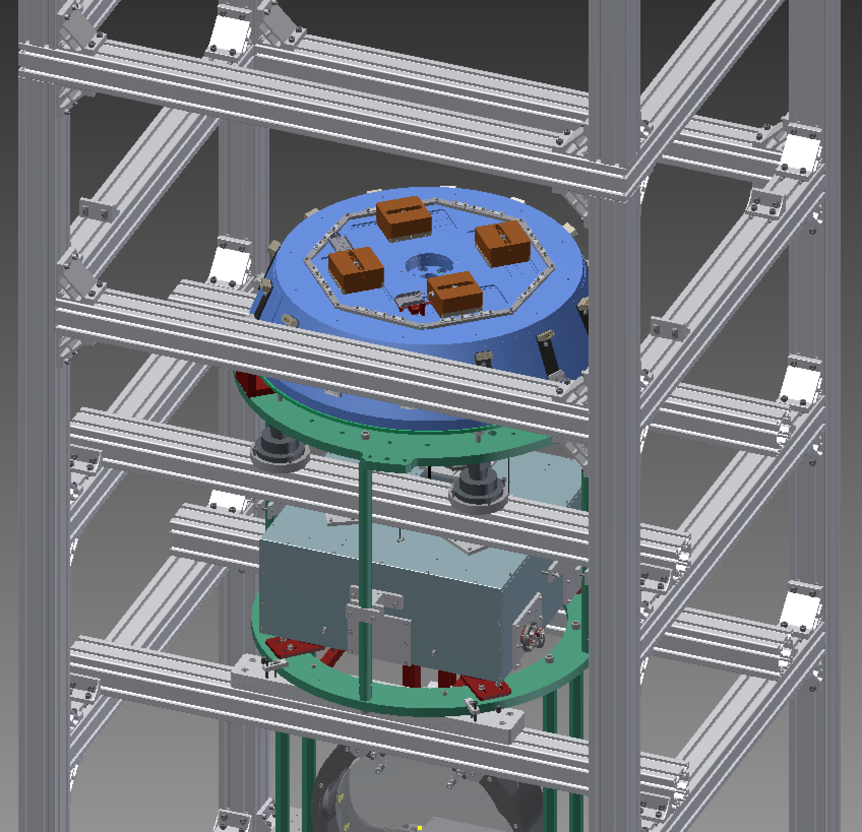

Connect payload cables to BF cap

Suspend BF + payload

Install load gauge adapter

Weigh/trim/balance BF+payload

Remove load gauge adapter
Unhook the load gauge and chain block, and crane away the load gauge adapter.

Install crossbars for under SF
Install the crossbars for under the SF, running in the Y direction. There should be a gap of 120 mm from between the crossbar and the inside of the corner upright. Do not tighten the screws holding the brackets yet.  Install the six jacks as shown, with a triangle of jacks on round bases and one of jacks on square bases. Note that the round bases have a diameter of 120 mm and the rectangular bases are 110 mm wide. Do not tighten the screws holding the bases to the crossbeams yet. [???: Double check that the jack positions are right, especially the ones on the outside – they seem to have changed in the Inventor.] | 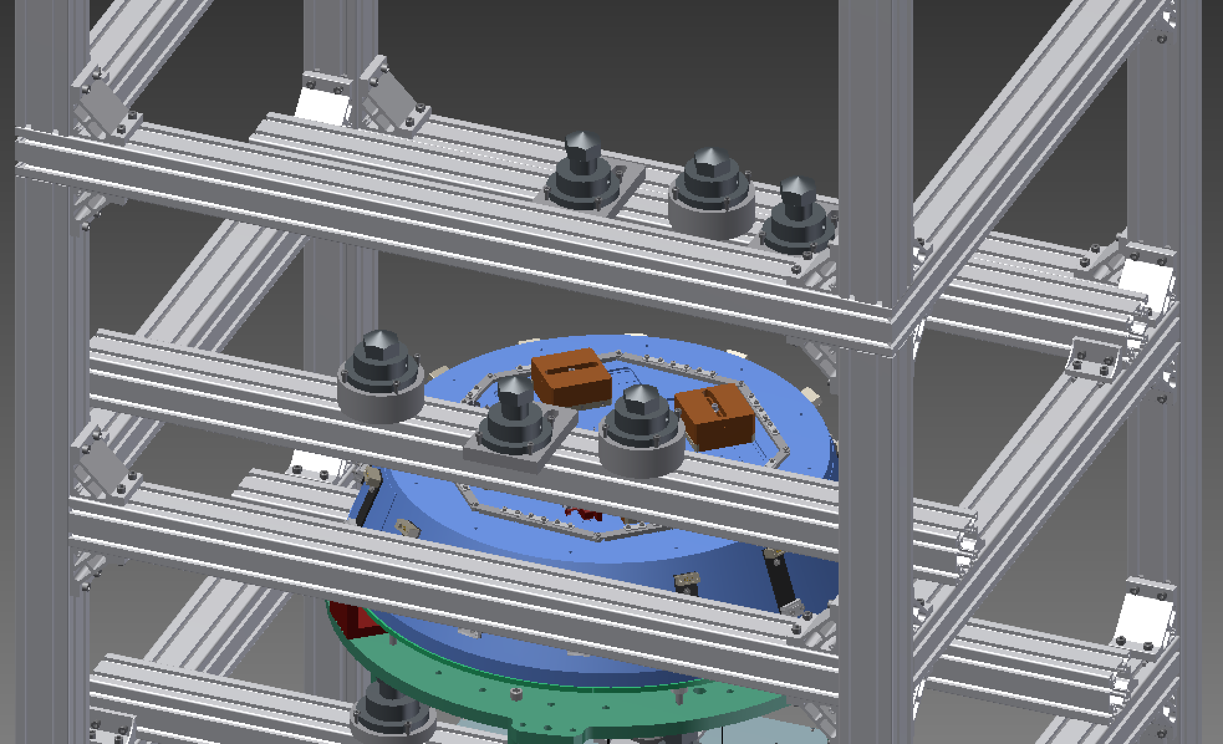  -X  +X  590 mm  595 mm  434 mm  429 mm  26.6 mm

Install EQ stop parts up to ring under SF
+X
[1]: 1 x JGW-D1605122-355 Safety disk filter with damper  [2]: 3 x JGW-D1605122-354 Stop for filter  [3]: 3 x JGW-D1605122-356 Rod suspension disk  (1): 6 x ISO 4762 - M5 x25  (2): 3 x ISO 4032 - M6 nut  (3): 3 x SSHH-ST-M6-40  (4): 3 x ISO 4762 - M6 x35  (5): 6 x ISO 4762 - M12 x 35 SDC  Pick the [1] disk up with the crane and orient it so that, as viewed looking towards –X, the tab that is opposite a single hole is at 9:30, and the tab that is not opposite a hole is at 1:30 (see figure).  Place 3 x [2] stops on the [1] ring with the upright parts to the outside. Secure with 6 x (1) screws inserted from below. Put a (2) locknut on each of 3 x (3) lock screws and insert the screws into the [2] stops from the outside.  Through each of the central holes in the tabs around the edge of the ring under the BF, insert a (4) screw from underneath and attach a [3] rod.  Crane the [1] ring on top of the [3] rods, positioning it so that each of the rods is underneath the leftmost hole in one of the tabs around the end. Secure the ring to the rods with 3 x (1) screws inserted from above. | 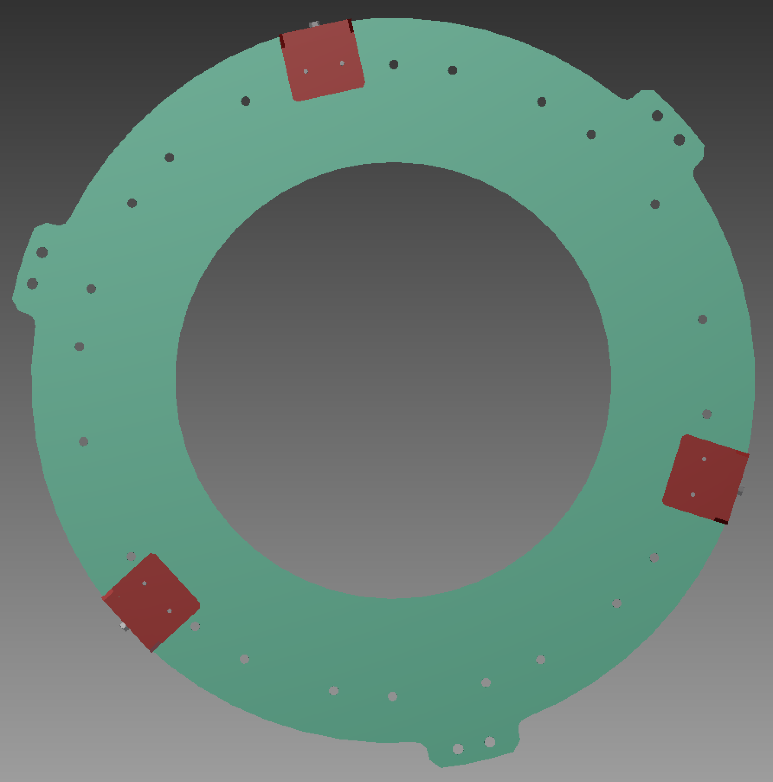  [2], (1), (2), (3)  [1]  -X  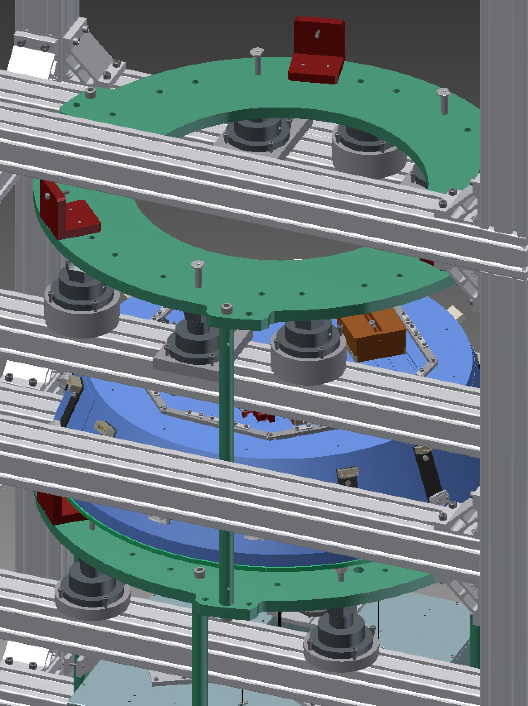  (4)  [1]  [3]  (4)  +X  -X

Install jacks and pushers at ring under SF
[???: Need picture with Hirata-san’s modified design.]

Crane in SF
[???: Crane away load gauge adapter]  Pick up the SF with the crane.  Orient the SF until, viewed looking from above in the –X direction, the keyhole for the maraging rod at the top is just above the 3 o’clock position and there are cable mounts at the 9 o’clock and 3 o’clock positions. [???: Is there a better way of specifying this? Unlike with the BS, the jacks do not precisely locate the SF.]  Lower the SF onto the jacks and adjust to be central. There should be 25 mm from the outside of the SF bottom plate (radius 365 mm) to the outside of the main part of the ring (radius 390 mm), or 10 mm to the inside of the restraint brackets. | 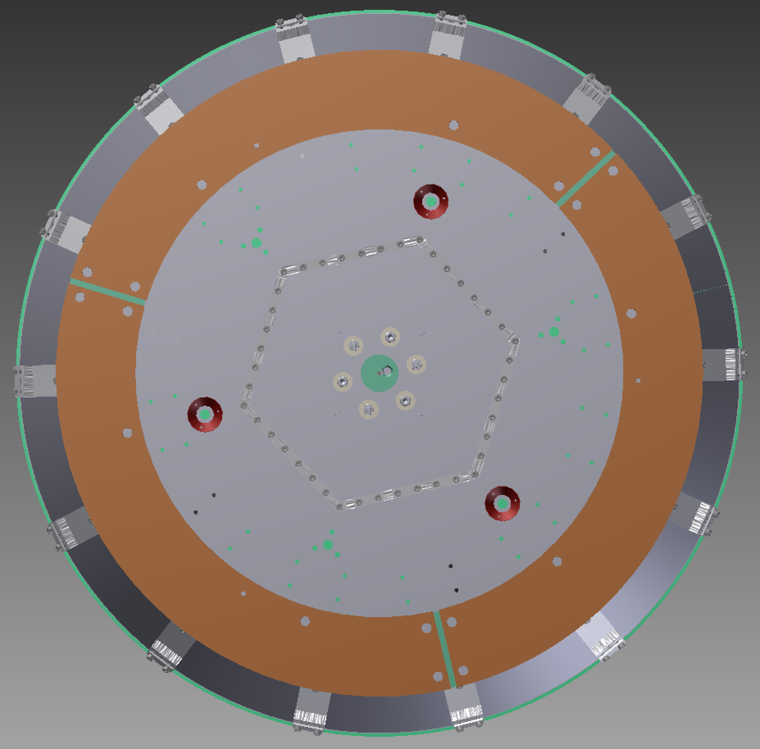  -X  -Y  tank  +X  -X

Remove SF cap with crane
Remove 16 x ISO 4762 M8 x 25 on the bottom of the SF around the outside edge, and crane away the cap.

Wire up SF stepper, LVDT
[1]: parts for BF&SF Stepper Adapter, D1503901/05
[2]: parts for BF&SF LVDT Adapter, D1503901/06
[3]: SF-PI Motor Cable D1503901/15
[4]: SF-PI Signal Cable D1503901/08
[5]: TR-Flange Motor Cable D1503901/20
[6]: TR-Flange Signal Cable D1503901/19
[7]: feedthrough
[8]: 2 x feedthrough adapter
[9]: 2 x Generic D-Sub 9 Cable M-F
Cut 5 cm [???: or TBD] lengths of UHV heat-shrink tubing, and place over all the pins of both the LVDT and stepper motor.
For each of the [1] and [2] adapters, take a long section of the appropriate cable, and feed the free end into the SF [???: where?]. Crimp the appropriate pins on the end the cable. Plug the pins into the ones from the LVDT or stepper, and adjust the heat-shrink to cover the connection. [???: Shrink the heat-shrink?] Route the cable to the edge of the SF and cut the cable at a suitable point about 10 cm [???: or TBD] beyond. Attach a D-Sub 9 connector to the cut end. Secure the cable to the hexagon_bottom_plate_SF_assembly on the bottom of the SF.
Connect up the rest of the cables to the rack per D1503600, and test.

Replace SF cap with crane

Route cables from BF up to SF

Hook BF+payload to SF and raise SF to suspend BF+payload
[1]:

Install load gauge adapter
[1]: small hexagon assembly
{1}: short test rod for SF filter (from ATF)
Check that the jacks are in position on the top level of the assembly frame, and if necessary position per 6.4.
Crane the load gauge adapter onto the blocks.
Hang chain block, load gauge, maraging rod adapter and {1} test rod from the load gauge adapter.

Weigh/trim/balance SF+BF+payload
Install the IM-RM Safety bar, D1605127, per 6.2.
Retract the 4 x Part-15009-locking recoil mass around the IM, and the 6 x Part-10024-clamp filter around the BF and SF.
Hook the test rod into the SF, and then adjust the length of the chain until there is some tension.
Using 46 mm wrenches, adjust the jacks to raise the SF+BF+payload until it is suspended.
Note the load gauge reading.
Adjust the jacks to lower the SF+BF+payload until the SF is sitting on the jacks as before.
Subtract the mass of the IM-RM Safety bar from the load gauge reading and compare to the rated load of the PI top filter If necessary, add/subtract trim mass to/from the SF.

Remove load gauge adapter
Unhook the load gauge and chain block, and crane away the load gauge adapter.

Place damper ring
Required:  [1]: 1 x Part-76-damping plate with magnets  [2]: 3 x Part-77-fasten wire damper  [3]: TBD x magnet  (1): 6 x ISO 4672 M5 x 20  (2): 3 x ISO 4672 M6 x 40  {1} 1 x magnet template  {2} 3 x spacers ≈20 mm thick  Attach 3 x [2] holders to the top of the [1] ring with 6 x (1) screws. Also insert 3 x (2) screws from above.  Place the [1] ring upside down on a clean non-magnetic surface, with the {1} template on top.  Attach TBD number of [3] magnets to the [1] ring through the holes in the template, placing them in a symmetrical pattern with alternating polarities. Leave gaps for the spacers.  Remove the {1} template, turn the [1] ring right-side-up, and sling it from the crane using appropriate slings.  Lower the [1] ring until it is just above the SF, with the [2] holders at 9, 1 and 5 o’clock (looking towards the –X direction). Put 3 x {2} spacers on the Cu ring of the SF in line with the gaps between the magnets.  Adjust the position and angle until the (2) screws line up with the holes in the Cu ring.  Lower the [1] ring onto the spacers and tighten the (2) screws.  Disconnect the crane. | 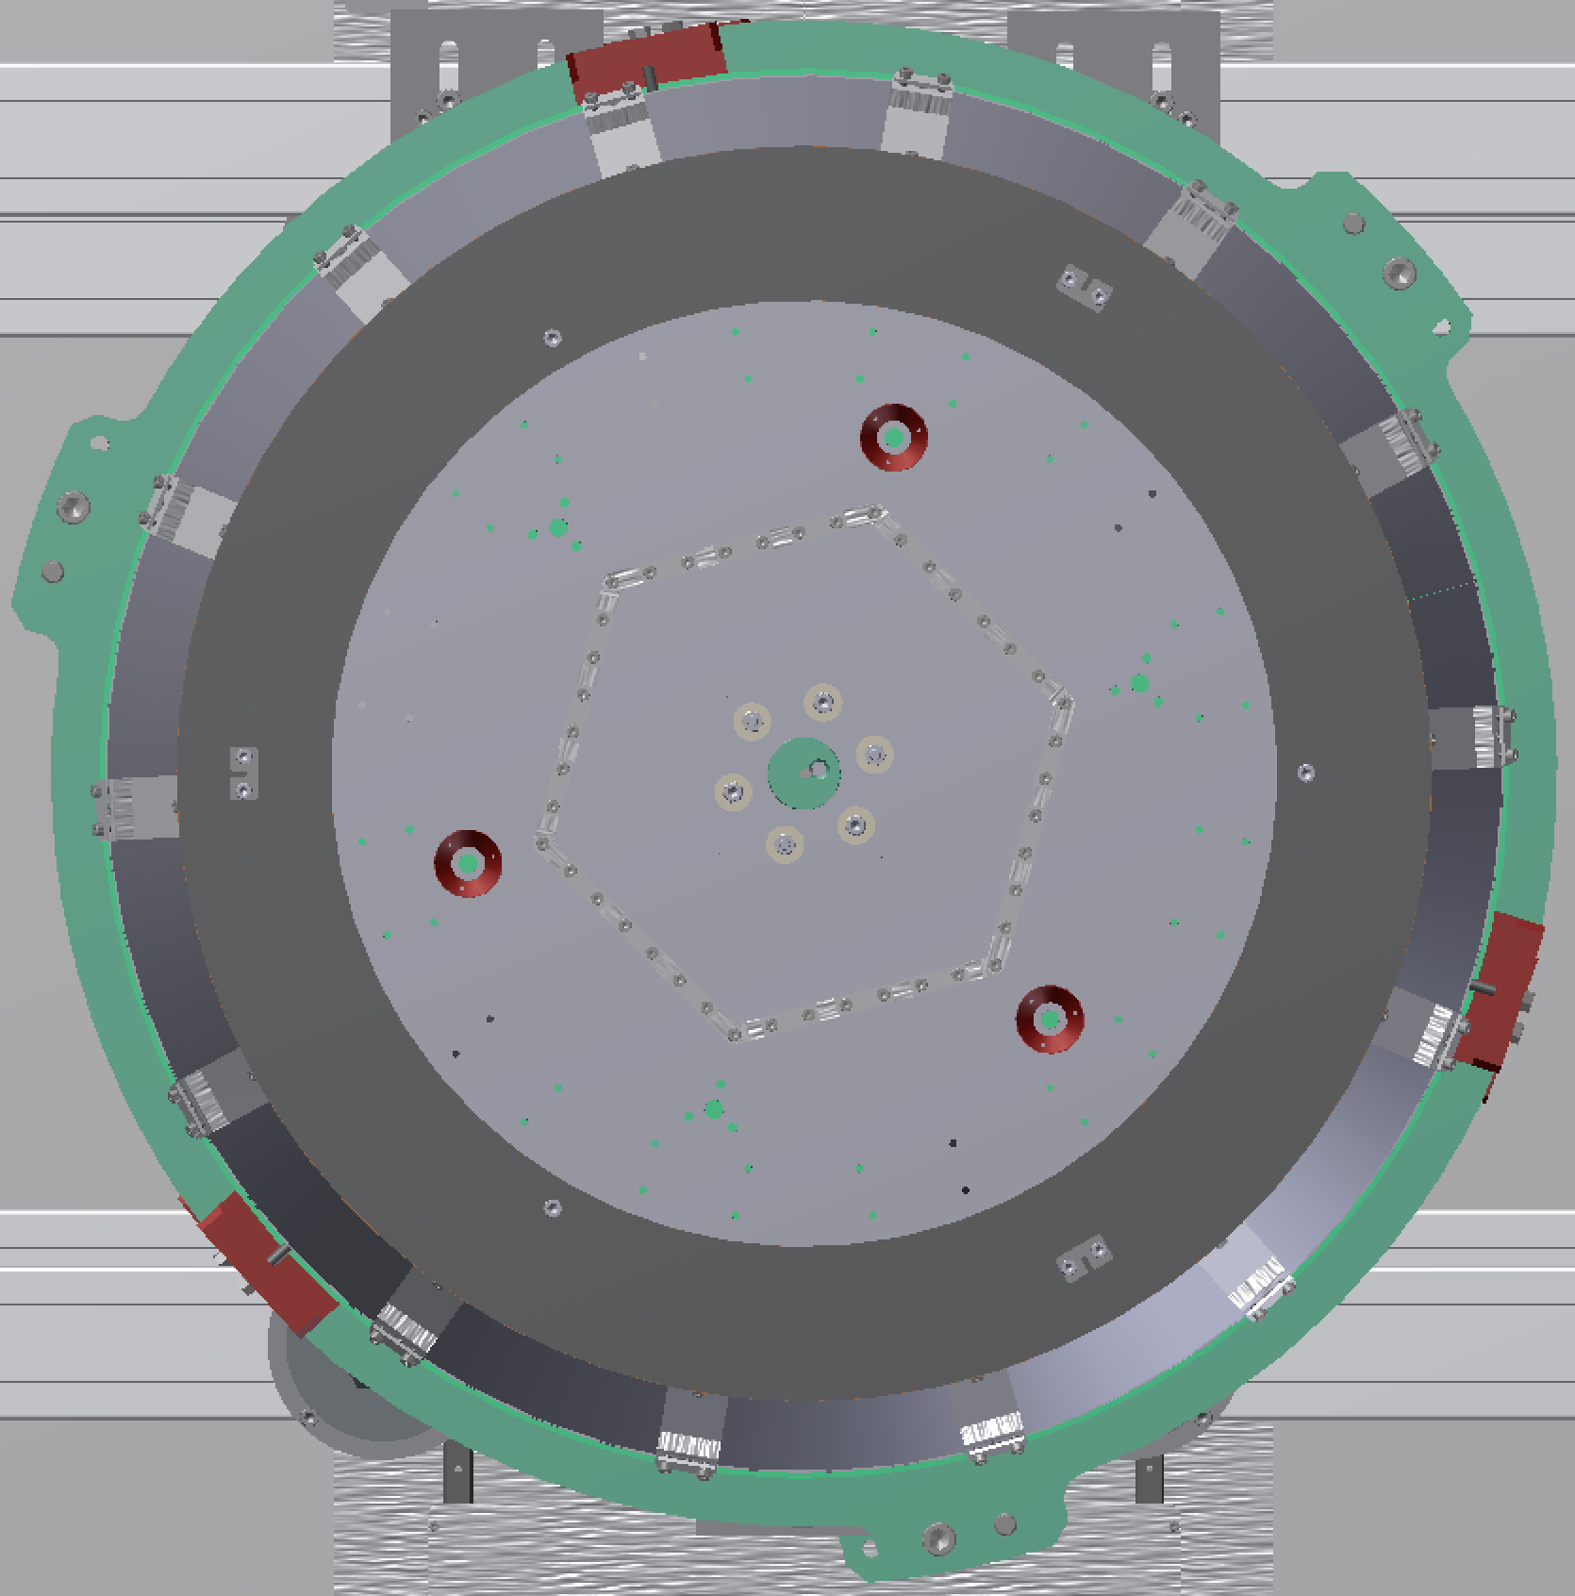  -Y  tank  [2], (1)  (2)  [1]  +X  -X

Reposition top jacks
Move the 3 NB-03 jacks from the top level down to the crossbars under the PI.  Place the jack on the tank side of the frame symmetrically (there should be 308.25 mm from the jack adapter block to the nearest point on the right angle brackets).  Place jacks on the ±X sides with 695 mm between the jack adapter block to the nearest point on the right angle brackets at the tank end.  Set the jacks to 200 mm high from the base of the adapter block to the tip of the rotating section (nominal height). | 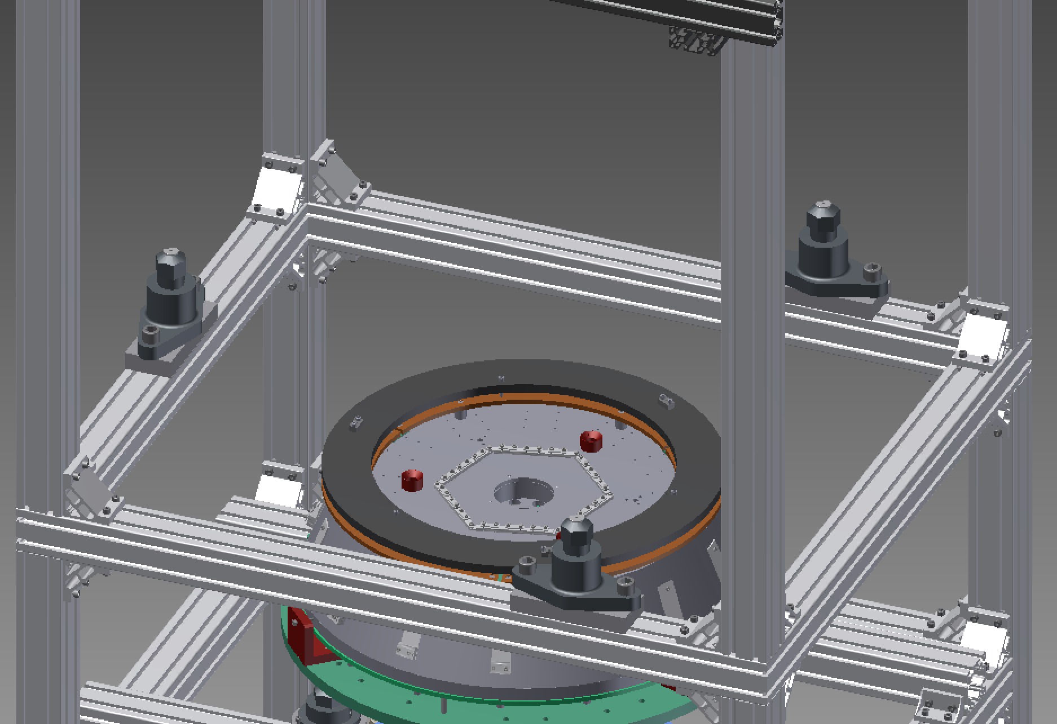  695 mm  308.25 mm  -Y  tank  +Y  +X  -X

Remove top crossbars
Remove the lifting eyes, the top outside crossbars on all four sides, the brackets on the inside corners and the brackets that supported the crossbars from underneath.  If the extension bars are wobbly, lower them a few centimeters until the upper right-angle brackets are connected. | 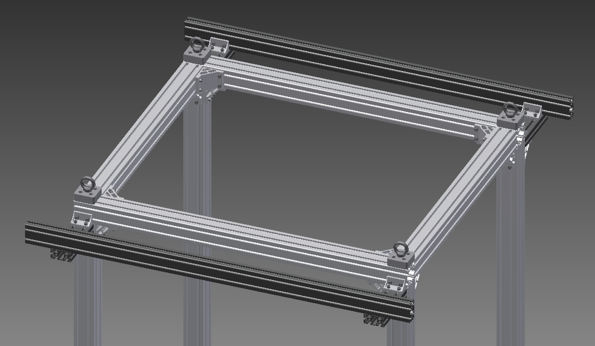  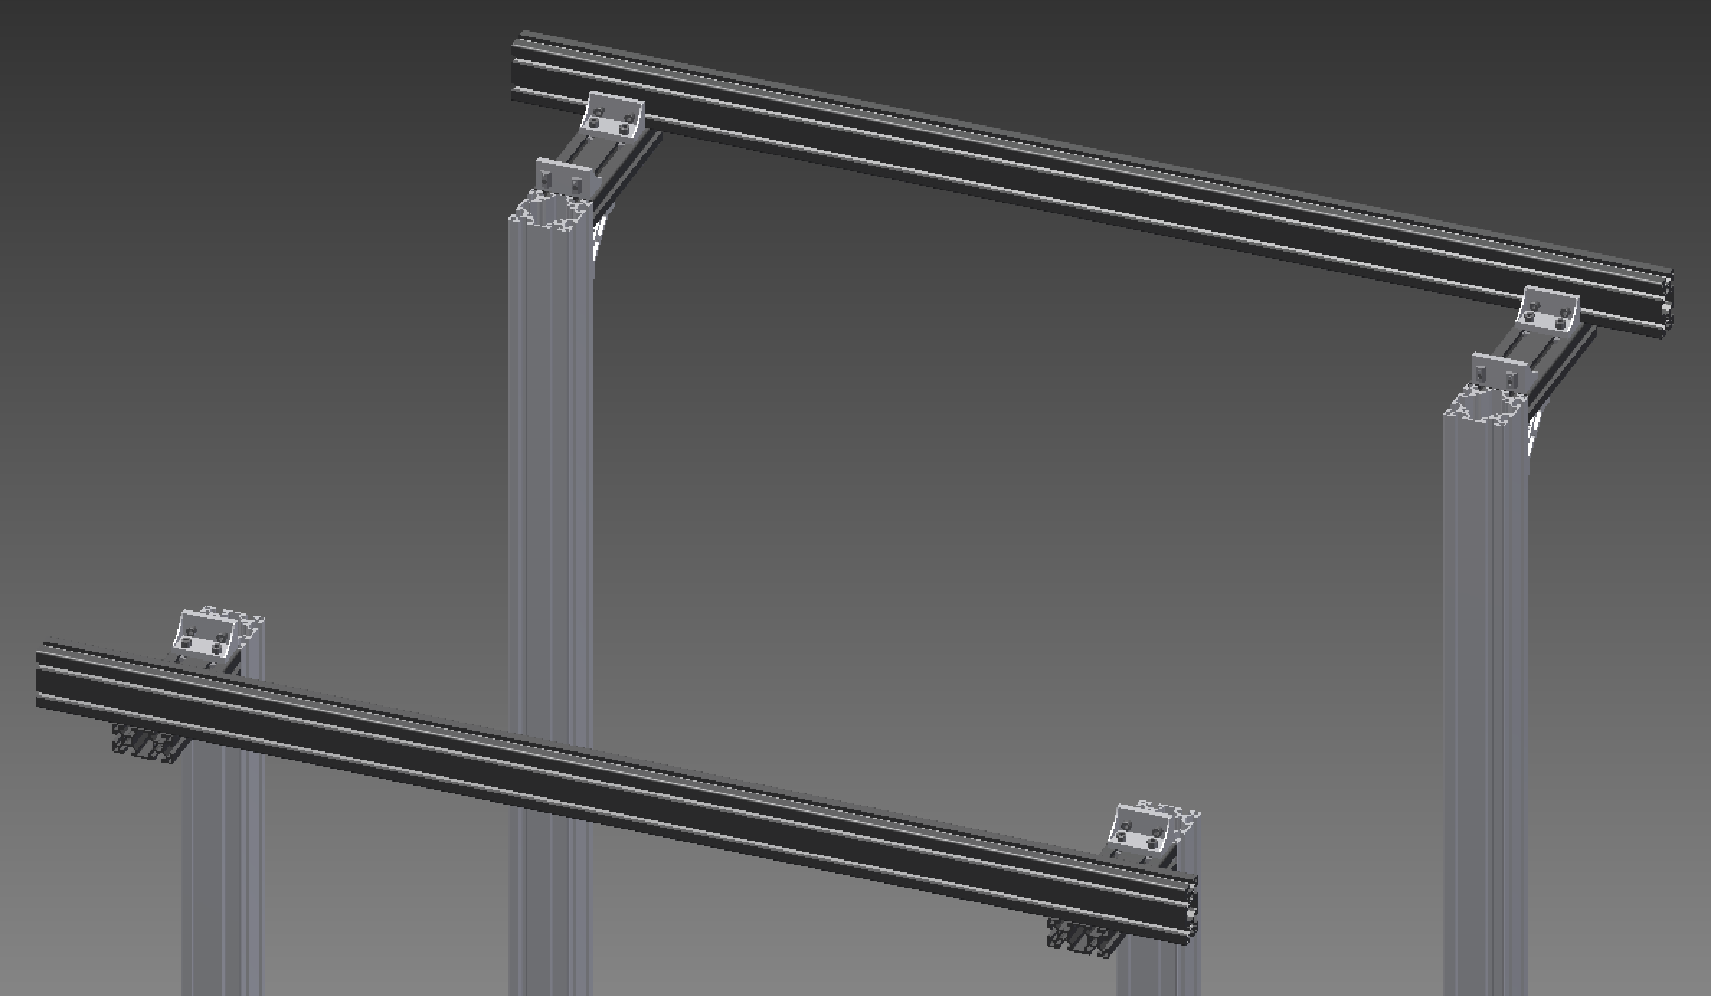

Attach crane adapter

Install PI Guides
{1}: 4 x PI Guide  Install 4 x {1} guides on the uprights, opposite the brackets for the clean bag extension and 350 mm below the top.  Adjust the rod part of the guide to the outside (so as not to interfere with the PI when it first comes down). | 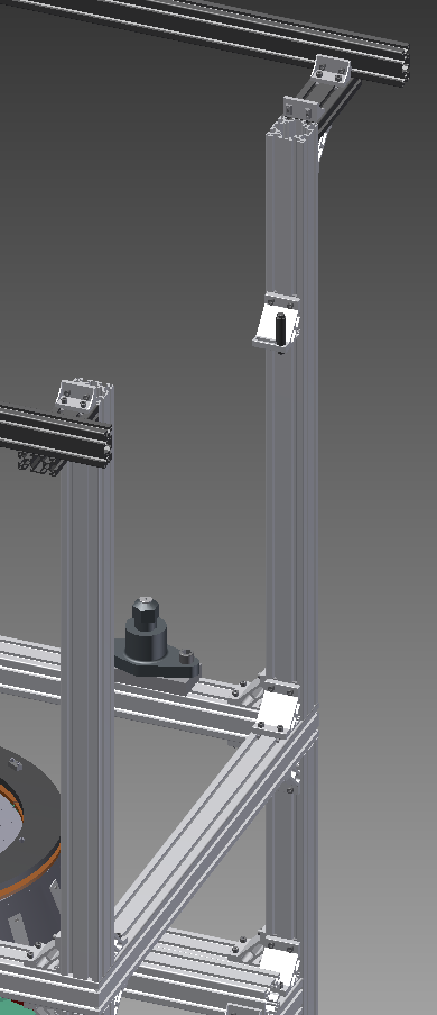  350 mm

Insert screws for security structure
Identify the M12 threaded holes for the security structure screws, in the bottom plate of the PI accessible through the cutouts immediately anticlockwise of each IP leg.  Plan A:  (1): 3 x ISO 4762 M12 x 35 treated  For each hole, insert a (1) screw from above, screw it in as far as it will go, and tighten moderately.  Plan B:  (1): 3 x TBD M12-M10 adapters  (2): 3 x ISO 7093 A ST 10 – 140 HV – A  (3): 3 x UNI EN 24032 M10  For each of the hole, insert the M10 end of a (1) adapter from below and secure with a (2) washer and a (3) on top. Leave the nut very loose.  Plan C:  (1): 3 x ISO 4762 M10 x 35 treated  (2): 3 x ISO 7093 A ST 10 – 140 HV – A  For each of the holes, insert a (1) screw with a (2) washer from above and just leave them sitting in the M12 hole. | 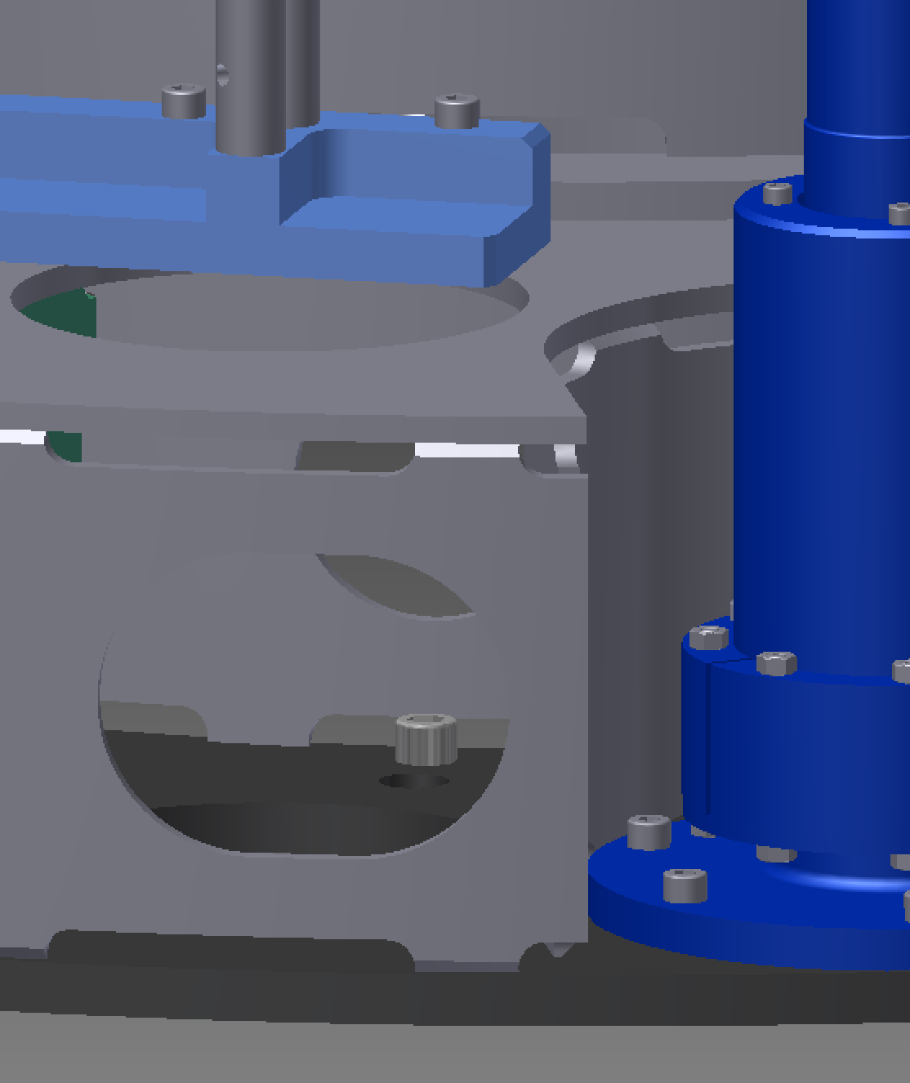  (1)

Crane in PI
Move the PI to TBD position on the line of the crane with the forklift.  Attach the crane adapter to the PI per 8.19.  Lift the PI with the crane and move it into the cleanbooth if it isn’t already.  Remove any remaining wrapping material.  Rotate the PI on the crane so that, as viewed looking towards –X, there is an IP leg at 9 o’clock, the fishing rod slot is at 2 o’clock, and the M4 holes for the magic wands are at 10 o’clock and 4 o’clock.  Check the levelness of the PI in both directions with a bubble level and, if necessary, readjust the slings and/or put weights on one side so that it hangs straight.  [???: Maybe hook maraging rods into PI here – currently 8.28.] | 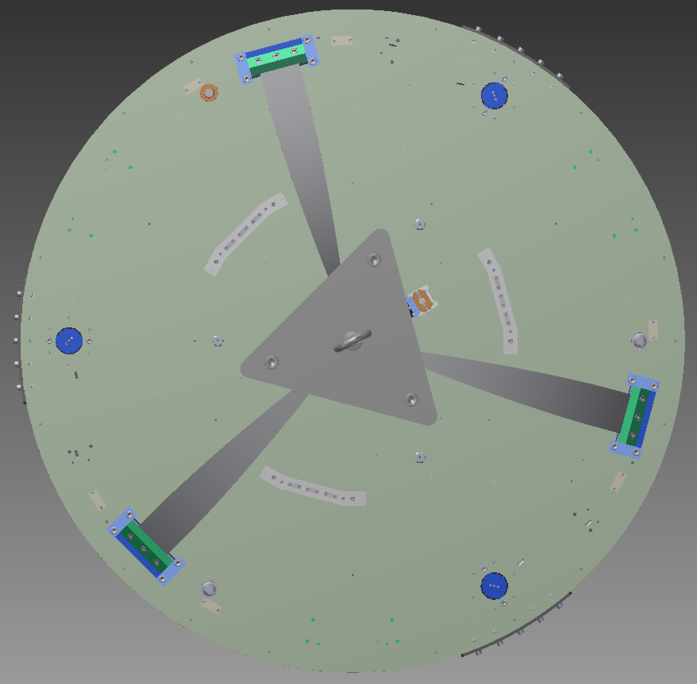  -Y  +Y  +X  -X

Adjust PI Guides
Lower the PI with the crane until it is about 90 mm above the jacks (leaving room for a 78 mm tall adapter_conical_bellows). Adjust the position and angle until each IP leg is directly above a jack.  [???: Need to add some extra checks that PI is centered.]  Adjust the rods on the PI Guides inwards to capture the PI horizontally. There should be approximately 42 mm from the outside of the bracket to the outside of the cylinder. If necessary adjust the height of the PI Guides until the top filter plate touches near the top of the rods (to allow room for lowering). | 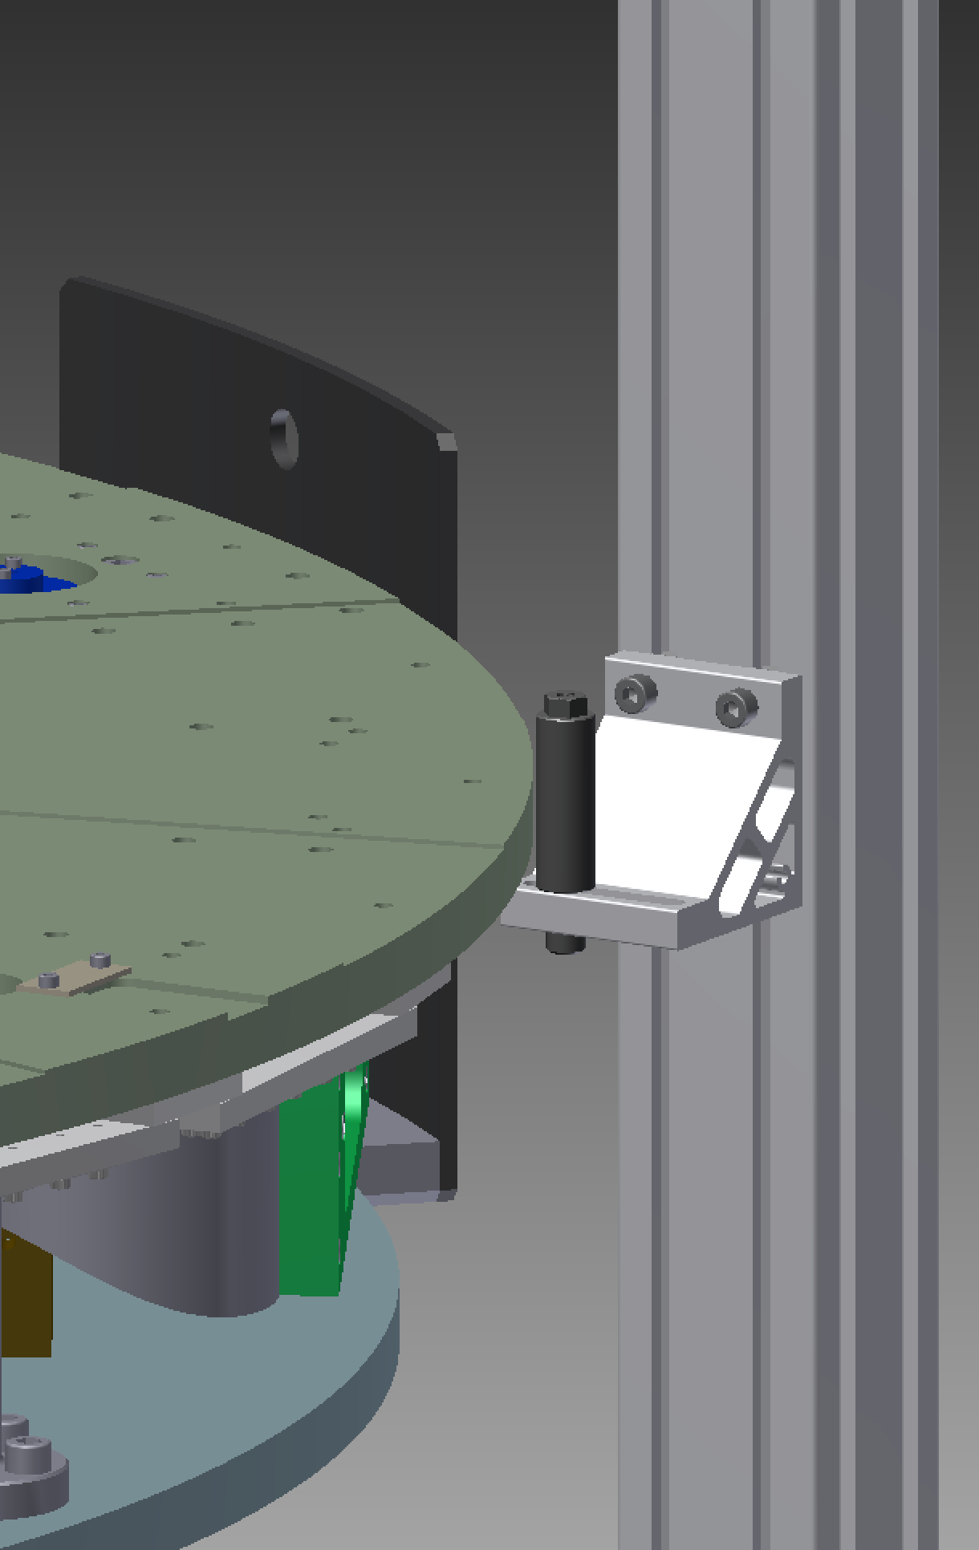  ≈42 mm  (This picture has the PI at its final, low position. In reality, at this step, it will be further up.)

Insert conical bellows
[1]: 3 x adapter_conical_bellows  {1}: 3 x Newport_PS-0_125_additional_machining  Below each IP leg, insert a [1] bellows from below into the large hole in the base of the PI. Support the [1] bellows and insert a {1} disc between the bottom of the bellows and the tip of the NB-03 jack.  While supporting the [1] bellows, lower the PI very gradually with the crane until there is about a 5 mm gap between the shoulder of the [1] bellows and the bottom of the PI, so that the [1] bellows are captured at the top and cannot fall off the jacks but are still not supporting the weight of the PI. | 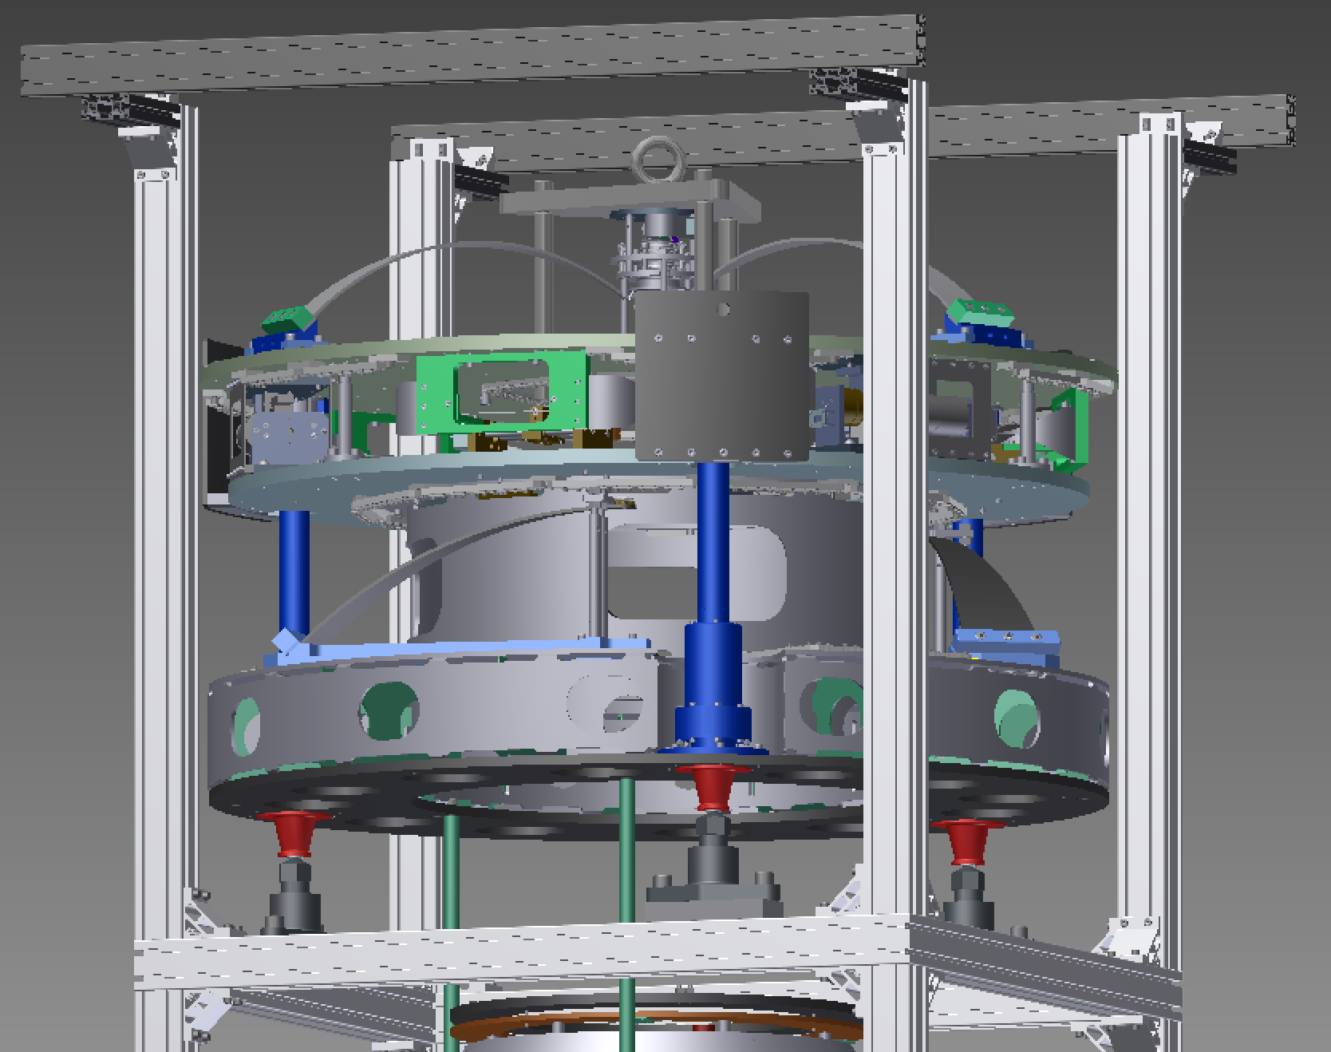  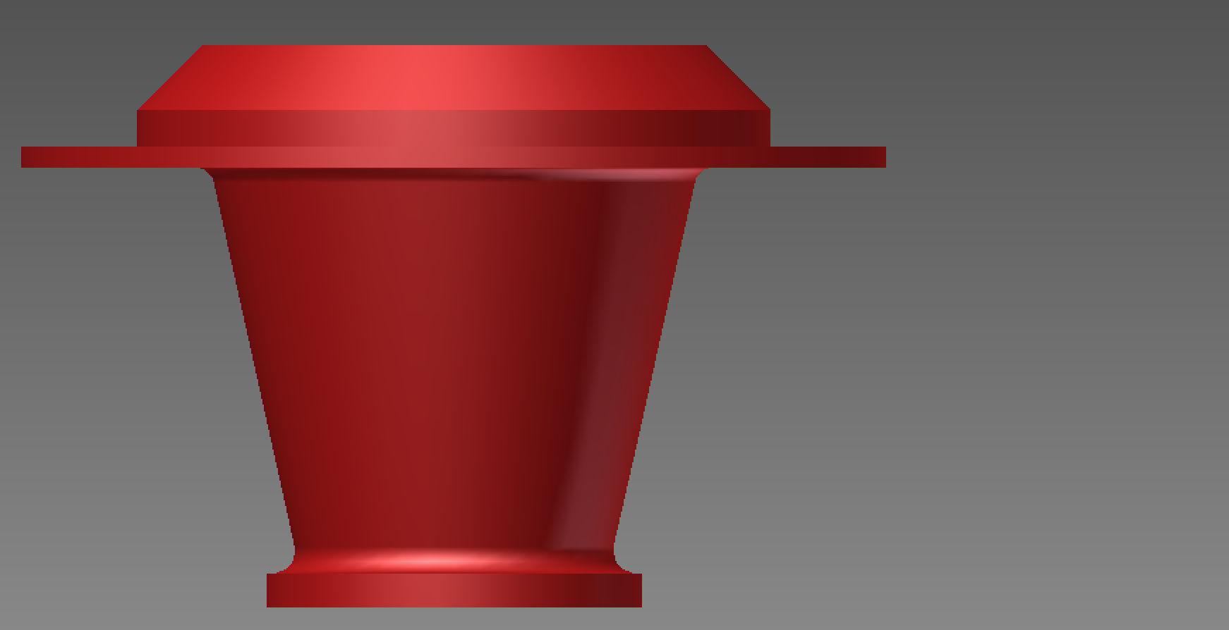  5 mm  (PI)  78 mm  14 mm

Attach SS rods to PI
[1]: 3 x Part-10005-rod security structure 602 (regular, or modified with M10 hole at top, depending on choice of plan in the previous step, 8.20)  Screw 3 x [1] rods around the ends of the screws from step 8.20, but leave them very loose so that it easy to back them off again.  If the rod is too stiff to turn, insert a hex wrench or similar tool into one of the vent holes about 30 mm from each end of the rod and use it as a lever. | 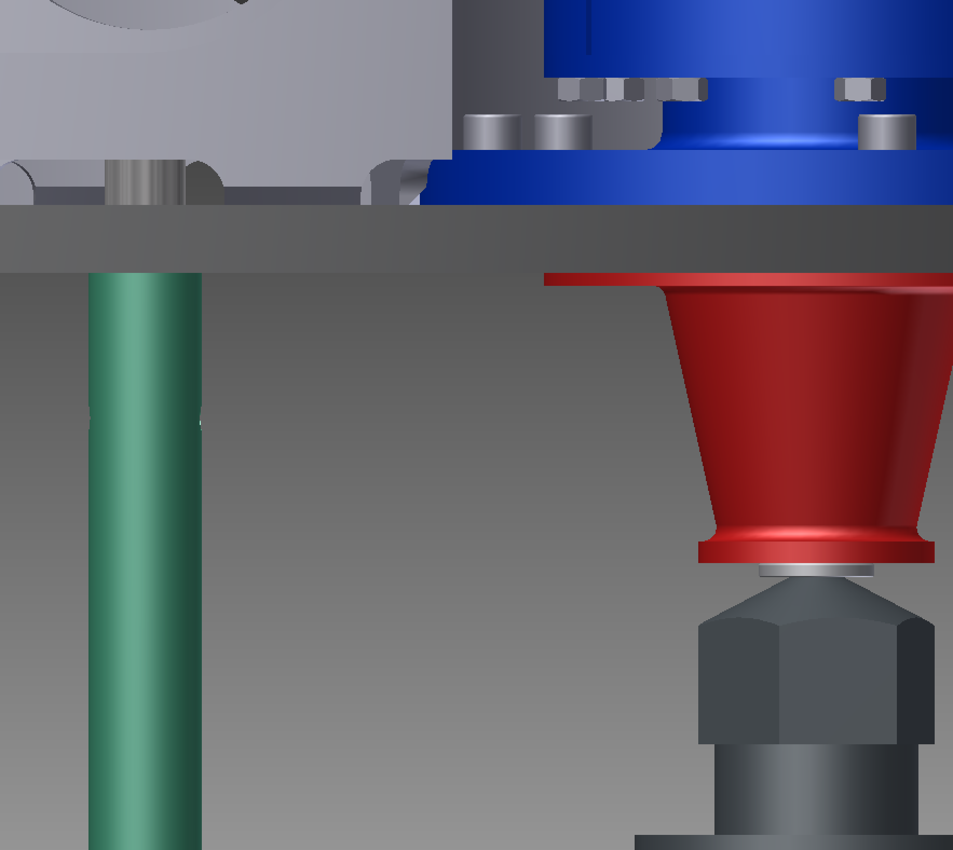  Vent/tool hole  Leave this very loose.

Connect SS rods to ring below SF
(1): 3 x ISO 4762 M12 x 35 treated  Check whether the rods line up with the holes in the security structure ring below the SF and make adjustments to the position/angle of the PI as needed.  Insert the 3 x (1) screws from below, through the security structure ring, and into the ends of the rods.  In small increments, gradually screw the (1) screws further into the bottom of the rods. After each round of adjustment, check the position/angle of the PI and the alignment of the rods. Stop if anything gets so stiff that it indicates an alignment problem between the PI and the ring. Also stop when there is a gap of about 5 mm between the screw heads and the bottom of the disk.  There will naturally be a gap of about 5 mm between the bottom of the rods and the top of the ring – don't worry about this. | 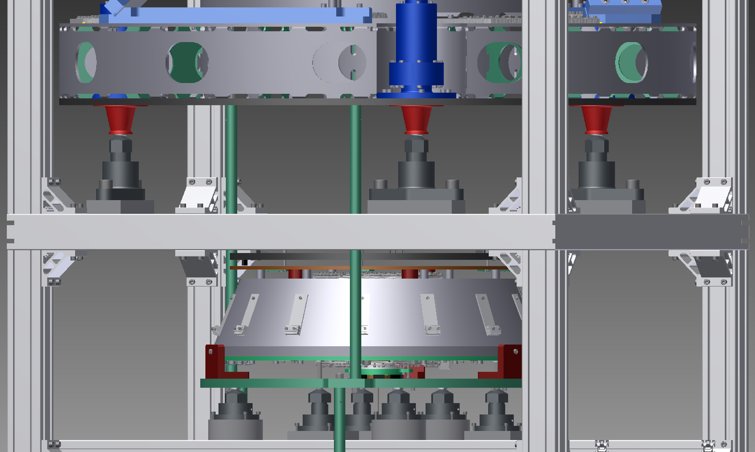  (1)  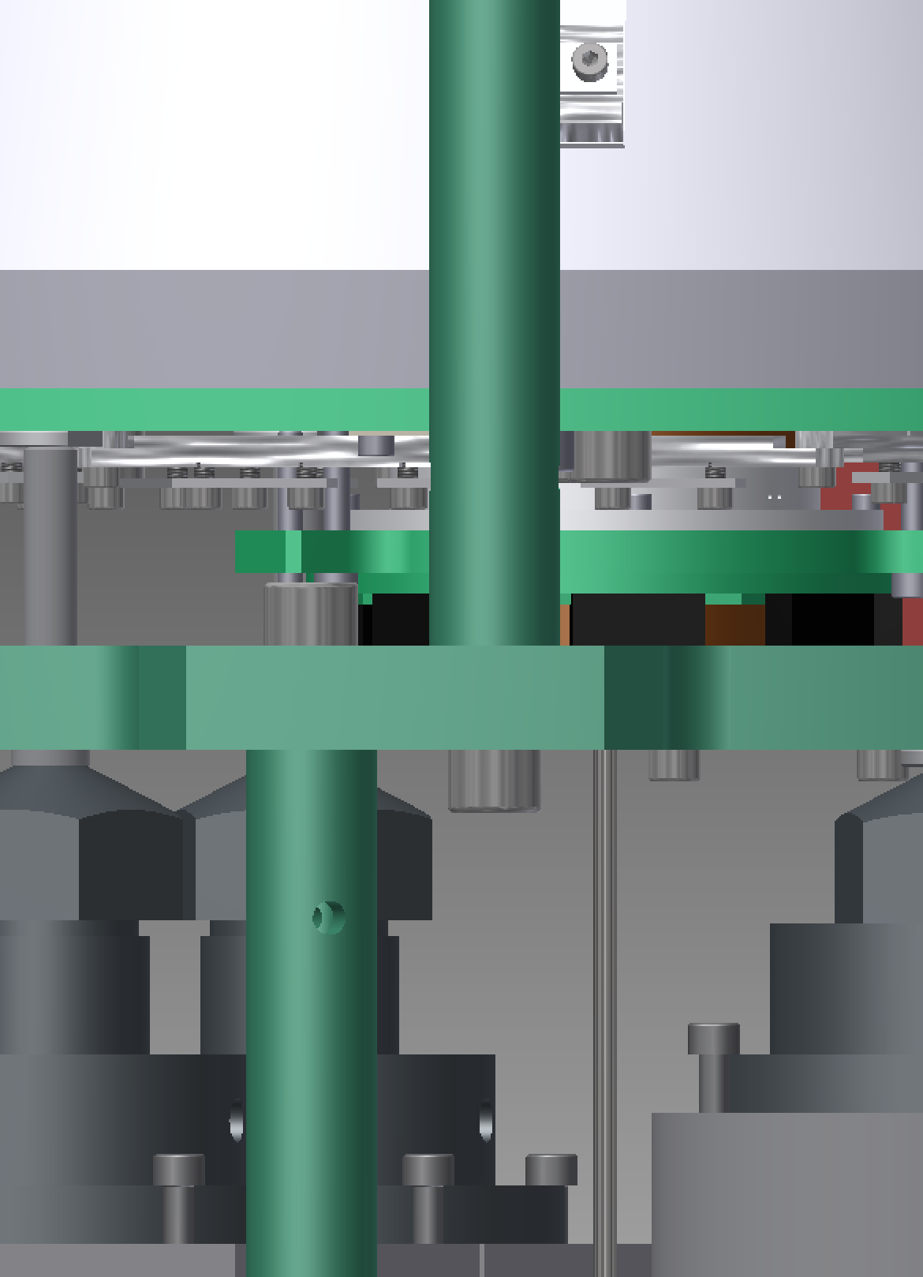  Leave at least a 5 mm gap here.  There will be a ≈5 mm gap here.

Raise jacks to support PI
Raise all the jacks in parallel by 1/6 of a turn at a time until at least one of the conical bellows has its flange against the underside of the PI (approximately 5 mm / 2 mm/turn = 2.5 turns). Ideally they should all touch after the same number of turns.
Recheck that the top of the PI is level.
If the flanges are not all touching, diagnose the problem and decide how to proceed.
Otherwise, raise all the jacks in parallel by steps of 1/6 turn for another 1-2 turns, or until the whole weight of the PI is on the jacks. If more than 2 turns are required, back off the screws at the bottom of the rods (from the previous step, 8.26) so that the ring below the SF is not lifted.
When the weight is completely on the jacks, disconnect the crane.
Then, lower all the jacks in parallel by steps of 1/6 turn for around 5 turns, until the rods are about to touch down on the ring under the SF.
Continue to lower the jacks in parallel by smaller steps until one rod does touch down. Recheck that the top of the PI and the ring are both level. If there is any visible gap between the bottom of the other rods and the ring, screw them down until they touch.
Screw in the 3 x (1) screws from 8.26 and tighten firmly.

Suspend SF damper ring
[1]: 1 x Part-43-Half-wire d 3.5  [2]: 2 x small hexagon assembly  [3]: 3 x Part-10031-wire damping filter standard  [???: Might have to hook wires at top end before PI is placed - 8.22.]  Attach 2 x [2] wire clamp assemblies to the [1] maraging rod.  Pass the [1] rod into the assembly frame and hook the top end to the keystone of the top filter.  Pass the 3 x [3] rods for the damper into the assembly frame and hook the top ends into the receiving parts (Part-36-regulation magnet’s plate).  Lift the damper ring and hook the 3 x [3] rods so that the ring is suspended.  Adjust the nuts on the rod receiving parts on the top side of the top filter until the gap between the damper ring (not counting magnets) and the Cu ring is 13.7 mm or TBD at all points. | 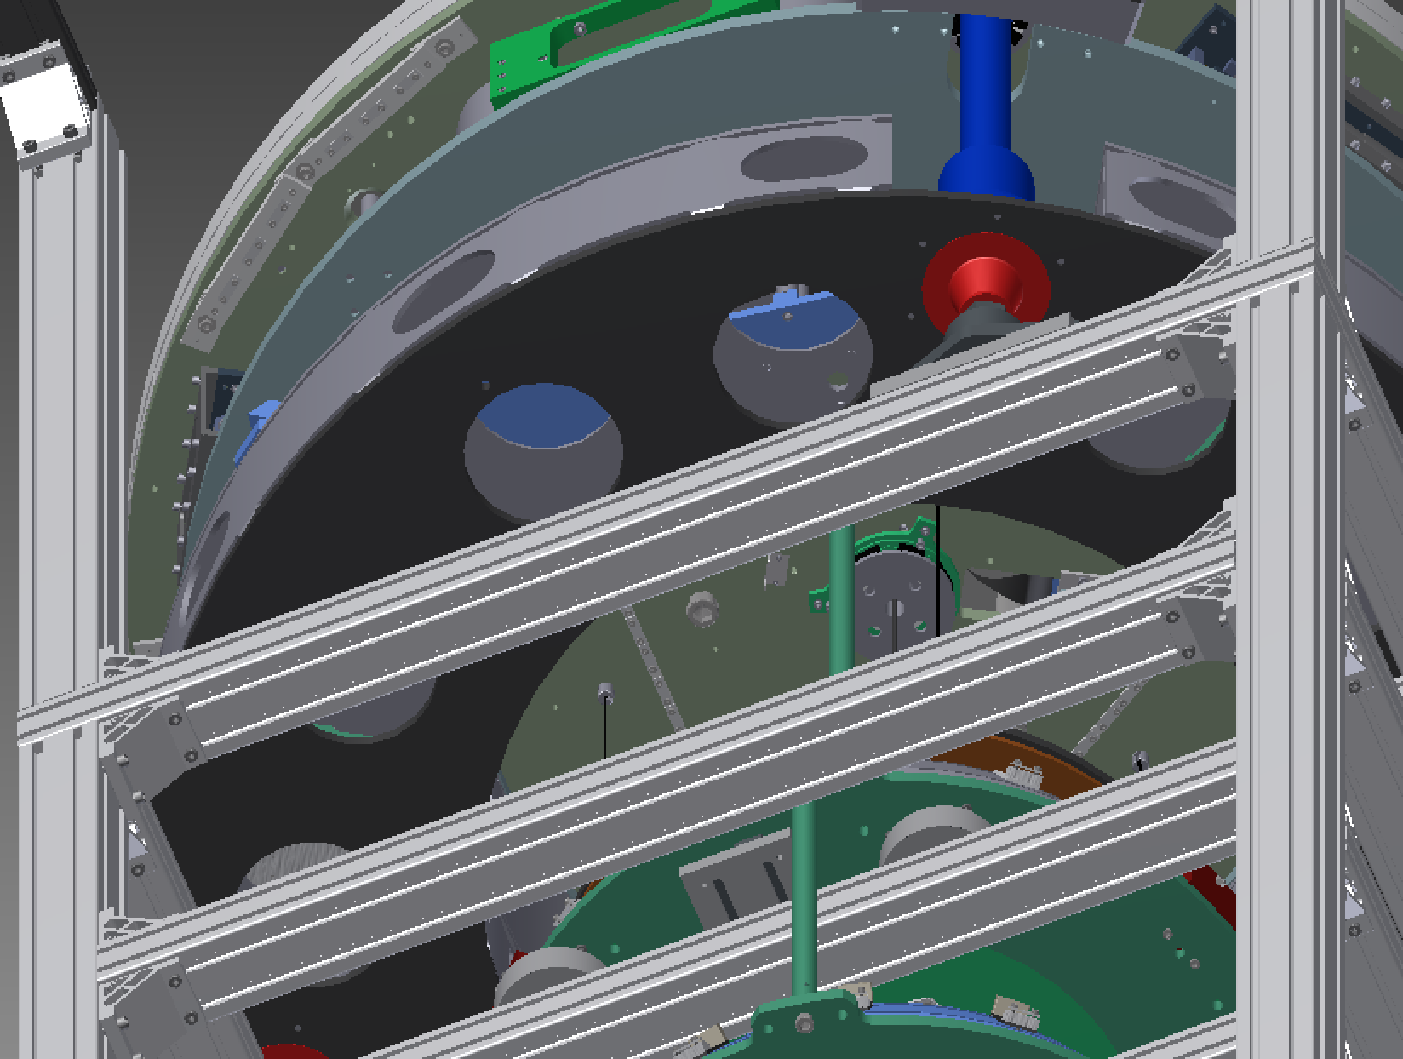  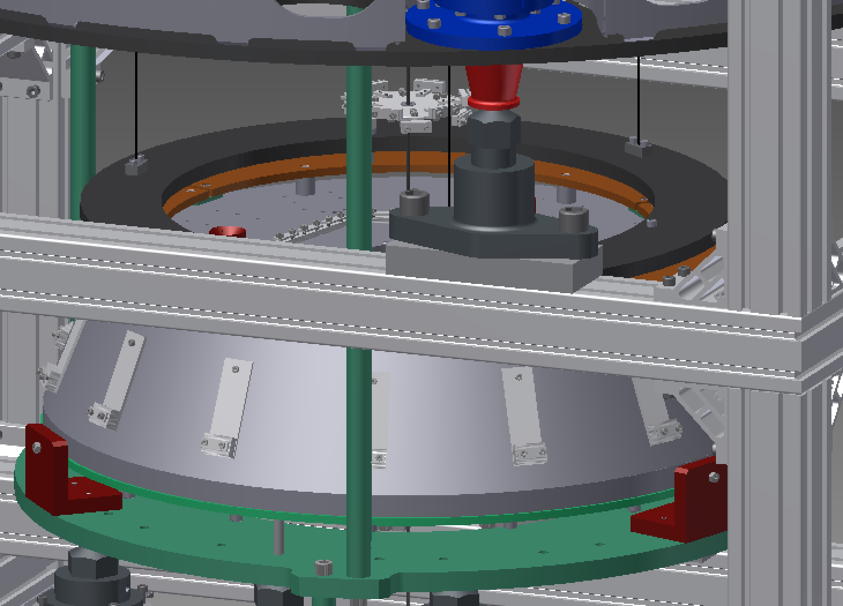  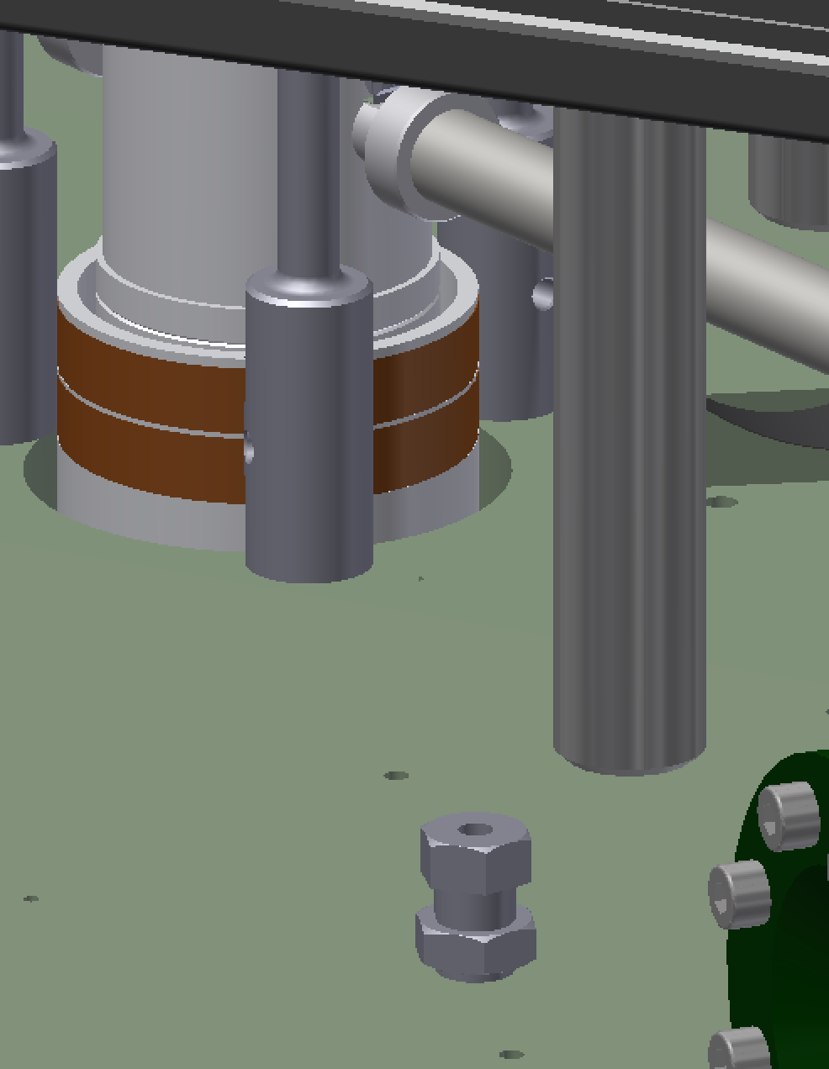

Route cables up to PI

Wire up LVDTs, picos, steppers
Required:
[1]: 4 x TR-Flange Signal Cable D1503901-19
[1’]: (if needed) 4 x Signal Cable Extension D1503901-10
[2]: 1 x PI Stepper Adapter D1503901-24
[3]: 4 x TR-Flange Motor Cable D1503901-20
[3’]: (if needed) 4 x Motor Cable Extension D1503901-16
[???: need to check existing wiring to see if correct length, gender]

Place PI ballast
Required:  [1]: approx. 6-9 x Arc_weight_IP_t38_n3  [2]: 6 (or TBD) x Part-51-tie rod  (1): 6 (or TBD) x ISO 7093 A ST 8 – 140 HV – A  (2): 6 (or TBD) x UNI EN 24032 M8  Install 6 (or TBD) x [2] tie rods at evenly spaced intervals around the edge of the top filter.  Install a first layer of 3 x [1] weights.  Install a second layer of 3 x [1], starting from a different point on the rim so that the weights in the two layers are staggered.  Secure the weights with a (1) washer and (2) nut on each [2] tie rod. | 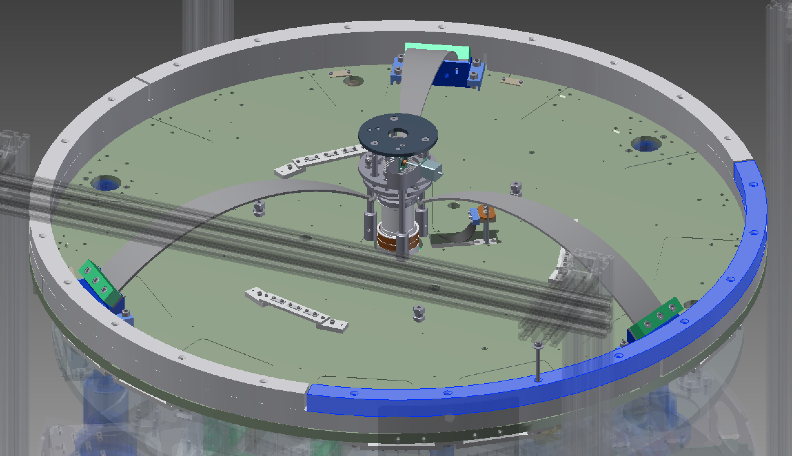  [2], (1), (2)  [1]

Install magic wands
Required:  [1]: 2 x Assembling balance units less items below  [2]: 2 x blade assemblies  [3]: 2 x B-part-49-clamp (9.5 mm, for keystone)  [4]: 2 x B-part-48-clamp (12 mm, for wand)  (1): 4 x ISO 4762 M4 x 20  (2): 4 x ISO 4762 M4 x 6  For each [1] wand, attach to the top filter with 2 x (1) screws. [???: At TAMA, the outer end of the wand fouled on the ballast mass – need to check this is fixed.]  Identify the top and bottom ends of the blade assembly: there is screw hole at each end of the blade, but the hole at the top end is nearer to the tip than at the bottom.  For each [1] wand, install a [2] blade assembly between the keystone and the end of the wand using [3]+(2) at the top and [4]+2 at the bottom. | 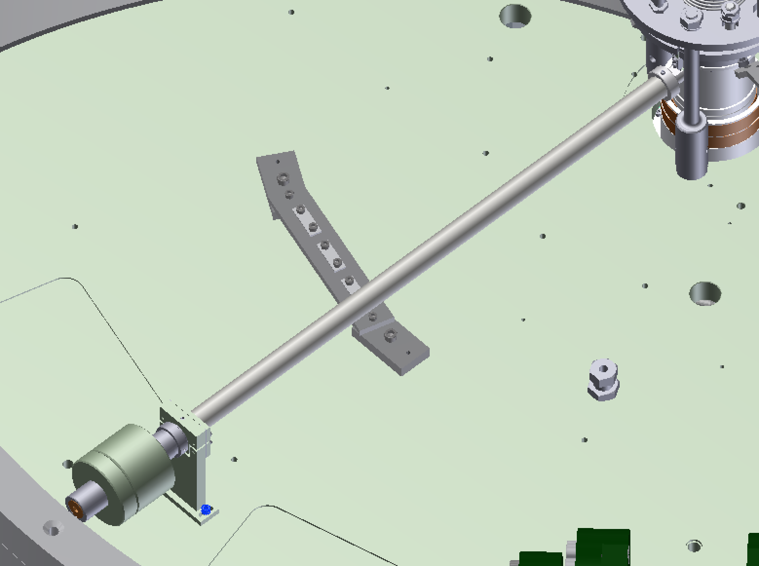  (1)  [1]  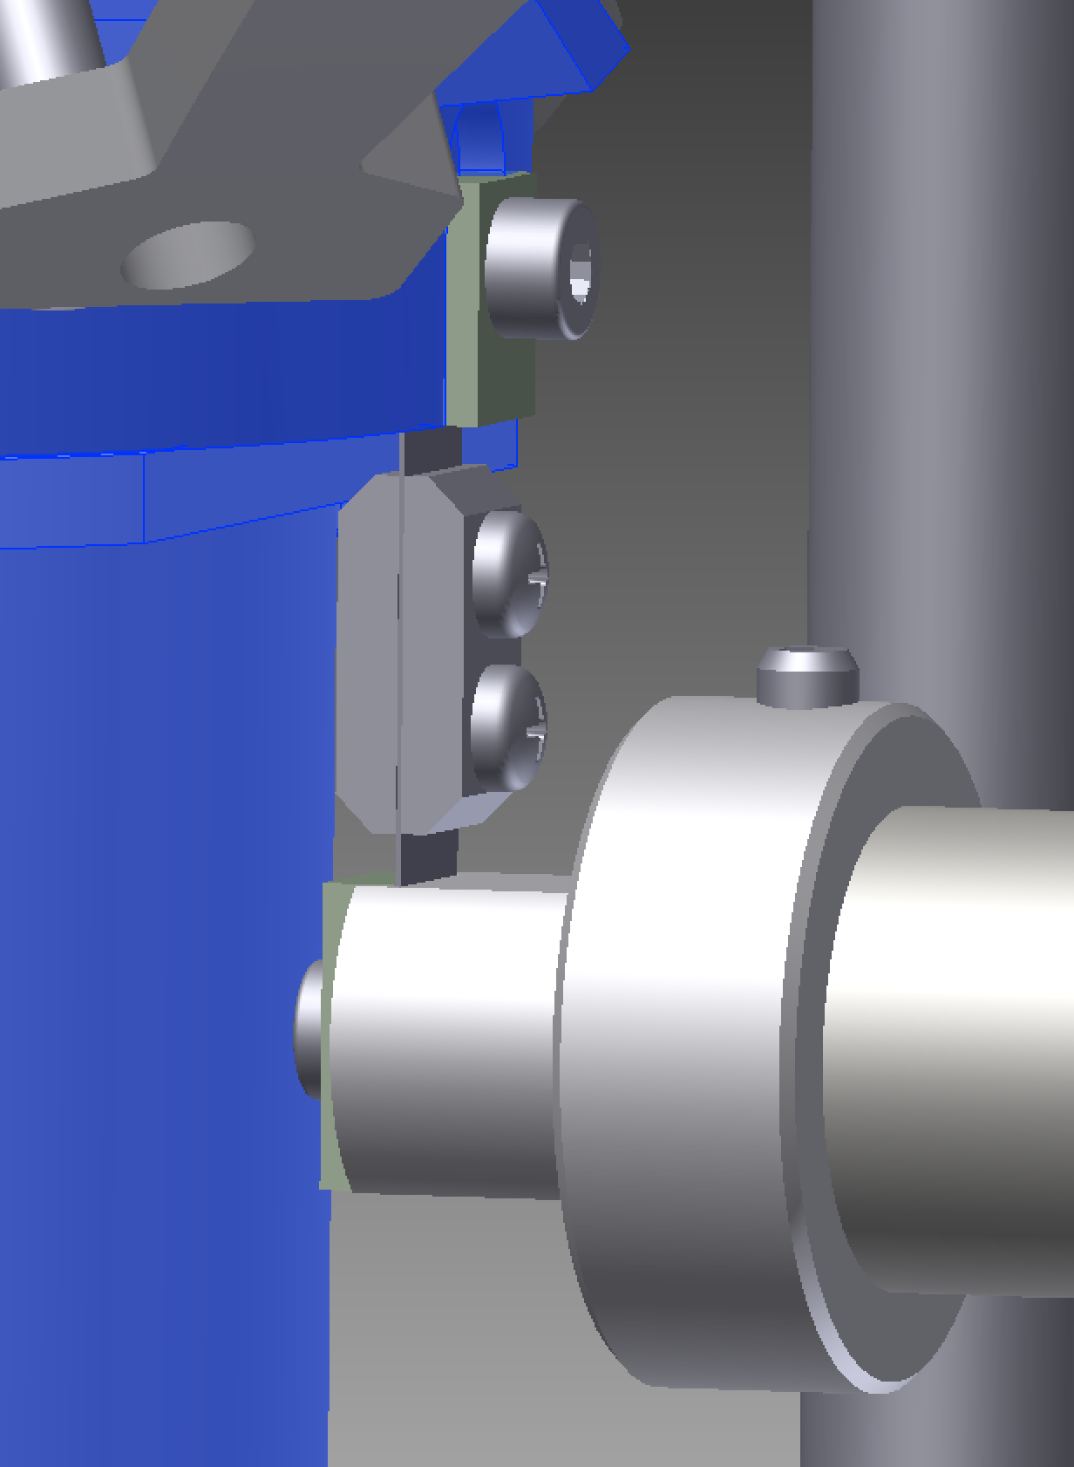  [2]  [1]  [3], (2)  [4], (2)  [2]

Install geophones
Required:  [1]: 3 x geophones in pods  [2]: 3 x geophone interface  [3]: 3 x geophone cable, D1503901 Sheet 07  (1): 12 x ISO 4762 M8 x 25  (2): 12 x ISO 4762 M10 x 20 treated  Handle the geophones with the connector end down whenever possible.  Attach each [1] geophone to a [2] adapter plate using 3 x (1).  Identify geophone locations: three positions on the top of the top filter, 30° clockwise from each spring base (clock positions 12:30, 04:30 and 08:30 as viewed looking in –X direction).  Put each geophone assembly in position with the connector end still pointing down.  Very slowly and carefully, lay each geophone assembly down to a horizontal position with the connector end pointing clockwise around the rim of the top filter.  Fix each assembly to the top filter using 4 x (2).  [???: Mass of geophones is ≈32 kg per VI elog 4/16/2015] | 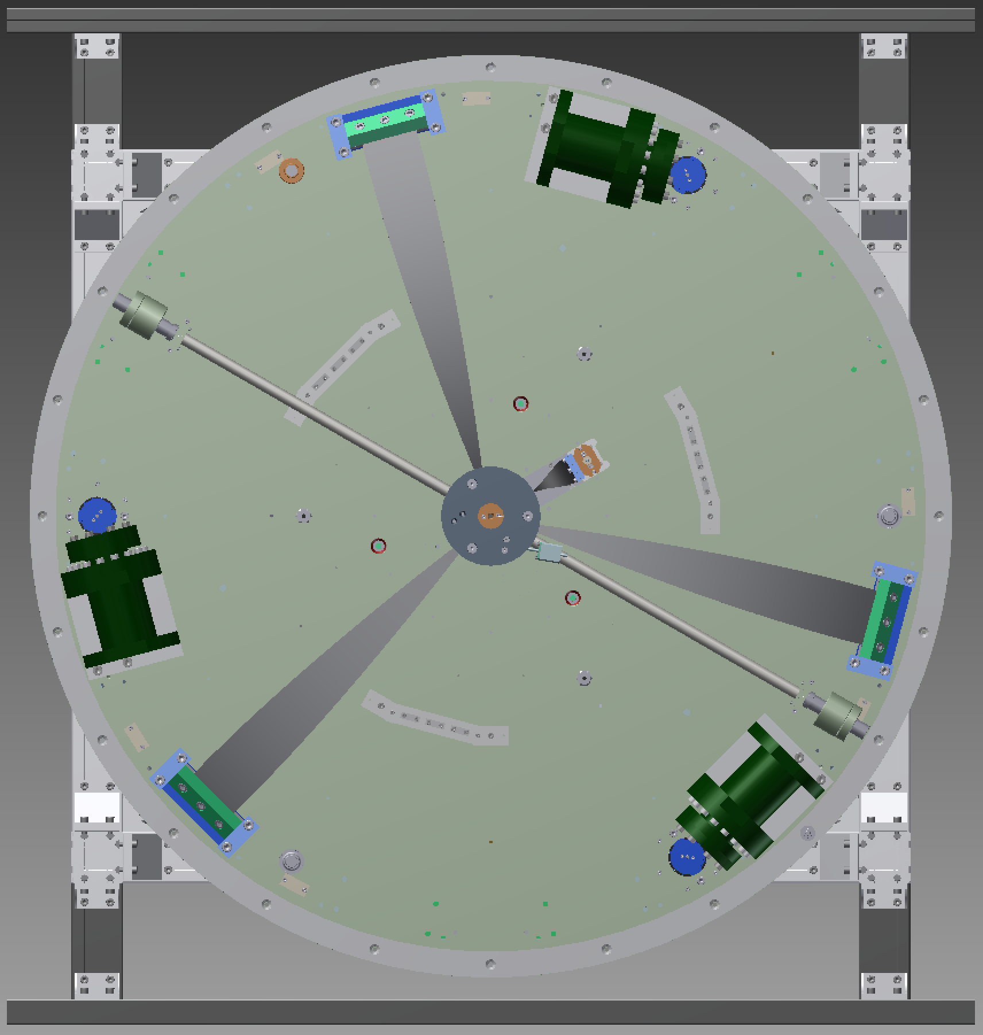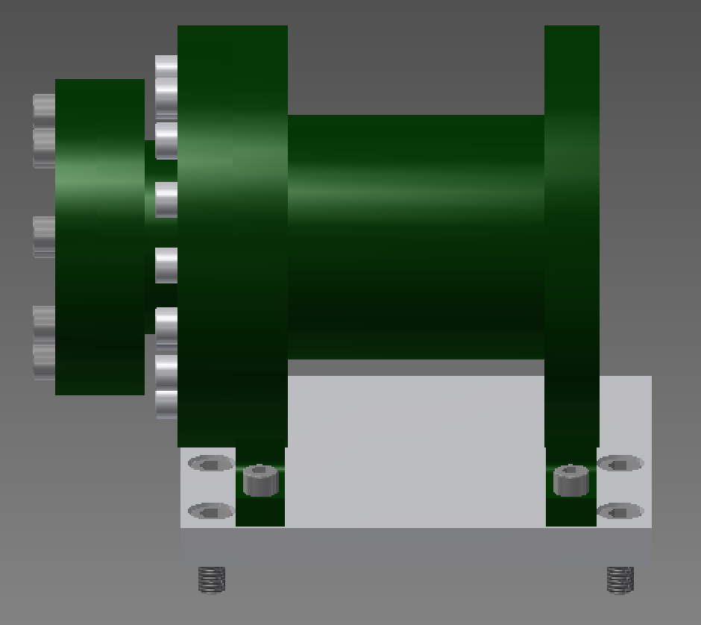  [1]  [2]  (2)  (1)  -Y  (tank)

Hook SF+BF+payload and lower SF to suspend SF+BF+payload

Level, center, tune PI

Attach security transport plates
Required (see D1605179):  [1]: 3 Part-34-security transport  [2]: 3 Part-35-security transport  (1): 3 ISO 4672 M8 x 16 treated  (2): 4 ISO 4762 M8 x 25 treated  (3): 4 ISO 4762 M8 x 60 treated  Assemble 3 x [1] and 3 x [2] with 3 x (1), leaving the screws slightly loose.  At three places around the PI (near each leg), attach [1]+[2] using 4 x (2) at the top and 4 x (3) at the bottom.  Tighten all the screws. | 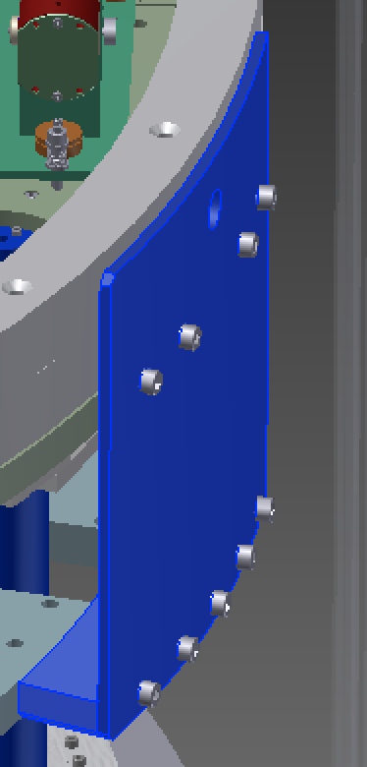  (2)  (3)  (1)

Dummy procedure step for cutting and pasting

