JGW-E1503840-v2 KAGRA 11 August 2015

PR2/PR3/PRM Suspension Installation Procedure

Mark Barton

Distribution of this document:
JGW-DCC

This is an internal working note
of the KAGRA collaboration.

http://gwcenter.icrr.u-tokyo.ac.jp

Table of Contents
1 Introduction 3
1.1 Purpose and Scope 3
1.2 References 3
1.3 Version history 3
2 Background 4
2.1 Type of Suspension 4
2.2 Constraints/Assumptions 7
2.2.1 Pre-assembly 7
2.2.2 Constraints from the cleanbooths 8
2.2.3 Mechanical constraints 11
3 Procedure 11
3.1 Install optical bench and damper 11
3.2 Setup of assembly area 12
3.3 Assemble payload 12
3.4 Add BF 12
4 Construction 12

Introduction

Purpose and Scope
Describes how to assemble and install a PR2 or PR3 Type Bp suspension at Kamioka.

References
stuff

Version history
7/16/2015: Pre-rev-v1 draft.
8/7/2015: -v1 for pre-review
8/11/2015: -v2 for review

Background

Type of Suspension
The PR2, PR3 and PRM suspensions will be Type Bp, which is a cut-down version of the full Type B, with a traverser replacing the preisolator (inverted pendulum and top filter). (See Figure 4 for a diagram with the key parts labeled.) That is, it consists of:
- Traverser
- SF (standard filter)
- IM (intermediate mass) and IRM (intermediate recoil mass)
- Optic and RM (recoil mass)
- Damping ring suspended around the suspension (between the BF and IM/IRM levels) via cables from traverser
- Optical bench supported below the optic via cables from the damping ring.
The SF is mounted directly on top of the traverser rather than suspended from it as for the full Type B.
PRM is not needed till bKAGRA and will use subassemblies recycled from EXA or EYA.
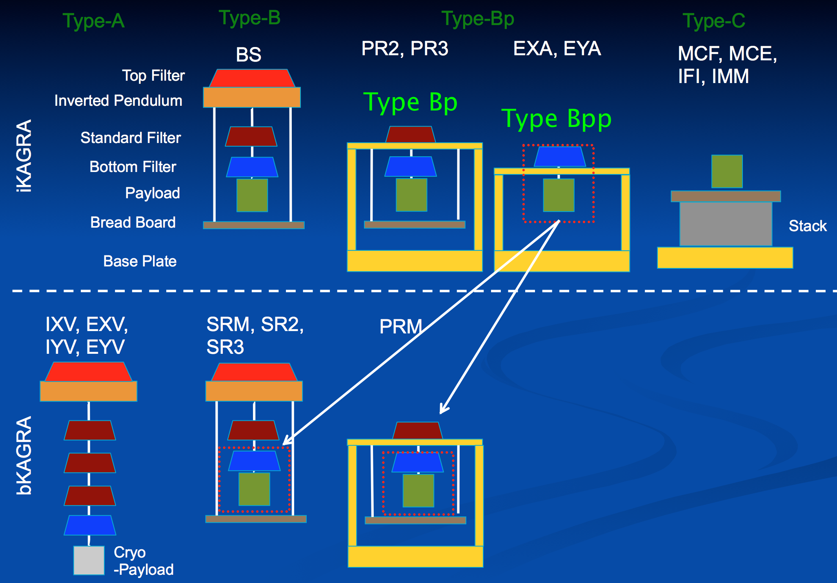
Figure 1 - Suspension types - from JGW-G1503737-v6
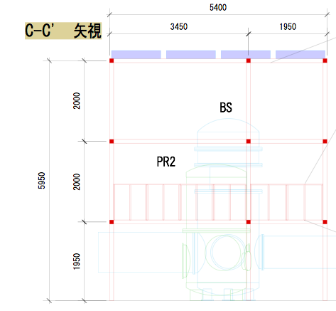
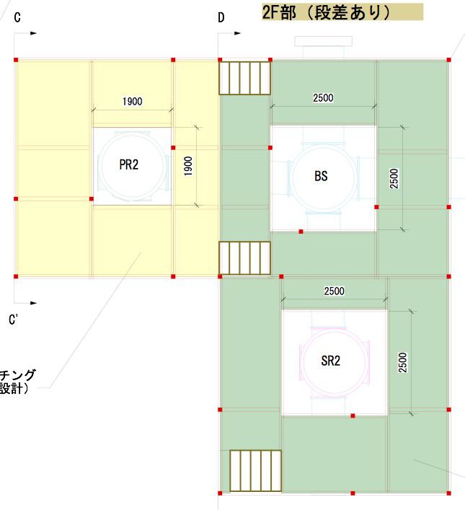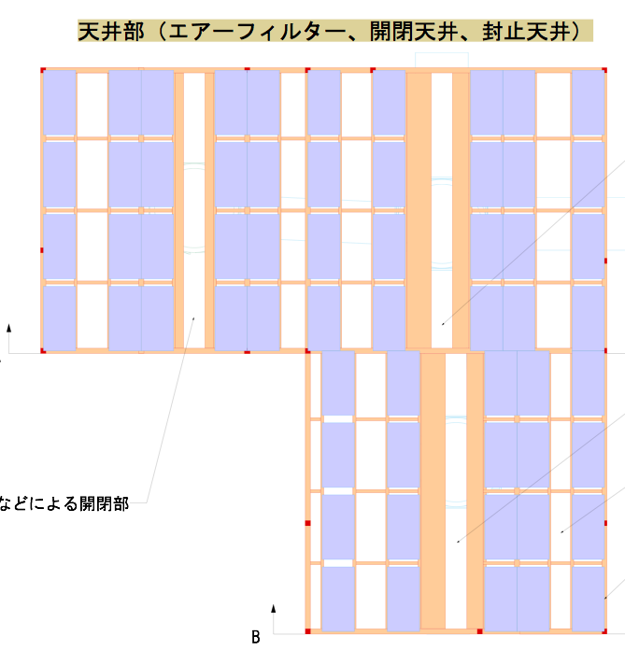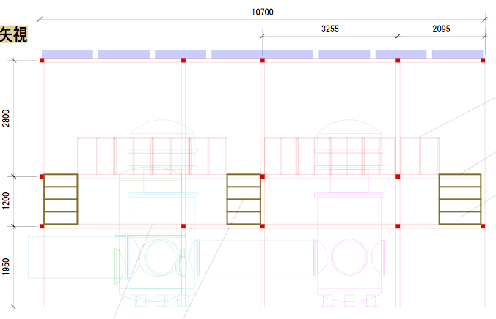
Figure 2 - Cleanbooth around PR2 (and BS/SR2) - work areas indicated with red arrows
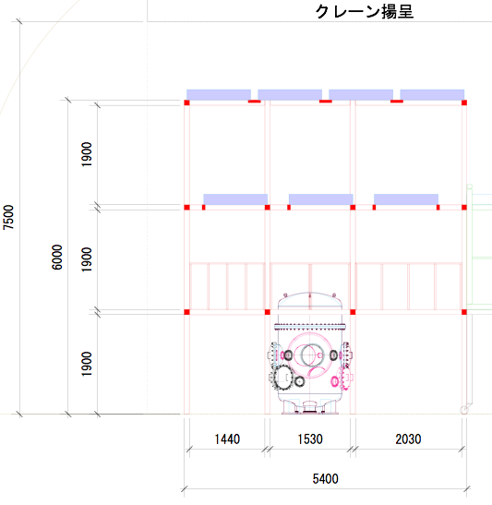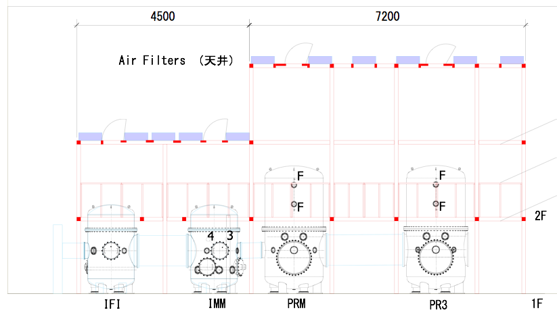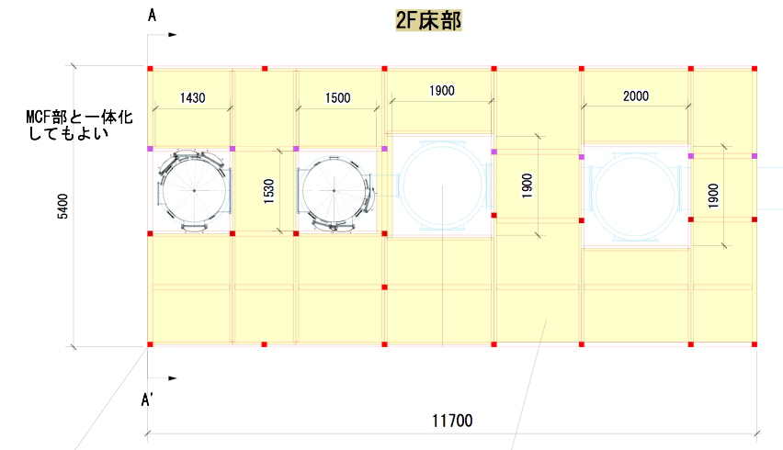
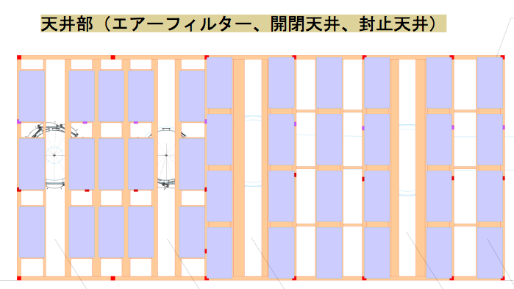
Figure 3 - Cleanbooth around PR3/PRM (and IMM/IFI) - work areas indicated with red arrows
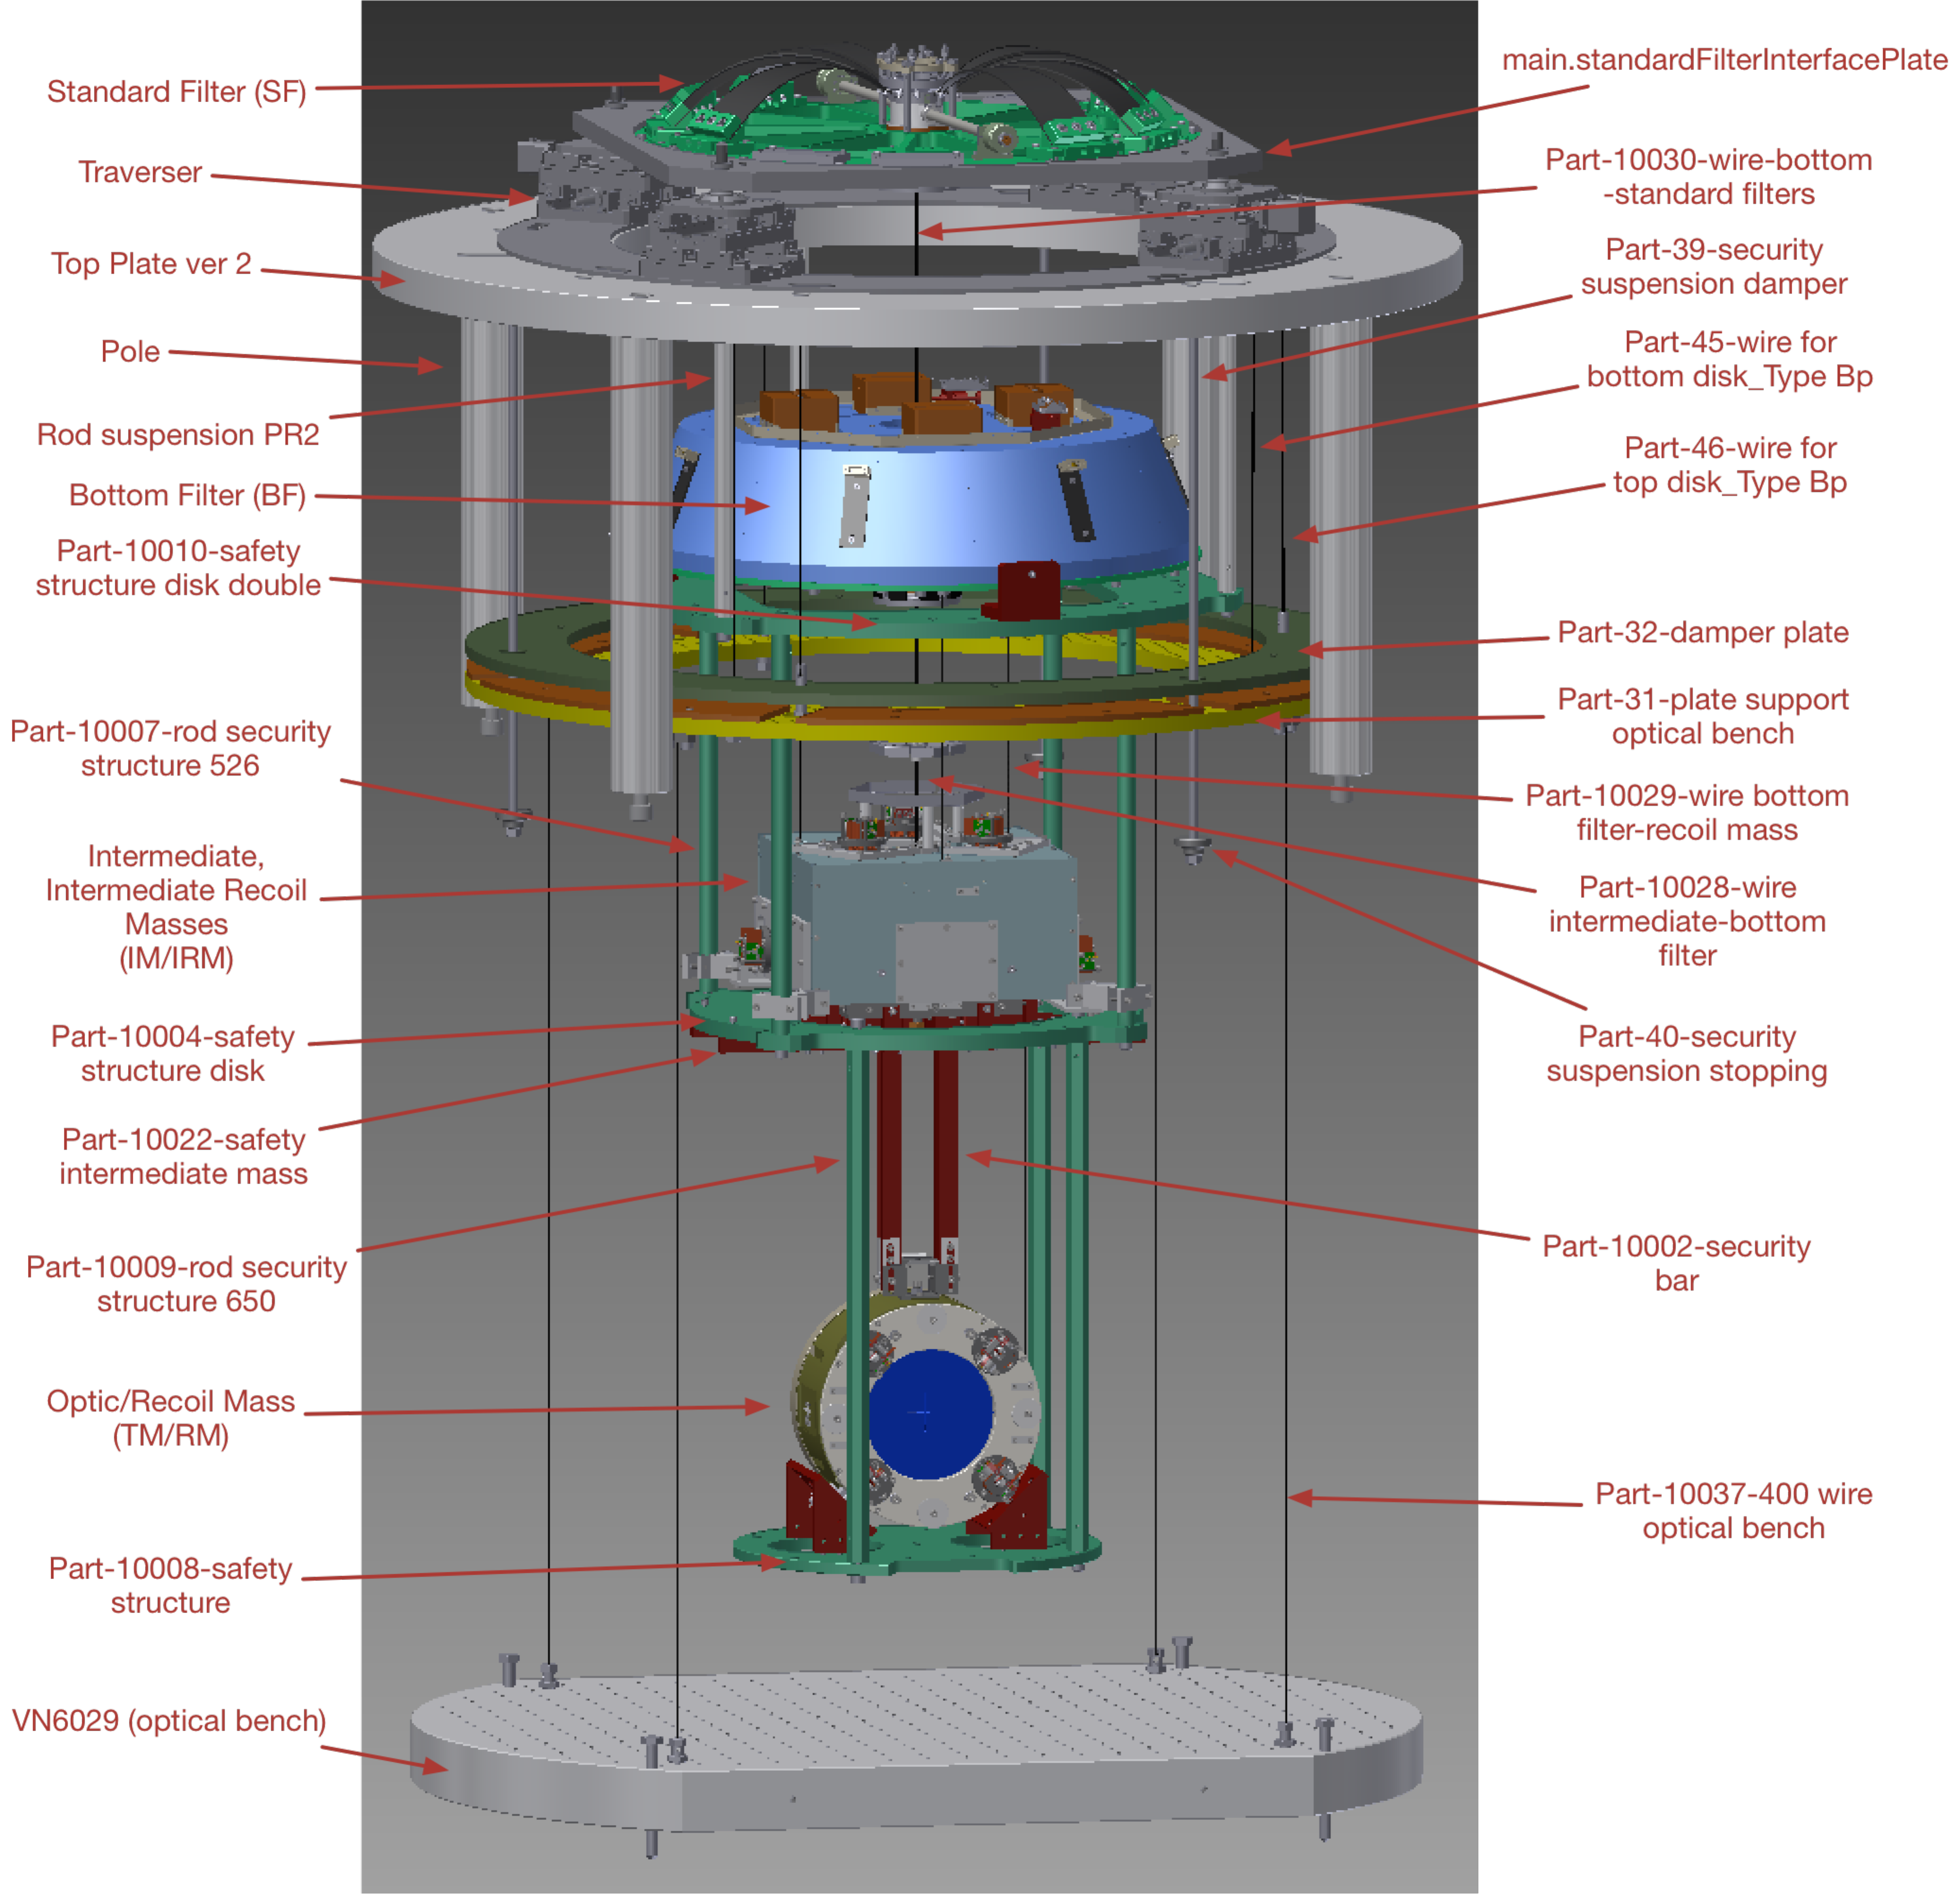
Figure 4 - Items to be installed, with Inventor names of items relevant to assembly order

Constraints/Assumptions

Pre-assembly
- The “support pipe” that holds the traverser will already have been installed in the vacuum pipe.
- As far as possible, the major components (traverser, SF etc) will be assembled individually at NAOJ, shipped to Kamioka and then combined.
- The optic will arrive with the flags and standoffs already glued on.
- The RM is so simple that it barely matters. The OSEMs will probably not be installed to avoid possible damage in shipping.
- The IM will arrive assembled except probably for the flags, which would be easy to damage in shipping.
- The IRM will arrive assembled except probably for OSEMs, which would be easy to damage in shipping.
- The BF and SF will arrive assembled except for fine trim mass on the BF (which will only be decided after a trial hanging of the entire chain from the SF), with the wires from the internal components terminated with Burndee pins inside the shell (i.e., without the Burndee to D-Sub adapter cables.)
- The traverser will arrive assembled, mounted on the “top plate”, with brackets to immobilize it during shipping.

Constraints from the cleanbooths
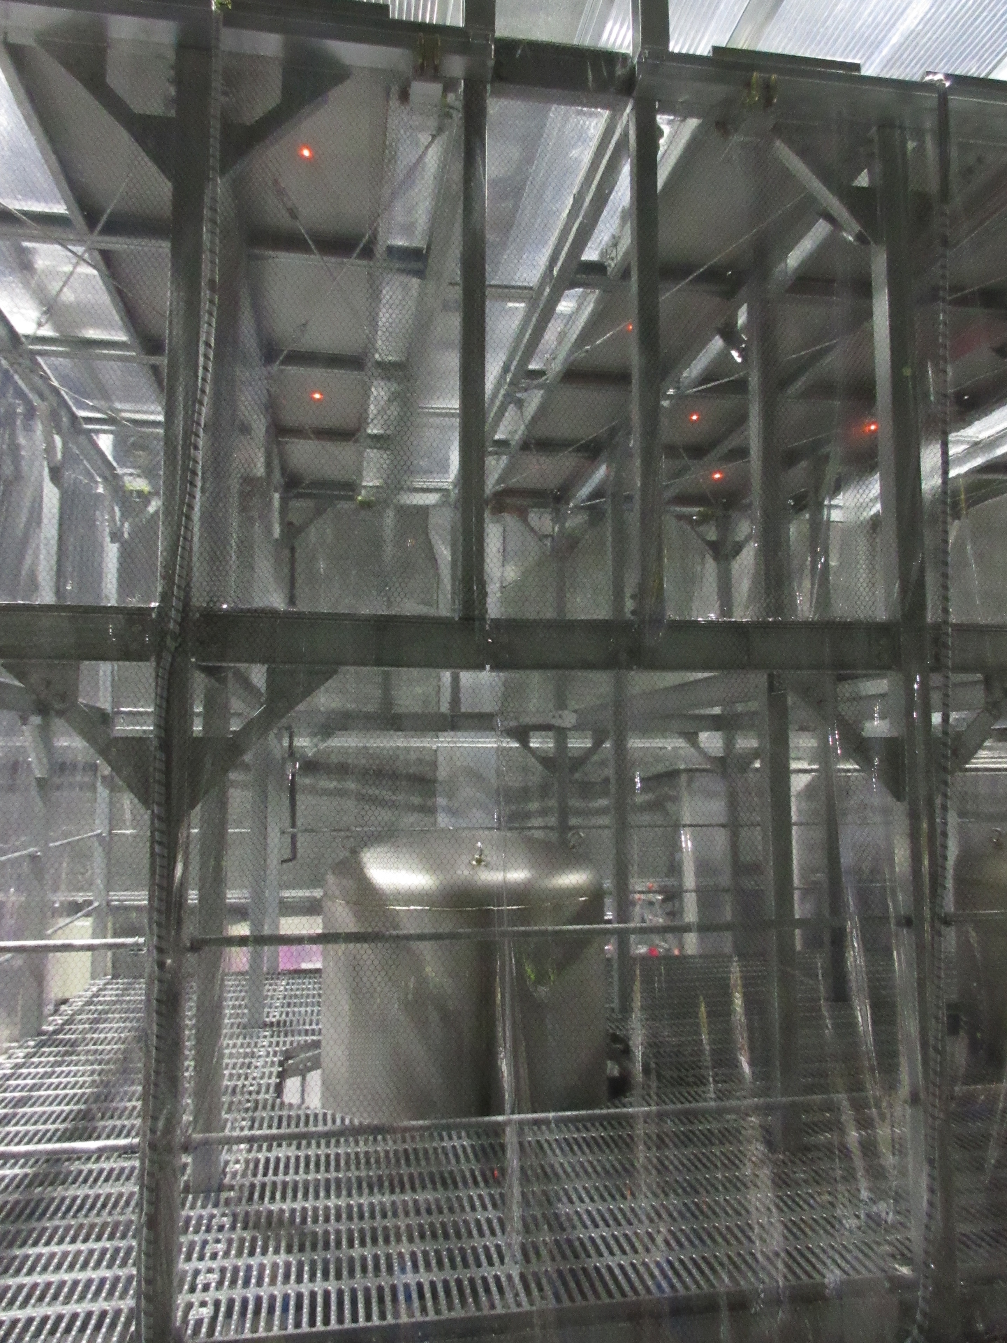
Figure 5: View of the second floor of the cleanbooth around PR3. The area in the foreground is approximately 1300x2050 mm and is where the suspension will be assembled prior to insertion. (There’s a bigger space on the far side, but it needs to be kept clear for the tank lid.) One of the diagonal braces in the corners is highlighted.
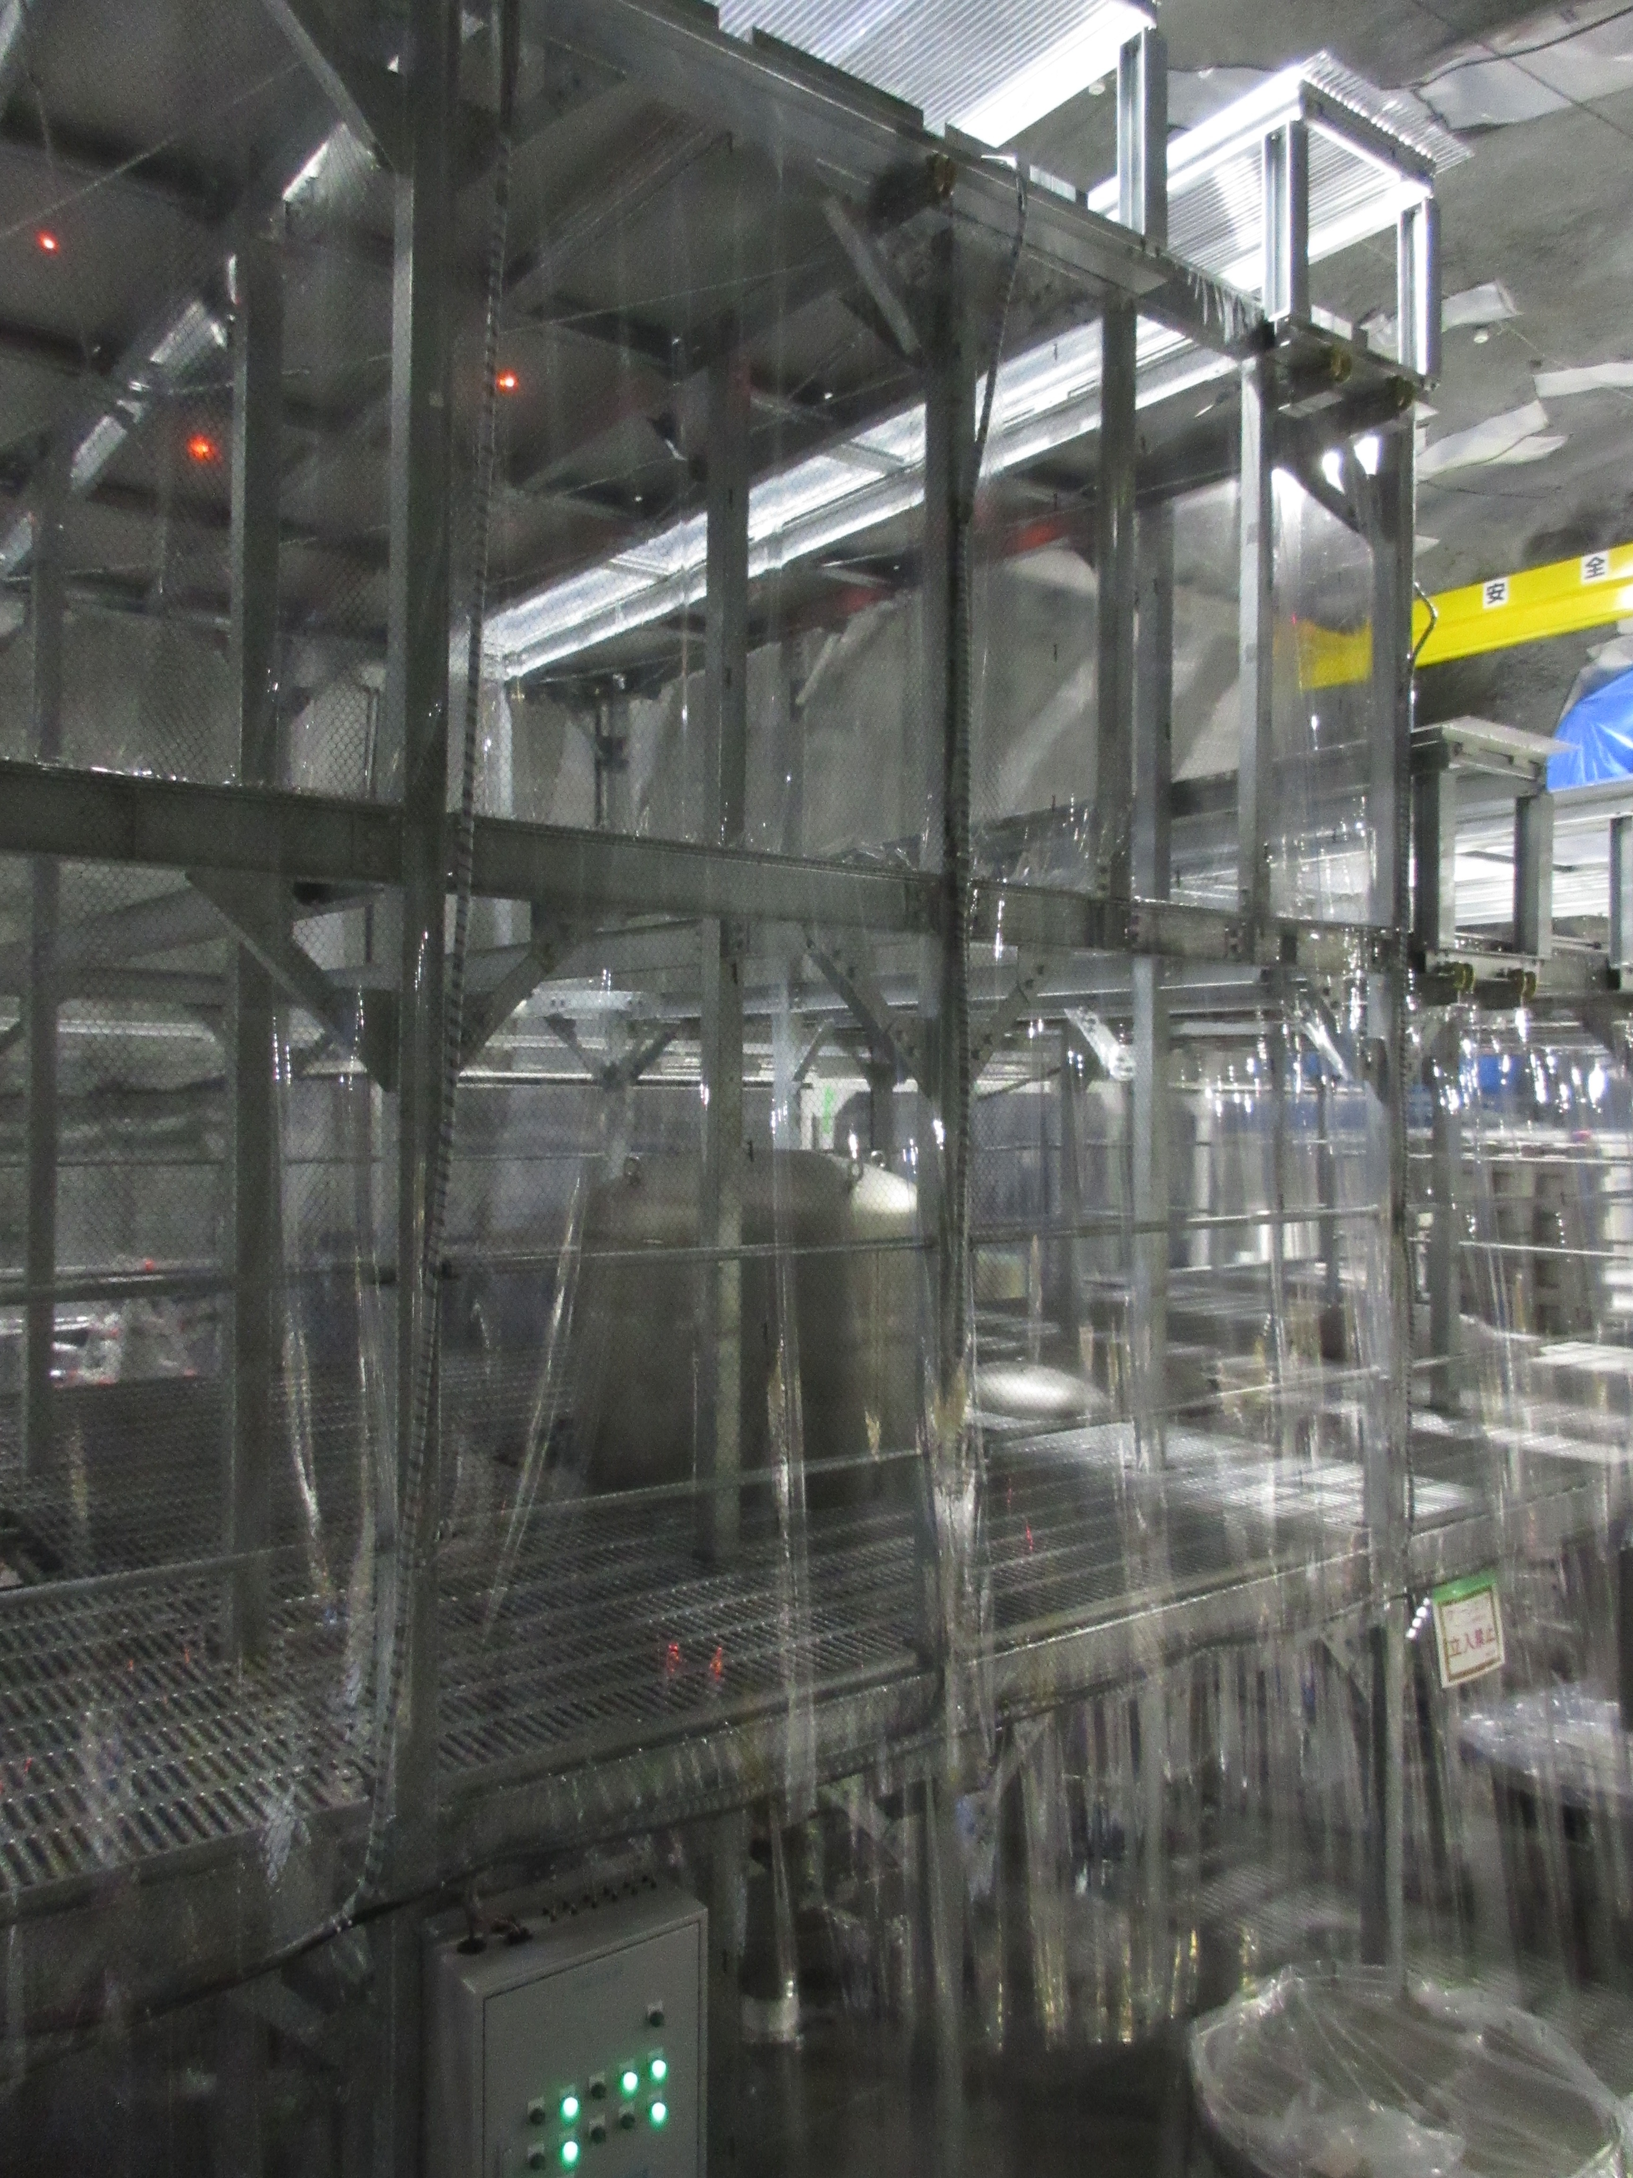
Figure 6: View of the second floor near PRM. The space to the front left of the tank is 1300x2050 mm, slightly smaller than for PR3. The space to the back right is larger but reserved for the tank lid.
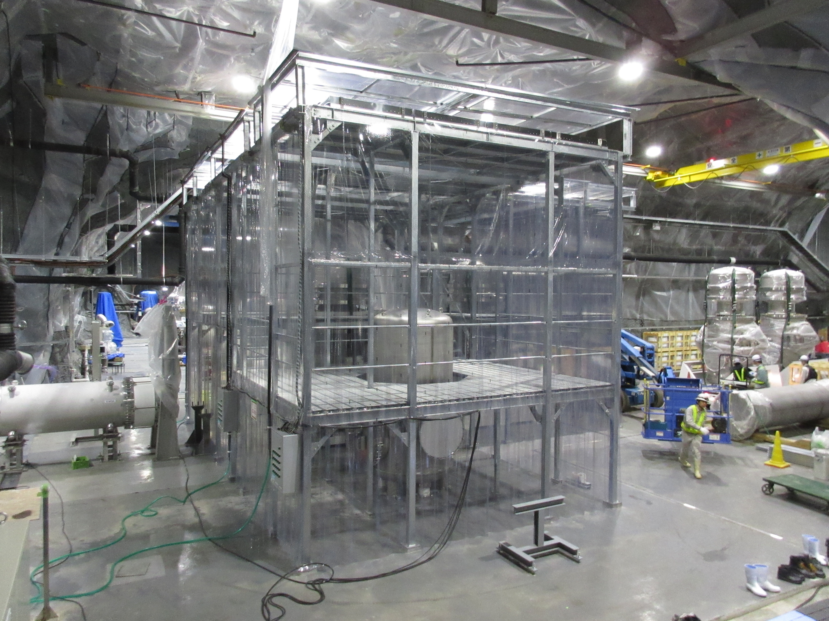
Figure 7: The second floor around PR2. The space on the left will be used for assembly and is ???x2010 mm. The space on the right has to be reservd for the tank lid.
- Most final assembly will have to be done on the second floor of the cleanbooths - see Figure 5, Figure 6 and Figure 7.
- The vertical space shouldn’t be a problem. The height of the suspension chain is 1968 mm, whereas the ceiling is ≈3800 mm for PR3/PRM (≈4000 for PR2), except in the corners where there are some short diagonal braces across the corners at about head level (1890-2040 from floor, see Figure 5).
- The second floor of each cleanbooth is composed of panels with slots to allow circulation of clean air. The panels come in two widths: 250 mm (wide) with 210x20 mm slots every 40 mm; and 200 mm (narrow) with 160x20mm slots every 40 mm. These are supported by joists that run across the cleanbooth every 2-3 m. A complex mix of wide and narrow panels are used - in Figure 5 and Figure 6 the pattern is W NNN WWWWW NNNN WWWWW NN W from foreground to background.
- The floor panels are rated for loads of 500 kg/m². The weight of the suspension with traverser is approximately 964.6 kg (Hirata-san’s calculation) but it would probably be better to design the assembly frame with feet that stand on the joists on either side of the tank and don’t rely on the panels.
- The crane hook access slots in the cleanbooth ceiling only run one way (see Figure 2 and Figure 3) so the assembly has to be done at a position somewhere along that line.
- When the tank is opened for insertion of the assembled suspension, the vacuum tank lid has to be moved to somewhere on the same line. (Even if the crane moved in two directions, the pillars near PR3 and PRM prevent the lid from being moved very far.)
- In each case (PR2/PR3/PRM) the opening in the floor for the tank is not central in the work area, creating a narrow space and a wide space: 1300+opening+1790 mm for PRM, 1530+opening+1780 mm for PR3, ???=opening+??? for PR2.
- The vacuum tank lid is too big to be stored at the narrow end, so the wide space has to be made empty before the suspension can be inserted in the tank. That means most assembly will have to be done at the narrow end, e.g, 1300x2050 for PRM, 1530x2350 mm for PR3, ???x2100 mm for PR2 (foreground of Figure 5 and Figure 6; left of Figure 7.)
- Because of the linear motion of the crane it will be difficult to move anything heavy or delicate into the cleanbooth. The cleanbooth for PR3 and PRM is connected to the MCF cleanroom, which has a small area for moving items between floors with the crane while staying inside the clean area. However this is at the far end from the PR3/PRM areas and the floor in between is slotted and slightly uneven. So anything that can’t be carried probably has to come in another way. And the PR2(/BS/SR2) has no areas for moving loads between floors.
- One possibility may be to use the portable staircase. Loads could be delivered onto the top of the staircase using the crane and then pulled inside.
- The crane at Kamioka is slower and smoother than the one at TAMA.

Mechanical constraints
- The earthquake stop structure attaches to the underside of the top plate supporting the traverser, so there is no possibility of installing the traverser separately from the rest of the chain.
- The assembly of the entire suspension (top plate supporting traverser down to optic) will be done on the second floor of the cleanbooth and the chain will then be craned into the tank on top of the traverser.
- A frame similar to the one used for the Type B prototype test at TAMA will be needed to support the suspension during assembly.
- The vertical space available is not nearly enough for the suspension chain to be lifted out of its assembly frame vertically (as was done at TAMA), so the frame has to be designed to allow the suspension to slide out sideways.
- All three tanks have a pair of joists nearby with a separation in the range of approximately 1900-2100 mm so probably the same design of frame could work for all three if it had 100 mm of adjustment in the position of each of the feet.
- Several times during the Type B prototype test at the TAMA West End there was damage to flags during craning of the suspension. The crane at Kamioka is slower and smoother but the number of crane movements should be minimized. Therefore if possible, the entire suspension should be built up in the position it will be in immediately before final installation, so there is exactly one crane movement.

Procedure
This is just a rough outline as yet:

Install optical bench and damper
This version of the procedure assumes the optic and RM will be hung from the IM/IRM where the rest of the suspension is to be built up, on the “narrow” side of the cleanbooth. If this is inconvenient (considering that they would be rather close to the floor) they could be connected on a table on the wide side of the space (where the tank lid will go later) and be craned to the narrow side.
- Bring in
- Get small optical breadboard (≈800x800 mm, no legs) onto 2F.
- Put “Part-31-plate support optical bench” ring on top of optical bench.
- Put “Part-32-damper plate” on top of support ring
- Install eye-bolts or similar on support ring.
- Using crane, lift support ring with damper ring on top.
- Install 4 of “Part-10037-400 wire optical bench”.
- Using crane, lift damper ring plus support ring plus optical bench.
- Lower rings and optical bench into the vacuum tank until the optical bench is below the top of the support tube.
- Place cross-beams across the top of the support tube.
- Lower the rings and optical bench until the rings are sitting on the cross-beams.
- Disconnect crane and remove eyebolts.

Setup of assembly area
- Place floor mat in center of area where the suspension is to be built up.
- Place breadboard from small assembly frame (as used at 20 m lab) on the floor mat.
- Place spacers of TBD height on the breadboard and bolt them down. [??: decide height of spacers]
- Place the hanging frame from Fabian’s procedure, JGW-E1503830, and clamp it to the spacers.
- [??: Other stuff?]

Assemble payload
This will be done according to Fabian’s procedure, JGW-E1503830, Procedure for hanging the test and recoil masses. It will end with the IM/IRM sitting on the hanging frame, via the “Part-10022-safety intermediate mass” bars and the “Part-10004-safety structure disk” ring. The winch fixtures will have been removed.

Add BF
- Attach “Part-10007-rod security structure 526” rods on top of “Part-10004-safety structure disk” ring.
- Attach “Part-10010-safety structure disk double” ring on top of “Part-10007-rod security structure 526” rods.
- Assemble the rest of the small assembly frame (as used at the 20 m) around the payload.
- Install jacks at three points on top of the small assembly frame below the disk.
- Lift suspension clear of hanging frame using jacks and remove hanging frame.

Construction
