JGW-E1503840-v1 KAGRA 7 August 2015

PR2/PR3/PRM Suspension Installation Procedure

Mark Barton

Distribution of this document:
JGW-DCC

This is an internal working note
of the KAGRA collaboration.

http://gwcenter.icrr.u-tokyo.ac.jp

Table of Contents
1 Introduction 3
1.1 Purpose and Scope 3
1.2 References 3
1.3 Version history 3
2 Background 4
2.1 Type of Suspension 4
2.2 Constraints/Assumptions 7
3 Procedure 8
3.1 Install optical bench and damper 9

Introduction

Purpose and Scope
Describes how to assemble and install a PR2 or PR3 Type Bp suspension at Kamioka.

References
stuff

Version history
7/16/2015: Pre-rev-v1 draft.

Background

Type of Suspension
The PR2, PR3 and PRM suspensions will be Type Bp, which is a cut-down version of the full Type B, with a traverser replacing the preisolator (inverted pendulum and top filter). That is, it consists of:
- Traverser
- SF (standard filter)
- IM (intermediate mass) and IRM (intermediate recoil mass)
- RM (recoil mass) and optic
The SF is mounted directly on top of the traverser rather than suspended from it as for the full Type B.
PRM is not needed till bKAGRA and will use subassemblies recycled from EXA or EYA.
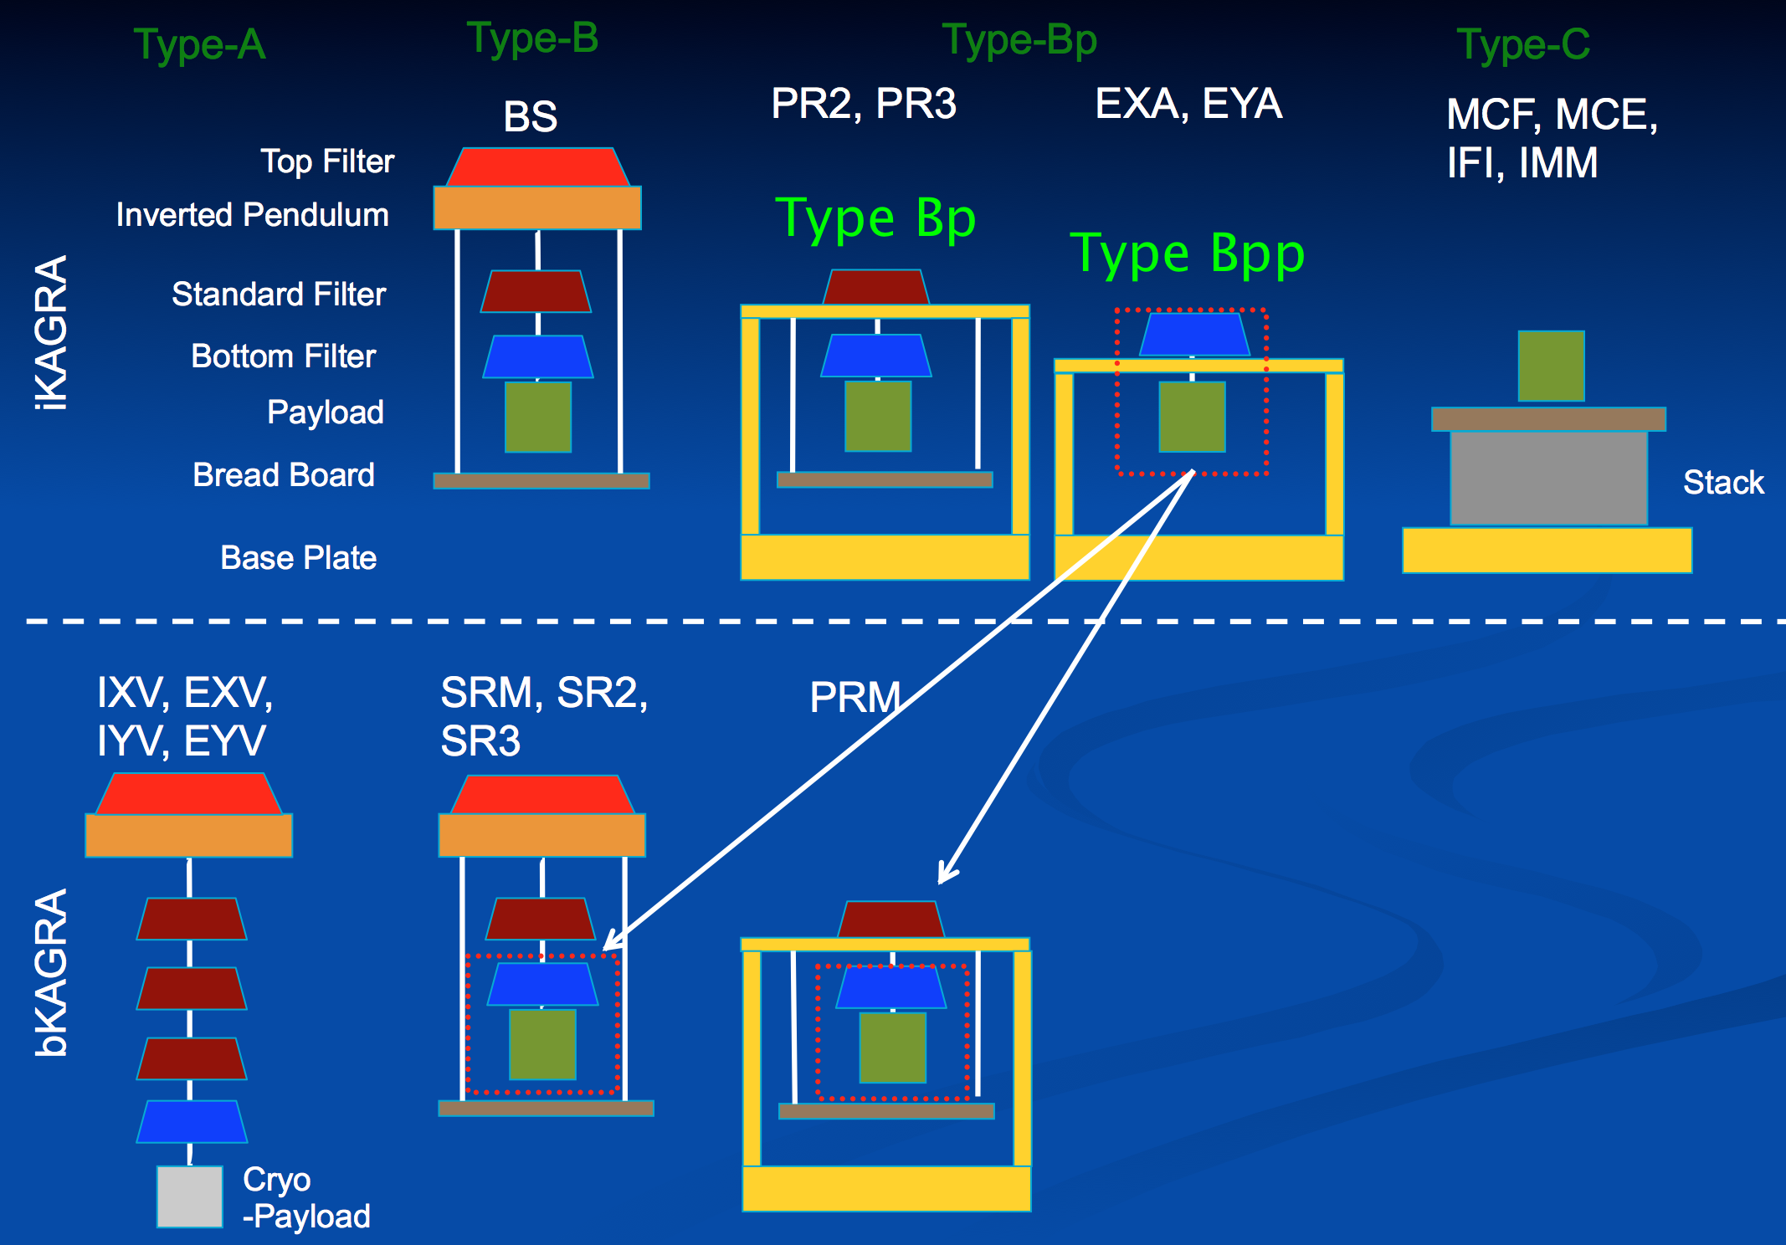
Figure 1 - Suspension types - from JGW-G1503737-v6
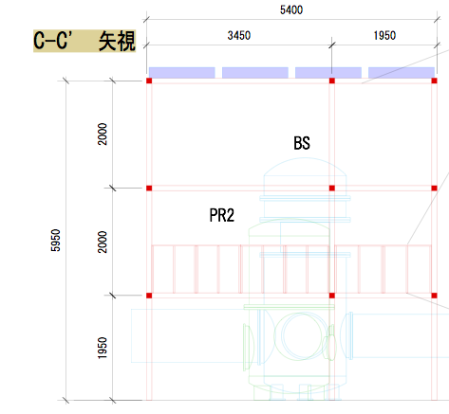
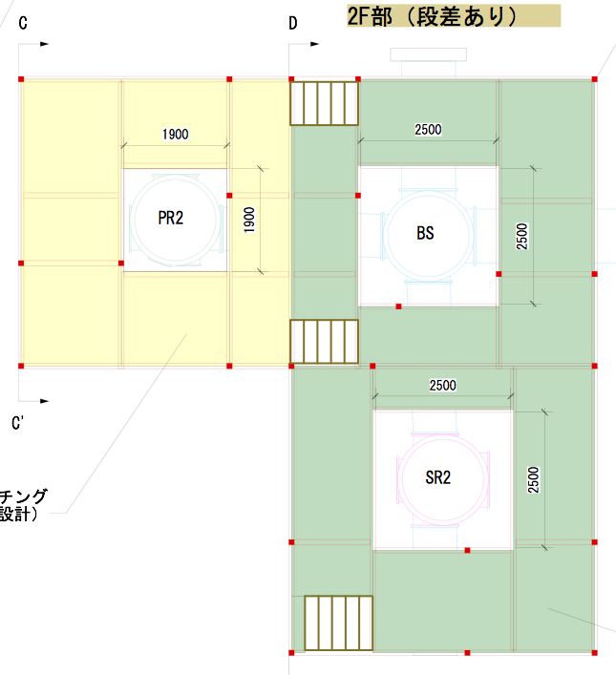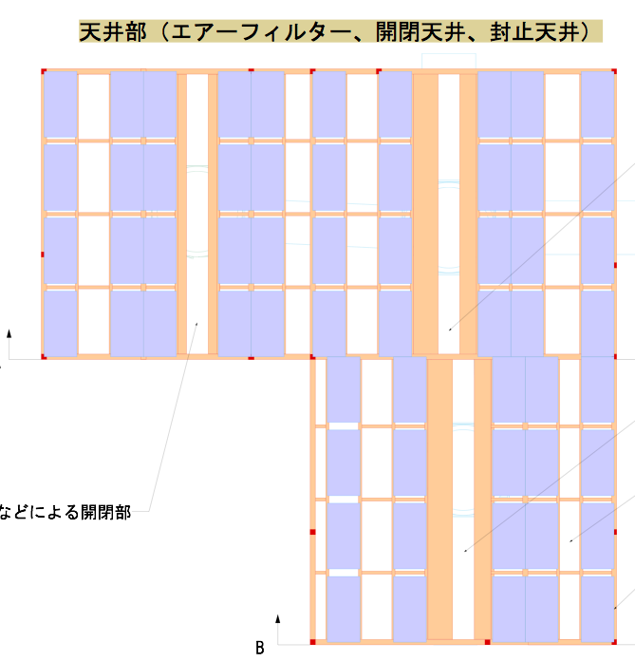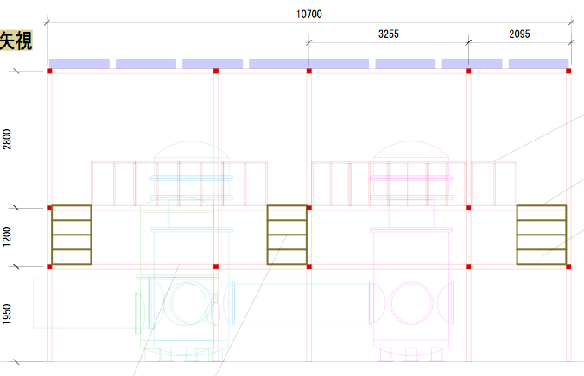
Figure 2 - Cleanbooth around PR2 (and BS/SR2)
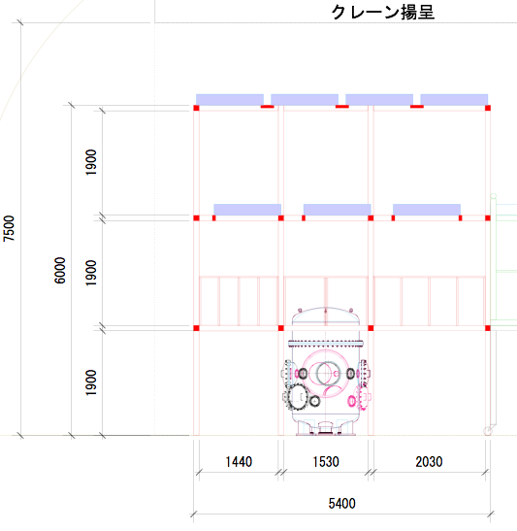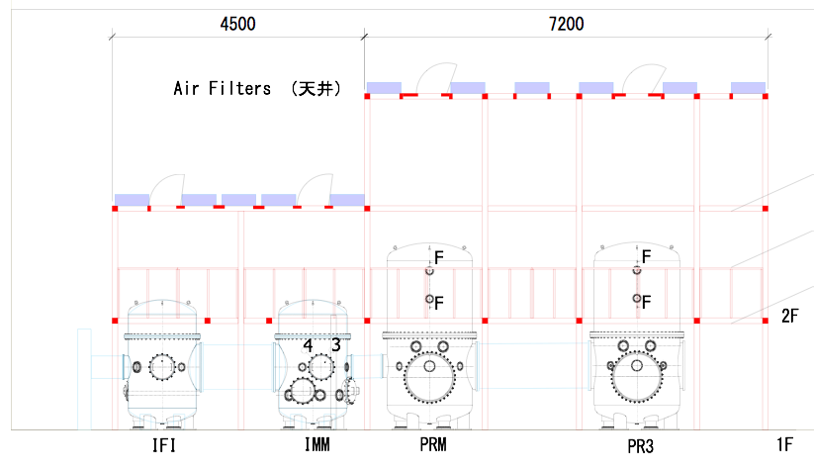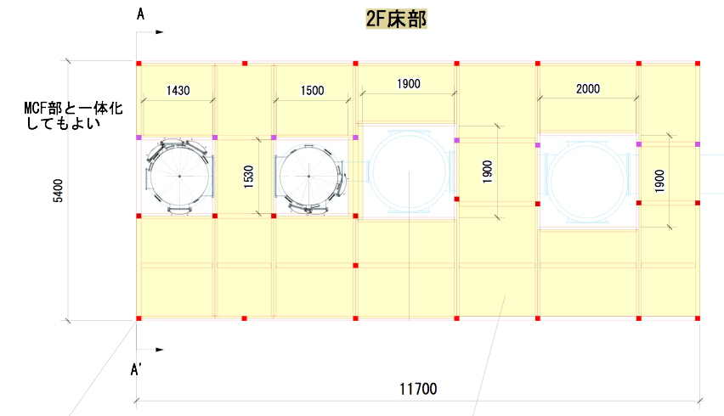
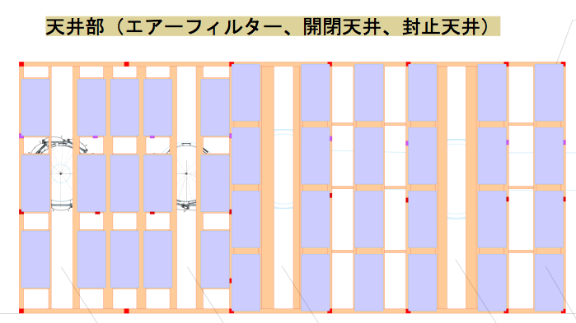
Figure 3 - Cleanbooth around PR3/PRM (and IMM/IFI)
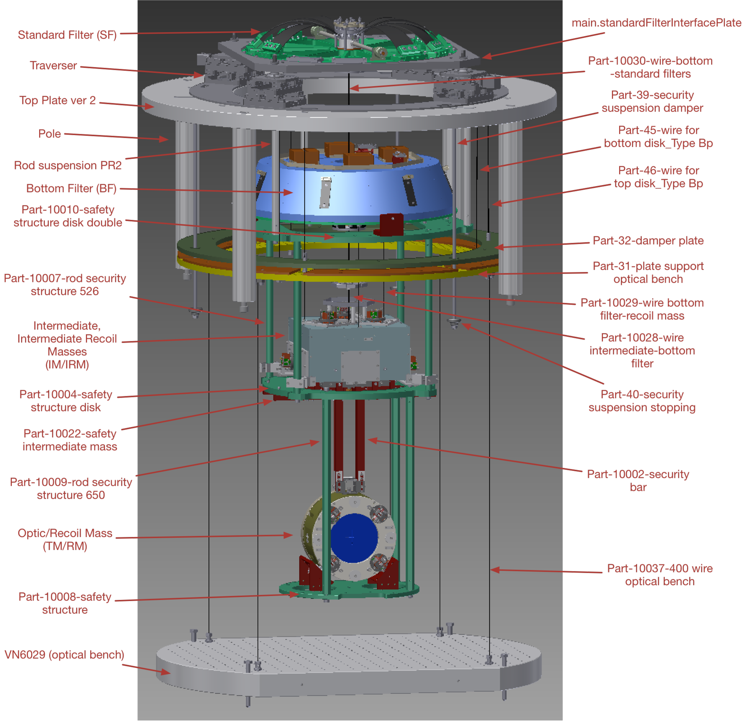
Figure 4 - Items to be installed, with Inventor names of items relevant to assembly order

Constraints/Assumptions
- The “support pipe” that holds the traverser will already have been installed in the vacuum pipe.
- As far as possible, the major components (traverser, SF etc) will be assembled individually at NAOJ, shipped to Kamioka and then combined.
- The optic will arrive with the flags and standoffs already glued on.
- The RM is so simple that it barely matters. The OSEMs will probably not be installed to avoid possible damage in shipping.
- The IM will arrive assembled except probably for the flags, which would be easy to damage in shipping.
- The IRM will arrive assembled except probably for OSEMs, which would be easy to damage in shipping.
- The BF and SF will arrive assembled except for fine trim mass on the BF (which will only be decided after a trial hanging of the entire chain from the SF), with the wires from the internal components terminated with Burndee pins inside the shell (i.e., without the Burndee to D-Sub adapter cables.)
- The traverser will arrive assembled, mounted on the “top plate”, with brackets to immobilize it during shipping.

- The earthquake stop structure attaches to the underside of the top plate supporting the traverser, so there is no possibility of installing the traverser separately from the rest of the chain.
- The assembly of the entire suspension (top plate supporting traverser down to optic) will be done on the second floor of the cleanbooth and the chain will then be craned into the tank on top of the traverser.
- The crane hook access slots in the cleanbooth ceiling only run one way (see Figure 2 and Figure 3) so the assembly has to be done at a position somewhere along that line.
- The vacuum tank lid has to go somewhere on the same line unless it can be removed entirely.
- A frame similar to the one used for the Type B prototype test at TAMA will be needed to support the suspension during assembly.
- The vertical space available is not nearly enough for the suspension chain to be lifted out of its assembly frame vertically (as was done at TAMA), so the frame has to be designed to allow the suspension to slide out sideways.
- The second floor of the PR2 (and BS/SR2) cleanbooth is 4000 mm tall.
- The second floor of the PR3/PRM (and IFI/IMM) cleanbooth is 3800 mm tall.
- [??: Need to check if there are any incursions that mean it’s less in practice.]
- The height of the suspension chain is 1968 mm.
- The assembly frame should be designed to fit in the smaller of these two spaces, i.e., it should be less than 3800 mm [??: need to check that this will be OK].
- The maximum load on the mesh flooring of the second floor is 500 kg/m².
- The weight of the suspension with traverser is approximately 964.6 kg (Hirata-san’s calculation).
- It’s probably a bad idea to put the assembly frame directly on the mesh flooring, and it should be designed with a wide base that can bridge two joists.
- All three tanks have a pair of joists nearby with a separation in the range of approximately 1900-2100 mm so probably the same design of frame could work for all three if it had 100 mm of adjustment in the position of each of the feet. [??Need to check exact values]

Procedure
This is just a rough outline as yet:

Install optical bench and damper
- Get optical bench onto 2F. [??: How?]
- Put “Part-31-plate support optical bench” ring on top of optical bench.
- Put “Part-32-damper plate” on top of support ring
- Install eye-bolts or similar on support ring.
- Using crane, lift support ring with damper ring on top.
- Install 4 of “Part-10037-400 wire optical bench”.
- Using crane, lift damper ring plus support ring plus optical bench.
- Lower rings and optical bench into the vacuum tank until the optical bench is below the top of the support tube.
- Place cross-beams across the top of the support tube.
- Lower the rings and optical bench until the rings are sitting on the cross-beams.
- Disconnect crane and remove eyebolts.

Setup of assembly area
- Place floor mat in center of area where the suspension is to be built up.
- Place breadboard from small assembly frame (as used at 20 m lab) on the floor mat.
- Place spacers of TBD height on the breadboard and bolt them down. [??: decide height of spacers]
- Place the hanging frame from Fabian’s procedure, JGW-E1503830, and clamp it to the spacers.
- [??: Other stuff?]

Assemble payload
This will be done according to Fabian’s procedure, JGW-E1503830, Procedure for hanging the test and recoil masses. It will end with the IM/IRM sitting on the hanging frame, via the “Part-10022-safety intermediate mass” bars and the “Part-10004-safety structure disk” ring. The winch fixtures will have been removed.

Add BF
- Attach “Part-10007-rod security structure 526” rods on top of “Part-10004-safety structure disk” ring.
- Attach “Part-10010-safety structure disk double” ring on top of “Part-10007-rod security structure 526” rods.
- Assemble the rest of the small assembly frame (as used at the 20 m) around the payload.
- Install jacks at three points on top of the small assembly frame below the disk.
- Lift suspension clear of hanging frame using jacks and remove hanging frame.

