JGW-T1503467-v2 KAGRA 19 August 2015

Possible fixes for Type Bp suspension damping issue (PR2/PR3/PRM)

Mark Barton

Distribution of this document:
JGW-DCC

This is an internal working note
of the KAGRA collaboration.

http://gwcenter.icrr.u-tokyo.ac.jp

Table of Contents
1 Introduction 3
1.1 Purpose and Scope 3
1.2 References 3
1.3 Version history 3
2 The Current Design 3
3 Possible fixes 4
3.1 Rigidly connect the bottom of the traverser to the top of the bottom filter 4
3.2 Put the bottom filter on the traverser 8
3.3 Hold magnets close to the bottom filter to induce eddy current damping. 9
3.4 Mount OSEMs near the BF and magnets on the BF 11

Introduction

Purpose and Scope
Shoda-san's model of the Type Bp suspension design (see T1503908) shows that the pendulum mode will be hard to control because there is no inverted pendulum stage and no eddy-current dampers. This document considers the mechanical feasibility of a number of possible fixes.

References
JGW-T1503908: “Type-Bp performance simulation”

Version history
8/5/2015: -v1 for discussion at VIS meeting.
8/19/2015: -v2 for discussion at VIS review meeting.

The Current Design
The affected system is the Type Bp, used for the PR2 and PR3 suspensions (as the PRM in bKAGRA). The main parts relevant to this discussion, with their names in the Inventor CAD drawing, are shown in Figure 1. The traverser legs stand on a “support pipe” (not shown), which stands on supports at the bottom of the vacuum tank.
The full Type B chain as tested at TAMA and planned to be used for the BS has an inverted pendulum stage at the top which allows both DC position control and low-noise slow actuation. It also has eddy-current damping via a ring with magnets which hangs from the bottom of the IP and interacts with a conductive ring on the standard filter.
The reduced Type Bp chain has a traverser for DC position adjustments, but this is not suitable for control because it uses stepper motors. It also lacks any eddy-current damping.
Shoda-san’s simulation (T1503908) says that seismic motion is likely to ring up the fundamental pendulum mode, leading to residual motion in excess of the requirement, and making locking difficult.
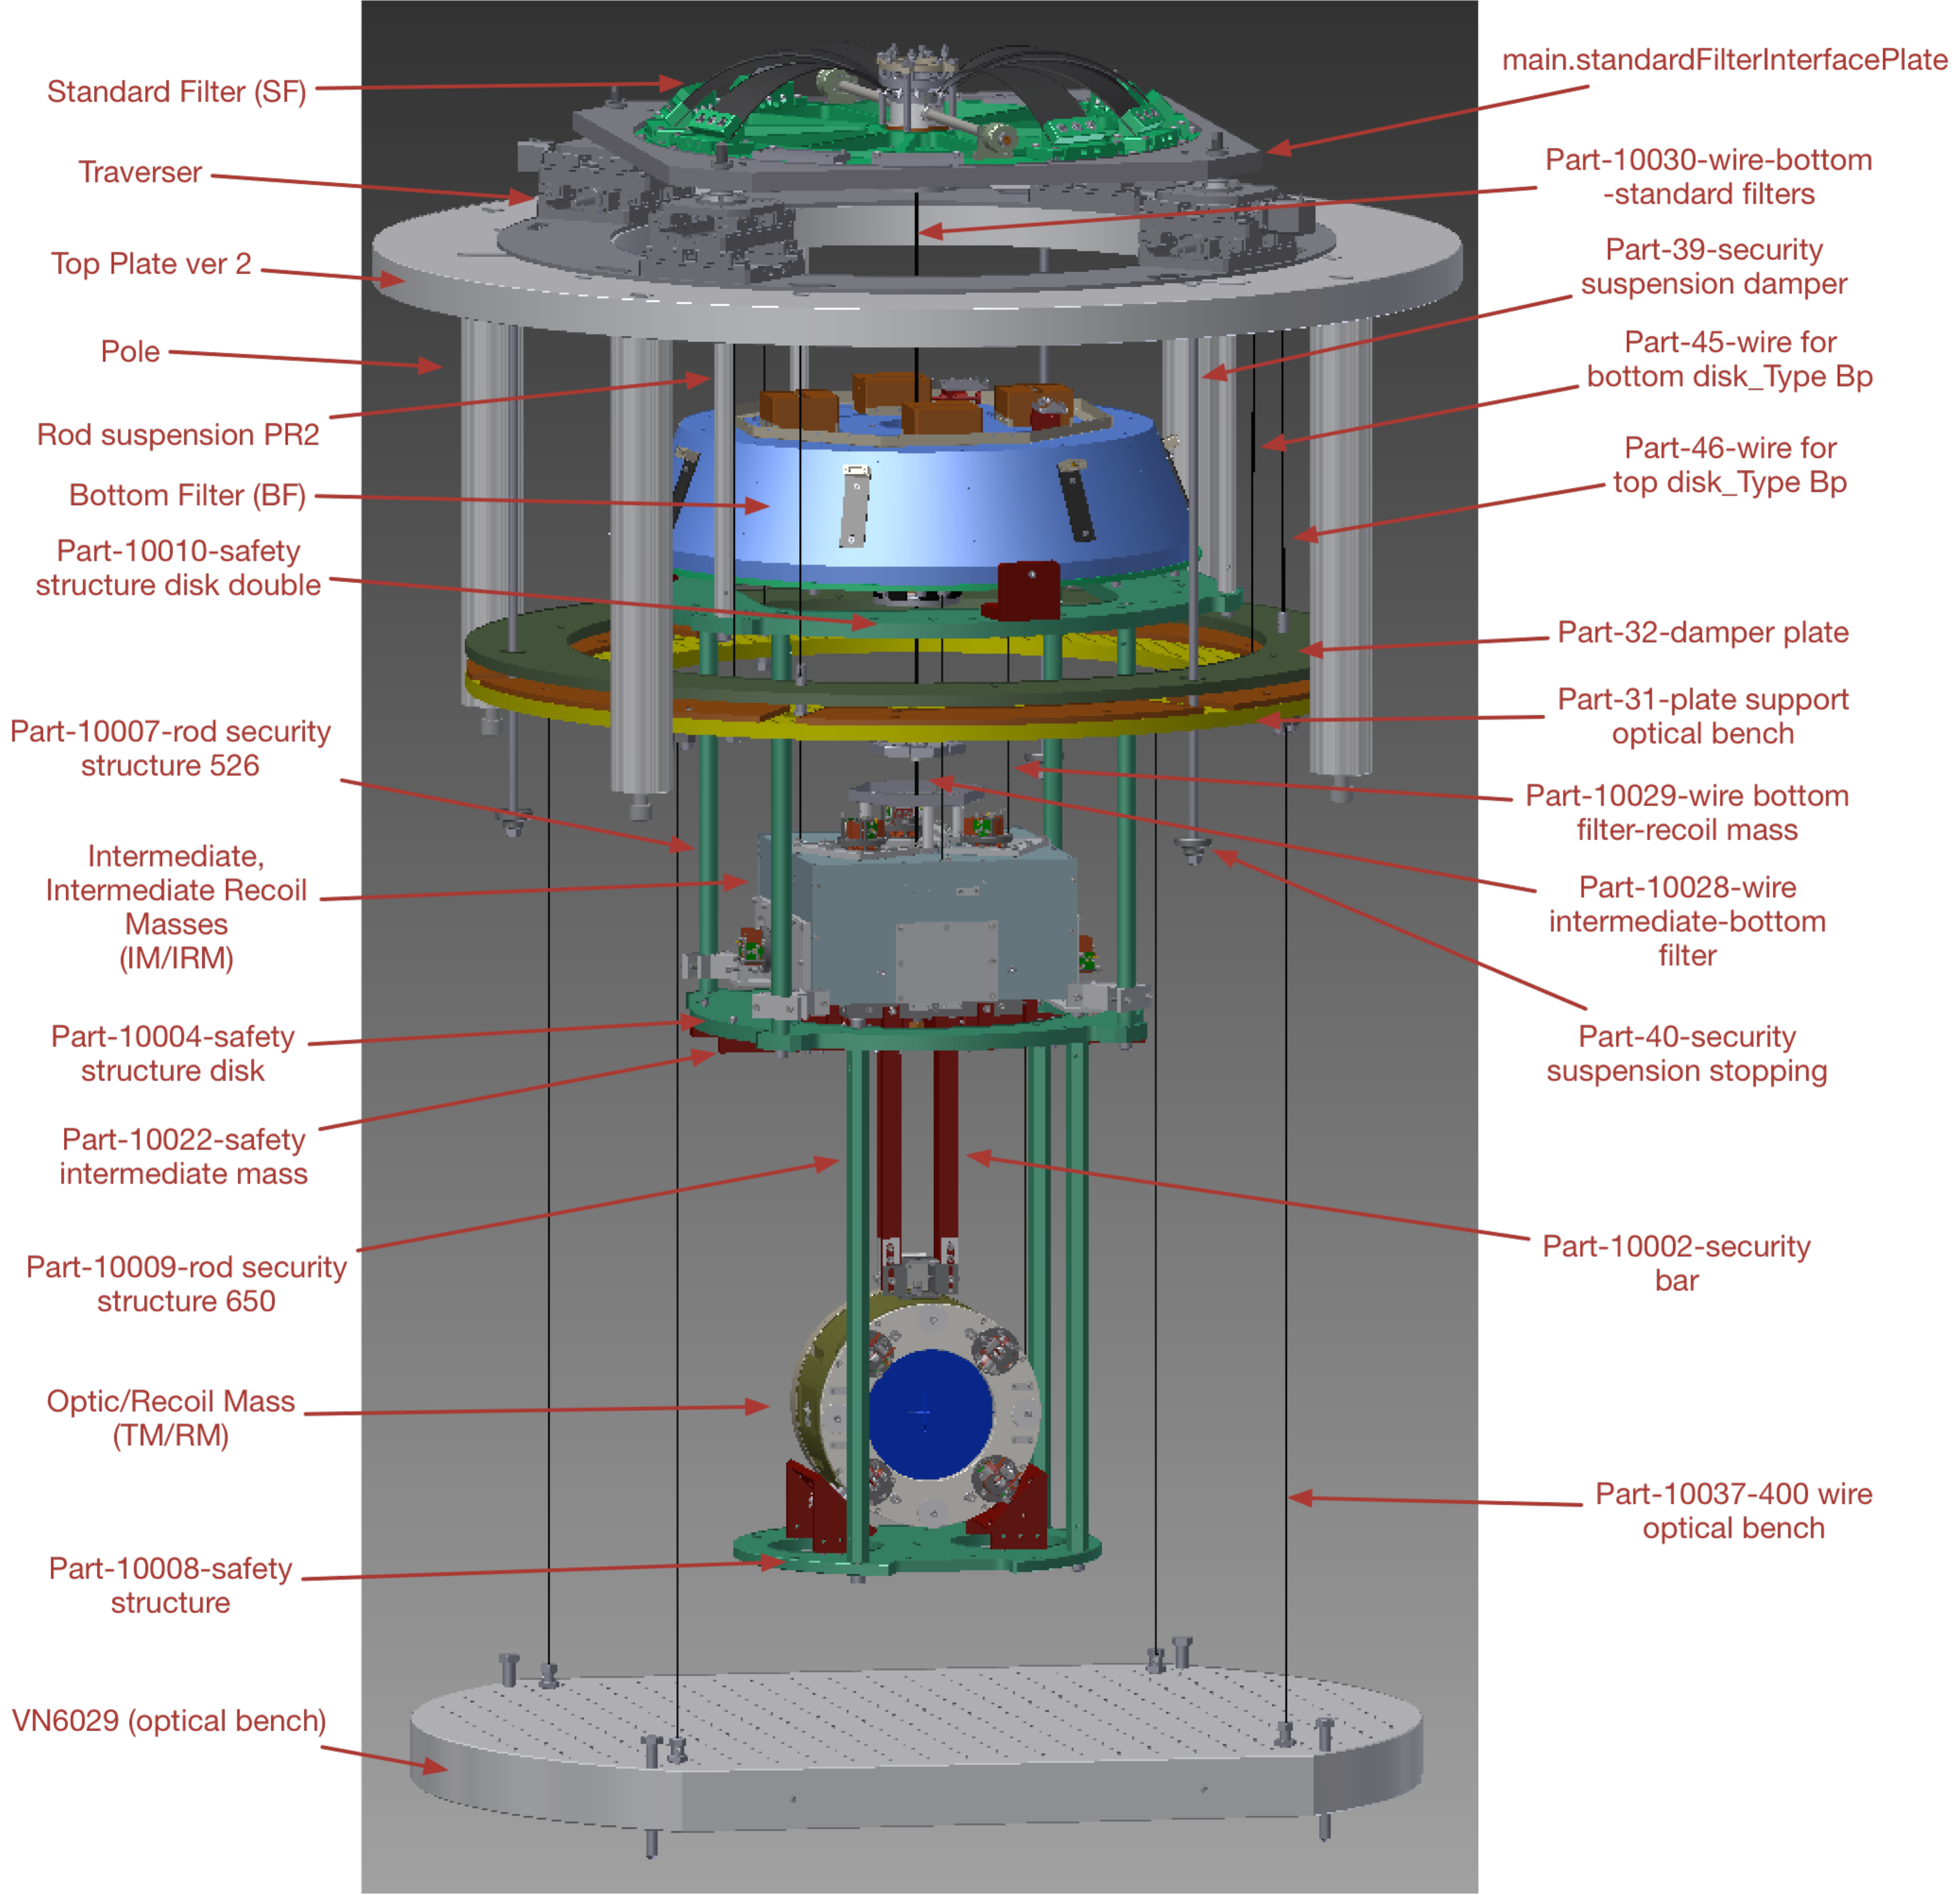
Figure 1 - Items to be installed, with Inventor names of items relevant to assembly.

Possible fixes
The following fixes have been suggested (Aso-san’s email, 8/1/2015):

Rigidly connect the bottom of the traverser to the top of the bottom filter
See Figure 2. This will make the suspension system behave like a double pendulum.
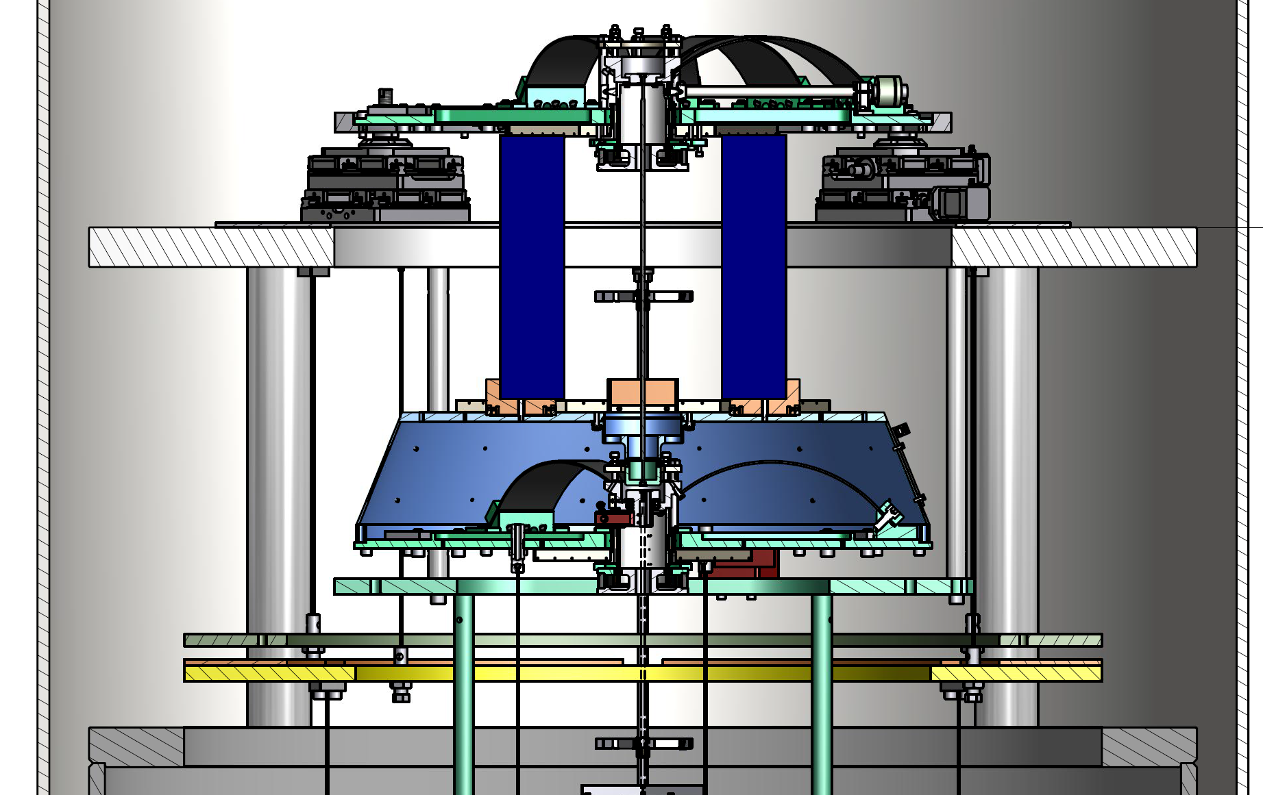
Figure 2: Concept of possible immobilizing structure locking the BF to the SF
Considerations:
- We want to make the connection as rigid as possible to avoid low frequency eigenmodes. We should use pipes instead of solid rods.
- There are 16 spare M10 unthreaded holes on the bottom of the SF where there are dummy spring mounts (only 8 of the 12 possible spring positions are used). See Figure 3. These could be used to mount some immobilizing structure.
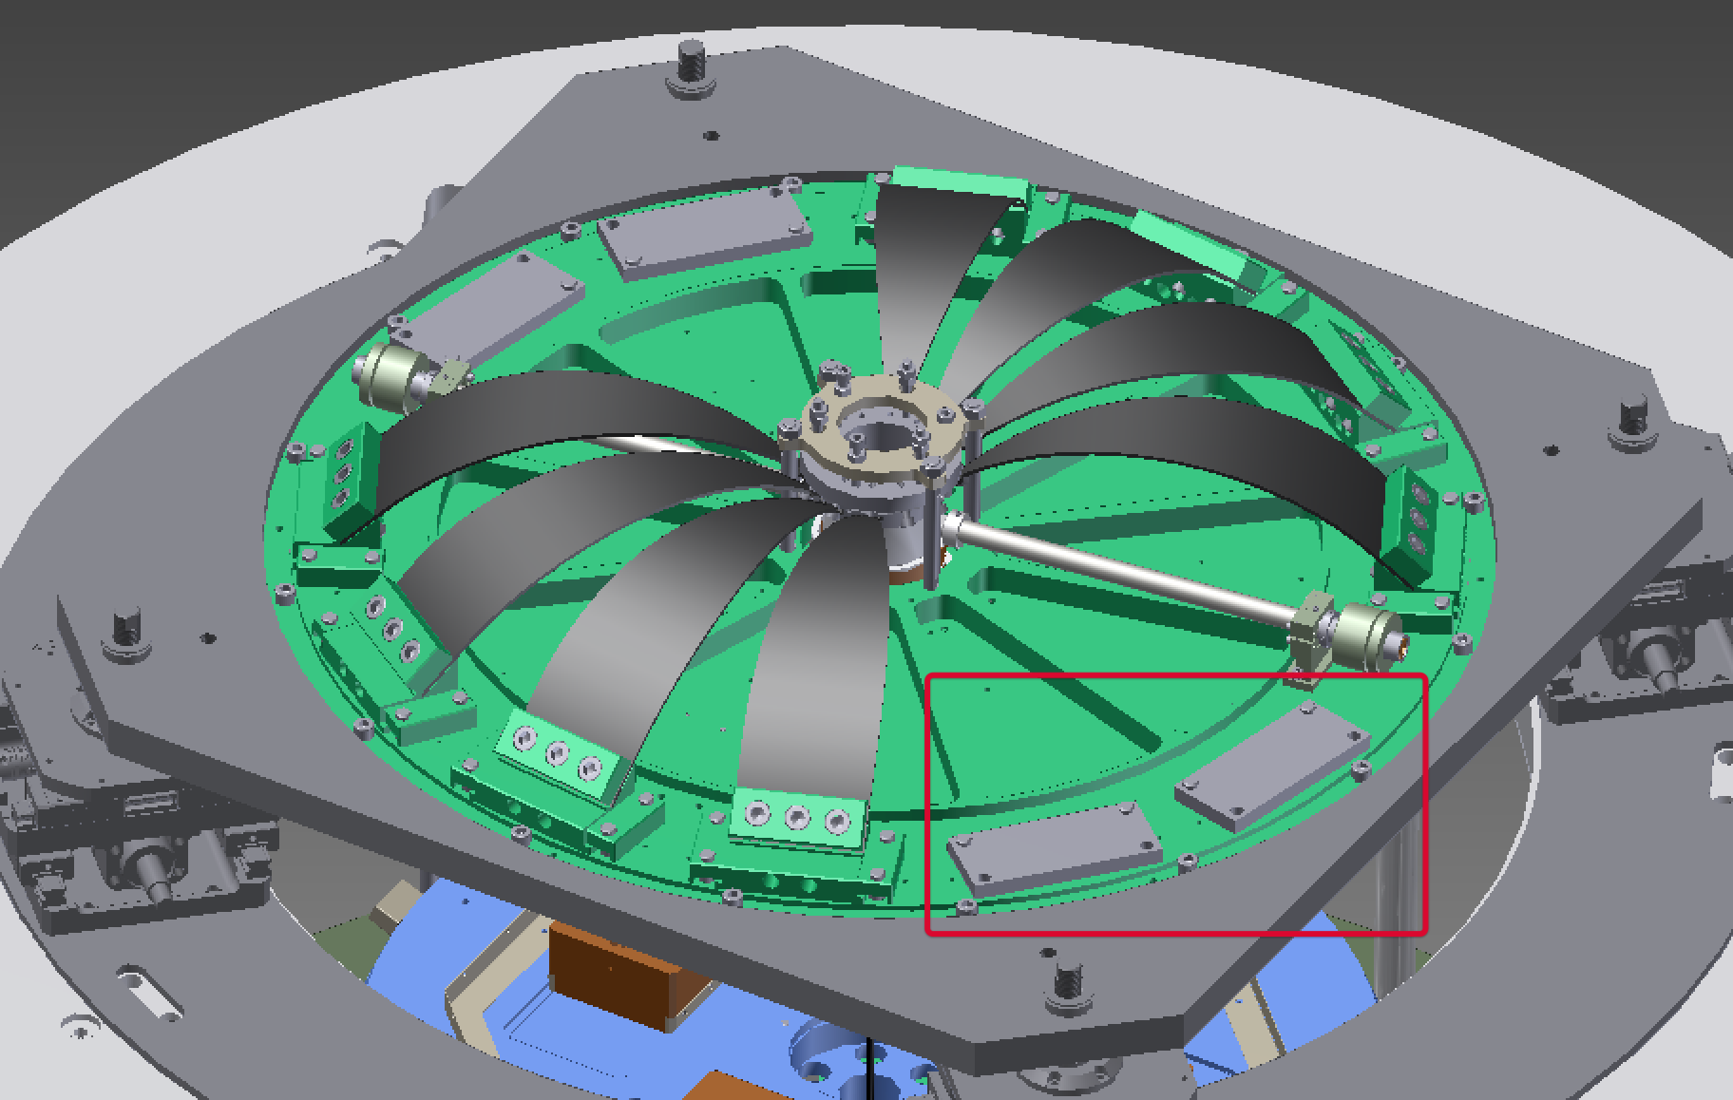
Figure 3: Available mounting holes in the SF
- There four M6 threaded holes on top of the BF that are normally used to hold the pitch/roll trim weights. Since the BF would no longer be freely suspended, the trim weights could be removed and the holes could be used to mount some immobilizing structure. See Figure 4.
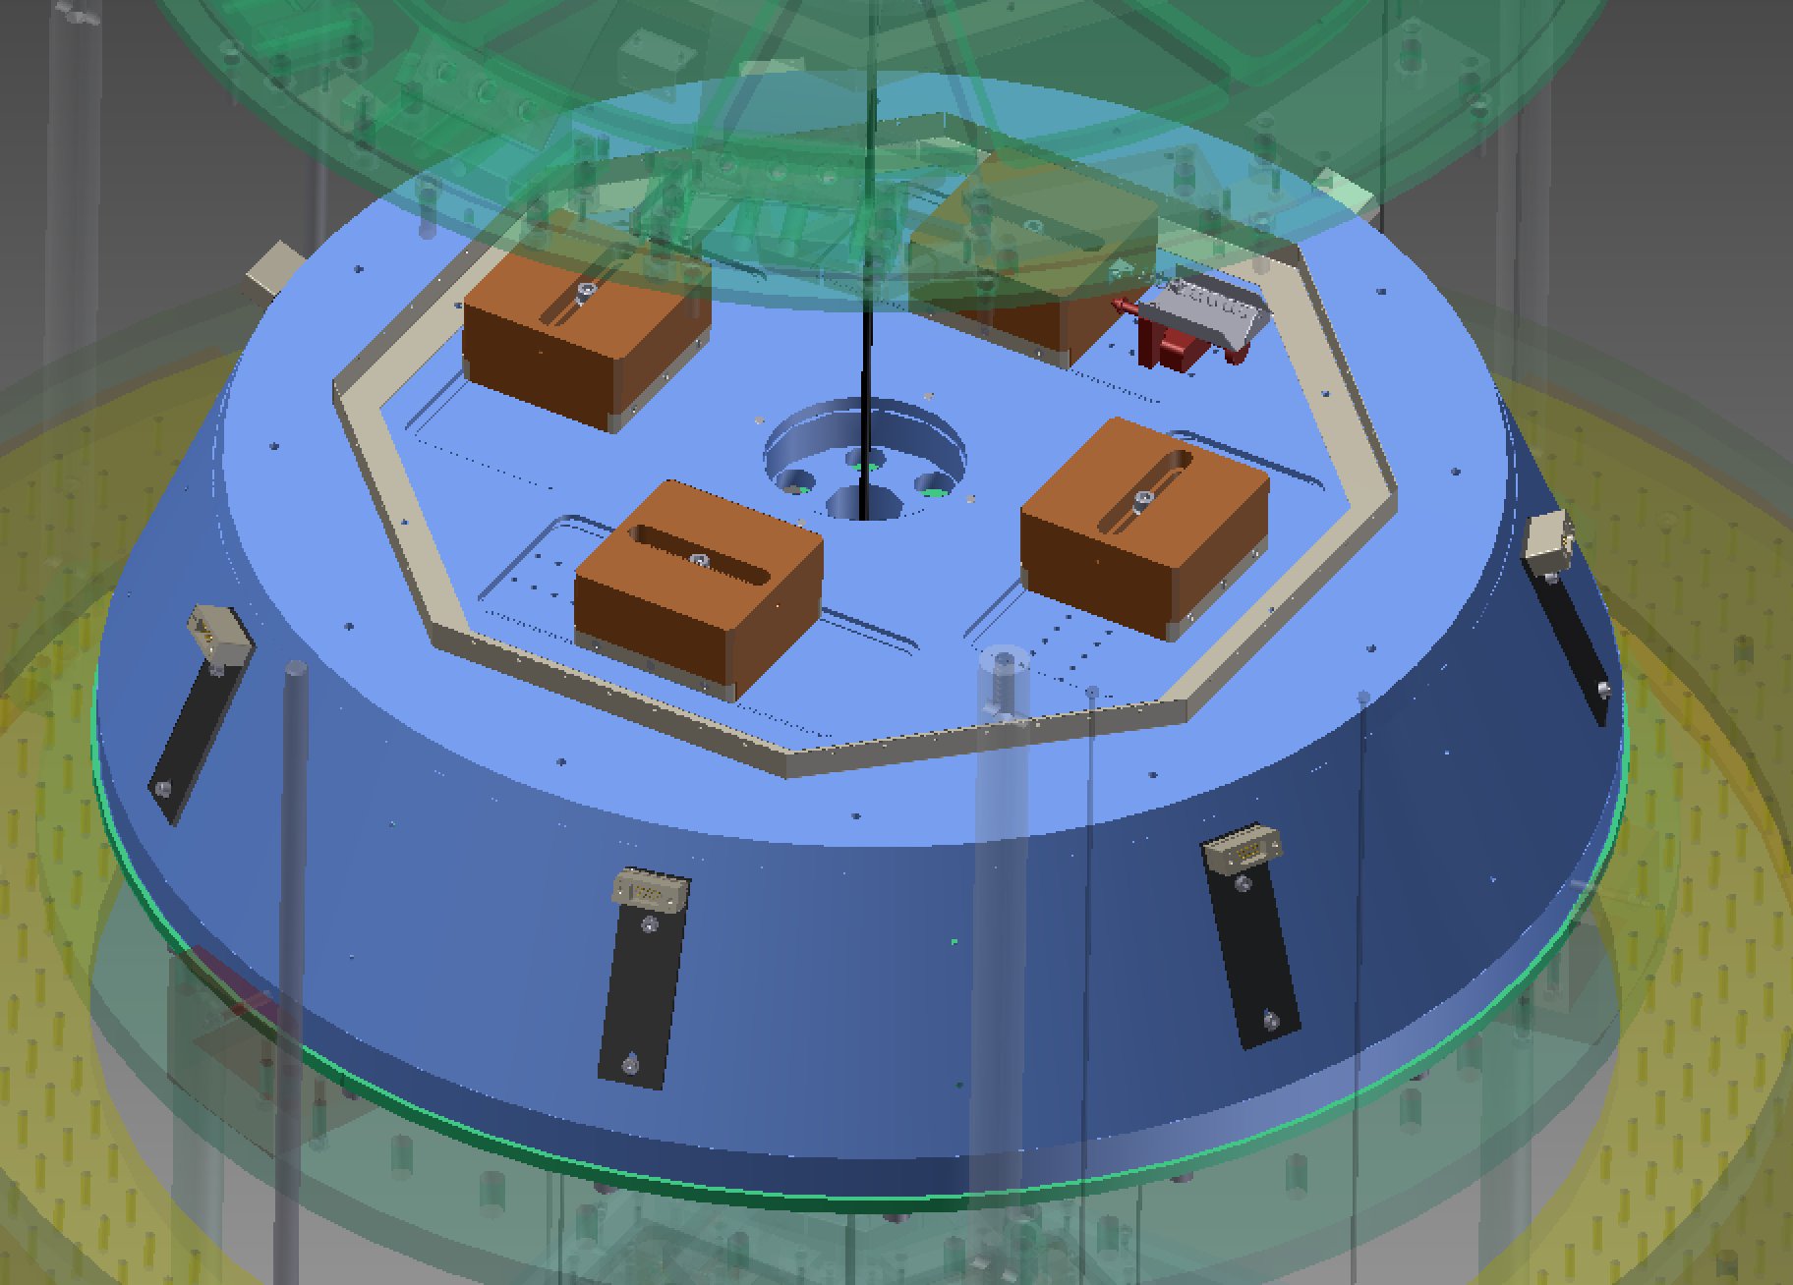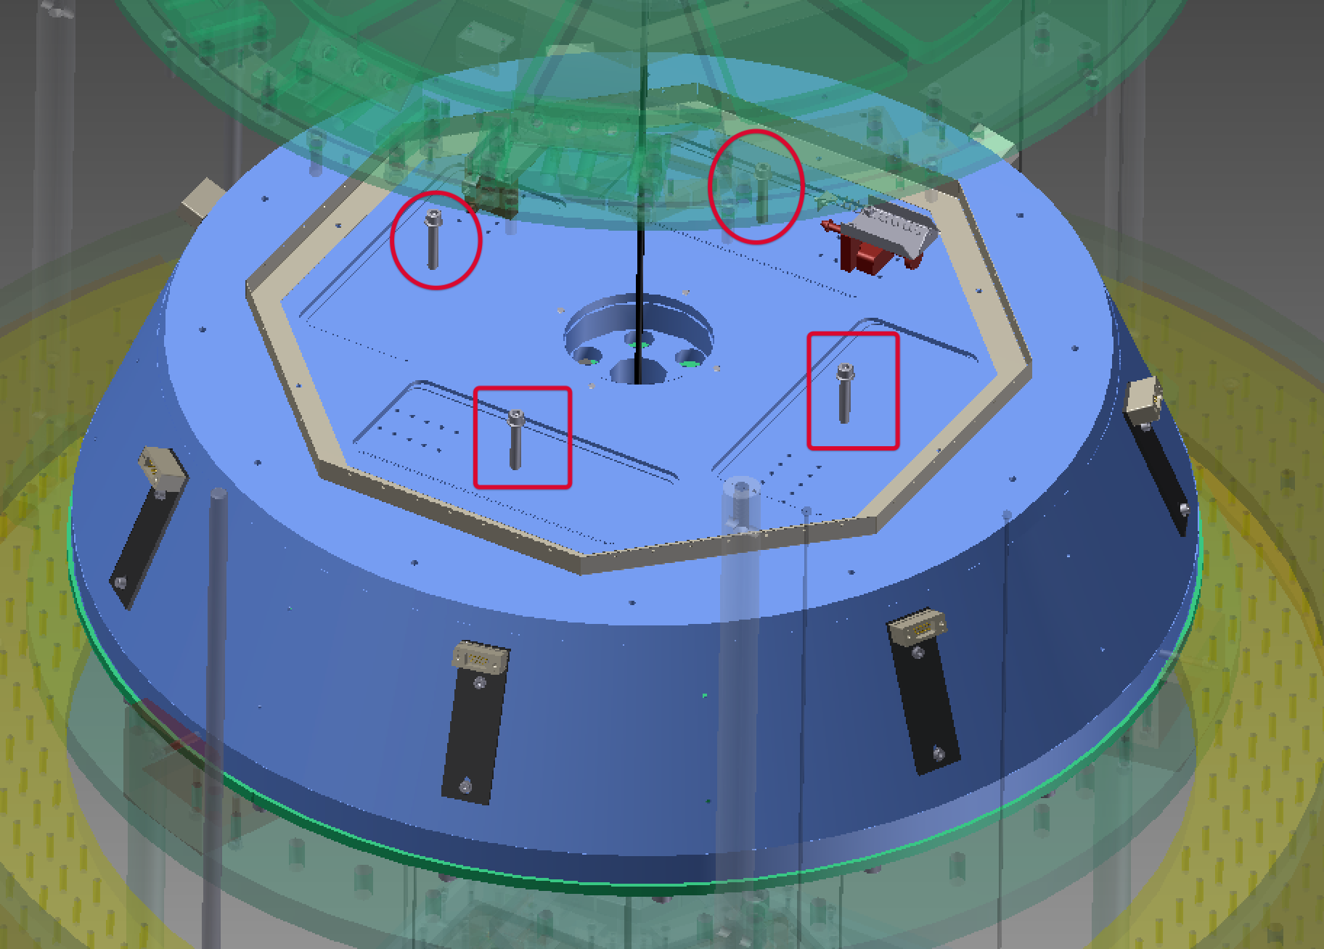
Figure 4: Available mounting holes in BF cap (after removal of pitch/roll trim masses)
- Alternatively, the entire cap of the BF could be removed, and spare spring mount holes in the base of the BF could be used, as for the SF. See Figure 5. In this case the cabling would have to be reworked, because all the TM/RM and IM/IRM cabling is normally anchored to the outside of the BF before continuing to the top (not shown in the CAD diagrams). The immobilizing structure would need to be provided with cable clamps.
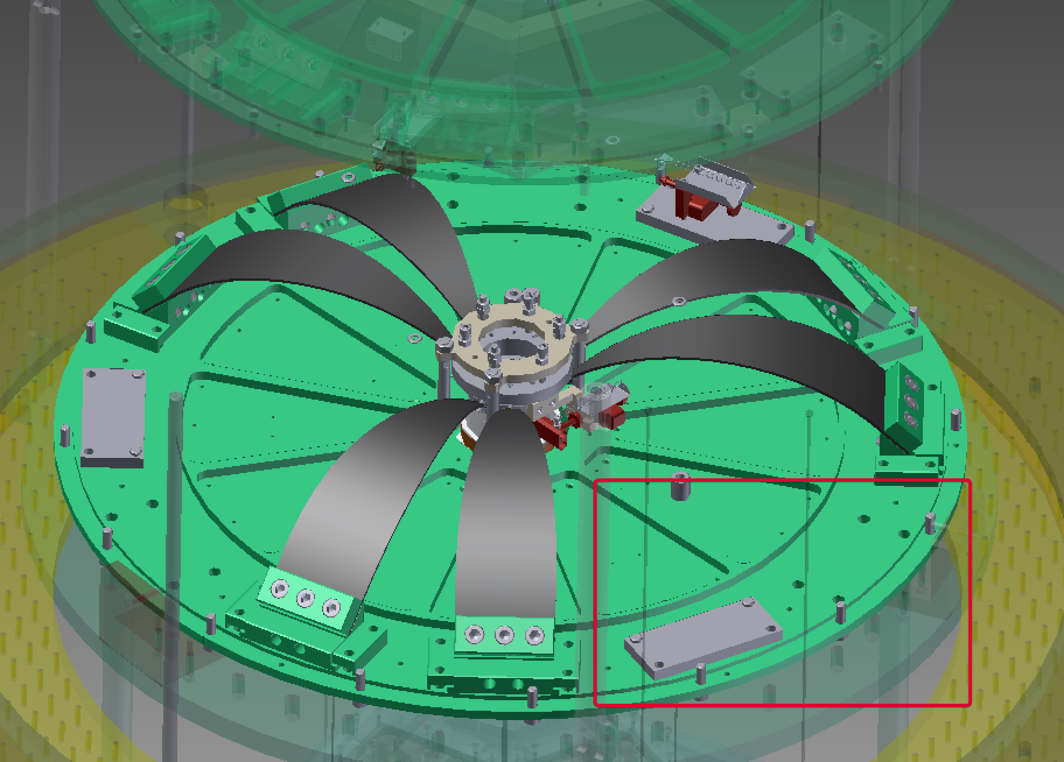
Figure 5: Available mounting holes in the BF base (view with cap removed)
However perhaps the simplest approach would be to add extra rigidity to the earthquake stop structure with extra diagonal braces and then simply lock the BF in place with the existing screws (or new ones places slightly lower in the brackets). See
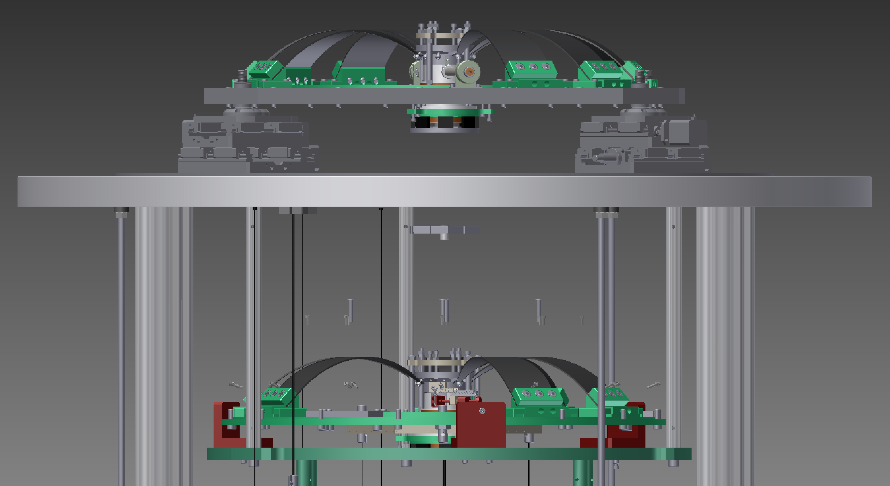
Figure 6: Possible braces for EQ stop structure
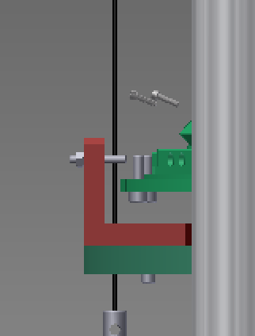

Figure 7: Required modifications to brackets on EQ stop structure

Put the bottom filter on the traverser
In this scheme, the SF would be completely eliminated - see Figure 8.
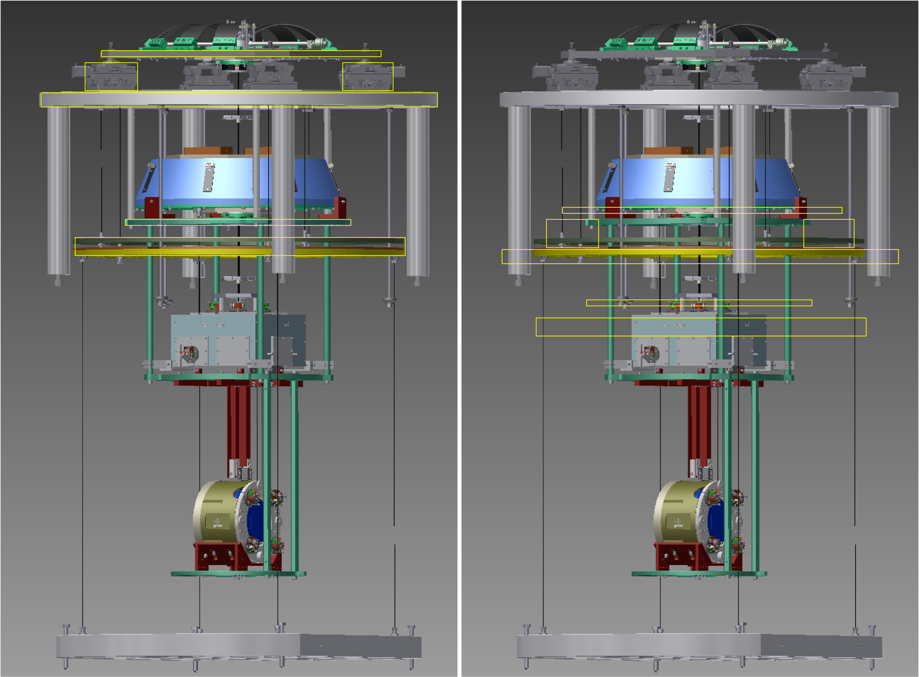
Figure 8: "Chop Top" version, with SF eliminated and traverser lowered
Considerations:
- The length of the 4*“Pole” legs which support the traverser would have to be reduced so that the height of the bottom filter with respect to the IM remains the same.
- The BF is 730 mm in diameter, whereas the SF is 732 mm. So the BF would fit in the inset in the “main.StandardFilterInterfacePlate”, with just a tiny bit of play.
- [??: Need to check hole positions to see if the BF can be bolted in place.]
- The traverser would have to be lowered by 535.5 mm. A “Pole” is 592.5 mm long, so they would have to be reduced to 57 mm.
- The “rod suspension PR2” holding up the “Part-10010-safety structure disk double” below the BF is only 393.5 mm long, so if the disk maintained its relationship to the BF, it would be above the “Top Plate” and below the “main.StandardFilterInterfacePlate”. This doesn’t work for several reasons: (i) The tabs on the disk would foul on the traverser stepper motor units. (ii) The disk is responsible for supporting the rest of the EQ structure which would then be on the other side of (below) the “Top Plate”.
- Therefore the disk should be moved to a point well below the BF and just below the “Top Plate”, by shortening 3*“rod suspension PR2” to a few centimeters long, and shortening 4* “Part-10007-rod security structure 526” rods to keep the rest of the EQ stop structure the same height.
- The “Part-32-damper plate” and “Part-31-plate suppport optical bench” should be lowered so as to be approximately the same distance below the “Part-10010-safety structure disk double”. This would require lengthening 3*“Part-45-wire for bottom disk_Type Bp” and 3*“Part-46-wire for top disk_Type Bp” (probably also 3*“Part-39-security suspension damper”) and shortening 4*“Part-10037-400 wire optical bench”.
- The shortened version of the suspension would be a bit more difficult to assemble and adjust because there would be many narrower gaps vertically. However it’s probably doable. Instead of bringing in the SF on the traverser and hooking it to the already-built-up BF+payload, we would bring in the BF on the traverser and hook it to the payload.

Hold magnets close to the bottom filter to induce eddy current damping.
The SF in the full Type B has an eddy-current damping ring just above it (Figure 9). The same concept could be adapted for the Type Bp.
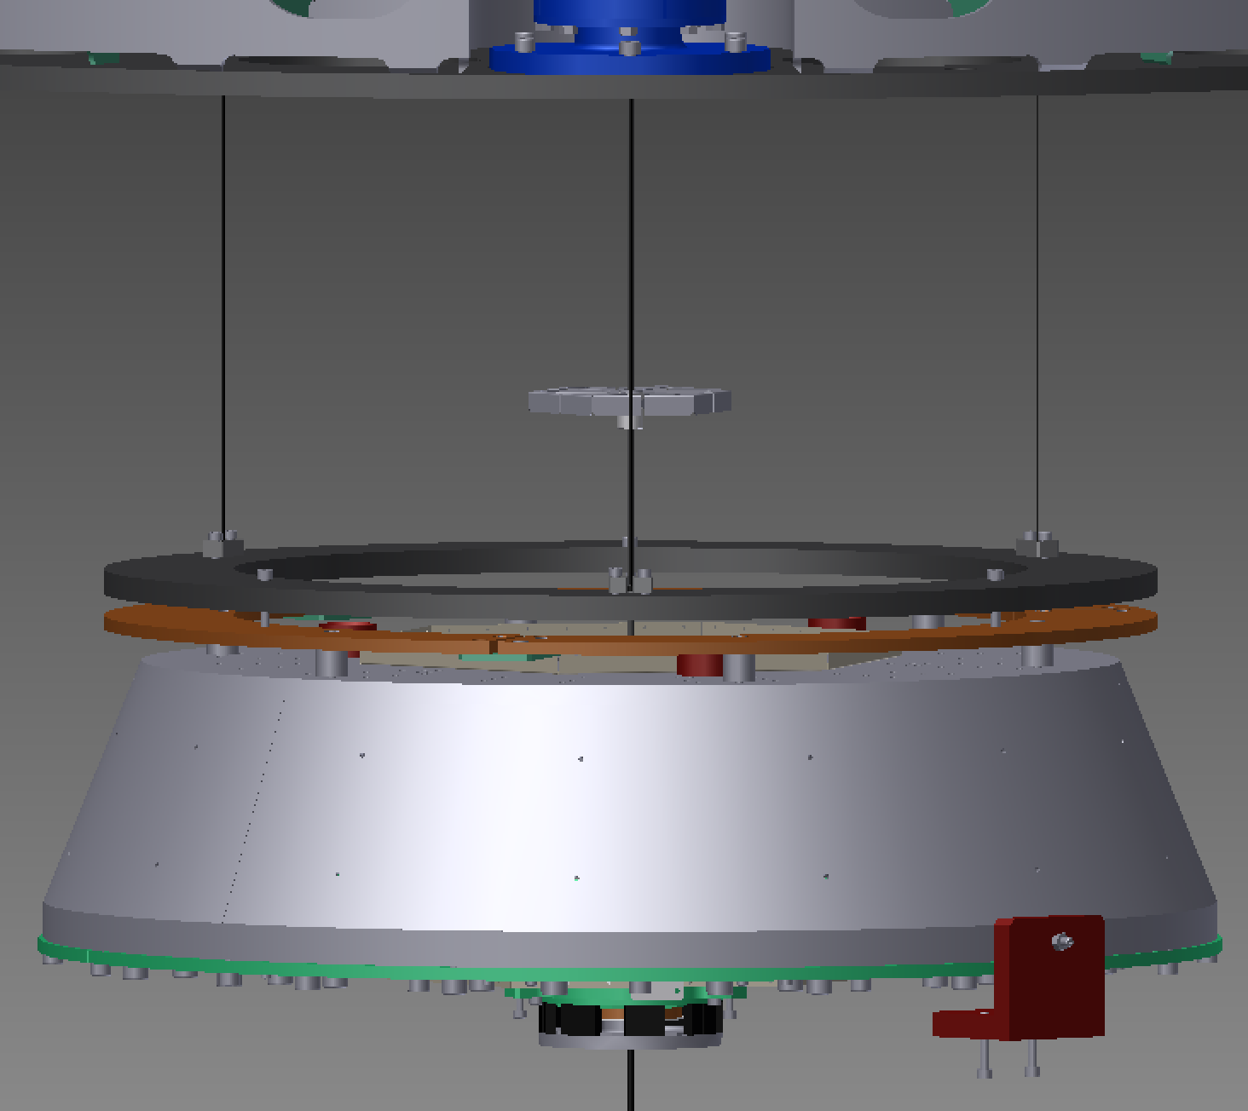
Figure 9: Damping ring for SF in full Type B (for comparison)
Considerations:
- The BF and cap are made of stainless steel which does not have good conductivity and would not give strong eddy-current damping. (Damping goes as the square of the conductivity, and SS is about 4 times worse a conductor than Cu, so 16 times worse for ECD.) Also, much of the surface of the BF is covered with cables.
- A ring of Cu plates could be attached to the BF (as with the SF in the full Type B, Figure 9), but the total weight hanging from the SF needs to stay the same. There is some ballast mass that can be taken off the BF (or at least there was in the TAMA test), but it is very likely not enough. [??: Find out how much ballast was allowed for.] Spacers would be needed under the ring to accommodate cables coming up the side of the BF. The SF could probably be reconfigured to carry more weight, but this would take time and might need extra blade springs to be made.
- Alternatively, magnets could be put on the BF, with Cu plates on a ring hanging nearby. This would save weight, because the magnet holder could be a thin ferromagnetic plate. However putting the magnets on the BF might create some coupling to ambient magnetic field.
- If the ECD is above the BF, the spare blade mount holes in the bottom of the SF could be used to support an adapter which in turn supported a ring. There are 12 holes around the top of the BF which could probably be used to support a SF-style ring (they may even have been added specifically for that).
- It would be mechanically easiest to put the Cu plates on the existing “Part-10010-safety structure disk double” just below the BF, with magnets stuck to a thin plate bolted to the underside of the BF with spare blade mounting block holes. See Figure 10. However, not only does this have the magnets-on-the-suspended-part problem, the “Part-10010-safety structure disk double” is not as well isolated as a hanging ring, so this might introduce more ground noise at higher frequencies.
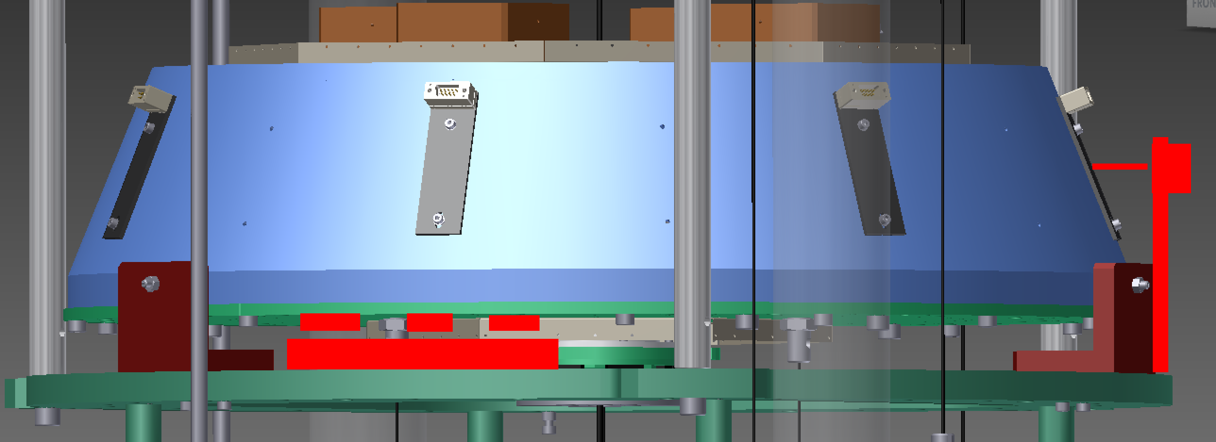
Figure 10: Possible ECD location underneath BF (and possible OSEM location at side)

Mount OSEMs near the BF and magnets on the BF
Considerations:
- It might be possible to make do with one OSEM in the optic axis direction, but probably two would be better.
- There are plenty of places on the BF where two flags could be fitted. Probably the easiest would be to modify 2 of the 14 cable brackets around the edge. See Figure 10. Alternatively, the flags could go on top of the trim masses (preferably the fixed ones not the motorized ones) or they could be clipped to the suspension wire. See Figure 11.
- Some brackets to hold the OSEMs would be needed. These could mount to the EQ stop structure.
- Two extra cables and feedthoughs would be required (20->22). A suspension uses 10 of 12 channels on three four-channel satellite amps, so probably no extra electronics would be needed.
- An actual OSEM has a very limited range transversely, so initial adjustment would be tricky. OSEMs mounted on the EQ stop structure would move with the traverser so horizontal would not be an ongoing problem but the chain would have to be kept well-adjusted against vertical drift. Yaw shouldn’t be an ongoing problem because there is no yaw adjustment at the SF, and the body of the BF does not rotate when the yaw IM and TM is adjusted. If position sensing was not required, it might be possible to get additional range by removing the end of the flag.
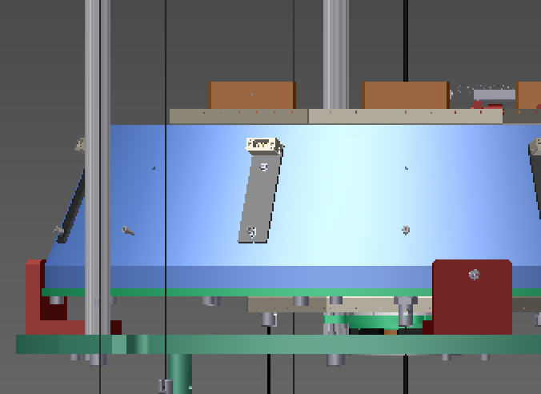
Figure 11: Other possible OSEM flag locations: on top of trim masses, and clipped to wire.

