JGW-T1503239-v3 *KAGRA* 17 Feb 2016

**OSEM Coil/Magnet/Flag Calculation**

Mark Barton

Distribution of this document:

JGW-DCC

This is an internal working note

of the KAGRA collaboration.

http://gwcenter.icrr.u-tokyo.ac.jp

**Table of Contents**

1 Introduction 3

1.1 Purpose and Scope 3

1.2 References 3

1.3 Version history 3

2 Theory 3

3 Parameters/Results 9

4 Conclusion 12

5 Conclusion 13

# Introduction

## Purpose and Scope

Gives the calculation of the position of the magnet in the field of the OSEM coil to give maximum force/current and minimum cross-coupling from position of the coil to force.

## References

LIGO-T1000164: [Calculation and measurement of the OSEM actuator sweet spot position](https://dcc.ligo.org/LIGO-T1000164)

## Version history

1/15/2015: Pre-rev-v1 draft. Based on LIGO-T1000164, but with updates for KAGRA.

2/2/2015: -v1. Calculations for optic/RM and IM/IRM OSEM-magnet combos.

1/21/2016: -v2. New combos for IM flag with double magnet and new small BS magnet.

2/16/2016: -v3. Minor fix to double-magnet calculation.

# Theory

The “sweet spot” for the magnet is the position relative to the coil for which the force is maximum and the variation in the force for small excursions of the coil is zero. For a single turn coil and a point dipole magnet, the sweet spot is one radius from the center. For a coil with many turns and/or a finite-sized magnet, it is necessary to integrate over the volume of each.

The theory for the force on a current line element in a magnetic field is derived in the Mathematica notebook MagDipole.nb accompanying this document in the DCC. Note that this notebook and the extracts from it below had to be updated from the version included with LIGO-T1000164-v3 to allow for changes introduced in Mathematica 9. Formerly, the Mathematica vector analysis functions were in a separate package, Calculus`VectorAnalysis, and assumed a default set of Cartesian coordinates



From Mathematica 9, the functions were added to the Mathematica kernel and the calling convention for Grad[], Div[] and Curl[] was changed to require the coordinates to be supplied explicitly.

Briefly, if the magnitude and coordinates of a current element within the coil are





and the coordinates of an arbitrary test point are



then the distance between them is





and the magnetic vector potential from the line element is



giving a field of

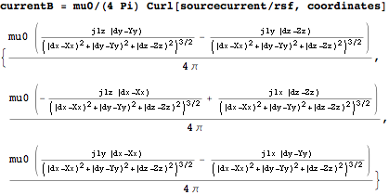

The field gradient is

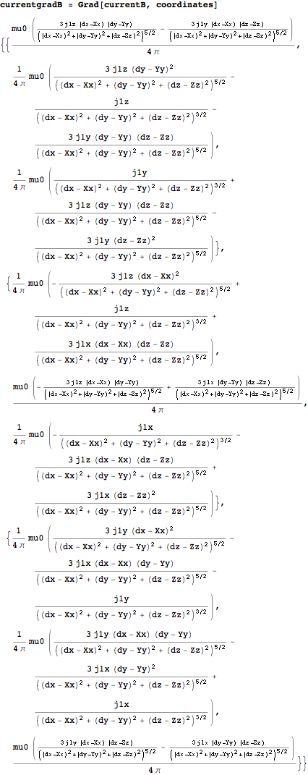

The potential of a dipole element {m2x,m2y,m2z} in the field is

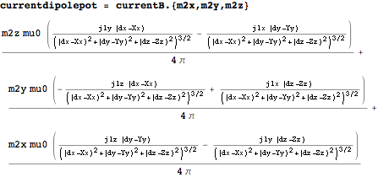

and the force on it is

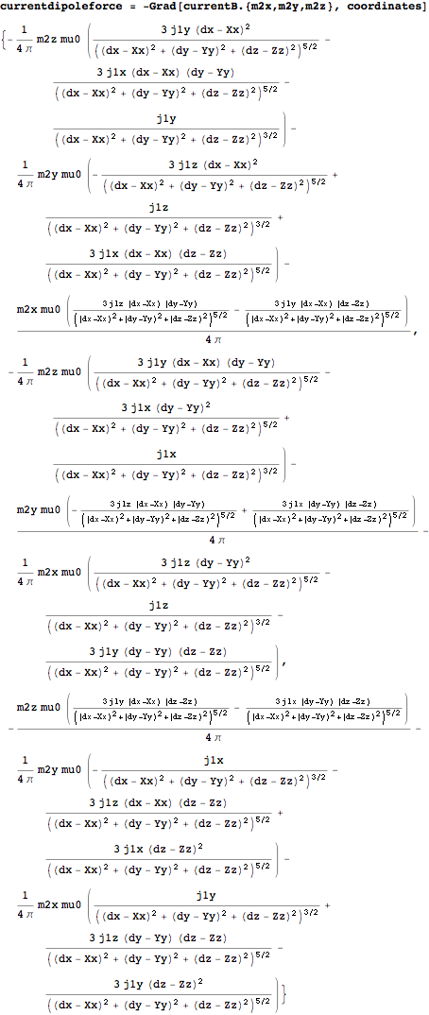

Because of cylindrical symmetry it is convenient to transform to cylindrical coordinates {r1, theta1, z1} about the centre of the coil and {r2, theta2, z2} about the centre of the magnet:



where coilsigma is the current density per unit area in the coil and mz is the magnetic moment per unit volume in the magnet.

*Effectively*, the above integrand is integrated over all six variables as follows:



where coillen, coilrad1 and coilrad2 are the coil length and inner and outer radii, l and a are the magnet length and radius, and z is the distance from the centre of the coil.

In practice, of the 6 integrations required, only z1 and z2 can be done analytically, or at least *could* in older versions of Mathematica. Newer versions of Mathematica seem to have gotten dumber but fortunately, because the results took a long time to compute from scratch, they were were archived and so are still available. See SweetSpot.nb for the expressions, which are too long to reproduce here.

The integrals over theta1 and theta2 can be combined by applying the transformation , and multiplying by 2*Pi. The three remaining integrals, deltatheta, r1 and r2 can then be done numerically in a few seconds.

The coupling of small displacements of the coil to force on the magnet can be calculated from the second derivative of the force. In –v1 of this document, as well as versions up through –v3 of the predecessor document, LIGO-T1000164, this was reported as a value for coupling in the tables, but the values were complete nonsense due to two compounding errors:

* The first (rather than second) derivative had been calculated.
* The Mathematica numerical derivative function ND[] turns out to be very unreliable for some functions including the force as calculated above, and the value was not zero (as expected for a first derivative at a maximum), but non-zero and by coincidence in the ball-park of what the second derivative should have been.

After trying a bunch of different approaches to get a reliable second derivative value, the method settled on for this version uses the Mathematica FunctionInterpolation[] function to create a fitted approximation to the force function calculated numerically as above, followed by Series[] to extract a power series, Normal[] to convert it to a regular expression and Coefficient[] to extract the square term:

deriv2[KPR] = -2*

Coefficient[Normal[Series[fzi[KPR][z], {z, zmax[KPR], 2}]], z^2]

The final calculation method was checked by plotting the second derivative approximation together with the full curve as in Figure 1.



Figure 1: Force as a function of displacement (for original design of optic flag and magnet) in black against an approximation using second derivative (red)A successful

# Parameters/Results

The parameters of the OSEM coil are given in Promec drawings

10212-Gr.12-body BOSEM intermediate.pdf

and

10203-Gr.12-Osem intermediate mass.pdf

(Akutsu-san has redesigned many of the details of the OSEM body relative to these drawings, but the coil is unchanged.) The coil outer radius can be calculated from the inner radius (9 mm) plus the wire diameter (0.36 mm) and the number of layers (27). In fact the 600 turns do not quite fill the channel allowed for the coil.

The original optic flag design for PRx was detailed in 10304-Gr.13-Varia details.pdf and used a 3 mm long, 6 mm diameter magnet.

The original IM flag design was detailed in 10207-Gr.12-Varia details.pdf and used a 10 mm long, 10 mm diameter magnet.

Fabian adjusted both of these designs to use the sweet-spot positions calculated in –v1 of these documents, and these have been used for the PR suspensions.

More recently it has been proposed to reduce the magnet size on the BS optic to 3 mm long, 3 mm diameter (4 times reduction in magnetic moment) and to add extra magnets with opposite polarity to the IM flags so that the net magnetic moment of each flag is zero, and the coupling to external fields is reduced.

Tatsumi-san will adapt the design of the BS flags, probably keeping a cavity the same size as the original magnet and using a holder to keep the new, smaller magnets in the desired position.

Fabian has already done a provisional design of the two-magnet IM flags:

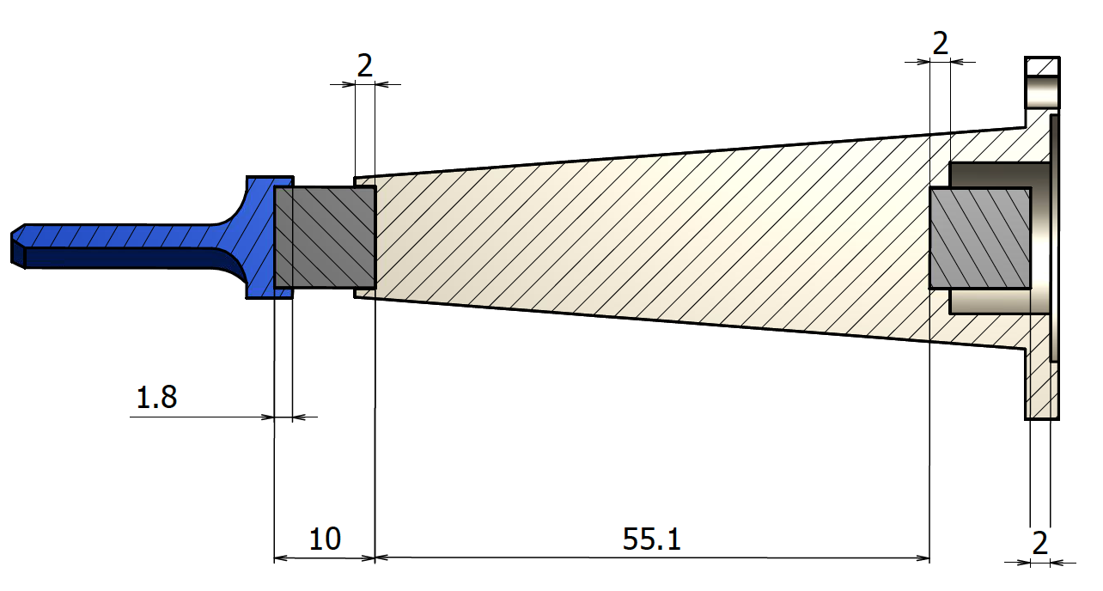

It turns out to be convenient to have a distance of 55.1 mm between the faces of the magnets (or 65.1 mm between centers; misstated as 60.1 mm in –v2, although the exact separation barely matters).

Because of the ease of breaking the long flags, a revised design was prepared using ferromagnetic disks that could be glued into the flag tip and base parts and be attracted by the magnet, so that the entire flag assembly would be held together magnetically.

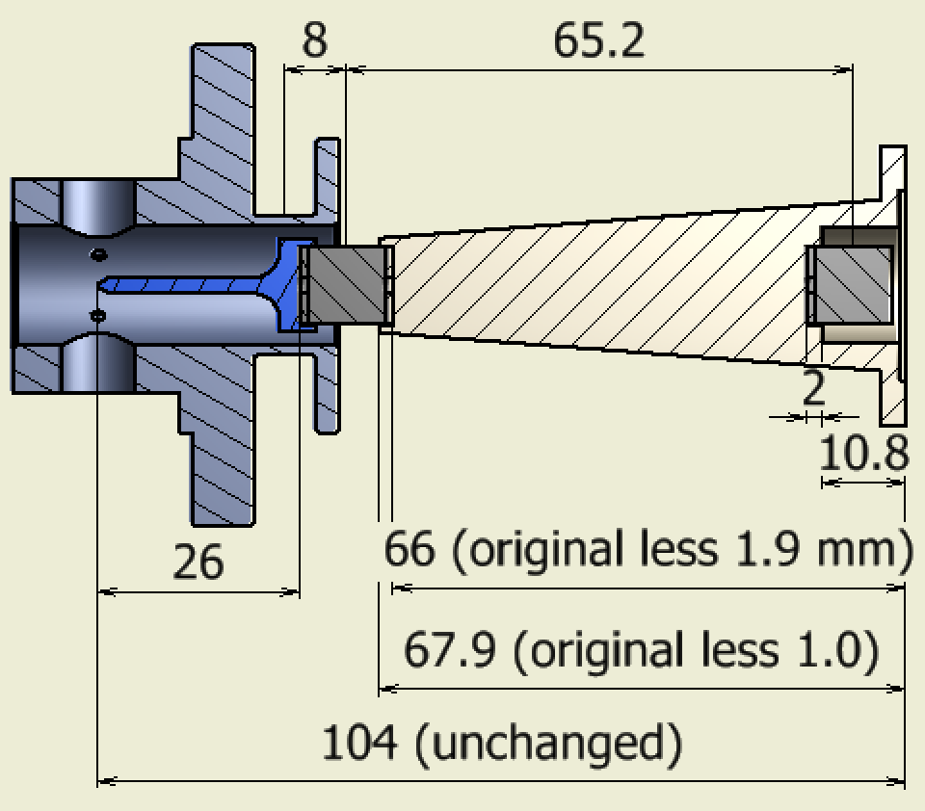

To approximate this using the formalism of the magnetic force calculation, a dipole moment corresponding to the actual volume of the magnet material was assumed to be uniformly distributed over the volume of the magnet plus disks, which were each 1 mm thick.

The parameters and results for these combinations are given in Table 1.

Table 1: Parameters and results.

|  |  |  |  |  |  |  |  |  |
| --- | --- | --- | --- | --- | --- | --- | --- | --- |
| Parameter | 3x6 magnet for PR | 10x10 magnet for IM | | 3x3 magnet for BS | Opposed 10x10 magnets for BS | Opposed 10x10 magnets for BS, disk version | Description | |
| l | 3 mm | 10 mm | | 3 mm | 10 mm | 10+1+1 mm | length of magnet | |
| a | 3 mm | 5 mm | | 1.5 mm | 5 mm | 5 mm | radius of magnet | |
| coillen | 8 mm | 8 mm | | 8 mm | 8 mm | 8 mm | length of coil | |
| coilrad1 | 9 mm | 9 mm | | 9 mm | 9 mm | 9 mm | inner radius of coil | |
| coilrad2 | 18.72 mm | 18.72 mm | | 18.72 mm | 18.72 mm | 18.72 mm | outer radius of coil (inner radius plus 27 layers @ 0.36 mm) | |
| coilturns | 600 | 600 | | 600 | 600 | 600 | number of turns | |
| mz (NdFeB) | 8.78 105 A/m; 1.10 T | 8.78 105 A/m; 1.10 T | | 8.78 105 A/m; 1.10 T | 8.78 105 A/m; 1.10 T | 8.78 105 A/m; 1.10 T | magnetic moment/volume | |
| dipole | 0.0745 A.m | 0.690 A.m | | 0.0186 A.m | 0.690 A.m | 0.690 A.m | net magnetic moment | |
| coilsigma | 7.72 106 A/m2 | 7.72 106 A/m2 | | 7.72 106 A/m2 | 7.72 106 A/m2 | 7.72 106 A/m2 | coil current density | |
| fmax (theory) | 0.129 N/A | | 1.12 N/A | 0.0313 N/A | 1.11 N/A | 1.26 N/A | | maximum force (theory) |
| zmax (theory) | 6.72 mm | | 7.44 mm | 6.93 mm | 7.44 mm | 7.99 mm | | sweet spot (theory) |
| z95minus/plus | 5.2/8.5 mm | | 5.8/9.3 mm | 5.3/8.79 mm | 5.7/9.4 mm | 6.2/10.0 mm | | 95% force positions |
| pairoffset | - | | - | - | 65.1 mm | 65.2 mm | | magnet distance (between centers) |
| Promec magnet position | 7.4 mm | | 7.9 mm | 7.4 mm | 7.9 mm | 7.9 mm | | actual position (Promec design, as read from Inventor by Fabian) |
| deriv2 (theory) | 4720 N/A/m2 | | 37000 N/A/m2 | 1080 N/A/m2 | 4724 N/A/m2 | 4724 N/A/m2 | | displacement-force cross-coupling |

# Conclusion



Figure 2: Force for optic/RM as a function of distance between coil and magnet centers, with optimum position (6.72 mm) in black and Promec design (7.4 mm) in red. Positions for 95% of maximum force are in grey.



Figure 3: Force for IM/IRM as a function of distance between coil and magnet centers, with optimum position (7.44 mm) in black and Promec design (7.9 mm) in red. Positions for 95% of maximum force are in grey.



Figure 4: Force for BS with smaller magnets as a function of distance between coil and magnet centers, with optimum position (6.93 mm) in black, first stage redesign (6.72 mm) in green, and Promec design (7.9 mm) in red. Positions for 95% of maximum force are in grey.



Figure 5: Force for BS-IM with double magnets as a function of distance between coil and magnet centers, with optimum position (7.45 mm) in black, first stage redesign (6.72 mm) in green, and Promec design (7.9 mm) in red. Positions for 95% of maximum force are in grey. Force without second magnet is in yellow.

# Conclusion

All versions of the design have the sweet spot well within the zone where the force is at least 95% of the maximum.

As expected, adding a second magnet to the BS-IM flags makes very little difference to the sweet spot. If it is convenient, the double-magnet flags can be made by simply drilling out a cavity in the base of single-magnet flags without needing to modify the tip end.

Also, decreasing the size of the BS magnets makes little difference. Ideally, the holder for the smaller magnets should be designed to put the center of the magnet 7.45 mm from the center of the coil when the tip of the flag is centered between the LED and PD. However designing it hold the magnet in the center of the cavity for the original larger magnet should also be OK.