JGW-T1503239-v1 *KAGRA* 2 Feb 2015

**OSEM Coil/Magnet/Flag Calculation**

Mark Barton

Distribution of this document:

JGW-DCC

This is an internal working note

of the KAGRA collaboration.

http://gwcenter.icrr.u-tokyo.ac.jp

**Table of Contents**

1 Introduction 3

1.1 Purpose and Scope 3

1.2 References 3

1.3 Version history 3

2 Theory 3

3 Results 8

4 Conclusion 10

# Introduction

## Purpose and Scope

Gives the calculation of the position of the magnet in the field of the OSEM coil to give maximum force/current and minimum cross-coupling from position of the coil to force.

## References

LIGO-T1000164: [Calculation and measurement of the OSEM actuator sweet spot position](https://dcc.ligo.org/LIGO-T1000164)

## Version history

1/15/2015: Pre-rev-v1 draft. Based on LIGO-T1000164, but with updates for KAGRA.

2/2/2015: -v1. Calculations for optic/RM and IM/IRM OSEM-magnet combos.

# Theory

The theory for the force on a current line element in a magnetic field is derived in the Mathematica notebook MagDipole.nb accompanying this document in the DCC. Note that this notebook and the extracts from it below had to be updated from the version included with LIGO-T1000164-v3 to allow for changes introduced in Mathematica 9. Formerly, the Mathematica vector analysis functions were in a separate package, Calculus`VectorAnalysis, and assumed a default set of Cartesian coordinates



From Mathematica 9, the functions were added to the Mathematica kernel and the calling convention for Grad[], Div[] and Curl[] was changed to require the coordinates to be supplied explicitly.

Briefly, if the magnitude and coordinates of a current element within the coil are





and the coordinates of an arbitrary test point are



then the distance between them is





and the magnetic vector potential from the line element is



giving a field of

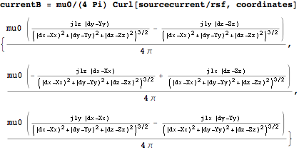

The field gradient is

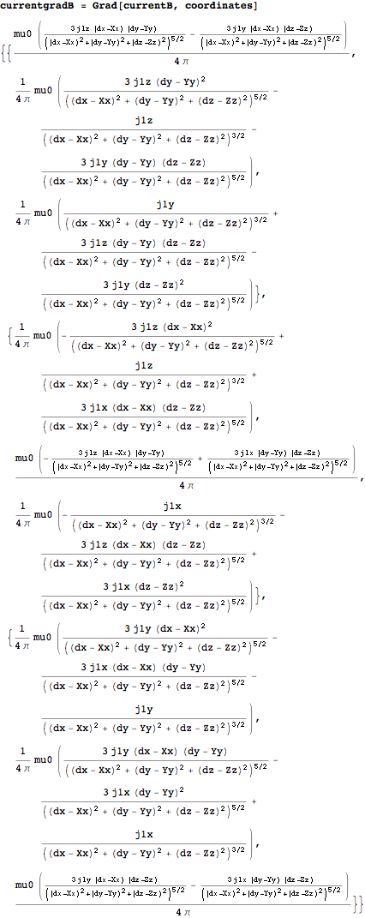

The potential of a dipole element {m2x,m2y,m2z} in the field is

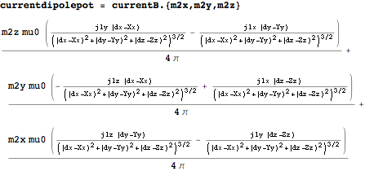

and the force on it is

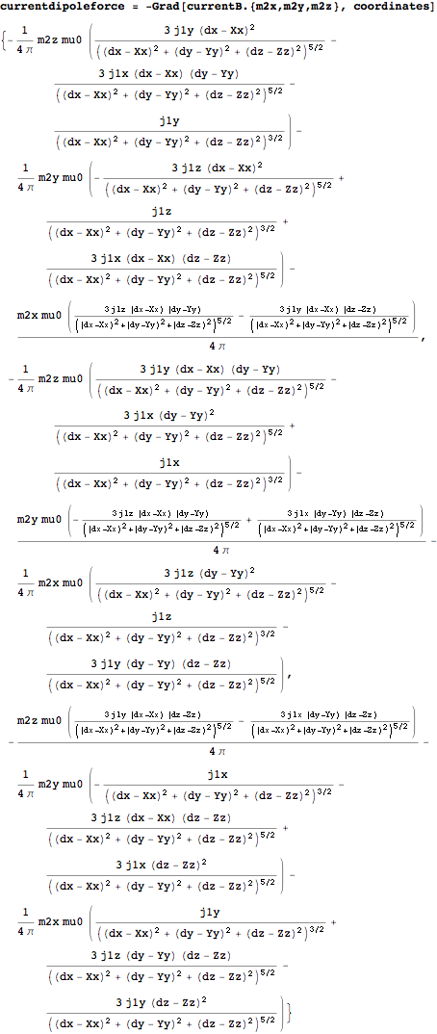

Because of cylindrical symmetry it is convenient to transform to cylindrical coordinates {r1, theta1, z1} about the centre of the coil and {r2, theta2, z2} about the centre of the magnet:



where coilsigma is the current density per unit area in the coil and mz is the magnetic moment per unit volume in the magnet.

*Effectively*, the above integrand is integrated over all six variables as follows:



where coillen, coilrad1 and coilrad2 are the coil length and inner and outer radii, l and a are the magnet length and radius, and z is the distance from the centre of the coil.

In practice, of the 6 integrations required, only z1 and z2 can be done analytically, or at least *could* in older versions of Mathematica. Newer versions of Mathematica seem to have gotten dumber but fortunately, because the results took a long time to compute from scratch, they were were archived and so are still available. See SweetSpot.nb for the expressions, which are too long to reproduce here.

The integrals over theta1 and theta2 can be combined by applying the transformation , and multiplying by 2*Pi. The three remaining integrals, deltatheta, r1 and r2 can then be done numerically in a few seconds.

# Results

The parameters of the OSEM coil are given in Promec drawings

10212-Gr.12-body BOSEM intermediate.pdf

and

10203-Gr.12-Osem intermediate mass.pdf

The coil outer radius can be calculated from the inner radius (9 mm) plus the wire diameter (0.36 mm) and the number of layers (27). In fact the 600 turns do not quite fill the channel allowed for the coil.

The magnet size for the flags on the optic is not currently known (the flag is detailed in 10304-Gr.13-Varia details.pdf but not the magnet) but will be added as soon as possible.

Table 1: Parameters and results.

|  |  |  |  |  |
| --- | --- | --- | --- | --- |
| Parameter | | 3x6 magnet for optic, OSEM coil | 10x10 magnet for IM,  OSEM coil | Description |
| l | | 3 mm | 10 mm | length of magnet |
| a | | 3 mm | 5 mm | radius of magnet |
| coillen | | 8 mm | 8 mm | length of coil |
| coilrad1 | | 9 mm | 9 mm | inner radius of coil |
| coilrad2 | | 18.72 mm | 18.72 mm | outer radius of coil (inner radius plus 27 layers @ 0.36 mm) |
| coilturns | | 600 | 600 | number of turns |
| mz (NdFeB) | | 8.78 105 | 8.78 105 | magnetic moment/volume |
| coilsigma | | 7.72 106 A/m2 | 7.72 106 A/m2 | coil current density |
| fmax (theory) | 0.129 N/A | | 1.12 N/A | maximum force (theory) |
| zmax (theory) | 6.72 mm | | 7.60 mm | sweet spot (theory) |
| magnet position (design) | 7.4 mm | | 7.9 mm | actual position (Promec design, as read from Inventor by Fabian) |
| coupling (theory) | 10.8 N/A/m | | 94.1 N/A/m | displacement-force cross-coupling |

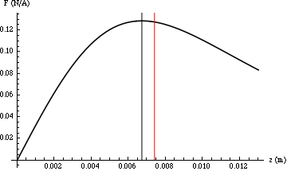

Figure 1: Force for optic/RM as a function of distance between coil and magnet centers, with optimum position (6.72 mm) in black and Promec design (7.4 mm) in red.

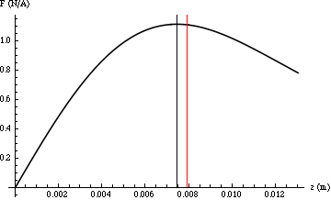

Figure 2: Force for IM/IRM as a function of distance between coil and magnet centers, with optimum position (7.60 mm) in black and Promec design (7.9 mm) in red.

# Conclusion

The Promec optimization seems to have been decent and there is no pressing need to tweak it, but if it’s easy, the magnet could be moved within the flag assembly towards the tip (and thus towards the coil when the OSEM is centered) by 0.68 mm for the optic flags and 0.46 mm for the IM flags.