JGW-T1402723-v1 Sep. 8, 2014

Noise Budget of Optical Lever
with Position Sensitive Detector (PSD)

Takanori Sekiguchi

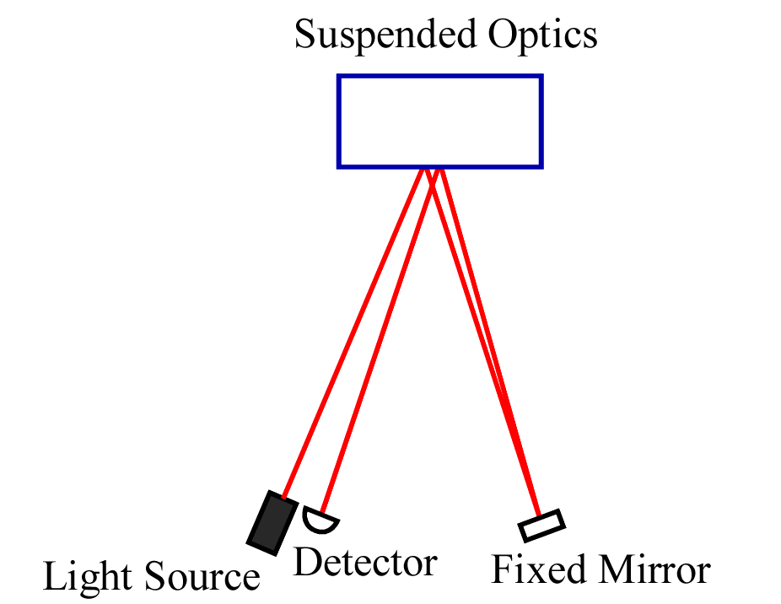

Fig.1: Configuration of an optical lever

Assumption
Light source: SLD (Super Luminescent Diode)
Output power: 1.0 mW
Relative intensity noise: 3 x 10⁻⁵ /rtHz @1 Hz
Detector: Two-Dimensional PSD (Position Sensitive Detector)
Photosensitivity: 0.6 A/W
Linear Range: +/- 4 mm
Readout: Transimpedance amplifier
Transimpedance resistance: 100 kΩ
Operational amplifier voltage noise: 2 nV/rtHz (knee freq: 2 Hz)
Operational amplifier current noise: 0.3 pA/rtHz (knee freq: 100 Hz)
RIN rejection ratio by normalization: 1%
Optical configuration: double bounce
Roundtrip length: 4 m
Intensity reflectivity of the suspended optics: 0.5

Noise Budget
DC Sum current from PSD: 150 μA, DC Sum output voltage: 15 V
Expected sensitivity to mirror angle: 33 μrad/V

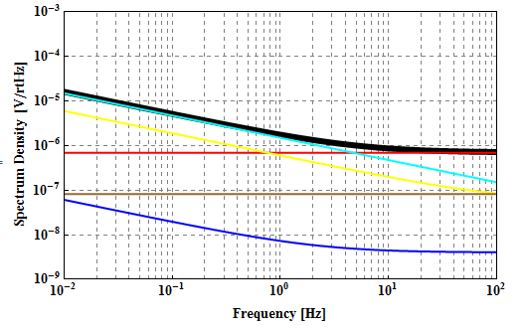
Fig. 2: Noise spectrum in output voltage.
Blue: OP-amp voltage noise, Yellow: OP-amp current noise, Brown: Johnson noise of transimpednace resistor
Cyan: Relative intensity noise of light source, Red: Shot noise limit, Black: Sum of them

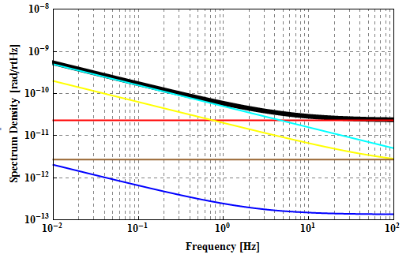
Fig. 3: Noise spectrum in optics angle. 3x10⁻¹¹ rad/rtHz @10 Hz

