TMCM-6110 Stepper motor driver manual
2017/02/28

O. Version History
2014/07/08: (Ver.01)スタートアップを追加
2017/02/28: English version

I. ハードウェア準備
Hardware Preparation

II. ソフトウェア準備 ]
Software Preparation

III. Start up

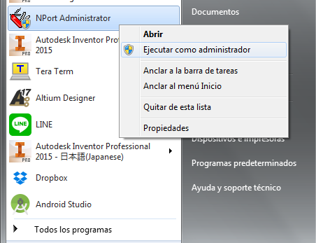
- NPort Administrator: Right click and select launch with administrator privileges.
- Click Search button to search for a serial conversion device to be connected.
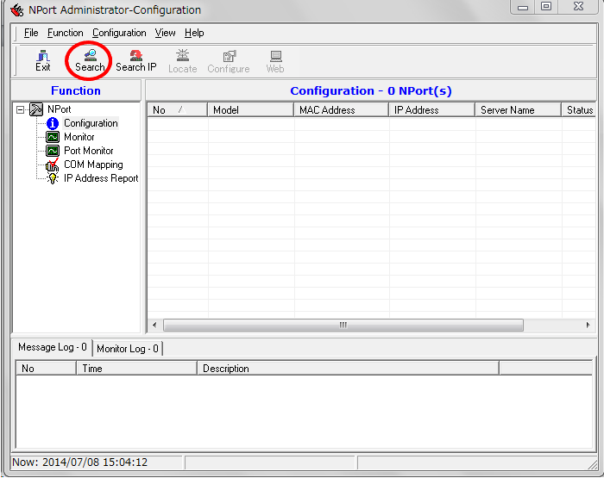

- If they are found, the devices will appear in the list, as shown in the next figure.

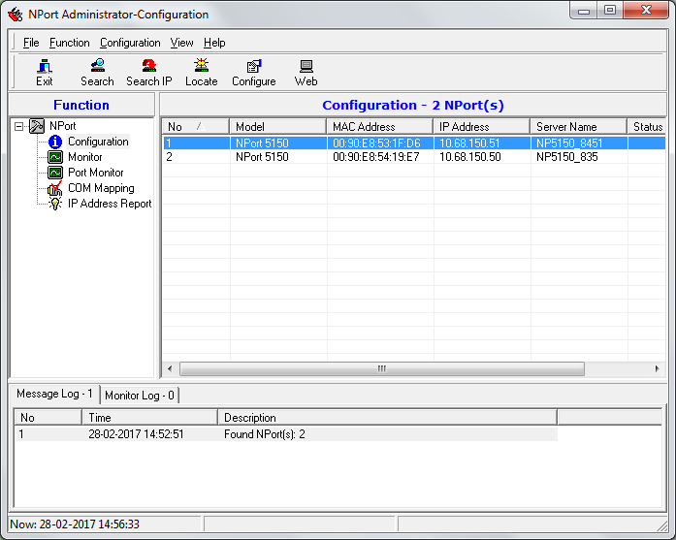
Note: Setting the IP number can be done either from the NPort Administrator program, or from the built-in web-server, by writing the IP address in a web browser. The following steps show how to do it from the NPort Administrator program and in the Appendix it is explained how to do the same in the web-server.

- Select the connected device and press the Configure button. Click on Network Tab and click on Modify to change the IP Address, Netmask and others parameters according to the table above.

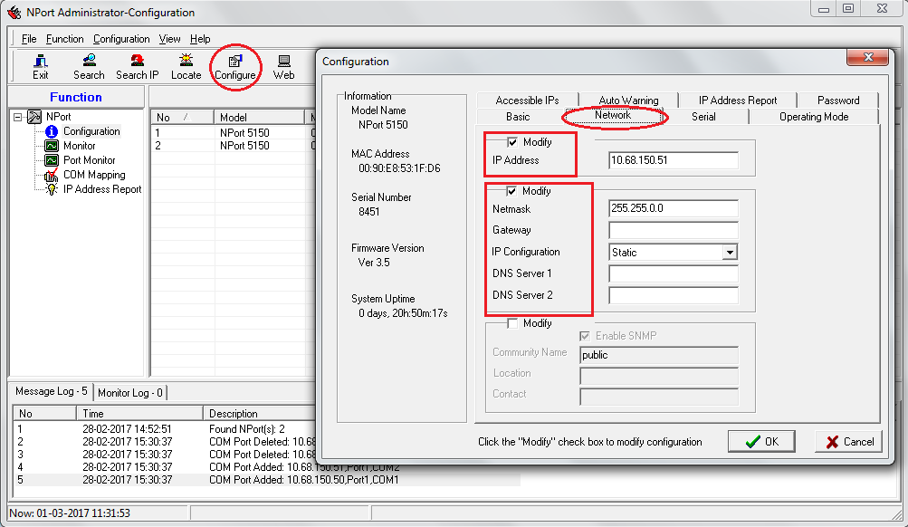
- Click on Serial Tab and click on Modify and Settings to change the Baud Rate, Interface to RS-482-2-wire, and others parameters.

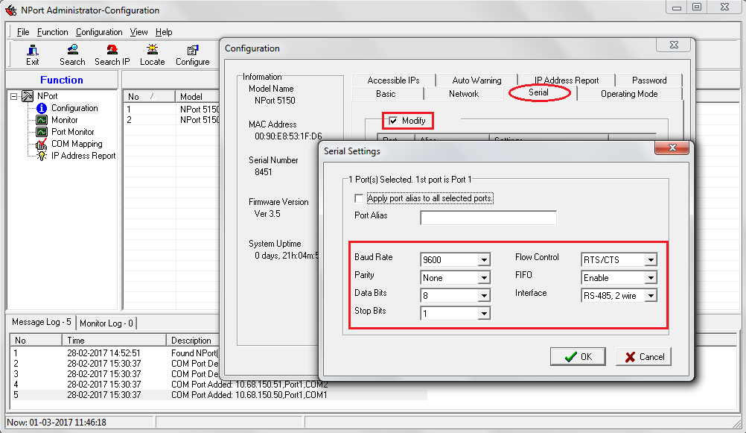

- Click on Operating Mode Tab and click on Modify and Settings to select the Real COM mode.

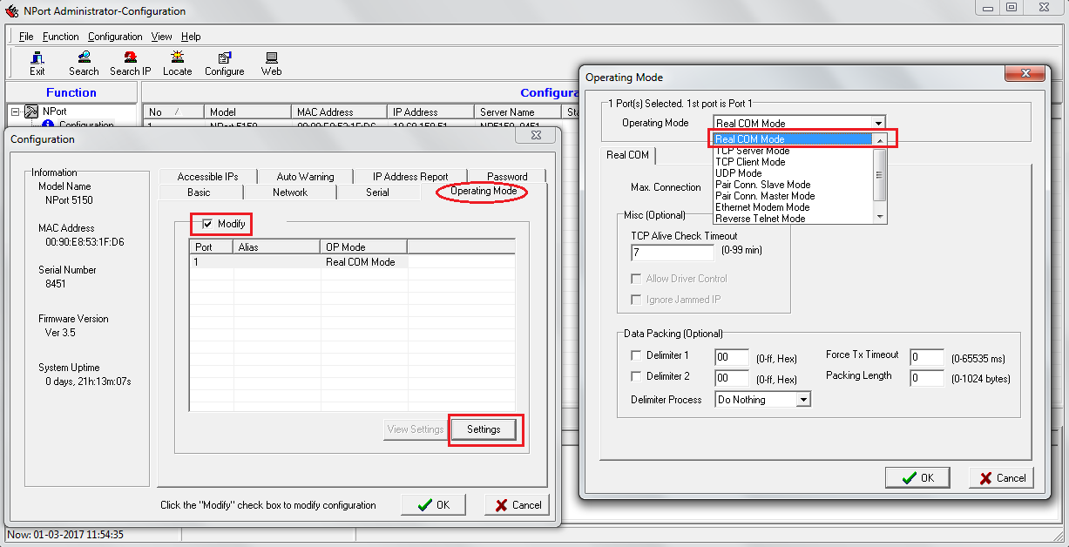

- Go back to NPort Administrator and click on the COM Mapping. If there is no port in the list, click Add to add a port.

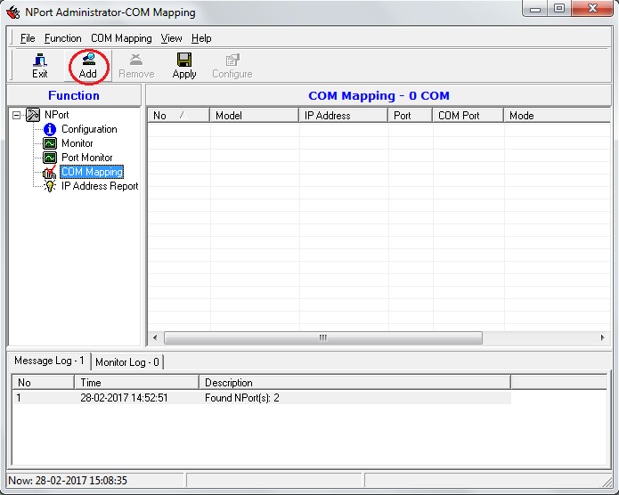
Note: You can also add the ports from the list or manually writing the IP address.

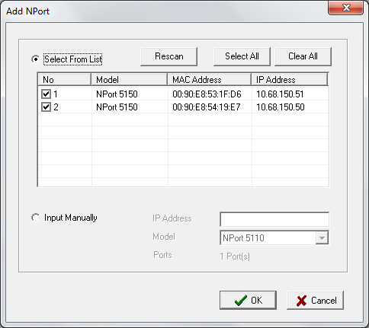

- After selecting the port, the COM Port will appear with a “+” symbol and that means the changes have not been applied yet.

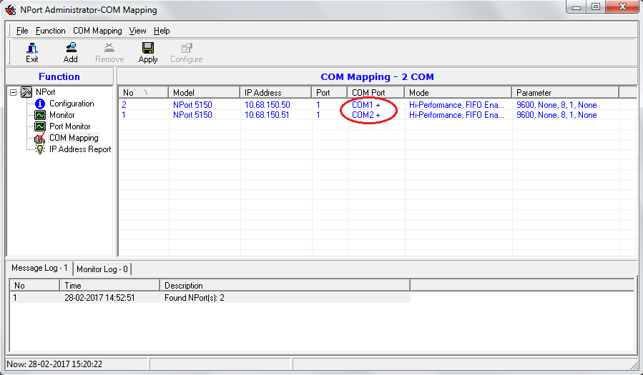

Note: After pressing the Apply button, the “+” symbol will disappear.

- Start TMCL with administrator privileges.

- Select the Connection tab and set the same connection port that was selected before.
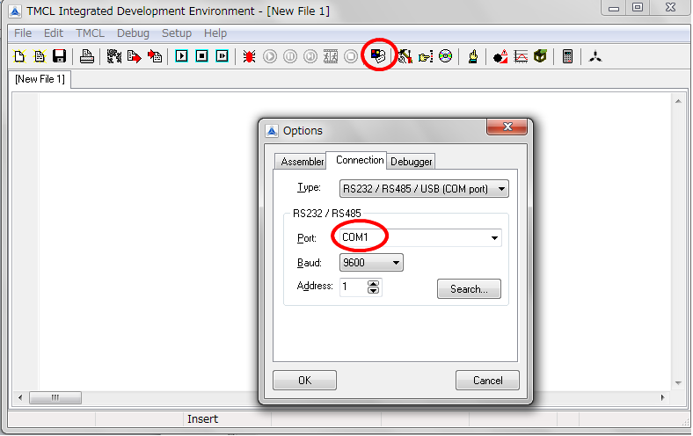

- Click the Direct Mode icon and if the motor is connected the following window will appeard and the software will detect the module automatically (TMCM-6110 in this case). Then by selecting a command from here is possible to control the motor by executing the command.

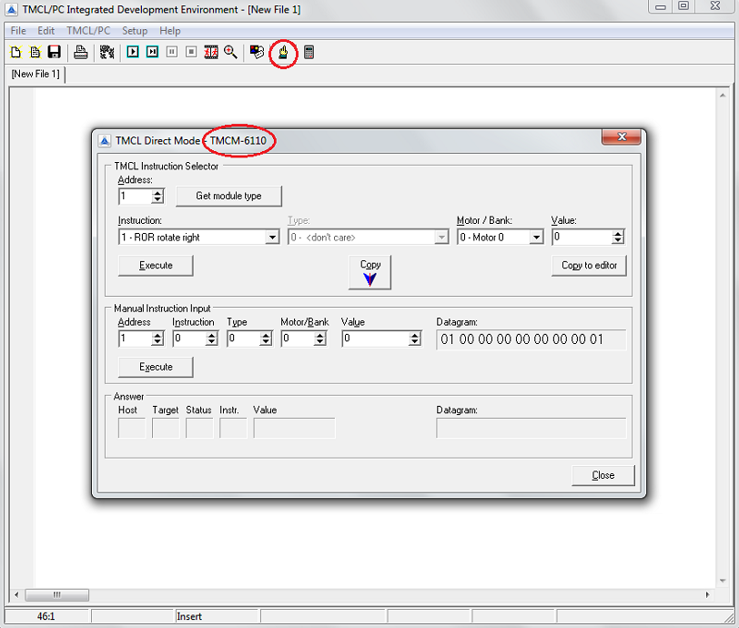
Note: If the motor is not connected or if the serial port has a different configuration the software will not be able to detect it automatically, so it will ask about the Module Type.
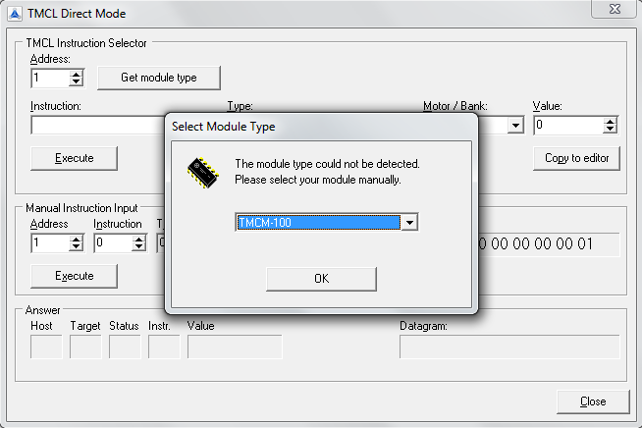

- Select the instructions to move or to stop the motor.

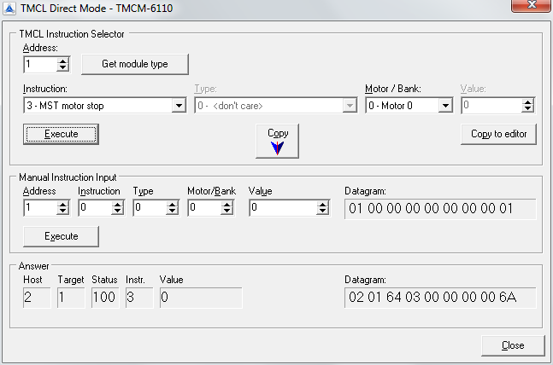
Note: If the motor is not connected the software will show the following window.

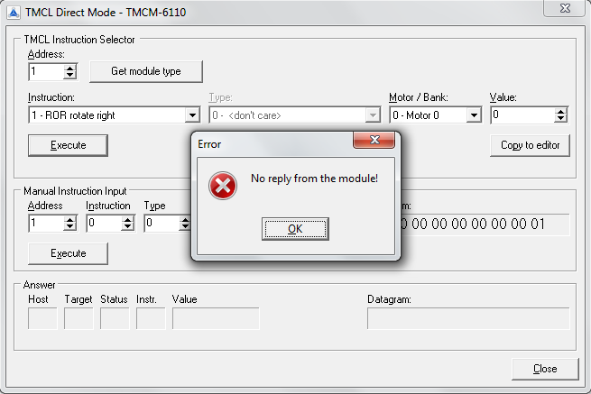

APPENDIX A: If you want to control the motor by using command lines.

- Select the Instruction 139 (Enter ASCII mode) so it can be operated from the terminal. After selecting this, the commands from direct mode will not be accepted unless you change the Enter ASCII mode. From now on you can only operate from TeraTerm or another terminals.
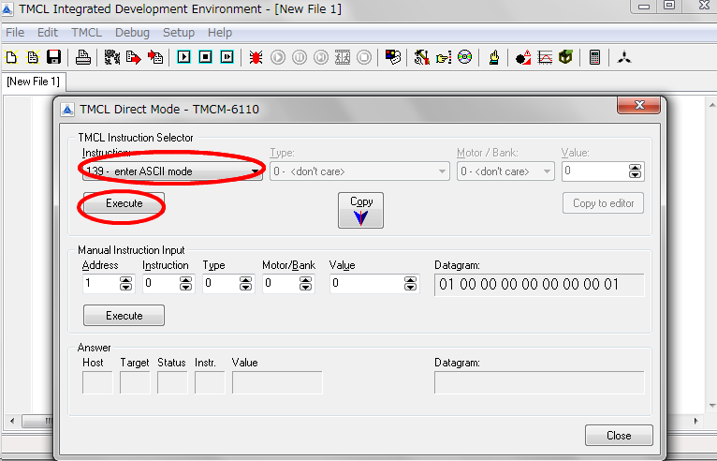

- When you finished with the TMCL part, open TeraTerm and select the same serial port as before. At this point you can not connect to the module, unless the TMCL is finished.
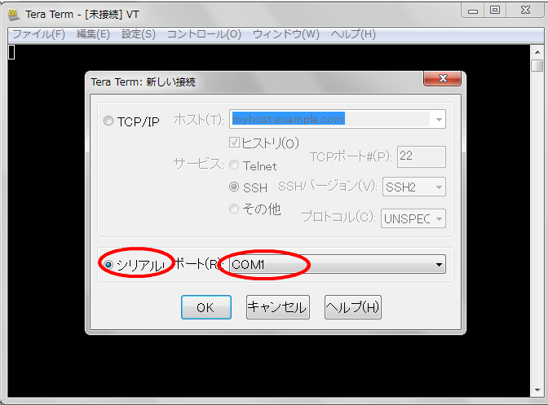

- Set the line code of CR + LF for the reception on terminal. This is useful to see a break line when you type a command.
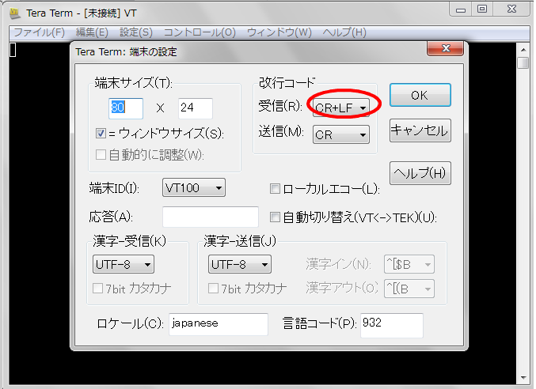

- Enter the corresponding commands from the command line and operate the Stepper Motor.

APPENDIX B

Setting the parameters through the web-server:
i) Select the connected device and open the web browser. Please note that you can not make settings from the web browser unless you have administrator privileges:
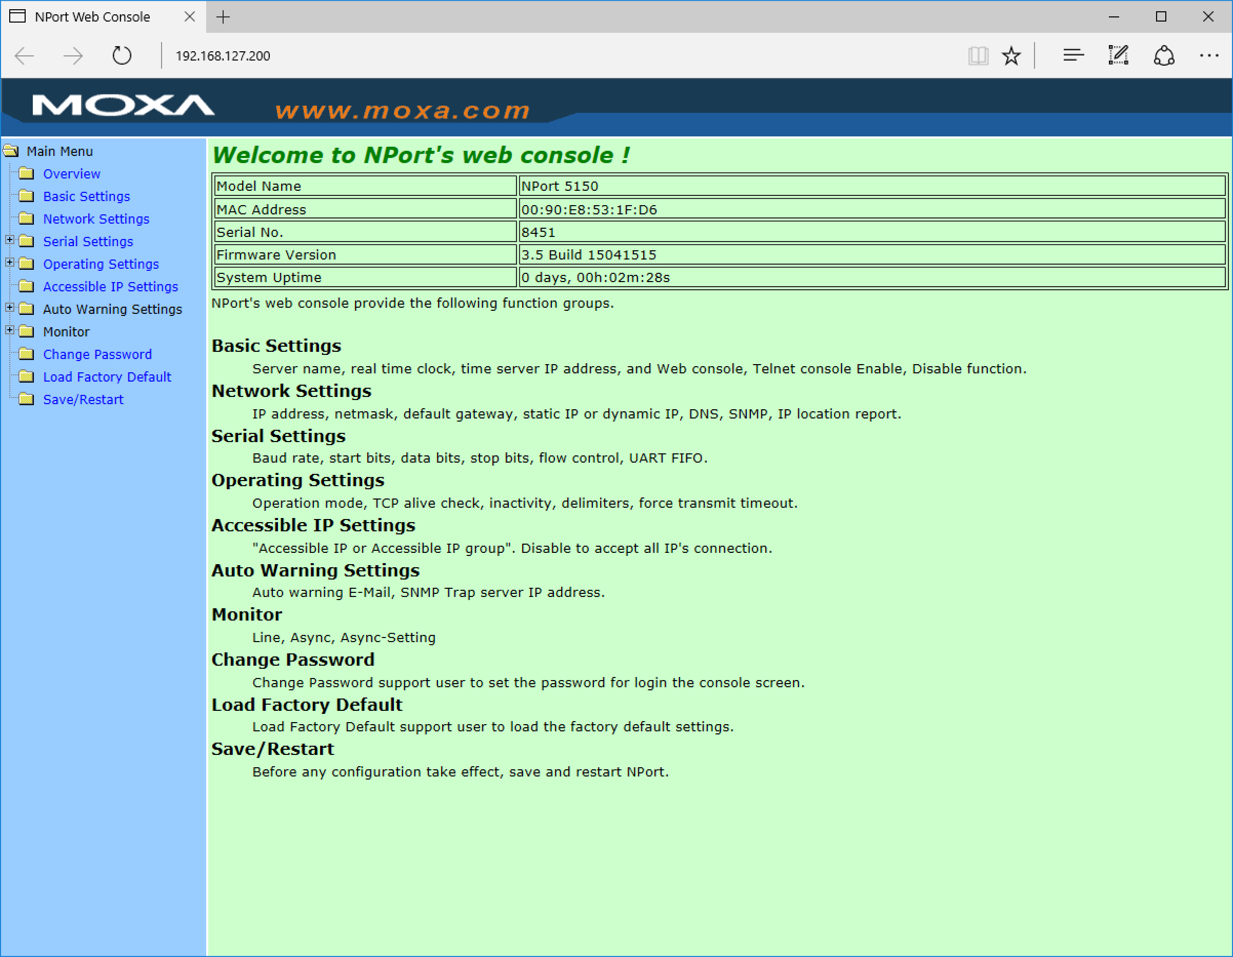
ii) Click on Network Settings to change the IP Address, Netmask and others parameters.
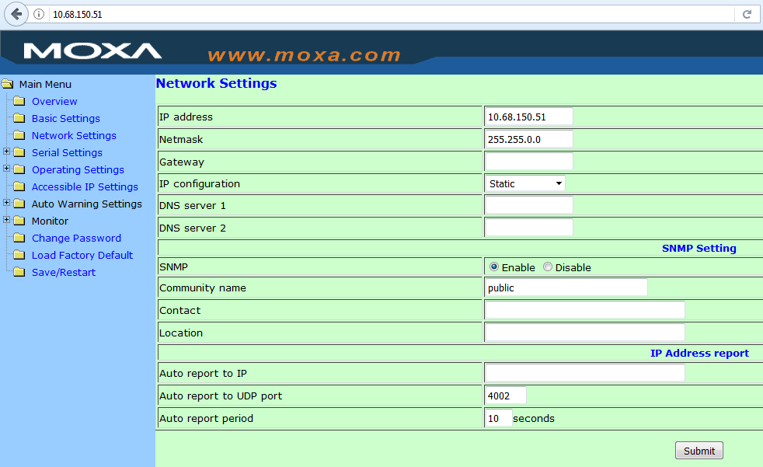

iii) Click on Serial Settings to change the Baud Rate, Interface to RS-482-2-wire, and others parameters.

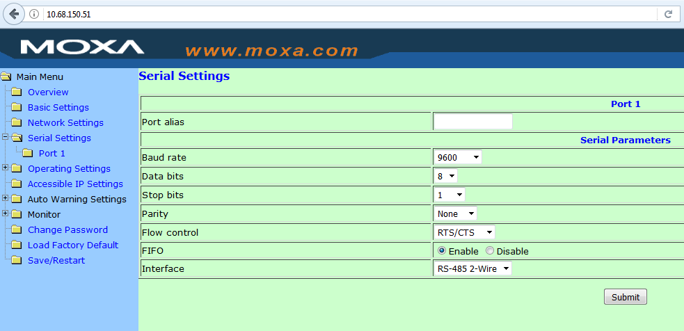

iv) Click on Serial Settings and select the Real COM mode.

