**Mirror suspensions hierarchy for beam splitter and recyclers**

K. Agatsuma, F. Pena Arellano, A. Bertolini, R. DeSalvo, E. Hennes, E. Majorana, I. Pinto, T. Sekiguchi, R. Takahashi, J. van Heijningen and J. van den Brand

**JGW-T1402264**

**Abstract.**

Drafts report describing the Design of the KAGRA’s warm mirror suspension system. It also contains considerations and lesson learned in view of the design of the Einstein Telescope.

Part of this material has been used also in the ELiTES periodic reports.

**Introduction**

The mirror suspensions and controls are formed by the bottom filter, suspending the intermediate mass and its recoil mass, and the mirror with its recoil mass, both suspended from the intermediate mass [[1]]. The mirror controls are hierarchical.

The mirror is controlled via electro-magnetic actuators from its recoil mass in the longitudinal, pitch and yaw degrees of freedom. The mirror actuation is limited to very low authority, to maintain actuation noise within acceptable limits. Slower and larger range actuation, in all 6 degrees of freedom, is possible actuating on the intermediate mass from its intermediate recoil mass, with electromagnetic actuators of larger force. Even lower frequency and larger amplitude movements are possible from the Inverted pendulum.

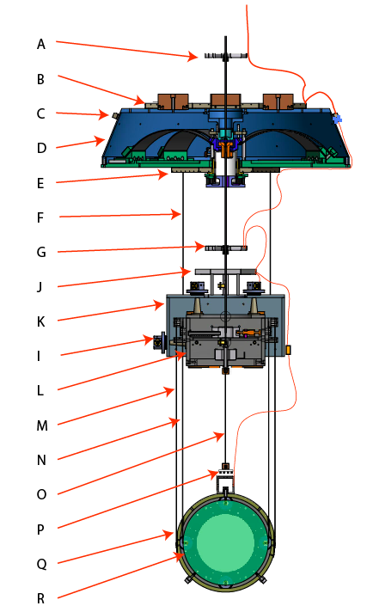

Figure 1: Warm Mirror suspension scheme: A: Electrical cabling spider on suspension wire, B: Upper cabling shelf, C: switchover connectors from large gauge wire ribbons to small gauge wires for suspension, D: bottom filter, E: Lower cabling shelf, F: intermediate recoil mass suspension wires (two shown out of three), G: Electrical cabling spider, J: Cabling shelf, K: Intermediate recoil mass, I: Optical Sensor/Electro-magnetic actuators (3 of 6 shown) controlling the intermediate mass, L: Intermediate mass, M: Mirror recoil mass suspension wire (2 of 4 shown), N: Mirror suspension wire (2 of 4 shown), O: magnetic damper whip, P: magnetic damper pad, Q: Mirror recoil mass, R: mirror. A typical wiring scheme is shown in red on the right side.

**Bottom filter (recycler and beam splitter warm mirrors)**

The bottom filter of an attenuation chain is similar to a standard filter provides additional functions and therefore is substantially more complex. It provides:

* Suspension and seismic isolation of the intermediate mass
* Suspension of the intermediate recoil mass
* Static and dynamic vertical positioning of the intermediate mass with respect to its recoil mass
* Static tilt positioning of the intermediate recoil mass with respect to the intermediate mass
* Static yaw positioning of the recoil mass with respect to its recoil mass.

These functions are provided as follows:

* The intermediate mass is suspended from the keystone like a normal filter
* The intermediate recoil mass is suspended from the bottom filters by means of three wires at 120o. The intermediate recoil mass therefore tracks the tilt movements of the bottom filter.
* The static and dynamic vertical positioning of the intermediate mass with respect to its recoil mass is obtained via the voice coil actuator, and/or thermal tuning.
* The static tilt positioning of the intermediate recoil mass with respect to the intermediate mass is obtained by tilting the bottom filter by means of two manual and two stepper motor controlled tuning masses.
* The static yaw positioning of the recoil mass with respect to its recoil mass is obtained with a stepper motor controlled rotational mechanism similar to the one mounted in the keystone of the pre-attenuator filter.

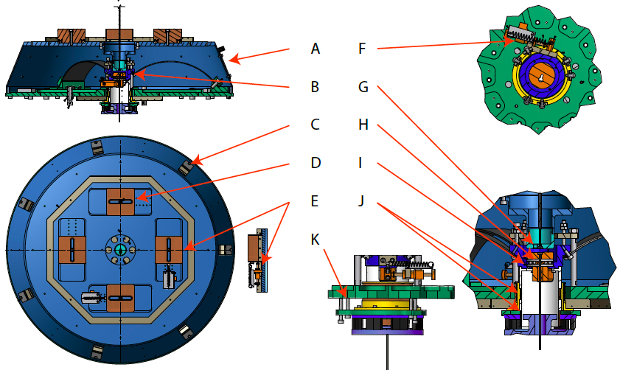

Figure 2: bottom filter, A: Filter body; B: intermediate mass rotational mechanism (see letters F to J), C: Connector switching heavy seismic attenuation electrical wires to thin suspension wires, D: manual tuning weight for tilt tuning (one of two), E: pico-motor controlled tuning weight for tilt tuning (one of two), F: intermediate mass rotation picomotor, J: fixed suspension point of the bottom filter, H: ceramic ball thrust-bearing, I: rotating suspension point for intermediate mass wire, J: LVDT and actuator coils, K: Push-pull screws for actuator permanent magnet plate, to set LVDT zero-point and center magnet gap to actuator coil.

**Intermediate mass and intermediate recoil mass**

The mirror and its recoil mass are suspended from the intermediate mass, which is controlled by its reaction mass, with the former suspended by the bottom filter and the latter from the body of the filter. The recoil mass has the shape of a box, encasing the intermediate mass.

Sensing and actuation are collocated, made by means of six OSEMs, three on the top and three on the sides of the box. They are positioned to form as diagonalized action as possible. The three horizontal actuators are as much as possible on the plane of the center of mass, to minimize tilt action. A single, centered actuator generates force along the beam line only. Two units are placed on opposite sides, one forward and one backwards, so that when operated with opposite polarity they generate a pure transversal force, and when operated with same polarity they generate a pure yaw torque. The three actuators on the cover are placed on an equilateral triangle, centered around the suspension wire, with one point aligned towards the beam line. When operated with same polarity they actuate in the vertical direction. When the two side units are operated with opposite polarity they produce pure roll torque, when the forward unit is operated with opposite sign than the back ones, and √3/2 force ratio, a pure pitch torque is applied. The same argument is applicable to the collocated position sensors. Starting from a control matrix with a hardwired diagonalization vastly simplifies the problem of control diagonalization and makes diagonalization more precise. The intermediate mass carries a whip loaded with a magnet matrix, designed to damp the mirror recoil mass modes, especially the bounce mode, which would otherwise be short-circuited on the mirror. This damping solution is very convenient, but it is not suitable for the four main mirrors, where the thermal noise from the Eddy current dissipation would spoil the interferometer sensitivity.

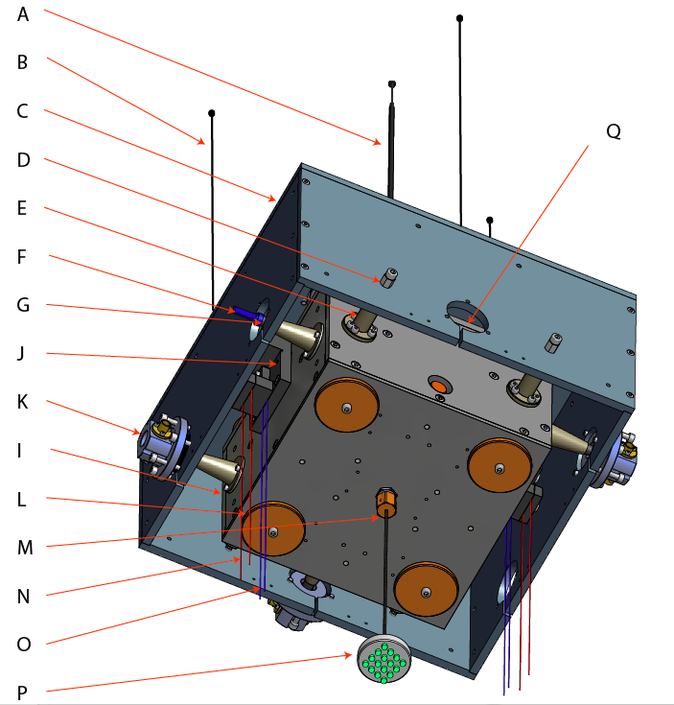

Figure 3: Intermediate mass and its recoil mass. A: Intermediate mass suspension wire, B: intermediate recoil mass suspension wires (three), C: Intermediate recoil mass, D: Range limiter screw (acts as transport lock when tightened), E: range limiter post, F: position sensor obscuration flag, G: magnet for voice coil actuator on its post, (G and E are added for illustration only, only three sensor/actuator pairs (K) mounted on the side for transversal mode control), J: wire clamping block, K housing for the LED-photodiode shadowmeter position sensor and actuator coil (three shown for transversal mode control and three unseen on the top for the vertical and tilt degrees of freedom), I: intermediate mass, L: static balancing masses, M: chuck for Eddy current damping whip wire, P: Eddy current damper plate and magnet matrix, Q: Cut to avoid short circuiting loop for actuation magnetic field.

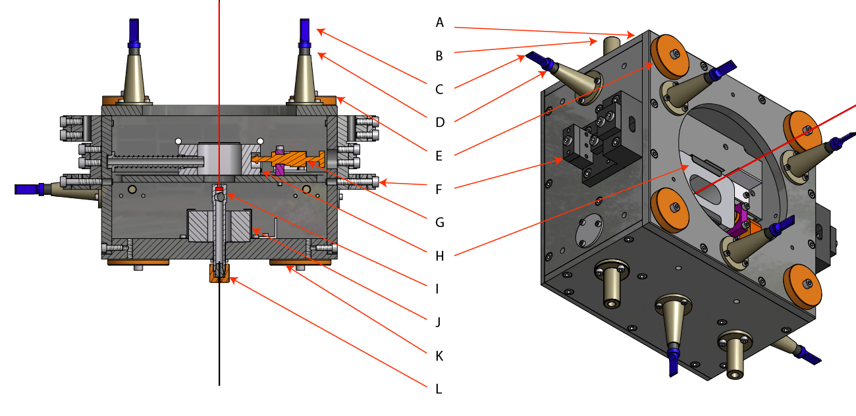

Figure 4: Intermediate mass: A: Intermediate mass frame, B: motion range limiter pillar, C: Position sensor flag, D Electro Magnetic actuator magnet, E: Upper trimming masses, F: wire clamping block, G: roll adjustment picomotor, H: roll adjustment mass, I: suspension wire support point, J: pitch adjustment mass, K: lower trimming masses, L: magnetic whip chuck.

**Intermediate mass and mirror Sensing and actuating**

Position sensing and actuating between the intermediate recoil mass and the intermediate mass, and between the mirror recoil mass and the mirror are collocated.

Position sensing is made with shadometers, i.e. a LED shines on a photodiode light detector, and a moving flag generates an occultation proportional to the displacement[[2] [3]].

Actuation is applied by a 600 turn coil with 28 mm effective diameter acting on a permanent magnet 7 mm off center. The coil is mounted on the same fixed support of the Optek OP 232 LED and Hamamatsu S1223-01 (3.6x3.6 mm2) photo-diode, while the magnet is mounted on the back of the occultation flag. The working point of the position sensor is when half of the LED light is occulted. The length of the flag is chosen so that when the shadowmeter is at its working point, the center of the permanent magnet is ½ of a coil radius away from the center of the coil, to obtain the maximum of the force and the force uniformity. For the intermediate mass a 10 mm diameter, 10 mm thickness (785 mm3) Nickel plated NdFeB magnet is used for large actuation force. For the test mass a 6 mm diameter x 2 mm (56 mm3) thickness magnet is used for small actuation noise.

The flag, the magnet stand and the coil body have been made out of PEEK. To avoid electrostatic charging problems Carbon fiber loaded Semitron ESD 480 PEEK was used as well. The resistivity of carbon loaded PEEK was measured, it was quite not uniform, changing by ±25% on the scale of a centimeter around a value of 49 kΩ-mm, and was very sensitive to temperature, but always high enough to fully avoiding interfering with actuation magnetic field via Eddy currents. Because any metal loops near the actuation coils is susceptible to generate Eddy currents that would introduce frequency dependent delays to the control forces, great care was made to introduce appropriate cuts in the metallic structure of the recoil mass. In addition, to further reduce the Eddy current problem, the recoil masses were designed in titanium grade V, for its small electrical conductivity. For the same reason, the permanent magnets on the intermediate mass were mounted on rigid PEEK stands. Using PEEK for the magnet structure and flag has the additional advantage that the low quality factor of PEEK eliminates the possibility that the stand’s own resonances introduce mechanical noise in the sensor signal. Of course this solution would not be suitable for any mirror susceptible to inject thermal noise contributions to the interferometer noise budget.

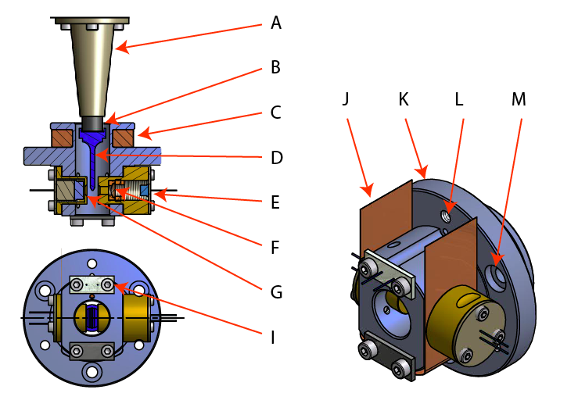

Figure 5: Optical Position Sensor Electro Magnetic Actuator. A: Magnet stand, B: Permanent Magnet, C: actuation coil, D: position sensor occultation flag, E: LED source, F: Lens, G: detection photodiode, I: cabling plate, J: grounding shield, K: sensor/actuator body, L adjustment pushing screw thread (one of three), M: adjustment pulling screw housing (one of three).

Finally, it is important to operate the position sensor at its sensitivity peak of 0.1 to 1.0 nm/√Hz between 0.1 and 10 Hz, which is also the frequency range utilized by the control actuators. Because the sensor shares the body of the actuator coil, the mounting must be strong to make sure that applied control forces do not bend the structure and thus falsify or pollute the position signal. To do so six screws were positioned on a hexagon on the rim of the sensor body. Three pulling screws operating against three pushing screws allow precise tuning while maintaining maximal stiffness of attachment to the recoil mass frame.

The strange light spot profile of the LED visible in figure is intrinsic in all LED engineering and unavoidable, it is due to the shade of the electrical feed wire welded on the center of the emitting area. The spot is somewhat uniformed by letting the light cone expand and window it with a rectangular mask but some residual non-uniformity and response non-linearity is unavoidable in a compact design if dynamic ranges larger than a mm are desired. A 3.5 mm sensitivity range can be achieved at the price of less linearity of the signal. The OP232 LED was chosen because its spot is more regular than most other LEDs, for its small size, and for its stability.

Evidence was collected that the larger sensing noise at low frequency is due to slow migration of the emitting spot on the diode surface, or by small launching angle fluctuations. It is likely that this migration is due to internal thermal fluctuations and it was checked that it does not depend from feed current fluctuations. It was found that the low frequency noise can be decreased by using an array of three LED parallel to the flag’s knife edge, operated in series.

Better linearity and more low frequency stability could be achieved by replacing the LED by a collimated fiber and an external light source, like a super-radiant LED. This choice may be forced in a cryogenic environment, where the power dissipation of the LED must be avoided.

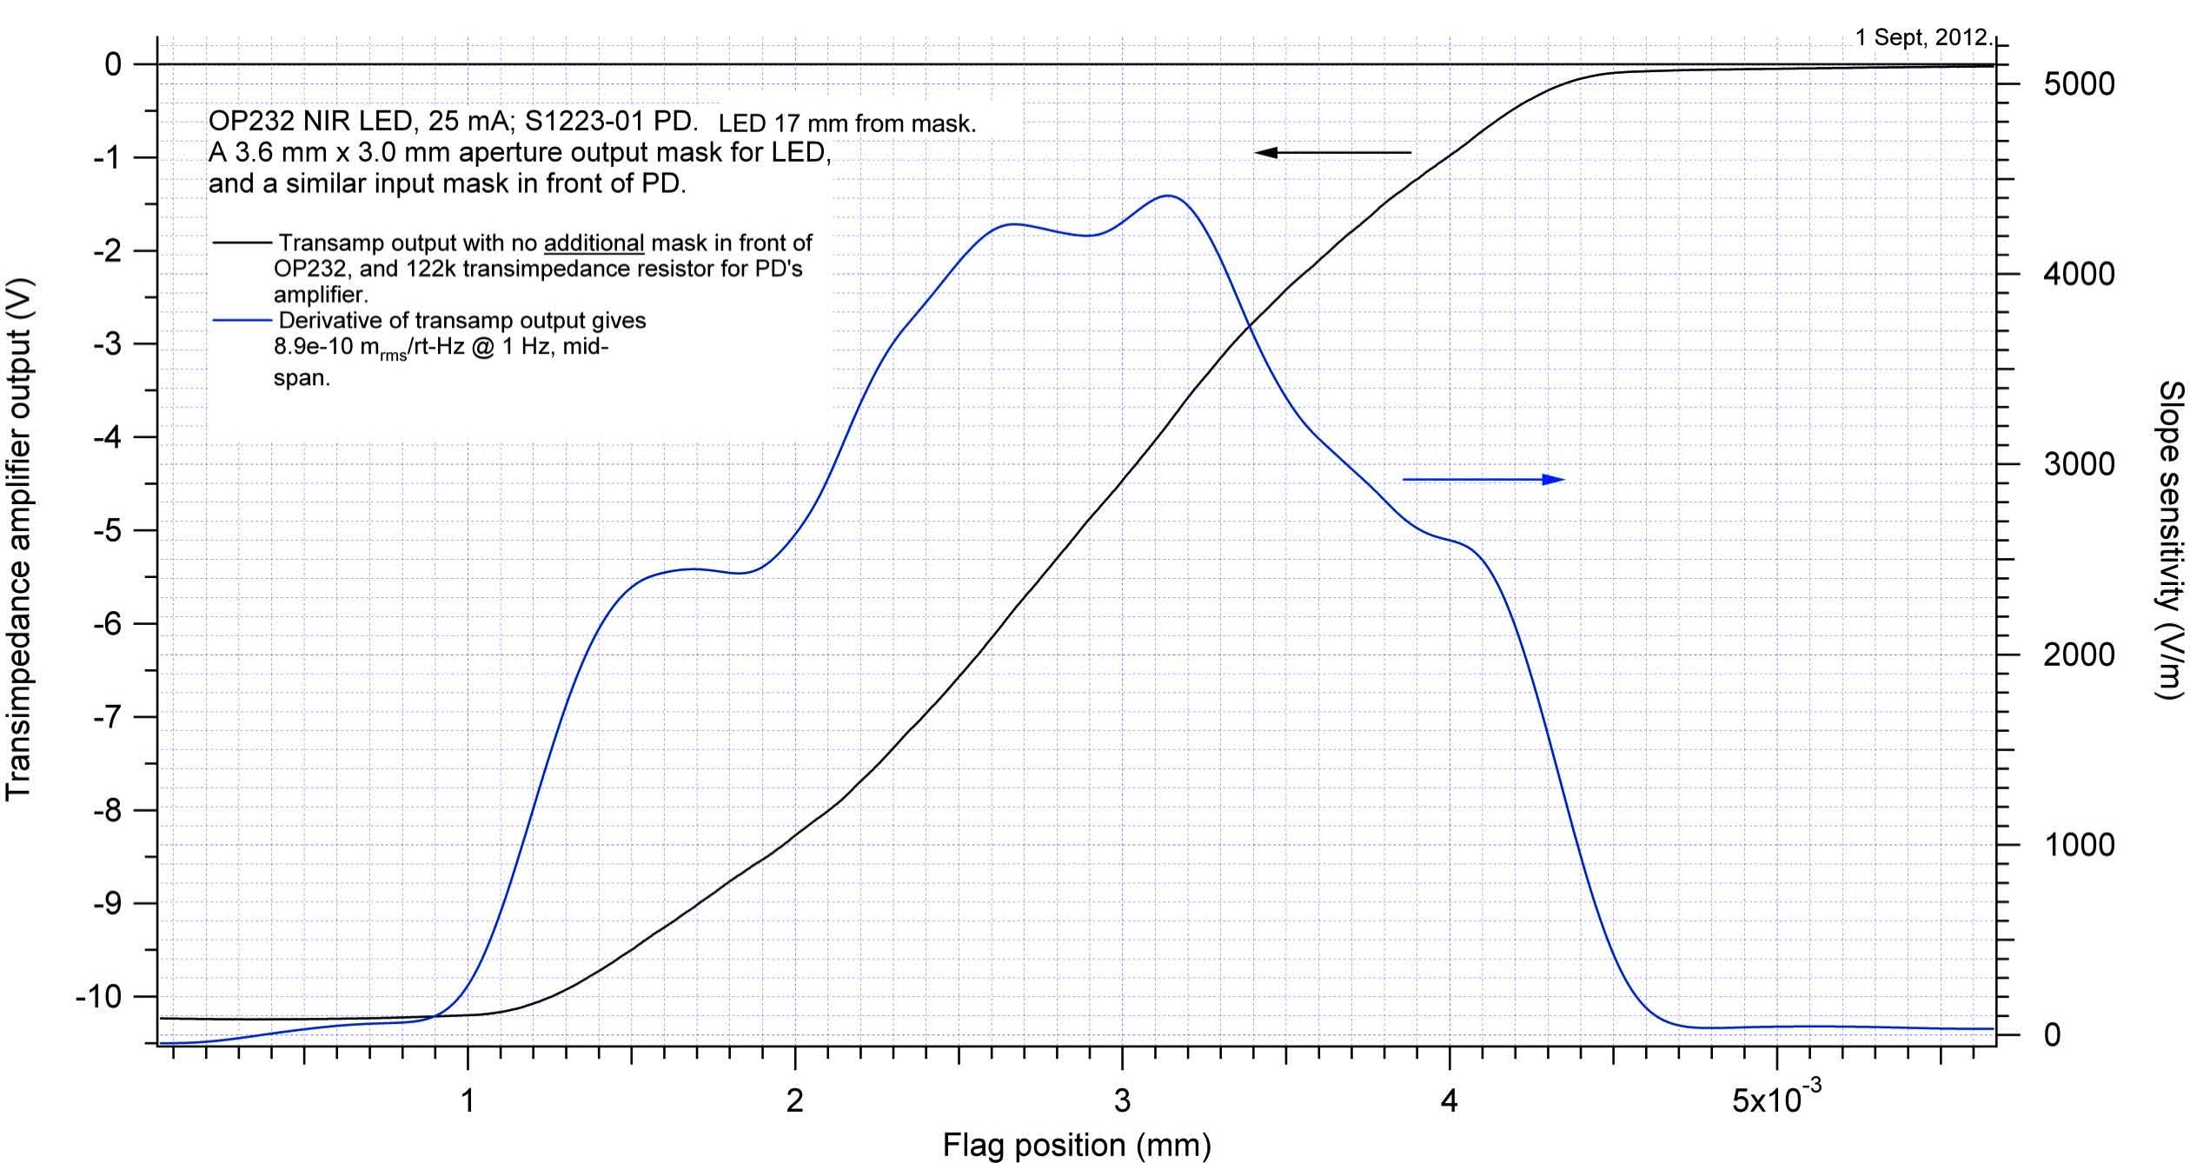

Figure 6 LED light-spot profile and sensor linearity curve.

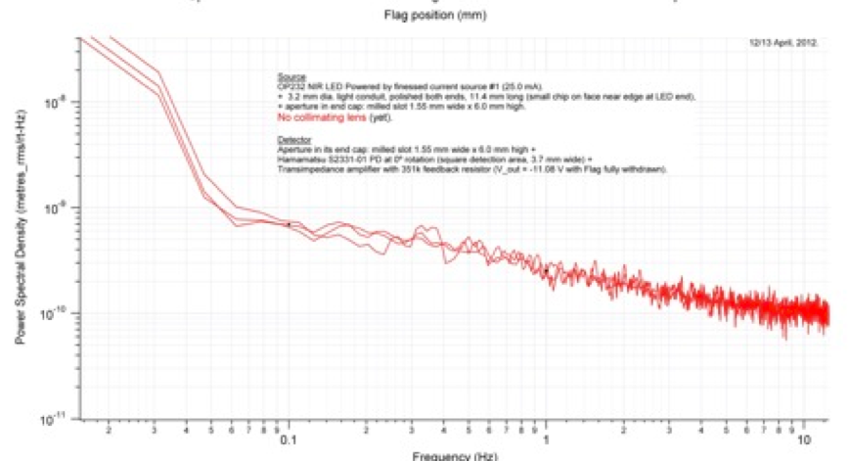

Figure 7: Expected sensitivity performance of the position sensor at the center.

**Wire clamping design**

Wire clamping on the intermediate mass and wire breakout on the mirror sides are the most delicate steps in mirror suspensions.

The room temperature mirrors of KAGRA will not contribute significantly to the interferometer thermal noise and can be suspended with two high carbon steel wires (piano-wires) looping below the mirror body like in initial Virgo. The two wire suspensions allow pitch control from the intermediate mass, therefore reducing or even eliminating static controls on the mirrors, and therefore reducing the mirror control noise

The mirror will be controlled from a recoil mass concentric to the mirror, also suspended with two looping wires from the intermediate mass.

The delicate step at the intermediate mass level is the wire clamping. Two requirements compete at the clamps. In order to hold the weight of the mirror or recoil mass, the wire clamp must be tightened to the point that either the wire or the clamp plate, or both, go in plastic regime and make an intimate, not slipping grip.

On the other hand, if either the clamp or the wire go plastic, a massive concentration of dislocations is generated just at the flexure point of the wire, thus generating an excess of pendulum dissipation and hysteresis. In addition the wires need to be precisely positioned along the beam line, and geometrical constraints force mounting of the clamp plates on the side of the intermediate mass, with the wire potentially slipping in the clamp in the all-important longitudinal direction. Additionally, it is very important that the clamping points of the wires be on the same horizontal plane, to avoid holding the wire asymmetrically. Finally the inner mirror suspension wires and the outer recoil mass suspension wires need to be precisely located with respect to each other.

All these competing requirements are satisfied with a double clamping configuration; an higher clamp is tightened first, to hold the mirror weight, allowing for the needed plasticity in the wire to clamp area. A lower clamp is obtained between two flat plates and a grooved block. The grooves in the block have a 120o opening that generate an ideal three-point wire clamping against the flat mating plate. The block has two grooves on both sides, the inside ones to position the mirror suspension wires, and the outside ones for the recoil mass. This clamp is tightened with much smaller screw torqueing to yield good transversal grip while avoiding plasticity. While clamping wires, there is always the risk that the tightening stress concentrates away from the clamp edge, and the clamped wire can slip during pendulum oscillation. To concentrate the clamping action at the edge, the block is stepped with thin and flat ridges at both edges. Finally, in order to guarantee good co-planarity of the edge of the clamp, before use the back plate, the grooved block and the outer camping plate are pre-bolted together with dowel pins guaranteeing their relative positioning, then the lower edges of the three parts are ground flat. Then the parts are ready to be unbolted and used to clamp the wires.

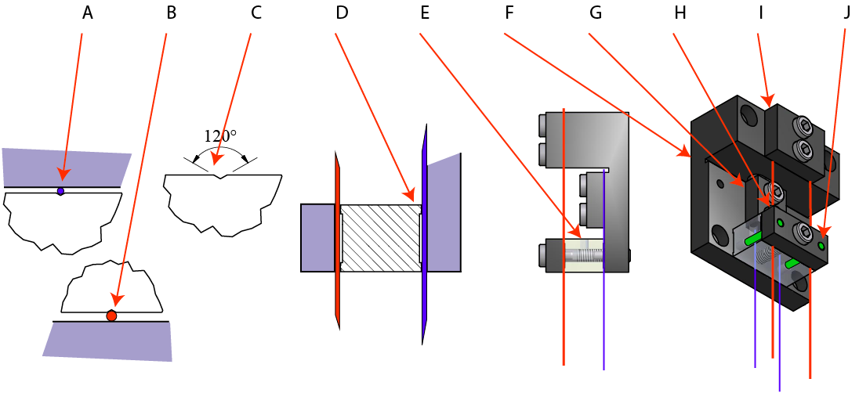

Figure 8: Wire clamps: A: mirror wire (blue throughout), B: recoil mass wire (red throughout), C: detail of V-slots on wire positioning block, clamping wires in 3 point at 120o, D: detail of stepped edge of wire positioning block, to concentrate compression near edge, E: Wire positioning block, F: Wire Base block, G: mirror wire vertical load clamp, H: Transversal wire positioning clamp, I: recoil mass wire vertical load clamp, J: positioning pin.

**Mirror and mirror recoil mass**

The suspension wires loop below the mirror to hold its weight. The most important step of suspending the wire is the break-off point where the wires leave the mirror sides. Because the mirror must oscillate as a pendulum in the longitudinal direction, without friction, the wire cannot be allowed to slip along the mirror sides. At the same time, it is impossible to clamp the wire to the mirror. The most common solution adopted is to use breakoff fused silica prisms or metallic rods glued to the side of the mirror, with notches that position the wires. Breakoff rods were chosen for the KAGRA room temperature mirrors. Two notches fix the same longitudinal wire separation defined by the grooves in the wire clamps above. The wire diameter and length determine the wire elasticity and the bounce mode frequency of the mirror. Wires as thin as possible should be used, to keep the bounce mode frequency low. The wire elasticity and the wire separation, together with the height of the break-off rod with respect to the mirror’s center of mass, determine the mirror’s pitch and yaw mode frequencies.

The diameter of the breakoff rod determines the angle of the wire above and below the rod, thus determining the force that keeps the wire against its positioning notch.

It is important to mount the breakout rod at the correct height with respect to the mirror center of mass and, longitudinally, at the center of mass, while taking into account the wedge of the mirrors. Special tooling was designed for this delicate task. The same tool is also used to glue in place the flags that generate the light obscuration signal in the optical position sensor and the magnet of the coil actuator mounted on the recoil mass.

The breakoff wire of the recoil mass is simply fastened to the recoil mass with two brackets; the wire spacing is twice that of the mirror’s. The wire suspending the recoil mass is larger in diameter because the recoil mass encages the mirror and must provide protection in case of mirror suspension wire failure, especially during earthquakes.

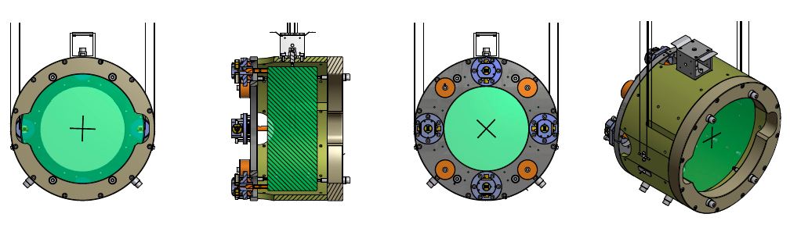

Figure 9. recycler mirror.

Whip damping

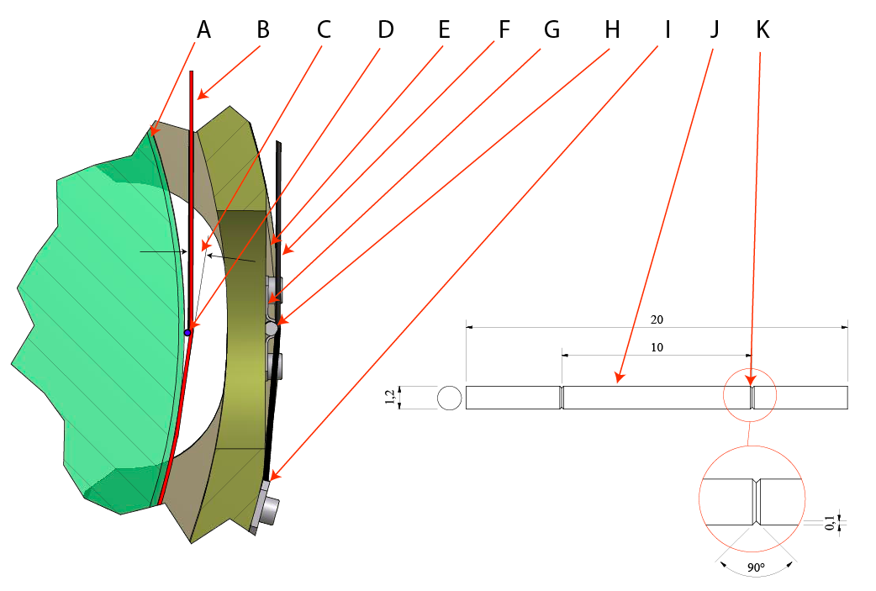

Figure 10: Suspension wire breakoff scheme: A: Mirror, B: mirror suspension wire (not to scale), C: glued wire breakout angle, D: breakout rod, E: mirror recoil mass, F: recoil mass suspension wire (not to scale), G: breakout rod bracket, H: Breakout rod, I, suspension wire safety clamp, J: breakout rod side view, K: wire locating notch

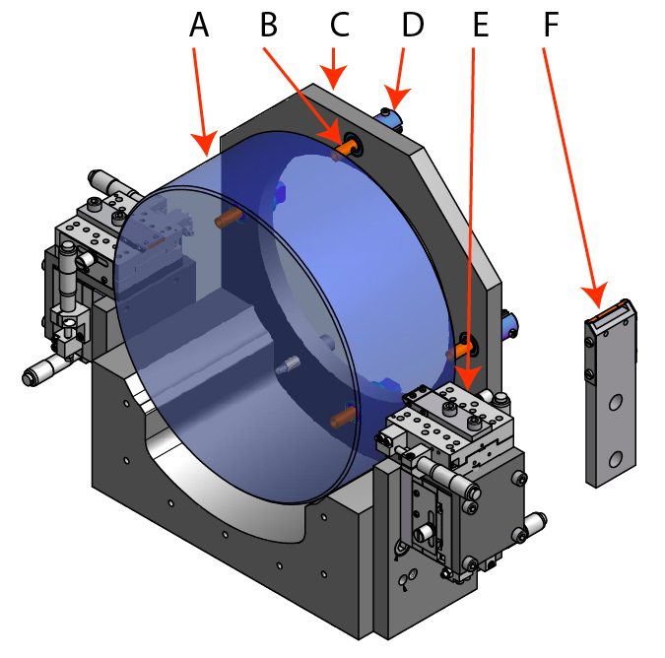

Figure 11: Mirror standoff and OSEM flag glueing jig. A: Mirror, B: OSEM flags, C: Jig backplane, D: OSEM flag aligner, E: wire breakoff rod micro-positioners, F: breakoff rod on its positioning holder.

**Relative alignment of mirror and mirror recoil mass.**

The most delicate task during the suspension process are the alignment of the mirror, and the relative alignment of the recoil mass with respect to the mirror and wire tension equalization. A special jig has been designed for this, the assembly sequence is the following.

* The mirror is placed on a positioning sled
* The jig positions the intermediate mass above the mirror
* A winch box is mounted on the intermediate mass roof,
* The two mirror suspension wires are strung from their winch, fed through the clamps, slung below the mirror and back up through the wire clamp on the opposite side to the corresponding winch,
* The wires are tensioned and positioned in the breakout bar notches and around the mirror
* The wires are pulled until the mirror weigh is barely lifted
* The sled is lowered and retracted
* The four wire resonant frequencies are checked and equalized
* The recoil mass is placed on its positioning sled and advanced in position
* The recoil mass cap is bolted in place
* The two recoil mass wires are strung like the previous ones
* The wires are tensioned and positioned in the breakout bar notches and clamped below the bar
* The wires are pulled until the mirror weigh is barely lifted
* The sled is lowered and retracted
* Electrical wires is installed between the mirror position sensors and the intermediate mass
* All wire resonant frequencies are checked and equalized
* Trimming masses are added to balance the recoil mass
* Alignment is checked
* Position sensors are tuned and tested
* The weight holding clamps are torqued
* The tension of the wire winches are loosened
* The wires resonant frequency is checked
* The positioning clamps are torqued
* The magnetic whip damper is mounted and checked
* The wires resonant frequency is checked
* Alignment is checked

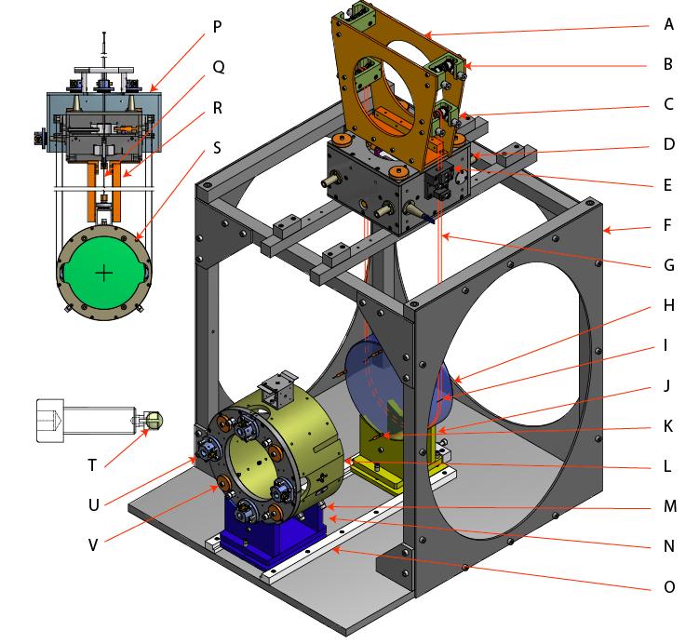

Figure 12: Mirror and recoil mass suspension jigs. A: winch box, B: recoil mass wire winch (two pairs), C: mirror wire winch (two pairs), D: Intermediate mass, E: wire clamping block, F: jig main frame, G: suspension wires, H: mirror, I: breakout rod, J: mirror positioning sled, K: position sensor flag and actuator magnet, L: recoil mass, M: mirror locking screws, N: recoil mass positioning sled, O: rail, P Intermediate recoil mass, Q: magnetic whip damper, R: transport bars, S: recoil mass cap, T: silica ball tip of range limiting screws, U Position sensor body, V: trimming masses.

* The mirror is locked to the recoil mass by means of the locking screws
* The mirror is protected with its caps
* The transport bars are mounted between the mirror recoil mass and the intermediate mass
* The intermediate recoil mass is mounted around the intermediate mass and locked in position for transport
* Electrical wiring from the mirror recoil mass is secured to the intermediate recoil mass
* The position sensing flags and actuator magnets are bolted in place

Note, the screws that lock the mirror have two functions, locking when fully screwed in, and range limiting points when retracted one turn. Those screws are fused silica ball tipped to avoid problems with mirror electrostatic charging during earthquakes and other shaking events. It was observed in Virgo and LIGO that mirror charging events could impede interferometer operation and require mirror discharging procedures. Silica tipped end stops solved that problem.

**Beam splitter mirror**

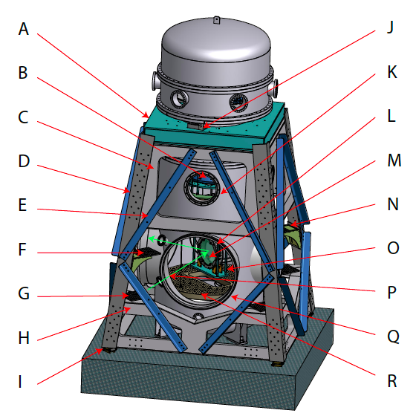

Figure 13: Beam splitter system. A: Inverted pendulum support platform, B: bottom filter, C: upper stiffening pyramid, D: L-beam structural leg,E: vibration damping cross beam, mounted on constrained layer of dissipating rubber, F: optical lever receiver shelf, G: optical lever launcher shelf, G:lower stiffening pyramid, I: height regulating foot, J: hydraulic piston leveling the inverted pendulum, K: access port, L: mirror recoil mass, M: mirror, N: monitor camera shelf, O: safety and transport structure, P: optical lever path(green arrows); Q: beamline flange, R: suspended optical bench.

The beam splitter is housed in a type-B seismic attenuation chain, equal to those used for the recycling mirrors, as visible in figure “Beam splitter system”. To split the beams at 90o, the beam splitter mirror is tilted 45 from the four beam axis, as visible in figure “Beam splitter, recoil mass and allowable beam sizes”. This is relatively simple with the small beam diameter in KAGRA. Note that the beam-splitter mirror has to be almost twice in diameter (380 mm) than the beam diameter acceptance (203 mm), and that suspended beam defining baffles are necessary. In absence of beam defining baffles the acceptance on the reflected and transmitted beams would be substantially different, and the recombination of the returning beams unbalanced. This would harm the interferometer visibility and the recombined light beam profile. The recoil mass was carefully designed to protect the mirror but not producing any additional clipping of the beams. The recoil mass design takes advantage of the crabbing of the beams across the mirror thickness to position the magnetic actuators on the front (50% reflective) surface of the mirror, well outside of the beam profile (G on figure “Beam splitter, recoil mass and allowable beam sizes”). Otherwise the position sensor and actuators are the same as in the other type-B, both on the mirror recoil and on the intermediate mass.

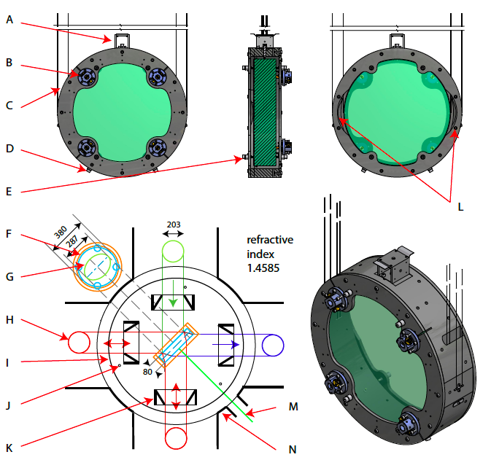

Figure 14: Beam splitter, recoil mass and allowable beam sizes. A: Whip damper and cabling plate, B: Optical Sensor Magnetic Actuator (1 of 4), C: recoil mass, D: Lateral range limiting screw (1 of 3), E: longitudinal range limiting screw (1 of 8), F: Mirror profile, G: Maximum acceptance beam imprint on mirror front face (50% reflectivity), H: maximum beam acceptance, red to the 3 km arm Fabry Perot cavities, green from the power recycling cavity, blue to signal recycling cavity, I Suspended auxiliary optical table, J: optical table suspension wire (1 of 3), K: beam defining baffle on optical table (1 of 4), L: beam flares on recoil mass Anti Reflection side, M: Optical lever path (green), N: vacuum tank profile at beam height.

The optical levers are launched and received from the one of the legs of the outer structure. The 380 mm to 80 mm mirror diameter-to-thickness aspect ratio was chosen. A more slender diameter-to-thickness aspect ratio may cause mirror-warping problems, due to the natural surface tension of the deposited coatings. Originally, a more conservative 380 to 120 ratio was considered, the thinner substrate was chosen to maintain the beam crabbing inside the substrate to a reasonable minimum and allow a larger beam aperture.

**ET beam splitter considerations.**

ET considered two possible solutions, which, for equal tunnel length used, are equivalent in sensitivity to Gravitational waves. The first configuration is composed of three 60o-opening Michelson detectors arranged in a 10 km equilateral triangle. The second, more conservative, configuration is composed by four 90o-opening Michelson detectors arranged in two traditional 7.5 km long L-arrangements (keeping the same tunnel and vacuum pipe length), rotated 45o from each other.

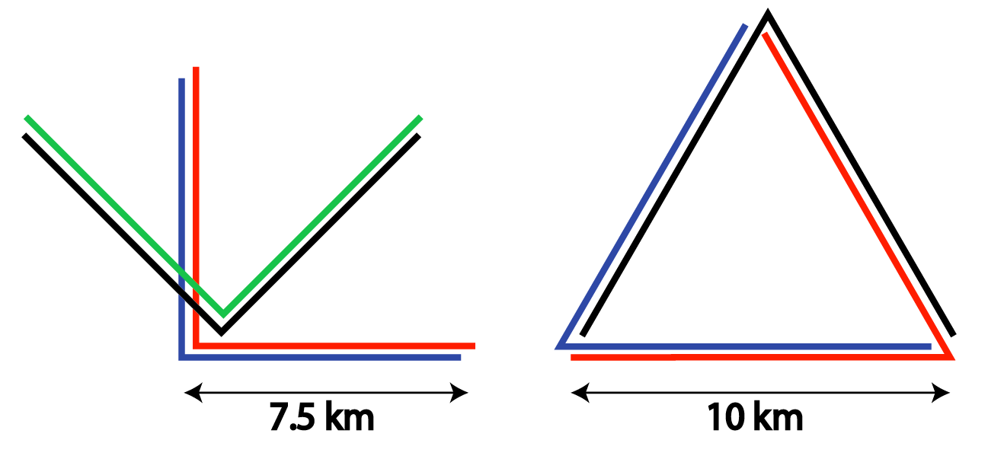

Figure 15: Triangular and conventional Michelson configuration. The longer path-length of the triangular geometry is compensated by the cosinus of 90o, therefore the sensitivity of the two configurations have identical sensitivity with same overall tunnel and vacuum pipe lengths.

The beam splitters for the two cases are considered.

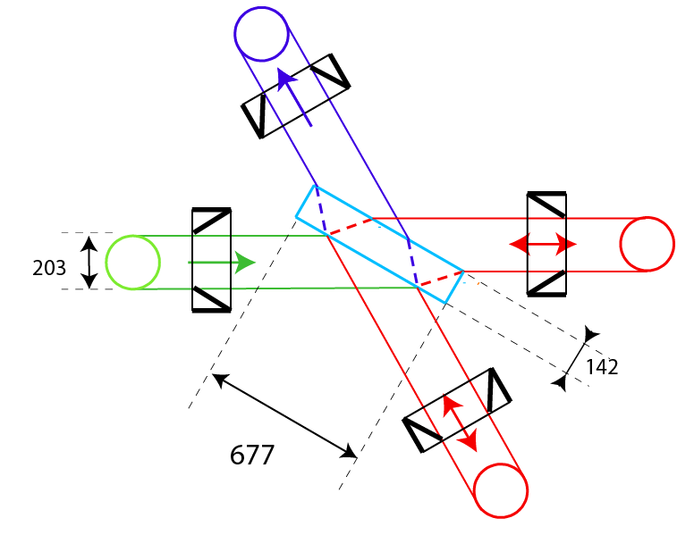

Figure 16: Comparison with 60o opening interferometer.

The same substrate diameter to thickness aspect ratio was maintained for the two cases, even if the smaller incidence angle of the beams in the 60o case require thicker coatings and therefore would require a more conservative diameter to thickness aspect ratio. The required beam splitter diameter is 1.87 times the acceptable beam diameter for the 45o case and 3.34 times the acceptable beam diameter for the 60o case. Scaling up from the KAGRA case for the 620 mm diameter ET mirrors the beam splitter would be about ~1000 mm diameter and ~ 50 kg weight for the 90o interferometer and ~1750 mm and ~ 270 kg weight for the 60o interferometer. In the 60o case, the substrate is almost twice as large and 5.5 times heavier than the case of a 45o beam splitter.

If the aperture of the beam splitter ends up being limited by the size availability of the beam splitter substrate, the allowable beam size of the 60o interferometer will be much more restricted than that of the 90o interferometer, and its performance will be similarly reduced due to the higher mirror thermal noise.

**Test mass Mirror control strategies**

Few words on some possible lock strategies, green lock made not necessary by the Inverted Pendulums.

**Lock acquisition requirements**

Few words about required actuator authority and noise level

**Lock holding requirements**

Few words about holding lock from the intermediate mass

**ACKNOWLEDGMENTS**

The content of this chapter describes design and results of KAGRA seismic attenuation and suspension prototypes and production units, engineered and manufactured by Galli & Morelli (Lucca, IT), according to the specifications of the KAGRA Gravitational Wave Telescope Project.

We thank Galli & Morelli for kindly allowing the inclusion of their proprietary material in this report.

1. R. DeSalvo, Recycler and Beam Splitter mirror suspension assembly sequence, JGW-T1100637, October 2011, <http://gwdoc.icrr.u-tokyo.ac.jp/cgi-bin/private/DocDB/ShowDocument?docid=637>
2. N. Lockerbie, A position-sensitive detector for the Advanced LIGO suspensions, 2006, <http://www.ligo.org/pdf_public/lockerbie.pdf>
3. L Carbone, et al., Sensors and actuators for the Advanced LIGO mirror suspensions, Class. Quantum Grav. 29 (2012) 115005