JGW-T1402170-v1 Jan.30, 2014

Disposition of Sensors and Actuators
in Type-A Vibration Isolation System

Takanori Sekiguchi

1. Disposition of Sensors and Actuators
1.1 Overview
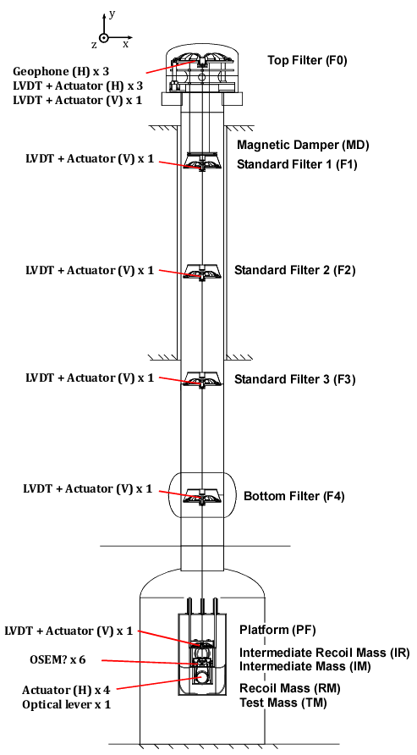
Fig.1: Sensor and actuator list
1.2. Coordinate Definition
- X: Transversal axis
- Y: Vertical axis
- Z: Longitudinal (beam) axis
- Pitch: Rotation around X-axis
- Yaw: Rotation around Y-axis
- Roll: Rotation around Z-axis

1.3. Details
[1] Top Stage (F0) Horizontal Sensors and Actuators
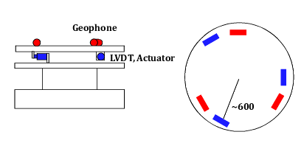
Fig.2: Disposition of horizontal sensors and actuators at F0

Geophones sense inertial motion of F0 (xF0, zF0, yawF0).
LVDTs sense relative motion between ground and F0 (xF0-xg, zF0-zg, yawF0-yawg).
Coil magnet actuators can drive 3 DoFs motion of F0 (xF0, zF0, yawF0)

[2] GAS Filters (F0~F4, PF) Sensors and Actuators

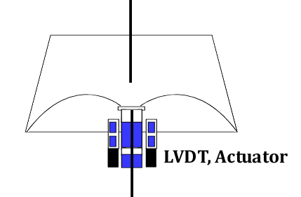
Fig.3: Sensor and actuator in a GAS filter

LVDTs in GAS filters sense vertical relative motion between the GAS filter and the stage below.
(yF1-yF0 (=yg), yF2-yF1, yF3-yF2, yF4-yF3, yPF-yF4, yIM-yPF)
Coil magnet actuators can drive the relative motion mentioned above.

[3] Sensors and Actuators on IM, TM
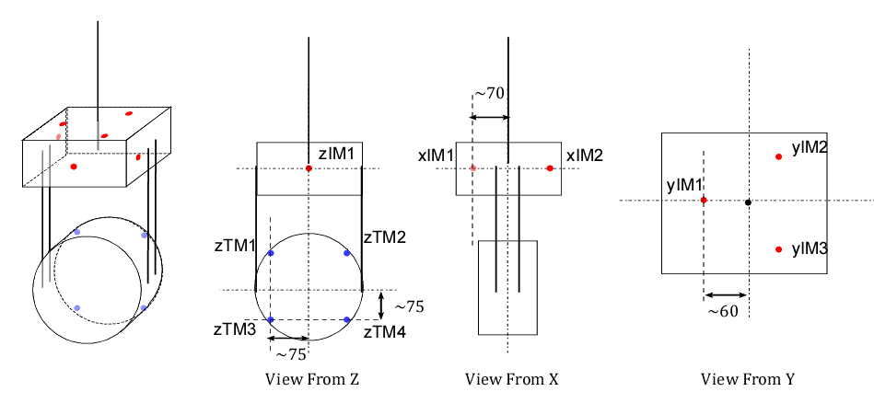
Fig.3: Sensors and actuators on IM and TM

IM has 6 relative displacement sensors and actuators (like OSEM), which can sense or drive 6 DoFs relative motion between IM and IRM. (xIM-xIR, yIM-yIR, zIM-zIR, pitchIM-pitchIR, yawIM-yawIR, rollIM-rollRM).

TM has 4 coil magnet actuators which can induce the relative motion between TM and RM (zTM-zRM, pitchTM-pitchRM, yawTM-yawRM). An optical lever can sense TM angular motion about 2 DoFs (pitchTM, yawTM).

2. Noise Model
2.1. Sensor Noise
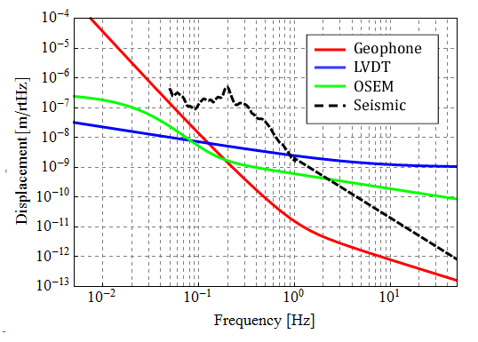
Fig.4: Sensors noise model

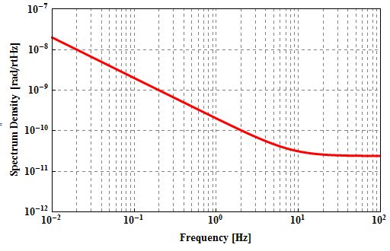
Fig.5: Sensors noise model (optical lever)

Geophone noise: calculated from electronics noise of the pre-amplifier designed at NIKHEF
(JGW-D1201466-v1)
LVDT noise: current achieved sensitivity in pre-isolator prototype test at Kashiwa. Sensitivity is now limited by ADC noise.
OSEM noise: current achieved noise in payload prototype test at NAOJ with a simple driver circuit.
Optical lever noise: noise estimated from driver electronics noise assuming high reflection on the mirror (0.5) and 4 m round trip length

2.2. Actuator Noise
TBD. Requirement is calculated in (JGW-T1402160-v1).

