JGW-T1402160-v1 Jan. 23, 2014

Actuator Response of Cryogenic Payload
with Different Suspension Points of Sapphire Fibers

Takanori Sekiguchi

1. Model

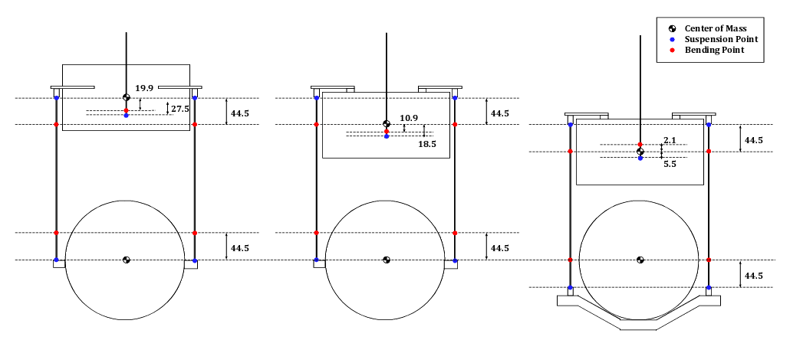
Left: Suspension points are at CoM of IM and TM
Middle: Upper bending points are at CoM of IM, lower suspension points are at CoM of TM
Right: Bending points are at CoM of IM and TM

The pitch mode of IM is tuned at 0.3 Hz.

2. Calculated TFs
2.1. FzIM to zTM [m/N]
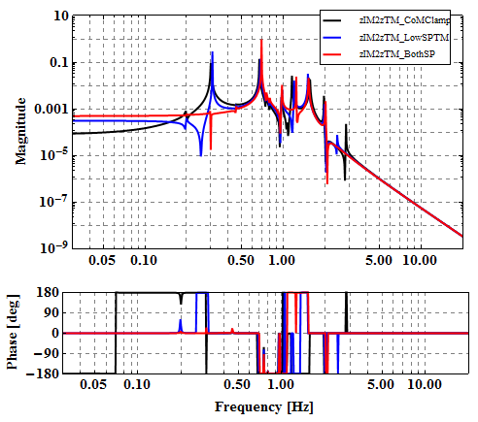

2.2. FzIM to pitchTM [rad/N]
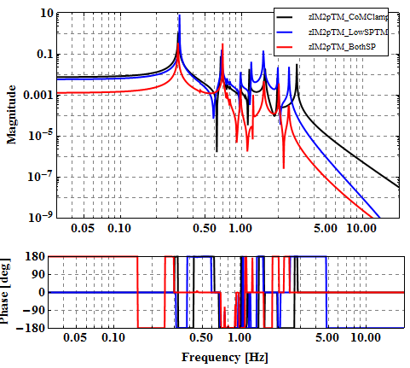

2.3. TxIM to zTM [m/Nm]
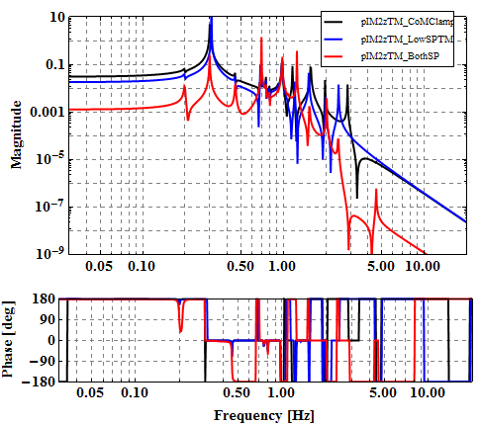

2.4. TxIM to pitchTM [rad/Nm]
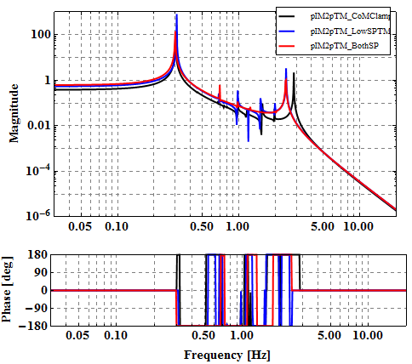

2.5. FzTM to zTM [m/N]
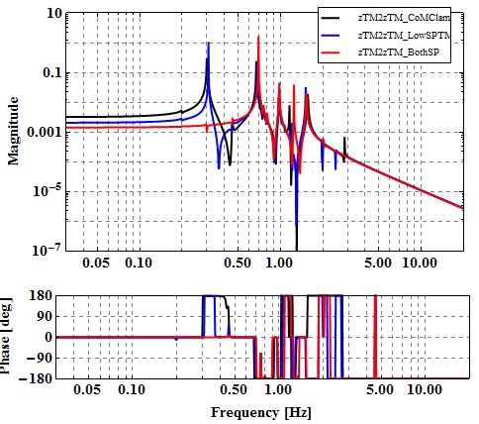

2.6. FzTM to pitchTM [rad/N]
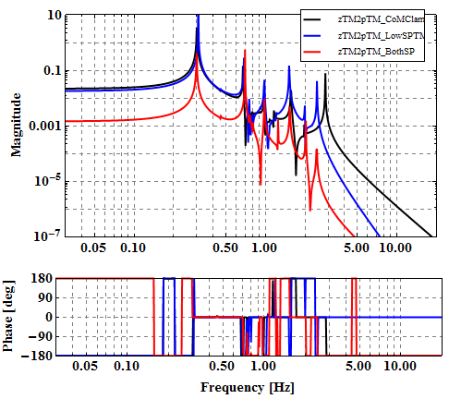

2.7. TxTM to zTM [m/Nm]

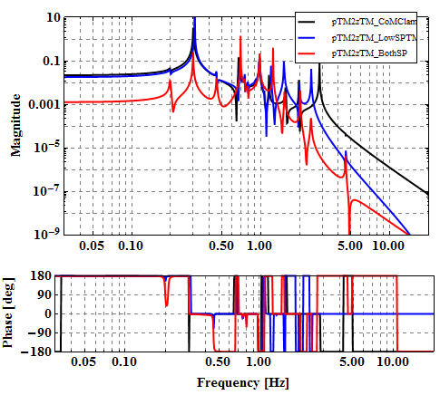

2.8. TxTM to pitchTM [rad/Nm]
