***JGW-T1402159-v1 Jan.28, 2014***

**Requirement for Actuator Noise in Type-A Vibration Isolation System**

**Takanori Sekiguchi**

**1. Introduction**

Requirement for electronic noise of the actuators on the test mass (TM) and the intermediate mass (IM) is considered for Type-A vibration isolation system.

Here the author assumes that TM contains 4 coil magnet actuators and IM contains 6 actuators as shown in Fig. 1. At TM level, longitudinal, pitch and yaw motions can be controlled, and at IM level, 6 DoFs (longitudinal, transversal, vertical, pitch, yaw and roll) can be controlled.

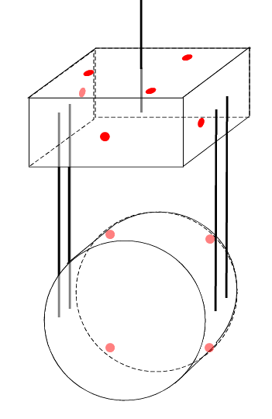

Fig.1: Actuator distribution

Mechanical parameters assumed in the model are shown in [JGW-T1302090-v1](http://gwdoc.icrr.u-tokyo.ac.jp/cgi-bin/private/DocDB/ShowDocument?docid=2090). In the calculation model, IP control and optical lever control are applied but they essentially do not affect the actuator response of the suspension above 10 Hz.

**2. Calculation Method**

Transfer functions from actuators on TM and IM to the motion of the TM are calculated from suspension model. From the requirement on the TM displacement / angle spectrum density, the requirement on the actuator noise is calculated as follows:

****.

Here *x*TM is required TM displacement/angle induced by the actuator noise and *H* is transfer functions from actuation force to TM displacement/angle. The requirement on the TM displacement/angle is shown in the preliminary design document of cryogenic payload ([JGW-T1402106-v1](http://gwdoc.icrr.u-tokyo.ac.jp/cgi-bin/private/DocDB/ShowDocument?docid=2106)), which is essentially 1/10 of the quantum noise level of the interferometer in amplitude spectrum density (Fig. 2).

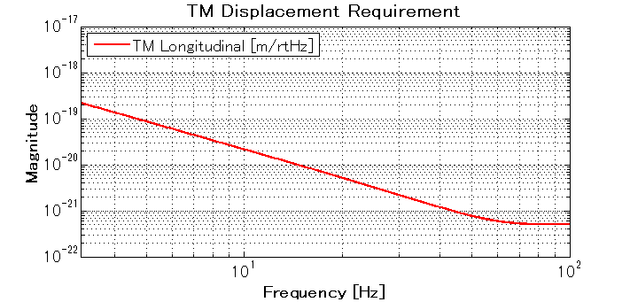

Fig. 2: Requirement on TM longitudinal displacement noise

For vertical motion, we allow 100 times larger displacement, assuming 1% coupling between horizontal and vertical motion. For pitch and yaw motion, we assume 1 mm mis-centering of the beam spot. For transversal motion, we assume 0.1% coupling.

|  |  |  |
| --- | --- | --- |
|  | @10 Hz | @100 Hz |
| TM Longitudinal | 2E-20 [m/rtHz] | 5E-22 [m/rtHz] |
| TM Vertical | 2E-18 [m/rtHz] | 5E-20 [m/rtHz] |
| TM Pitch / Yaw | 2E-17 [rad/rtHz] | 5E-19 [rad/rtHz] |
| TM Transversal | 2E-17 [m/rtHz] | 5E-19 [m/rtHz] |
| TM Roll | TBD | TBD |

Tab. 1: Requirement on TM displacement/angle spectrum density

**3. Actuator Transfer Functions**

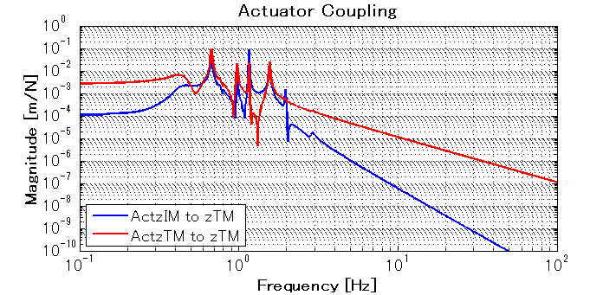

Fig. 3: Actuator transfer function about longitudinal DoF

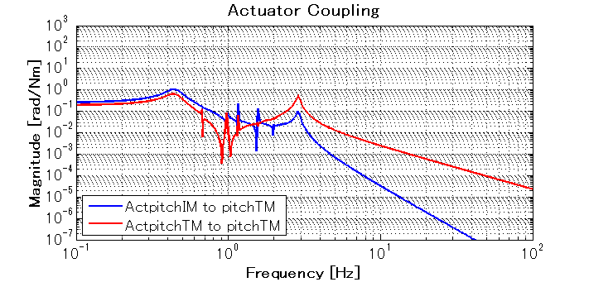

Fig. 4: Actuator transfer function about pitch DoF

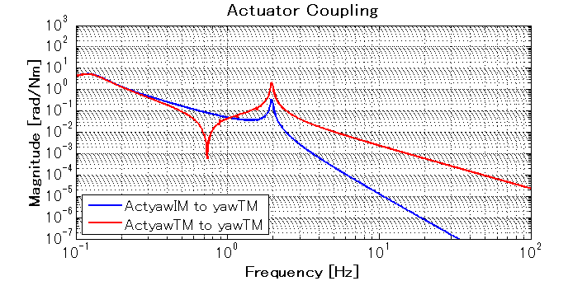

Fig. 5: Actuator transfer function about yaw DoF

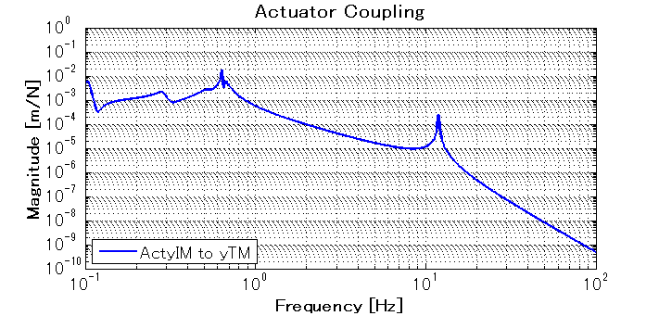

Fig. 5: Actuator transfer function about vertical DoF

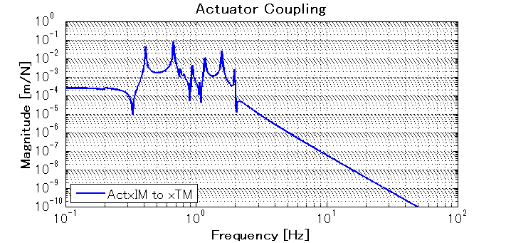

Fig. 6: Actuator transfer function about transversal DoF

**4. Requirement on Actuator Force Noise about Each DOF**

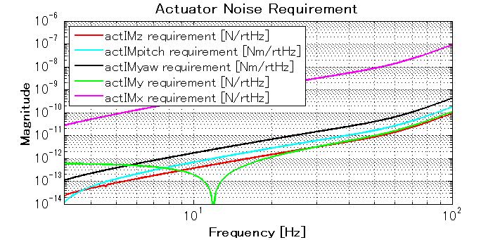

Fig. 7: Actuator noise requirement on IM

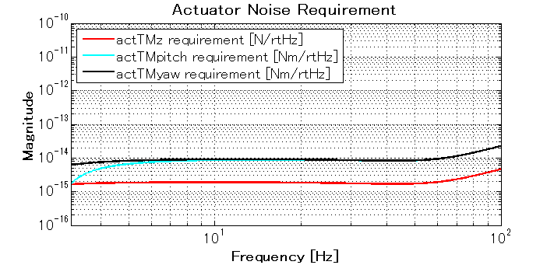

Fig. 8: Actuator noise requirement on TM

**4. Requirement on Noise about Each Actuator**

Here we assume the following actuator disposition (Fig. 9).

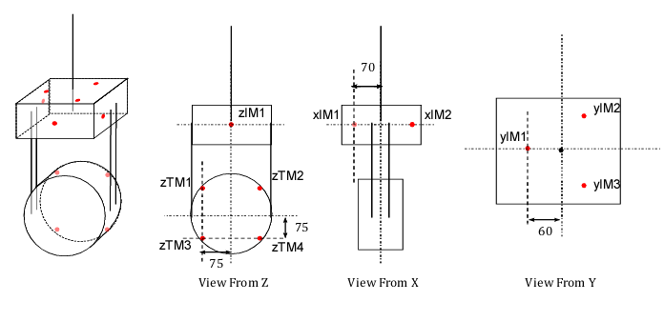

Fig. 9: Actuator distribution and dimension

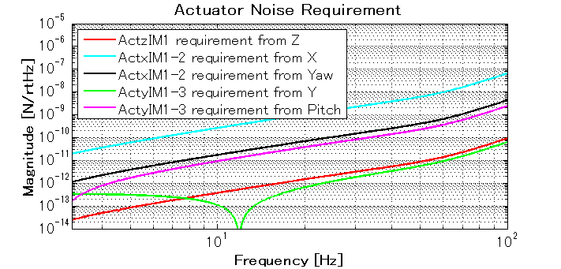

Fig. 10: Actuator noise requirement on IM (about each actuator)

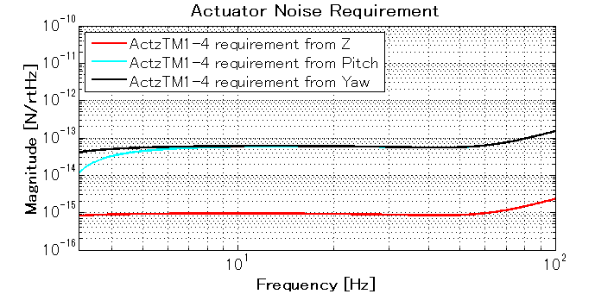

Fig. 11: Actuator noise requirement on TM (about each actuator)

|  |  |
| --- | --- |
|  | Requirement (>10 Hz) |
| zIM1 | 4E-13 [N/rtHz] |
| xIM1-2 | 2E-11 [N/rtHz] |
| yIM1-3 | 2E-13 [N/rtHz] |
| zTM1-4 | 1E-15 [N/rtHz] |

Tab. 2: Actuator noise requirement

**5. Actuator Force Range**

Although we don’t have specific design of dewhitening filter and coil driver circuits, the author assumes that the actuation noise above 10 Hz is limited by electronic noise of dewhitening filter. The nominal noise level of dewhitening filter is ~1 nV/rtHz (source: [JGW-1200817-v1](http://gwdoc.icrr.u-tokyo.ac.jp/cgi-bin/private/DocDB/ShowDocument?docid=817)). The author also assumes that the maximum voltage applied on actuator coil is limited by the range of DAC output voltage, which is 10V. From these assumptions, the maximum DC force applicable on the actuator is estimated as follows:

|  |  |
| --- | --- |
|  | Maximum DC Force |
| zIM1 | 4E-3 [N] |
| xIM1-2 | 2E-1 [N] |
| yIM1-3 | 2E-3 [N] |
| zTM1-4 | 1E-5 [N] |

Tab. 3: Actuation range of each actuator

From these values, the range of displacement/angle movable by the actuators is estimated:

|  |  |
| --- | --- |
|  | Range |
| zTM by TM actuators | 1E-7 [m] |
| zTM by IM actuators | 6E-6 [m] |
| pitchTM by TM actuators | 9E-7 [rad] |
| pitchTM by IM actuators | 6E-5 [rad] |
| yawTM by TM actuators | 3E-5 [rad] |
| yawTM by IM actuators | 2E-1 [rad] |
| yTM by IM actuators | 9E-6 [m] |
| xTM by IM actuators | 1E-4 [m] |
| rollTM by IM actuators | 8E-5 [rad] |

Tab. 4: TM displacement/angle range movable by actuators