***JGW-T1402131-v1 Jan. 13, 2014***

**Suspension Thermal Noise of Test Mass Suspension**

**With Metal Wires + Heat Links**

**Takanori Sekiguchi**

**1. Introduction**

The suspension fibers for the test mass need to subtract the heat to keep the mirror temperature around 20K and hold the weight of the mirror. In the default design, the test mass is suspended by thick sapphire fibers with 1.6 mm diameters. However, the interface between fibers and the mirror, or the fibers and cantilever blades has not been decided yet and we still need R&D for them.

Here, as an alternative (backup) solution, the author investigates the possibility of using thin metal fibers for the test mass suspension. The heat in the mirror is absorbed by additional heat links attached on the top of the mirror. Fig.1 shows a conceptual drawing of the idea.

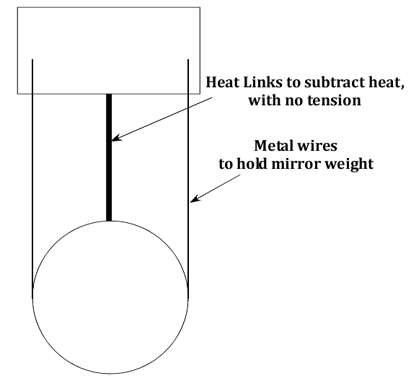

Fig. 1: Schematic drawing of test mass suspension with metal wires

**2. Model**

Here we assume a single pendulum model with an elastic fiber as shown in Fig. 2. The shape of fiber with uniform thickness and tension can be expressed as

. (1)

The coefficients inside trig functions are the solution of the following equation about *k*:

. (2)

Here *E* is the Young’s modulus, *I* is the second moment of area, *T* is the tension on the fiber, *ρ* is the linear density and *ω* is the angular frequency. The *ABCD* coefficients in eq. (1) are calculated from the following boundary conditions:

[Fixing at upper clamp] , (3)

[No gradient at upper clamp] , (4)

[E.o.M. about rotation] , (5)

[E.o.M. about translation] . (6)

Here *J* is the mirror moment of inertia, *h* is the vertical separation of suspension points and mirror center of mass, *k* is the additional spring coefficient due to horizontal separation of fibers from center of rotation, *M* is the mirror mass and *F* is the external force on the mirror.

From these equation, the transfer function *H*(*ω*) from the external force *F* to the position of the mirror *x*(*z*=*L*) can be calculated. Suspension thermal noise can be estimated from the imaginary part of the transfer function:

. (7)

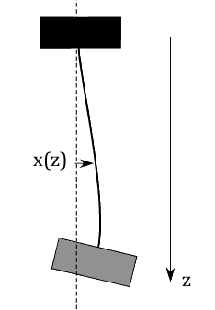

Fig. 2: Elastic fiber model

**3. Parameter List**

**[Mirror]**

Mass: 22.7 [kg]

Moment of inertia: 0.111 [kg m2]

**[Sapphire Fibers]**

Loss: 2E-7

Young’s modulus: 400 [GPa]

Density: 4.0 [g/cm3]

Length: 300 [mm]

Diameter: 1.6 [mm]

Number of wires: 4

Horizontal separation of wires: 30 [mm]

Resonant frequency of cantilever springs: 10 [Hz]

**[Metal Wires] (Tungsten)**

Loss: 1E-5

Young’s modulus: 411 [GPa]

Density: 17.8 [g/cm3]

Length: 300 [mm]

Diameter: 0.3 [mm]

Number of wires: 4

Horizontal separation of wires: 30 [mm]

**[Heat Link] (Copper)**

Loss: 6E-4

Young’s modulus: 120 [GPa]

Density: 9.0 [g/cm3]

Length: 190 [mm]

Wire attachment point height from mirror COM.: 110 [mm]

Diameter: 1.0 [mm] (60 [μm])

Number of wires: 6 (800)

**[Heat Link] (Sapphire)**

Loss: 2E-7

Young’s modulus: 400 [GPa]

Density: 4.0 [g/cm3]

Length: 190 [mm]

Wire attachment point height from mirror COM.: 110 [mm]

Diameter: 1.0 [mm]

Number of wires: 8

**4. Calculation Results**

**(i) 1 [mm] copper heat links**

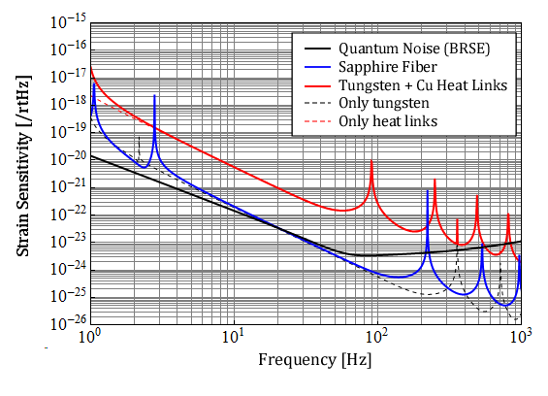

Fig.3: Suspension thermal noise levels in strain sensitivity with 1 mm heat links

**(ii) 60 [μm] copper heat links**

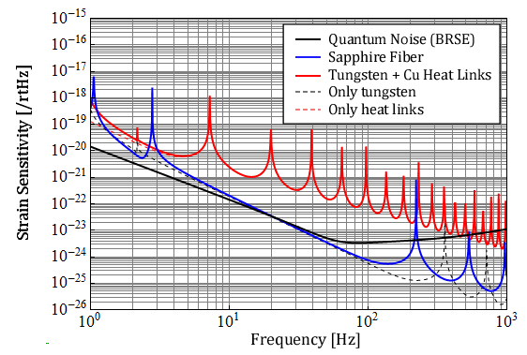

Fig.4: Suspension thermal noise levels in strain sensitivity with 0.06 mm heat links

**(iii) 1 [mm] sapphire heat links**

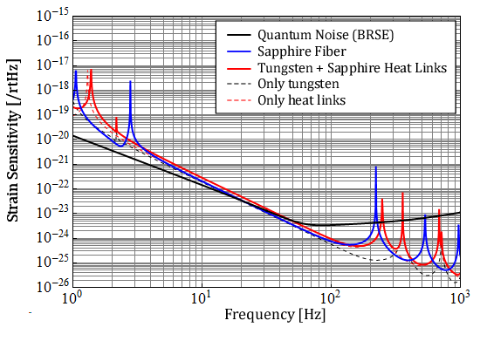

Fig.5: Suspension thermal noise levels in strain sensitivity with 1 mm sapphire heat links

**5. Conclusion**

* The author investigates suspension thermal noise of thin metal fibers + copper heat links for the test mass suspension. It turns out that the strain sensitivity of metal wire case is worse than that in sapphire fiber case at least by a factor of 20 above 10 Hz.
* The thermal noise mainly comes from the additional heat links while the thermal noise level of the metal fiber itself can be comparable with sapphire fiber suspension.
* One can reduce the thermal noise level at low frequencies by reducing the wire diameter or increasing the wire length, because those operations reduce spring coefficients of the heat links at DC. However, they reduce violin mode frequencies and the peaks of violin modes contaminate the strain sensitivity in the observation band quite a lot.
* Metal fibers + heat links solution should not be applied in terms of KAGRA sensitivity, unless heat link material with good quality factor, like sapphire, is used.