Preliminary design of Type-A suspension system
(cryogenic seismic attenuation system)
for KAGRA sapphire mirrors

Version 1

Eiichi Hirose, Takanori Sekiguchi
Institute for Cosmic Ray Research
University of Tokyo
Jan 6, 2014

Contents

- Scope of this work
- Introduction
- Requirements
- Selection of topology
- Mathematical modeling
- Noise estimation
- Sensor requirements
- Realization of three dimensional model
- Problems to be solved
- Future work
- Conclusion
- Acknowledgment
- References

- Scope of this work
This document describes preliminary design of a seismic attenuation system (SAS) for KAGRA’s cryogenic mirrors, Type-A suspension system. Since there are some constraints in the system, the main work here is as follows.
Constrained optimization of the system with feedback control
Realization of a three dimensional model in the existence of various constraints
The constraints are things that have been already purchased and requirements which the system has to satisfy. Things already procured are a vibration isolation system that works at room temperature and a cryostat into which the cryogenic part of Type-A suspension system will be installed. Although authors think of this work as still preliminary, realization of a three dimensional model is a lot necessary to check feasibility of the design.

- Introduction
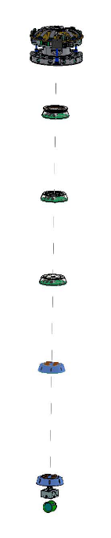FIG.1 Type-A suspension (IP: Inverted Pendulum, GASF: Geometric Anti-Spring Filter), IM: Intermediate Mass, IRM: Intermediate Recoil Mass, TM: Test mass (sapphire), RM: Recoil Mass, moving mass is for attitude control)
F0: Pre-isolator (IP+GASF)
F1: GASF
F2: GASF
F3: GASF
F4: GASF
PF: Platform (GASF+moving mass)
IM+IRM
TM+RM
room temp.
cryogenic temp.

FIG.1 shows an appearance of Type-A suspension. IP stands on the ground (second floor), so seismic motion will be input through this part. A heat-link to the cryo-cooler head will be attached to IRM for cooling purpose, and this is also a path of seismic noise to the test mass (TM). F0, F1, F2, and F3 have been already designed and procured except some parts assuming the total mass below is 300 kg, which should include F4. The recoil chain (IRM and RM) are independent from the main chain (IM and TM) and they are suspended from Platform independently. Sapphire TM will be suspended from IM with either sapphire rods or metal wires. In case of sapphire rods, we will use sapphire blades to compensate length difference between the sapphire rods. The blades would not be needed if we chose metal wires. The detail will be discussed later.
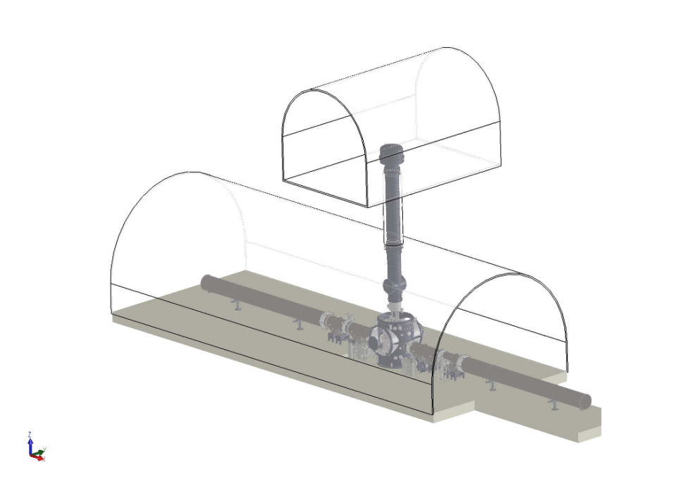
CRYOSTAT
Cross section of the tunnels
Vacuum tube
for the beam line
2nd floor
FIG.2 Cryostat system

FIG.2 shows a look of cryostat system that consists of vacuum container and four pulse-tube cryo-cooler units. Inside the outer casing, there is a two-layered container (outer shield and inner shield). Platform and both main chain and recoil chain will be installed inside the inner shield. Also, things such as baffles to minimize wide-angle scattering from TM and the heat-link will be installed inside the inner shield.

Sensors and actuators that work at cryogenic temperature (~ 20 Kelvin) are not yet investigated at this point. Therefore, we will set requirements that they have to satisfy to achieve requirements of Type-A SAS.

Also, we have not fully developed a technique to suspend sapphire TM using sapphire rods. A strength test for several techniques will be done in two months and we will reflect the result into design. Figure of Merit (FOM) for the consideration will be strength, thermal resistance, quality factor, and handling (such as installation, removal, replacement)

3. Requirements

Seismic displacement noise
longitudinal | 2×10⁻²⁰ m/$\sqrt{Hz}$ @10Hz,  3×10⁻²² m/$\sqrt{Hz}$ @100Hz
vertical | 2×10⁻¹⁸ m/$\sqrt{Hz}$ @10Hz  3×10⁻²⁰ m/$\sqrt{Hz}$ @100Hz
RMS without global control | 10⁻⁷ m (2.5×10⁻⁷ m aLIGO differential)
RMS velocity w/o global control | 10⁻⁷ m/s
RMS with DARM loop (aLIGO) | 10⁻¹⁵ m
RMS with MICH loop (aLIGO) | 10⁻¹² m
Angular noise (pitch and yaw)
@10Hz, @100Hz | 2×10⁻¹⁷ rad/$\sqrt{Hz}$ @10Hz  3×10⁻¹⁹ rad/$\sqrt{Hz}$ @100Hz
RMS without global control | 10⁻⁷ rad w/o global control  (10⁻⁷ rad @ <0.1Hz in aLIGO, 10⁻⁶ in iLIGO)
Damping time
1/e damping time (aLIGO) | < 60s (10s in aLIGO)
TABLE 1 Type-A SAS requirements

TABLE 1 shows requirements we set for Type-A SAS. Most values are set to satisfy requirements from the interferometer while some of them are imported from aLIGO requirements.

4. Selection of topology
Several designs of the cryogenic suspension have been proposed. Two points are discussed here:
a) Topology of the last three stages (FIG.3)
b) Border between cryogenic and room temperature (FIG.6)

a)
In room temperature SAS (Type-B SAS), we adopt Virgo or TAMA like design for the last several stages of the suspension. In that design, the test mass (TM) and its recoil mass (RM) are both suspended from the intermediate mass (IM). The motion of IM is controlled by the sensors and actuators between IM and its recoil mass (IRM). Here this design is named as a ‘branch model’ (see FIG. 3).

Another model proposed here is named as a ‘parallel model’, where RM is suspended from IRM, not from IM. The topology is closer to GEO600 or advanced LIGO suspension system.
Parallel Model
Branch Model
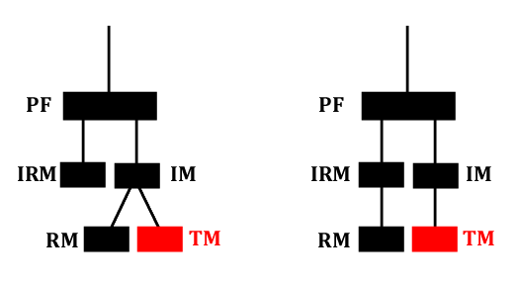
FIG.3 Topology of cryogenic payload

Pro and cons of adopting the parallel model are listed below:

Pros
- Thermal noise from the RM suspension is reduced (FIG.4).
- The pendulum modes of RM and TM can be damped at IM level.
Cons
- Transfer functions from actuators to the TM motion become more complicated.
- Relative motion between IM and IRM changes the positional relation between RM and TM. This may cause difficulty in assembly or non-linear effect (like changes of actuation efficiency).

(i) It has been pointed out that the thermal noise from RM suspension or upper stages can limit the sensitivity of KAGRA. Especially, coupling from vertical thermal fluctuation is a big concern due to the rigidity of TM suspension in vertical direction. FIG.4 shows an estimation of suspension thermal noise in two topological model cases. In the branch model, the vertical resonance of the RM suspension appears in the thermal noise spectrum, and that pollutes the sensitivity in the observation band.

Here we assume the suspension of RM has a relatively low Q factor (Q~1E4). There are materials with better Q at cryogenic temperature like CuBe (Q~2E5), but degradation of Q can easily happen due to the clamp loss or the loss from the heat links. In the parallel model, we don’t need to care the loss of the recoil chain because the thermal fluctuation of the recoil chain is filtered out by the Platform GASF.

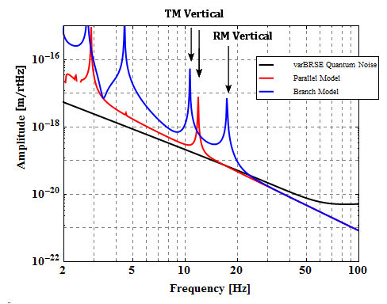
FIG.4: Estimation of suspension thermal noise level in two topological models.

(ii) In the branch model, the differential pendulum mode of the TM and RM (FIG. 5) is difficult to damp at upper stages. In Virgo, this mode is damped by an auxiliary length sensor (optical lever) which senses the displacement of TM directly from the ground. It is more difficult to implement such sensor in KAGRA due to cryogenic environment around TM.

In the parallel model, the pendulum modes of TM and RM always couple to the upper stage motion and therefore they can be damped by sensors and actuators implemented at the intermediate stage.

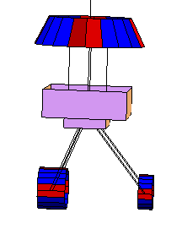
FIG.5: Differential mode of TM and RM.

The problems of (iii) and (iv) are less critical. The complexity of the frequency response of mirror actuation can be compensated by digital servo filters. Once the suspension calms down (~0.1 μm RMS in TM displacement), the non-linearity of actuators would disappear. The thermal noise from RM suspension is more critical and fundamental issue, which impacts the KAGRA sensitivity directly. Therefore we choose the parallel model as a default design.

b)
Possibility of putting the last GAS filter (PF) at room temperature is discussed here (‘hot’ Platform in FIG.6).
Hot Platform
Cold Platform
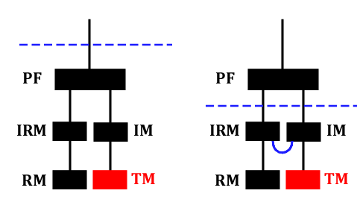
FIG.6 Position of PF

Pros and cons of the hot Platform idea are listed as follows:

Pros
- The total mass inside the cryostat is reduced and initial cooling time is shortened.
- The GAS spring goes to the room temperature part. Thermal compression and Young’s modulus change in spring material are less critical.
Cons
- More wires go through the ceiling of the cryostat and more heat come through the holes for them.
- Vertical thermal noise from GAS filter becomes larger.
- Heat links are inserted between IM and IRM. The vibration from the cryostat shortcuts through them.

- The initial cooling time is reduced from ~27 days to ~23 days. Cooling of the inner radiation shield takes 2 weeks in both cases. After the inner shield reaches at steady state, cooling time of the payload is reduced from 13 days to 9 days. The ratio of cooling time is almost same as the ratio of the payload mass.

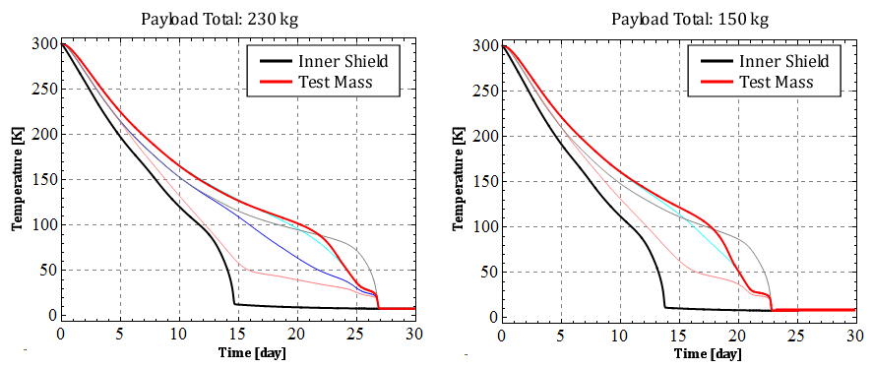
FIG.7 Initial cooling simulation (left: cold Platform, right: hot Platform)

(iii) The radiation effect from the wire holes is discussed in JGW-G1302074. The heat from the holes is not critical if we prepare duct shields with appropriate size.

(iv) Thermal noise from GAS filter is critical because of the rigidity of TM suspension. The suspension thermal noise below the resonant frequency of TM vertical bounce mode is limited by the loss of GAS filters. FIG.8 shows the effect of GAS filter loss to the thermal noise level.

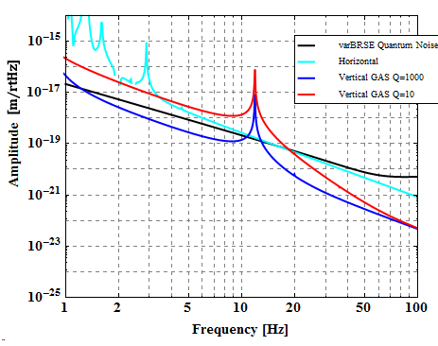
FIG.8: Suspension thermal noise with various Q factor of GAS filters. In this simulation, it is assumed that the entire payload is at uniform temperature (20K). The resonant frequency of GAS filter is 0.5 Hz.

(v) The vibration from the cryostat shortcuts through the additional heat links between IM and IRM. They enhance the vibration from the cryostat by 1-2 orders of magnitude in the observation band (>10 Hz).

Thermal noise from the GAS filter and vibration transmitted through heat links are both critical for KAGRA sensitivity. The cold Platform is chosen as a default design, but the problem (ii) must be solved to use springs in cryogenic environment.

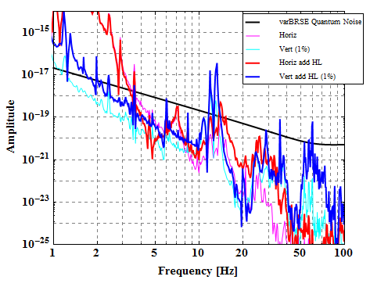
FIG.9: TM vibration through heat links. Thick red and blue lines show the vibration from the cryostat with additional heat links between IR and IRM. Thin magenta and cyan lines show the vibration without them. Here we assume that the vibration of thecryostat is same as that in CLIO (measured by K. Yamamoto)

5. Mathematical modeling
Simulation of the mechanical system is based on the three-dimensional rigid-body models constructed in Methmatica codes. The suspension system is resolved into rigid bodies and elastic components (cantilever springs, wires and heat links) and equations of motion are constructed from Lagrangian. Imaginary parts of the spring constants are introduced to estimate suspension thermal noise. Details of the calculation method are written in JGW-P1200770.

In order to take into account the effect of violin modes of the heat links, the spring coefficient (k) of the heat link is assumed to be frequency-dependent. The frequency dependence of the spring coefficient is calculated by FEA in COMSOL Multiphysics. Details of the calculation and consideration about the geometry of heat links are written in JGW-T1301987 and JGW-T1301996.

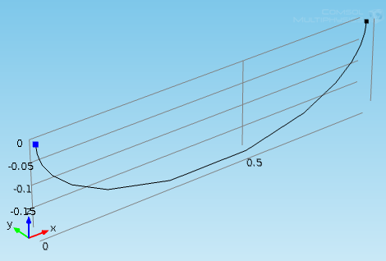
FIG.10 Heat link model in COMSOL

Mechanical parameters of Type-A SAS used in the calculation are summarized in JGW-T1302090.

The local control of the suspension is simulated in MATLAB/Simulink models. The suspension model constructed in Mathematica is converted into a state-space model and inserted as a Simulink block into the model. (During the conversion, frequency dependence of the heat link spring coefficient is ignored and the structural damping is converted into viscous damping).

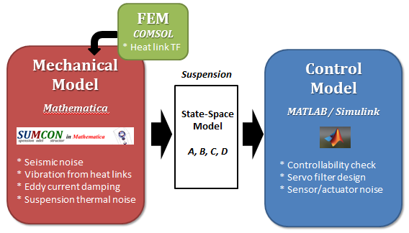
FIG.11 Model diagram

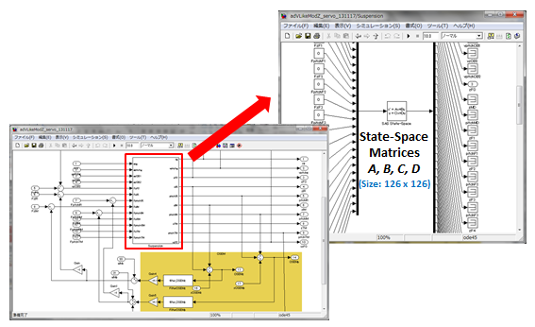
FIG 12: A simulink model of the suspension with feedback controls

6. Noise estimation
Based on the mathematical model described above, we investigated noise contribution to TM motion,$∼→zTM$ from a few noise sources, and TM motion (both longitudinal and angular motion) in the existence of feedback control. The assumptions are as follows.
Bad weather (micro-seismic noise is especially large)
IP control only (no other controls are applied)
Coupling between yaw motion and horizontal motion is introduced

In order to introduce coupling to yaw motion, the suspension points of GAS filters are shifted by ~1 mm from ideal suspension points, and asymmetry of the stiffness of inverted pendulums is introduced.
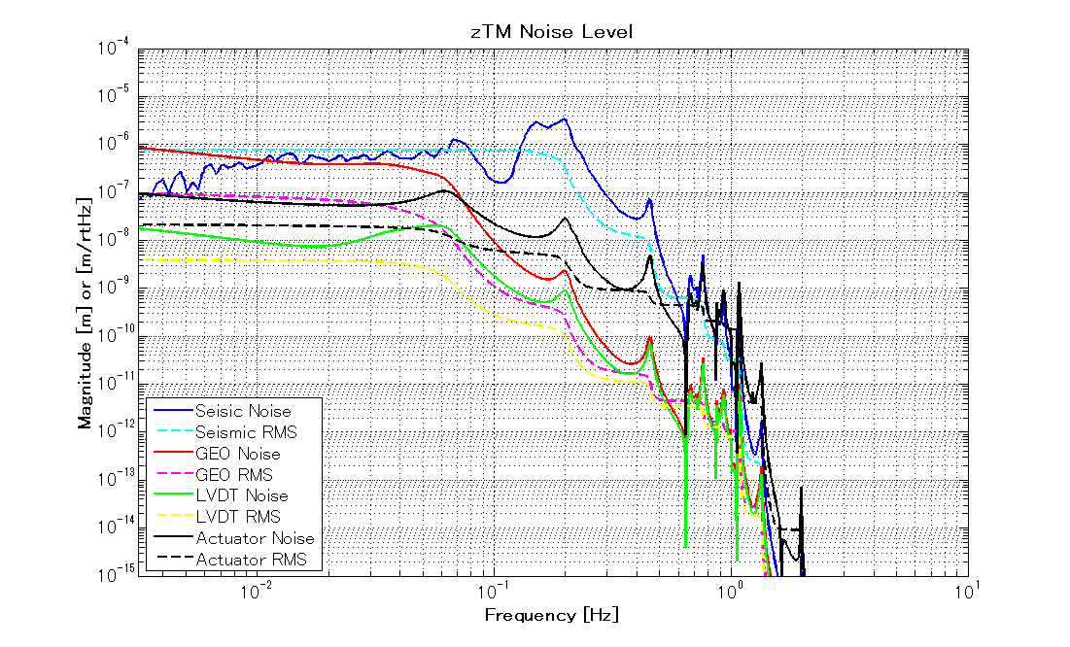
FIG. 13 Noise contributions to TM motion (longitudinal) from a few sources

FIG.13 shows several noise sources’ contribution to horizontal motion of TM (zTM), such as seismic noise, geophone accelerometer, position sensor for GASF (LVDT , linear variable differential transformer), and actuator on IP. RMS in the figure corresponds to integrated value of the noise z (i.e., $RMS=\sqrt{\int_{f}^{∞}{df z^{2}}}$ ).

Achieved RMS is 8E-7 m, which is 8 times larger than the requirement. In order to improve total RMS, one needs to boost the gain of inertial control at micro-seismic peak. However, the inertial sensor (geophone) assumed in the simulation is not sensitive enough at low frequencies, so boosting the control gain would introduce large amount of sensor noise below ~30 mHz and increase total RMS.

Note that RMS is limited by micro-seismic peak and no damping at intermediate stages would be required at steady state.
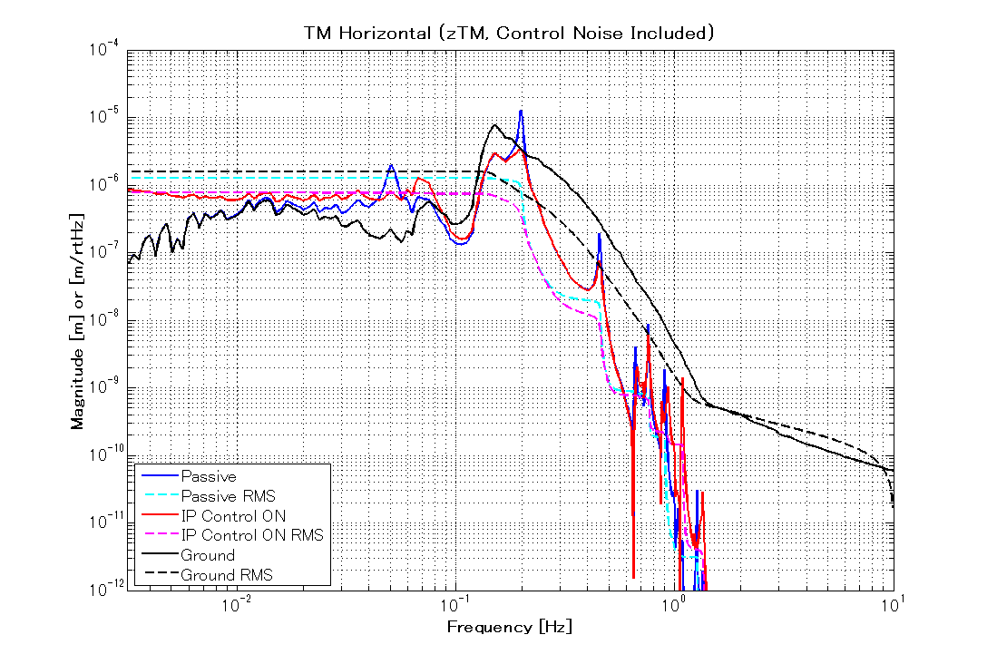
FIG. 14 Horizontal motion of TM w/ and w/o feedback control

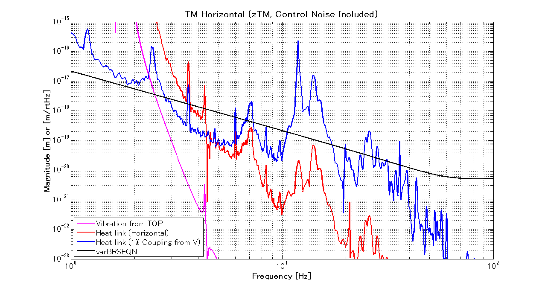
FIG. 15 Noise contributions to TM motion in observation band. The vibration from top (magenta line) indicates the total noise including sensor and actuator noises of IP control.

Fig.15 shows the noise contribution to zTM in the observation band. Seismic vibration and sensor/actuator noise from the top stage are not critical, but the vibration of the cryostat transmitted through heat links is more crucial. In the current design, the vibration from the cryostat is larger than the required noise level, so further attenuation should be implemented.

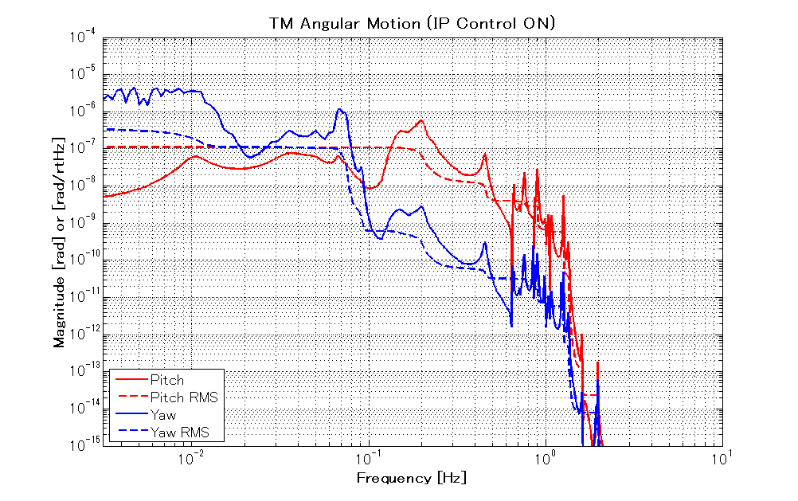
FIG. 16 TM angular motions

FIG. 16 shows angular motion of TM w/ and w/o feedback control. RMS of the angular fluctuation is in the order of ~0.1 μrad, which almost meets the requirement. For further stabilization, angular control with optical levers would be studied.

7. Sensor requirements

The sensor noise of inertial sensor at the top stage should be low enough at low frequencies (<200 mHz). The noise from the inertial sensor must be ~10 times smaller in RMS than current sensor noise of L-4C geophone (current RMS is ~3E-7 m).

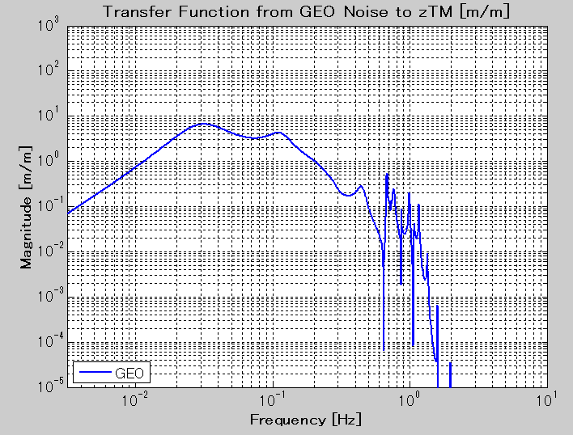
FIG.17 Coupling coefficient from geophone (inertial sensor) noise to zTM with a designed servo filter Integrated RMS of the sensor displacement noise spectrum times this coupling coefficient must be less than 3E-8 m.

8. Realization of a three dimensional model
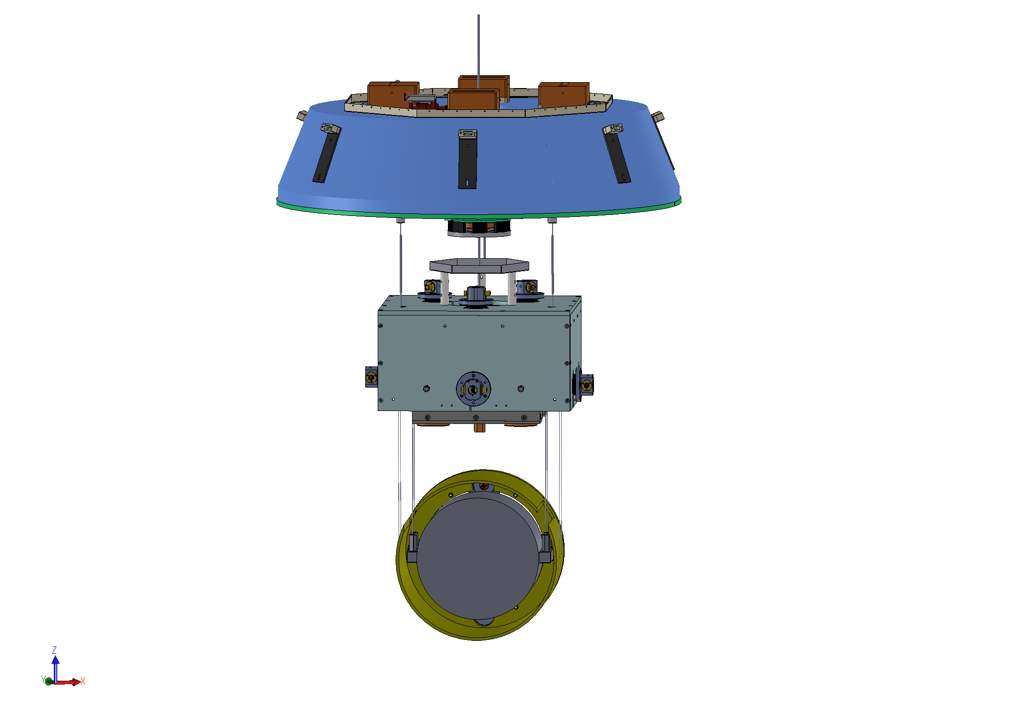
IRM
RM
TM
IM
Platform
FIG. 18 Platform IM-TM system

FIG. 18 shows a realization of cryogenic part of Type-A SAS. Platform is similar to that of Type-B SAS, room temperature vibration isolation system for BS, PRM, and SRM. IRM and IM are almost identical to those in Type-B, but there need a few modifications due to the following reasons.
- RM is suspended from IRM, not IM
- IM must have blades for sapphire TM to compensate their length difference
Recent discussion indicates that these blades are made of sapphire and its first bending mode should have a natural frequency below 10 Hz. This forces length of the blade is about 200mm, but there is little space inside IM to have those blades (FIG. 20). Therefore, we probably need to design a ‘folded blade’ to satisfy these constraints. RM should be designed newly and this must be done very carefully taking things into account, such as aperture size, actuator design, integration with baffles, and handling of IM-TM system. Also, Platform will be installed in cryostat, which means the condition is totally different from one Type-B’s bottom filter operates. Therefore, we need to carefully re-design not only blades but some other parts.
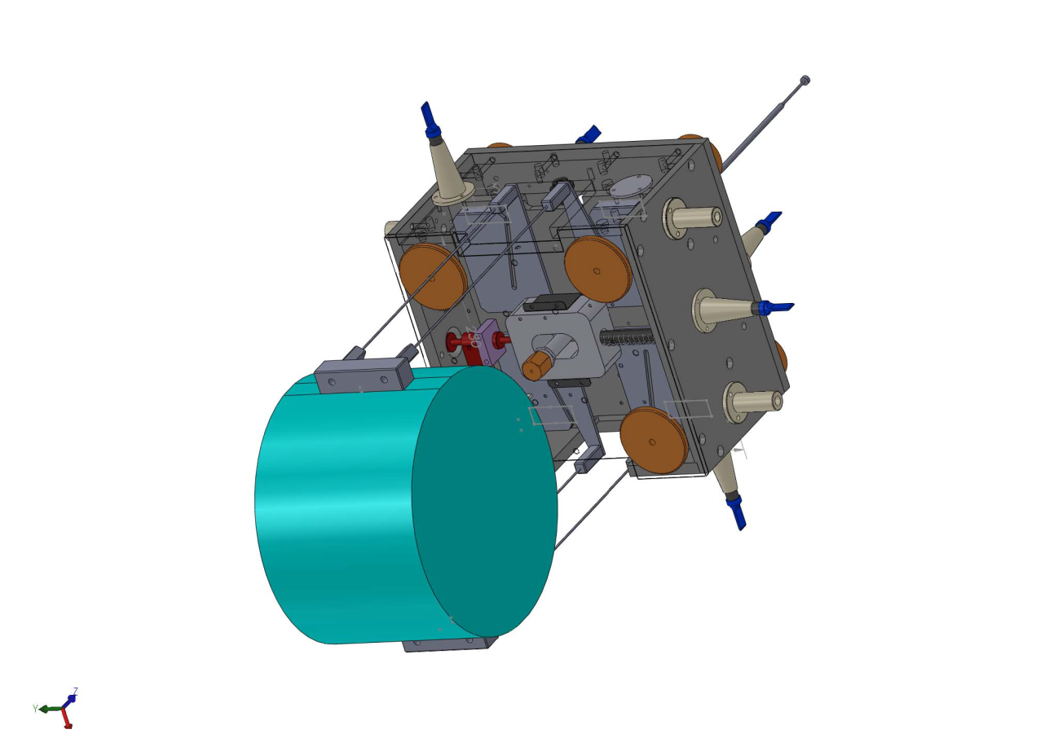FIG. 19 IM-TM system with folded-blades (IM has moving masses to control its attitude. Inside IM, one room is for blades and y-axis moving mass while the other room is for x-axis moving mass.)
sapphire blade
sapphire rod
BOSEM
TM
IM

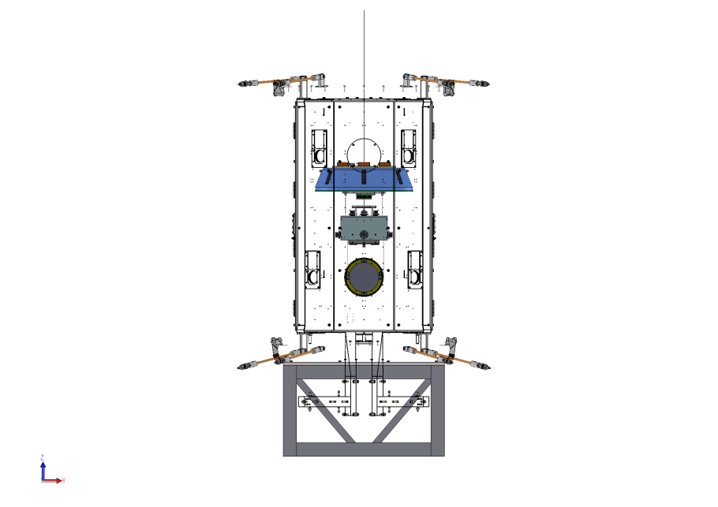
inner shield
front view
FIG. 20 PF-IM-TM system inside the inner shield

9. Problems to be solved (no particular order)
- We have to find a technique to suspend sapphire TM. So far, hydroxide-catalysis bonding, indium welding, optical contact, and screw. A strength test at cryogenic temperature will be performed and we will use the result in suspension design.
- For backup, instead of sapphire rods, we probably should seriously consider use of metal wires to suspend sapphire mirrors.
- Detailed design of Plat from, RM, IM, and IRM must be done.
- Detailed design (including FEA) of sapphire blades must be done.
- As FIG. 15 shows, we have to find a solution to attenuate vibration through the heat-link.
- Consideration of integration of heat-link to realize the above must be done.
- We need a mechanism to adjust wire length in both F4 and Platform. We can probably use the same mechanism that is used in F0, so integration and confirmation that it can be used at cryogenic temperature will be keys here.
- We should not use a geophone sensor L4-C and replace it with something better such as http://www.sciencedirect.com/science/article/pii/S0168900206006383
- Authors are not sure whether sensors like OSEM can be used in IM since they are tested at cryogenic environment. Instead, LVDT may be used which is essentially identical to LVDT used in Top filter.

10. Future work (things should be included in the next version)

- Further reduction of RMS of TM horizontal displacement is required. Impact from micro-seismic peak must be mitigated by passive / active attenuation. We need more aggressive tuning of IP resonant frequencies (currently tuned at 50 mHz) and further gain of inertial controls. Control simulation with less noisy inertial sensors should be performed.
- Stabilization of pitch/yaw motion of TM would be necessary. Servo filters of angular control with optical levers / wave front sensors are to be designed. The requirement for the sensor noise level is to be also set from the designed servo filters.

11. Conclusion
We first set the design requirements for Type-A SAS. Then, we determined topology and fundamental dimensions (JGW-T1302090) considering feedback control of the system. Also, we started designing a three-dimensional model. As we listed up, there are still many items that should be sorted out.

12. Acknowledgment
Authors greatly thank Brian Lantz, Jeff Kissel, Brett Shapiro, and Hugo Paris, and Dan Debra for very useful discussion during a workshop held at Ginzton Laboratory in December 9 – 13, 2013. We learned a lot through the workshop and this work would not be possible without their help.

