JGW-T1302090
Type-A SAS Mechanical Model Parameters

Takanori Sekiguchi

1. Introduction
1.1. About This Document
This document contains parameters for mechanical modeling of Type-A vibration isolation system.

1.2. Version Information
Version 1: MODEL20131220, Advanced Virgo-Like (RM suspended from IR)

1.3. Note
- The clamp position of a wire is different from its effective flexure point. The separation between the bending point and the clamp point can be calculated as Δ=√EI/T, where E is Young’s modulus, I is the moment of area, T is the tension on the wire.

2. Mechanical Model
2.1. Room Temperature Part

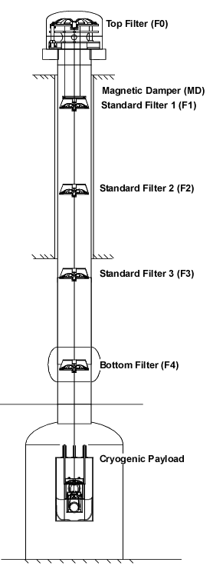
Fig: Overview of Type-A SAS

2.1.1. Top Filter (F0)

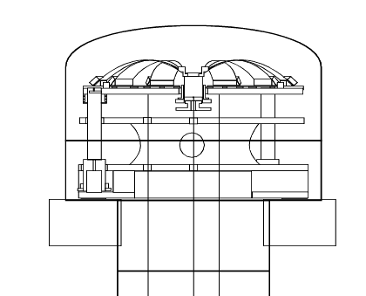
Fig: Closer look at F0

Rigid Body Property
- Mass: 474 [kg]
- Moment of inertia (X): 60 [kg m²]
- Moment of inertia (Y): 120 [kg m²]
- Moment of inertia (Z): 60 [kg m²]

Linkage
F0 is supported by three inverted pendulum (IP) legs from the ground.

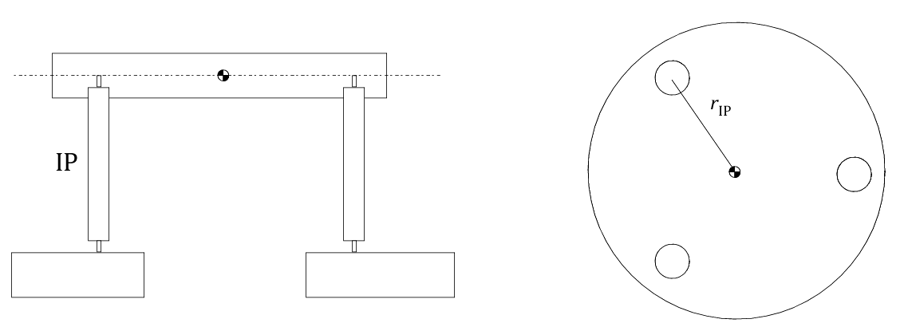
Fig: Support of F0

IP Property
- Radial distance of the legs from center of mass (r_IP): 600 [mm]
- Length of the IP leg: 500 [mm]
- Load on three IPs: 1085 [kg]
- Effective stiffness of each IP: 13 [N/m] (tuned at 30 [mHz] in the translation mode)
- Effective Q factor: 3
- Additional yaw stiffness due to torsional stiffness of the top flexures: 200 [Nm/rad]
- Center of percussion level: -80 [dB] (overcompensated)

2.1.2. Magnetic Damper (MD)

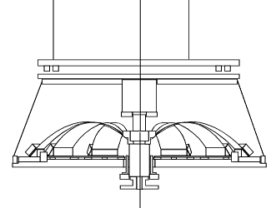
Fig: Closer look at MD and F1

Rigid Body Property
- Mass: 30 [kg]
- Moment of inertia (X): 1.3 [kg m²]
- Moment of inertia (Y): 2.5 [kg m²]
- Moment of inertia (Z): 1.3 [kg m²]

Linkage
MD is suspended by three wires from F0.
Eddy current damping is exerted between MD and F1.

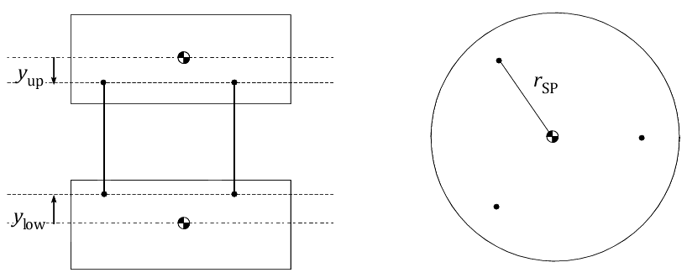
Fig: Suspension of MD

Wire Suspension Property
- Radial distance of the wires from center of mass (r_SP): 400 [mm]
- Upper clamp y-position from the center of mass (y_up): -5 [mm]
- Lower clamp y-position from the center of mass (y_low): +5 [mm]
- Material: C-70 steel (E = 200 [GPa], σ = 0.3, φ = 3E-4)
- Natural length: 1795.5 [mm] (1800 [mm] in tension)
- Diameter: 0.5 [mm]
- Tension on each wire: 98.1 [N] (500 [N/mm²] stress)

Eddy Current Damping Property
- Damping point at MD in the local coordinate: (x, y, z) = (0, -10, 0) [mm]
- Damping point at F1 in the local coordinate: (x, y, z) = (0, 200, 0) [mm]
- Damping strength (X): 18 [N/(m/sec)]
- Damping strength (Y): 45 [N/(m/sec)]
- Damping strength (Z): 18 [N/(m/sec)]
- Damping strength (RX): 2.5 [N m/(rad/sec)]
- Damping strength (RY): 2.0 [N m/(rad/sec)]
- Damping strength (RZ): 2.5 [N m/(rad/sec)]

2.1.3. Standard Filter 1 (F1)
Fig: Closer look at MD and F1

Rigid Body Property
- Mass: 104 [kg]
- Moment of inertia (X): 1.3 [kg m²]
- Moment of inertia (Y): 2.5 [kg m²]
- Moment of inertia (Z): 1.3 [kg m²]

Linkage
F1 is suspended by a single wire from a GAS filter on F0.
(Eddy current damping is exerted between MD and F1.)

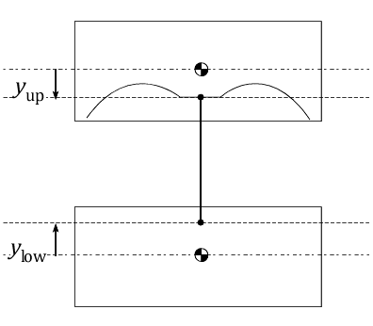
Fig: Suspension of F1

Wire Suspension Property
- Upper clamp y-position from the center of mass (y_up): +120 [mm]
- Lower clamp y-position from the center of mass (y_low): +5 [mm]
- Material: Maraging steel (E = 195 [GPa], σ = 0.3, φ = 1E-3)
- Natural length: 2262.2 [mm] (2271 [mm] in tension)
- Diameter: 3.1 [mm]
- Tension on each wire: 5700 [N] (755 [N/mm²] stress)

GAS Filter Property (on F0)
- Spring constant: 516 [N/m] (tuned at 0.15 [Hz])
- Quality factor: 20
- Center of percussion level: -80 [dB]

2.1.4. Standard Filter 2 (F2)
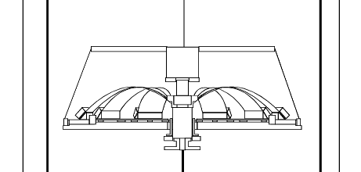
Fig: Closer look at F2

Rigid Body Property
- Mass: 90 [kg]
- Moment of inertia (X): 4.0 [kg m²]
- Moment of inertia (Y): 6.4 [kg m²]
- Moment of inertia (Z): 4.0 [kg m²]

Linkage
F2 is suspended by a single wire from a GAS filter on F1.

Fig: Suspension of F2

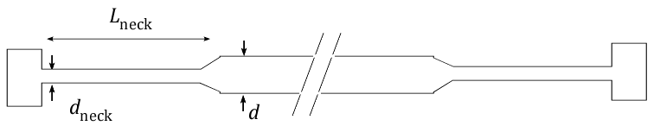
Fig: Wire structure

Wire Suspension Property
- Upper clamp y-position from the center of mass (y_up): -5 [mm]
- Lower clamp y-position from the center of mass (y_low): +5 [mm]
- Material: Maraging steel (E = 195 [GPa], σ = 0.3, φ = 1E-3)
- Natural length: 2266.1 [mm] (2271 [mm] in tension)
- Main diameter (d): 3.8 [mm]
- Neck diameter (d_neck): 2.8 [mm]
- Neck length (L_neck): 20 [mm]
- Tension on each wire: 4680 [N] (760 [N/mm²] stress on the neck)

GAS Filter Property (on F1)
- Spring constant: 1177 [N/m] (tuned at 0.25 [Hz])
- Quality factor: 10
- Center of percussion level: -80 [dB]

2.1.5. Standard Filter 3 (F3)
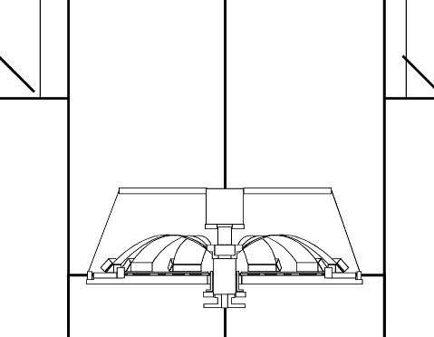
Fig: Closer look at F3

Rigid Body Property
- Mass: 87 [kg]
- Moment of inertia (X): 4.0 [kg m²]
- Moment of inertia (Y): 6.4 [kg m²]
- Moment of inertia (Z): 4.0 [kg m²]

Linkage
F3 is suspended by a single wire from a GAS filter on F2.

Fig: Suspension of F3

Fig: Wire structure

Wire Suspension Property
- Upper clamp y-position from the center of mass (y_up): -5 [mm]
- Lower clamp y-position from the center of mass (y_low): +5 [mm]
- Material: Maraging steel (E = 195 [GPa], σ = 0.3, φ = 1E-3)
- Natural length: 2267.0 [mm] (2271 [mm] in tension)
- Main diameter (d): 3.8 [mm]
- Neck diameter (d_neck): 2.5 [mm]
- Neck length (L_neck): 20 [mm]
- Tension on each wire: 3800 [N] (774 [N/mm²] stress on the neck)

GAS Filter Property (on F2)
- Spring constant: 955 [N/m] (tuned at 0.25 [Hz])
- Quality factor: 10
- Center of percussion level: -80 [dB]

2.1.6. Bottom Filter (F4)
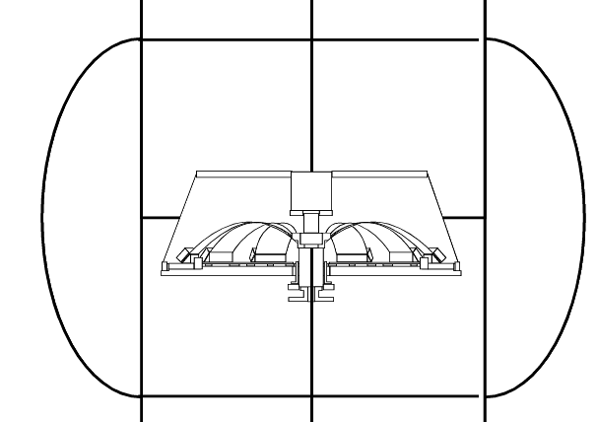
Fig: Closer look at F4

Rigid Body Property
- Mass: 84 [kg]
- Moment of inertia (X): 4.0 [kg m²]
- Moment of inertia (Y): 6.4 [kg m²]
- Moment of inertia (Z): 4.0 [kg m²]

Linkage
F4 is suspended by a single wire from a GAS filter on F3.

Fig: Suspension of F4

Fig: Wire structure

Wire Suspension Property
- Upper clamp y-position from the center of mass (y_up): -5 [mm]
- Lower clamp y-position from the center of mass (y_low): +5 [mm]
- Material: Maraging steel (E = 195 [GPa], σ = 0.3, φ = 1E-3)
- Natural length: 2369.7 [mm] (2373 [mm] in tension)
- Main diameter (d): 3.8 [mm]
- Neck diameter (d_neck): 2.2 [mm]
- Neck length (L_neck): 20 [mm]
- Tension on each wire: 2940 [N] (773 [N/mm²] stress on the neck)

GAS Filter Property (on F3)
- Spring constant: 740 [N/m] (tuned at 0.25 [Hz])
- Quality factor: 10
- Center of percussion level: -80 [dB]

Load on F4
- Total mass: 216 [kg]

2.2. Cryogenic Payload

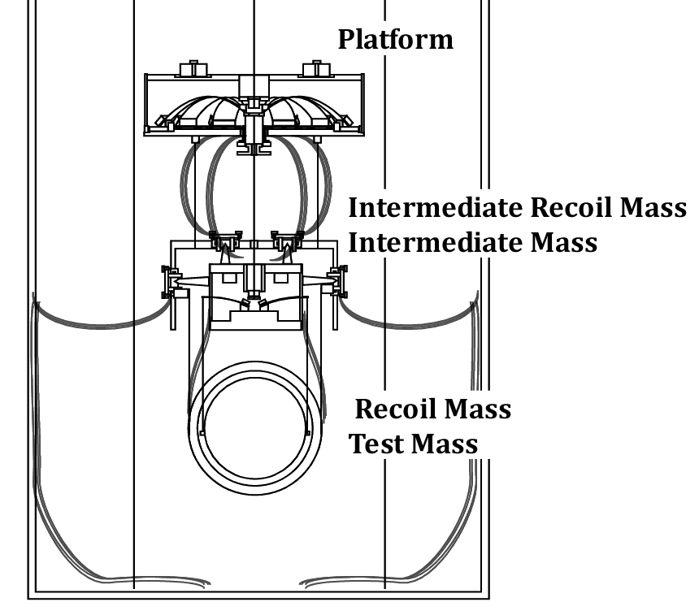
Fig: Overview of Cryogenic Payload

2.2.1. Platform (PF)

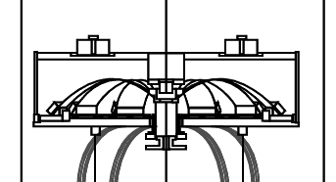
Fig: Closer look at PF

Rigid Body Property
- Mass: 61.5 [kg]
- Moment of inertia (X): 2.4 [kg m²]
- Moment of inertia (Y): 3.8 [kg m²]
- Moment of inertia (Z): 2.4 [kg m²]

Linkage
PF is suspended by a single wire from a GAS filter on F4.

Fig: Suspension of PF

Fig: Wire structure

Wire Suspension Property
- Upper clamp y-position from the center of mass (y_up): -5 [mm]
- Lower clamp y-position from the center of mass (y_low): +5 [mm]
- Material: Copper beryllium (E = 134 [GPa], σ = 0.3, φ = 5E-6)
- Natural length: 3380.7 [mm] (3385 [mm] in tension)
- Main diameter (d): 4.1 [mm]
- Neck diameter (d_neck): 2.0 [mm]
- Neck length (L_neck): 20 [mm]
- Tension on each wire: 2120 [N] (675 [N/mm²] stress on the neck)

GAS Filter Property (on F4)
- Spring constant: 533 [N/m] (tuned at 0.25 [Hz])
- Quality factor: 10
- Center of percussion level: -80 [dB]

2.2.2. Intermediate Recoil Mass (IR)

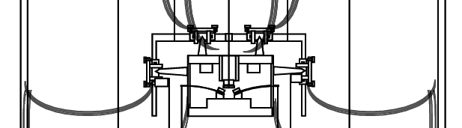
Fig: Closer look at IR and IM

Rigid Body Property
- Mass: 44.9 [kg]
- Moment of inertia (X): 0.561 [kg m²]
- Moment of inertia (Y): 0.815 [kg m²]
- Moment of inertia (Z): 0.899 [kg m²]

Linkage
IR is suspended by three wires from PF.
Heat links are connected from the inner radiation shield.

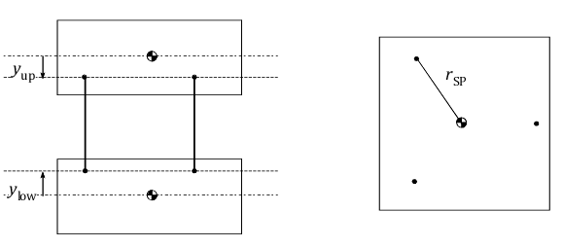
Fig: Suspension of IR

Wire Suspension Property
- Upper clamp y-position from the center of mass (y_up): -50 [mm]
- Lower clamp y-position from the center of mass (y_low): +50 [mm]
- Material: Copper beryllium (E = 134 [GPa], σ = 0.3, φ = 5E-6)
- Natural length: 299.2 [mm] (300 [mm] in tension)
- Diameter: 1.0 [mm]
- Tension on each wire: 257 [N] (327 [N/mm²] stress)

Heat Link Property
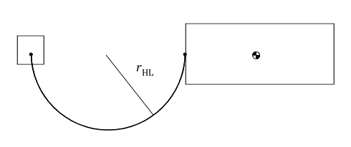
Fig: Heat link geometry

- Material: Pure aluminum (E = 70 [GPa], σ = 0.38, φ = 1E-2)
- Wire diameter: 0.15 [mm]
- Number of wires: 180 (4 fibers with 45 strands for each)
- Shape: Semi-circle with 150 mm radius (r_HL) and 470 mm length
- Clamp position at IR in local coordinate: (x, y, z) = (145, 0, 0) [mm]
- Heat links are on XY plane.

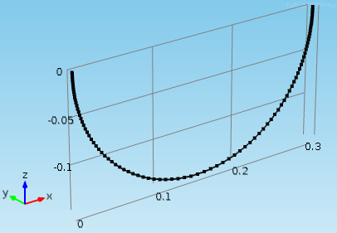
Fig: A heat link model in COMSOL (coordinate system is different from that of the suspension model)

- DC spring constant (X in suspension model, X in COMSOL): 0.077 [N/m]
- DC spring constant (Y in suspension model, Z in COMSOL): 0.0146 [N/m]
- DC spring constant (Z in suspension model, Y in COMSOL): 0.0102 [N/m]
- First violin mode: 2.5 [Hz]
- Second violin mode: 6 [Hz]
- Details of calculation: JGW-T1301996

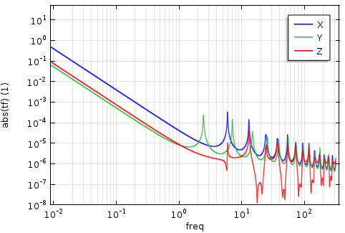
Fig: Simulated mechanical transfer functions of a heat link attached to a 50 [kg] mass
(results about a single fiber with 45 strands)

2.2.3. Intermediate Mass (IM)

Fig: Closer look at IR and IM

Rigid Body Property
- Mass: 53.2 [kg]
- Moment of inertia (X): 0.352 [kg m²]
- Moment of inertia (Y): 0.677 [kg m²]
- Moment of inertia (Z): 0.474 [kg m²]

Linkage
IM is suspended by a single wire from a GAS filter on PF.

Fig: Suspension of IM

Fig: Wire structure

Wire Suspension Property
- Upper clamp y-position from the center of mass (y_up): -5 [mm]
- Lower clamp y-position from the center of mass (y_low): -4 [mm]
- Material: Copper beryllium (E = 134 [GPa], σ = 0.3, φ = 5E-6)
- Natural length: 399.1 [mm] (400 [mm] in tension)
- Main diameter (d): 1.8 [mm]
- Neck diameter (d_neck): 1.6 [mm]
- Neck length (L_neck): 20 [mm]
- Tension on each wire: 745 [N] (371 [N/mm²] stress on the neck)

GAS Filter Property (on PF)
- Spring constant: 750 [N/m] (tuned at 0.5 [Hz])
- Quality factor: 1E3
- Center of percussion level: -80 [dB]

2.2.4. Recoil Mass (RM)

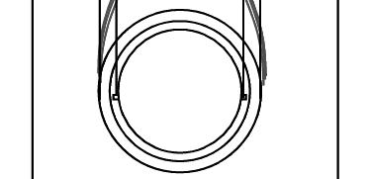
Fig: Closer look at RM and TM

Rigid Body Property
- Mass: 33.7 [kg]
- Moment of inertia (X): 0.433 [kg m²]
- Moment of inertia (Y): 0.433 [kg m²]
- Moment of inertia (Z): 0.642 [kg m²]

Linkage
RM is suspended by four wires from IR.

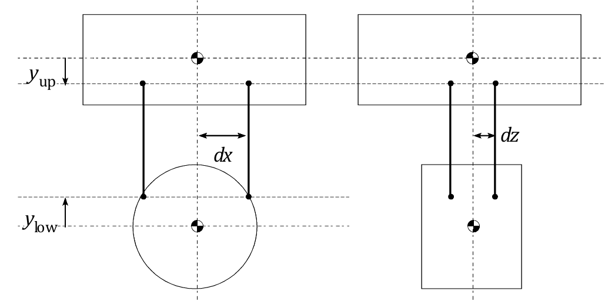
Fig: Suspension of RM

Wire Suspension Property
- X-distance between the wire and the center of mass (dx): 145 [mm]
- Z-distance between the wire and the center of mass (dx): 30 [mm]
- Upper clamp y-position from the center of mass (y_up): 0 [mm]
- Lower clamp y-position from the center of mass (y_low): 0 [mm]
- Material: Copper beryllium (E = 134 [GPa], σ = 0.3, φ = 5E-6)
- Natural length: 300.0 [mm] (300 [mm] in tension)
- Diameter: 0.6 [mm]
- Tension on each wire: 82.6 [N] (294 [N/mm²] stress)

2.2.5. Test Mass (TM)

Fig: Closer look at RM and TM

Rigid Body Property
- Mass: 22.7 [kg]
- Moment of inertia (X): 0.111 [kg m²]
- Moment of inertia (Y): 0.111 [kg m²]
- Moment of inertia (Z): 0.137 [kg m²]

Linkage
RM is suspended by four cantilever springs and wires from IR.

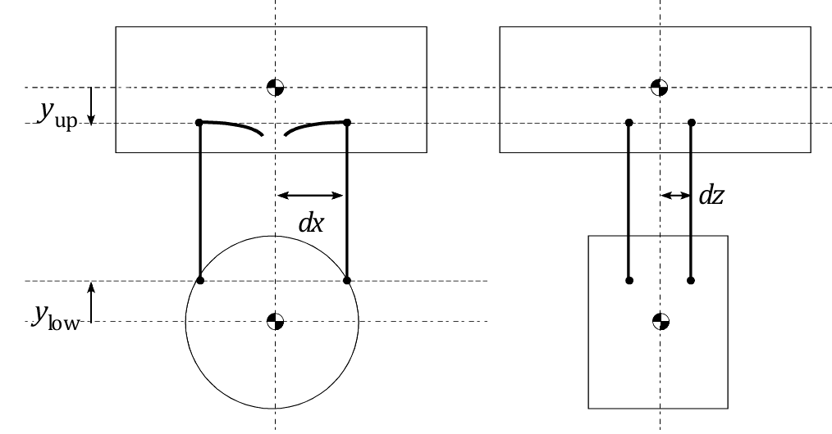
Fig: Suspension of TM

Wire Suspension Property
- X-distance between the wire and the center of mass (dx): 110 [mm]
- Z-distance between the wire and the center of mass (dx): 15 [mm]
- Upper clamp y-position from the center of mass (y_up): 0 [mm]
- Lower clamp y-position from the center of mass (y_low): 0 [mm]
- Material: Sapphire (E = 345 [GPa], σ = 0.3, φ = 2E-7)
- Natural length: 300.0 [mm] (300 [mm] in tension)
- Diameter: 1.6 [mm]
- Tension on each wire: 55.6 [N] (28 [N/mm²] stress)

Cantilever Spring Property
- Spring constant per blade: 22.4 [kN/m] (tuned at 10 Hz)
- Quality factor: 1E6

