Type-A Vibration Isolation System modeling
T. Sekiguchi

0. Introduction

1. Seismic Noise Model
M. Beker measured Kamioka seismic spectrum in 2010, using a Trillium 240 seismometer.
Araya measured the spectrum in 2007 with a CMG-3 seismometer on an extremely stormy day.
(Measured spectrum seems to be limited by instrumental noise above 1 Hz)

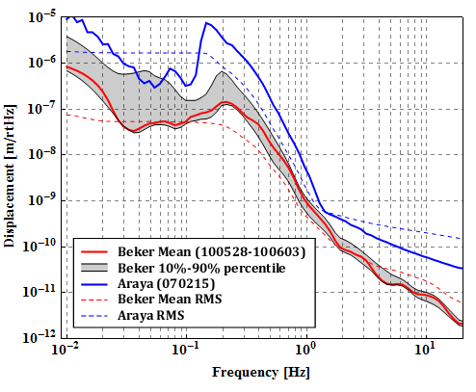

K. Yamamoto measured CLIO inner shield vibration in 2007.
Measured vibration level was 2-4 orders of magnitude larger than the ground vibration level, above 10 Hz.

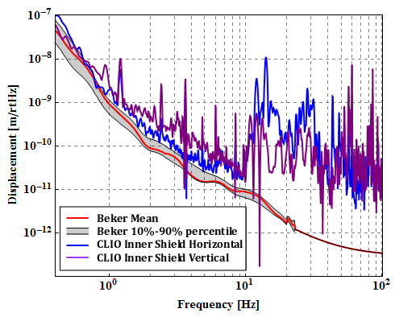

Although the vibration level of actual cryostat is unknown, the following vibration level is assumed:
* IP base vibration: M.Beker’s mean spectrum
* Cryo bar vibration: CLIO inner shield spectrum

2. Type-A SAS part parameters (COMMON IN ALL MODELS)

Filter 0 (F0)
M=474 kg, Ix=60 kgm2, Iy=120 kgm2, Iz=60 kgm2
IP position from center = 600 mm
IP resonant frequency (translation) = 30 mHz, IP COP Effect: -80 dB
GAS resonant frequency = 0.2 Hz

Magnetic Damper (MD)
M=30kg, Ix=1.3kgm2, Iy=2.5kgm2, Iz=1.3kgm2
Suspended from F0 by 3 wires
Wire length = 1.8 m, Material: C70 steel
Upper suspension point vertical position from C.o.M. = -120 mm
Lower suspension point vertical position from C.o.M. = +5 mm
Wire horizontal distance from center = 400 mm
Damping coefficient (between MD and F1)
Horizontal(x,z): 18 N/(m/s), vertical(y): 45 N/(m/s)
Pitch/Roll: 2.5 Nm/(rad/s), Yaw: 2 Nm/(rad/s)

Standard Filter 1 (F1)
M=104kg, Ix=4.4kgm2, Iy=7.3kgm2, Iz=4.4 kgm2
Suspended from F0 by a single wire
Wire length = 2.271 m, Material: Maraging steel
Upper suspension point vertical position from C.o.M. = -5 mm
Lower suspension point vertical position from C.o.M. = +5 mm
GAS resonant frequency = 0.25 Hz

Standard Filter 2 (F2)
M=90kg, Ix=4.0kgm2, Iy=6.4kgm2, Iz=4.0kgm2
Suspended from F1 by a single wire
Wire length = 2.271 m, Material: Maraging steel
Upper suspension point vertical position from C.o.M. = -5 mm
Lower suspension point vertical position from C.o.M. = +5 mm
GAS resonant frequency = 0.25 Hz

Standard Filter 3 (F3)
M=90kg, Ix=4.0kgm2, Iy=6.4kgm2, Iz=4.0kgm2
Suspended from F2 by a single wire
Wire length = 2.271 m, Material: Maraging steel
Upper suspension point vertical position from C.o.M. = -5 mm
Lower suspension point vertical position from C.o.M. = +5 mm
GAS resonant frequency = 0.25 Hz

3. Hot Platform Type-B like model

3.1. Parameters

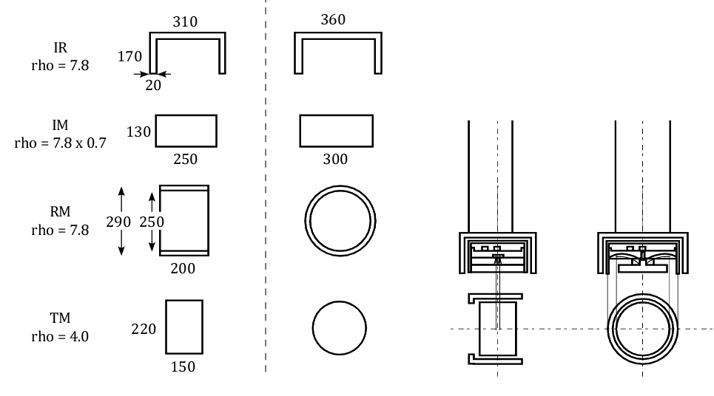

Bottom Filter / Platform (PF)
M=145.5kg, Ix=8 kgm2, Iy=12 kgm2, Iz=8 kgm2,
Suspended from F3 by a single wire
Wire length = 2.373 m, Material: CuBe
Upper suspension point vertical position from C.o.M. = -5 mm
Lower suspension point vertical position from C.o.M. = +5 mm
GAS resonant frequency = 0.25 Hz
(Room temperature)

Intermediate Recoil Mass (IR)
M=44.9kg, Ix=0.561kgm2, Iy=0.815 kgm2, Iz=0.899 kgm2,
Suspended from PF by 3 wires with vertical springs
Wire length = 3.630 m, Material: CuBe
Upper suspension point vertical position from C.o.M. = -75 mm
Lower suspension point vertical position from C.o.M. = +75 mm
Wire horizontal distance from center = 120 mm
Spring resonant frequency = 5 Hz

Intermediate Mass (IM)
M=53.2kg, Ix=0.352kgm2, Iy=0.677 kgm2, Iz=0.474 kgm2,
Suspended from PF by a single wire
Wire length = 3.785 m, Material: CuBe
Upper suspension point vertical position from C.o.M. = -5 mm
Lower suspension point vertical position from C.o.M. = -4 mm

Recoil Mass (RM)
M=33.7kg, Ix=0.433kgm2, Iy=0.433 kgm2, Iz=0.642 kgm2,
Suspended from PF by 4 wires
Wire length = 0.3 m, Material: CuBe
Upper suspension point vertical position from C.o.M. = 0 mm
Lower suspension point vertical position from C.o.M. = 0 mm
X-separation of wire and C.o.M. = 145 mm
Z-separation of wire and C.o.M. = 25 mm
Spring resonant frequency = 5 Hz

Test Mass (TM)
M=22.7kg, Ix=0.111kgm2, Iy=0.111 kgm2, Iz=0.137 kgm2,
Suspended from PF by 4 wires
Wire length = 0.3 m, Material: Sapphire
Upper suspension point vertical position from C.o.M. = 0 mm
Lower suspension point vertical position from C.o.M. = 0 mm
X-separation of wire and C.o.M. = 110 mm
Z-separation of wire and C.o.M. = 15 mm
Spring resonant frequency = 20 Hz

Heat links Between Suspension and Cryo Bars:
Semi-elliptic, pure aluminum (6N grade), thickness=1mm
Major radius = 400 mm (X, horizontal and perpendicular to beam axis)
Minor radius = 200 mm (Y, Vertical axis)
DC spring constant per one wire:
kx=0.387 N/m, ky=0.040 N/m, kz=0.012 N/m
First violin mode: 2 Hz, second mode: 8 Hz
Attached to IR from both sides, 4 wires for each connection

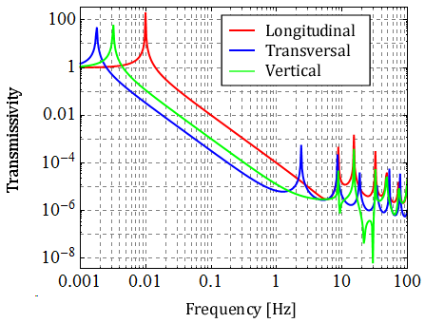
Vibration transmissivity of heat link (connected to a 120 kg free mass)

Heat links Between IR and IM:
U-shape, pure aluminum (6N grade), thickness=1mm
Straight line length (vertical axis) = 100mm, semicircle (X-Y plane) diameter = 25 mm
DC spring constant per one wire:
kx=5.04 N/m, ky=79.4 N/m, kz=2.64 N/m
First violin mode: 30 Hz, second mode: 60 Hz
Attached from both sides, 10 wires for each connection

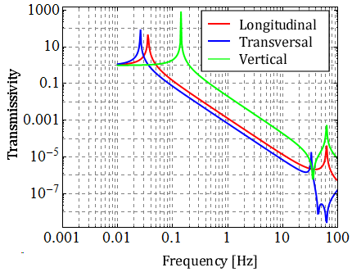
Vibration transmissivity of heat link (connected to a 120 kg free mass)

3.2. Model basic information

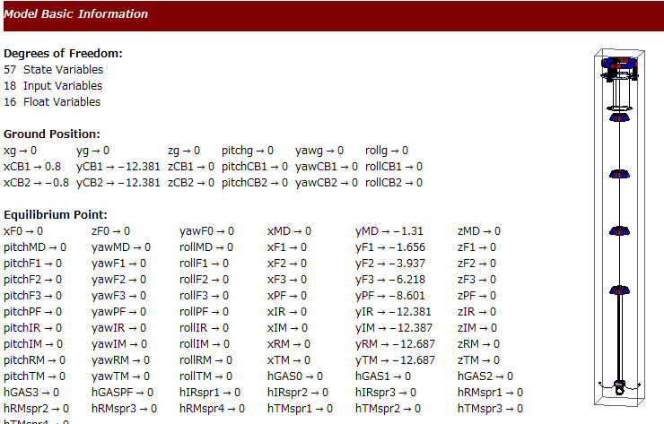

3.3. Vibration from heat links

Assume 1% coupling from vertical components.

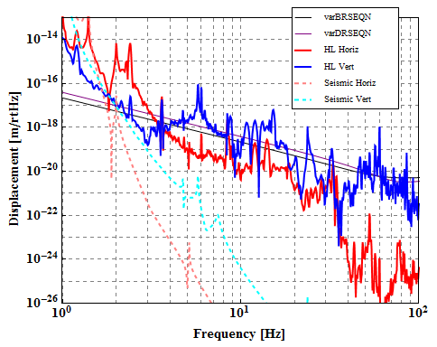
(HL_BlikeHotPF_default.m)

Identification of resonant peaks:
15 Hz: violin mode of HL from cryo bars
25 Hz: inner shield vibration
60 Hz: violin mode of HL between IR and IM

If the heat links between IR and IM are removed:

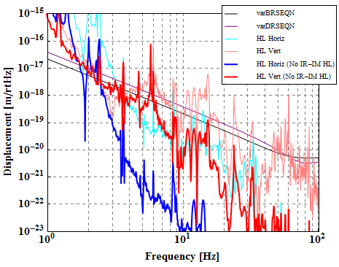
(HL_BlikeHotPF_redHL.m)

3.4. Suspension Thermal Noise

Assume 0.33% coupling from vertical components.

Default Loss Angle:
Sapphire fiber: 2E-7, TM Spring: 2E-7
CuBe fiber: 5E-6, RM Spring; 1E-5, Heat Link: ~1E-2
GAS filter: (Q=10)

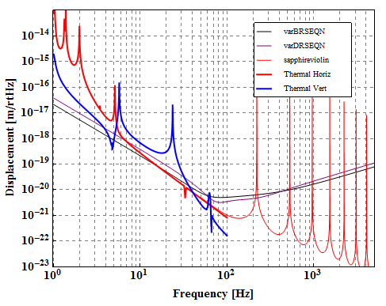
(TN_BlikeHotPF_default.m)

Identification of resonant peaks:
5.1 Hz: TM pitch mode
5.7 Hz: RM vertical
23.7 Hz: TM vertical
60 Hz: Heat link between IM and IR

Contribution:
Sapphire fibers mainly contribute to the horizontal thermal noise.
Bottom GAS filter mainly contributes to the vertical thermal noise.

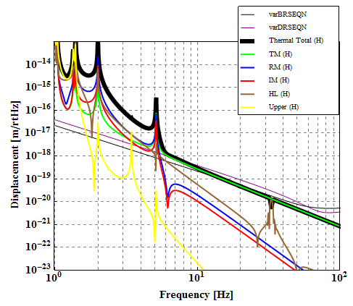
(TN_BlikeHotPF _Contribute _H.m)

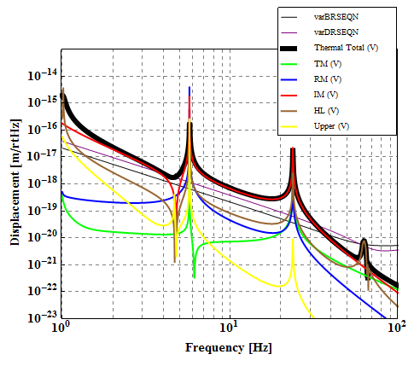
(TN_BlikeHotPF _Contribute _V.m)

Changing TM Spring Stiffness:

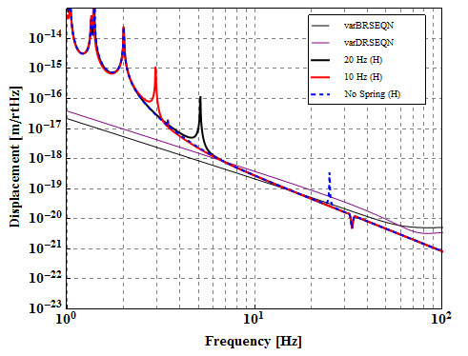
(TN_BlikeHotPF _TMspr _H.m)

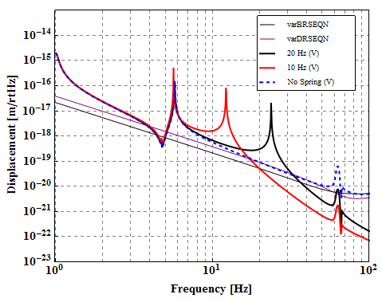
(TN_BlikeHotPF _TMspr _V.m)

In no spring case, vertical thermal noise spectrum has a huge peak at 140 Hz, which is not shown in the upper figure.

3.5. Controllability

3.6. Control Noise

4. LIGO like Model

4.1. Parameters

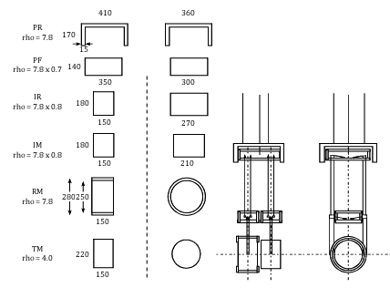

Bottom Filter (F4)
M=80.1kg, Ix=4.4 kgm2, Iy=6.0 kgm2, Iz=4.4 kgm2,
Suspended from F3 by a single wire
Wire length = 2.373 m, Material: CuBe
Upper suspension point vertical position from C.o.M. = -5 mm
Lower suspension point vertical position from C.o.M. = +5 mm
GAS resonant frequency = 0.25 Hz
(Room temperature)

Platform Recoil Mass (PR)
M=38.2kg, Ix=0.40 kgm2, Iy=0.63kgm2, Iz=0.80 kgm2,
Suspended from F4 by 3 wires with springs
Wire length = 3.23 m, Material: CuBe
Upper suspension point vertical position from C.o.M. = -75 mm
Lower suspension point vertical position from C.o.M. = +75 mm
Wire horizontal distance from center = 150 mm
Spring resonant frequency = 5 Hz

Platform (PF)
M=65.5kg, Ix=0.78 kgm2, Iy=0.91kgm2, Iz=0.35 kgm2,
Suspended from F4 by a single wire
Wire length = 3.385 m, Material: CuBe
Upper suspension point vertical position from C.o.M. = -5 mm
Lower suspension point vertical position from C.o.M. = +5 mm

Intermediate Recoil Mass (IR)
M=35.4kg, Ix=0.16kgm2, Iy=0.20 kgm2, Iz=0.22 kgm2,
Suspended from PF by 4 wires with vertical springs
Wire length = 0.40 m, Material: CuBe
Upper suspension point vertical position from C.o.M. =0 mm
Lower suspension point vertical position from C.o.M. =0 mm
Upper suspension point Z-translation from C.o.M. = - 80 mm
X-separation of wire and C.o.M. = 140 mm
Z-separation of wire and C.o.M. = 30 mm
Spring resonant frequency = 3 Hz

Intermediate Recoil Mass (IM)
M=35.4kg, Ix=0.16kgm2, Iy=0.20 kgm2, Iz=0.22 kgm2,
Suspended from PF by 4 wires with vertical springs
Wire length = 0.40 m, Material: CuBe
Upper suspension point vertical position from C.o.M. =0 mm
Lower suspension point vertical position from C.o.M. =0 mm
Upper suspension point Z-translation from C.o.M. = + 80 mm
X-separation of wire and C.o.M. = 110 mm
Z-separation of wire and C.o.M. = 30 mm
Spring resonant frequency = 3 Hz

Recoil Mass (RM)
M=22.7kg, Ix=0.24kgm2, Iy=0.24 kgm2, Iz=0.40 kgm2,
Suspended from IR by 4 wires
Wire length = 0.3 m, Material: CuBe
Upper suspension point vertical position from C.o.M. = 0 mm
Lower suspension point vertical position from C.o.M. = 0 mm
X-separation of wire and C.o.M. = 145 mm
Z-separation of wire and C.o.M. = 15 mm
Spring resonant frequency = 5 Hz

Test Mass (TM)
M=22.7kg, Ix=0.111kgm2, Iy=0.111 kgm2, Iz=0.137 kgm2,
Suspended from PF by 4 wires
Wire length = 0.3 m, Material: Sapphire
Upper suspension point vertical position from C.o.M. = 0 mm
Lower suspension point vertical position from C.o.M. = 0 mm
X-separation of wire and C.o.M. = 110 mm
Z-separation of wire and C.o.M. = 15 mm
Spring resonant frequency = 20 Hz

Heat links Between Suspension and Cryo Bars:
Semi-elliptic, pure aluminum (6N grade), thickness=1mm
Major radius = 400 mm (X, horizontal and perpendicular to beam axis)
Minor radius = 200 mm (Y, Vertical axis)
DC spring constant per one wire:
kx=0.387 N/m, ky=0.040 N/m, kz=0.012 N/m
First violin mode: 2 Hz, second mode: 8 Hz
Attached to IR from both sides, 4 wires for each connection

4.2. Model basic information

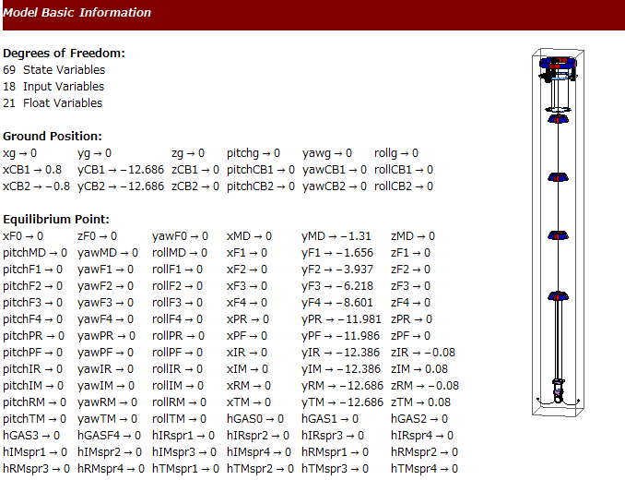

4.3. Vibration from heat links

Assume 1% coupling from vertical components.

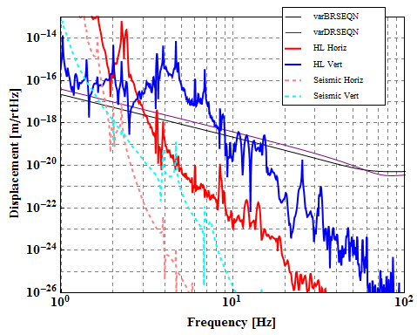

4.4. Suspension thermal noise

Assume 0.3% coupling from vertical components.

Default Loss Angle:
Sapphire fiber: 2E-7, TM Spring: 2E-7
CuBe fiber: 5E-6, IM,IR,RM Spring; 1E-5, Heat Link: ~1E-2
GAS filter: 1E-1(Q=10)

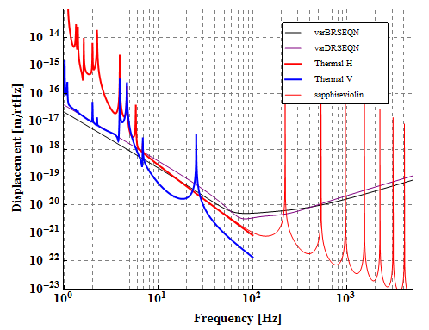

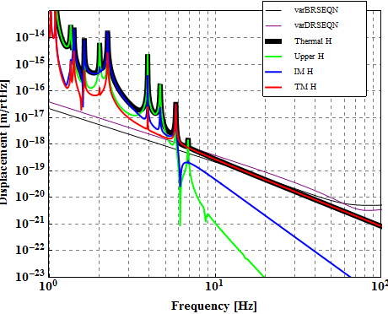
(TN_LIGOlike _default _cont _H.m)

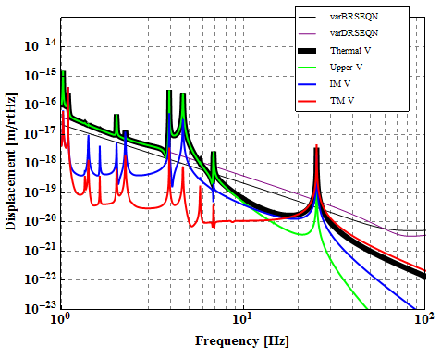
(TN_LIGOlike _default _cont _V.m)

4.9. Concerns
* Is it possible to put TM 8 cm away from center line?

5. Type-B like Model
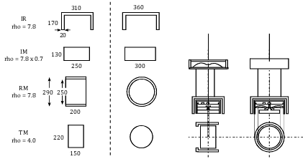

5.1. Parameters

Filter 4 (F4)
M=84.0kg, Ix=4 kgm2, Iy=6.4 kgm2, Iz=4 kgm2,
Suspended from F3 by a single wire
Wire length = 2.373 m, Material: CuBe
Upper suspension point vertical position from C.o.M. = -5 mm
Lower suspension point vertical position from C.o.M. = +5 mm
GAS resonant frequency = 0.25 Hz
(Room temperature)

Platform (PF)
M=61.5kg, Ix=2.4 kgm2, Iy=3.8 kgm2, Iz=2.4 kgm2,
Suspended from F4 by a single wire
Wire length = 3.385 m, Material: CuBe
Upper suspension point vertical position from C.o.M. = -5 mm
Lower suspension point vertical position from C.o.M. = +5 mm
GAS resonant frequency = 0.5 Hz

Intermediate Recoil Mass (IR)
M=44.9kg, Ix=0.561kgm2, Iy=0.815 kgm2, Iz=0.899 kgm2,
Suspended from PF by 3 wires with vertical springs
Wire length = 0.3 m, Material: CuBe
Upper suspension point vertical position from C.o.M. = -50 mm
Lower suspension point vertical position from C.o.M. = +50 mm
Wire horizontal distance from center = 120 mm
Spring resonant frequency = 5 Hz

Intermediate Mass (IM)
M=53.2kg, Ix=0.352kgm2, Iy=0.677 kgm2, Iz=0.474 kgm2,
Suspended from PF by a single wire
Wire length = 0.4 m, Material: CuBe
Upper suspension point vertical position from C.o.M. = -5 mm
Lower suspension point vertical position from C.o.M. = -4 mm

Recoil Mass (RM)
M=33.7kg, Ix=0.433kgm2, Iy=0.433 kgm2, Iz=0.642 kgm2,
Suspended from PF by 4 wires
Wire length = 0.3 m, Material: CuBe
Upper suspension point vertical position from C.o.M. = 0 mm
Lower suspension point vertical position from C.o.M. = 0 mm
X-separation of wire and C.o.M. = 145 mm
Z-separation of wire and C.o.M. = 25 mm
Spring resonant frequency = 5 Hz

Test Mass (TM)
M=22.7kg, Ix=0.111kgm2, Iy=0.111 kgm2, Iz=0.137 kgm2,
Suspended from PF by 4 wires
Wire length = 0.3 m, Material: Sapphire
Upper suspension point vertical position from C.o.M. = 0 mm
Lower suspension point vertical position from C.o.M. = 0 mm
X-separation of wire and C.o.M. = 110 mm
Z-separation of wire and C.o.M. = 15 mm
Spring resonant frequency = 20 Hz

Heat links Between Suspension and Cryo Bars:
Semi-elliptic, pure aluminum (6N grade), thickness=1mm
Major radius = 400 mm (X, horizontal and perpendicular to beam axis)
Minor radius = 200 mm (Y, Vertical axis)
DC spring constant per one wire:
kx=0.387 N/m, ky=0.040 N/m, kz=0.012 N/m
First violin mode: 2 Hz, second mode: 8 Hz
Attached to IR from both sides, 4 wires for each connection

5.2. Model basic information

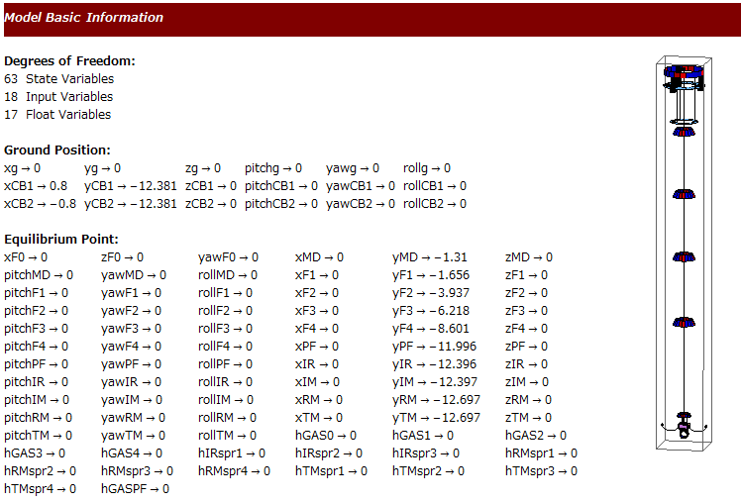

5.3. Seismic noise from heat links

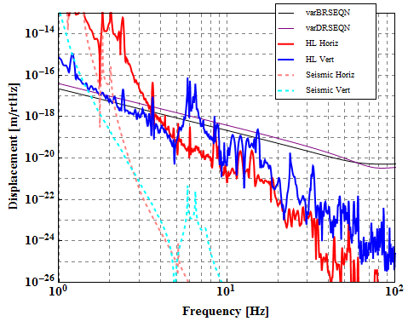

5.4. Suspension thermal noise

