Torsion Mode Damping Report
T. Sekiguchi
Torsion Mode Damping
One of the most serious concerns in the tall suspension is the excitation of the torsion modes of the wires. Single wire suspension allows a suspended filter to be isolated in all six DoFs about rigid body motions. However, a long wire suspension becomes quite soft in rotation around the vertical axis. The wire torsion modes have extremely low resonant frequencies (~10 mHz) and high Q factors therefore the decay time can be crucially long (~ hour) without damping. They are easily excited by mis-control actuation or radiation pressure of the laser, and once they are excited one has to wait until they decay to sufficiently small amplitude for interferometer lock acquisition. Damping of the torsion modes is absolutely imperative for efficient operation of the gravitational wave detector.

In TAMA-SAS, active control system using photo sensors and coil-magnet actuators were implemented for torsion mode damping [Ref.1]. This method works effectively and reduces the decay time of the torsion modes by a factor of 10 or more, while it is limited by range of photo sensors and therefore stops operating whenever large angular excursions occur. In order to avoid the above-mentioned problems, in KAGRA-SAS, the torsion modes are damped passively by using eddy current dampers. An additional filter is inserted below the top stage for the specific purpose of providing means to damp the torsional resonances. A disc with a number of permanent magnets is suspended from the top stage and produces braking torques between the damper and a conductive plate attached on the first attenuation stage (see figure 1). Although the damping torque is exerted only on the first stage, with a proper choice of wire torsional stiffness, the rotational motions of the lower stages are also damped.

The torsional stiffness of the wire of circular cross section can be calculated by the following equation:
.
G represents the shear modulus of the material of the wire, d is the diameter and L is the length of the wire. Since the torsional stiffness depends strongly on wire thickness, one can optimize the stiffness by changing wire diameters. In order to avoid the increase of bending stiffness, the wire is provided with smaller diameter necks at the both ends (Figure 1.5).

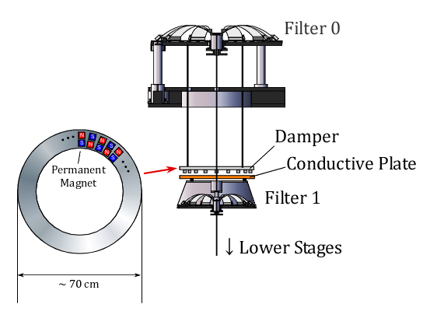
Figure 1: Conceptual design of torsion mode damper

Figure 1.5: Design of the wire with necks at the both ends

In order to demonstrate the performance of the damper, a simulation with one-dimensional pendulum model is performed. Table 1 shows the parameters used for the simulation of the Type-A SAS. The wire diameters are optimized so that all the resonant modes are coupled with the motion of the first stage so that they can be effectively damped. Figure 2 shows the calculated frequency response of the suspended payload to an external torque and figure 3 shows the impulse torque response. Table 2 shows the calculated frequencies and decay times (at which the amplitudes decreases by 1/e) of resonant modes. All the torsion modes are effectively damped and the typical decay time scale is ~1 minute, which is quite short considering that the period of the resonant modes are 10~100 sec.

 | D [mm] | L [m] | kt [Nm/rad] | I [kg m²] | γ [kg m²/sec]
Stage 1 | 3.1 | 2.27 | 0.30 | 7.4 | 2.0
Stage 2 | 3.8 | 2.27 | 0.65 | 6.8 | -
Stage 3 | 3.8 | 2.27 | 0.65 | 6.6 | -
Stage 4 | 3.8 | 1.99 | 0.68 | 6.4 | -
Stage 5 | 3.5 | 3.47 | 0.29 | 3.2 | -
Payload | 1.3 | 0.40 | 0.036 | 0.50 | -
Table 1: Parameters used for the simulation. D: wire diameter, L: wire length, kt: torsional stiffness of the wire, I: moment of inertia of the suspended mass, γ: damping coefficient

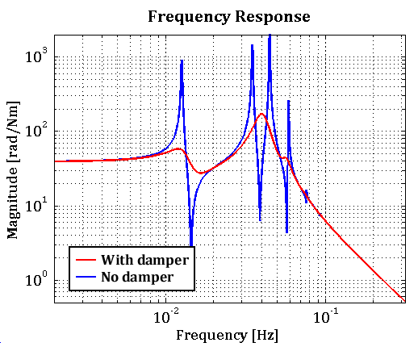
Figure 2: Frequency response of the suspended payload to an external torque.

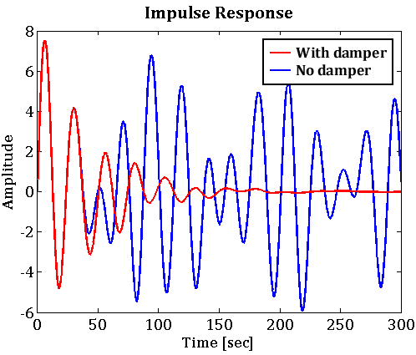
Figure 3: Impulse torque response of the suspended payload

Frequency [mHz] | Q-factor | Decay Time [sec]
12.9 | 3.1 | 76
39.8 | 3.4 | 27
40.3 | 3.8 | 30
56.4 | 7.4 | 42
73.2 | 10.1 | 44
91.8 | 7.8 | 27
Table 2: Oscillation frequencies and decay times of torsional resonant modes in the damped system

The eddy current damper affects not only on the torsion modes but also on the other pendulum modes of the chain. Figure 4 shows a simulated transfer function of the horizontal displacement from the ground to the mirror in type-A system. The Q-factors of some pendulum modes are suppressed by factors of ~10. These modes are further damped by active control system on the top stage.

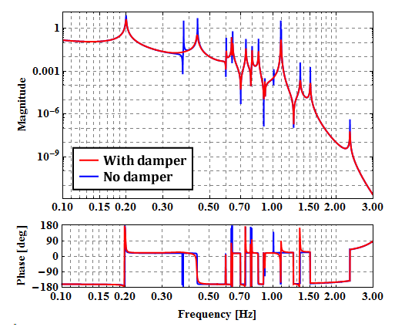
Figure 4: Transfer function from ground displacement to the mirror displacement in Type-A system

Appendix (Type-B)
In type-B1 system, the optical payload has relatively small moment of inertia. In order to make all the resonant modes couple to the damper, the torsional stiffness of the wire suspending the Intermediate Mass must be tuned quite precisely. An error of the wire diameter of just 0.1 mm makes quite large difference in decay time (Figure 4.5 & Table 2.5). In order to damp all the torsion modes, it is required to estimate the moment of inertia of each stage precisely and tune the wire thickness with respect to the estimation. If all stages have similar moment of inertia, one doesn’t need strict tuning of wire thickness, but in our case the optical payload has 10 times smaller moment of inertia than other stages and therefore one needs precision tuning of the wire thickness.

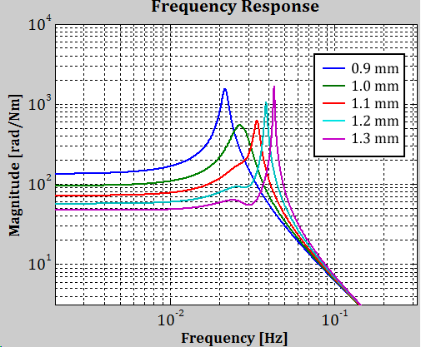
Figure 4.5: Frequency response of the suspended payload to an external torque in Type-B1 SAS with various diameters of IM suspension wire.

Wire Diameter [mm] | Decay Time [sec]
0.9 | 171
1.0 | 52
1.1 | 129
1.2 | 257
1.3 | 444
Table 2.5: Comparison of longest decay time with various IM suspension wire

Type-B1

 | D [mm] | L [m] | kt [Nm/rad] | I [kg m²] | γ [kg m²/sec]
Stage 1 | 2.3 | 1.28 | 0.16 | 7.3 | 3.0
Stage 2 | 2.0 | 0.51 | 0.21 | 6.8 | -
Payload | 1.0 | 0.58 | 0.012 | 0.42 | -
Table 3: Parameters for Type-B1 SAS

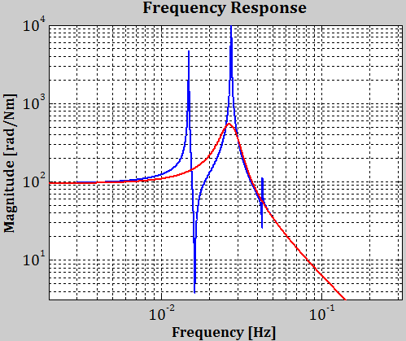
Figure 5: Frequency response of the suspended payload to an external torque in Type-B1 SAS.

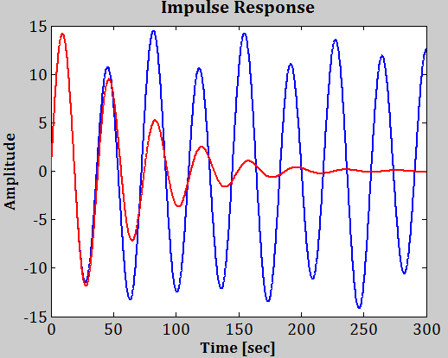
Figure 6: Impulse torque response of the suspended payload in Type-B1 SAS.

Frequency [mHz] | Q-factor | Decay Time [sec]
25.9 | 4.3 | 52
29.4 | 4.1 | 44
Table 4: Oscillation frequencies and decay times of resonant modes in Type-B1 system. The other resonant mode is critically damped.

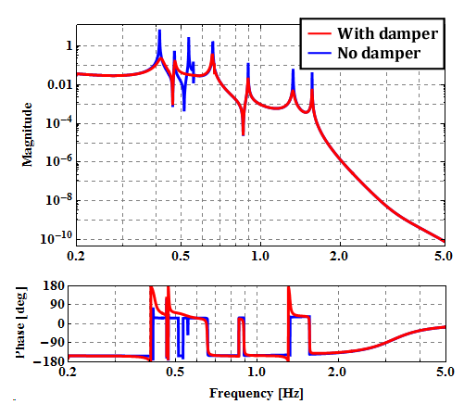
Figure 7: Transfer function from ground displacement to the mirror displacement in Type-B1 system

Type-B2

 | D [mm] | L [m] | kt [Nm/rad] | I [kg m²] | γ [kg m²/sec]
Stage 1 | 2.3 | 1.28 | 0.16 | 7.3 | 2.0
Stage 2 | 2.0 | 0.51 | 0.21 | 8.1 | -
Payload | 1.2 | 0.61 | 0.025 | 1.3 | -
Table 4: Parameters for Type-B2 SAS

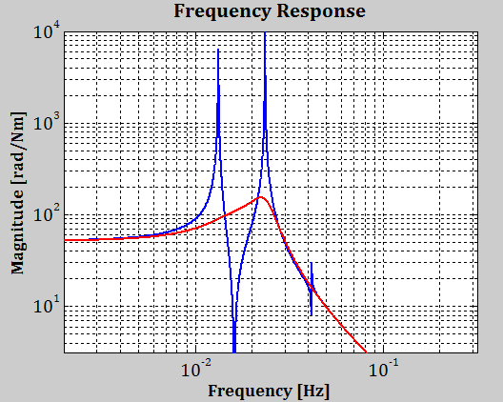
Figure 8: Frequency response of the suspended payload to an external torque in Type-B2 SAS.

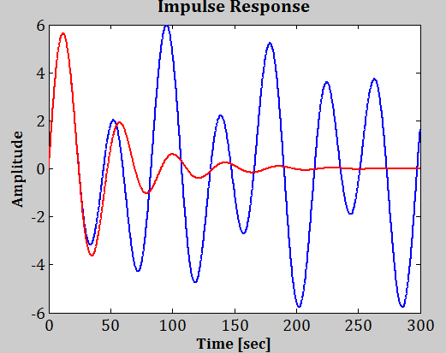
Figure 9: Impulse torque response of the suspended payload in Type-B1 SAS.

Frequency [mHz] | Q-factor | Decay Time [sec]
15.8 | 1.3 | 25
23.2 | 3.3 | 45
30.5 | 1.3 | 14
Table 5: Oscillation frequencies and decay times of resonant modes in Type-B2 system.

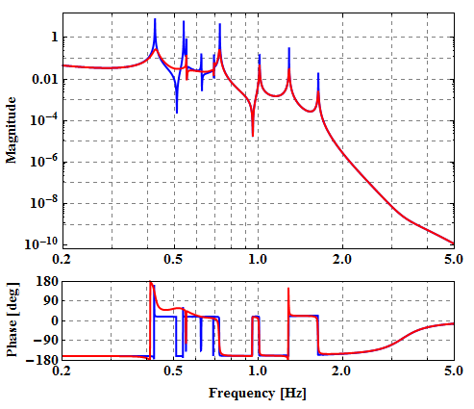
Figure 10: Transfer function from ground displacement to the mirror displacement in Type-B2 system

