Torsion Mode Damping Report
T. Sekiguchi
Torsion Mode Damping
One of the biggest concerns in the long suspension is the torsion modes of the wires. Single wire suspension allows the suspended filter to be isolated in all six DoFs about rigid body motions, while it becomes quite soft in rotation around the vertical axis. The wire torsion modes have extremely low resonant frequencies (~10 mHz) and therefore the decay time can be crucially long (~ hour) without any damping. They are easily excited by mis-control actuation or radiation pressure of the laser, and once they are excited you have to wait until they decay to small amplitude enough for interferometer lock acquisition. Damping of the torsion modes is absolutely imperative for saving operating time of the gravitational wave detector.

In TAMA-SAS, active control system using photo sensors and coil-magnet actuators are implemented for torsion mode damping [Ref.1]. It works effectively and reduces the decay time of the torsion modes by a factor of 10 or more, while it is limited by range of photo sensors and therefore stops the operation for large excursion of rotation angle. In order to avoid above-mentioned problems, in KAGRA-SAS, the torsion modes are damped passively by using eddy current dampers [Ref.2]. A disc with a number of permanent magnets is suspended from the top stage and produces braking torques between the damper and a conductive plate attached on the first attenuation stage (see figure 1). Although the damping torque is exerted only on the first stage, the rotational motions of the lower stages are also damped, if one chooses the torsional stiffness of the wires and damping strength properly.

The torsional stiffness of the wire of circular cross section can be calculated by the following equation:
.
G represents the shear modulus of the material of the wire, d is the diameter and L is the length of the wire. Since the torsional stiffness depends strongly on wire thickness, one can optimize the stiffness easily by tuning wire diameters. In order to avoid the increase of bending stiffness, the wire has necks with smaller diameters at the both ends (Figure 1.5).

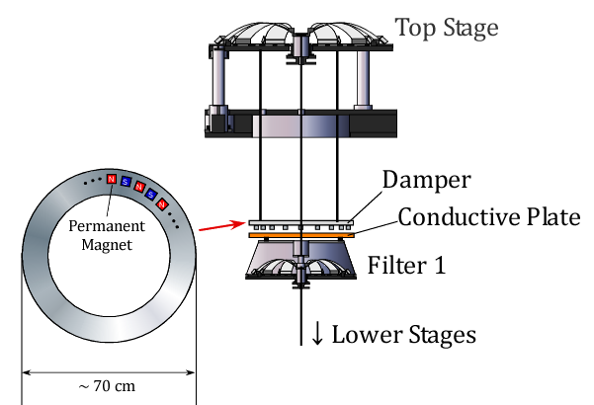
Figure 1: Conceptual design of torsion mode damper

Figure 1.5: Design of the wire with necks at the both ends

In order to demonstrate the performance of the damper, simulation with one-dimensional pendulum model is performed. Table 1 shows the parameters used for the simulation about Type-A SAS. The wire diameters are optimized so that all the resonant modes are coupled with the motion of the first stage so that they are effectively damped. Figure 2 shows the calculated frequency response of the suspended payload to an external torque and figure 3 shows the impulse torque response. Table 2 shows the calculated frequencies and decay times (at which the amplitudes decreases by 1/e) of resonant modes. All the torsion modes are effectively damped and the typical decay time scale is ~1 minute, which is quite short considering that the period of the resonant modes are 10~100 sec.

 | D [mm] | L [m] | kt [Nm/rad] | I [kg m²] | γ [kg m²/sec]
Stage 1 | 3.1 | 2.27 | 0.30 | 7.4 | 2.0
Stage 2 | 3.8 | 2.27 | 0.65 | 6.8 | -
Stage 3 | 3.8 | 2.27 | 0.65 | 6.6 | -
Stage 4 | 3.8 | 1.99 | 0.68 | 6.4 | -
Stage 5 | 3.5 | 3.47 | 0.29 | 3.2 | -
Payload | 1.3 | 0.40 | 0.036 | 0.50 | -
Table 1: Parameters used for the simulation. D: wire diameter, L: wire length, kt: torsional stiffness of the wire, I: moment of inertia of the suspended mass, γ: damping coefficient

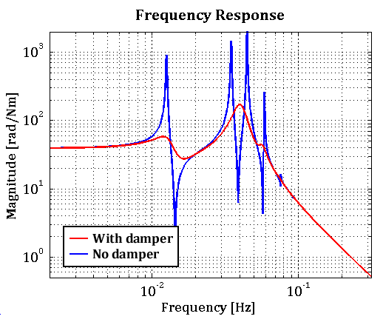
Figure 2: Frequency response of the suspended payload to an external torque.

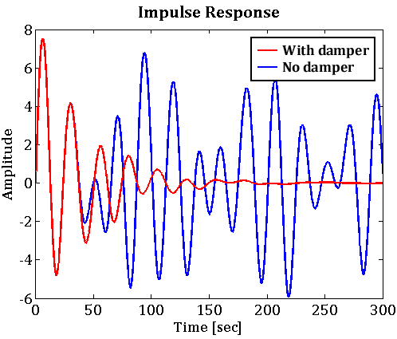
Figure 3: Impulse torque response of the suspended payload

Frequency [mHz] | Q-factor | Decay Time [sec]
12.9 | 3.1 | 76
39.8 | 3.4 | 27
40.3 | 3.8 | 30
56.4 | 7.4 | 42
73.2 | 10.1 | 44
91.8 | 7.8 | 27
Table 2: Oscillation frequencies and decay times of resonant modes in damped system

The eddy current damper affects not only on the torsion modes but also on the other modes. Figure 4 shows simulated transfer function of the horizontal displacement from the ground to the mirror in type-A system. Q-factors of some pendulum modes are suppressed by factors of ~10. These modes are further damped by active control system on the top stage.

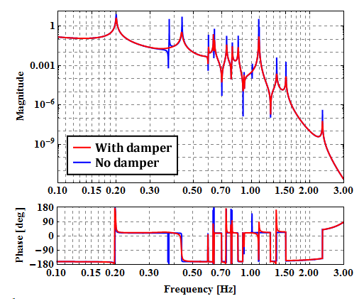
Figure 4: Transfer function from ground displacement to the mirror displacement in Type-A system

Appendix (Type-B)
In type-B1 system, the payload has relatively small moment of inertia. In order to make all the resonant modes coupled, the torsional stiffness of the wire for IM suspension must be tuned precisely. The error of the wire diameter of 0.1 mm makes quite large difference in decay time (Figure 4.5 & Table 2.5). In order to damp all the torsion modes, it is required to estimate the moment of inertia of each stage precisely and tune the wire thickness with respect to the estimation. If all stages have similar moment of inertia, one doesn’t need strict tuning of wire thickness, but in our case the payload has 10 times smaller moment of inertia than other stages and therefore one needs strict tuning for the wire thickness.

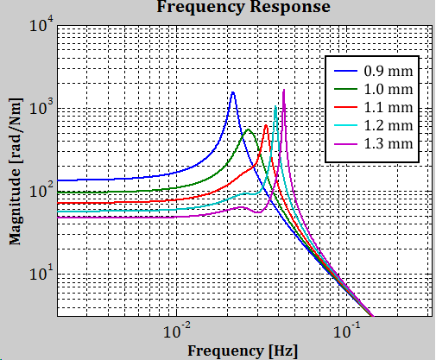
Figure 4.5: Frequency response of the suspended payload to an external torque in Type-B1 SAS with various diameters of IM suspension wire.

Wire Diameter [mm] | Frequency [mHz] | Decay Time [sec]
0.9 | 22 | 171
1.0 | 26 | 52
1.1 | 34 | 129
1.2 | 39 | 257
1.3 | 43 | 444
Table 2.5: Comparison of longest decay time with various IM suspension wire

Type-B1

 | D [mm] | L [m] | kt [Nm/rad] | I [kg m²] | γ [kg m²/sec]
Stage 1 | 2.3 | 1.28 | 0.16 | 7.3 | 3.0
Stage 2 | 2.0 | 0.51 | 0.21 | 6.8 | -
Payload | 1.0 | 0.58 | 0.012 | 0.42 | -
Table 3: Parameters for Type-B1 SAS

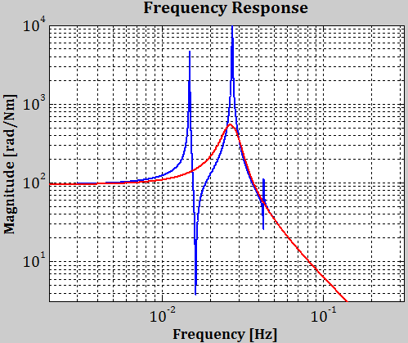
Figure 5: Frequency response of the suspended payload to an external torque in Type-B1 SAS.

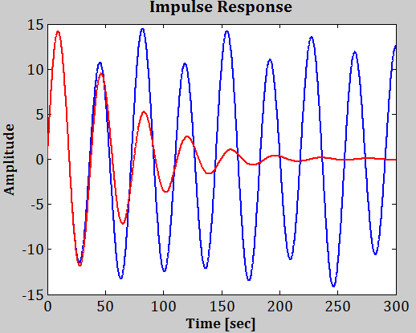
Figure 6: Impulse torque response of the suspended payload in Type-B1 SAS.

Frequency [mHz] | Q-factor | Decay Time [sec]
25.9 | 4.3 | 52
29.4 | 4.1 | 44
Table 4: Oscillation frequencies and decay times of resonant modes in Type-B1 system. The other resonant mode is critically damped.

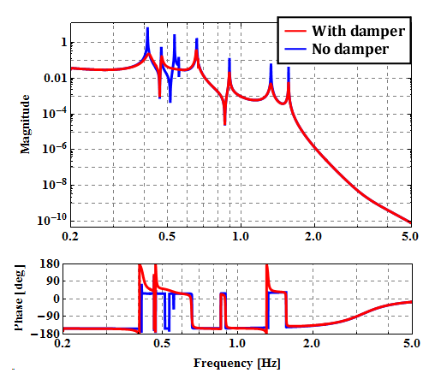
Figure 7: Transfer function from ground displacement to the mirror displacement in Type-B1 system

Type-B2

 | D [mm] | L [m] | kt [Nm/rad] | I [kg m²] | γ [kg m²/sec]
Stage 1 | 2.3 | 1.28 | 0.16 | 7.3 | 2.0
Stage 2 | 2.0 | 0.51 | 0.21 | 8.1 | -
Payload | 1.2 | 0.61 | 0.025 | 1.3 | -
Table 4: Parameters for Type-B2 SAS

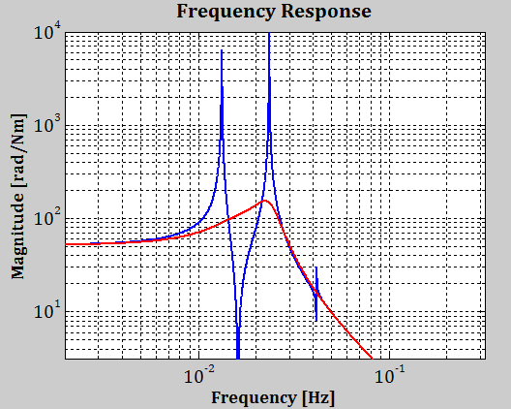
Figure 8: Frequency response of the suspended payload to an external torque in Type-B2 SAS.

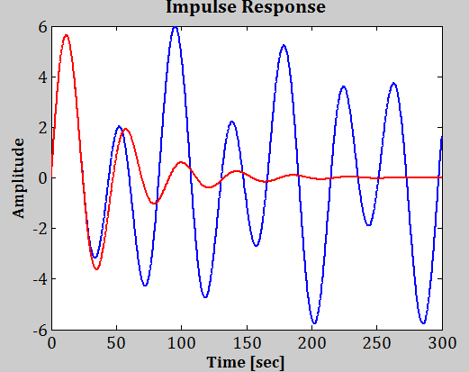
Figure 9: Impulse torque response of the suspended payload in Type-B1 SAS.

Frequency [mHz] | Q-factor | Decay Time [sec]
15.8 | 1.3 | 25
23.2 | 3.3 | 45
30.5 | 1.3 | 14
Table 5: Oscillation frequencies and decay times of resonant modes in Type-B2 system.

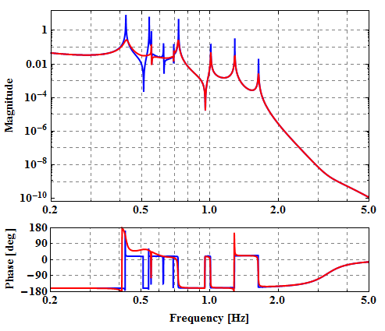
Figure 10: Transfer function from ground displacement to the mirror displacement in Type-B2 system

