KAGRA Preisolator Prototype in Kashiwa
Control Development for the Preisolation System in KAGRA
Takanori Sekiguchi

Preisolator Prototype
A prototype of the preisolator for KAGRA seismic attenuation system is manufactured and delivered to ICRR at Kashiwa. Its performance and controllability by the use of sensors and actuators are investigated.

The preisolator locates at top of the attenuation chain in KAGRA-SAS. Its role is to isolate the suspension from the microseismic vibration around 0.2-0.3 Hz and to reduce the RMS displacement and velocity of the suspended mirror. It can be achieved by supporting the top stage with inverted pendulums which are tuned at sufficiently low frequency (<100 mHz) and isolating the suspension system from microseismic vibration passively. Vertical vibration isolation is achieved by a GAS filter which is twice as large in diameter as a standard filter to be tunable at lower frequency.

The other important role of the preisolator is to control the top stage motion and damp resonant modes of the attenuation chain actively. The preisolator is equipped with two kinds of vibration sensors: LVDT and geophone. LVDTs are used for locking the top stage to the ground at low frequencies (less than 50 mHz) to prevent the top stage drifting by ground tilt and temperature change. Geophones are used to damp the resonant modes of the chain without re-introducing microseismic vibration. Since LVDTs refer to ground motion to read the displacement, active damping with LVDT will re-introduce ground vibration and spoil the performance of IP. Also geophones are superior to LVDTs in noise performance above 0.1 Hz. LVDT drivers, voice coil drivers and geophone preamplifiers used in the experiment are designed and fabricated at Nikhef.

Signal monitoring and controls are achieved by real time digital control system, which is imported from LIGO and installed by O. Miyakawa in Kashiwa laboratory as a standalone system.

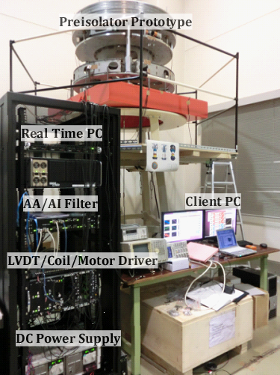
Figure 0: Outlook of the prototype for preisolator and its control system in Kashiwa Lab.

(Details of the mechanics and digital system will be described here)

IP Control
In order to design the servo filters for the IP control, a simple point-mass model is prepared. It is a double pendulum model with M1=730 kg and M2= 340kg masses. The following graph shows the simulated transfer function from actuation force on the top stage to its displacement (the left figure). The simulation result is compared with the measured TF in the right figure.

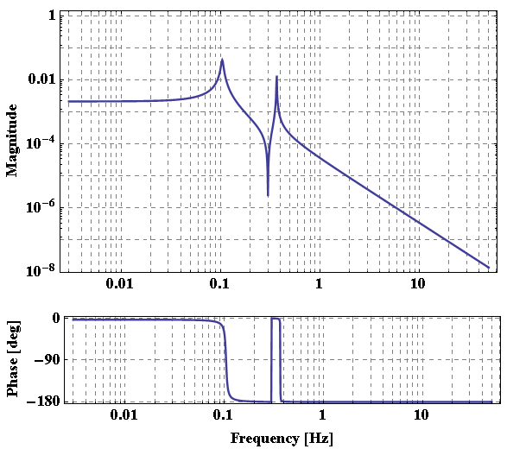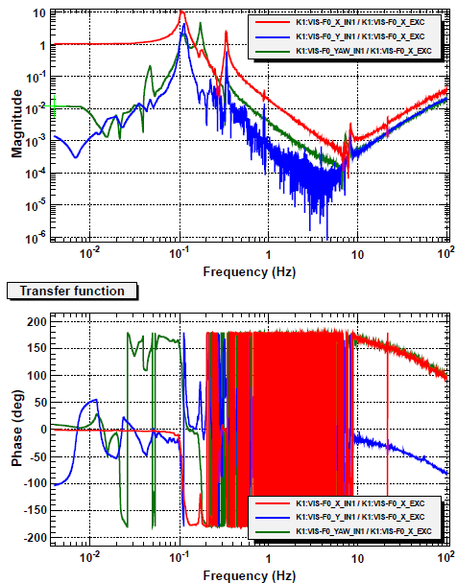
Figure 1: Transfer function from the actuation force on the top stage to its displacement. (Left) simulated transfer function. (Right) measured transfer function. The red line shows the transfer function from Fx to X and the other lines show couplings to other DoFs (Y and Θ).

This suspension model can be regarded as a linear filter in Fourier space with force inputs and displacement or velocity outputs. The displacement and velocity information is introduced to a sensing filter and sensor signals are obtained from its output. These signals are introduced to a servo filter and fed back to the suspension system as force inputs. The following figure shows a block diagram of the control system.

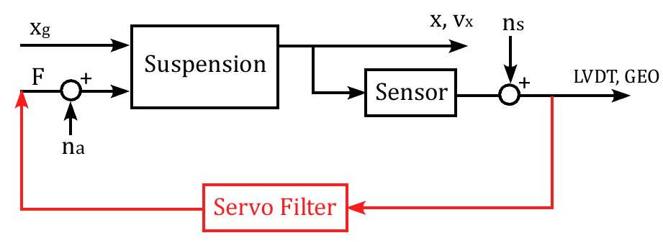
Figure 2: Block diagram of the suspension control system
In the simulation, all the linear filters are converted to state-space matrices, and the series connection of the filter and feedback connection are done by built-in functions in Mathematica (later than version 8).

LVDTs read the relative displacement between the top stage (xF0) and the ground (xg), while geophones read only the velocity of the top stage (vxF0). The detailed block diagram of the IP control is shown in the figure below.

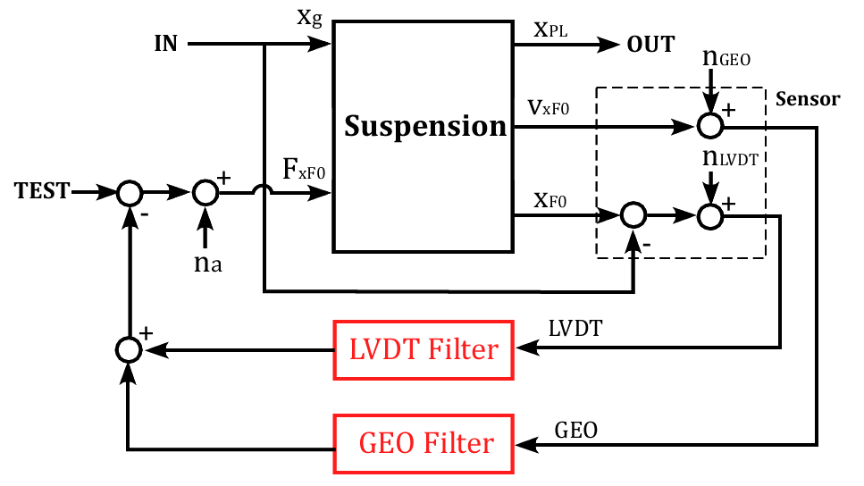
Figure 3: Detailed block diagram of the IP control

Control Filter Design
In order to damp the resonant modes of the suspension, the feedback force should be proportional to the velocity of the top stage around resonant frequencies. In order not to spoil the isolation performance of IP, it is required to achieve the damping by using inertial sensor. Therefore above 0.1 Hz the control is mainly handled by the geophone and the filter shape is designed to be a derivative filter (∝ s) with displacement input. The filter rolls off above 5 Hz to avoid noise injection and oscillation at high frequency resonances. Below 0.1 Hz, the control is mainly handled by the LVDT and the geophone control is cut off below 0.01 Hz, to avoid tilt coupling and noise injection. At the crossover frequency, the phase difference of two filters must be close to 90 degree, so the LVDT control has flat response to the displacement around 0.1 Hz. The gain of the filter is further increased below 0.01 Hz with integrator. Since LVDT control re-introduces seismic noise above the resonance of IP, it is required to roll off the filter gain steeply at high frequencies. This is achieved by adding Chebyshev filter with a cutoff frequency around 0.5 Hz. The cutoff frequency cannot be too low because it rotates the phase around the crossover frequency. Figure 4 shows the designed control filter and figure 5 shows the calculated open-loop transfer function. The unity gain frequency is ~ 1 Hz and the phase margin is ~60 degree. The crossover frequency is ~50 mHz and the phase difference is ~ 120 deg.

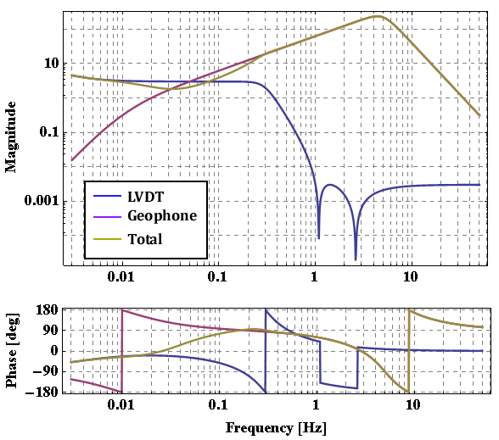
Figure 4: Control filter shape with a displacement input.

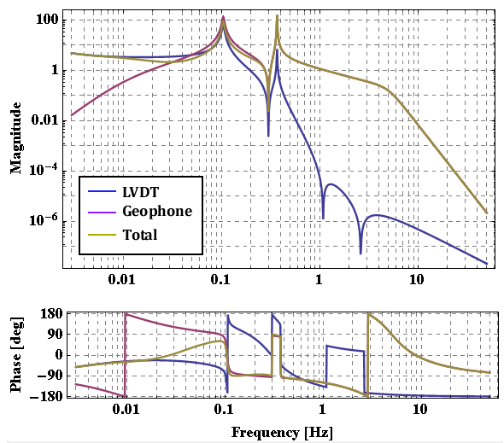
Figure 5: Calculated open-loop transfer function of the IP control

The following figure shows the calculated closed-loop transfer function, from the ground displacement to the payload displacement. The amplitude of closed-loop TF gets smaller than the original TF without control in almost whole frequency region. The small peak at 0.3 Hz is a shifted IP resonance peak introduced by the LVDT control.
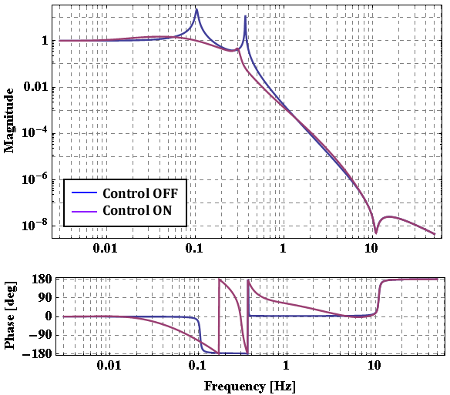
Figure 6: Calculated transfer function from ground displacement to the payload displacement

In order to see the sensor noise effects, the following seismic and sensor noises are introduced. The black curve in figure 7 shows seismic noise spectrum in Kashiwa. The red curve shows estimated noise level from the preamplifier noise, and the blue curve shows the LVDT sensor noise level with the current gain tuning (~2 V/mm). Figure 8 shows the vibration noise budget at the payload stage. It is dominated by the seismic noise all over the frequencies, while the sensor noise and actuator noise are almost negligible. The RMS velocity is reduced from 3 μm/s to 1 μm/s, but is not dramatically suppressed. This is because the RMS displacement or velocity is dominated by microseismic peak at 0.15 Hz and is not isolated by IP with relatively high resonant frequency. In order to suppress it, one needs to reduce the resonant frequency of IP.

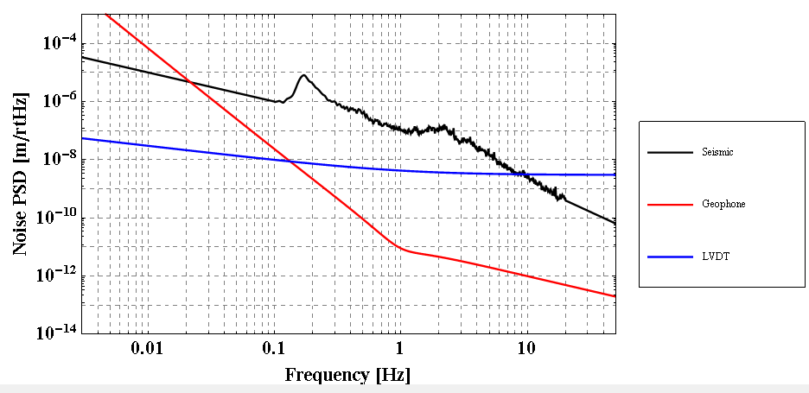
Figure 7: Model of the seismic noise in Kashiwa and sensor noise

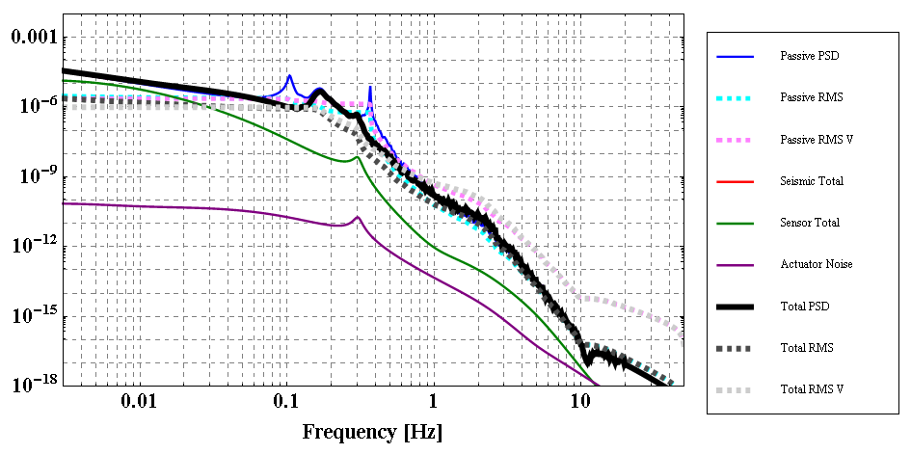
Figure8: Noise budget of the controlled preisolator prototype in Kashiwa

Ground Tilt Effect
The ground tilt affects the preisolator system in two ways. One effect is the drift of the inverted pendulum at low frequencies. The lower the resonant frequency becomes, the more sensitive the IP becomes to the ground tilt (see figure 9).

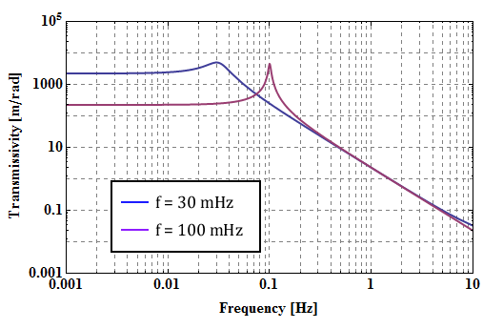
Figure 9: IP response to the ground tilt.

The other effect of the ground tilt is the coupling to geophones. Horizontal geophones are sensitive to the ground tilt and they get more sensitive at lower frequencies. So the low frequency geophone signals can be easily dominated by ground tilt, not the pure displacement of the ground. This is the reason why one would not like to use geophones for low frequency controls (<100 mHz).

The power spectrum of the ground tilt can be estimated from the ground speed and the spectrum of the vertical seismic noise. More details are written in A. Takamori’s PhD thesis. The following plot shows the estimated ground displacement and ground tilt at TAMA site. Ratio of the ground tilt and displacement is 100 ~ 1000 m/rad.

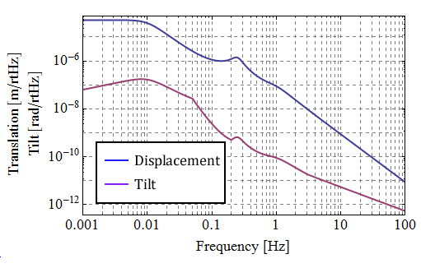
Figure 10: Estimated ground tilt and displacement at TAMA site.

If these ground displacement and tilt are measured by geophones, one obtains the following spectrum and coupling from the tilt. Below 50 mHz, the geophone signal is dominated by coupling from the tilt in this case.

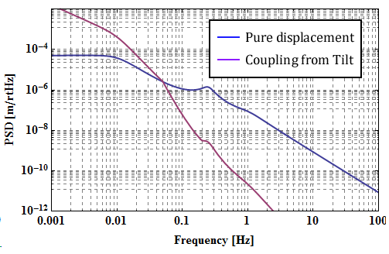
Figure 10: Predicted geophone signal and coupling from the ground tilt.

Simulation of the Preisolator in Kamioka Mine (WILL BE UPDATED)
In Kamioka, it is expected that the seismic noise is quite small and therefore the top stage motion will be dominated by the control noise. In order to investigate this, the resonant frequency of the IP is lowered to ~30 mHz and the seismic noise is replaced to that of Kamioka mine.

Figure 11 shows newly designed control filter shapes. In order not to spoil the performance of IP, the crossover frequency is further reduced to 20 mHz and LVDT control gain is steeply cut off around microseismic peak.

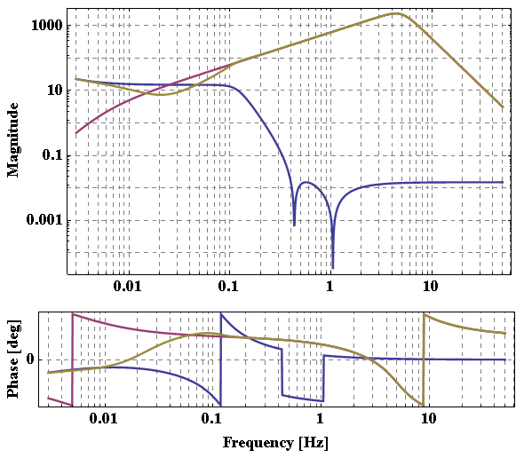
Figure 11: Control filter shape with a displacement input.

Figure 12 shows calculated transfer function from ground displacement to the payload displacement, and figure 13 shows the noise budget in the controlled system. The payload vibration is dominated by geophone noise, and RMS displacement and velocity gets even worse below 50 mHz. In order to avoid large drift due to the control, one needs to decrease the gain at low frequencies. This will be simulated soon.
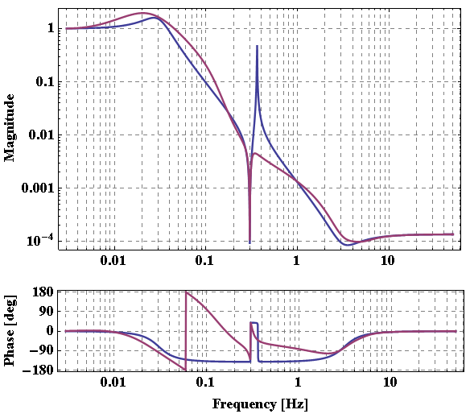
Figure 12: Control filter shape with a displacement input.

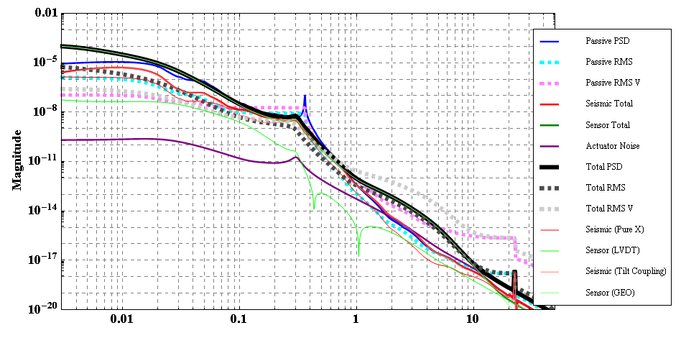
Figure 13: Control filter shape with a displacement input.

