Geophone Noise Investigation

Takanori Sekiguchi
January 18, 2013

Introduction
Better understanding of the noise behavior of a geophone is required for us, since we think of using geophones for the SAS controls in KAGRA. Although the geophone itself has a good noise performance, the noise level is easily enhanced by electrical devices for data acquisition system, like pre-amps and ADC. So we are interested in the noise behavior of geophones with the combination of such electric devices.

The self-noise of a geophone and pre-amp (designed in Nikhef) combination has been investigated by M. Beker in Nikhef, by the use of three channel correlation analysis, but the measurement was often disturbed by large seismic noise injection and it was difficult to subtract true instrumental noise from such large signals.

So now our strategy is to use controlled EIB-SAS in the clean room at Nikhef to measure the self-noise of seismic sensors. It can passively attenuate the seismic noise by a factor of 10-100, at the frequencies of 1-10 Hz, and the attenuation factor would be possibly enhanced by active control with geophones and LVDTs on the bench.

This report is intended to show the basic idea of three channel correlation analysis, expected noise behavior of a seismic sensor, results from the self-noise measurement of instruments on the ground and the EIB-SAS and the discussion with them. The measurement shown here is done during my stay in Nikhef from Jan. 7 to Mar. 23 in 2013.

Three channel correlation analysis
The instrumental noise of a seismic sensor can be measured by a so-called three channel correlation analysis [Sleeman et al. 2006]. Assume the output of each sensor is given by
,
where Y_{i}, X and N_{i} are the Fourier transforms of the output from i-th channel, the common input (like seismic noise) and the instrumental noise of i-th sensor. The cross power spectra between channels i and j can be written as
P_{xx} is the auto power spectrum of the input signal x, H_{i} is the transfer function of i-th instrument and N_{ij} is the cross power spectrum of the noise. It is assumed that the common input and the instrumental noises are uncorrelated, thence N_{ij} is assumed to be 0 for i≠j. From these assumptions, it can be shown that the noise of each instrument is given by
.
The second term of the right hand side is called estimator, which estimates the output from i-th channel in the case where there is only a common input, without any noise. The key feature of this analysis is that we can measure the instrumental noise even without knowing the transfer function of each sensor.

Geophone Noise Model
The noise sources of Geophones were investigated by [Rodgers 1992]. The self-noise of a geophone and its pre-amplifier, in terms of the noise at the input of the geophone (seismic motion), can be described by
[(m/sec²)²/Hz].
Here E_{nn} is the power spectrum density of the total electronic noise, S_{nn} is the suspension thermal noise and H(ω) is the geophone transfer function. More specifically, each noise component is written as
Here V_{nn}/I_{nn} is the op-amp input voltage/current noise and R is the parallel combination of the geophone coil resistance r_{c} and the readout resistance r_{d}. Z(ω) is the additional impedance of the coil due to the back-action effect of the oscillator inside a geophone. M, η and ω₀ are the mass, damping ratio, natural angular frequency of the oscillator. We use CS3002 op-amp and the nominal values of the input voltage and current noise are:
Note that the current noise is not given by the manufacturer and the value here is only the guess from other measurements. Figure 1 shows expected noise curves with an L-4C geophone, in terms of input voltage noise (T_{nn} means the total noise level). Since an L-4C seismometer has relatively high resistance value of the coil (5.5 kΩ), the sensitivity is mainly limited by the op-amp current noise at low frequencies.

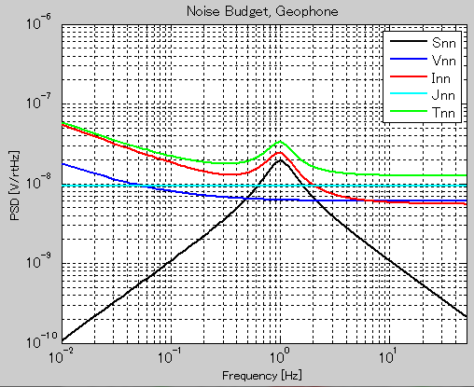
Figure 1: Noise estimation with an L-4C geophone. (Snn = suspension thermal noise, Vnn = op-amp voltage noise, Inn = op-amp current noise, Jnn = Johnson noise of the coil and readout resistor, Tnn = total noise)

Pre-amp Noise Measurement
Since we expect the noise of a geophone mainly limited by electronic noise, firstly the noise performance of the pre-amp is investigated. The input of the pre-amp is shorted by a 2.2 kΩ (= resistance value of an L-22E geophone coil) resistor and the resulting voltage is obtained by Virgo data acquisition system (1 kHz sampling rate). The amplification factor of the pre-amp is ~1830.

Without connection to a geophone, there is no suspension thermal noise or impedance increase due to back-action effect of an oscillator. Thence expected noise curves are shown in Figure 2.

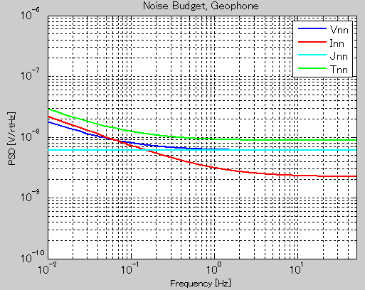
Figure 2: Noise estimation of the pre-amp (shorted by a 2.2 kΩ resistance)

Figure 3 shows the measured noise level of a pre-amp, in terms of input voltage, and Figure 4 shows the equivalent noise level in terms of input seismic acceleration, in case we connect the pre-amp to an L-22E geophone. The estimated noise level from 3-ch correlation is almost same as the auto-power spectrum; because we expect no common input seismic noise (while there might be common signal from an external electric field effect, which might explain increase of the estimator below 20 mHz).

The measured noise curve fits very well to the prediction. The difference in low frequencies would come from underestimation of the op-amp current noise, or surrounding electric field noise.

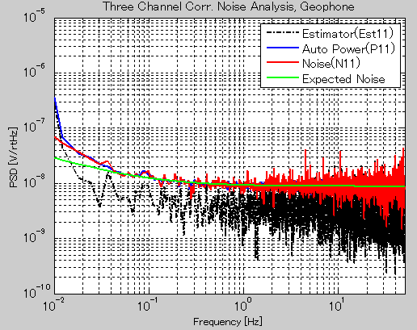
Figure 3: Comparison with the measured noise of the preamp (Red Curve) and the expected noise (Light Green Curve).

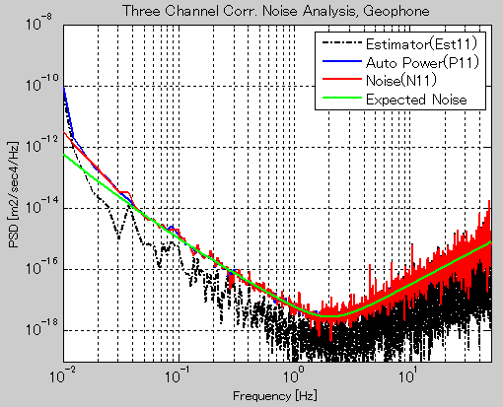
Figure 4: The preamp noise level in terms of input seismic acceleration (with the parameters of L-22E seismometer)

Geophone Noise Measurement on the Ground (Horizontal)
The preamps are then connected to horizontal L22E geophones. The geophones are put on the ground in the same direction so that they are exposed to same seismic excitation.

Figure 5 shows the measured power spectrum of the signal and noise. The estimator curve (black dash-dot curve) is almost overlapped with the auto-power spectrum curve of the signal (blue solid curve). The 3-ch correlation analysis rejects the common seismic excitation by 4 orders of magnitude at most in power (2 orders of magnitude in amplitude). However, the estimated noise curve is still 2-3 orders of magnitude above the prediction.

A mysterious thing is that the common signal rejection ratio decreases below 0.1 Hz, and even with smaller signal the estimate noise curve does not reach the expectation. I guess that there are two common signal injections: pure translation and the tilt of the ground. The 3-ch correlation analysis is intended to reject only one common injection so that either of the two signals will remain after the subtraction by 3-ch correlation.

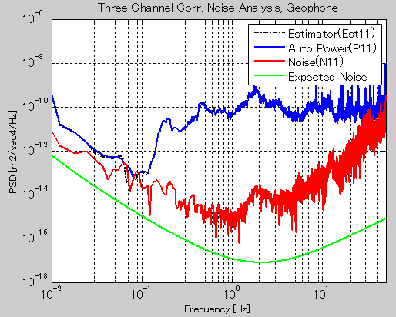
Figure 5: The preamp noise level in terms of input seismic acceleration (with the parameters of L-22E seismometer)

Geophone Noise Measurement on Uncontrolled EIB-SAS (Horizontal)
The power supply and data sending lines are then connected to the geophones on the EIB-SAS (Figure 6). Three vertical geophones (L22E) and three horizontal geophones (L4C) are installed on the bench, but the data can be taken only three channels at the same time because at the moment we have only three cables and connectors. Firstly they are connected to horizontal geophones.

In order to see the passive attenuation performance of EIB-SAS, the signals from the geophone on EIB-SAS and on the ground are compared in Figure 7. The vibration is attenuated by a factor of 10-100 at the frequency of 1-10 Hz, while the vibration increases out of the frequency band. The enhancement at low frequencies would come from the tilt of the bench, which is excited by air flows or thermal expansion. Above 10 Hz, there are direct transmission of acoustic vibration, and resonant peaks of the bench.

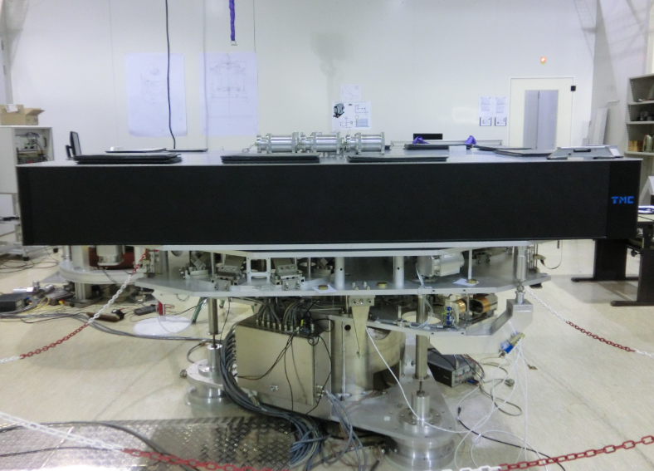
Figure 6: EIB-SAS in the clean room at Nikhef.

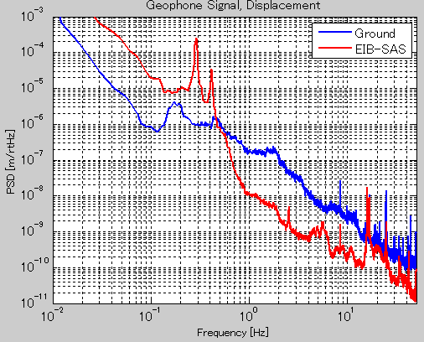
Figure 7: Measured spectra of the motion displacement of the ground and the bench on EIB-SAS

The result from 3-ch correlation analysis is shown in Figure 8. In the broad frequency band, the signal of the seismic motion is rejected by 3-4 orders of magnitude in power, but the measured noise curve is still above the prediction. It is interesting to see that the resonant peaks shown in the signal and in the estimated noise have different frequencies. It means that there are some couplings from other DoFs and they are not rejected by the analysis.

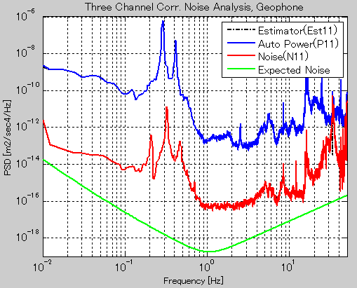
Figure 8: Measured signal and noise power spectrum of the horizontal L-4C geophone on uncontrolled EIB-SAS.

Geophone Noise Measurement on Damped EIB-SAS (Horizontal)
We test the measurement on active controlled EIB-SAS with simple viscous damping filter. Figure 9 shows the measurement result. The peaks disappear around 0.1-1 Hz, but the measured noise level is still far away from prediction. We would need to actively suppress the vibration of the bench, by the use of geophones in EIB-SAS.

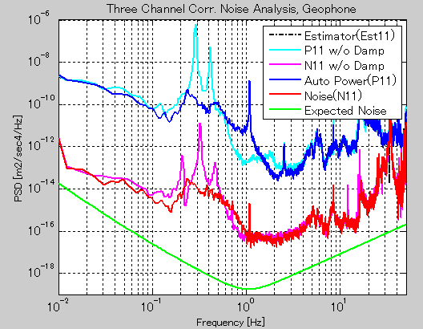
Figure 9: Measured signal and noise power spectrum of the horizontal L-4C geophone on damped EIB-SAS (compared with the measurement without any damping).

Geophone Noise Measurement on Uncontrolled EIB-SAS (Vertical)
Since L4C is more sensitive than L22E, it is more difficult to reach the target noise level. So we switch the measurement from horizontal L4C to vertical L22E. Figure 10 shows the measurement result. The estimated noise curve fits to the expectation below 0.1 Hz, and gets closer to the prediction above 1 Hz (but still ~1 order of magnitude above). The large measured noise at 0.1-1 Hz is surely due to the coupling from the pitch motion of the bench, which is unavoidable because we cannot place the geophones in the same place.

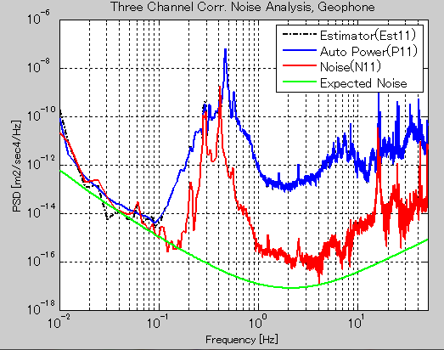
Figure 10: Measured signal and noise power spectrum of the vertical L-22E geophone on uncontrolled EIB-SAS.

Geophone Noise Measurement on Fully Controlled EIB-SAS
will be performed in the next week.

Appendix A: Sensitivity of Geophone
The sensitivity of the geophone to the ground acceleration can be written as
.
Here ω₀ is the resonant angular frequency of the oscillator, η is the damping ratio and G_{e} is the effective sensitivity of the geophone, which is specifically described as
.
G is the generator constant of the coil inside, or the intrinsic sensitivity of a geophone.

Appendix B: Geophone Nominal Parameters

L-4C
f0 = 1.0; % Resonant frequency
G = 276.8; % Generator constant
damp = 0.28; % Damping ratio
M = 0.963; % Oscillator mass
rc = 5500; % Coil resistance

L-22E
f0geo = 2.0; % Resonant frequency
G = 98.4; % Generator constant
damp = 0.7; % Damping ratio
M = 0.073; % Oscillator mass
rc = 2200; % Coil resistance

