Thermoelastic damping for a ribbon: 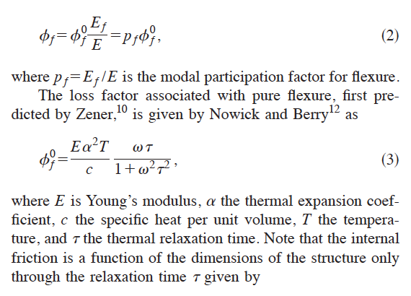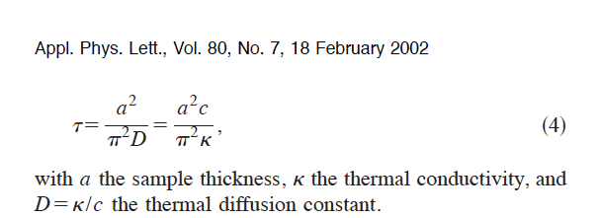

Young's modulus 130-188 GPa

Thermal expansion (25 °C) 2.6 µm·m−1·K−1

Molar heat capacity 19.789 J·mol−1·K−1

Standard atomic weight 28.0855(3) g mol-1

Calculated Specific heath capacity per unit mass c 704.6 **J·K−1 kg-1**

Density (near r.t.) 2329 kg·m−3

Calculated Specific heath capacity per unit volume 1.6410134 106 J·K−1 m−3

Thermal conductivity 149 W·m−1·K−1

a = 5.2 10-5 m

a = 9.2 10-5 m

Evaluation of thermoelastic damping for Chao’s cantilevers,

please cross check for accuracy, I always make mistakes in my formulas

Thin cantilever:

 = E [130-188] 109 **N/m2** 2 2.62 10-12**(m·m−1·K−1)2** 300 **oK**  **s-1**  **s /**

c 1.6410134 106 **J·K−1 m−3** (1+2 **s-2** 2 **s2** )

⧫ = a2 **m2** 704.6 **J·K−1 kg-1 / (**π2 149) **W·m−1·K−1**

a=5.2 10-5 m

⧫ = 1.295 10-9 **m2 kg-1**

 = 2.545 10-13  **/** (1+2 1.295 10-9 )2)



**For 59 Hz a loss angle of 0.945 10-6 is predicted**

**a loss angle of 1.3 10-6 is measured**

**subtracting the 0.3 10-6 loss estimated from the residual air gives 1. 10-6**

Thick cantilever:

a=9.2 10-5 m

⧫ = 4.05 10-9 **m2 kg-1**

 = 7.959 10-13  **/** (1+2 4.05 10-9 )2)



**For 103 Hz a loss angle of 5.15 10-6 is predicted**

**a loss angle of 4.3 10-6 is measured**

**subtracting the 0.3 10-6 loss estimated from the residual air gives 4. 10-6**

Notes:

An average Young’s modulus was used, not knowing the orientation of the crystal in the diving board. Depending on the orientation, the calculated thermoelastic loss can be either 18% higher or lower, thus bracketing the measured values. It seems that the measured losses are in agreement with the thermoelastic dissipation better than it can be hoped, and that the mechanical losses are nowhere to be seen.

Details and more measurements with silicon aligned both ways to follow.

Measurements with loaded cantilevers for measurement of Q vs. frequency to follow.

**Evaluation for a 100 µm flexure, Q-factor of a ribbon, at room temperature, before dilution.**

a= 10-4 m

⧫ = 4.479 10-9 **m2 kg-1**

 = 9.41 10-13  **/** (1+2 4.479 10-9 )2)



Notes:

The thermoelastic noise will obviously disappear at cryogenics.

Alessandro organizing meetings with silicon manufacturing companies in Holland for my visit, and procuring samples for tests.