Design of the mirror wiring jig, it will evolve into an assembly manual.
The magnet and wire breaker gluing jig are developed and described separately.
The design of the structure to string the wires around the mirrors and recoil mass is shown in figure 1. The winch-box is mounted above the intermediate mass (which at this point of assembly is still without its recoil mass).
The mirror, which has already its magnets and wire breakers glued in place, is supported on a stand sliding below the intermediate mass.
Details of the winch box are shown in figure 2. Details of the winch unit are shown in figure 3, each winch unit has two independent winches for the forward and back wires.
Figure 1, Wiring structure, mirror, mirror recoil mass, intermediate mass and winch box.
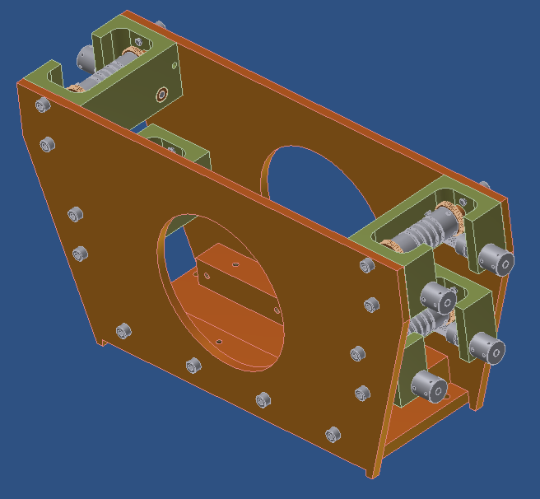
Figure 2 Winch box for the recycler mirrors.

Mirror and recoil mass assembly sequence.

- The mirror is positioned first, its two wires wrapped around it, wrapped to the drum of the lower winches.
- The winch drum has grooves used to roughly align the wires above one clamp or the other.
- The winch are positioned so that the wires hang down slightly outside their intended final position, so that they are transversally positioned by a small notch at the upper surface of the locking pad of the weight holding clamp.
- The wires are fed through both the middle (mirror weight holding clamp) and lower (positioning) wire clamps, around the mirror and back to the opposite winches. All four wire clamps are kept loose.
- The wires holding the mirror are pulled to pick the weight load.
- The stand supporting the mirror is lowered by means of the three screws and extracted.
- The mirror is aligned by means of laser optical levers and optical survey tools.
- The middle clamp is locked to hold the mirror weight.
- The bottom clamp is closed to contact by hand for transversal positioning, but not tightened.
- The recoil mass barrel (with OSEMs) is pushed forward and positioned (Figure 4).
- The recoil mass front plate is bolted on the recoil mass barrel.
- The recoil mass wires are fed through the top clamp, the bottom clamp (which is further loosened and then closed back to contact), around the recoil mass, up through the other two clamps on the other side.
- The secondary wire clamps on the recoil mass are mounted and left in contact for transversal positioning, but otherwise loose.
- The wire ends are attached to the four winches.
- The winches are pulled to pick up the weight.
- The stand supporting the recoil mass is lowered by means of the three screws and extracted.
- The recoil mass is aligned with respect with the hanging mirror.
- The top clamp is locked to hold the recoil mass weight.
- The bottom clamp is locked.
- The secondary wire clamps on the recoil mass are locked
- The magnetic whip is mounted.
- The OSEMs are wired all the way to the intermediate mass, and their signal is nulled.
- Final alignment cross check is performed.
- The wires are cut and the winch box removed.
- The mirror is immobilized inside the recoil mass by means of the locking screws.
- The two transport brackets are bolted to the bottom of the recoil mass, then they are bolted to the side of the whip pad stand on the recoil mass.
- The unit is ready for assembly of the intermediate recoil mass.
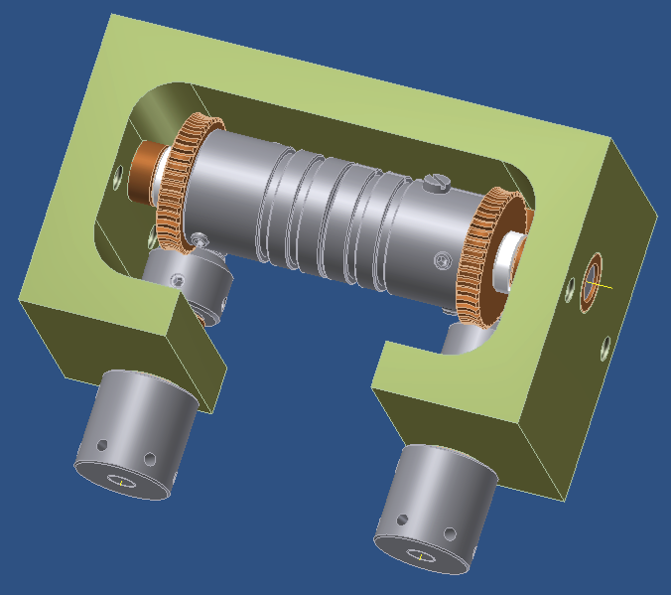
Figure 3. Winch details; each unit contains 2 independent winches. The drum of each winch has two slots, which can be used to wrap wire either for the mirror or for its recoil mass. The wires are fastened to the drum with a screw.

Figure 4, the recoil mass is pushed forward, around the mirror.

Remember to do.
Make 10 cm space between top of intermediate mass and lower winches, as well as between lower and higher winches, to insert hands.
Move the winches one more mm out to engage positioning notches.

