Visiting GT Crystal Systems

Eiichi Hirose
Oct 4, 2011

Summary:
After LSC-VIRGO meeting at Gainesville, FL, I flew to Boston and visited GT Crystal Systems (formally known as Crystal Systems Inc., now subsidiary of GT Advanced Technologies). I met Bill Ripley, Dave Joyce, and a couple of persons who recently joined the company. Absorption recently measured in PSC, University of Tokyo varies from sample to sample, and they were very interested in the results since they are now able to trace back to check how those samples were made. According to Bill, an A-axis sapphire window we ordered a few months ago will be delivered next February or March, and maximum size of C-axis sapphire window they can supply will be 200 mm in diameter. The size is smaller than 220 mm, which LCGT community thought was supposed to be supplied by the company.

GT Crystal Systems
It is located in Salem, MA. The city is beautiful and famous for Salem Witch Trials. They are recently purchased by GT Advanced Technologies, and they just launched a brand-new office and factory in building 2. (Office in building 1 is now empty)
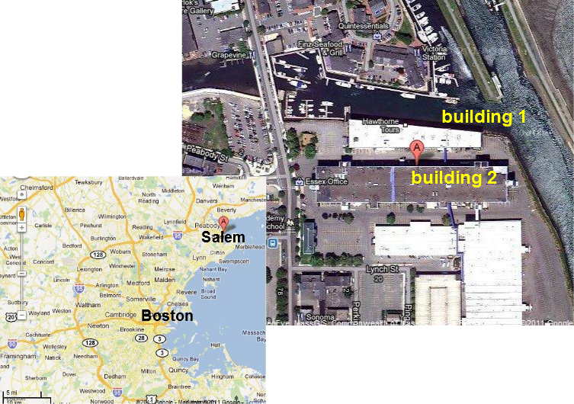
Fig. 1: Google map of the company’s location

It seems the company is doing very well mainly selling furnaces for LED applications, supplying LED sapphires. Bill said they made a billion dollars in the last six months.
There are about 60 furnaces making LED sapphire 24/7. They are pretty much automated except when starting/ending the process. Someone needs setting up something before the process starts, and picking up the boule after the process ends. Bill said those two are only timings when the furnaces are taken care of by human being. Unfortunately, no picture was allowed. The view was impressive. I did not see anyone when Bill brought me there, since what is happening can be monitored remotely. The detailed company profile will be found in their website. (http://www.gtat.com/), but David Joyce outlined the history. Crystal Systems Inc. (CSI) for which they used to work was bought by GT Solar, and GT Solar recently changed their name to GT Advanced Technologies. Currently, they make money out of selling furnaces to all over the world, and the rest is mostly from supplying LED sapphires. Yet, they are up for developing more advanced technologies for the future needs, such as very-low-absorption sapphire. They currently focus on LED, solar, and general optics.

Absorption measurement of C-axis samples
I presented results of absorption measurement recently done at PSC, University of Tokyo. The slide will be found in the following place.
http://gwdoc.icrr.u-tokyo.ac.jp/DocDB/0006/G1100626/001/GTAT_2011Sep30_hirose.pdf . The samples are all C-axis, 10mm in diameter, and 40mm long from three different furnaces. The results show some variations from sample to sample. David and Bill said the data were very useful and they would trace back to check how each sample was made. Our concern is that even in a same furnace there exists a certain variation.

Estimation of delivery date of an A-axis sapphire
It takes 4-6 weeks for allocation, and they may complete the process before Christmas. Bill gave me a rough estimation that they would deliver our A-axis sapphire (a window whose diameter/thickness is 250mm/150mm) sometime in next February or March.

Maximum size of C-axis sapphire
They told me the maximum size of C-axis sapphire window would me 200mm in diameter, but it is different from information LCGT gained in August, through New Metals & Chemicals Corporation, a representative in Japan.

To-do list
- Check the maximum size of C-axis sapphire. We already asked which (200mm dia. or 220mm dia.), and are waiting for their response.
- Need to determine specifications as soon as possible
Since we have never provided them with detailed specifications including polishing/coating, they are a little concerned about what are followed by their making sapphire. For, they know it takes a lot of time to figure out what is needed to satisfy them. Considering the LCGT’s schedule, they think we have to have the specifications right now and start talking to polishers/coaters.
- Need to start talking to polishers/coaters
They might be able to help us finding them, but again to do that we need to have specifications in hand. They also pointed out we should talk to LIGO people who have experience in sapphire.

