LCGT filter zero general description

Gianni Gennaro, Riccardo DeSalvo

The top filter of the LCGT chain is built to fit inside a 1500 mm diameter vacuum chamber; it is twice as large in diameter as the standard filter to allow for more load, mount over an inverted pendulum horizontal movement and to be tunable at lower frequencies than the standard filter to serve as lower frequency attenuation stage.

In addition a larger filter allows sufficient space for the horizontal sensors and actuators for the Inverted pendulum, and for the attachment of the isolation chain yaw Eddy current damping system.

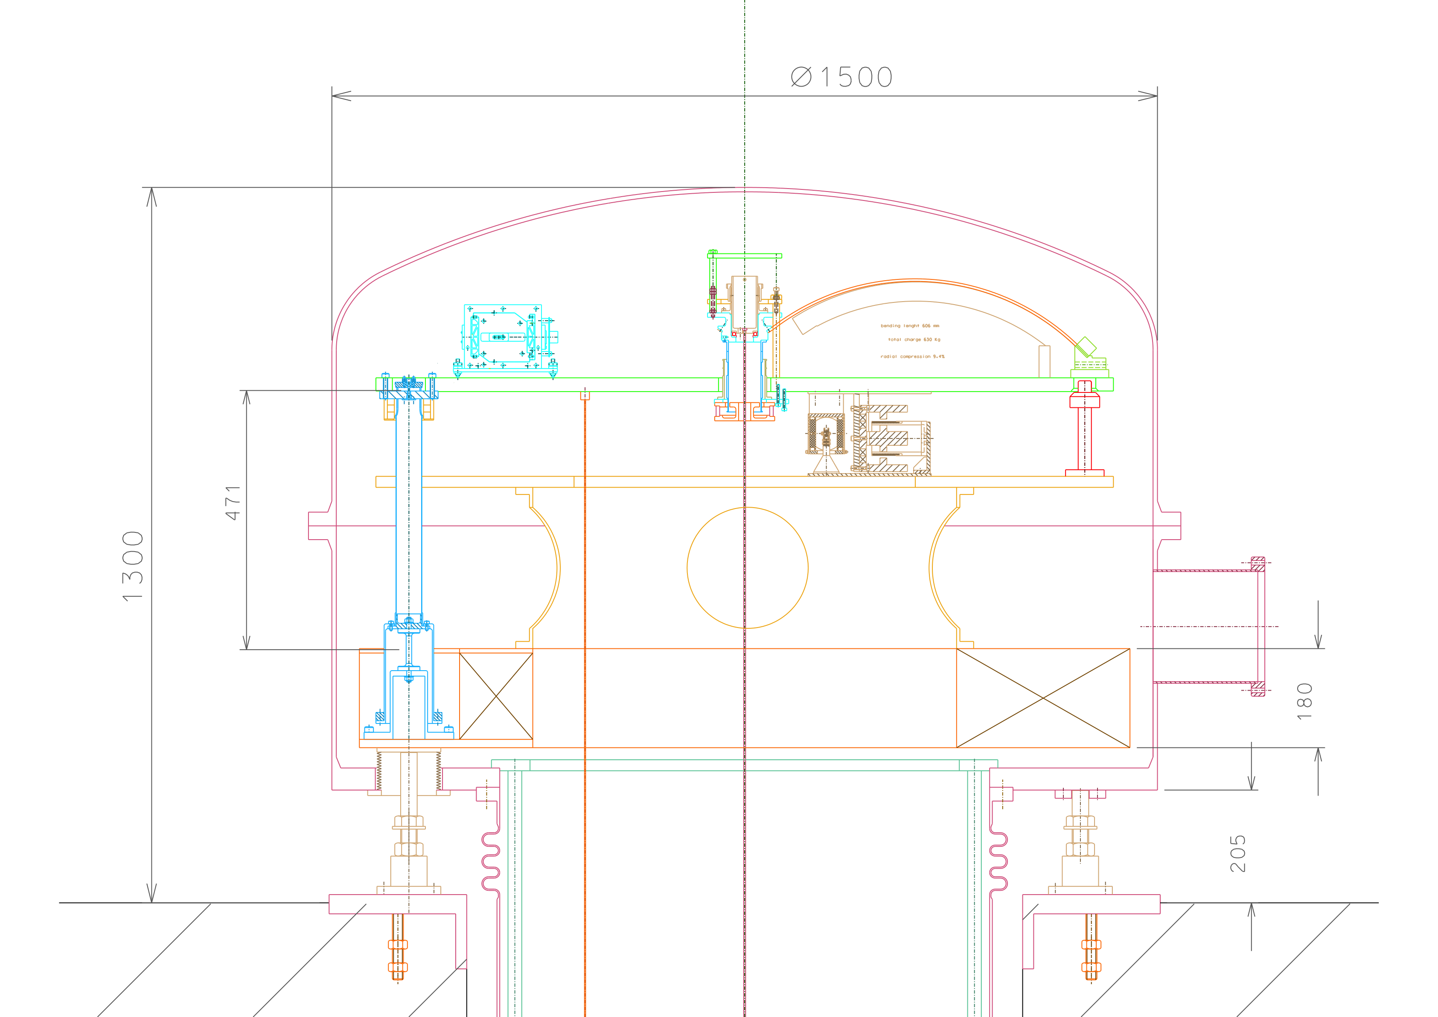

Figure 1: Schematics of filter zero inside a vacuum chamber.

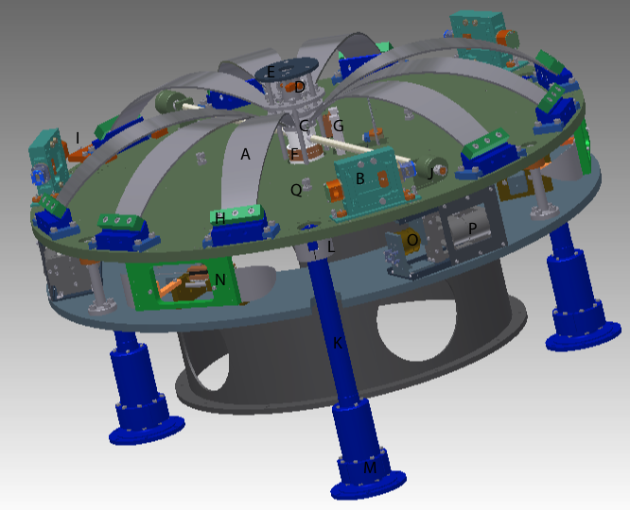

Figure 2: Three-D figure of the filter zero.

Filter zero can mount up to 12 blades (A), less than 9 are necessary to suspend the required load. Three blades are removed to make space for three horizontal accelerometers (B). The Blades join on a central Keystone (C). A picomotor controlled rotation mechanism (D) allow the rotation of the suspension wire for fine tuning of the chain and payload yaw. A platform (E) is mounted above the keystone for an optional vertical accelerometer. A coaxial LVDT and a voice coil actuator (F) are mounted below the keystone, acting against the filter baseplate. A stepper motor actuated tuning spring (G) allows fine tuning of the filter vertical working point. The blades are mounted on sliding clamps (H) that allow tuning of the filter resonant frequency, by means of a special tool (I). Two “magic wand” counterweights (J) null the center of percussion effect of the blades. The filter baseplate sits on three Inverted pendulum legs (K) provided with magnetic dampers (L) for their internal resonances, and counterweights (M) for center of percussion compensation. Three stepper motor driven horizontal springs (N), as well as three LVDT position sensors (O) and three voice coil actuators (P), all mounted tangentially at the periphery of the baseplate, control the degrees of freedom of the table. Inside of the baseplate three hooking points (Q) support the wires of a magnetic damping platform for the rigid body modes of the first standard filter and of the entire attenuation chain. A number of threaded holes are foreseen for cables.

The blades used in filter zero are scaled up versions of those used in the standard filter. If the thickness and length are scaled by the same factor using the same profile, the same stress level in the material would be maintained. Simply scaling up the blades of filter zero would require blades 6 mm thick. Each would be carrying 158 kg. Only 5 mm thick maraging is readily available, for a load of 73 kg per blade, which over 9 blades 120 mm wide at the base makes 657 kg. The width of the blades is not scaled up because there is no need to carry so much load. Profile style C is tentatively retained, the definitive choice between style A, B, or C will be made after tests with the standard filter prototype presently in production with all three choices of blades.

The nominal load per blade (adjustable by tuning the width of some of the blades) is 73 kg per blade, which means that only 9 of the 12 blades need to be implemented in the filter.

Besides the dimensions, the main differences of filter zero from the standard filter are the lack of the external shell, the presence of an angular tuning mechanism on the keystone, used to tune mirror yaw by rotating the entire attenuation chain from its top, and the space to introduce a platform above the keystone to mount a vertical accelerometer, if a suitably sensitive one will be developed.

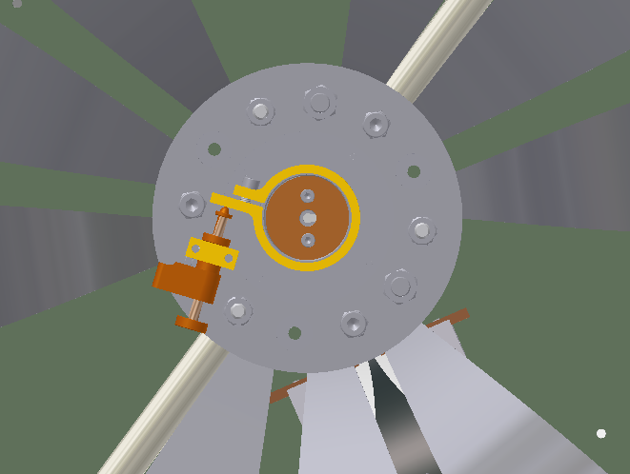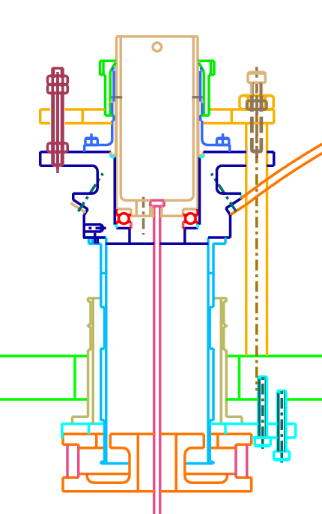

Figure 2: Schematic view of the rotational mechanics in the keystone of filter zero.

A picomotor screw (left image, brown) push on a circular clamp (yellow) attached on the rotating cup of the filter. Above the keystone (right image, dark blue) there is a thrust ball bearing (red), which in its turn supports a rotatable cup (brown), which is grabbed by the clamp (light green). The rotating clamp is pushed against the picomotor screw by a spiral spring mounted around the cup, the thrust bearing would have ceramic balls to avoid cold welding under vacuum.

The wire (fuchsia) hangs from the bottom of the cup with the usual keyhole arrangement.

Attached to the baseplate (light green) there is a range limiter ring (orange). The lower end limiting is tuned via three range limiter threaded rods (violet) while the upper end limitation is performed by three screws (darker brown).

The coils of the LVDT and voice coil actuator (light blue) are attached below the keystone. The permanent magnet and LVDT secondary (orange and brown) are attached to the base plate via six push-pull screws to tune positioning and tilt.

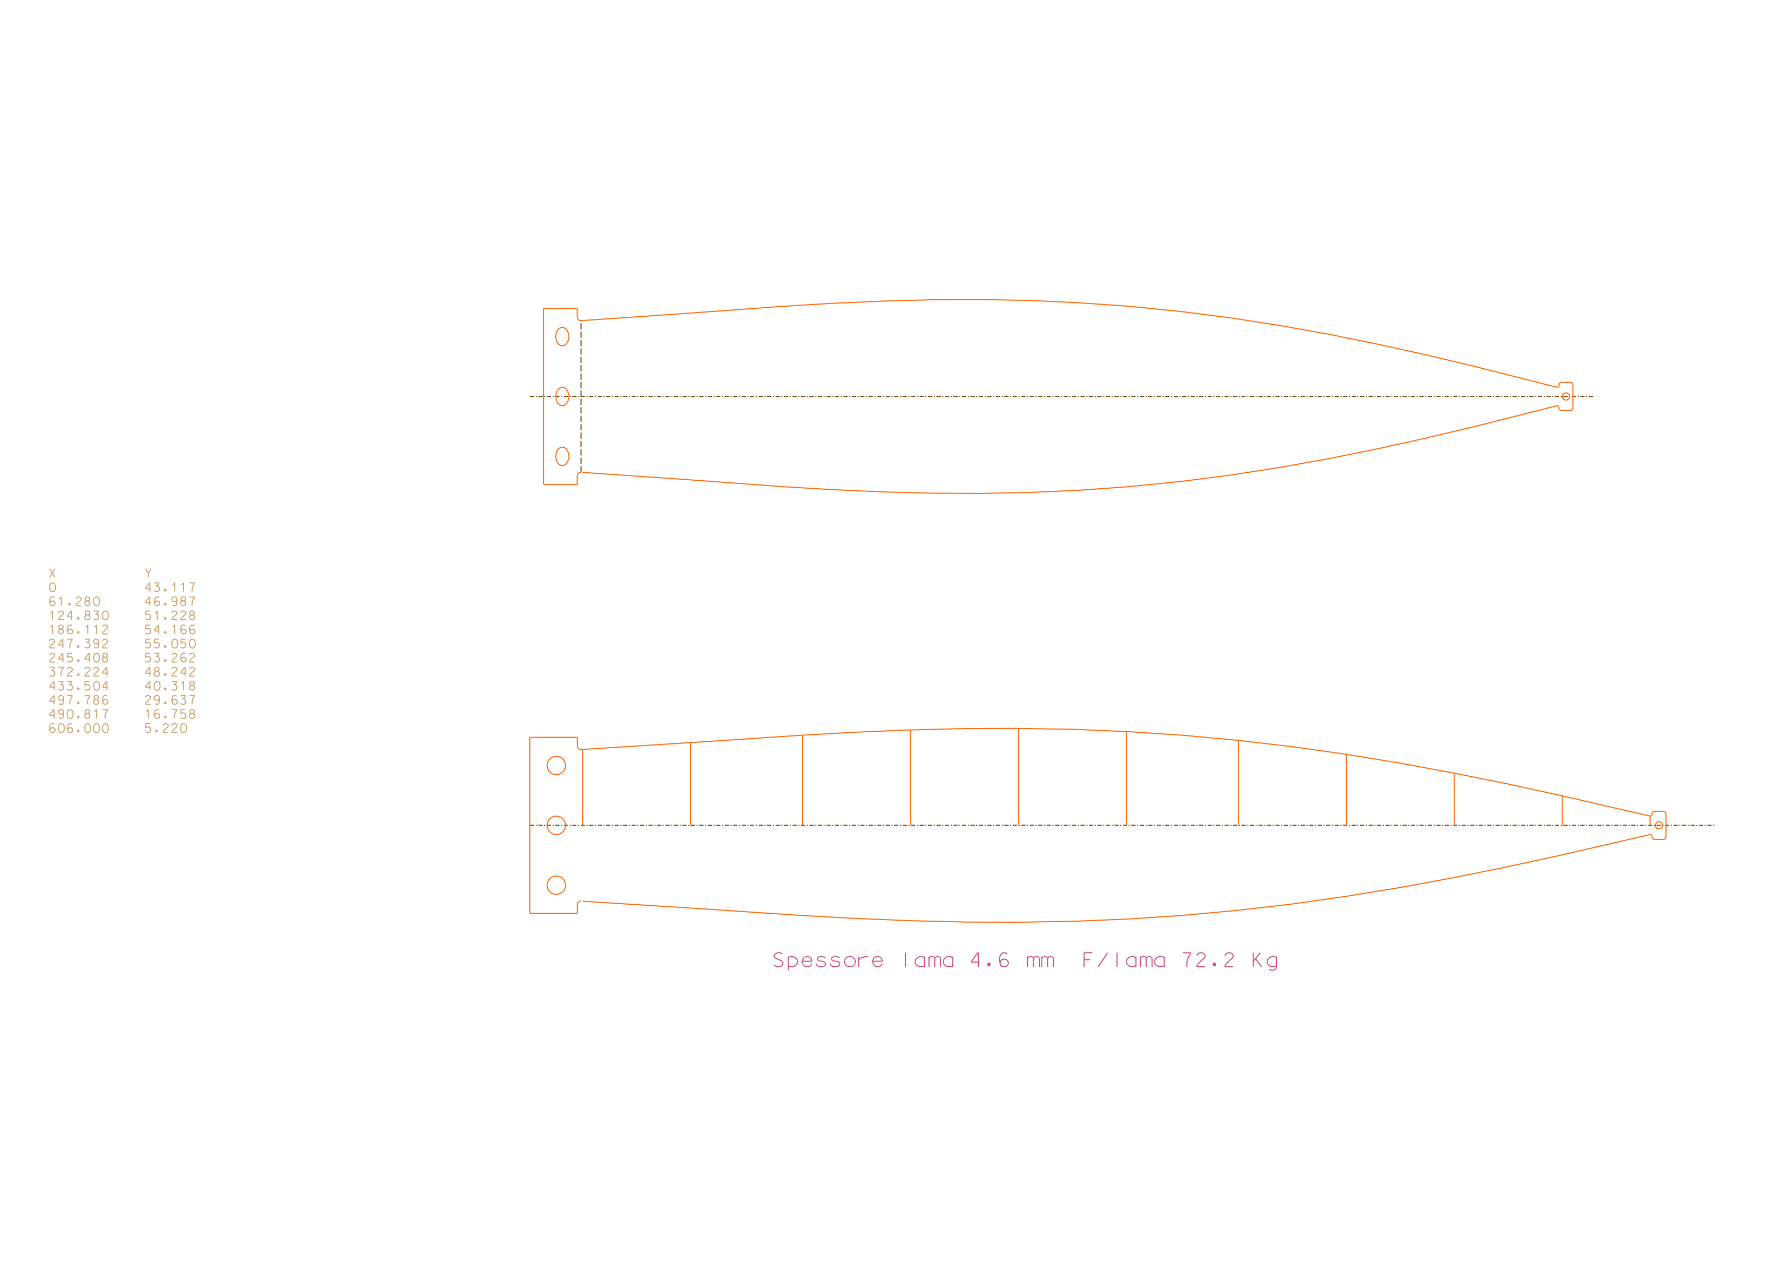

Figure 3: Filter zero blade design. This design is the TAMA design improved by M.Beker of NIKHEF to further uniformize the stress along the blade and reduce the peak stress.

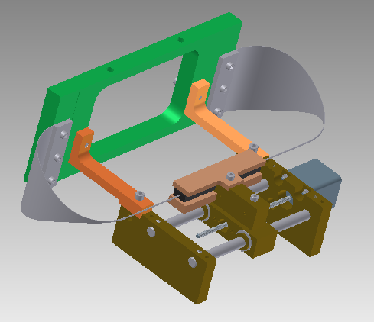

Figure 4:stepper motor controlled horizontal tuning springs. This design is borrowed by the AEI optical bench design. Leaf blades are used instead of helical blades to tune the working point of the Inverted pendulum bench. The pink braket are for transport only. The green plate moves with the IP table, the stepper motor is bolted to ground. A similar design, with a single blade, is used to set the GAS filter static working point.

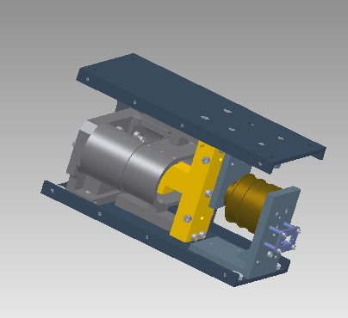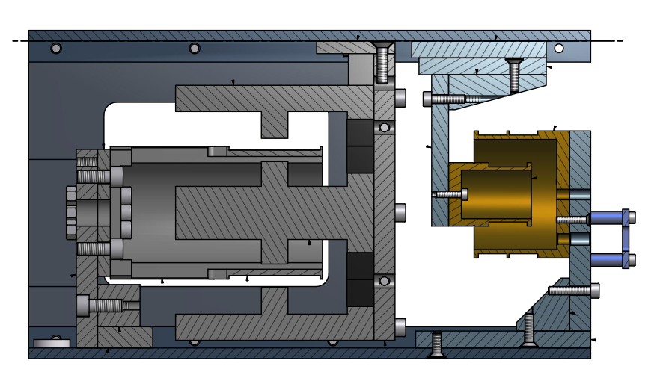

Figure 5: LVDT-Actuator unit for the Inverted pendulum tuning.

The back panel is for transport only.

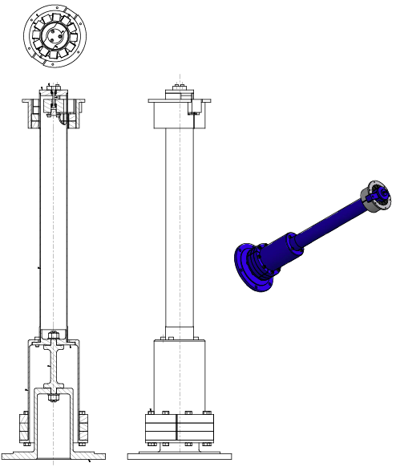

Figure 6: Inverted pendulum configuration complete with center of percussion compensation counterweights and resonance damping magnets. This design is borrowed from HAM- and AEI-SAS.

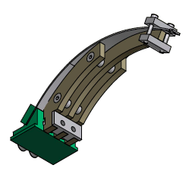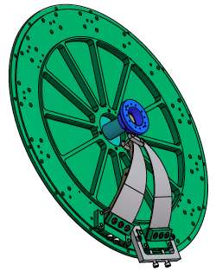

Figure 7: Left, blade pre-stressing fixture, in preparation to mounting the bades in filter zero. Right, a special tool holds the keystone in position while blades are mounted on. Blades are mounted and released in symmetric groups of three to avoid transversal stress on the keystone holder. After mounting of all blades, the axial stress is transferred from the keystone holting tool to the range limiter fixture (not shown).

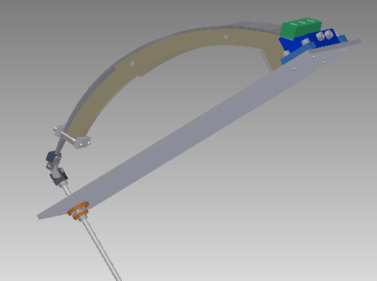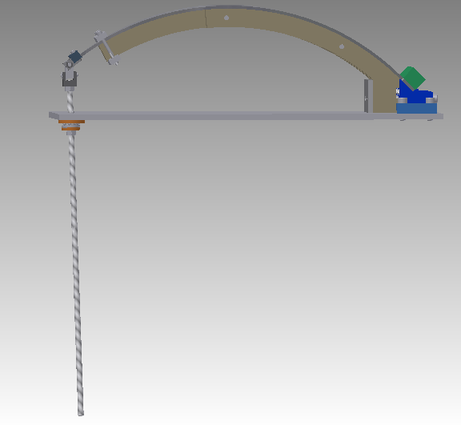

Figure 8: blade stressing procedure. The blade is mounted on its clamp on the stressing table, the pre-stressing fixture is secured to the clamp by means of two bolts. A threaded rod with a homo-kinetic joint is attached to the blade’s tip. Spinning the threaded rod pulls the blade’s tip to the tip of the pre-stressing fixture. The blade’s tip is clamped to the fixture and the pukking threaded rod removed. The clamp is unbolted from the table and the blade-clamp assembly is ready for implementation on the filter.

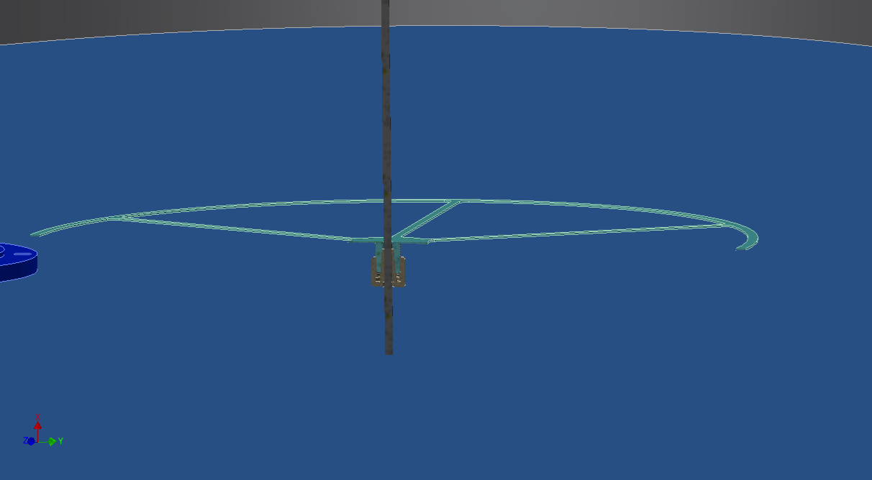

Figure 8: Two spiders are mounted by means of peek wedges on the suspension wire ½ m below a filter and ½ above the next one. They will guide the electrical wiring draping from the bottom of the upper filter, to the upper spider, to the lower spider, to the lower filter.