**Schematic design of a proposed SAS-based seismic isolation for LCGT**

**First draft**



**Schematics of the mechanics of the LCGT test mass seismic attenuation system**

The design of the LCGT test mass seismic attenuation chain is based on three standard GAS filters, preceded by a pre-isolation and static control stage, made by a larger GAS filter mounted on short Inverted pendulum legs.

The pre-isolation stage sits directly on the floor of an utility tunnel. The attenuation chain resides below it, in a 900 mm diameter vertical pipe inside a 1000 mm borehole extending to the main LCGT tunnel.

The mirror suspension system resides in a separate chamber in the lower tunnel.

The minimal rock and reinforced concrete thickness between the two tunnels is 5 to 6 meter.

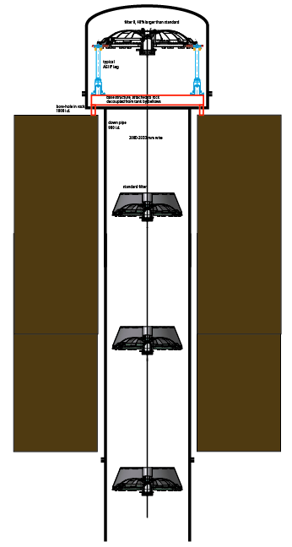

Figure: Schematic view of the LCGT test mass attenuation chain. It stretches between two separate tunnels. The pre-isolation stage sits on the floor of the top tunnel, the third of the standard filters is suspended below the ceiling of the lower tunnel. The filters are equally spaced.

The aim of the seismic system is to attenuate the seismic noise at or below the LCGT sensitivity level (at least for the vertical direction) at the beginning of the suspension payload because it is expected that the thermal conduction and requirements may allow for little attenuation in the horizontal direction and none in the vertical direction).

**The design of the standard filter**

The design of the standard vertical filter of the LCGT attenuation chains is now at version 5. Three standard filters are foreseen, numbered one to three starting from the top.

These three filters will be virtually identical, the number and width of the blades implemented inside each filter will be chosen to match the payload, filter one will have all 12 blades, wile filter two and three will have 10 and 8 blades respectively.

A wider filter, called filter zero, is used at the top stage, to suspend the larger load, to provide attenuation at the lowest frequencies, and to facilitate the connection to the Inverted pendula and to the ground. This larger filter will be just a scaled up version of the standard filter.

The function and the configuration of the standard filter is the same of the TAMA-SAS filters. The 12 GAS blades of the standard filter are virtually identical to those used in TAMA SAS, except for the attachment at the two ends, which was successfully tested in the LIGO HAM SAS.

The new blade attachment scheme uses separate blades joining at a central keystone. The blade clamps at the outer diameter are mounted on radial slides to allow for easy frequency tuning.

This scheme was also adopted and further tested by AEI SAS and NIKHEF SAS.

It allows easy tuning of the payload, by simply changing the number of blades per filter, as well as their thickness and width.

Up to ~500kg can be suspended from a fully loaded standard filter. The standard filter is 730 mm in outer diameter.

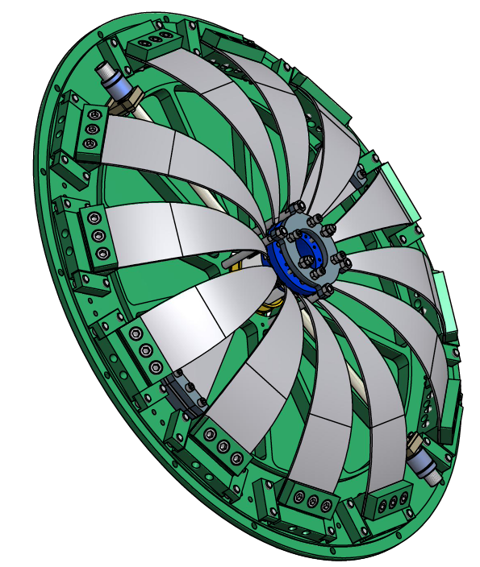

Figure: View of a standard filter loaded with 12 blades. The blades are flat at construction. They arch under load and wedg against a central keystone (blue) that support the filter’s payload via a suspension wire.

Each blade is supported by a clamp, with a 45o blade launching angle. Each clamp sits over the flat main base plate of the filter, and can slide forward and is locked on both sides by two lip clamps.

An end range ring (grey) above the keystone holds the blades under compression when the payload is absent. Six screws mounted on this ring, three pushing against the keystone, and three extending through it, delimit its oscillation range of ~ ±2 mm.

Two wands, used to compensate the blade’s center of mass effects, and two compensation blades are visible below the 12 suspension blades.

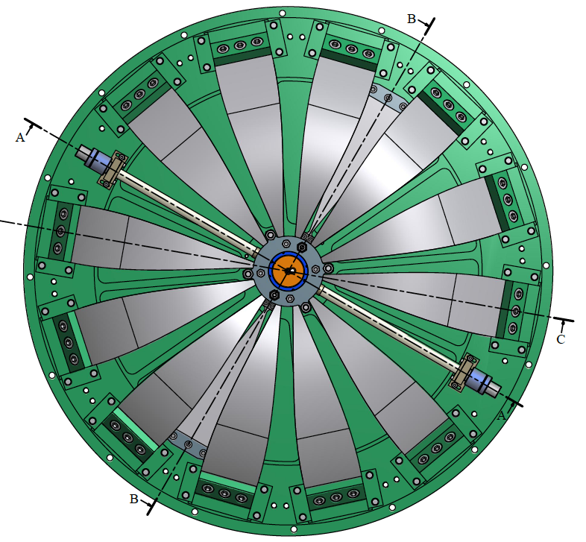

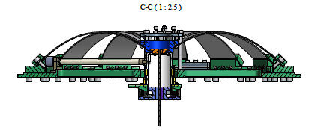

Figure: Top and side view of the standard filter.

**Frequency tuning of the standard filter**

To measure and tune the frequency of the filter, is loaded with a dummy mass. The dummy mass is adjusted until it floats between the end stops. The dummy mass is further adjusted until the vertical point of minimal frequency (maximal compression) is identified. This is the vertical working point of the filter. Its vertical resonant frequency is measured.

The vertical mechanical frequency tune of the filter is obtained by changing the radial compression of the blades against the central keystone. More compression yields lower resonant frequency, excessive compression leads to bistability.

The radial compression changes are applied on pairs of opposed blades, to maintain symmetric load on the keystones. To change the radial compression a temporary tool is mounted around the lip clamps holding the blade clamp. The four screws of the lip clamps are loosened, the two radial screws on the tool are used to advance or retract the blade clamp. The locking screws are tightened again and the tool is reused on a different blade.

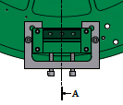 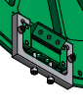

Figure: Views of the tool used to change the radial compression of the filter’s blades.

**Center of mass compensation of the standard filter**

The vertical attenuation performance of the bare blades of the filter is limited to 60 dB by the Center Of Percussion (COP) effect. It can be compensated by adding a counterweighted wand in parallel to the suspension blades. The wand is hinged on the GAS filter base plate, with the wand on one side, and a tuneable counterweight on the other side of the hinge.

The tip of the wand is hinged on the filter keystone.

Stochino brought the GAS filter attenuation limit to 60 dB with aluminum wands, Bertolini brought it to 90 dB with more rigid Titanium Nitride wands.

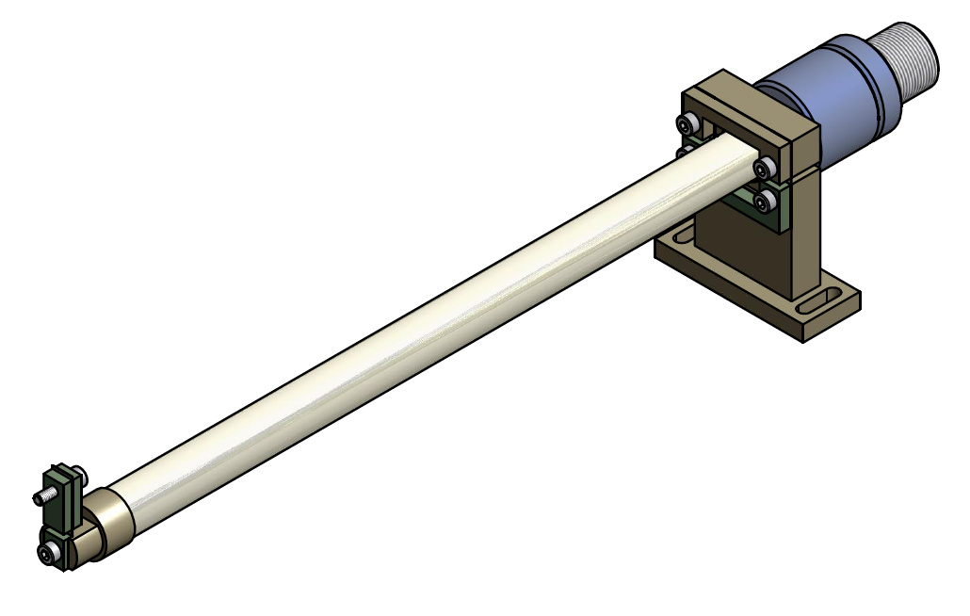

Figure: Magic wand to compensate the blade’s center of percussion limitation. COP compensation can be tuned by adjusting the position of the two counterweights (blue) along a fine threaded back end.

**Thermal compensation issues**

The second stage of LCGT will feature cryogenic payloads. It is therefore likely that the LCGT filters will need to cope with the challenges of operation in the vicinity of a cryogenic environment.

Although the seismic attenuation chain itself is not cryogenic, it may be exposed to areas of the solid angle at different and changing temperatures. This may lead temperature gradients inside the filter and changes of the filter’s operating temperature.

This is a problem because the Young’s modulus of the maraging blades changes by 2 10-4/oC. The filter payload lifting capabilities change by a corresponding amount. In addition temperature gradients may lead to a tilting keystone.

Steps are necessary to mitigate both effects.

**Thermal shielding of the standard filter**

To avoid thermal gradients we designed the filter inside a closed shell, which defines a local uniform thermal bath for the blades.

The shell has also a mechanical function, its center provides a convenient hooking point for the wire that suspend the filter from the previous element.

This hooking point, as well as the hooking point for the payload on the keystone, are located near the filter center of mass, to produce low frequency tilt frequencies.

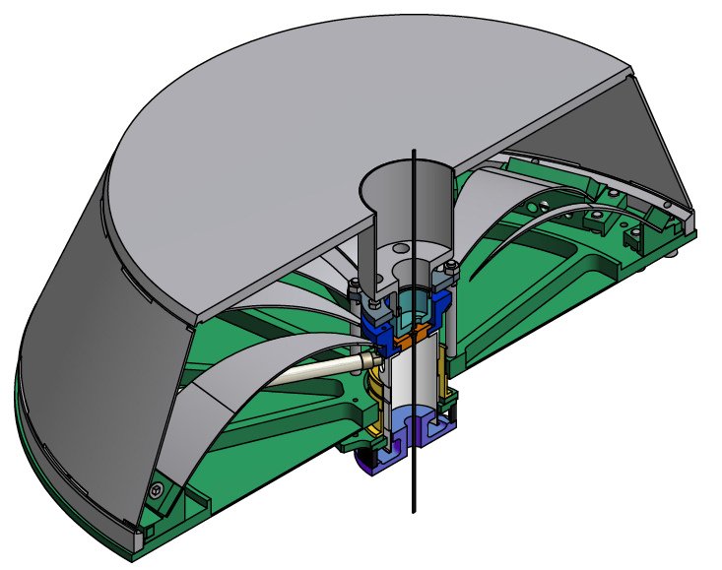

Figure: The standard filter is fully enclosed into a shell. The shell has two functions: thermal shield against asymmetric thermal loads, and hooking point for the wire that supports the filter.

**Thermal compensation of the standard filter**

LCGT is expected have transients from warm to cooled state, which, over long time scales, may change the working temperature of the standard filter by a few degrees (especially the lowest filter, which will be closest to the cryostat).

To reduce the effects of these transients the filter body will be polished and possibly gold plated on the lower surface exposed to colder bodies, to slow down the filter thermal response to the transients. The aim is to cause all thermal variations to be slower that the thermalization time inside the shell.

The top surface would be left with a larger black body coefficient, to establish preferential thermal equilibrium with the upper vacuum chamber, which is supposedly more thermally stable.

Because of the low frequency tune (soft spring) and of the relatively high thermal changes of Young’s modulus in Maraging (~2 10-4/oC), any change in temperature will generate a relatively large change of the filter’s working point.

Two ways have been devised to compensate for this fact.

We are designing an internal thermal compensator based on a thin bimetal blade, in parallel to the GAS blades. The bimetal blade is designed to provide a thermally changing force that will compensate the increase of Young’s modulus at lower temperature. Like the magic wands, the bimetal blades will be fastened on the filter base plate at one end, and hinge on the keystone at the other end.

The compensation bimetal blades will either mount below the filter main blades or replace a pair of GAS blades in filter 3 and possibly filter 2.

In alternative a small electrical heat radiator above the filter may be used to maintain the working temperature of the filter even in case of cold leaks.

**Wire hooking procedure of the standard filter**

The filter’s suspension wires are double nail head wires, machined from a solid rod of Maraging steel, longer but of the same type used in TAMA SAS.

The split cup fastener type used in TAMA SAS is unsuitable for the function in LCGT. Both the keystone, and the shell nose are provided with receptacles snugly receiving the wire nail head and a side slot, similar to that that allows the insertion of the wire in bicycle brakes.

Three screws threaded in the range-limiting ring (grey) push on the keystone (blue).

These screws are reachable through three holes in the filter’s shell.

Normally the keystone is allowed to rest against the nose of the filter shell.

To hook the suspension wire to the filter’s shell or to the keystone, the three screws are used to separate the keystone from the nose by a few mm. In this configuration it is possible to insert the nail head of the wires through the side hole, slide it into its receptacle, and let it lodge in there. When the holding screws are retracted, and the keystone to nose distance is reduced, both wires are imprisoned in place.

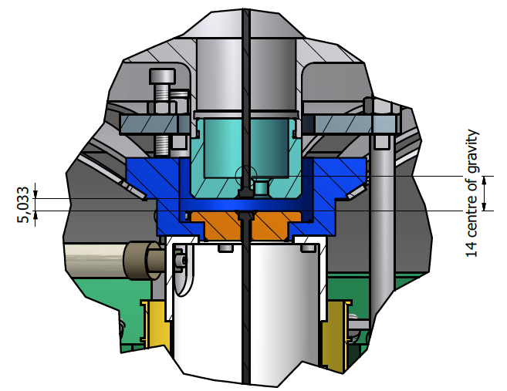

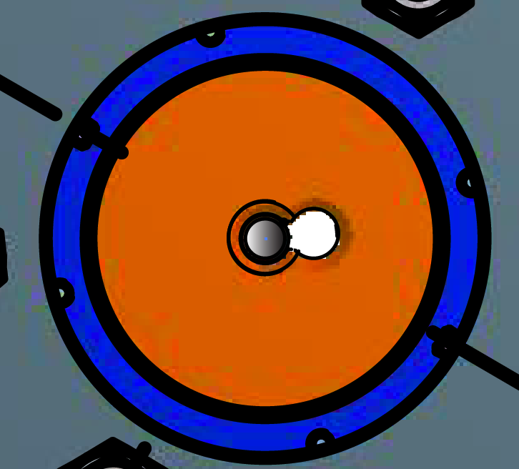

Figure: Details of the attachment of the wires to the filter. Side and Top view.

**Load corrections of the standard filter**

The load carried by the standard filter is fixed by the number, width and thickness of the blades. Most blades will be identical, carrying ~ 40 kg each. As blades always mount in pairs, eliminating a pair generates a load reduction of ~80 kg.

Smaller steps in payload can be achieved using a pair of narrower or thinner blades.

The standard filter needs to be loaded with its exact payload. After fixing the filter’s nominal payload, the actual payload needs to be fine tuned to the filter’s nominal payload to bring the filter to float at its working point. This fine tuning is achieved by adding or removing some ballast mass from the next filter or structure below.

This operation should be always performed starting from the lowest filter, and working the way up the chain. Attention must be paid to ambient temperature, as it can change the values of optimal load.

It is foreseen that each filter, weighting ~87 kg fully loaded with 12 blades, will carry approximately 10% of ballast weight.

Filter 1 is obviously the most loaded, as it has to lift also the mass of filter 2 and filter 3, weighting ~90 kg each. A payload of up to 300 kg is foreseen, with no modifications.

**Load reserve.** The LCGT load requirements should be easily met by the proposed standard filter. However future evolution with possibly heavier mirrors may require larger payloads. It is useful to evaluate how much more load can be imposed on the standard filters by changing blades but without changing their outer physical shape.

Nominally the shape of the blades is such that the radius of curvature is kept constant along the blade, for optimal use of the material strength.

Simulations made at NIKHEF show that the stress distribution is not constant and that a small modification of the blade’s profile leads to a 10% reduction of the peak stress. This would allow the use of 10% thicker blades, carrying 33% more load with no additional stress on the material.

Higher stress levels are nominally possible, but not as thoroughly tested as the ones tested at TAMA, LIGO, AEI and NIKHEF.

**Center of mass and Tilt correction of the standard filter**

The ballast mass will be bolted to the plates above and below the standard filters.

The distribution of mass can be altered to change the tilt angular frequency of the filter. Moving mass from the bottom to the top plate will decrease the tilt resonant frequency.

Ballast mass can also be moved laterally to level the filters if necessary.

**Assembly procedure of the standard filter**

The standard filter is composed of 12 pre-stressed blades mounted between the base plate and a central keystone.

Several specialized tools are necessary to properly and safely pre-stress the filter.

The first tool is the holder that keeps the keystone in place while the individual blades are installed, before the load is transferred to the retaining ring.

It bolts to the bottom of the base plate and grabs the keystone.

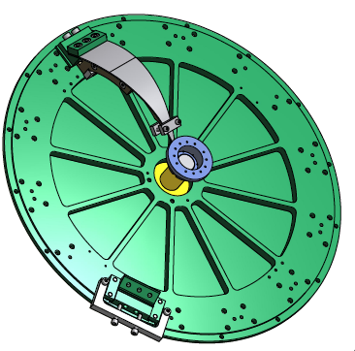

Figure: Keystone holder, shown in yellow at the center of the baseplate. Also shown at 11:00 a blade as it is brought on the filter for assembly. Pairs of identical blades are always mounted in the same step, to insure stress symmetry on the keystone.

Each blade needs to be pre-stresses individually, and kept under stress until the stress is transferred to the filter and keystone.

This is achieved as illustrated in figure.

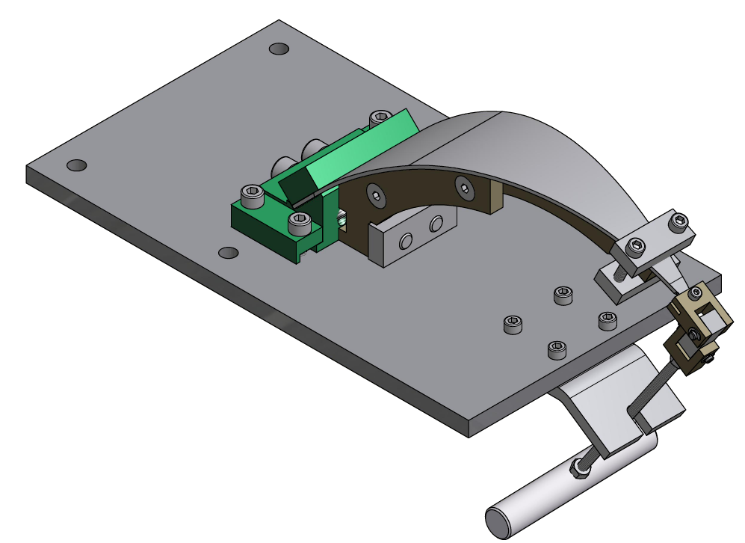

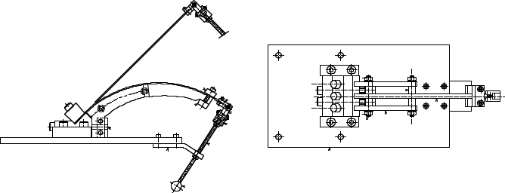

Figure: Pre-stressing procedure of each blade.

The blade (flat when unstressed) is mounted on its clamp (green), the clamp is locked on the stressing stand. The blade extends straight up with a 45 degree angle.

A properly shaped support (dark grey) is bolted to the blade clamp.

A pulling handle is attached to the tip of the blade.

A tip clamp is used to fasten the blade’s tip to its support

The pre-stressed blade assembly is released from the pulling handle and the stressing stand.

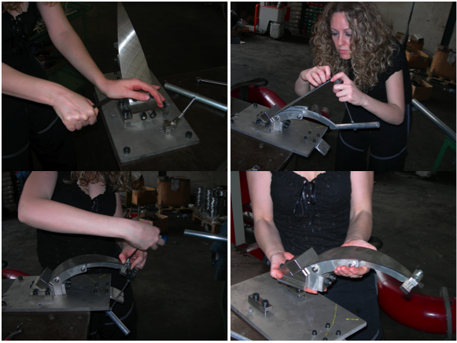

Figure: Blade pre-stressing sequence

Pairs of blades are mounted on the base plate, clamped down, and bolted to the keystone., then the support is freed up from the blade and extracted sideways.

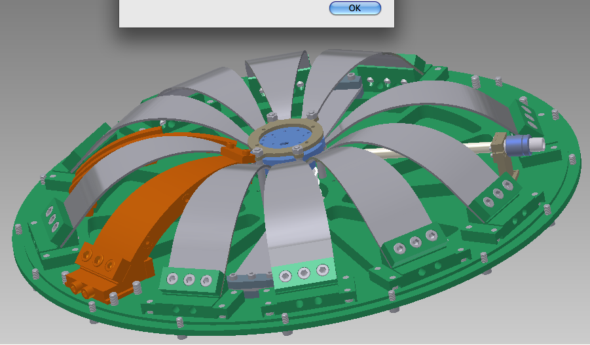

Figure: assembly of pre-stressed blades on a standard filter, and extraction of the blade holder (orange) from the angular space reserved fro the magic wands.

There is no place to extract the blade’s support between two adjacent blades. The support is extracted from the side where the next pair of blades will be assembled.

The blades are not spaced at 20 degrees around the disk, a wider angular space is left between blade 1 and 12 and between blade 6 and 7 to extract the last blade support. The space left will later be used to implement the magic wands

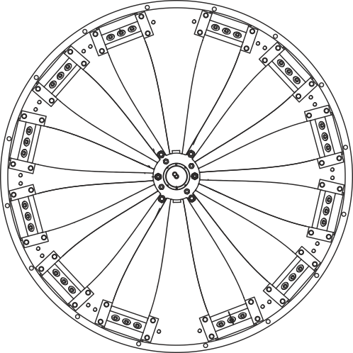

Figure: Illustration of the wider space left at 12:00 and 6:00 for the extraction of the blade’s holder, and for implementation of the magic wands.

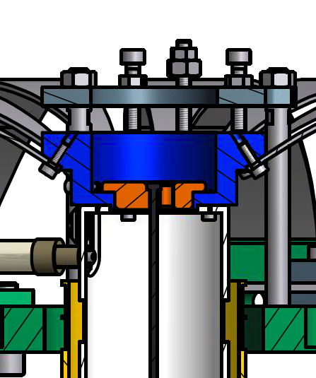

Figure: sequence to transfer the stress from the keystone holder to the range limiter. The keystone range limiter (Dark Grey) is bolted to the base plate, above the keystone (Blue) and the stress is transferred to the range limiter by tightening the three pushing screws, then the keystone holder is removed from below the filter base plate.

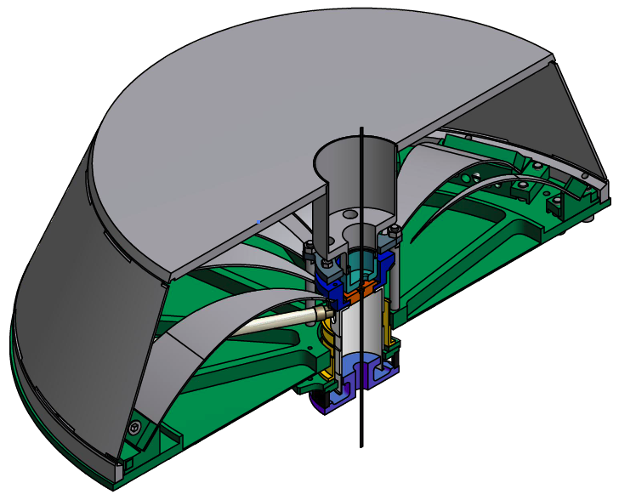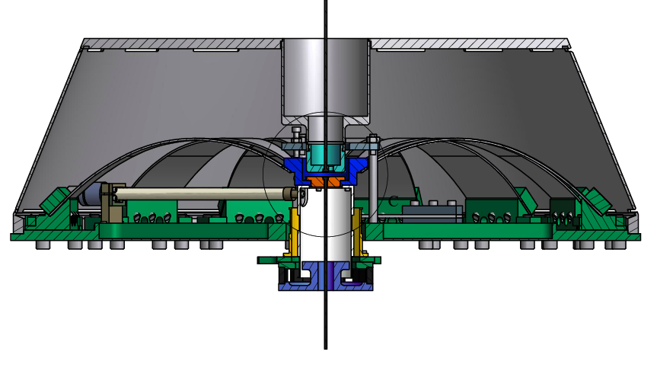

Figure: The external Shell is bolted to the baseplate.

**Assembly procedure of the attenuation chain in the borehole.**

The installation of the LCGT seismic attenuation chains requires two superimposed tunnels. The bottom tunnel is the LCGT beam tunnel, the top tunnel houses the base of the seismic attenuation chains.

This is done to give the best mechanical stability to the seismic attenuation chains, taking full advantage of the underground location.

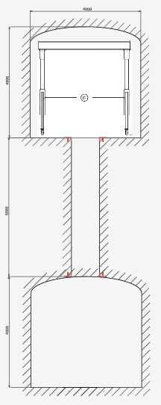

Figure: View of the overlapping tunnels. A minimal separation of 5 m between the tunnel (>1 tunnel diameter) is required for rock stability. Larger separation between the tunnels is equally good for the SAS, as longer wires produce attenuation at lower frequency. All implementation of the seismic system and of its vacuum system will be lowered from the top tunnel with the help of an A-frame crane.

Figure: Sequence of installation of the vertical vacuum pipe down the 1000 mm diameter borehole

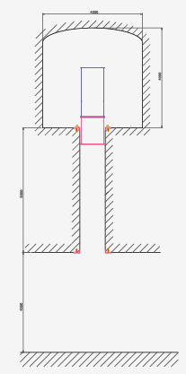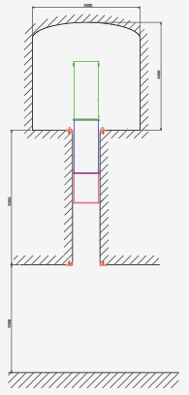

Panel 1, the lowest, pipe section is lowered with the crane partially into the borehole, and grabbed with a temporary clamping, to allow bolting of the middle section.

Panel 2, the lowest and middle pipe sections are lowered and re-grabbed, to allow mounting of the top pipe. After lowering a section, it has to be grabbed near the floor, to allow the bolting of the next section

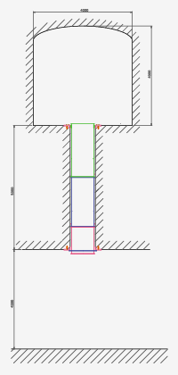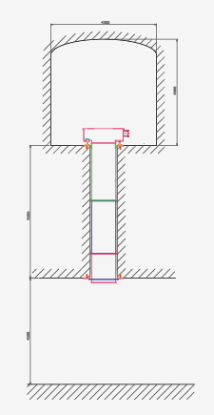

Panel 3, the three pipes are lowered in place, a clamping ring is attached to the bottom pipe and bolted to the ceiling to hold the weight of the three pipes.

Panel 4, the bottom of the inverted pendulum vacuum chamber is bolted on top of the top pipe section

Figure: sequence of insertion of the SAS chain.

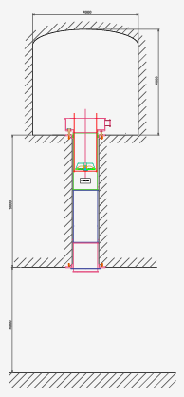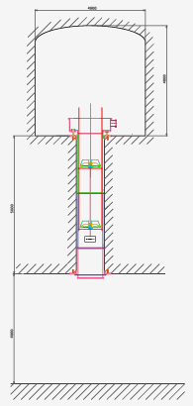

Panel 1, the bottom filter is loaded with a dummy load, suspended from its wire from the crane, and tested for correct functioning. A safety structure (red) surrounds the filter, the safety structure is simply a steel ring supported by three rods. All cabling is prepared. The safety structure rods are grabbed. The filter is lowered on its safety structure. The safety structure is attached to the crane, lowered and re-grabbed.

Panel 2, a second safety structure is bolted on top of the first, the mid filter is attached to the wire of the bottom filter, the mid filter is hanging from its wire, and it is tested and cabled. Then both filters are lowered on their safety structure.

The safety structures are attached to the crane, lowered and re-grabbed.

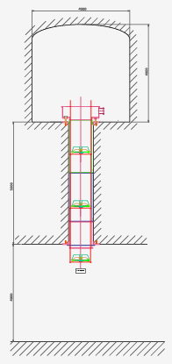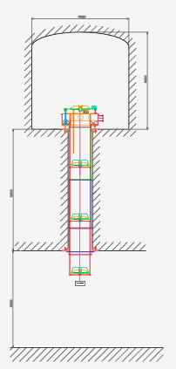

Panel 3, the operation is repeated for the top filter

Panel 4, the filter zero, and the IP are attached to the top filter wire.

The safety structure is attached to the IP basement, the entire chain is lowered on its basement.

Now the bottom filter sticks out in the lower tunnel (in the topmost part of the cryostat) where it can be accessed from the side. Its dummy payload can be replaced with the real payload.